Supporting information for
Two-transition-metal water oxidation catalysts. Faster rates via electronic structure tuning
Meilin Tao, ¹ Qiushi Yin, ¹ Alexey L. Kaledin,² Natalie Uhlikova,¹ Yu-Sheng Chen, Tianquan Lian,¹ Yurii V. Geletii,¹ Djamaladdin G. Musaev,^{1,2} John Bacsa,¹ Craig L. Hill¹

Additional specific syntheses
Ru(bpy)₃(ClO₄)₃ was prepared as literature.¹ Solid PbO₂ (1.5 g) was added to a solution of [Ru(bpy)₃]Cl₂·6H₂O (300 mg, 0.4 mmol) in 0.6 M sulfuric acid (10 mL), then the resulting orange-red solution was vigorously stirred until it turned green. After removing the solid PbO₂ powder via a filter with fine porosity frit, the solution was cooled in ice-bath and then 2.2 mL of 70% (11.6 M) HClO₄ was slowly added. The resulting dark green precipitate was filtered through a medium-sized frit and then dried under water pump vacuum to remove most of the water. The samples were further dried under high-vacuum for 3-6 hrs and stored in a sealed glass container at 5 °C until use. Yield: ~ 200 mg.
Synthesis of tetraheptylammonium nitrate (THpANO₃)
The THpANO₃ was synthesized by reacting tetra-n-heptylammonium bromide (THpABr) with AgNO₃. Typically, an aqueous solution of AgNO₃ (40 mg AgNO₃ dissolved in 10 mL of H₂O) was added to a solution of THpABr (110 mg) in toluene. The resulting mixture was shaken vigorously forming light yellow AgBr. The colorless organic layer was filtered to remove AgBr precipitate before use.
Table S1. Elemental analysis of Na₂K₈Co₂Ni₂P₂W₁₈O₆₈•30H₂O
Elements | weight %  (found) | Weight %  (estimated) | stoichiometry  (found) | stoichiometry  (estimated)
Co | 2.00 | 2.22 | 2.0 | 2.0
Ni | 2.11 | 2.21 | 2.1 | 2.0
P | 1.04 | 1.15 | 2.0 | 2.0
W | 61.70 | 62.46 | 18.7 | 18.0

X-ray structures of two different salts of Co₂Ni₂P₂. The crystallographic details are given in Table S2
Table S2a. Crystal data and structure refinement for Co₂Ni₂P₂.
Identification code | KNaCo₂Ni₂P₂ | Formula weight | 5591.76
Empirical formula | Co₂H₆₀K₈Na₂Ni₂O₉₈P₂W₁₈ | Temperature/K | 100
Crystal system | monoclinic | Space group | C2/m
a/Å | 12.1762(3) | α/° | 90
b/Å | 21.5100(5) | β/° | 104.896(3)
c/Å | 16.9887(5) | γ/° | 90
Crystal size/mm³ | 0.418 × 0.215 × 0.033 | Volume/Å³ | 4299.99(19)
Radiation | MoKα (λ = 0.71073) | ρ_{calc}g/cm³ | 4.319
2Θ range for data collection/° | 3.788 to 67.082 | F(000) | 4976.0
Index ranges | -18 ≤ h ≤ 18, -31 ≤ k ≤ 32, -25 ≤ l ≤ 26 | Goodness-of-fit on F² | 1.162
Reflections collected | 54212 | μ/mm⁻¹ | 25.332
Independent reflections | 7915 [R_{int} = 0.0699, R_{sigma} = 0.0377] | Largest diff. peak/hole / e Å⁻³ | 6.8/-5.7
Data/restraints/parameters | 7915/338/333 | Z | 2
Final R indexes [I>=2σ (I)] | R₁ = 0.0732, wR₂ = 0.1815 | Final R indexes [all data] | R₁ = 0.0802, wR₂=0.1848
Table S2b. Crystal data and structure refinement for KNaCo₃Ni₂P₂.
Identification code | KNaCo₃Ni₂P₂ | Formula weight | 5479.135
Empirical formula | Co₄H₄₈K₆Ni₂O₉₂P₂W₁₈ | Temperature/K | 100
Crystal system | triclinic | Space group | P-1
a/Å | 12.0428(3) | α/° | 87.452(1)
b/Å | 12.3345(3) | β/° | 70.621(1)
c/Å | 16.3707(4) | γ/° | 61.378(1)
Crystal size/mm³ | 0.1 x 0.1 x 0.03 | Volume/Å³ | 1994.30(9)
Radiation | Synchrotron | ρ_{calc}g/cm³ | 6.723
2Θ range for data collection/° | 0.77 to 20.16 | F(000) | 2405.313
Index ranges | -18 ≤ h ≤ 20, -20 ≤ k ≤ 20, 0 ≤ l ≤ 27 | Goodness-of-fit on F² | 1.0341
Reflections collected | 17575 | μ/mm⁻¹ | 6.723
Independent reflections | 17572 | Largest diff. peak/hole / e Å⁻³ | 3./-2.0
Data/restraints/parameters | 17572/10/1201 | Z | 0.5
Final R indexes [I>=2σ (I)] | R₁ = 0.0292, wR₂ = 0.0695 | Final R indexes [all data] | R₁ = 0.0343, wR₂ = 0.0713

Multiwavelength synchrotron X-radiation anomalous dispersion scattering (synchrotron XRAS). In conventional X-ray diffraction, the intensities, are proportional to the structure factors, |F(hkl)²|. If the nature of the scattering, including any phase changes, is identical for all atoms, then |F(hkl)| = F(-h-k-l) (known as Friedel's law). The imaginary component of the atomic scattering factor (see equation 1 below) has a phase that lags π/2 behind that of the primary wave. Dispersion attenuates the Bragg X-ray peaks, and the introduction of the real and imaginary components causes Friedel’s law to break down, and give rise to intensity differences or signals that can be used to locate the anomalous scatterers. By varying the wavelength, the differences can be used to identify different elements in the molecule because every element in a crystal has its own, unique absorption K edge (illustrated in Figure S1). The charge density distributions of molecules are approximated atomic form factors that are calculated using wave-functions. At states close to the absorption edges of the atoms, X-ray radiation induces strong resonance of the atoms and the X-rays are strongly absorbed by them. In these cases, the atomic scattering factor f₀, without resonance effects, is no longer valid. The atomic scattering factor may be expressed as the sum of three terms (equation 1):
f = fo + Δf' + i•Δf" (1)

The anomalous dispersion expressed by the terms Δf' + i•Δf", not only reduces the intensities of the diffraction but also introduces a phase shift in the scattered X-rays by elastic collisions with the photon. The scattering factor is therefore a complex number, where f’ and f’’ respectively, are the real and imaginary parts. Anomalous scattering becomes appreciable when the frequency of the radiation closely matches that of the natural frequencies of the absorption edges of the electronic shells. Strong fluorescence occurs when the X-ray energy is above the absorption edge. This is because, when the X-ray energy is increased to an energy slightly above the absorption edge, the imaginary component, f" sharply increases (and the real component f’ dips at the same place) and X-ray absorption and re-emission occurs. This is the region where the resonance X-ray absorption and reemission is at a maximum. Most resonant scattering experiments are best done just below the edge where f" is most affected and there is little fluorescence and absorption.
The XRAS data were acquired over a wide range of wavelengths that included the two K-edges of cobalt and nickel, and data collections displaced at either side of the two K-edges (Figure S1). Single wavelength refinements with Shelx and olex2.refine on the XRAS data provide strong evidence that the outer sites were cobalt. The refined population of the atom cobalt occupying the outer sites (especially with data close to the K-edges of Co) resulted in a consistently 95% or greater occupancy and simultaneously Ni was always close to 100%. This was strong evidence that outer site is cobalt not Ni. However, the programs GSAS-II and Jana2006 allowed us to use all the multiple wavelength data (including the high resolution data) to simultaneously refine the populations of cobalt and nickel atoms at these specific metal sites with the atom positions and anisotropic thermal parameters. The high resolution (30 keV) data does not discriminate between Ni and Co sites. It was found that the displacement parameters for the outer Co(2) (outer) site were consistently larger than the inner M1 site. This means that this Co(2) site is partially vacant. Accurate site occupancy factors for this site were determined (from the 30 keV data) and fixed at 0.979(4) for the subsequent refinements. This fact made the analysis significantly more difficult because cobalt has fewer electrons than nickel and the outer site behaves as a weaker Bragg scatterer because of its fractional population. If the XRAS data had not included, the K-edges for both Ni and Co assignments of this site could have been incorrect because a partially occupied atom can scatter as intensely as a full occupied cobalt atom and vice versa.
The data was recorded to a maximum resolution of 0.60 Å. This data was not measured with as many high-angle reflections as we would have liked, however it did allow us to the perform the later refinements on the longer wavelength data without biased nuclear vibration atomic positions for the Ni and Co atoms. The 30 keV atomic positions and thermal parameters could then be frozen for the refinements of the X-ray resonance scattering factors. Once these scattering factors had been determined, all the parameters were refined, using all the data sets.
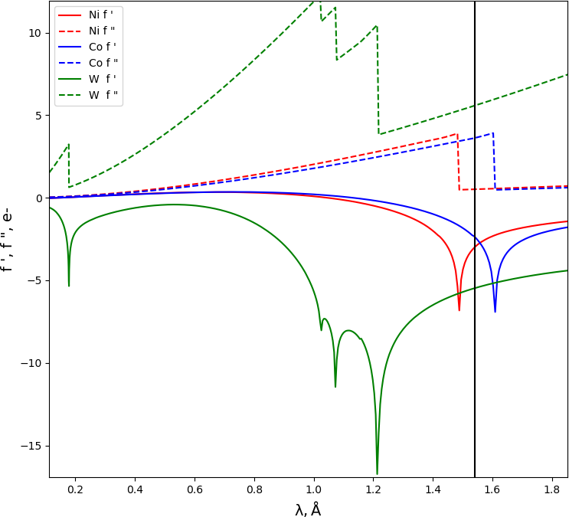
Fig. S1 | The resonant scattering signals for W, Ni and Co in Co₂Ni₂P₂ used by GSAS-II² for multi-wavelength refinements. The M^{II} = C, Ni atom site fractions were refined with the resonant data. The results confirm not only the Co, Ni atom sites, but also show that there is very little mixing between the sites. The 30 keV data was used to provide the best atomic and thermal motion model. Subsequently, the entire structure along with the optimized site fractions, was refined on all the data to provide the best overall results.

- Refinements on the 30 keV, 0.413 Data
The high-resolution data (30 keV, 0.4133 Å) provided the optimal atomic positions with their displacement parameters. The f’ values, from GSAS and Jana2006, are tabulated. The anomalous dispersion for all the atoms was the lowest here meaning that the accuracy of the atomic parameters is the least affected by absorption. The low-wavelength data also allows for accurate data measurements and for the higher angle reflections to be collected.
Table S3. F-prime values at 30 keV.
Element | GSAS f’(e) | JANA f’(e) | GSAS f ’’ (e) | JANA f’’(e) | μ (b/atom)
Co | 0.213 | 0.216 | 0.356 | 0.358 | 827.98
Ni | 0.227 | 0.232 | 0.410 | 0.413 | 955.62
W | -0.580 | -0.505 | 2.777 | 2.805 | 6470

- Refinements on the 8.39 keV (1.478 Å) Data
The resonant scattering profiles in the region of 1.478 Å are shown in the Fig. S2. This region is at or slightly above the absorption edge energy of nickel. However, it is higher in energy, than the cobalt absorption edge. At this wavelength, the anomalous absorption for nickel is very large. There is, however, very strong absorption by W, and fluorescence by cobalt and W at these wavelengths, which will influence the accuracy of the refinements (Table S4).
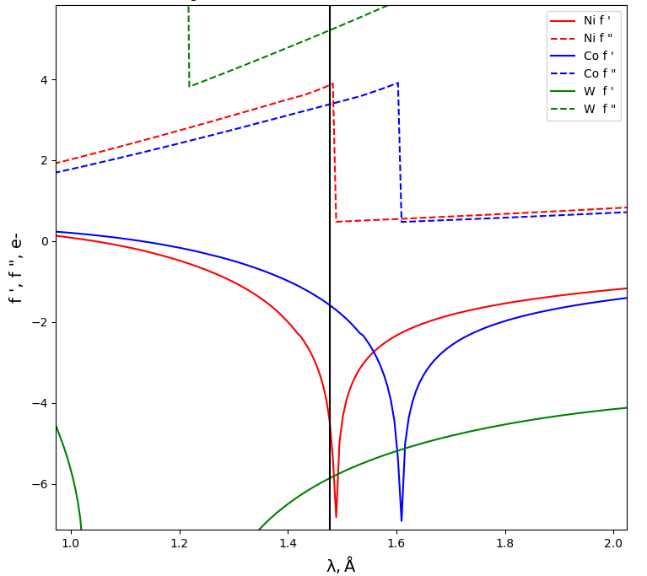

Fig. S2. Resonant scattering signals for W, Ni and Co centered on 1.478 Å (8.39 keV).

Table S4. F-prime values at 8.39 keV
Element | GSAS f’(e) | JANA f’(e) | GSAS f ’’ (e) | JANA f ’’(e) | μ (b/atom)
Co | -1.588 | -1.52 | 3.386 | 3.374 | 28197
Ni | -4.519 | -3.948 | 3.861 | 3.784 | 32153
W | -5.858 | -5.811 | 5.217 | 5.338 | 43452

Table S5. Refined F-prime values at 8.39 keV
Element | Olex2 f’(e) | JANA f’(e)* | Olex2 f’’’(e) | JANA f’’(e)* | μ
Co | -1.637 | -8.4(2) | 3.386 | 0.14 | 28197
Ni | -4.445 | -11.2(4) | 4.025 | 15.7 | 1706
W | -6.43 | -28.4(2) | 5.22 | 0.6(4) | 43452

- Refinements of the site fractions using GSAS on the 8.29 keV Data
The resonant scattering profiles in the region of 1.495 Å is shown in the Figure S3. This region is slightly below, in energy, the absorption edge for nickel. At these wavelengths, the anomalous absorption for nickel is very strong. However, the X-ray fluorescence due resonance re-emission from the nickel atoms should be significantly lower than above the absorption edge. At this wavelength it was expected to be s the spectroscopic properties of nickel should be optimal for the location of the nickel atoms (Table S6).

Table S6. F-prime values at 8.29 keV (1.495 Å).
Element | GSAS f’(e) | JANA f’(e) | GSAS f’’ (e) | JANA f’’(e) | μ (b/atom)
Co | -1.777 | -1.695 | 3.449 | 3.473 | 29069
Ni | -4.916 | -6.884 | 0.483 | 0.495 | 4067.4
W | -5.741 | -5.693 | 5.318 | 5.441 | 44825

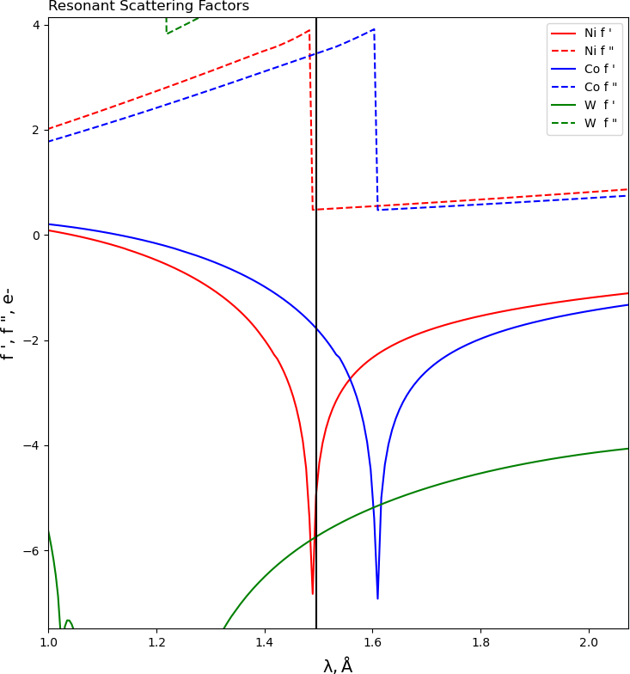

Fig. S3 | The resonant scattering signals for W, Ni and Co in Co₂Ni₂P₂ centered on 1.495 Å (8.29 keV).

Table S7. Refined F-prime values at 8.29 keV
Element | Olex2 f’(e) | JANA f’(e) | Olex2 f’’’(e) | JANA f’’(e) | Olex2  μ (b/atom)
Co | -4.996 | -9.5(4) | 9.971 | 5.4(7) | 29007
Ni | -7.96 | -8.4(4) | 2.132 | -2.7(8) | 4369
W | -12 | -27.4(5) | 2.5 | 8.7(6) | 47919

Table S8. F-prime values at 8.290 keV
Element | GSAS f’(e) | GSAS f ’’ (e) | μ (b/atom)
Co | -1.777 | 3.449 | 29069
Ni | -4.916 | 0.483 | 4067.4
W | -5.741 | 5.318 | 44825

Results from the Multiwavelength refinements of the site occupancies on 0.413, 1.478 and 1.496 Å X-rays (Co-K edge data).

Table S9. Refined Site occupancies for M2 (outer site) at 8.290 keV
Before (from 30 keV)
Element | M2 | R1
Co | 0.979(8) | 2.93
Ni | 0.000 (fixed) | 2.93
Element | M1 | 2.93
Ni | 1.000 (fixed) | 2.93
Co | 0.000 (fixed) | 2.93
After (from 30 keV, 8.39 keV, 8.29 keV)
Element | M2 | R1
Co | 0.973(8) | 4.18
Ni | 0.007(8) | 4.18
Element | M1 | 4.18
Ni | 1.000 | 4.18
Co | 0.000 | 4.18

The site occupancy constraint f(Ni)+f(Co) = 0.979 was applied. Therefore, a new constraint that makes the inner site fully occupied was also added.
The site occupancy for site M2, when refined as cobalt, refined to 0.98. Thereafter, the constraint, f(Ni)+f(Co)=0.98, on the outer metal atom M2 was applied which set the upper limit of the combined site fraction for this site (slightly less than one).

- Refinements on the 8.24 keV (1.505 Å) Data
The scattering profiles in the region of 1.505 Å are shown in the Figure S4. This region is still close, in energy, to the absorption edge for nickel, and the X-ray fluorescence due to resonance re-emission from the nickel atoms should be significantly lower than above the absorption edge. Here, it is expected that the spectroscopic properties of nickel should be optimal for the location of the nickel atoms (Table S10).
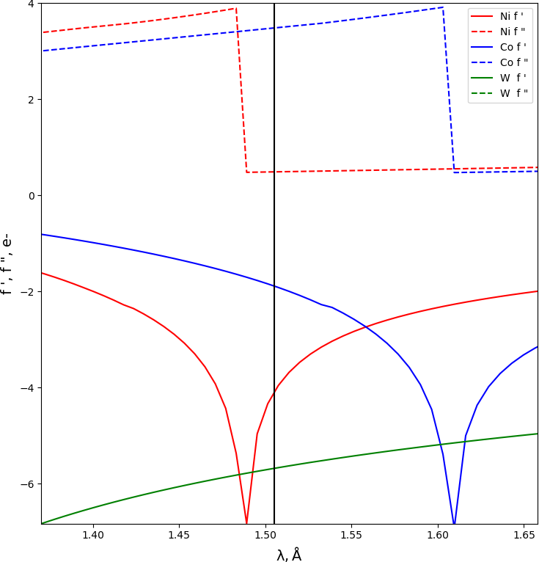

Fig. S4 | The resonant scattering signals for W, Ni and Co in Co₂Ni₂P₂ centered on 1.505 Å (8.24 keV).

Table S10. F-prime values at 8.24 keV (1.505 Å)
Element | GSAS f’(e) | GSAS f ’’ (e) | μ (b/atom)
Co | -1.887 | 3.482 | 29535
Ni | -4.094 | 0.488 | 4140
W | -5.682 | 5.372 | 44825

- Refinements on the on the 7.77 keV (1.596 Å)
This is slightly higher in energy than the absorption edge of cobalt and far below the absorption edge of nickel. It is anticipated that the Co sites would be most affected by resonance at these energies (however with fluorescence from Co).
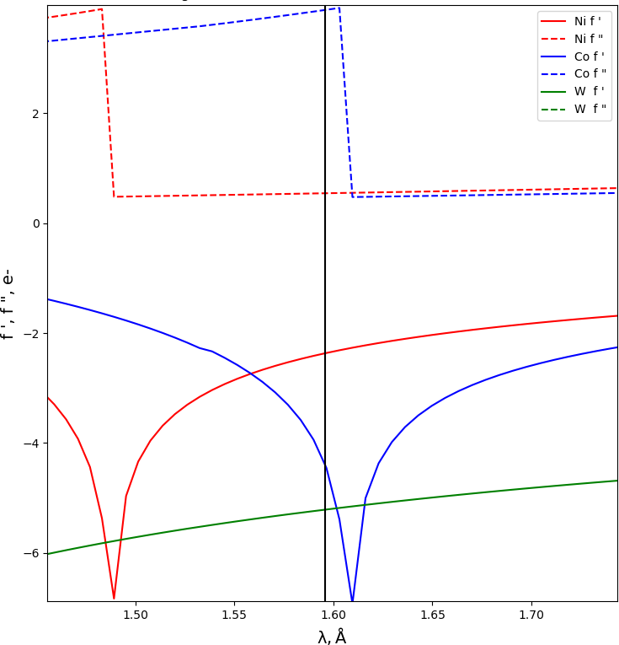

Fig. S5 | The resonant scattering signals for W, Ni and Co in Co₂Ni₂P₂ centered on 1.596 Å (7.77 keV).

Table S11. F-prime values at 7.78 keV (1.596 Å)
Element | GSAS f’(e) | GSAS f’’ (e) | μ (b/atom)
Co | -4.398 | 3.876 | 34863
Ni | -2.366 | 0.543 | 4880
W | -5.682 | 5.896 | 53028

Table S12. Refined F-prime values at 7.78 keV (1.596 Å)
Element | Olex2 f’(e) | JANA f’(e) | Olex2 f’’’(e) | JANA f’’(e)
Co | -8.29 | -8.0(4) | 2.49 | 2.6(5)
Ni | -6.27 | -5.9(7) | 1.90 | 2(1)
W | -22.2 | -21(1) | 9.7 | 10(1)

Table S13. Refined Site occupancies for the M1 (inner site) and the M2 (outer site) on the 8.39, 8.29 and 8.24 keV
Element | M2 | R1
Co | 0.96(1) | 4.18
Ni | 0.00 | 4.18
Element | M1 | 4.18
Ni | 0.99(1) | 4.18
Co | 0.000 | 4.18

- Refinements on the 7.67 keV (1.617 Å) Data
This is slightly below in energy than the absorption edge of cobalt and far below the absorption edge of nickel. I’d expect the Co sites to be highly affected by resonance at these energies. The missing fluorescence from both elements is also advantageous.

Table S14. F-prime values at 7.67 keV (1.617 Å)
Element | GSAS f’(e) | GSAS f’’ (e) | μ (b/atom)
Co | -4.901 | 0.478 | 4354
Ni | -2.218 | 0.556 | 5063
W | -5.682 | 5.896 | 54859

Table S15. Refined F-prime values at 7.67 keV (1.617 Å)
Element | Olex2 f’(e) | JANA f’(e) | Olex2 f’’’(e) | JANA f’’(e)
Co | -5.95 | -5.1(5) | 7.06 | -5.6(5)
Ni | -3.839 | -3.7(5) | 0.694 | 2(1)
W | -13 | -12(1) | 2.1 | 6(1)
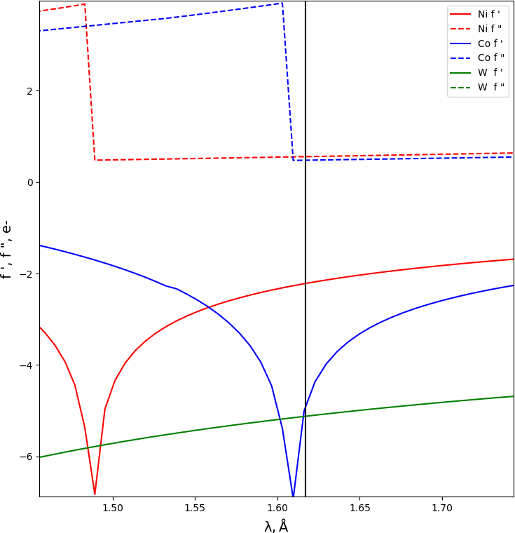

Fig. S6 | The resonant scattering signals for W, Ni and Co in Co₂Ni₂P₂ centered on 1.6170 Å (7.67 keV).

Table S16. Final Refined Site occupancies for M1 and M2 (inner and outer central-belt positions, respectively) over the entire wavelength range (0.413, 1.478, 1.496, 1.505, 1.596 and 1.617 Å)
Element | M1 | R1
Ni | 1.000 (free) | 10.5
Co | 0.000 (free) | 10.5
Element | M2 | 10.5
Co | 0.99 (2) | 10.5
Ni | 0.00 (2) | 10.5
Conclusions and Summary
The XRAS based evaluations were complex. It is clear that absorption was a significant issue at the wavelengths, and required very careful corrections. However, freely refining the site occupancies of the first-row transition metals led to negative occupancies for the minor fractions. While this was very strong evidence that the assignments as Co and Ni were correct, it may be physically unacceptable. It was not straightforward how to prevent negative occupancies without imposing a bias in the refinements. The following constraint, deemed to be physically acceptable, to prevent unacceptable negative occupancies for the minor fractions, was used. This constraint, effectively restrained the occupancy of one of the species to be equal or less than 1. This effectively made the site M1 fully occupied (and the site M2 have an occupancy of 0.98). To summarise: our XRAS refinements effectively gave a M2 site that consisted of cobalt only and a M1 site that was nickel. Refinements of the f-prime values were also carried out, and these supported the site occupancy refinements, because they exhibit the same patterns of values as for Ni and Co respectively. It was also possible to evaluate the difference electron densities at the absorption edges and these also supported the assignments.
Kinetics of water oxidation by [Ru(bpy)₃]³⁺, O₂ yield measurements and turnover frequency
The rapid kinetics of catalytic [Ru(bpy)₃]³⁺ decay was monitored using a Hi-Tech Stopped Flow SF-61SX2 instrument equipped with a diode array spectrophotometer (400-700 nm). One of the feeding syringes was filled with a solution of [Ru(bpy)₃](ClO₄)₃ in water at pH 3 and the second with a freshly prepared buffer solution of the catalyst. All concentrations are given after 1:1 mixing of solutions in the feeding syringes. The consumption of [Ru(bpy)₃]³⁺ was followed by a decrease in absorbance at 670 nm (ε₆₇₀ = 4.2 × 10² M^{–1} cm^{–1}) with optical path length l = 10 mm (Figure S7). The data were acquired and treated using KinetAsystTM 3.0 software.
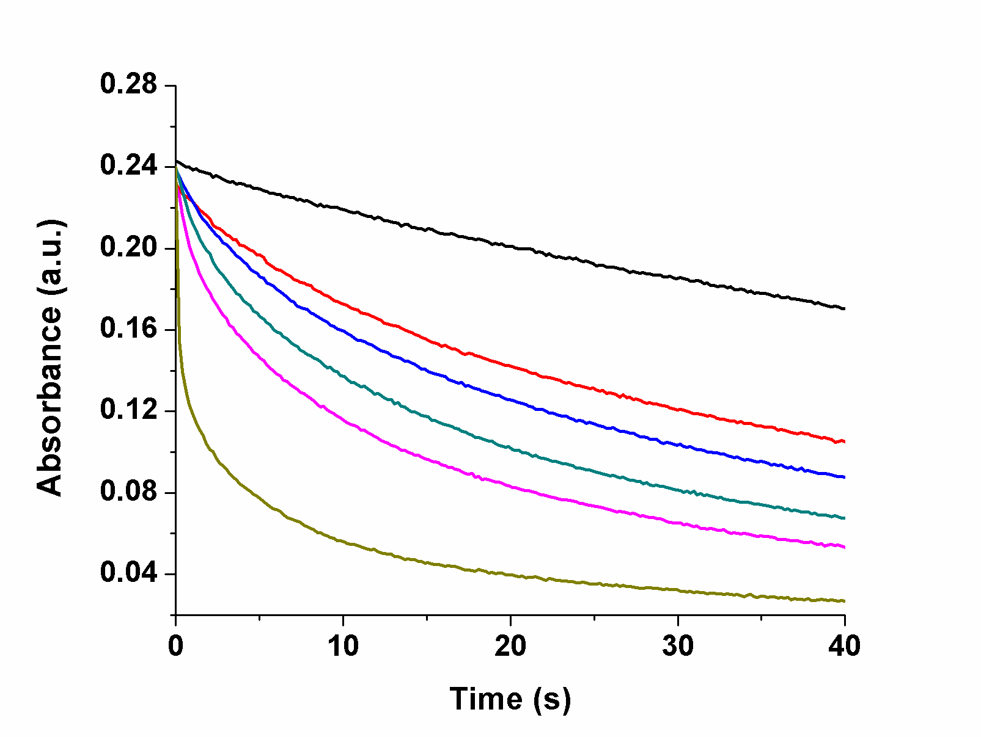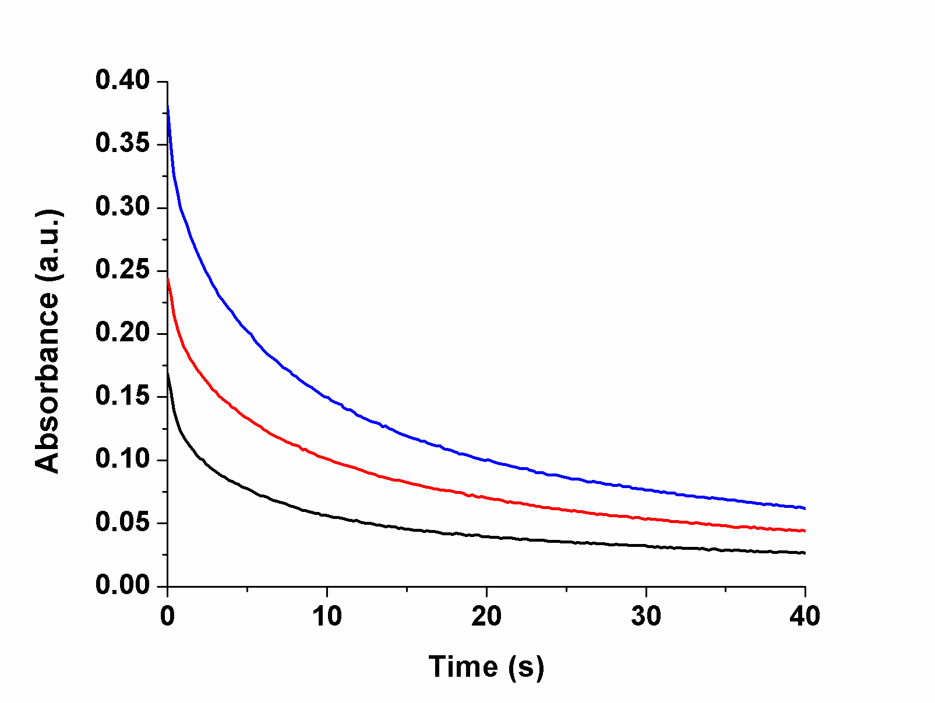
Figure S7. a) Effect of Co₂Ni₂P₂ at different final concentrations: 0 µM (black), 2.5 μM (red), 3.75 μM (blue), 5 μM (green) and 7.5 μM (pink), 10 μM (brown). Conditions: 0.6 mM [Ru(bpy)₃]³⁺, 80 mM sodium borate buffer at pH 8.0, 298 K; b) Effect of [Ru(bpy)₃]³⁺ with different concentrations: 0.4 mM (black), 0.6 mM (red), 0.8 mM (blue). Co₂Ni₂P₂ was 5 µM in 80 mM sodium borate buffer at pH 8.0, 298 K.

Light-driven catalytic water oxidation
The overall light-driven catalytic water oxidation reaction is given in eq 2.
2 S₂O₈^{2–} + 2 H₂O → 4 SO₄^{2–} + O₂ + 4 H⁺ (2)
The experiment was performed in a cylindrical cuvette (NSG, 32UV10) with a total volume of ~2.5 mL. The cell was filled with 2.0 mL of reaction solution with 1.0 mM Ru(bpy)₃Cl₂·6H₂O, 5.0 mM Na₂S₂O₈, 0.2–6.0 μM catalyst in 80 mM sodium borate buffer and pH 9.0. The reaction cell was sealed with a rubber septum, carefully deaerated and filled with Ar. All procedures were performed with minimum exposure to ambient light. The reaction was initiated by turning on the LED-light source (λ = 455 nm; light intensity 17 mW, beam diameter ~0.4 cm). A magnetically-coupled stirring system (SYS 114, SPECTROCELL) was used to the mix reaction solutions (4×103 RPM). The O₂ concentration in the headspace was quantified by GC. The solution pH was measured after the reaction.
Analysis of dioxygen in the reaction headspace was performed using a computer-controlled Agilent 6850 model gas chromatograph equipped with a thermal conductivity detector and a HP-MOLESIEVE capillary GC column (30m × 0.535 mm × 25.00 μm); argon was the carrier gas. Typically, the O₂ yield was quantified by withdrawing a gas sample from the headspace without stopping the reaction. Contamination of the head-space with air was corrected by quantification of N₂ present in the head-space (from the N₂ peak in the GC traces).

Speciation of Co(II) at pH 8 in borate and phosphate buffers. As noted in the text, Co(II) in borate and phosphate buffered aqueous solutions is not only the species, [Co(H₂O)₆]²⁺ because these buffer anions replace the aqua ligands on Co(II). Therefore in this paper (text and SI), the divalent cobalt is referred to as “Co(II)”. In the other studies, however, including syntheses and X-ray crystal structures, writing “Co(H₂O)₆]²⁺” is appropriate. The quantification of these buffer anion-cobalt interactions follow. In water, divalent cobalt is in a pH-dependent equilibrium with Co(OH)⁺ and Co(OH)₂, pK₁ = 9.65 and pK₂ = 9.15.³ At pH 8.0, aqueous cobalt is a dominant species, the molar fraction of Co(OH)₂, is only 0.0013.
In borate buffer at pH 8.0 the dominant borate species is B(OH)₃, which weakly binds aqueous Co(II). At pH 9.0, the concentration of B(OH)₄⁻ increases, and the molar fraction of Co[B(OH)₄]_{n}^{(n-2)-} may reach several percent.
The extremely low solubility of Co₃(PO₄)₂, K_{sp} = [Co²⁺_{aq}]³[PO₄³⁻]² = 2x10⁻³⁵, raises the question whether the solution of Co(II) in phosphate buffer remains homogeneous. At pH 8.0, the upper level concentration of Co²⁺(aq) in 0.1 M NaPi buffer would be only 0.01 µM. However, the formation constant of Co(HPO₄) is log₁₀(K_{c}) = 2.21,⁴ which significantly decreases the concentration of Co²⁺(aq) and makes Co(HPO₄) the dominant species, 90-93%, in 0.1 M NaPi buffer at pH 8.0.
Four complementary methods assessing stability of Co₂Ni₂P₂ -- Experimental details
1. Extraction of Co₂Ni₂P₂ from post-reaction solution and POM WOC stability measured by cathodic adsorptive stripping voltammetry (CAdSV)
After aging 1 mM of Co₂Ni₂P₂ in 80 mM, pH 8.0 borate buffer and 80 mM, pH 8.0 phosphate buffer, 1.0 mL of a concentrated (50 mM) toluene solution of tetra-n-heptylammonium (THpA) NO₃ was added to the aged solution. This extracts >99% of the POM into the toluene layer.⁵ The aqueous layer was evaluated by CAdSV (see below) to confirm the amount [Co(II) from POM decomposition. The concentration determined from the calibration curve (Figure S8), and the hydrolytic transformation of Co(II) in NaBi buffer (100 mM, pH 8.0) and NaPi buffer (100 mM, pH 8.0) was 5% and 10%, in separate reproducible experiments.
Cathodic adsorptive stripping voltammetry (CAdSV). Cathodic adsorptive stripping voltammetry (CAdSV) was performed with slight modifications to the literature method.⁶ A bismuth film glassy carbon (GC) electrode was prepared by applying a -0.26 V potential (vs Ag/AgCl (3 M NaCl) for 45 s under stirring, and the electrolyte was 10 mL 1 M HCl solution containing 0.02 M Bi(NO₃)₃•5H₂O and 0.5 M LiBr. The electrode was then rinsed with water and dried under a flow of air. Differential pulse voltammetry (DPV) was then performed with the following parameters: chronoamperometry at -1.3 V, for 15 s with stirring at 300 rpm. The voltammogram was then recorded from -0.7 V to -1.3 V at ν = 4mV/s without stirring, a pulse potential = 50 mV, 0.1s pulse width, 0.0167 s sampling width, 0.2 s pulse period, and 2 s quiet time.
Calibration curves using Co(NO₃)₂•6H₂O as the source of aqueous Co(II) were prepared for NaPi and borate buffers (Figure S8). In all cases, the peak current (i_{p}) was used to determine the concentration of cobalt present.
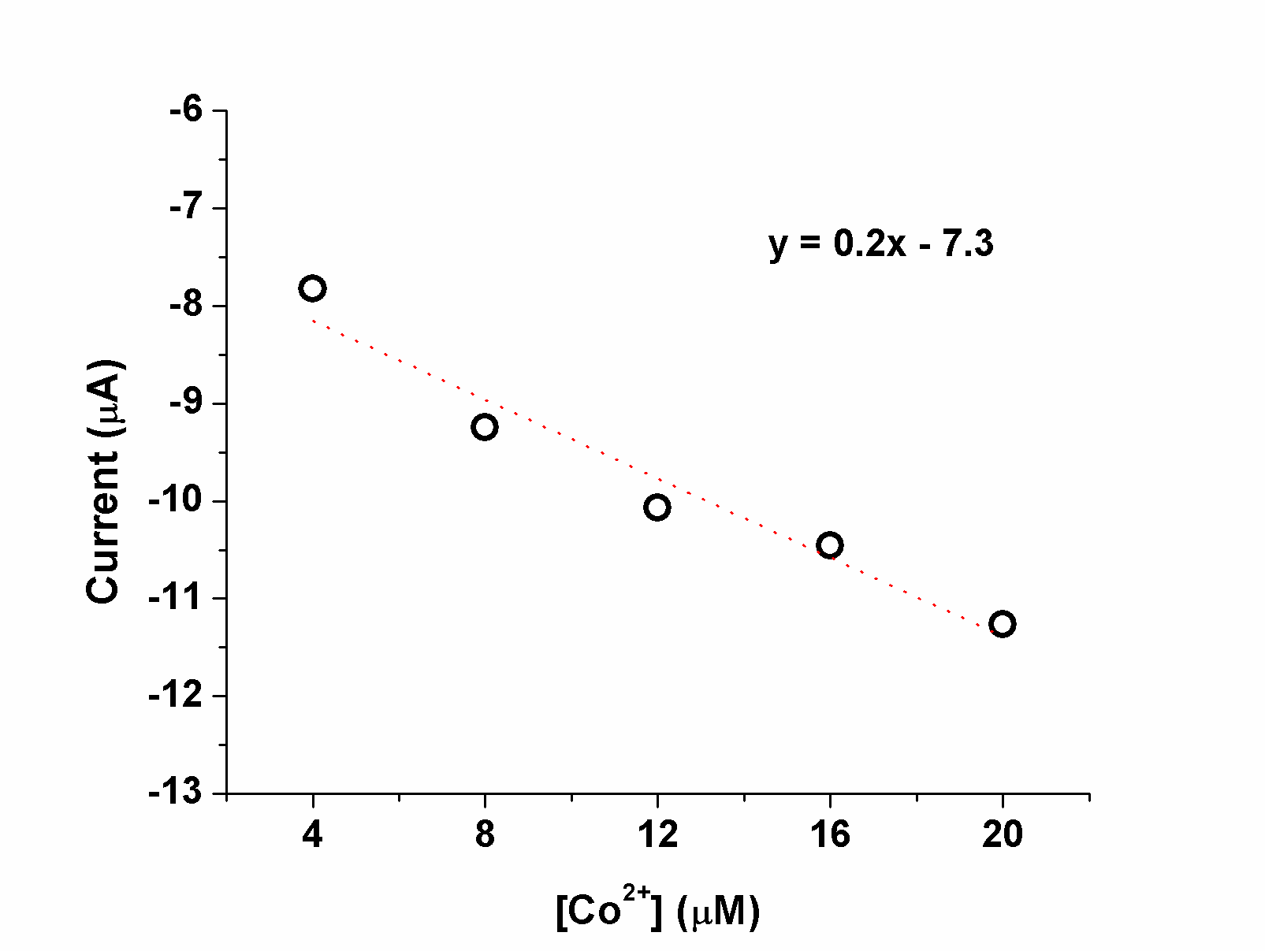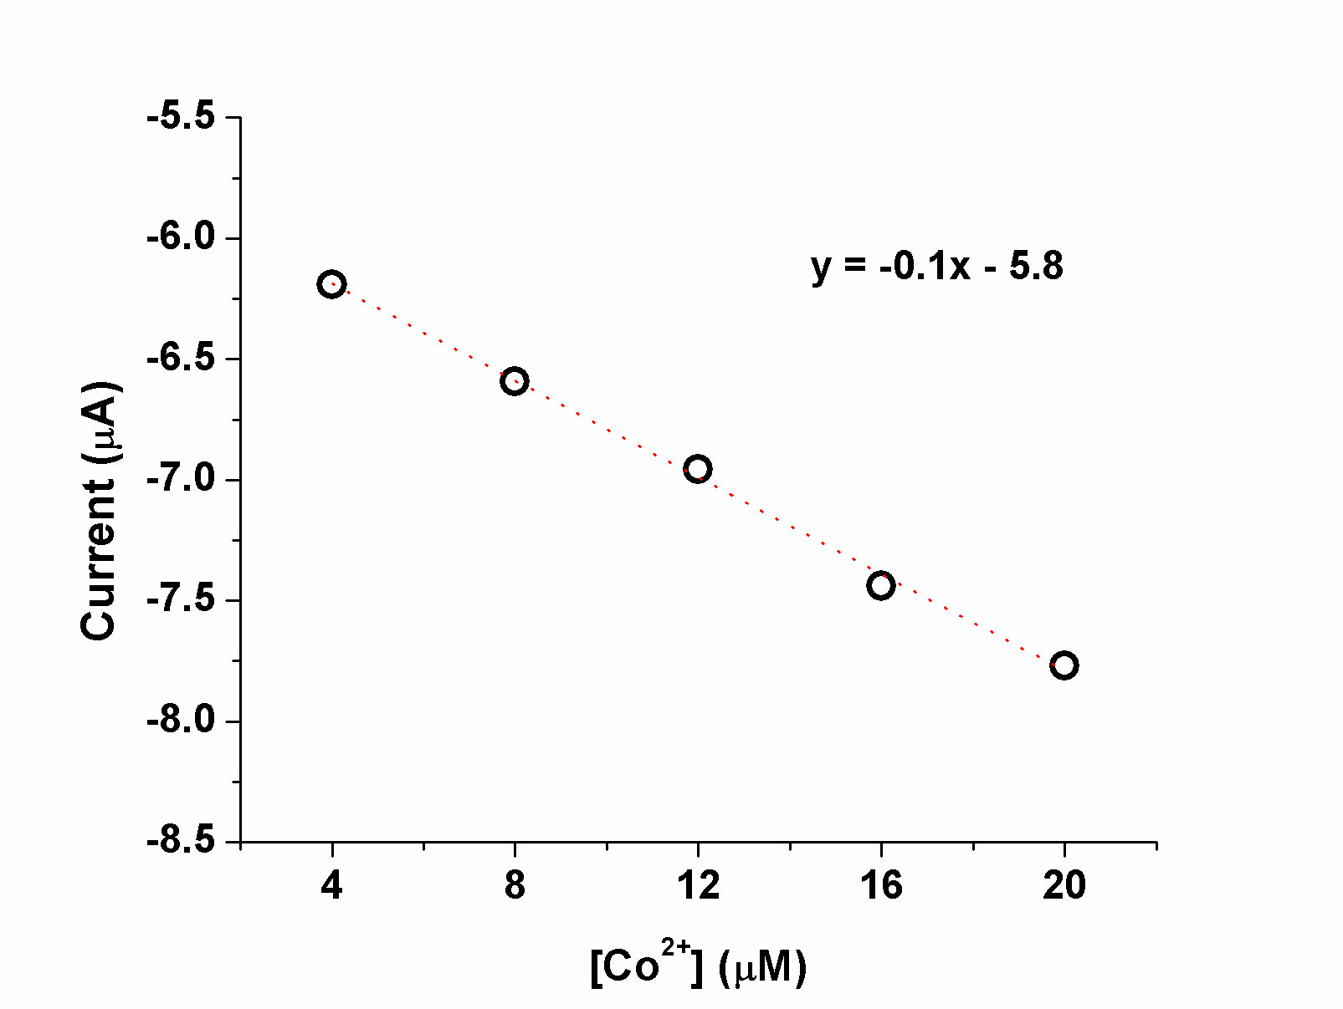

Figure S8. CAdSV calibration curves (left: NaBi buffer; right, NaPi buffer). Cathodic adsorptive stripping voltammetry with bismuth film glassy carbon electrode and 0.4 mM dimethyl glyoxime (DMG). Voltammogram peak current (i_{p}) recorded from -0.7 V to -1.3 V at ν = 4 mV/s, pulse potential = 50 mV and step potential = 2 mV. With Co(NO₃)₂ in NaBi buffer (100 mM)
2. Stability of Co₂Ni₂P₂ and quantification of Co(II) present determined by ³¹P NMR line broadening analysis. Co(II)-induced line broadening was used to determine the amount of Co(II) leached from the POM. To generate a calibration curve, standard solutions were prepared by diluting stock solutions of Co(NO₃)₂, Ni(NO₃)₂, 0.2 M sodium phosphate (NaPi, pH 8.0), and 99.9% D₂O to the concentrations used in the calibration curves to yield 1.0 mL of 0.1 M NaPi solution with 25% D₂O. The probe was tuned to the ³¹P signal of the 0.1 M NaPi containing no added cobalt and nickel. The full widths at half-maximum (fwhm) of the peaks were determined using a Bruker Ascend™ 600 MHz NMR with VnmrJ software and plotted against Co(II) to obtain the calibration curves and corresponding linear regressions (Figure S9). For the stability determination of Co₂Ni₂P₂, a 5 μL solution of Co₂Ni₂P₂ in 1 mM buffer was mixed with 245 μL of water, 250 μL of D₂O, and 500 μL of the appropriate 0.2 M phosphate buffer to yield a final 1.0 mL solution containing 5 μM Co₂Ni₂P₂ and 0.1 M NaPi pH 8.0 then added with 25% D₂O. The time t = 0 was set upon addition of buffer to the POM powder; typically about 10 min elapsed between sample mixing and the first ³¹P NMR spectrum acquisition. Spectra were then obtained approximately every 6 min for 1 h. The exact time of acquisition was variable due to delays in the autosampler; therefore, the reported time in the NMR file log was used to determine the exact
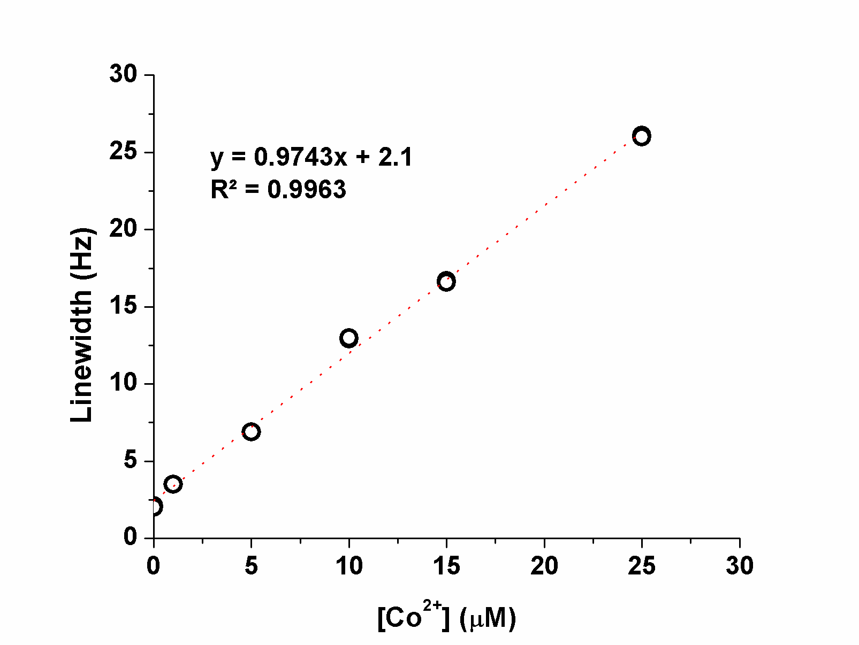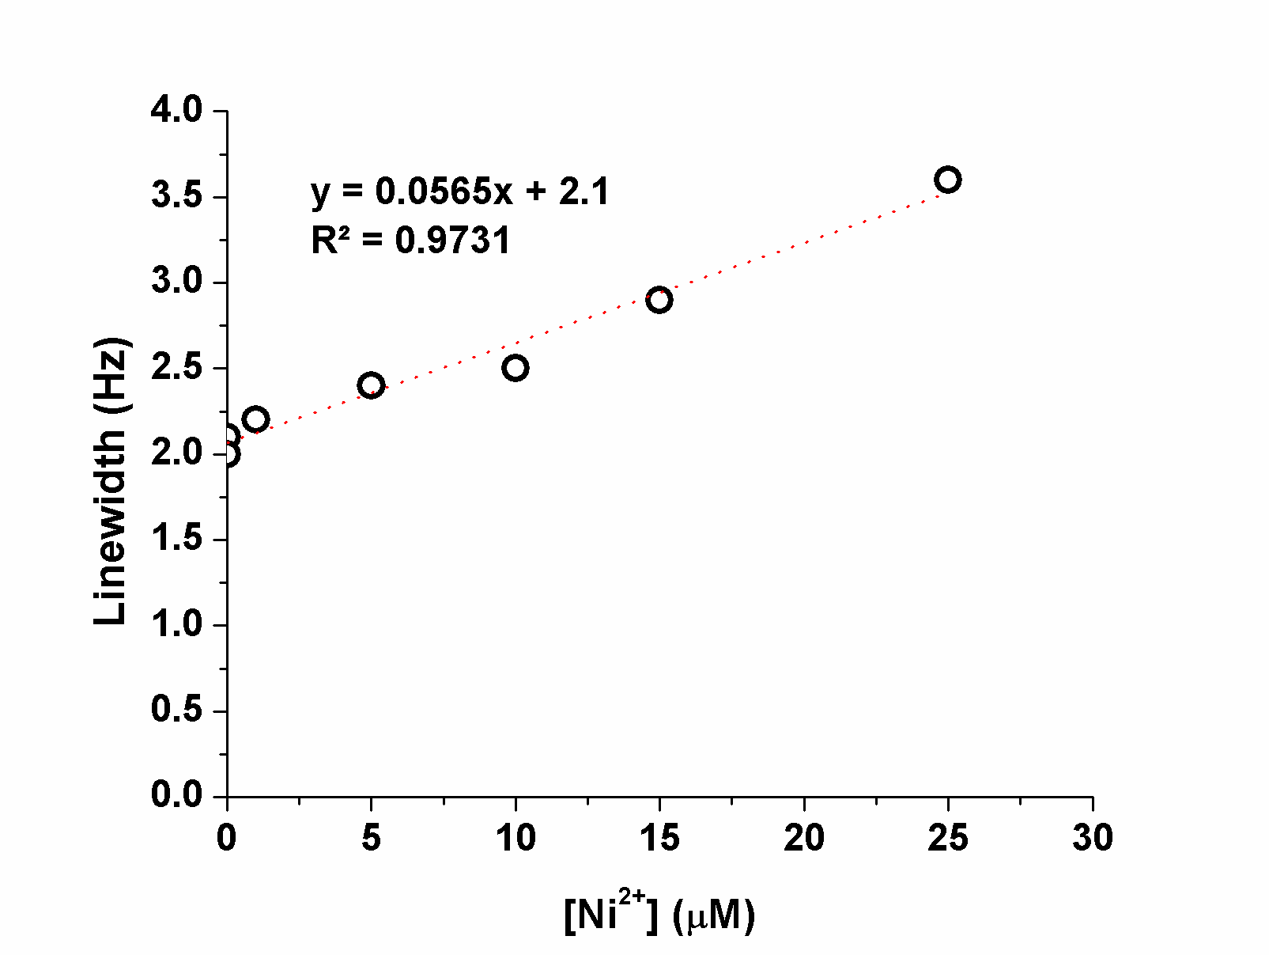

Figure S9. ³¹P NMR line broadening calibration curves for pH 8.0 (100 mM of NaPi).
elapsed time. The [Co(II)] vs time profiles for Co₂Ni₂P₂ in 0.1 M NaPi pH 8.0 are shown in Figure S10. The experiments were conducted twice to assess error (Figure S10a). The generation of Co(II) from Co₂Ni₂P₂ was 1.0 μM at the first measurement and ca. 1.4 μM after 1 hour, which means that after 1 h in 100 mM NaPi at pH = 8.0, about 14% of the Co₂Ni₂P₂ decomposes to Co(II). This is not surprising given the speciation studies of Co₄P₂ as a function of pH and in different buffers

Fig. S10 | Co(II) concentration (open circles) and the percent of total Co(II) dissociated (solid circles) vs. time for Co₂Ni₂P₂ determined using ³¹P NMR line broadening analysis. We conducted the same experiment twice, first (blue curve), second (red curve).
including NaPi, under these pH and concentration conditions.^{5, 7, 8, 9, 10} ¹¹ The concentrations of Co(II) cease changing after 45-50 min. This is consistent with the recent study showing that Co(II) and Co-containing WOCs reach a hydrolytic equilibrium in the presence of buffer in a limited pH range.¹¹ Figure S10b indicates that Co₂Ni₂P₂ decomposition producing Co(II) equals that producing Ni(II); the Co(II) percent would be lower, which also confirmed the maximal decomposition was ~14%.
3. Stability of Co₂Ni₂P₂ determined by stopped flow kinetics analysis
To further assess the stability of the catalyst, Co₂Ni₂P₂, the dependence of catalytic activity on the storage time of Co₂Ni₂P₂ in stock solution in 160 mM NaBi buffer at pH 8.0 was measured (Figure S11). The catalyst was kept a desired time in a stock solution, then freshly prepared Ru(bpy)₃³⁺ was used in each run. After 1 h storage, the activity of Co₂Ni₂P₂ didn’t change, again suggesting the stability of Co₂Ni₂P₂ in borate buffer at pH 8.0.
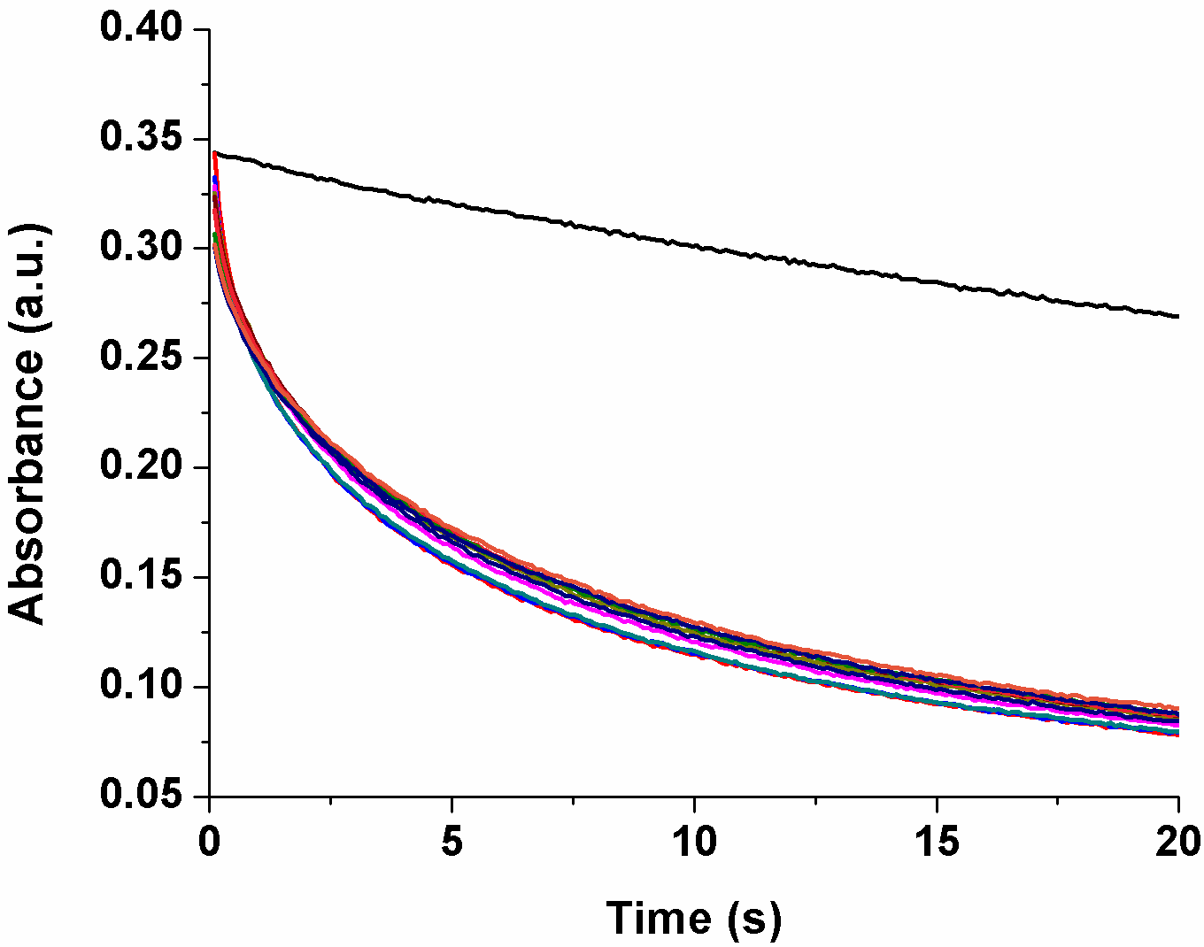
.
Fig. S11 | Co₂Ni₂P₂ catalyst stability probed by stopped-flow kinetics of Ru(bpy)₃³⁺ reduction. No catalyst (black curve); other curves are recorded with an interval of 1 hour. Conditions: 0.8 mM [Ru(bpy)₃]³⁺, 10 µM of Co₂Ni₂P₂, 80 mM sodium borate buffer at pH 8.0, 298 K.

4. Bpy titration experiment. The addition of 2,2’-bipyridine (bpy) to the solution of Co(H₂O)₆]²⁺ results in the formation of mono-, bis, and tris-bpy complexes of Co(II) with log₁₀(β_{i}) equal to 5.65, 11.25, and 16.05.¹² In the solution of 1.0 µM of Co²⁺ and 9.0 µM of bpy, the concentration of free Co(H₂O)₆]²⁺ is lower than 0.02 µM. At this law concentration of added bpy, the rate of [Ru(bpy)₃]³⁺ consumption dramatically decreases the water oxidation catalyzed by Co(II). If 9.0 µM bpy is added in the reaction catalyzed by 1.0 µM of Co₂Ni₂P₂, only a very small decrease of [Ru(bpy)₃]³⁺ consumption was observed (Figure 4 in text). This confirms that Co(II) can’t be the true catalyst in the Co₂Ni₂P₂ solution. However, because bpy decomposes Co₂Ni₂P₂ (removes Co(II)) as it does in the case of Co₄V₂,¹¹ but not in the case of Co₄P₂¹³), the addition of 40 µM bpy results in a visible inhibition of the reaction.
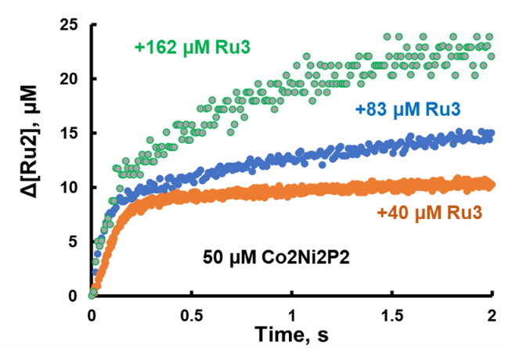

Fig. S12 | Titration of 50 µM Co₂Ni₂P₂ by [Ru(bpy)₃]³⁺ in 0.1 M sodium borate buffer at pH 8.0. Details are given in the main text.

Cyclic voltammetry of catalytic species
The catalytic current density attributed to water oxidation is generally proportional to the catalyst concentration (Figures 6, S13a, and S13b). However, the oxidative current for Co₂Ni₂P₂ plateaus after about 10 μM, possibly due to limited solubility. Interestingly, at higher concentrations of the catalysts, aqueous Co²⁺ may result in a higher oxidative current under these conditions, reversing the earlier trend. Much of this is attributable to electrodeposition of cobalt oxides in the presence of aqueous Co²⁺. This is consistent with a higher observed oxidative current on subsequent scans in the case of the aqueous cations (Figure S13b). Little change is observed in the case of Co₂Ni₂P₂. Furthermore, using the same working electrode in a fresh electrochemical solution containing no electroactive materials resulted in no additional oxidative current in the case of 10.0 μM Co₂Ni₂P₂ but a visible increase in the case of 20.0 μM Co(NO₃)₂ + 20.0 μM Ni(NO₃)₂. This suggests that cobalt oxide is formed in the oxidation of aqueous Co²⁺ and Ni²⁺ and is at least partially responsible for their catalytic activity. On the other hand, it appears that molecular Co₂Ni₂P₂ is responsible for the observed water oxidation and is not forming significant amounts of cobalt oxides at these timescales.
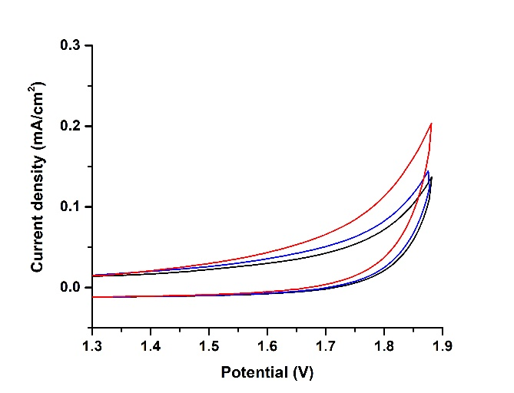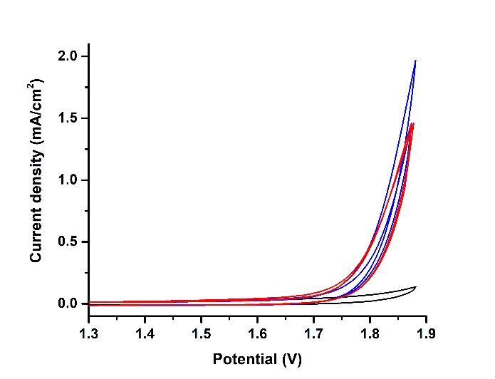
Fig. S13 | Cyclic voltammetry in a 0.1 M pH 8.0 borate buffer with 0.1 M of KNO₃ as the electrolyte. Left: Comparisons of no catalyst (black), 0.10 μM Co₂Ni₂P₂ (red), and 0.20 μM Co(NO₃)₂ + 0.20 μM Ni(NO₃)₂ (blue) shows the highest oxidative activity attributed to Co₂Ni₂P₂. Right: Comparisons of no catalyst (black), 10.0 μM Co₂Ni₂P₂ (red), and 20.0 μM Co(NO₃)₂ + 20.0 μM Ni(NO₃)₂ (blue) over two scan cycles. Ag/AgCl was used as the reference electrode. 50 mV/s scan rate. The plotted potential is relative to the reversible hydrogen electrode.

Kinetic model and fitting procedure.
The experimental data were fitted to the simplified kinetic model in equations 1-6:
POM + [Ru(bpy)₃]³⁺ POM(1) + [Ru(bpy)₃]²⁺ ΔG1 (1)
POM(1) + [Ru(bpy)₃]³⁺ POM(2) + [Ru(bpy)₃]²⁺ ΔG2 (2)
POM(2) → POM(X) k_{c} (3)
POM(X) + 2 [Ru(bpy)₃]³⁺ → POM + 2 [Ru(bpy)₃]²⁺ + O₂ fast (4)
[Ru(bpy)₃]³⁺ → [Ru(bpy’)(bpy)₂]²⁺ self-decomposition (5)
10 * [Ru(bpy)₃]³⁺ + [Ru(bpy’)(bpy)₂]²⁺ → 10 * Ru(bpy)₃]³⁺ + products (6)
For the thermodynamically favorable reactions (reverse of 1 and forward 2 the reaction rate constants were taken to be equal to the diffusion controlled reactions 1x10¹⁰ M⁻¹s⁻¹. The values forward (1) and reverse (2) reaction rate constants as well as of k_{c} were variable parameters. The initial concentrations of [Ru(bpy)₃]³⁺ were calculated from the initial absorbance at 670 nm, where the extinction coefficient is 420 M⁻¹cm⁻¹ at 670 nm. [Ru(bpy)₃]³⁺ in the stock solutions undergoes slow decomposition to produce [Ru(bpy)₃]²⁺ in ca. 90% yield with an apparent [Ru(bpy)₃]³⁺ decomposition rate constant of 2.5x10⁻³ s⁻¹. The initial concentrations of [Ru(bpy)₃]²⁺ was taken to be equal to a sum of added [Ru(bpy)₃]²⁺ and calculated from the weight of [Ru(bpy)₃]³⁺ and the measured absorbance at 670 nm. We also took in account that the yield of O₂ per [Ru(bpy)₃]³⁺ did not exceed 20% (80% theoretical). Thus, only three variable parameters were used in fitting. If both forward and reverse reaction rate constants were the variable parameters, there is no visible improvement of fittings. The standard deviations for the forward and reverse rate constants are about 30% and less than 20% for k_{c}. The results of fitting are given in Figure S14

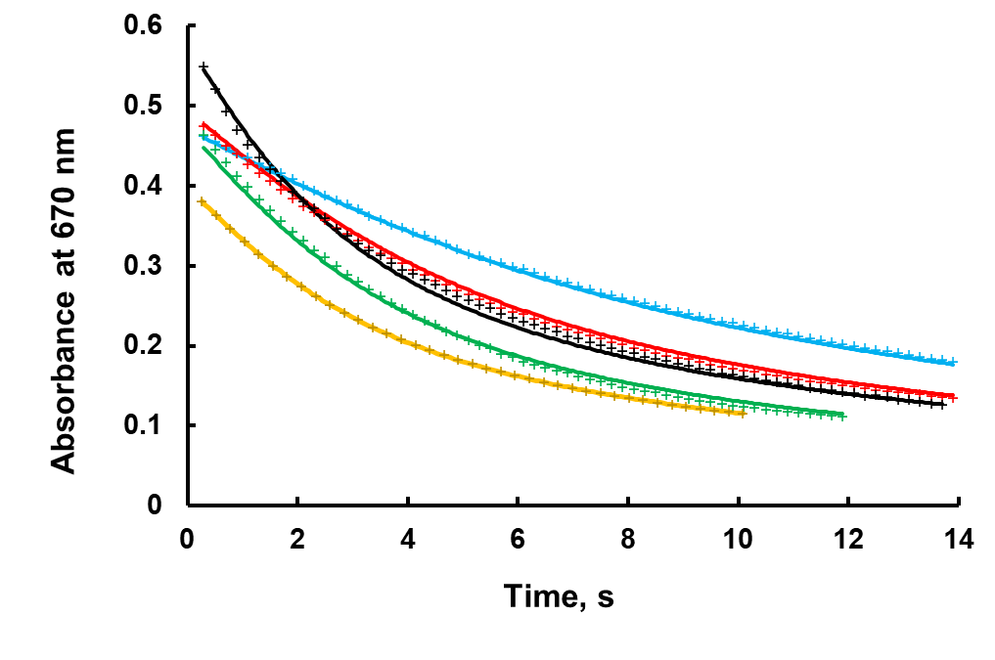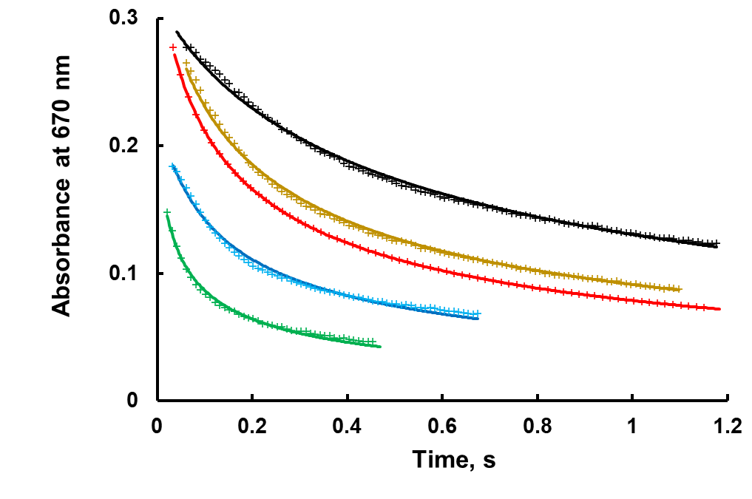
Fig. S14 | The results of fitting for Co₄P₂ (left) and Co₂Ni₂P₂ (right). The theoretical curves are solid lines. Conditions: 0.1 M sodium borate buffer at pH 8.0, at the concentrations in Table S17.
Table S17. Concentrations used for stopped-flow kinetic fitting.
Right Figure | [Ru(bpy)₃]³⁺, mM | [Ru(bpy)₃]²⁺, mM | Co₂Ni₂P₂, µM
Black | 0.70 | 0.80 | 1.0
Dark yellow | 0.80 | 0.50 | 2.5
Red | 0.20 | 0.20 | 1.5
Blue | 0.52 | 0.90 | 0.5
Green | 0.46 | 0.015 | 1.5
Left Figure | [Ru(bpy)₃]³⁺, mM | [Ru(bpy)₃]²⁺, mM | Co₄P₂, µM
Black | 1.38 | 0.2 | 5.0
Blue | 1.1 | 0.01 | 1.0
Red | 1.2 | 0.02 | 2.0
Green | 1.15 | 0.01 | 3.0
Yellow | 0.95 | 0.01 | 5.0

Calculations for Figure S15 (summary of possible reaction pathways in the oxidation of water by Co₂Ni₂P₂).
For conversion of computed potentials in Hartrees to potentials vs SHE and pK_{a} values see, for example, an earlier publication that uses similar formulation.¹⁴
Redox potentials:
Red – e → Ox
Abbreviations: H_{r} – a potential of Red in Hartrees
H_{ox} – a potential of Ox in Hartrees
H_{e} – a potential of hydrated electrons in Hartrees H_{e} = -0.104 or -2.83 V
The potential of SHE is based on the half reaction
1 hartree = 27.21 V
2 H⁺(aq) + 2 e⁻ → H₂(g)
The absolute electrode potential is 4.44 ± 0.02 V at 25 °C, or 2.22 V per electron = 0.08158 Hartrees
Thus, the oxidation potential of Ox/Red couple vs SHE is
E⁰ (V vs SHE) = -27.21*(H_{r}-H_{ox}) + (2.83+2.22)
Calculations of pK_{a}:
HA = A⁻ + H⁺ (7)
pK_{a} = log₁₀([HA]/[A⁻]) + pH, thus pK_{a} = pH at which [HA] = [A⁻]
ΔG₁ = G(A⁻) + G(H⁺) – G(HA)
Absolute G⁰(H⁺) at [H⁺] = 1M is -0.4205 Hatrees
G(H⁺) at pH = pK_{a} is [G⁰(H⁺)-0.06*pK_{a}], and, in addition, G(H⁺) should be used vs SHE
ΔG₁(in V) = G(A⁻) + G⁰(H⁺)-0.06*pK_{a} – G(HA) - 0.08158 = 27.21*[G(A⁻) - G(AH)] -2.22 – 0.06*pK_{a}
At the same time ΔG₁ = 0.06*pK_{a}, and we have
pK_{a} = {27.21*[G(A⁻) - G(AH)] -2.22}/0.12

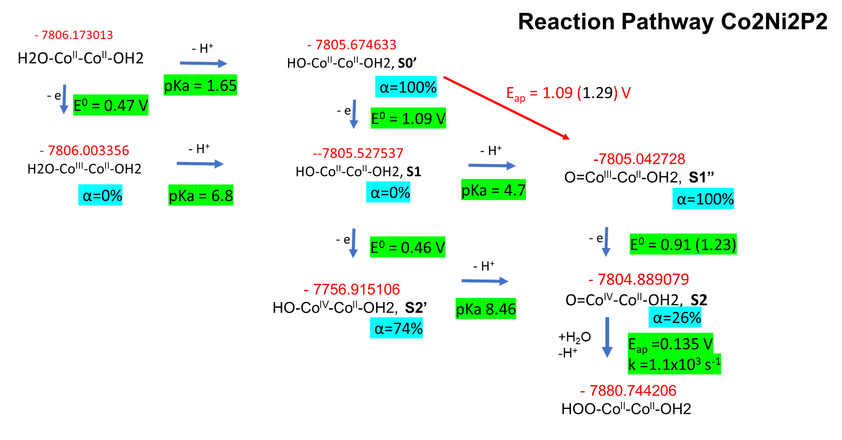
Fig. S15 | Possible reaction pathways in the oxidation of water by the Co active site on the outside of the central belt of Co₂Ni₂P_{2.} The calculated Gibbs free energies ofthe structures are in red color (in Hartrees) and the calculated standard reduction potential (versus NHE) and pK_{a}s are highlighted in green color. The experimental data are obtained from fitting using the kinetic model (Fig. S14) and from titration (Fig. S12) are in brackets. The distribution of different protonated forms as a function of pH was calculated at pH 8 using Curtipot software (http://www.iq.usp.br/gutz/Curtipot_.html). The dominant reaction species at pH 8 are highlighted in blue color. The most probable reaction pathway at pH 8 is S0’ → S1’’ → S2 → HOO-Co^{II}Ni₂Co^{II}-OH₂.

Computational Methods
The electronic structure calculations were carried out using the M06L density functional.¹⁵ We utilized the 6-31G(d,p) basis sets for P, O and H atoms, and LANL2DZ ECPs with the corresponding basis sets for W, Co, Ni. The effects of bulk aqueous solution were approximated at the level of the polarizable continuum model (PCM).¹⁶ Effects of long-range dispersion interactions were evaluated using semi-empirical GD3 method.¹⁷ Geometry optimizations were done without symmetry constraints, and the converged structures were tested for stability by frequency calculations. All the lowest energy configurations were found to be in their natural high-spin state, namely [Co₄]^{10-/13-tet} and [Ni₂Co₂]^{10-/11-tet} as the resting states. Subsequent removal of an electron or a Hydrogen atom resulted in the high-spin state as the lowest energy state. All the calculations were performed using Gaussian 09 (Revision E.01) quantum chemical software package.¹⁸ In addition, orbital population analysis and orbital coupling calculations were done with the NBO7 code.¹⁹

References
1. Ghosh PK, Brunschwig BS, Chou M, Creutz C, Sutin N. Thermal and Light-Induced Reduction of Ru(bpy)₃³⁺ in Aqueous Solution. J Am Chem Soc 106, 4772-4783 (1984).

2. Toby BH, Dreele RBV. GSAS-II: the genesis of a modern open-source all purpose crystallography software package J Appl Crystallography 46, 544-549 (2013).

3. Richens DT. The Chemistry of Aqua Ions: Synthesis, Structure, and Reactivity: A Tour through the Periodic Table of the Elements. John Wiley & Sons (1997).

4. Abu-Shandi K, Al-Wedian F. Estimation of composition, coordination model, and stability constant of some metal/phosphate complexes using spectral and potentiometric measurements. Chem Papers 63, 420-425 (2009).

5. Vickers JW, et al. Differentiating Homogeneous and Heterogeneous Water Oxidation Catalysis: Confirmation that [Co₄(H₂O)₂(α-PW₉O₃₄)₂]^{10–} Is a Molecular Water Oxidation Catalyst. J Am Chem Soc 135, 14110-14118 (2013).

6. Krolicka A, Bobrowski A, Kalcher K, Mocak J, Svancara I, Vytras K. Study on Catalytic Adsorptive Stripping Voltammetry of Trace Cobalt at Bismuth Film Electrodes. Electroanalysis 15, 1859-1863 (2003).

7. Ohlin CA, et al. Rates of Water Exchange for Two Cobalt(II) Heteropolyoxotungstate Compounds in Aqueous Solution. Chem Eur J 17, 4408-4417 (2011).

8. Lieb D, et al. Water Exchange Reactivity and Stability of Cobalt Polyoxometalates under Catalytically Relevant pH Conditions: Insight into Water Oxidation Catalysis. Inorg Chem 50, 9053-9058 (2011).

9. Stracke JJ, Finke RG. Water Oxidation Catalysis Beginning with 2.5 μM [Co4(H2O)2(PW9O34)2]10–: Investigation of the True Electrochemically Driven Catalyst at ≥600 mV Overpotential at a Glassy Carbon Electrode. ACS Catal 3, 1209-1219 (2013).

10. Folkman SJ, Soriano-Lopez J, Galán-Mascarós JR, Finke RG. Electrochemically Driven Water-Oxidation Catalysis Beginning with Six Exemplary Cobalt Polyoxometalates: Is It Molecular, Homogeneous Catalysis or Electrode-Bound, Heterogeneous CoO_{x} Catalysis? J Am Chem Soc 140, 12040-12055 (2018).

11. Sullivan KP, et al. Speciation and Dynamics in the [Co₄V₂W₁₈O₆₈]¹⁰⁻/ CO(II)_{aq} / CoC_{x} Catalytic Water Oxidation System. ACS Catal 8, 11952-11959 (2018).

12. Critical Stability Constants: First Supplement. Springer US (1982).

13. Yin Q, et al. A fast soluble carbon-free molecular water oxidation catalyst based on abundant metals. Science 328, 342-345 (2010).

14. Soriano-López J, Musaev DG, Hill CL, Galán-Mascarós JR, Carbó JJ, Poblet JM. Tetracobalt-polyoxometalate catalysts for water oxidation: Key mechanistic details. Journal of Catalysis 350, 56-63 (2017).

15. Zhao Y, Truhlar DG. A new local density functional for main-group thermochemistry, transition metal bonding, thermochemical kinetics, and noncovalent interactions. The Journal of Chemical Physics 125, 194101 (2006).

16. Barone V, Cossi M. Quantum Calculation of Molecular Energies and Energy Gradients in Solution by a Conductor Solvent Model. The Journal of Physical Chemistry A 102, 1995-2001 (1998).

17. Grimme S, Antony J, Ehrlich S, Krieg H. A consistent and accurate ab initio parametrization of density functional dispersion correction (DFT-D) for the 94 elements H-Pu. The Journal of Chemical Physics 132, 154104 (2010).

18. Frisch MJ, et al. Gaussian 09 Revision E.01.) (2013).

19. Glendening ED, et al. NBO 7.0.). Theoretical Chemistry Institute, University of Wisconsin, Madison (2018).

