Supplementary materials

We investigated the effect of channel exclusion and sample size on the selection of frequency bands of interest (FOIs) in section 3.2 in the main manuscript. Fig.S1 and Fig. S2 plot the results for data in Experiment 1 (mathematics learning).
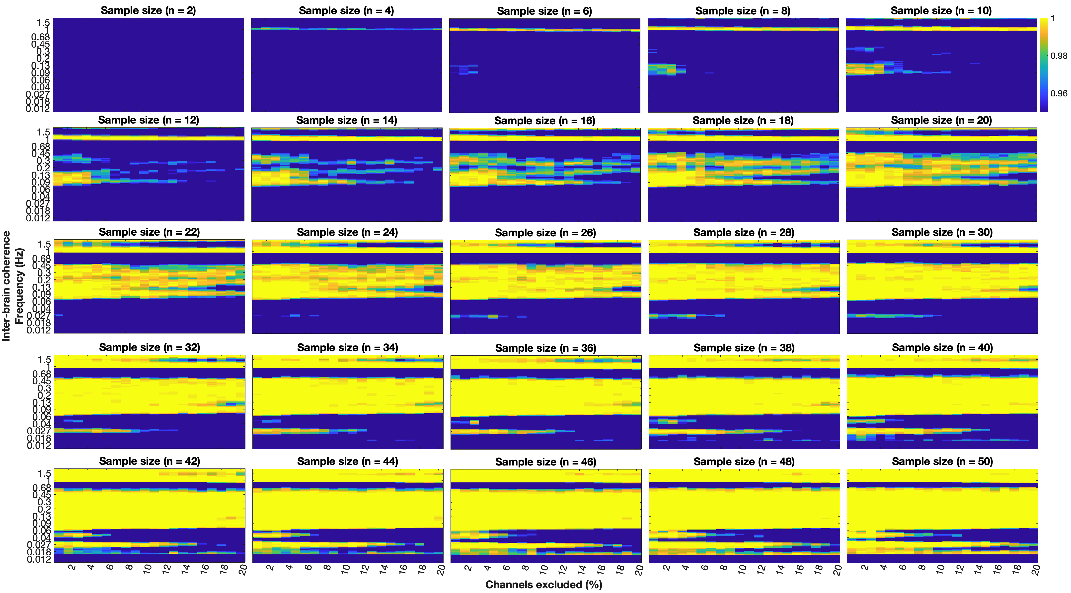
Fig. S1 Significance of frequency band of interest (FOI) across various channel exclusion rates and sample sizes. This plot was based on data from Experiment 1. Yellow colors indicate robustness above 95% among 500 repetitions.
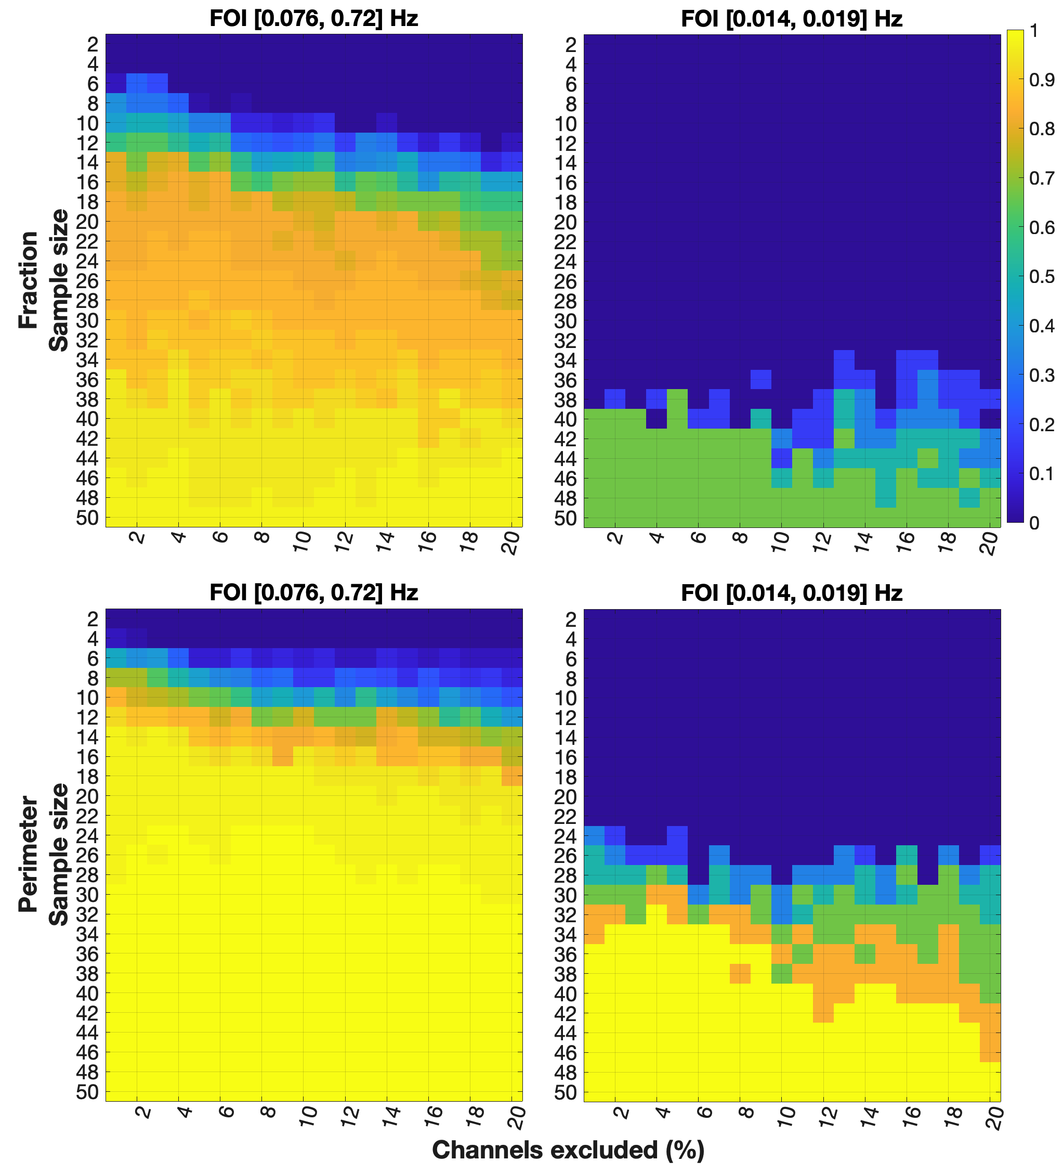
Fig. S2 Significance at the FOI level. Panels (A) and (B) plot the results from the Fraction and Perimeter lecture sessions in Experiment 1, respectively.

