SUPPORTING INFORMATION FOR:
Title: The impact of the pico y placa policy on fine particulate matter in Lima, Peru
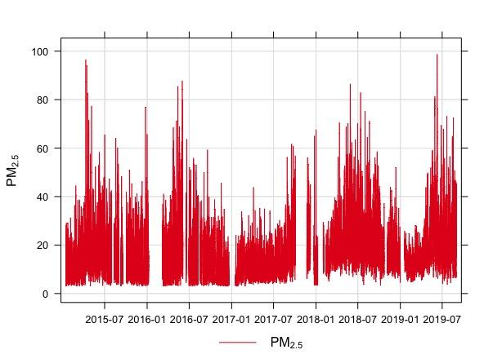
Figure S1: Time series of PM_{2.5} levels, in μg/m³; from the US embassy air quality monitoring site.

