a
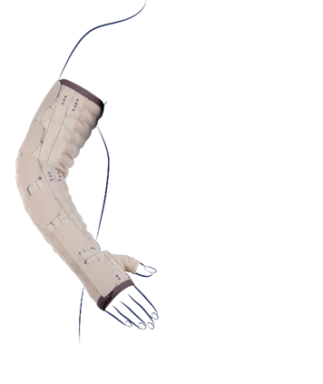

b
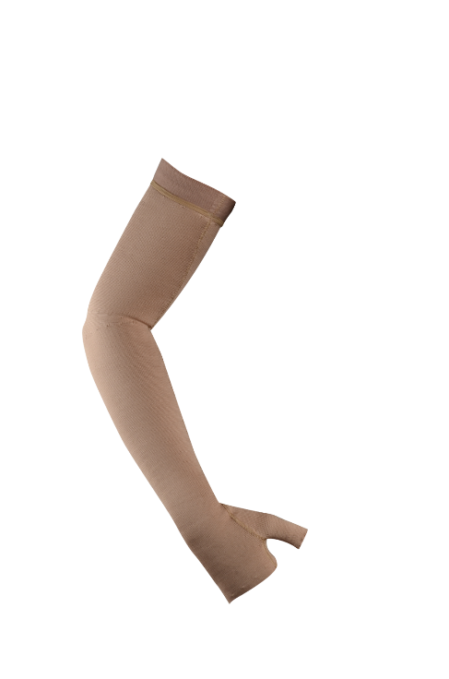

Supplementary Fig. 1 Medical devices used in the clinical investigation
a. Mobiderm® Autofit Arm-sleeve.
b. Lymphatrex® Expert Arm-sleeve.

a

b
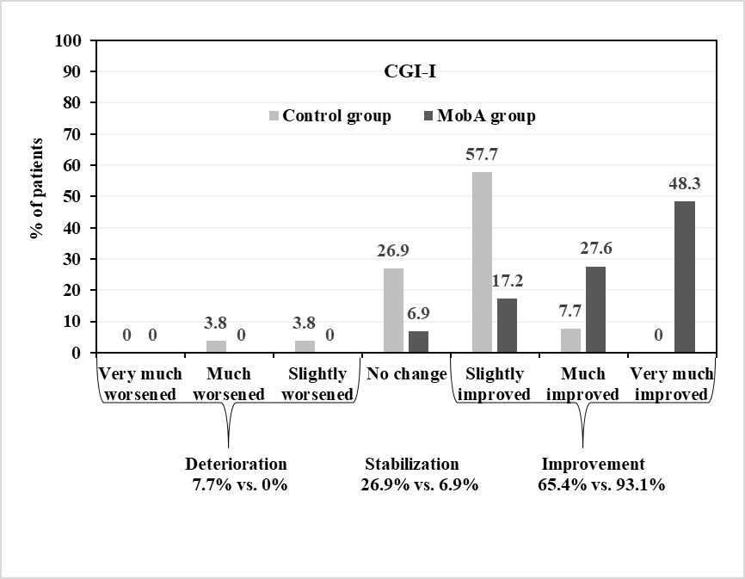
p=0.025
Supplementary Fig. 2 Physician assessments of change in patient’s condition at D90 (ITT, N=55)
a. The severity of patient’s clinical condition was assessed by the physician via the via Clinical Global Impression – Severity scale (CGI-S). Data represent the percentage of patients at D90 with improvement, no change and deterioration graded according to the evolution of the CGI-S categories for MobA and Control groups
b. The evolution of patient’s clinical condition was assessed by the physician via the Clinical Global Impression – Improvement scale (CGI-I). Data represent the percentage of patients at D90 for each evolution state according to the CGI-I in the MobA and Control groups

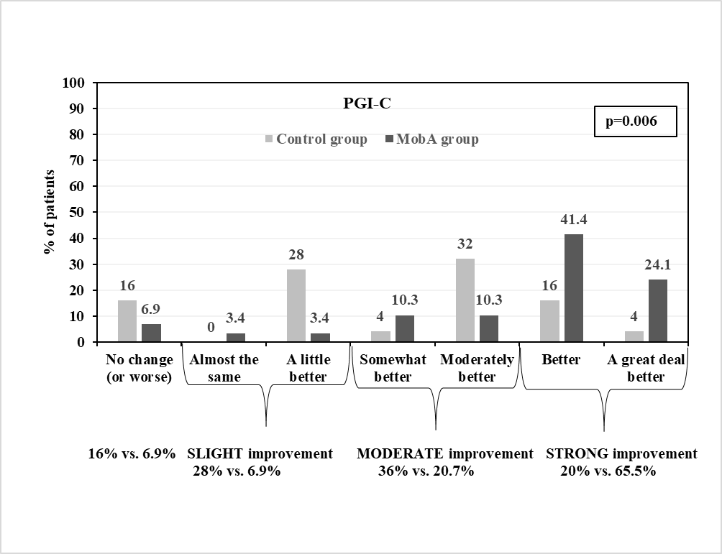
Supplementary Fig. 3 Patient assessment of improvement at D90 (ITT, N=54)
The evolution of global quality of life and limitations in activities was assessed by the patient via the Global Impression of Change (PGI-C) questionnaire. Data represent the percentage of patients at D90 for each evolution state according to the PGI-C for the MobA and Control groups.

Supplementary Fig. 4 Improvement in skin suppleness between D0 and D90 (ITT, N=55)
The improvement from inclusion in skin suppleness was graded as strongly, moderately, slightly or not at all at Day 90 (D90). Data represent the percentage of patients in each improvement category for MobA and Control groups

