Supplementary Information

High UV Sensitivity in Graphene-Silicon Schottky Photodiodes in Industry Standard Packaging

Ardeshir Esteki^{1,°}, Christoph P. Gebauer^{1,2,°}, Jülide Avci², Heinrich D. B. Gottlob², Max C. Lemme^{1,3,*}
¹Chair of Electronic Devices, RWTH Aachen University, Otto-Blumenthal-Strasse 2, 52074 Aachen, Germany
²Vishay Semiconductor GmbH, Theresienstrasse 2, 74072 Heilbronn, Germany
³AMO GmbH, Otto-Blumenthal-Str. 25, 52074 Aachen, Germany
°These authors contributed equally.
*Corresponding Author: max.lemme@eld.rwth-aachen.de
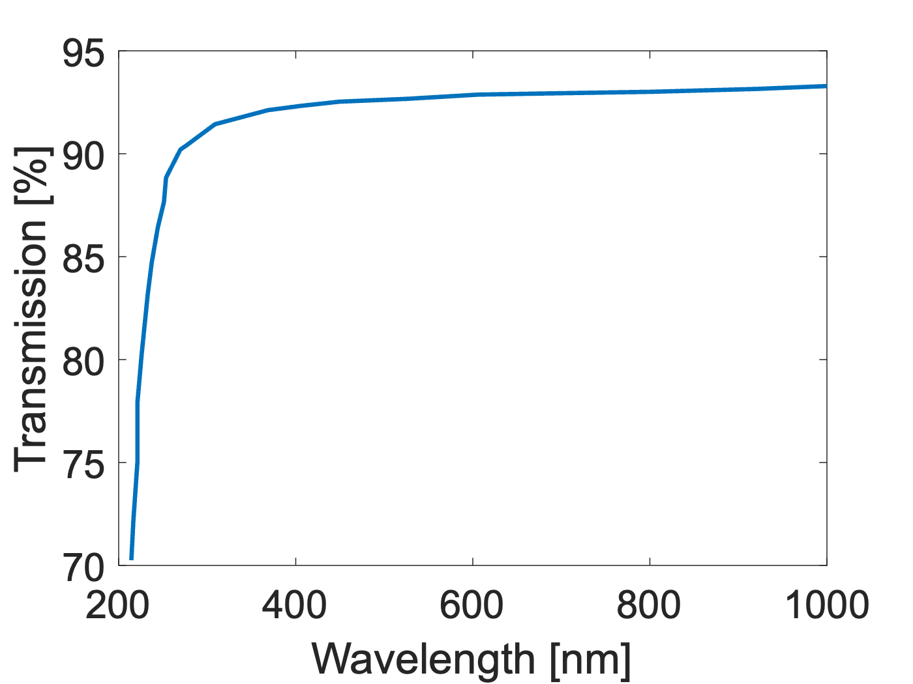
SI Figure 1. Optical transmission spectrum of the UV-transparent glass used to hermetically seal the TO18 header. The measurement shows high transmittance above 90% across most of the visible and near-infrared range, with good transparency starting from ~250 nm.

