Fig S1: OPLS-DA score plot showing L. aurea bulb samples from different locations.
Panels (A)–(J) depict pairwise comparisons: (A) GX_vs_HN, (B) GX_vs_JX, (C) GX_vs_ZJ, (D) HN_vs_JX, (E) HN_vs_ZJ, (F) JX_vs_ZJ, (G) SC_vs_GX, (H) SC_vs_HN, (I) SC_vs_JX, (J) SC_vs_ZJ. The horizontal axis represents the predicted principal component (variation between groups), and the vertical axis represents the orthogonal principal component (variation within groups). Percentages indicate the variance explained by each component. Points represent samples, with colors denoting group membership.

Fig S2: Dynamic distribution diagram of L. aurea metabolite content differences.
Panels (A)–(J) show pairwise comparisons: (A) GX_vs_HN, (B) GX_vs_JX, (C) GX_vs_ZJ, (D) HN_vs_JX, (E) HN_vs_ZJ, (F) JX_vs_ZJ, (G) SC_vs_GX, (H) SC_vs_HN, (I) SC_vs_JX, and (J) SC_vs_ZJ. The horizontal axis represents the cumulative number of substances arranged by difference multiple, while the vertical axis shows the logarithm of the difference multiple (base 2). Each point represents a substance, with green points indicating the top 10 downgraded substances and red points indicating the top 10 upgraded substances.

Fig S3: Fold difference bar chart of L. aurea bulb metabolites.
Panels (A)–(J) show pairwise comparisons: (A) GX_vs_HN, (B) GX_vs_JX, (C) GX_vs_ZJ, (D) HN_vs_JX, (E) HN_vs_ZJ, (F) JX_vs_ZJ, (G) SC_vs_GX, (H) SC_vs_HN, (I) SC_vs_JX, and (J) SC_vs_ZJ. The horizontal axis represents the log₂ of differential metabolite fold change (FC), and the vertical axis represents the differential metabolites. Red bars indicate upregulated metabolites, while green bars indicate downregulated metabolites.
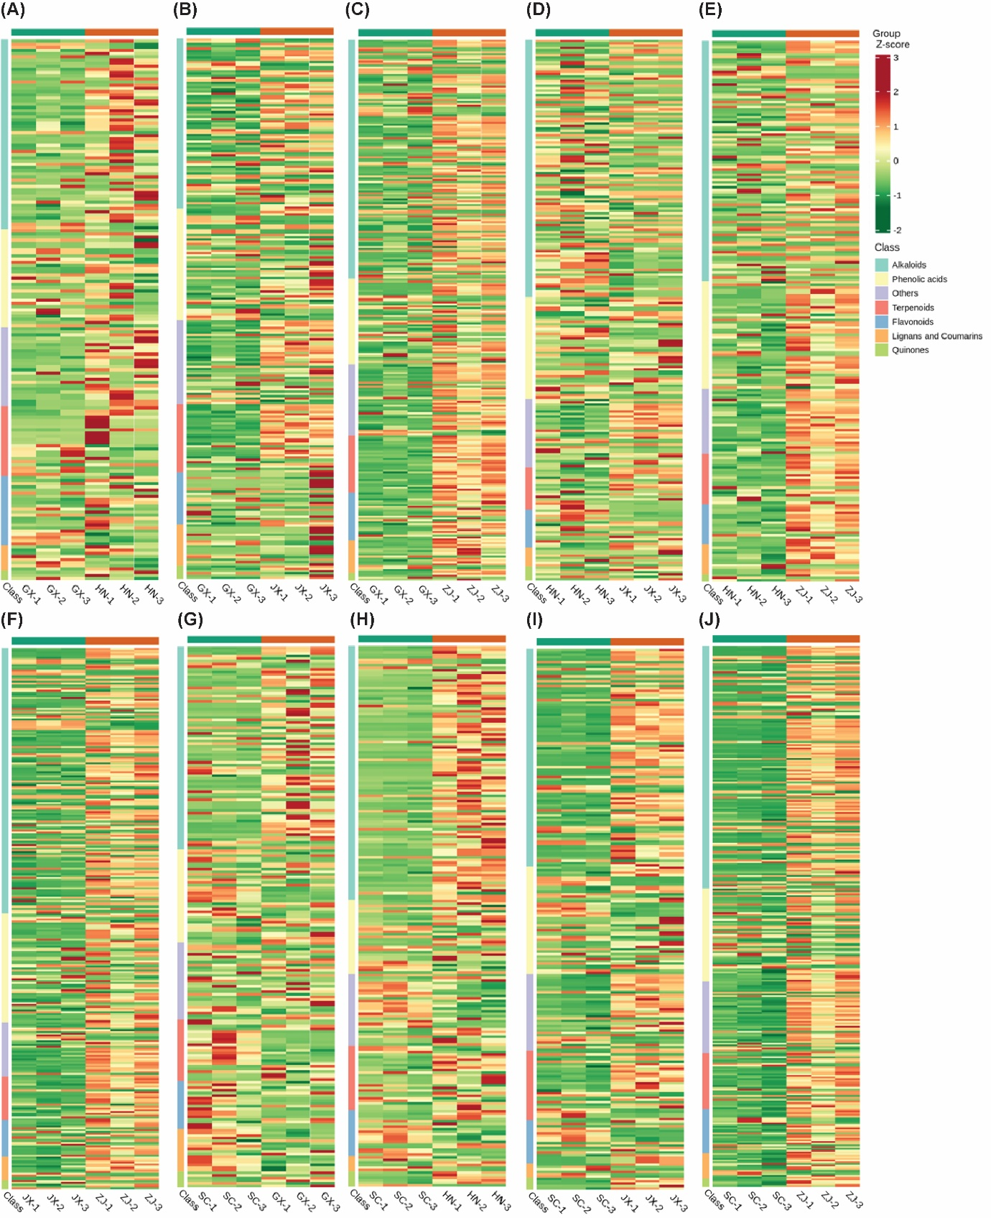

Fig S4: Heat map of L. aurea bulb metabolite classes.
Panels (A)–(J) show pairwise comparisons: (A) GX_vs_HN, (B) GX_vs_JX, (C) GX_vs_ZJ, (D) HN_vs_JX, (E) HN_vs_ZJ, (F) JX_vs_ZJ, (G) SC_vs_GX, (H) SC_vs_HN, (I) SC_vs_JX, and (J) SC_vs_ZJ. The horizontal axis represents sample names, while the vertical axis shows differential metabolite information. The Group indicates sample grouping and colors represent relative metabolite content after standardization (red for high content, green for low content). Class refers to the first-level classification of substances.

Fig S5: K-Means plot of L. aurea bulbs differential metabolites.
This analysis identified two distinct clusters, with the standardized scores for clusters 1 and 2 presented in panels (A and B). The horizontal axis represents the sample grouping, the vertical axis represents the standardized relative content of metabolites, Sub class represents the metabolite category number with the same change trend.

Fig S6: Venn diagram of differences among groups of L. aurea bulbs metabolites.
Panel A-E shows ven diagram between different compared groups: (A) GX_vs_ZJ, GX_vs_HN, SC_vs_GX, and GX_vs_JX; (B) HN_vs_ZJ, GX_vs_HN, SC_vs_HN, and HN_vs_JX; (C) JX_vs_ZJ, GX_vs_JX, SC_vs_JX, and HN_vs_JX; (D) JX_vs_ZJ, JX_vs_ZJ, SC_vs_ZJ, and HN_vs_ZJ; (E) SC_vs_ZJ, SC_vs_HN, SC_vs_GX, and SC_vs_JX. Here, each circle in the figure represents a comparison group. The numbers in the overlapping part of the circles represent the number of common differential metabolites between the comparison groups, and the numbers without overlapping parts represent the number of unique differential metabolites in the comparison groups.

Fig S7: Quantitation of L. aurea bulbs Gene Expression.
(A) The box plot of expression where the horizontal axis in the figure represents different samples; the vertical axis represents the logarithmic value of the sample expression FPKM. This figure measures the expression level of each sample from the perspective of the overall dispersion of the expression. (B) The expression density distribution diagram where the curves of different colors in the figure represent different samples. The horizontal axis of the points on the curve represents the logarithmic value of the corresponding sample FPKM, and the vertical axis of the points represents the probability density. (C) The violin plot of expression where different colors in the figure represent different samples, and the width of each violin graph reflects the number of transcripts at that expression level.

Fig S8: Volcano plot of DEGs of L. aurea bulbs from different locations.
Panels (A)–(J) show pairwise comparisons: (A) GX_vs_HN, (B) GX_vs_JX, (C) GX_vs_ZJ, (D) HN_vs_JX, (E) HN_vs_ZJ, (F) JX_vs_ZJ, (G) SC_vs_GX, (H) SC_vs_HN, (I) SC_vs_JX, and (J) SC_vs_ZJ. Here, the horizontal axis represents the fold change of gene expression, and the vertical axis represents the significance level of differentially expressed genes. Red dots represent upregulated differentially expressed genes, green dots represent down-regulated differentially expressed genes, and gray dots represent non-differentially expressed genes.

Fig S9: Radar charts depicting differentially expressed genes (DEGs) of L. aurea bulbs from different locations.
Panels (A)–(J) show pairwise comparisons: (A) GX_vs_HN, (B) GX_vs_JX, (C) GX_vs_ZJ, (D) HN_vs_JX, (E) HN_vs_ZJ, (F) JX_vs_ZJ, (G) SC_vs_GX, (H) SC_vs_HN, (I) SC_vs_JX, and (J) SC_vs_ZJ. Each point represents a gene, and its position on the chart reflects the magnitude of the log₂ fold change (log₂FC) of the gene’s expression across the two compared locations.

Fig S10: Heatmap of differential gene clustering analysis for L. aurea bulbs from different locations.
Panels (A)–(J) show pairwise comparisons: (A) GX_vs_HN, (B) GX_vs_JX, (C) GX_vs_ZJ, (D) HN_vs_JX, (E) HN_vs_ZJ, (F) JX_vs_ZJ, (G) SC_vs_GX, (H) SC_vs_HN, (I) SC_vs_JX, and (J) SC_vs_ZJ. The horizontal axis shows sample names and hierarchical clustering results, while the vertical axis represents differentially expressed genes with their respective hierarchical clustering results. Red indicates high gene expression, and blue indicates low gene expression.

Fig S11: K-Means plot of L. aurea bulbs differential genes.
Panels (A)–(J) show different subclass: (A) Subclass 1, (B) Subclass 2, (C) Subclass 3, (D) Subclass 4, (E) Subclass 5, (F) Subclass 6, (G) Subclass 7, (H) Subclass 8, (I) Subclass 9, and (J) Subclass 10. Here, the horizontal axis represents the sample, and the vertical axis represents the standardized expression level.

Fig S12: Venn diagram of DEGs of L. aurea bulbs.
Panels (A)–(E) show ven diagram between different sample comparisons: (A) GX_vs_ZJ, GX_vs_HN, SC_vs_GX, and GX_vs_JX; (B) HN_vs_ZJ, GX_vs_HN, SC_vs_HN, and HN_vs_JX; (C) JX_vs_ZJ, GX_vs_JX, SC_vs_JX, and HN_vs_JX; (D) JX_vs_ZJ, GX_vs_JX, SC_vs_ZJ, and HN_vs_ZJ; (E) SC_vs_ZJ, SC_vs_HN, SC_vs_GX, and SC_vs_JX. Here, the non-overlapping area of ​​the Venn diagram represents the differential genes unique to the differential grouping, and the overlapping area represents the differential genes shared by several overlapping differential groups.

Fig S13: Expression trend analysis in GX_vs_HN (A), SC_vs_JX (B), JX_vs_ZJ (C), and SC_vs_ZJ (D).
Here, the dots and boxes in the figure represent metabolites and genes, respectively. Red indicates upregulated genes/metabolites, green indicates down-regulated genes/metabolites, and blue indicates both upregulated and down-regulated genes.

Fig S14: KGML analysis network diagram of the gene and the metabolites to the pathway between GX_vs_HN (A), SC_vs_JX (B), JX_vs_ZJ (C), and SC_vs_ZJ (D).
The squares in the figure represent genes or gene products, circles represent metabolites, and diamonds represent pathway names. Red indicates that genes, gene products, or metabolites are upregulated, and green indicates that genes, gene products, or metabolites are downregulated.

Fig S15: CCA analysis of the gene and the metabolites to the KO00941 pathway in GX_vs_HN (A), KO00940 pathway in SC_vs_JX (B), KO001110 pathway in JX_vs_ZJ (C), and KO00940 pathway in SC_vs_ZJ (D).
The figure uses a cross to distinguish four regions. In the same region, the farther from the origin, the closer the distance, and the higher the correlation. Metabolites are marked in purple, and genes are marked red. If there are too many substances of a certain type, they will be displayed as dots to avoid text overlapping.

