Electronic Supplement to

Recalibration of the local magnitude scale of the Belgian seismic network: Improved models of geometrical spreading and path duration
  - by K. Vanneste, T. Camelbeeck & T. Lecocq
Royal Observatory of Belgium (ROB), Ringlaan 3, B-1180 Brussels, Belgium
Corresponding author contact details: Kris Vanneste, Royal Observatory of Belgium, Ringlaan 3, B-1180 Brussel, Belgium; Email::kris.vanneste@oma.be

This electronic supplement contains three figures and one table. Figure S1 shows a map of earthquakes in the BELSHAKE database, which were used to recalibrate the Belgian $M_{L}$ scale. Figure S2 shows histograms of differences between $M_{L}$ values recomputed from automatically determined amplitudes (using 4 different methods) and $M_{L}$ values in the ROB earthquake catalog. Figure S3 shows the $M_{L}$ calibration with application of station residuals. Table S1 lists residuals for individual seismic stations.
Contents
Figure S1 2
Figure S2 3
Figure S3 4
Table S1 5

Figure S1
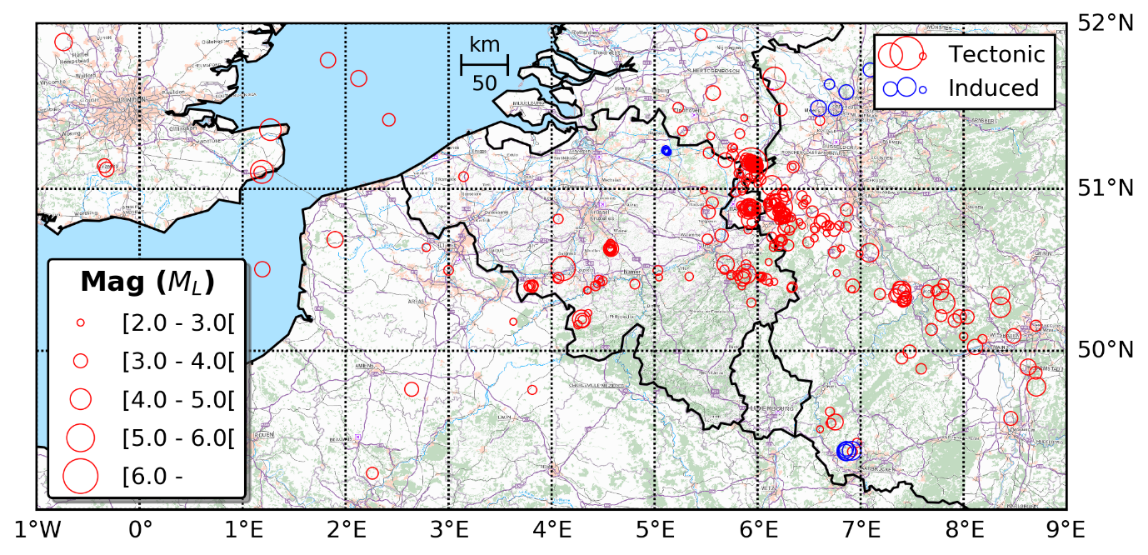
Figure S1 - Map of earthquakes included in the BELSHAKE database

Figure S2
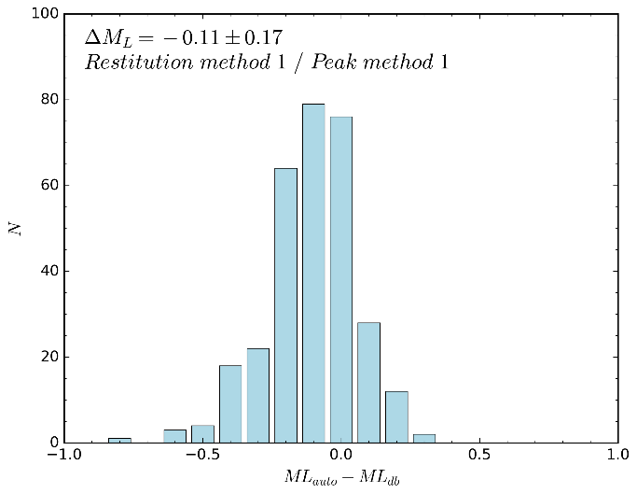 | 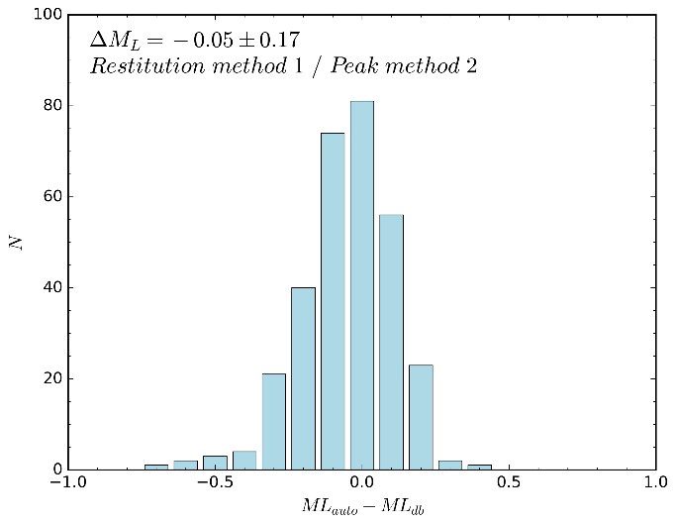
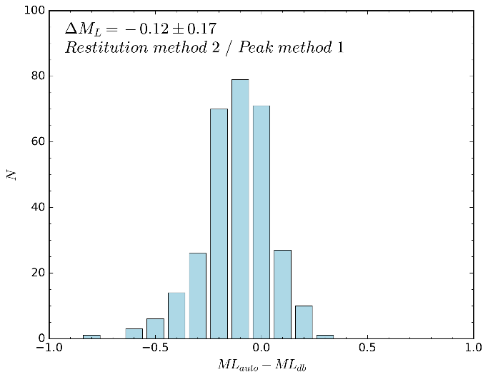 | 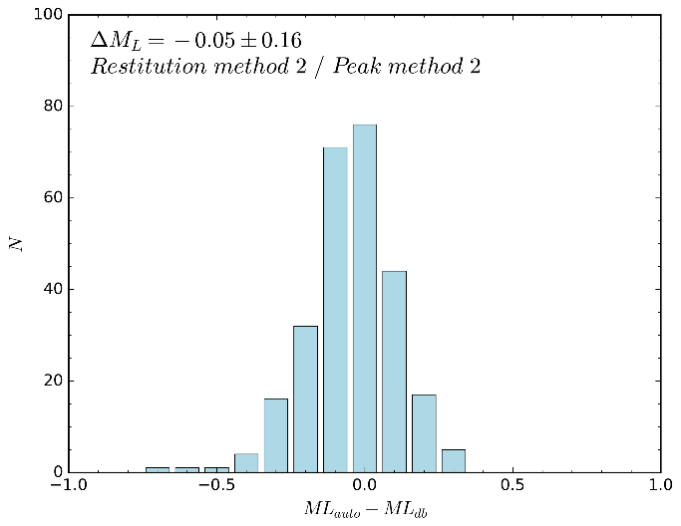
Figure S2 - Histograms of differences between $M_{L}$ values recomputed from automatically determined amplitudes and $M_{L}$ values in the ROB catalog. Panels correspond to amplitudes obtained with 4 different methods. Top row: restitution method 1; Bottom row: restitution method 2; Left column: peak measurement method 1; Right column: peak measurement method 2

Figure S3
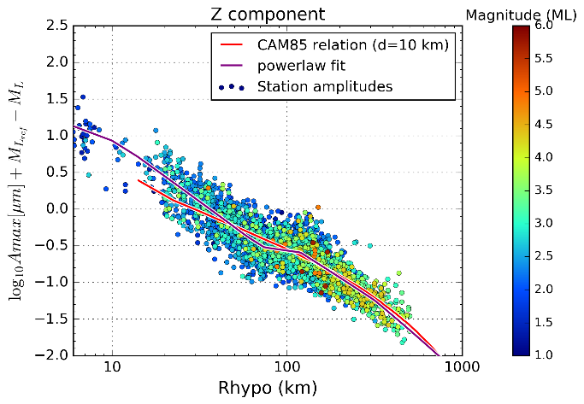 | 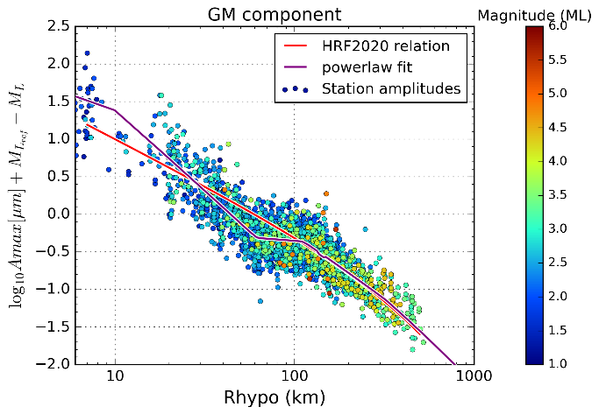
Figure S1 - Magnitude-corrected amplitudes, with station corrections applied, versus hypocentral distance, along with piecewise continuous powerlaw + kappa gradient fit. Left: Z component; Right: GM component

Table S1
station | depth (m) | soil class | mean | Z  sigma | n | mean | GM  sigma | n
BE.AUL | 5 | A | -0.30 | 0.164 | 72
BE.BEBN | 47 | A | 0.24 | 0.211 | 215 | 0.08 | 0.204 | 177
BE.BOST | 302 | A | -0.27 | 0.185 | 18 | -0.32 | 0.205 | 18
BE.BOU | 8 | A | -0.05 | 0.188 | 160
BE.BRE.01 | 0 | C | -0.11 | 0.160 | 10 | 0.18 | 0.106 | 10
BE.BRQ.00 | 0 | A | 0.17 | 0.157 | 45
BE.BRQ.01 | 30 | A | 0.01 | 0.168 | 45
BE.CLA | 0 | A | -0.07 | 0.134 | 185 | -0.08 | 0.153 | 179
BE.CSE | 0 | C | 0.58 | 0.183 | 21 | 0.68 | 0.155 | 21
BE.CTH | 0 | A | 0.00 | 0.199 | 50 | 0.15 | 0.157 | 23
BE.CTH.01 | 37 | A | -0.11 | 0.106 | 33 | -0.08 | 0.092 | 33
BE.DOU | 0 | A | -0.02 | 0.198 | 259 | -0.03 | 0.190 | 253
BE.DSLB | 600 | A | -0.24 | 0.181 | 32 | -0.11 | 0.208 | 30
BE.DSLS | 0 | C | 0.17 | 0.216 | 15 | 0.61 | 0.230 | 15
BE.GES | 0 | A | -0.07 | 0.147 | 142 | 0.09 | 0.190 | 142
BE.GRZ | 0 | B | 0.34 | 0.257 | 11 | 0.52 | 0.140 | 11
BE.HEY | 0 | A | 0.01 | 0.161 | 30 | -0.06 | 0.151 | 30
BE.HLN | 0 | C | 0.41 | 0.258 | 13 | 0.61 | 0.142 | 11
BE.HOU | 0 | A | 0.22 | 0.156 | 53 | 0.32 | 0.162 | 53
BE.HRK | 0 | C | 0.08 | 0.194 | 86 | 0.19 | 0.201 | 86
BE.HU1 | 0 | A | 0.01 | 0.217 | 10 | -0.09 | 0.216 | 10
BE.HUM | 0 | A | 0.02 | 0.177 | 121 | -0.02 | 0.176 | 113
BE.KIN | 0 | C | 0.18 | 0.139 | 10
BE.KLB | 0 | A | -0.01 | 0.172 | 175 | -0.08 | 0.158 | 172
BE.LCH | 0 | A | -0.06 | 0.174 | 108 | -0.08 | 0.202 | 108
BE.LES | 0 | A | -0.01 | 0.192 | 101 | -0.14 | 0.202 | 91
BE.MAS | 0 | C | 0.05 | 0.156 | 14 | 0.08 | 0.231 | 12
BE.MEMA | 0 | A | 0.34 | 0.203 | 15 | 0.19 | 0.190 | 15
BE.MEMB | 6 | A | 0.01 | 0.184 | 88 | -0.05 | 0.176 | 88
BE.MEMH | 6 | A | 0.00 | 0.174 | 102 | -0.11 | 0.195 | 102
BE.MEMS | 6 | A | -0.04 | 0.196 | 282 | -0.14 | 0.195 | 265
BE.MEU | 0 | B | 0.07 | 0.195 | 58 | 0.20 | 0.231 | 56
BE.MOL1 | 121 | B | -0.15 | 0.156 | 21 | -0.24 | 0.345 | 21
BE.MOL2 | 224 | B | -0.15 | 0.132 | 21 | -0.17 | 0.319 | 21
BE.MOL3 | 221 | B | -0.20 | 0.126 | 20 | -0.18 | 0.315 | 20
BE.MOL4 | 223 | B | -0.16 | 0.158 | 21 | -0.17 | 0.320 | 21
BE.MOL5 | 223 | B | -0.17 | 0.138 | 20 | -0.16 | 0.305 | 20
BE.MOLS | 0 | C | 0.18 | 0.218 | 27 | 0.44 | 0.225 | 27
BE.MOLT | 223 | B | -0.17 | 0.151 | 73 | 0.03 | 0.215 | 73
BE.MRD | 0 | A | -0.01 | 0.164 | 116 | -0.08 | 0.158 | 116
BE.MRG | 0 | A | -0.12 | 0.168 | 45 | 0.09 | 0.140 | 45
BE.OPT | 0 | B | 0.15 | 0.190 | 49 | 0.24 | 0.198 | 49
BE.OPTB | 379 | A | -0.21 | 0.201 | 21 | -0.08 | 0.215 | 21
BE.OSP | 0 | C | 0.11 | 0.220 | 13 | 0.53 | 0.198 | 13
BE.OT2 | 0 | B | 0.37 | 0.131 | 10 | 0.12 | 0.179 | 10
BE.OT3 | 0 | C | 0.50 | 0.174 | 15 | 0.38 | 0.297 | 15
BE.OT5 | 0 | B | 0.24 | 0.152 | 13 | 0.18 | 0.171 | 13
BE.OTT | 0 | A | 0.10 | 0.192 | 17 | 0.12 | 0.140 | 17
BE.RCHB | 45 | A | 0.05 | 0.169 | 83 | -0.05 | 0.190 | 80
BE.ROB | 0 | A | -0.20 | 0.191 | 78 | -0.27 | 0.196 | 72
BE.RQR | 18 | A | -0.16 | 0.166 | 131
BE.SKQ | 0 | A | -0.12 | 0.184 | 155 | -0.21 | 0.192 | 155
BE.SNF | 14 | A | -0.10 | 0.153 | 161
BE.STI | 17 | A | 0.02 | 0.176 | 214
BE.TGA | 0 | A | 0.30 | 0.152 | 12 | 0.27 | 0.140 | 12
BE.THN | 0 | C | 0.00 | 0.205 | 10
BE.TMM1 | 0 | A | 0.26 | 0.190 | 20 | 0.25 | 0.170 | 20
BE.TMM2 | 1 | A | 0.25 | 0.154 | 21 | 0.10 | 0.120 | 21
BE.TMM3 | 2 | A | 0.18 | 0.161 | 20 | 0.02 | 0.133 | 20
BE.TMM4 | 4 | A | 0.05 | 0.166 | 20 | -0.08 | 0.155 | 20
BE.TNL | 0 | A | -0.12 | 0.151 | 45 | -0.05 | 0.178 | 45
BE.UCCB | 95 | A | 0.02 | 0.198 | 66 | -0.04 | 0.158 | 66
BE.UCCS | 5 | C | 0.54 | 0.265 | 84 | 0.44 | 0.188 | 61
BE.VIA | 0 | A | 0.17 | 0.163 | 145 | 0.24 | 0.156 | 142
BE.WIB | 0 | A | -0.04 | 0.187 | 22 | -0.12 | 0.209 | 17
BE.WLF | 0 | A | 0.06 | 0.177 | 205 | -0.04 | 0.210 | 205
Table 7 – Mean and standard deviation of station $M_{L}$ residuals obtained for the Z component and the geometric mean (GM)

