Supplementary Table 1 (this is a screenshot, but real table will be submitted)

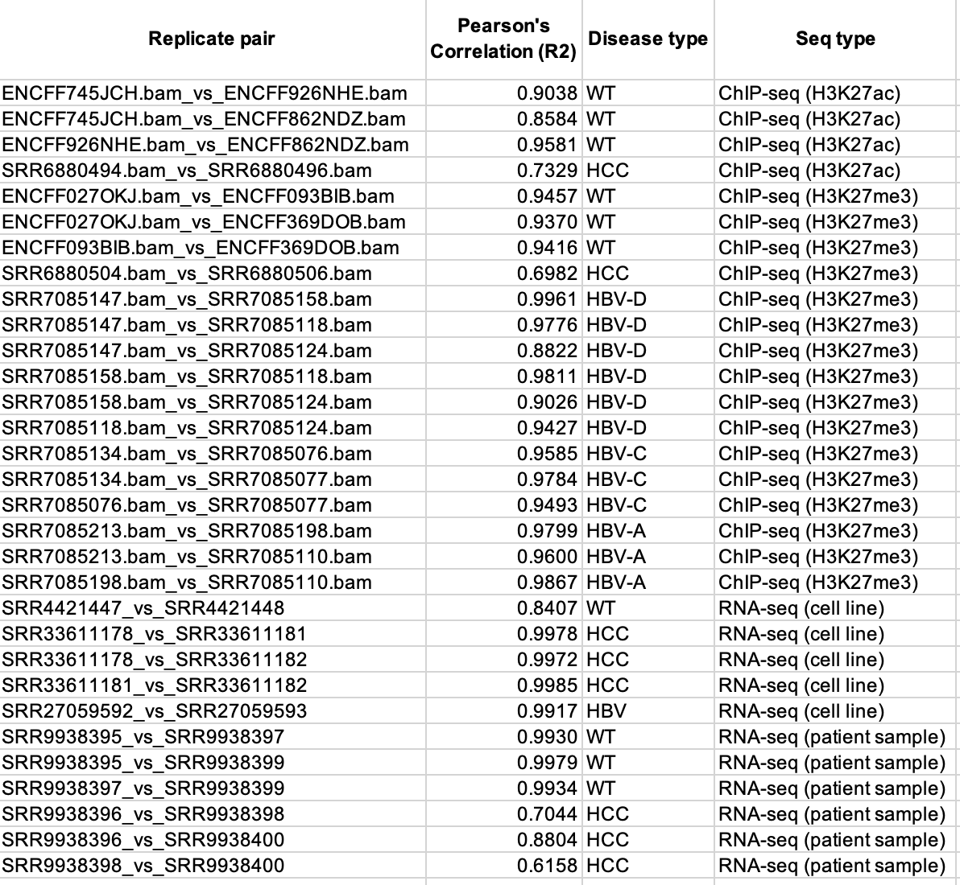
Supplemental figure 1

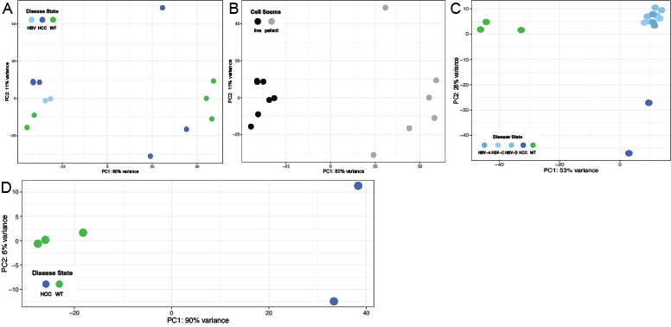
Supplemental Figure 1. Principle Component Analysis of sample replicates. (A) Comparing RNA-seq data for disease states (WT, HBV, and HCC). (B) Comparing RNA-seq data for cell line vs. patient-derived data. C) Comparing H3K27me3 ChIP-seq data for disease states (WT, HBV, and HCC) (D) Comparing H3K27ac ChIP-seq data for disease states (WT and HCC).
Supplemental figure 2

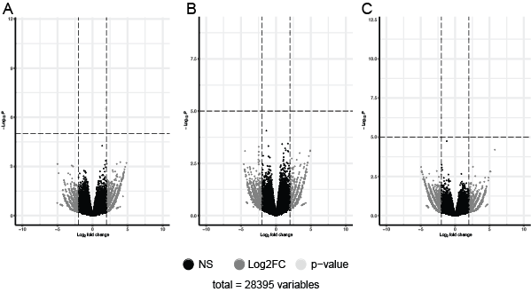

Supplemental Figure 2. Volcano plots of differential H3K27me3 in HBV genotypes. Differential H3K27me3 presence in HBV-D vs. HBV-C (A), HBV-D vs. HBV-A (B), and HBV-C vs. HBV-A (C).

