Online supplementary material
Contents
- SanQoL-5 questions (descriptive system)
- SanQoL-5 visualisation board
- Visual Analogue Scale
- Questions on willingness to pay for quality of life
- Sanitation upgrade sheet
- Distribution of VAS Increment
- Distribution of responses on a 0–100 Visual Analog Scale (VAS) for current status (pre-upgrade)
- Estimated coefficients from a Double-Bounded Dichotomous Choice Model predicting Willingness to Pay for Maize
- Linear regression for predicting Maximum Willingness to Pay for Maize
- Handling participants with an initial SanVAS score of 100
- Distribution of Willingness to Pay for SAPY per Unit Increase in VAS Score
- Descriptive Statistics by Gender for people who were sure about their WTP
1
- SanQoL-5 questions (descriptive system)
Attribute | Question (item)* | Responses
Disgust | How often do you feel disgusted while using the toilet? | Always  Sometimes  Never
Disease | How often do you worry that the toilet spreads diseases? | Always  Sometimes  Never
Safety | How often do you feel unsafe while using the toilet? | Always  Sometimes  Never
Shame | How often do you feel ashamed about using the toilet? | Always  Sometimes  Never
Privacy | How often do you worry about being seen while using the toilet? | Always  Sometimes  Never
- SanQoL-5 visualisation board
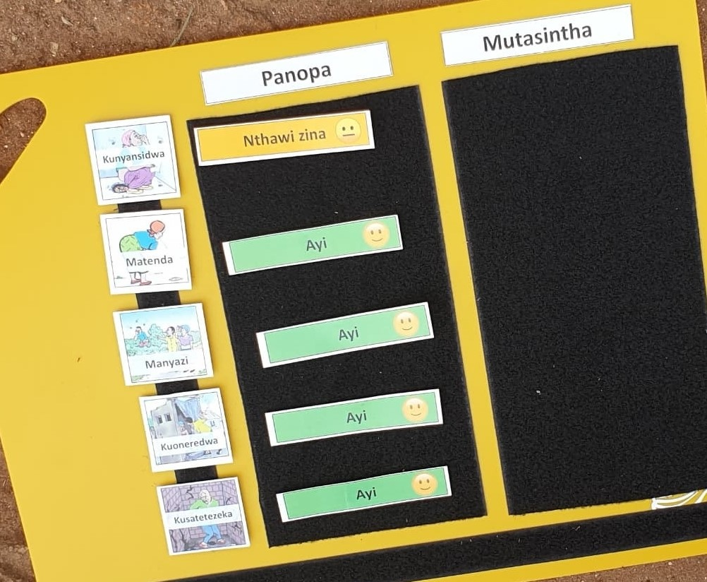

Note. “Panopa” means “current” and “Mutasintha”means “after upgrading”. “ayi” means “never” so is coloured green with smiley face. “Nthawi zina” means “sometimes” so is coloured yellow with expressionless face. “Always” was coloured red and shown with sad face.
2
- Visual Analogue Scale
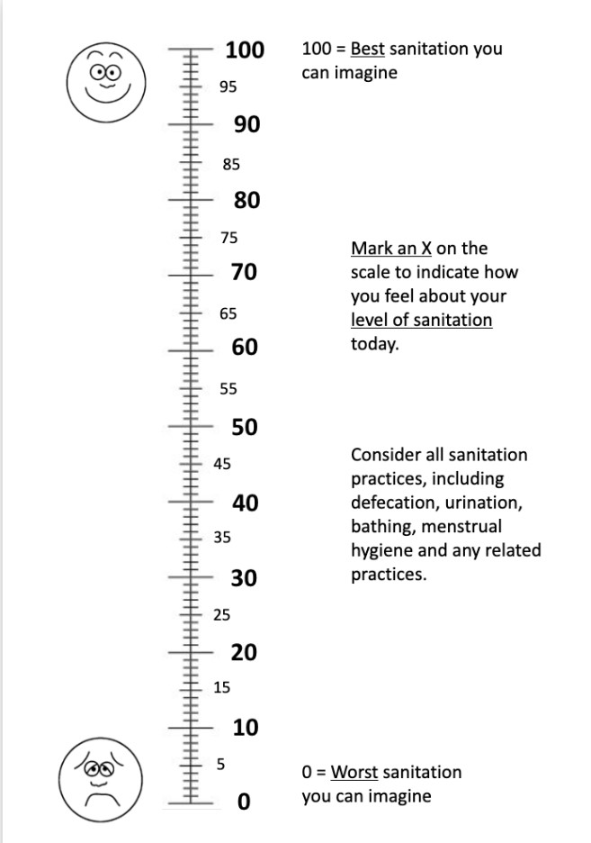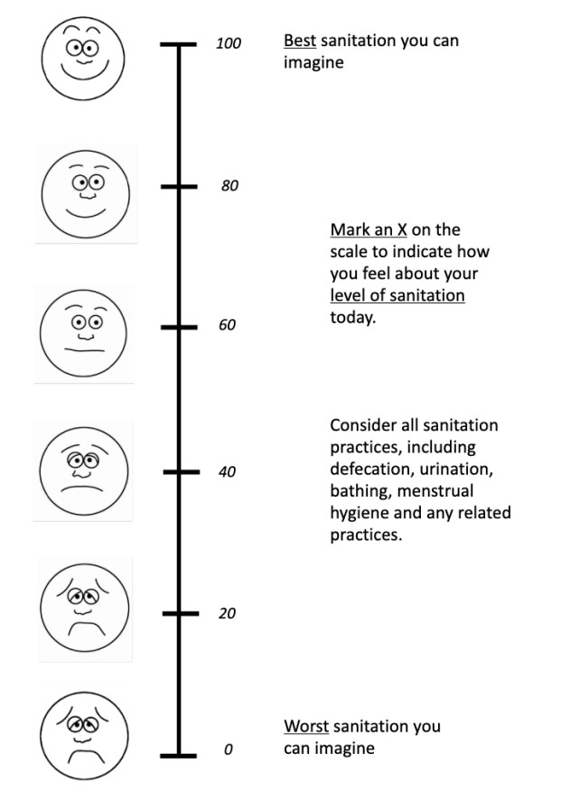

- Questions on willingness to pay for quality of life
Question | Response
Assume that you have better quality of life in these two ways [POINT TO BOARD], and that your family members feel the same improvement as you. Now assume you have the opportunity to pay for the latrine upgrade today [POINT TO PHOTOSHEET]. It will last ${san_life} years before needing to be replaced.
Consider what you would be willing to pay for you and your household to have better quality of life in these two areas, and it will last ${san_life} years. If it was ${cv_san_4cat} would you buy it? | Yes  No
[if no] What is the reason for saying no? | no reason given price is too high price is fair but I can't afford it I don't need an upgrade at any price
Would you pay ${san_up} / ${san_down}? | Yes  No
[if no] What is the reason for saying no? | no reason given price is too high  price is fair but I can't afford it
3
 | I don't need an upgrade at any price
What is the maximum amount you would pay for the upgrade, and get these quality-of-life improvements? You just said yes/no to ${amount}, so your maximum should be higher/lower than that, or the same. | 0 (don't want to upgrade or cannot afford anything)  5,000  10,000  15,000  20,000  25,000  30,000  35,000  40,000  45,000  50,000  60,000  70,000  80,000  90,000  100,000  110,000  120,000  130,000  140,000 150,000 more than 150,000
Now really imagine having to pay that maximum amount in reality. Imagine having the money in your hand now. How sure are you that you would pay the maximum amount you just stated? | Completely sure I would pay
 | Fairly sure I would pay
 | Not very sure I would pay
 | Very unsure I would pay
 | I didn't understand the task enough
4
- Sanitation upgrade sheet
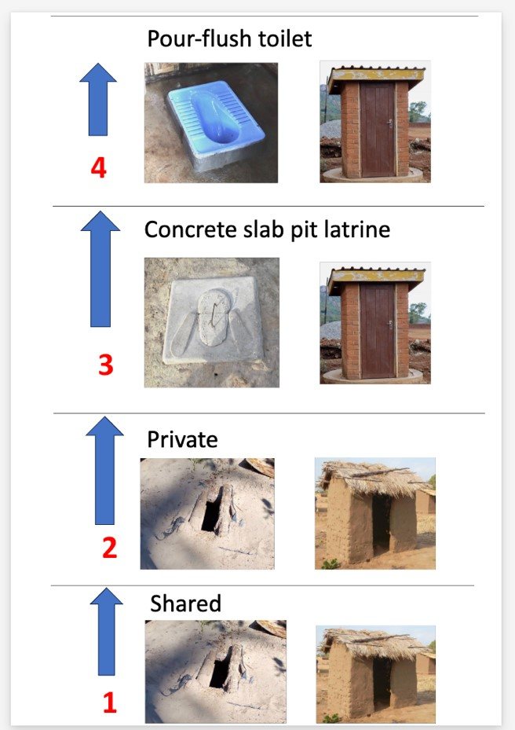
- Distribution of VAS Increment
5
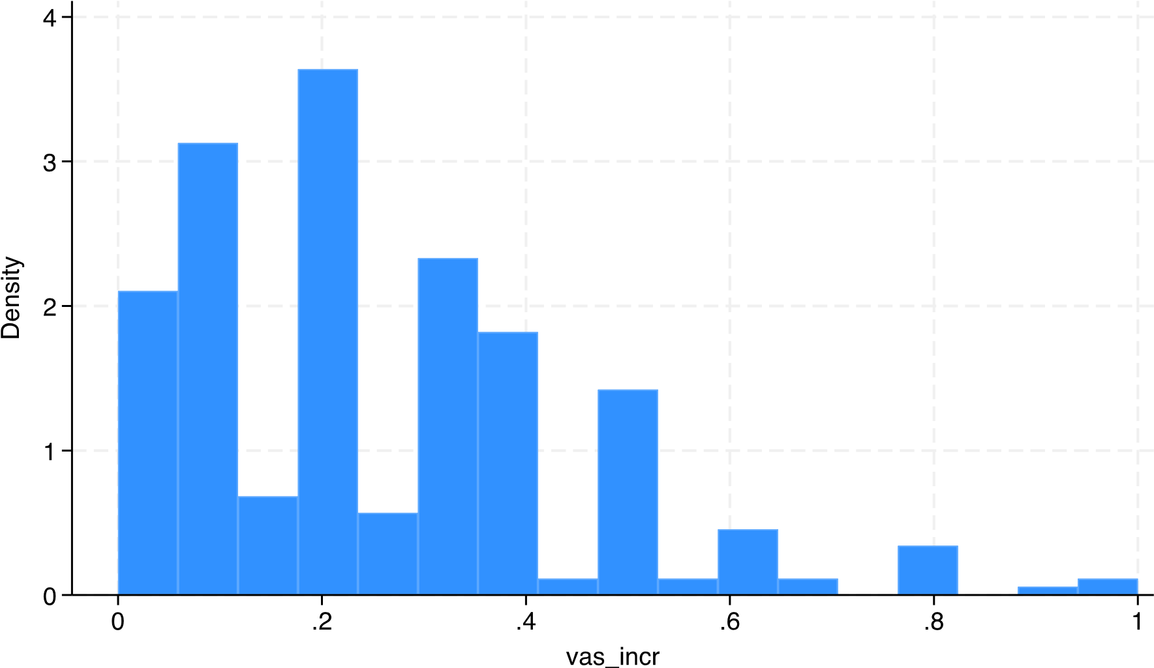
- Distribution of responses on a 0–100 Visual Analog Scale (VAS) for current status (pre-upgrade)
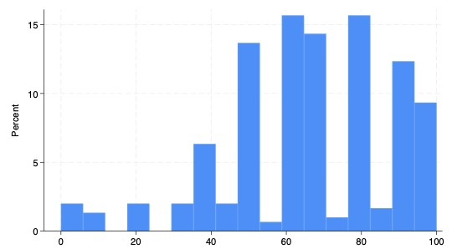
6
- Estimated coefficients from a Double-Bounded Dichotomous Choice Model predicting Willingness to Pay for Maize
Predictor | B | SE | z | p | 95% CI  (Lower) | 95% CI  (Upper)
Intercept (Beta) | 3849.28 | 190.89 | 20.17 | < .001 | 3475.15 | 4223.4
Intercept (Sigma) | 2819.21 | 245.08 | 11.5 | < .001 | 2338.87 | 3299.55
- Linear regression for predicting Maximum Willingness to Pay for Maize
Predictor | B | SE | t | p | 95% CI  (Lower) | 95% CI  (Upper)
Intercept | 3041.98 | 765.81 | 3.97 | < .001 | 1475.72 | 4608.24
Respondent Gender | 132.51 | 272.67 | 0.49 | 0.631 | -425.16 | 690.18
Household Size | 230.25 | 244.72 | 0.94 | 0.355 | -270.25 | 730.76
Respondent Age | 71.92 | 72.08 | 1.00 | 0.327 | -75.5 | 219.34
Education Level | -32.73 | 109.03 | -0.3 | 0.766 | -255.72 | 190.26
7
- Handling participants with an initial SanVAS score of 100
Participants who reported a SanQoL-5 score of 1.0 at baseline were carefully considered in the analysis to ensure the validity of inferred sanitation improvements. Given that SanQoL-5 increments were externally imposed by fieldworkers, a direct increase in SanQoL-5 was not possible for these individuals. To address this, we separately examined their SanVAS increments, which were self-reported and could capture perceived improvements in sanitation quality even when their initial SanQoL-5 was at the maximum level. Specifically, the analysis included a separate tabulation of SanVAS increments for cases where SanQoL-5 = 1.0 to assess whether these participants perceived any subjective benefits from the hypothetical upgrade. By relying on SanVAS changes instead of imposed SanQoL-5 modifications in the primary analysis, we ensured that potential improvements were measured through participants' own perceptions rather than artificial adjustments, thereby maintaining robustness in our valuation framework

K. Distribution of Willingness to Pay for SAPY per Unit Increase in VAS Score
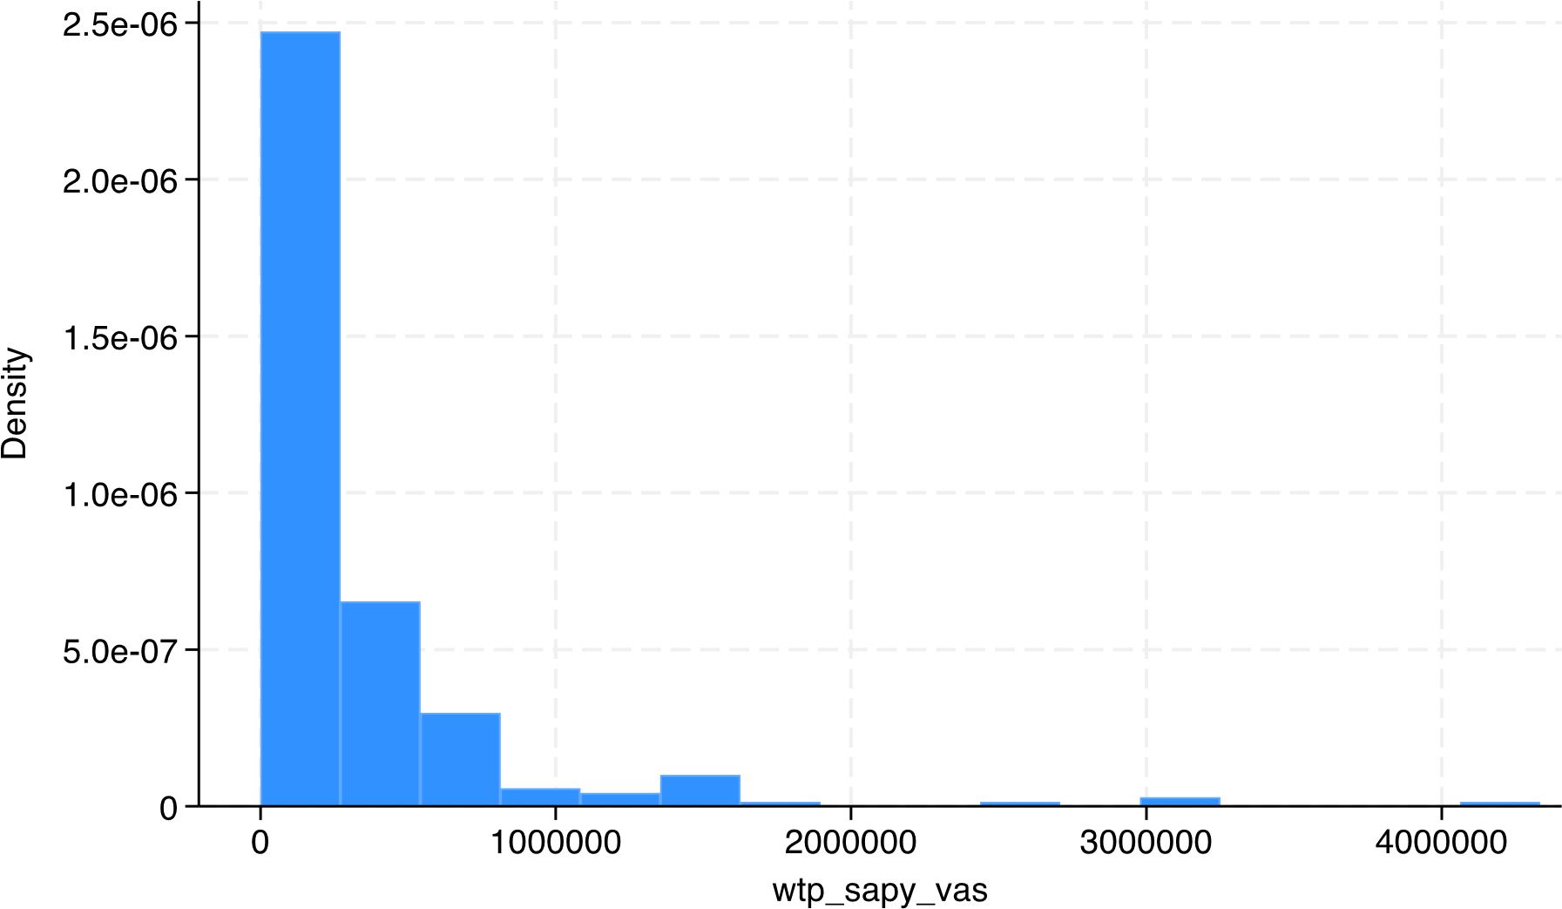
8
L. Descriptive Statistics by Gender for people who were sure about their WTP

Variable Male (n=96) Female (n=145) Total (n =241)
Demographic characteristics  Respondent age  <24 | 12 (12.5%) | 28 (19.3%) | 40 (16.6%)
25-34 | 23 (24.0%) | 32 (22.1%) | 55 (22.8%)
35-44 | 17 (17.7%) | 36 (24.8%) | 53 (22.0%)
45-54 | 21 (21.9%) | 27 (18.6%) | 48 (19.9%)
55-64 | 13 (13.5%) | 11 (7.6%) | 24 (10.0%)
65+ | 10 (10.4%) | 11 (7.6%) | 21 (8.7%)
Highest schooling completed  None | 33 (34.4) | 64 (44.1) | 97 (40.2)
Primary | 36 (37.5) | 57 (39.3) | 93 (38.6)
Secondary | 27 (28.1) | 24 (16.6) | 51 (21.2)
Household size  <5 members | 73 (76.0%) | 96 (66.2%) | 169 (70.1%)
>5 members | 23 (24.0%) | 49 (33.8%) | 72 (29.9%)
Main source of drinking water  Piped into compound/ yard | 1 (1.0%) | 0 (0.0%) | 1 (0.4%)
Public tap / standpipe | 0 (0.0%) | 4 (2.8%) | 4 (1.7%)
protected borehole or well | 88 (91.7%) | 135 (93.1%) | 223 (92.5%)
unprotected well or spring | 7 (7.3%) | 6 (4.1%) | 13 (5.4%)
Waged workdays in past 7 days  0 days | 76 (79.2%) | 114 (78.6%) | 190 (78.8%)
1 day | 5 (5.2%) | 2 (1.4%) | 7 (2.9%)
2 days | 1 (1.0%) | 11 (7.6%) | 12 (5.0%)
More than 2 days | 14 (14.6%) | 18 (12.4%) | 32 (13.3%)

