Electronic Supplementary information for
Three-in-One Fluorescent Sensing and Imaging of Chemical Warfare Agents: Sulfur Mustard, Sarin, and Cyanide
Junhong Liu ^{a†}, Yin Gong ^{a†}, Linwen Tan ^{e†}, Jinfeng Cen ^{a†}, Mo Li ^{c}, Chuyu Wang ª, Xuan Zhao ^{e}, Mingxue Sun ^{a*}, Qitao Tan ^{b*}, Wen-Qi Meng ^{a,d,e*}
ª Faculty of Naval Medicine, Naval Military Medical University, Shanghai, 200433, China. E-mail: wenqimeng@smmu.edu.cn
^{b} Department of Chemistry, College of Sciences, Shanghai University, Shanghai, 200444, China. E-mail: qttan@shu.edu.cn
^{c} School of Public Health, Hebei Medical University, Shijiazhuang, 050017, China. E-mail: xuxd@hebmu.edu.cn
^{d} Laboratory of New Drug Research and Clinical Pharmacy, School of Pharmacy, Xuzhou Medical University, Xuzhou, China.
^{e} Department of Environmental Health, School of Public Health, China Medical University, Shenyang 110122, China.
†These authors contributed equally to this work
*Corresponding author.

Figure S1. (A) Fluorescence emission spectra of TrioAlert (20 μM) in dichloromethane-PBS after gradual addition of SM (0-100 μM), sarin (0-100 μM), and KCN (0-200 μM) for 20 minutes (excitation wavelength: 480 nm for SM and sarin, 380 nm for KCN; slit width: 10 nm). (B) Time-dependent fluorescence intensity of TrioAlert (20 μM) in dichloromethane-PBS upon addition of SM (100 μM), sarin (100 μM), and KCN (200 μM) (excitation wavelength: 480 nm for SM and sarin, 380 nm for KCN; slit width: 10 nm). (C) Linear relationship between the fluorescence intensity of TrioAlert (20 μM) and the concentration of the reagents after gradual addition of SM (0-100 μM), sarin (0-100 μM), and KCN (0-200 μM) in dichloromethane-PBS (excitation wavelength: 480 nm for SM and sarin, 380 nm for KCN; slit width: 10 nm).
Figure S2. (A) Fluorescence emission spectra of TrioAlert (20 μM) in acetonitrile-PBS in the absence or presence of SM (100 μM) or 2-chloroethyl ethyl sulfide (CEES, 100 μM) after 20 min (excitation wavelength: 480 nm; slit width: 10 nm). (B) Fluorescence emission spectra of TrioAlert (20 μM) in acetonitrile-PBS in the absence or presence of sarin (100 μM) or DCP (100 μM) after 20 min (excitation wavelength: 480 nm; slit width: 10 nm).
Figure S3. (A) HaCaT cells were treated with different concentrations TrioAlert (0, 10, 20, 40, 60, 80 and 100 μM) for 12 h. Cell viability was assessed using the CCK8 assay. (B) HaCaT cells were treated with 20 μM TrioAlert for various durations (0, 1, 2, 4, 8, 12, and 24 h). Cell viability was assessed using the CCK8 assay.
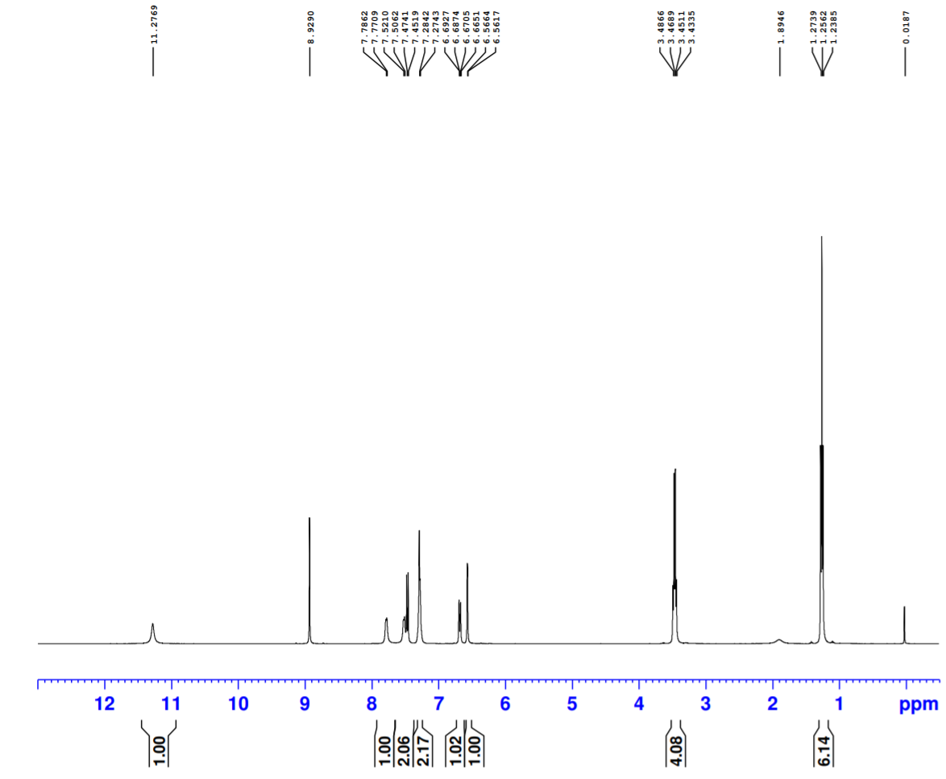
Figure S4. ¹H NMR for NNP-1 in Chloroform-d.
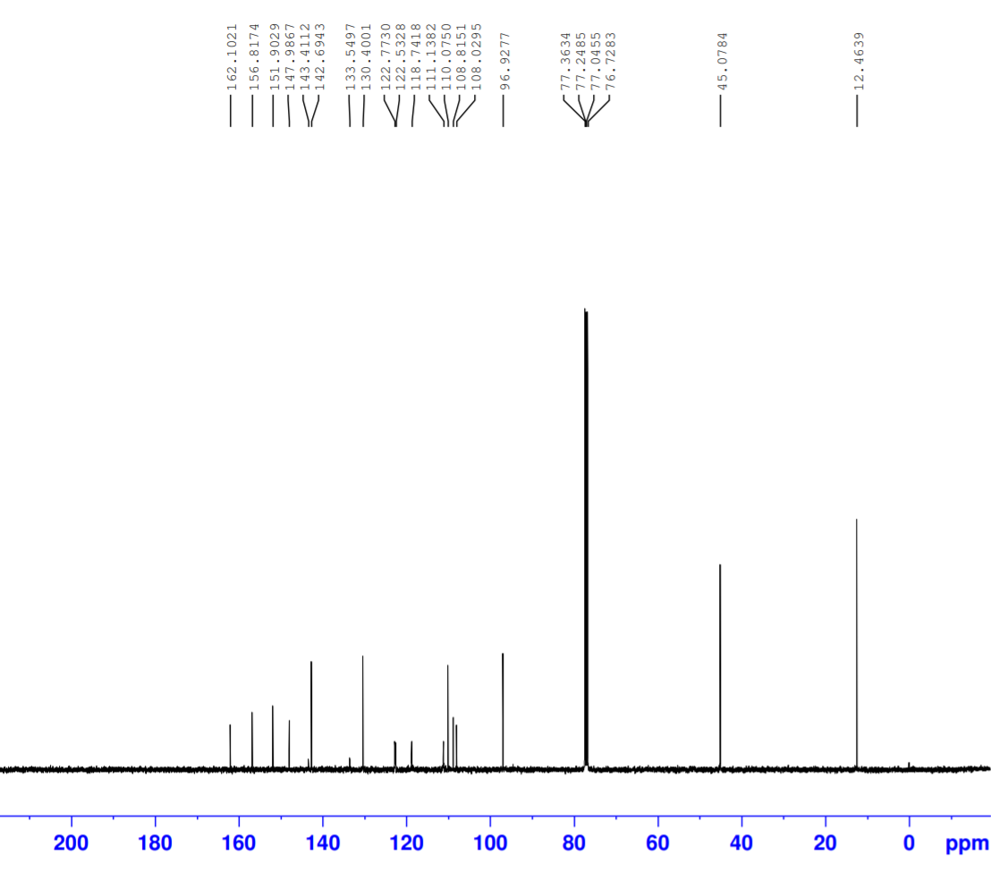
Figure S5. ¹³C NMR for NNP-1 in Chloroform-d.
Figure S6. HRMS spectrum of compound NNP-1.
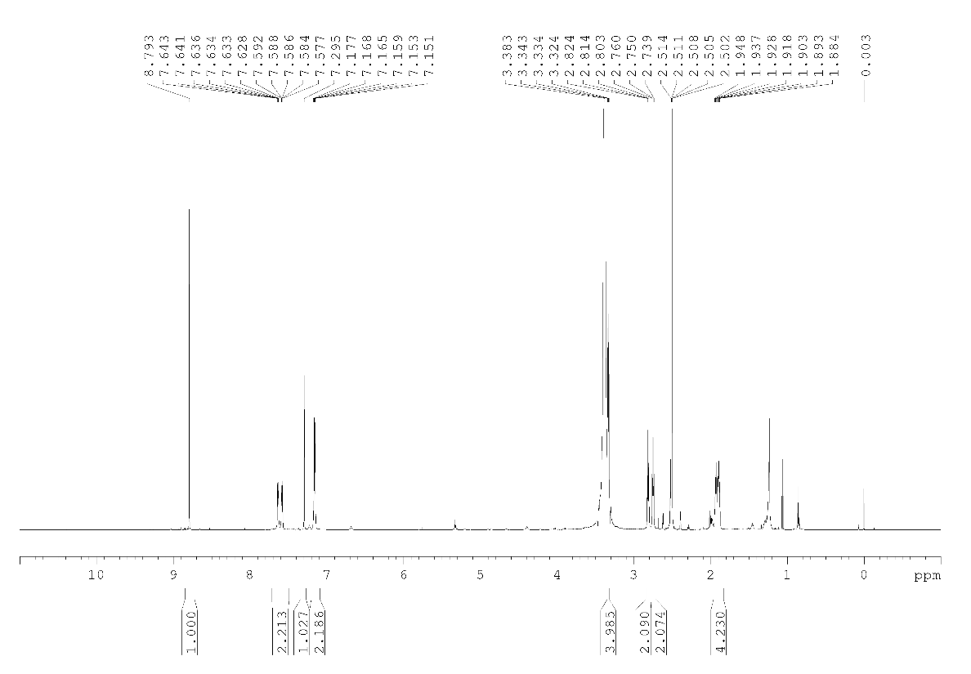
Figure S7. ¹H NMR for NNP-2 in DMSO-d₆.
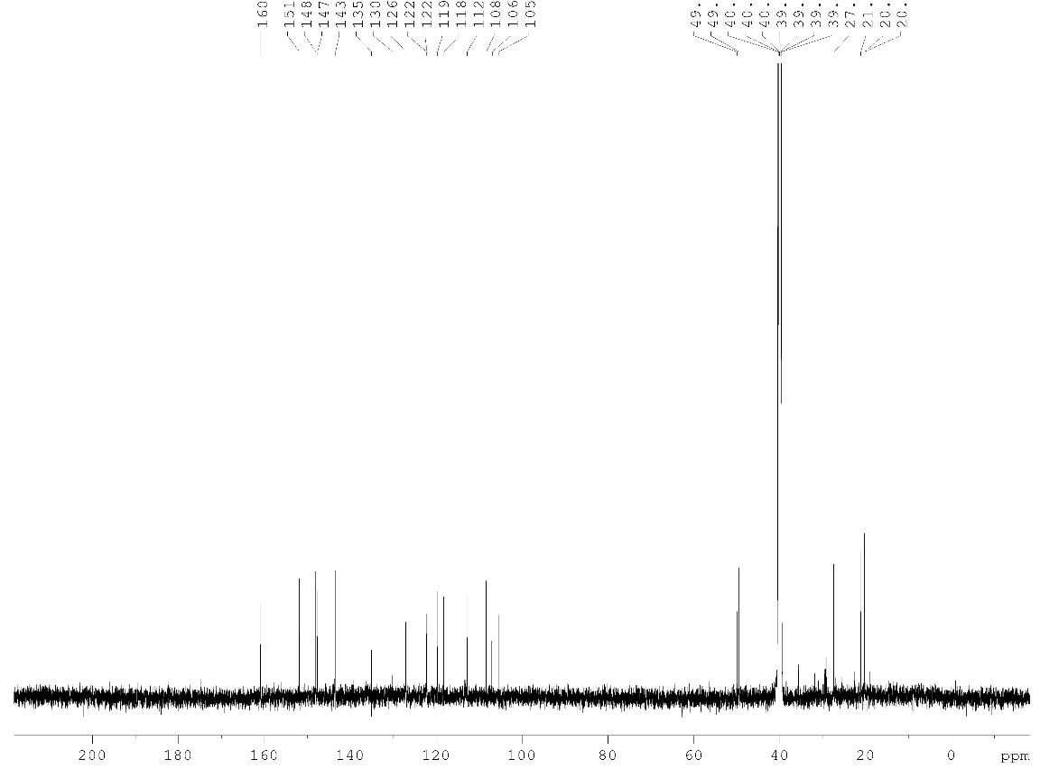
Figure S8. ¹³C NMR for NNP-2 in DMSO-d₆.
Figure S9. HRMS spectrum of compound NNP-2.
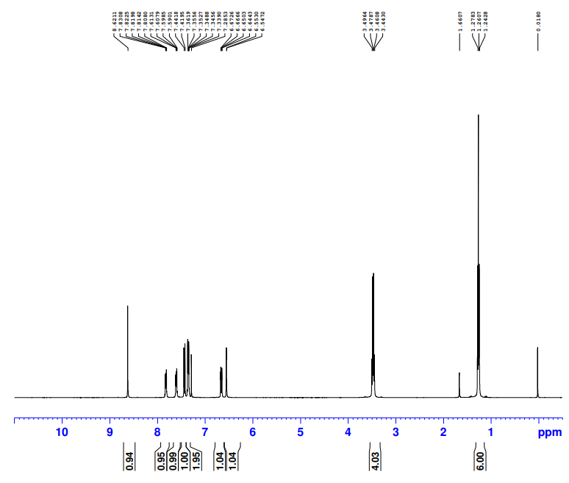
Figure S10. ¹H NMR for ONP-1 in Chloroform-d.
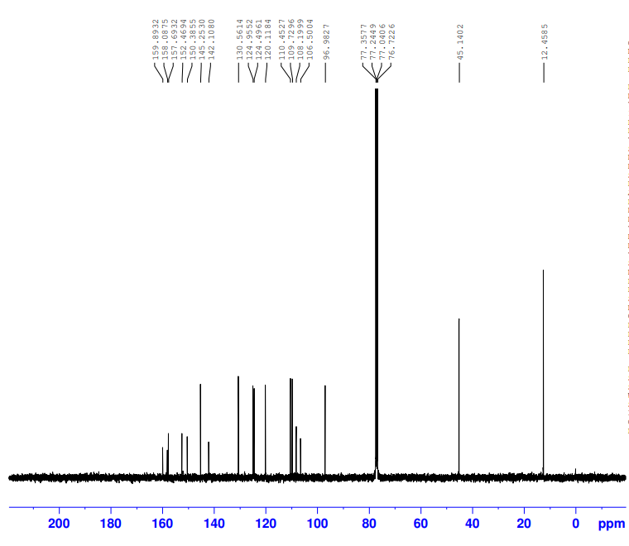
Figure S11. ¹³C NMR for ONP-1 in Chloroform-d.
Figure S12. HRMS spectrum of compound ONP-1.
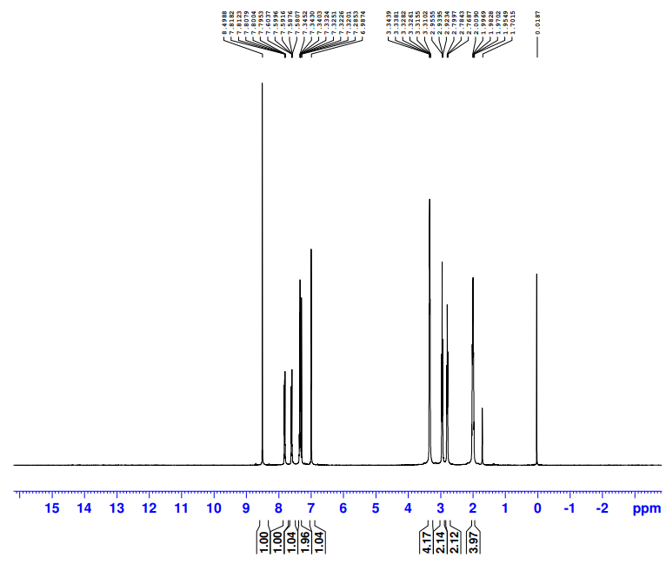
Figure S13. ¹H NMR for ONP-2 in Chloroform-d.
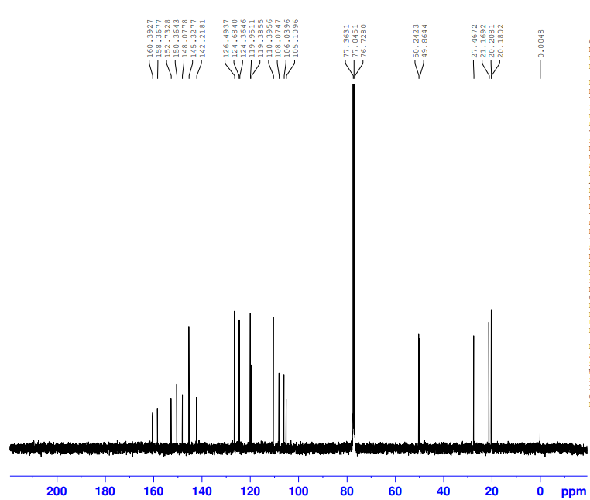
Figure S14. ¹³C NMR for ONP-2 in Chloroform-d.
Figure S15. HRMS spectrum of compound ONP-2.
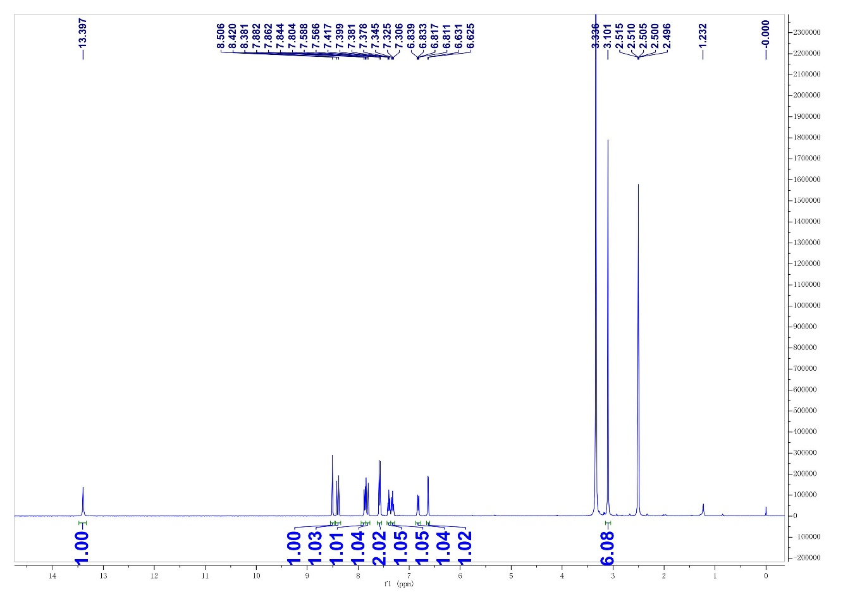
Figure S16. ¹H NMR for TrioAlert in DMSO-d₆.
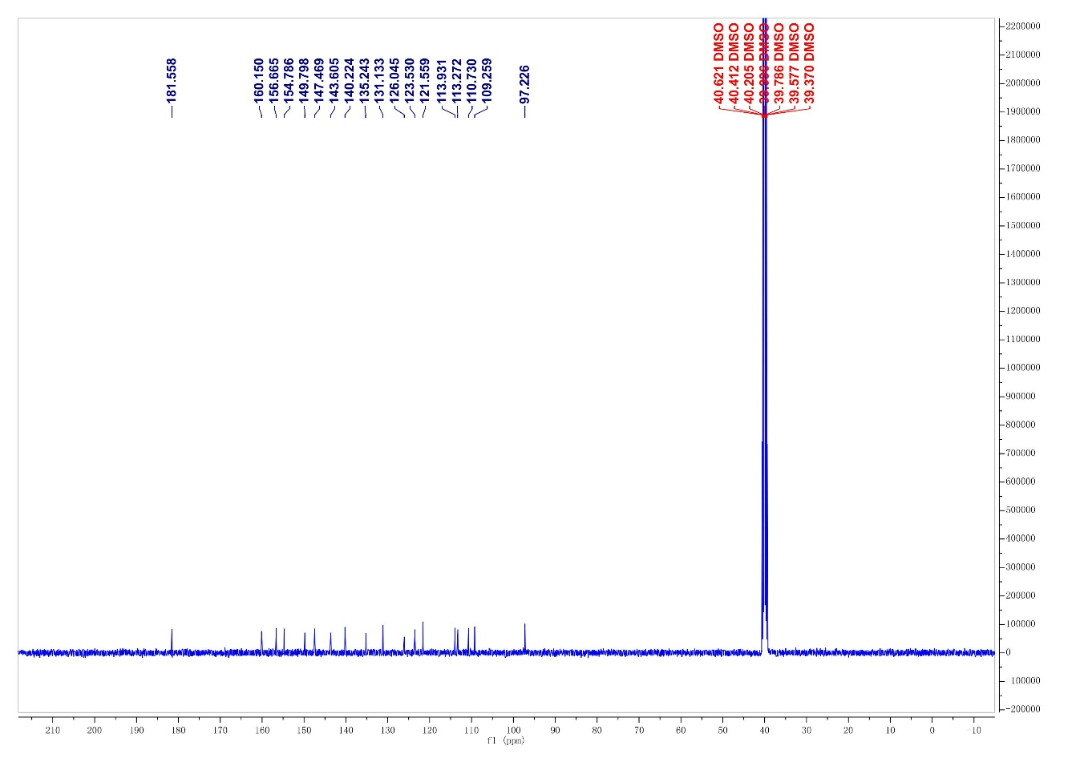
Figure S17. ¹³C NMR for TrioAlert in DMSO-d₆.
Figure S18. HRMS spectrum of compound TrioAlert.
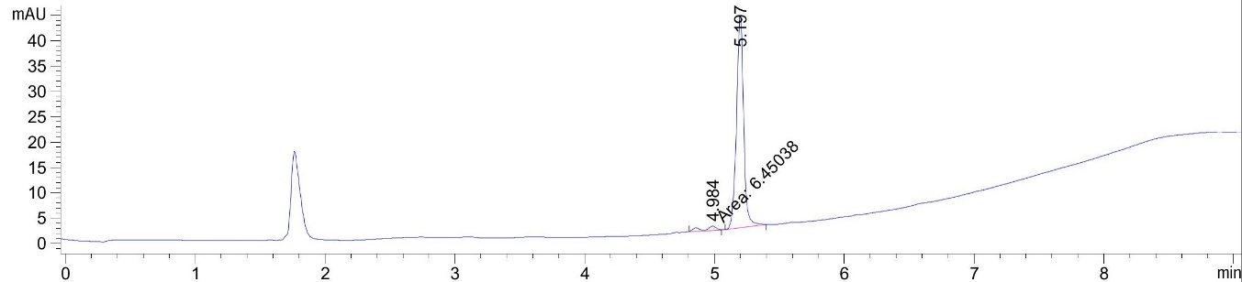
Figure S19. HPLC spectrum of compound TrioAlert.
Figure S20. The HRMS of reaction product of TrioAlert with SM.
Figure S21. The HRMS of reaction product of TrioAlert with DCP.
Figure S22. The HRMS of reaction product of TrioAlert with KCN.
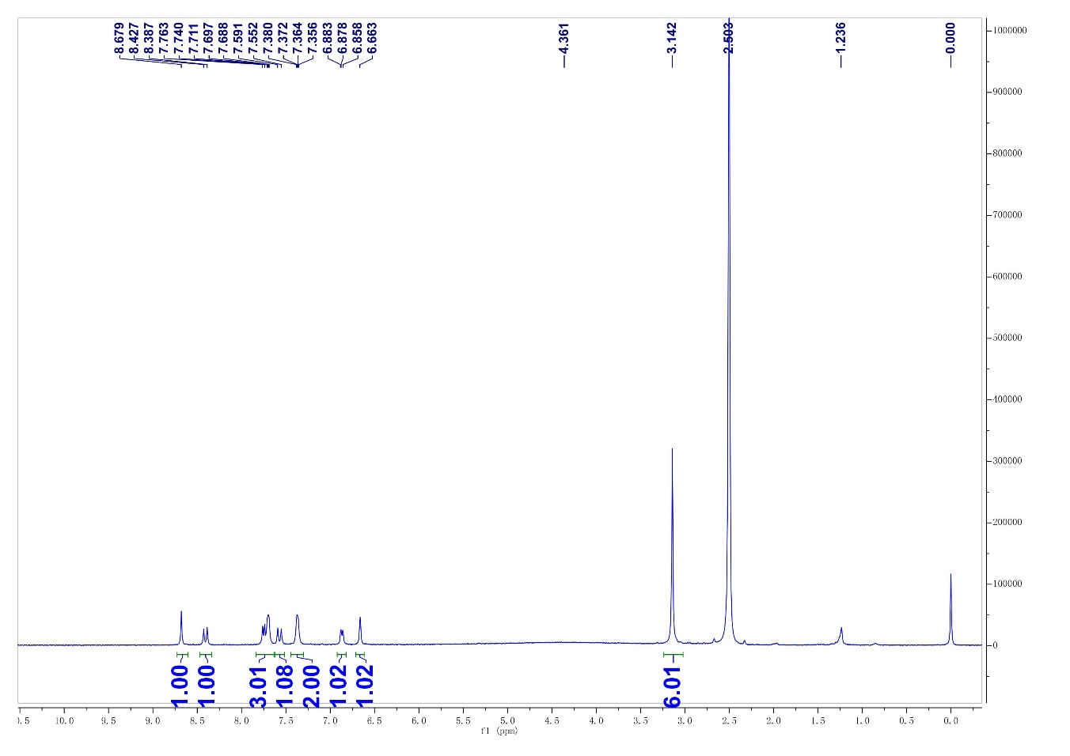
Figure S23. ¹H NMR for TrioAlert-B in DMSO-d₆.
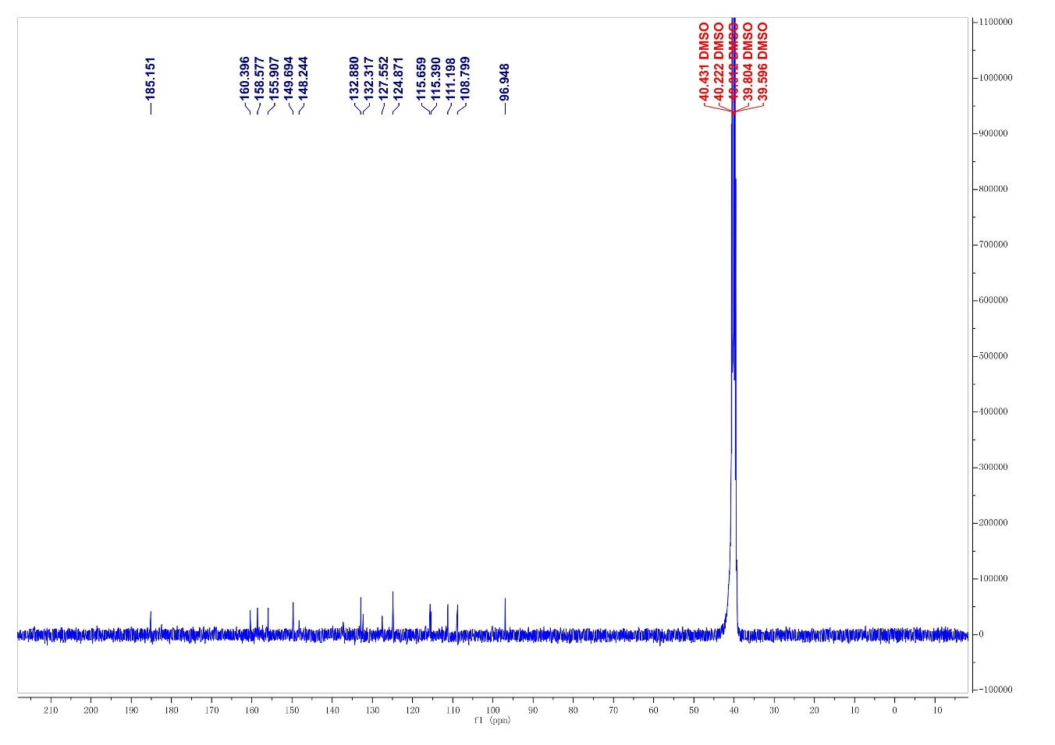
Figure S24. ¹³C NMR for TrioAlert-B in DMSO-d₆.
Figure S25. HRMS spectrum of compound TrioAlert-B.

