Additional files belonging to ‘Longitudinal associations between 24-hour movement behaviours and cognitive function in adults aged 55 and above: a compositional data analysis of the PASOCA study’ by Marent et al. (2025)
Contents
Additional Table 1A. Description of the cognitive tests and outcomes used. 2
Additional Table 1B. Description of the cognitive composite scores with the specific task outcomes. 6
Additional Figure 1 7
Additional Table 2. Comparison of the models using the D1 multivariate Wald test. 8
Additional Table 3A. Model estimates for Short-Term Memory. 9
Additional Table 3B. Model estimates for Long-Term Memory. 9
Additional Table 3C. Model estimates for Executive Function. 10
Additional Table 3D. Model estimates for Processing Speed. 10
Additional Fig. 2A: Hypothetical time reallocations for executive function at baseline 11
Additional Fig. 2B: Hypothetical time reallocations for executive function at follow-up 1 11
Additional Fig. 2C: Hypothetical time reallocations for executive function at follow-up 2 12
Additional Table 4. Hypothetical time reallocations and their estimated difference in executive function z-scores 13
STROBE Statement 15

Additional Table 1A. Description of the cognitive tests and outcomes used.

NAME AND ORDER OF TASKS | DESCRIPTION ª | OUTCOMES ª
- Motor Screening Task  MOT Voice | Coloured crosses are presented in different locations on the screen, one at a time. The participant must select the cross on the screen as quickly and accurately as possible. | Familiarisation task
- Delayed Matching to Sample  DMS Recommended Standard | The participant is shown a complex visual pattern, that is both abstract and non-verbal (the sample), followed by four similar patterns, after a brief delay. The participant must select the pattern which exactly matches the sample. In some trials the sample and the choice patterns are shown simultaneously, in others there is a delay (of 0, 4 or 12 seconds) before the four choices appear. | DMSPCAD - Percent Correct (all delays): The percentage of assessment trials containing a delay during which the subject chose the correct box on their first box choice. Calculated across all assessed trials containing a delay.  DMSMDLS - Median Correct Latency (simultaneous): The median latency between the presentation of the response stimuli options and the subject selecting the correct box on their first attempt. Calculated across all assessed trials containing simultaneous presentation.
- Verbal Recognition Memory  VRM Recommended Standard (immediate) | The participant is shown a sequence of 18 words on screen one by one. The participant is then tasked with recalling the words, whilst a rater marks which ones they remembered. In the next phase, the participant is presented with a sequence of 36 words on screen one by one, 18 from the original list and 18 distractors and is asked to choose as fast as possible whether they have seen it before, yes/no. The latter recognition phase is then repeated after a delay of minimum 20 minutes (see 6). | VRMFRDS - Free Recall Distinct Stimuli: The total number of distinct words that are correctly recalled from the presentation phase by the subject during the immediate free recall stage.  VRMIRTC - Immediate Recognition Total Correct: The total number of target words that the subject correctly recognises, plus the total number of distractor words that the subject correctly rejects.
- One Touch Stockings of Cambridge  OTS Standard | The participant is shown two displays containing three coloured balls. The displays are presented in such a way that they can be easily perceived as stacks of coloured balls held in stockings or socks suspended from a beam. This arrangement makes the 3-D concepts involved apparent to the participant and fits with the verbal instructions. There is a row of numbered boxes along the bottom of the screen.  The participant needs to move the balls in the lower display to copy the pattern in the upper display. They must work out in their head how many moves the solutions require and then select the appropriate box at the bottom of the screen to indicate their response. | OTSMDLC - Median Latency to Correct: The median latency, measured from the appearance of the stocking balls until the correct box choice was made by the subject. Calculated across all assessed trials.  OTSPSFC - Problems Solved on First Choice: The total number of assessed trials where the subject chose the correct answer on their first attempt. Calculated across all assessed trials.
- Spatial Working Memory  SWM Recommended Standard 2.0 Extended | The test begins with a number of coloured squares (boxes) shown on the screen. The aim of this test is that by selecting the boxes and using a process of elimination, the participant should find one yellow ‘token’ in each of a number of boxes and use them to fill up an empty column on the right-hand side of the screen. The number of boxes are gradually increased until a maximum of 12 boxes are shown for the participants to search. The colour and position of the boxes used are changed from trial to trial to discourage the use of stereotyped search strategies. | SWMSX - Strategy (6-12 boxes): The number of times a subject begins a new search pattern from the same box they started with previously. If they always begin a search from the same starting point we infer that the subject is employing a planned strategy for finding the tokens. Therefore a low score indicates high strategy use (1 = they always begin the search from the same box), a high score indicates that they are beginning their searches from many different boxes. Calculated across assessed trials with 6 tokens or more.  SWMBE46812 - Between Errors: The number of times the subject incorrectly revisits a box in which a token has previously been found. Calculated across all assessed four, six, eight, 12 token trials.
- Verbal Recognition Memory (delayed) | The participant is presented on the screen with 36 words one-by-one, half of them are from the original list and the other half are new distractors, and is asked to choose as fast as possible if they have seen it before, with a yes/no option. | VRMDRTC - Delayed Recognition Total Correct: The total number of target words that the subject correctly recognises in the delayed recognition phase, plus the total number of distractor words that the subject correctly rejects.  Time interval: the time (in seconds) between the display of the 18 words (see 3 Verbal Recognition Memory immediate) and the delayed recall phase. Minimum 1200 seconds (20 minutes).
Break of 5 minutes
- Paired Associates Learning  PAL Recommended Standard Extended | Boxes are displayed on the screen and are “opened” and “closed” in a randomised order. One or more of them will contain a pattern. The patterns are then displayed in the middle of the screen, one at a time and the participant must select the box in which the pattern was originally located. If the participant makes an error, the boxes are opened in sequence again to remind the participant of the locations of the patterns. After four attempts, the tasks ends at the level they reached. Starting with two patterns, with the maximum of 12 patterns. | PALFAMS28 - First Attempt Memory Score: The number of times a subject chose the correct box on their first attempt when recalling the pattern locations. Calculated across assessed trials, omitting 12 box level to provide a direct comparison to Recommended Standard.  PALTEA212 - Total Errors (Adjusted): The number of times the subject chose the incorrect box for a stimulus on assessment problems (PALTE), plus an adjustment for the estimated number of errors they would have made on any problems, attempts and recalls they did not reach. This measure allows you to compare performance on errors made across all subjects regardless of those who terminated early versus those completing the final stage of the task.
- Multitasking Test  MTT Standard | The test displays an arrow which can appear on either side of the screen (right or left) and can point in either direction (to the right or to the left). Each trial displays a cue at the top of the screen that indicates to the participant whether they have to select the right or left button according to the “side on which the arrow appeared” or the “direction in which the arrow was pointing”.  In some sections of the task this rule is consistent across trials (single task) while in others it may change from trial to trial in a randomised order (multitasking). Using both rules in a flexible manner places a higher demand on cognition then using a single rule.  Some trials display congruent stimuli (e.g. arrow on the right side pointing to the right) whereas other trials display incongruent stimuli, which require a higher cognitive demand (e.g. arrow on the right side of the screen pointing to the left). | MTTMTCMD - Multitasking cost (median): The difference between the median latency of response (from stimulus appearance to button press) during assessed blocks in which both rules are used versus assessed blocks in which only a single rule is used. Calculated by subtracting the median latency of response during single task block(s) from the median latency of response during multitasking block(s). A positive score indicates that the subject responds more slowly during multitasking blocks, and indicates a higher cost of managing multiple sources of information.  MTTICMD - Incongruency cost (median): The difference between the median latency of response (from stimulus appearance to button press) on the trials that were congruent versus the trials that were incongruent. Calculated by subtracting the median congruent latency (in ms) from the median incongruent latency. A positive score indicates that the subject is faster on congruent trials and a negative score indicates that the subject is faster on incongruent trials. A higher incongruency cost indicates that the subjects takes longer to process conflicting information.  MTTTC - Total correct: The number of trials for which the outcome was a correct response (subject pressed the correct button within the response window). Calculated across all assessed trials.
ª Descriptions are derived from the official explanation of the tasks and outcomes from Cambridge Cognition.

Additional Table 1B. Description of the cognitive composite scores with the specific task outcomes.
Short-term memory (STM) | Long-term memory (LTM) | Executive functioning (EF) | Processing speed (PS)
VRMFRDS | VRMDRTC | MTTMTCMD* | DMSMDLS*
VRMIRTC |  | MTTICMD*
PALFAMS28 |  | MTTTC
PALTEA212* |  | OTSMDLC*
DMSPCAD |  | OTSPSFC
 |  | SWMSX*
 |  | SWMBE46812*
See Supplementary Table 1A for the full description of each outcome.
STEP 1: Create z-scores based on the mean of the sample
STEP 2: Reverse-score the z-scores for the outcome measures with an Asterix (*) so that a higher score means better performance
STEP 3: Calculate the composite scores using the following formulas
STM = (VRMDRDS + VRMIRTC + PALFAMS28 + PALTEA212 + DMSPCAD)/5
LTM = VRMDRTC
EF = (MTTMTCMD + MTTICMD + MTTTC + OTSMDLC + OTSPSFC + SWMSX + SWMBE46812)/7
PS = DMSMDLS
Notes: Mellow, et al. ³⁷ did not include DMSPCAD for STM and SWMSX, SWMBE46812 for EF. In addition we included PALTEA212 (all levels, 2 to 12) for STM while they included PALTEA28 (levels 2 till 8, unsure if there was a level 12 available), and for EF we opted for MTTTC (total correct) versus MTTTIC (total incorrect) and OTSMDLC (response time to correct choice) versus OTSMDLFC (response time to first choice).

Additional Figure 1
A.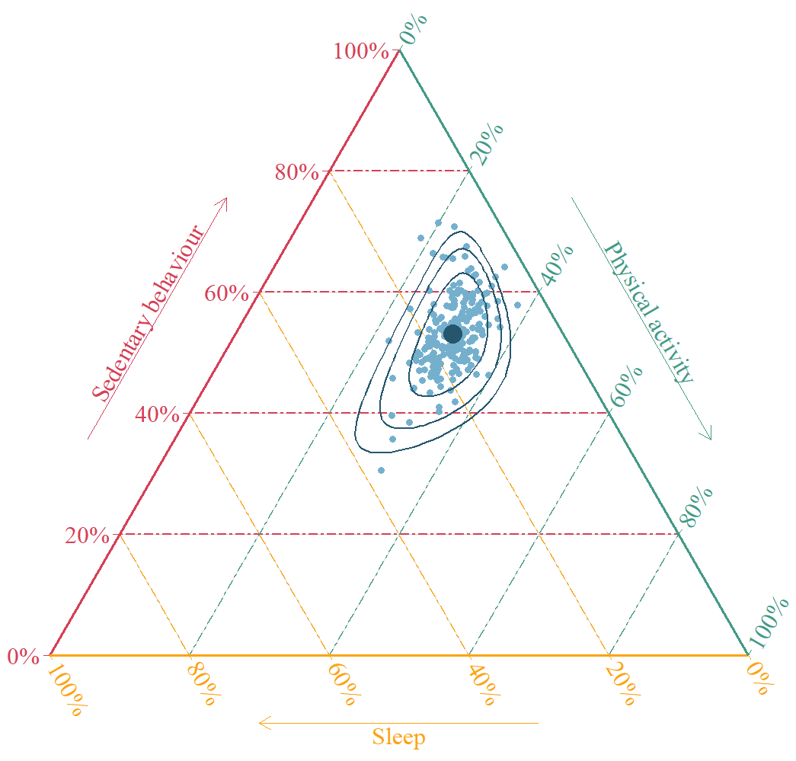 B.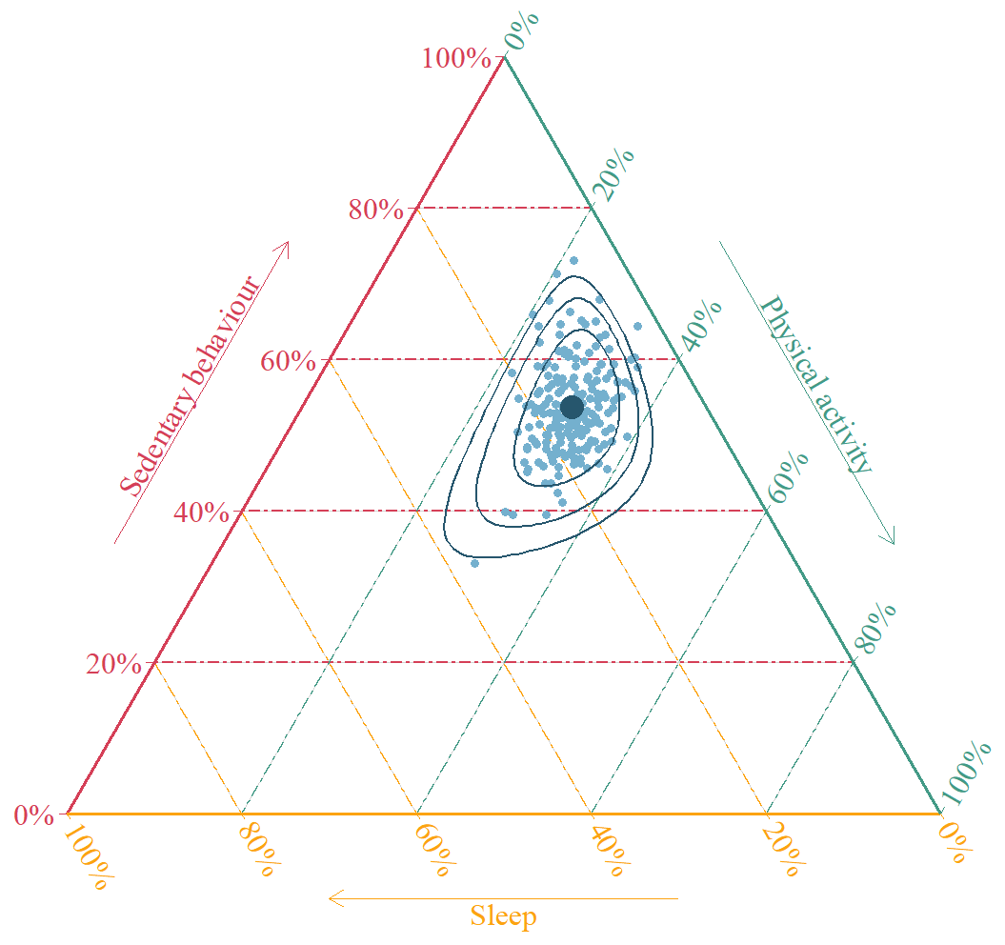 C.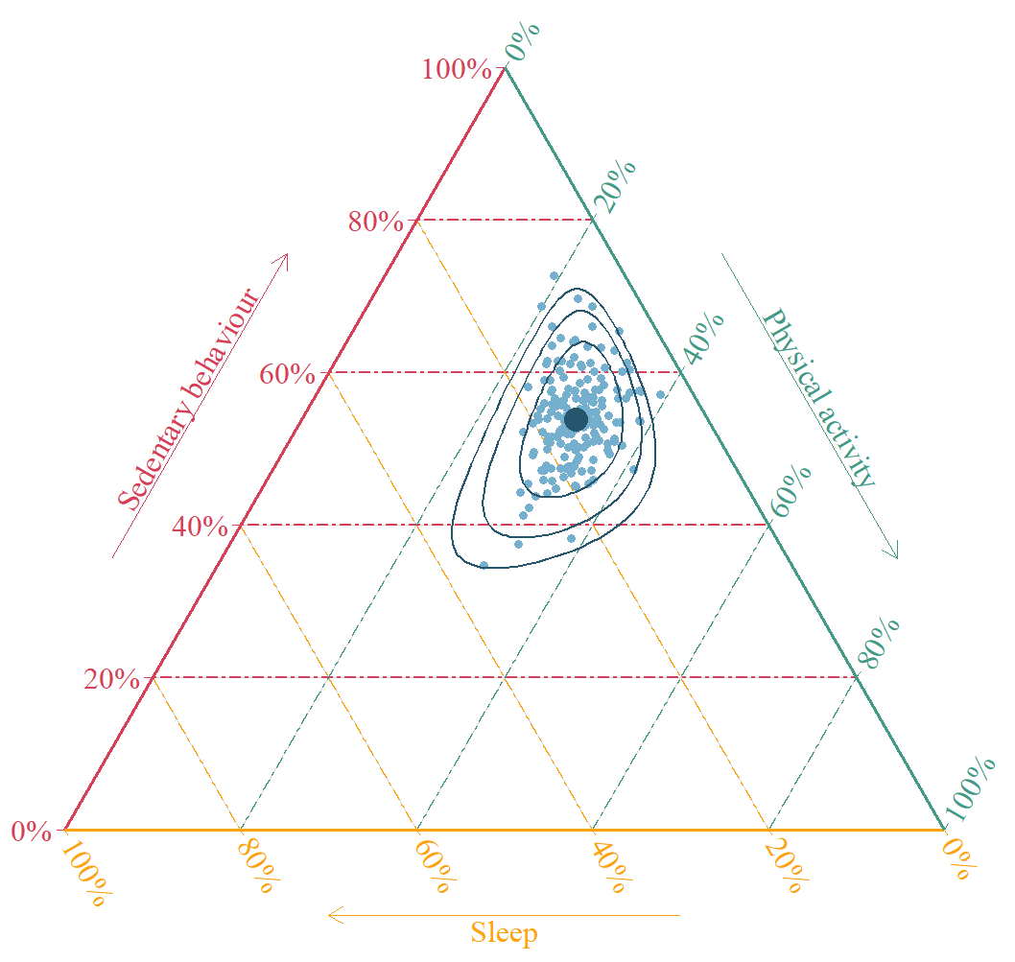 Ternary plots depicting the proportional allocation of time to physical activity, sedentary behaviour and sleep, with each vertex representing 100% time use in one behaviour. Panels A, B, and C correspond to baseline, follow-up 1, and follow-up 2, respectively. The position of each point within the triangle reflects the relative contribution of each behaviour, determined by drawing a line parallel to the base opposite the vertex of interest. The dark blue point indicates the compositional mean, while ellipses represent the 75%, 95%, and 99% confidence intervals. The compositional mean, which accounts for the interdependent nature of the behaviours, differs from the arithmetic median (representing the midpoint of each behaviour independently) presented in Table 1. For clarity, light and moderate-to-vigorous physical activity are combined as four compositions would require an extra dimension, which is not feasible in a 2D plot. The compositional means for all four behaviours are provided in Table 1.

Additional Table 2. Comparison of the models using the D1 multivariate Wald test.
Model Comparison | D1
Short-term Memory
Demographic Vs Crude | <0.001
Health Vs Demographic | 0.586
Full Vs Health | 0.884
Long-term Memory
Demographic Vs Crude | 0.008
Health Vs Demographic | 0.908
Full Vs Health | 0.988
Executive Function
Demographic Vs Crude | <0.001
Health Vs Demographic | 0.237
Full Vs Health | >0.999
Processing Speed
Demographic Vs Crude | 0.087
Health Vs Demographic | 0.626
Full Vs Health | 0.807
Four nested models were constructed for each cognitive outcome to examine the association between time-use behaviours and cognition. The first model (“Crude”) only included time-use variables, time and their interaction. The second model (“Demographic”) added sociodemographic covariates (age, sex, education and living situation). The third model (“Health”) further adjusted for health-related factors (BMI category, total prescribed medications and hearing issues), while the fourth model (“Full”) additionally included behavioural health indicators (alcohol consumption and smoking status). For long-term memory outcomes, the time interval between stimulus presentation and recall was included as an extra covariate in all models. Significance (bold) indicates whether the inclusion of additional covariates significantly improved model fit.

Additional Table 3A. Model estimates for Short-Term Memory.
Variable | Level | Estimate | 95% CI | p-value
Time use | ILR1: sleep:(SB+LPA+MVPA) | -0.33 | -0.88, 0.22 | 0.2
 | ILR2: SB:(LPA+MVPA) | 0.21 | -0.14, 0.56 | 0.2
 | ILR3: LPA:MVPA | -0.20 | -0.52, 0.11 | 0.2
Time | Follow-up 1 | 0.12 | -0.29, 0.54 | 0.6
 | Follow-up 2 | 0.13 | -0.26, 0.52 | 0.5
Age |  | -0.03 | -0.04, -0.02 | <0.001
Sex | Male | -0.16 | -0.32, 0.00 | 0.052
Education | Low | -0.40 | -0.65, -0.15 | 0.002
 | Middle | -0.30 | -0.49, -0.12 | 0.001
Living arrangement | Together | 0.05 | -0.19, 0.28 | 0.7
ILR1 x Time | ILR1 x Follow-up 1 | 0.18 | -0.41, 0.76 | 0.6
 | ILR1 x Follow-up 2 | 0.06 | -0.53, 0.65 | 0.8
ILR2 x Time | ILR2 x Follow-up 1 | -0.02 | -0.41, 0.36 | >0.9
 | ILR2 x Follow-up 2 | 0.02 | -0.37, 0.41 | >0.9
ILR3 x Time | ILR3 x Follow-up 1 | -0.06 | -0.41, 0.28 | 0.7
 | ILR3 x Follow-up 2 | -0.03 | -0.37, 0.31 | 0.9

Additional Table 3B. Model estimates for Long-Term Memory.
Variable | Level | Estimate | 95% CI | p-value
Time use | ILR1: sleep:(SB+LPA+MVPA) | -0.55 | -1.5, 0.42 | 0.3
 | ILR2: SB:(LPA+MVPA) | 0.19 | -0.45, 0.83 | 0.6
 | ILR3: LPA:MVPA | -0.21 | -0.77, 0.36 | 0.5
Time | Follow-up 1 | -0.33 | -1.1, 0.48 | 0.4
 | Follow-up 2 | -0.46 | -1.4, 0.44 | 0.3
Age |  | 0.00 | -0.02, 0.02 | 0.8
Sex | Male | -0.27 | -0.53, -0.02 | 0.033
Education | Low | -0.43 | -0.81, -0.04 | 0.03
 | Middle | -0.45 | -0.72, -0.18 | 0.001
Living arrangement | Together | -0.17 | -0.53, 0.20 | 0.4
Time interval (sec) |  | 0.00 | 0.00, 0.00 | 0.006
ILR1 x Time | ILR1 x Follow-up 1 | 0.37 | -0.76, 1.5 | 0.5
 | ILR1 x Follow-up 2 | 0.12 | -1.0, 1.3 | 0.8
ILR2 x Time | ILR2 x Follow-up 1 | 0.05 | -0.73, 0.83 | 0.9
 | ILR2 x Follow-up 2 | 0.19 | -0.64, 1.0 | 0.6
ILR3 x Time | ILR3 x Follow-up 1 | -0.06 | -0.73, 0.61 | 0.8
 | ILR3 x Follow-up 2 | -0.08 | -0.75, 0.59 | 0.8

Additional Table 3C. Model estimates for Executive Function.
Variable | Level | Estimate | 95% CI | p-value
Time use | ILR1: sleep:(SB+LPA+MVPA) | -0.41 | -0.87, 0.05 | 0.080
 | ILR2: SB:(LPA+MVPA) | 0.50 | 0.21, 0.78 | <0.001
 | ILR3: LPA:MVPA | -0.29 | -0.56, -0.03 | 0.030
Time | Follow-up 1 | 0.21 | -0.14, 0.57 | 0.2
 | Follow-up 2 | 0.34 | -0.01, 0.69 | 0.056
Age |  | -0.04 | -0.05, -0.03 | <0.001
Sex | Male | 0.17 | 0.03, 0.30 | 0.015
Education | Low | -0.34 | -0.55, -0.13 | 0.002
 | Middle | -0.25 | -0.41, -0.10 | 0.001
Living arrangement | Together | -0.02 | -0.24, 0.21 | 0.9
ILR1 x Time | ILR1 x Follow-up 1 | 0.09 | -0.39, 0.57 | 0.7
 | ILR1 x Follow-up 2 | 0.37 | -0.12, 0.86 | 0.14
ILR2 x Time | ILR2 x Follow-up 1 | -0.04 | -0.37, 0.28 | 0.8
 | ILR2 x Follow-up 2 | -0.27 | -0.60, 0.06 | 0.11
ILR3 x Time | ILR3 x Follow-up 1 | -0.15 | -0.43, 0.14 | 0.3
 | ILR3 x Follow-up 2 | 0.03 | -0.25, 0.31 | 0.8

Additional Table 3D. Model estimates for Processing Speed.
Variable | Level | Estimate | 95% CI | p-value
Time use | ILR1: sleep:(SB+LPA+MVPA) | 0.17 | -0.84, 1.2 | 0.7
 | ILR2: SB:(LPA+MVPA) | -0.05 | -0.68, 0.59 | 0.9
 | ILR3: LPA:MVPA | -0.41 | -0.94, 0.11 | 0.13
Time | Follow-up 1 | 0.10 | -0.73, 0.93 | 0.8
 | Follow-up 2 | -0.77 | -1.7, 0.14 | 0.095
ILR1 x Time | ILR1 x Follow-up 1 | -0.10 | -1.2, 1.0 | 0.9
 | ILR1 x Follow-up 2 | -0.75 | -1.9, 0.40 | 0.2
ILR2 x Time | ILR2 x Follow-up 1 | -0.08 | -0.86, 0.69 | 0.8
 | ILR2 x Follow-up 2 | 0.81 | -0.01, 1.6 | 0.053
ILR3 x Time | ILR3 x Follow-up 1 | 0.37 | -0.30, 1.0 | 0.3
 | ILR3 x Follow-up 2 | -0.20 | -0.88, 0.49 | 0.6

Notes: ilr = isometric-log ratio, SB = sedentary behaviour, LPA = light physical activity, MVPA = moderate-to-vigorous physical activity, 95% CI = 95% Confidence Interval

Additional Fig. 2A: Hypothetical time reallocations for executive function at baseline
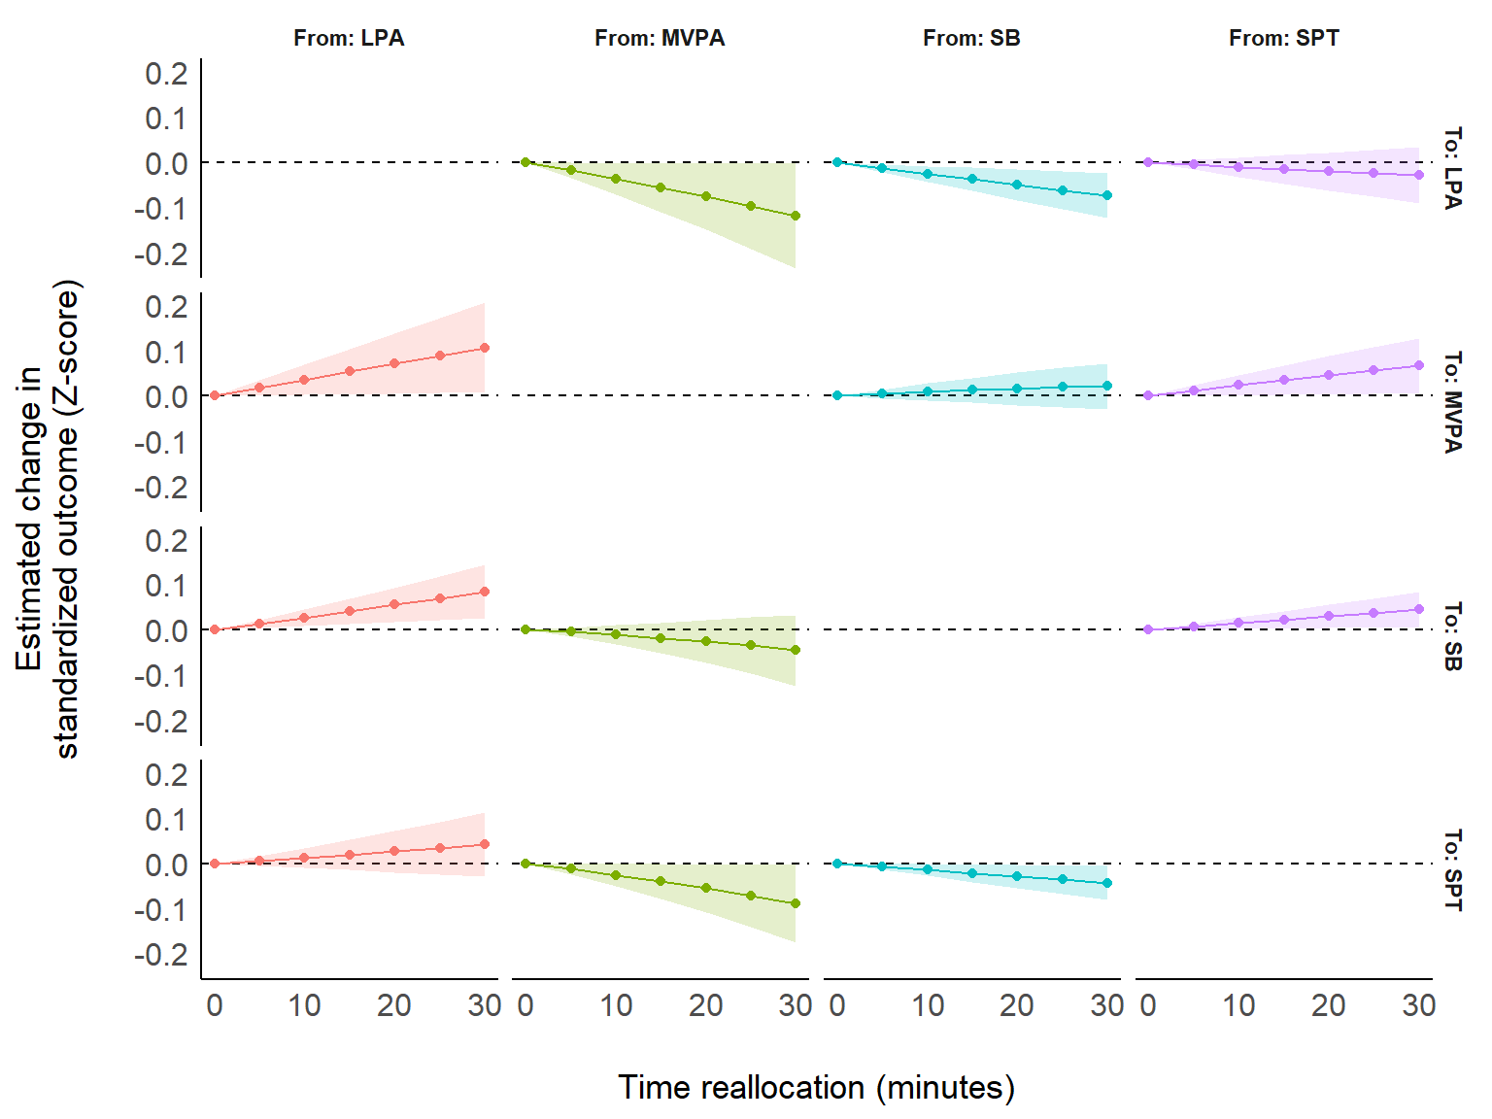

Additional Fig. 2B: Hypothetical time reallocations for executive function at follow-up 1
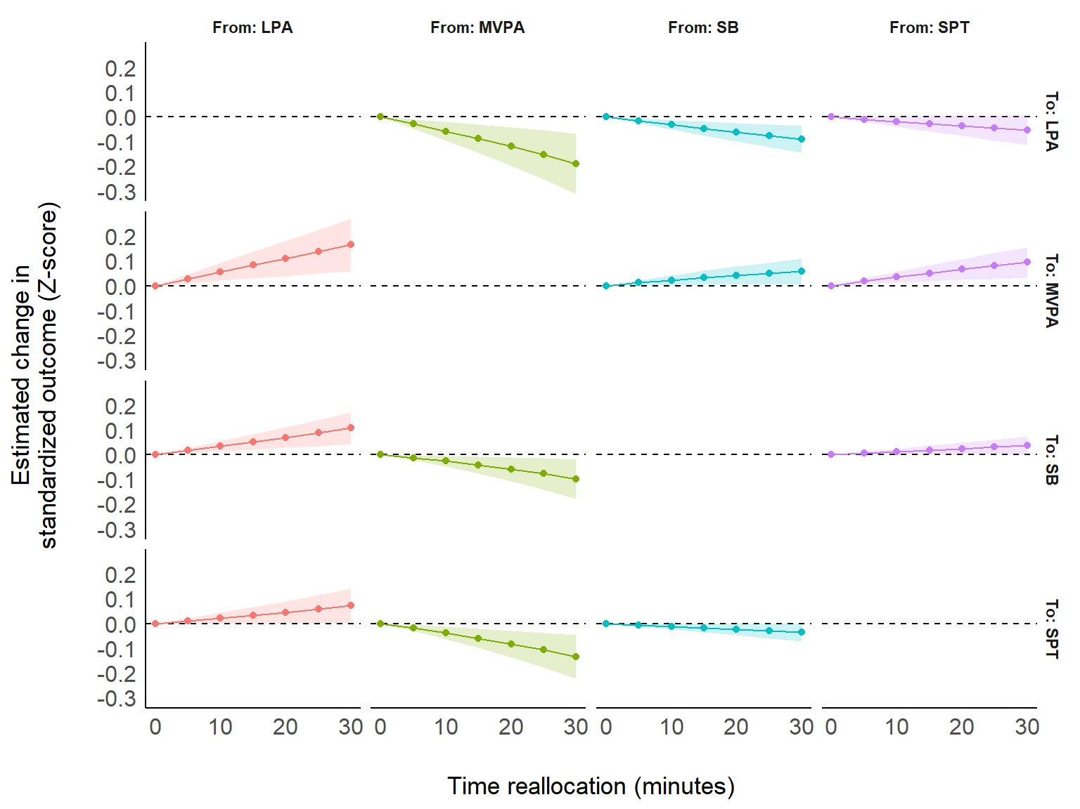
Additional Fig. 2C: Hypothetical time reallocations for executive function at follow-up 2 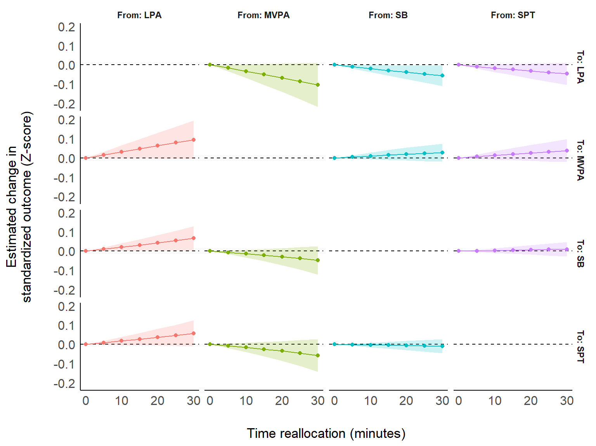
Notes: Panels A-C display the estimated change in executive function z-scores on the y-axis, with the x-axis representing time reallocations (−30 to +30 min/day) for each wave (baseline, first and second follow-up). Time is reallocated in 5-minute increments between one pair of behaviours while all others remain constant. Behaviour-Δ indicates time removed from that behaviour and reallocated to the behaviour+Δ, with Δ representing the amount of reallocated time. SB: sedentary behaviour, LPA: light physical activity, MVPA: moderate-to-vigorous physical activity; SPT: sleep period time (sleep). Models were based on the reference profile (see Table 3 in manuscript) and adjusted for age, sex, education level and living situation (Model 2).

Additional Table 4. Hypothetical time reallocations and their estimated difference in executive function z-scores

Time reallocation (min.) |  |  | Estimate (95% CI)
From | To | Amount | Baseline | Follow-Up 1 | Follow-Up 2
LPA | MVPA | 5 | 0.02 (0.00, 0.04) | 0.03 (0.01, 0.05) | 0.02 (0.00, 0.03)
LPA | MVPA | 10 | 0.04 (0.00, 0.07) | 0.06 (0.02, 0.09) | 0.03 (0.00, 0.07)
LPA | MVPA | 15 | 0.05 (0.00, 0.10) | 0.08 (0.03, 0.14) | 0.05 (0.00, 0.10)
LPA | MVPA | 20 | 0.07 (0.00, 0.14) | 0.11 (0.04, 0.18) | 0.06 (0.00, 0.13)
LPA | MVPA | 25 | 0.09 (0.01, 0.17) | 0.14 (0.05, 0.23) | 0.08 (0.00, 0.16)
LPA | MVPA | 30 | 0.11 (0.01, 0.21) | 0.17 (0.06, 0.27) | 0.10 (0.00, 0.19)
LPA | SB | 5 | 0.01 (0.00, 0.02) | 0.02 (0.01, 0.03) | 0.01 (0.00, 0.02)
LPA | SB | 10 | 0.03 (0.01, 0.05) | 0.03 (0.01, 0.05) | 0.02 (0.00, 0.04)
LPA | SB | 15 | 0.04 (0.01, 0.07) | 0.05 (0.02, 0.08) | 0.03 (0.00, 0.06)
LPA | SB | 20 | 0.05 (0.02, 0.09) | 0.07 (0.03, 0.11) | 0.04 (0.00, 0.08)
LPA | SB | 25 | 0.07 (0.02, 0.12) | 0.09 (0.04, 0.14) | 0.05 (0.00, 0.11)
LPA | SB | 30 | 0.08 (0.03, 0.14) | 0.11 (0.04, 0.17) | 0.07 (0.00, 0.13)
LPA | Sleep | 5 | 0.01 (−0.01, 0.02) | 0.01 (0.00, 0.02) | 0.01 (0.00, 0.02)
LPA | Sleep | 10 | 0.01 (−0.01, 0.03) | 0.02 (0.00, 0.04) | 0.02 (0.00, 0.04)
LPA | Sleep | 15 | 0.02 (−0.01, 0.05) | 0.03 (0.00, 0.07) | 0.03 (0.00, 0.06)
LPA | Sleep | 20 | 0.03 (−0.02, 0.07) | 0.05 (0.00, 0.09) | 0.04 (−0.01, 0.08)
LPA | Sleep | 25 | 0.03 (−0.02, 0.09) | 0.06 (0.00, 0.11) | 0.05 (−0.01, 0.10)
LPA | Sleep | 30 | 0.04 (−0.03, 0.11) | 0.07 (0.00, 0.14) | 0.06 (−0.01, 0.12)
MVPA | LPA | 5 | −0.02 (−0.04, 0.00) | −0.03 (−0.05, −0.01) | −0.02 (−0.03, 0.00)
MVPA | LPA | 10 | −0.04 (−0.07, 0.00) | −0.06 (−0.10, −0.02) | −0.03 (−0.07, 0.00)
MVPA | LPA | 15 | −0.06 (−0.11, 0.00) | −0.09 (−0.15, −0.03) | −0.05 (−0.10, 0.00)
MVPA | LPA | 20 | −0.08 (−0.15, 0.00) | −0.12 (−0.20, −0.04) | −0.07 (−0.14, 0.01)
MVPA | LPA | 25 | −0.10 (−0.19, 0.00) | −0.15 (−0.25, −0.05) | −0.08 (−0.18, 0.01)
MVPA | LPA | 30 | −0.12 (−0.24, 0.00) | −0.19 (−0.31, −0.07) | −0.10 (−0.22, 0.01)
MVPA | SB | 5 | −0.01 (−0.02, 0.01) | −0.01 (−0.02, 0.00) | −0.01 (−0.02, 0.00)
MVPA | SB | 10 | −0.01 (−0.03, 0.01) | −0.03 (−0.05, 0.00) | −0.01 (−0.03, 0.01)
MVPA | SB | 15 | −0.02 (−0.05, 0.02) | −0.04 (−0.08, −0.01) | −0.02 (−0.05, 0.01)
MVPA | SB | 20 | −0.03 (−0.07, 0.02) | −0.06 (−0.11, −0.01) | −0.03 (−0.07, 0.02)
MVPA | SB | 25 | −0.04 (−0.10, 0.03) | −0.08 (−0.14, −0.01) | −0.04 (−0.10, 0.02)
MVPA | SB | 30 | −0.05 (−0.12, 0.03) | −0.10 (−0.18, −0.02) | −0.05 (−0.12, 0.03)
MVPA | Sleep | 5 | −0.01 (−0.02, 0.00) | −0.02 (−0.03, −0.01) | −0.01 (−0.02, 0.00)
MVPA | Sleep | 10 | −0.03 (−0.05, 0.00) | −0.04 (−0.06, −0.01) | −0.02 (−0.04, 0.01)
MVPA | Sleep | 15 | −0.04 (−0.08, 0.00) | −0.06 (−0.10, −0.02) | −0.03 (−0.06, 0.01)
MVPA | Sleep | 20 | −0.06 (−0.11, 0.00) | −0.08 (−0.14, −0.03) | −0.03 (−0.09, 0.02)
MVPA | Sleep | 25 | −0.07 (−0.14, 0.00) | −0.11 (−0.18, −0.04) | −0.05 (−0.11, 0.02)
MVPA | Sleep | 30 | −0.09 (−0.18, 0.00) | −0.13 (−0.22, −0.05) | −0.06 (−0.14, 0.03)
SB | LPA | 5 | −0.01 (−0.02, 0.00) | −0.02 (−0.03, −0.01) | −0.01 (−0.02, 0.00)
SB | LPA | 10 | −0.03 (−0.04, −0.01) | −0.03 (−0.05, −0.01) | −0.02 (−0.04, 0.00)
SB | LPA | 15 | −0.04 (−0.06, −0.01) | −0.05 (−0.08, −0.02) | −0.03 (−0.06, 0.00)
SB | LPA | 20 | −0.05 (−0.08, −0.02) | −0.06 (−0.10, −0.03) | −0.04 (−0.07, 0.00)
SB | LPA | 25 | −0.06 (−0.10, −0.02) | −0.08 (−0.12, −0.03) | −0.05 (−0.09, 0.00)
SB | LPA | 30 | −0.07 (−0.12, −0.02) | −0.09 (−0.15, −0.04) | −0.06 (−0.11, 0.00)
SB | MVPA | 5 | 0.00 (−0.01, 0.01) | 0.01 (0.00, 0.02) | 0.01 (0.00, 0.01)
SB | MVPA | 10 | 0.01 (−0.01, 0.03) | 0.02 (0.00, 0.04) | 0.01 (−0.01, 0.03)
SB | MVPA | 15 | 0.01 (−0.01, 0.04) | 0.03 (0.00, 0.06) | 0.02 (−0.01, 0.04)
SB | MVPA | 20 | 0.02 (−0.02, 0.05) | 0.04 (0.00, 0.08) | 0.02 (−0.01, 0.05)
SB | MVPA | 25 | 0.02 (−0.02, 0.06) | 0.05 (0.00, 0.09) | 0.02 (−0.02, 0.06)
SB | MVPA | 30 | 0.02 (−0.03, 0.07) | 0.06 (0.01, 0.11) | 0.03 (−0.02, 0.08)
SB | Sleep | 5 | −0.01 (−0.01, 0.00) | −0.01 (−0.01, 0.00) | 0.00 (−0.01, 0.00)
SB | Sleep | 10 | −0.01 (−0.03, 0.00) | −0.01 (−0.02, 0.00) | 0.00 (−0.02, 0.01)
SB | Sleep | 15 | −0.02 (−0.04, 0.00) | −0.02 (−0.04, 0.00) | 0.00 (−0.02, 0.01)
SB | Sleep | 20 | −0.03 (−0.05, 0.00) | −0.02 (−0.05, 0.00) | −0.01 (−0.03, 0.02)
SB | Sleep | 25 | −0.04 (−0.07, 0.00) | −0.03 (−0.06, 0.00) | −0.01 (−0.04, 0.02)
SB | Sleep | 30 | −0.04 (−0.08, −0.01) | −0.04 (−0.07, 0.00) | −0.01 (−0.05, 0.03)
Sleep | LPA | 5 | −0.01 (−0.02, 0.01) | −0.01 (−0.02, 0.00) | −0.01 (−0.02, 0.00)
Sleep | LPA | 10 | −0.01 (−0.03, 0.01) | −0.02 (−0.04, 0.00) | −0.02 (−0.04, 0.00)
Sleep | LPA | 15 | −0.02 (−0.05, 0.02) | −0.03 (−0.06, 0.00) | −0.02 (−0.05, 0.01)
Sleep | LPA | 20 | −0.02 (−0.06, 0.02) | −0.04 (−0.08, 0.00) | −0.03 (−0.07, 0.01)
Sleep | LPA | 25 | −0.02 (−0.08, 0.03) | −0.05 (−0.10, 0.00) | −0.04 (−0.09, 0.01)
Sleep | LPA | 30 | −0.03 (−0.09, 0.03) | −0.05 (−0.11, 0.01) | −0.05 (−0.10, 0.01)
Sleep | MVPA | 5 | 0.01 (0.00, 0.02) | 0.02 (0.01, 0.03) | 0.01 (0.00, 0.02)
Sleep | MVPA | 10 | 0.02 (0.00, 0.05) | 0.03 (0.01, 0.06) | 0.01 (−0.01, 0.04)
Sleep | MVPA | 15 | 0.04 (0.00, 0.07) | 0.05 (0.02, 0.08) | 0.02 (−0.01, 0.05)
Sleep | MVPA | 20 | 0.05 (0.00, 0.09) | 0.07 (0.02, 0.11) | 0.03 (−0.01, 0.07)
Sleep | MVPA | 25 | 0.06 (0.01, 0.11) | 0.08 (0.03, 0.13) | 0.03 (−0.02, 0.08)
Sleep | MVPA | 30 | 0.07 (0.01, 0.13) | 0.09 (0.03, 0.16) | 0.04 (−0.02, 0.10)
Sleep | SB | 5 | 0.01 (0.00, 0.01) | 0.01 (0.00, 0.01) | 0.00 (0.00, 0.01)
Sleep | SB | 10 | 0.01 (0.00, 0.03) | 0.01 (0.00, 0.02) | 0.00 (−0.01, 0.02)
Sleep | SB | 15 | 0.02 (0.00, 0.04) | 0.02 (0.00, 0.04) | 0.00 (−0.01, 0.02)
Sleep | SB | 20 | 0.03 (0.00, 0.06) | 0.02 (0.00, 0.05) | 0.01 (−0.02, 0.03)
Sleep | SB | 25 | 0.04 (0.00, 0.07) | 0.03 (0.00, 0.06) | 0.01 (−0.02, 0.04)
Sleep | SB | 30 | 0.04 (0.01, 0.08) | 0.04 (0.00, 0.07) | 0.01 (−0.03, 0.05)
Notes: All bold estimated are significant. Values show the estimated difference in outcome compared to the reference profile (see Table 3 in manuscript). min = minutes, LPA = Light Physical Activity, SB = Sedentary Behaviour, MVPA = Moderate-to-Vigorous Physical Activity, CI = Confidence Interval.

STROBE Statement—Checklist of items that should be included in reports of cohort studies

 |  | Item No | Recommendation | Page No
Title and abstract |  | 1 | (a) Indicate the study’s design with a commonly used term in the title or the abstract | (a) 2  (b) 2
 |  | 1 | (b) Provide in the abstract an informative and balanced summary of what was done and what was found
Introduction
Background/rationale |  | 2 | Explain the scientific background and rationale for the investigation being reported | 3-4
Objectives |  | 3 | State specific objectives, including any prespecified hypotheses | 4-5
Methods
Study design |  | 4 | Present key elements of study design early in the paper | 5
Setting |  | 5 | Describe the setting, locations, and relevant dates, including periods of recruitment, exposure, follow-up, and data collection | 5
Participants |  | 6 | (a) Give the eligibility criteria, and the sources and methods of selection of participants. Describe methods of follow-up | 5-6
 |  | 6 | (b) For matched studies, give matching criteria and number of exposed and unexposed
Variables |  | 7 | Clearly define all outcomes, exposures, predictors, potential confounders, and effect modifiers. Give diagnostic criteria, if applicable | 6-9
Data sources/ measurement |  | 8* | For each variable of interest, give sources of data and details of methods of assessment (measurement). Describe comparability of assessment methods if there is more than one group | 6-9
Bias |  | 9 | Describe any efforts to address potential sources of bias | 9
Study size |  | 10 | Explain how the study size was arrived at | 11
Quantitative variables |  | 11 | Explain how quantitative variables were handled in the analyses. If applicable, describe which groupings were chosen and why | 9-10
Statistical methods |  | 12 | (a) Describe all statistical methods, including those used to control for confounding | 6-10
 |  | 12 | (b) Describe any methods used to examine subgroups and interactions
 |  | 12 | (c) Explain how missing data were addressed
 |  | 12 | (d) If applicable, explain how loss to follow-up was addressed
 |  | 12 | (e) Describe any sensitivity analyses
Results
Participants |  | 13* | (a) Report numbers of individuals at each stage of study—eg numbers potentially eligible, examined for eligibility, confirmed eligible, included in the study, completing follow-up, and analysed | 11
 |  | 13* | (b) Give reasons for non-participation at each stage
 |  | 13* | (c) Consider use of a flow diagram
Descriptive data |  | 14* | (a) Give characteristics of study participants (eg demographic, clinical, social) and information on exposures and potential confounders | 21-22
 |  | 14* | (b) Indicate number of participants with missing data for each variable of interest
 |  | 14* | (c) Summarise follow-up time (eg, average and total amount)
Outcome data |  | 15* | Report numbers of outcome events or summary measures over time | 21-22
Main results | 16 | (a) Give unadjusted estimates and, if applicable, confounder-adjusted estimates and their precision (eg, 95% confidence interval). Make clear which confounders were adjusted for and why they were included |  | 12-15
Main results | 16 | (b) Report category boundaries when continuous variables were categorized
Main results | 16 | (c) If relevant, consider translating estimates of relative risk into absolute risk for a meaningful time period
Other analyses | 17 | Report other analyses done—eg analyses of subgroups and interactions, and sensitivity analyses |  | 12-15
Discussion
Key results | 18 | Summarise key results with reference to study objectives |  | 15
Limitations | 19 | Discuss limitations of the study, taking into account sources of potential bias or imprecision. Discuss both direction and magnitude of any potential bias |  | 18
Interpretation | 20 | Give a cautious overall interpretation of results considering objectives, limitations, multiplicity of analyses, results from similar studies, and other relevant evidence |  | 15-19
Generalisability | 21 | Discuss the generalisability (external validity) of the study results |  | 18-19
Other information
Funding | 22 | Give the source of funding and the role of the funders for the present study and, if applicable, for the original study on which the present article is based |  | 20

*Give information separately for exposed and unexposed groups.

Note: An Explanation and Elaboration article discusses each checklist item and gives methodological background and published examples of transparent reporting. The STROBE checklist is best used in conjunction with this article (freely available on the Web sites of PLoS Medicine at http://www.plosmedicine.org/, Annals of Internal Medicine at http://www.annals.org/, and Epidemiology at http://www.epidem.com/). Information on the STROBE Initiative is available at http://www.strobe-statement.org.

