Supplementary Information for
Polycrystalline Perovskite Wafers as an Efficient Multisensory Integration Platform for Neuromorphic Computing

Shu Zhou,^{1,#,}* Lue Zhou,^{1,#} Shuyao Han,^{1,#} Hengyu Zhang,² Guixiang Liu,¹ Yuncheng Mu,¹ Zhenyi Ni,^{2,3} Yanglong Hou,^{1,4,5,}* and Gang Liu^{1,}*

¹ School of Materials, Shenzhen Campus of Sun Yat-sen University, Shenzhen, Guangdong 518107, China
² State Key Laboratory of Silicon Materials & School of Materials Science and Engineering, Zhejiang University, Hangzhou, Zhejiang 310027, China
³ Shangyu Institute of Semiconductor Materials, Shaoxing, Zhejiang 312300, China
⁴ State Key Laboratory of Optoelectronic Materials and Technologies, Sun Yat-sen University, Guangzhou, 510275, China
⁵ School of Materials Science and Engineering, Beijing Key Laboratory for Magnetoelectric Materials and Devices, Peking University, Beijing, China
# These authors contribute equally to this work
E-mail: *zhoush67@mail.sysu.edu.cn, hou@mail.sysu.edu.cn, liugang82@mail.sysu.edu.cn

Table S1. Summary of performance of state-of-the-art perovskite-based synaptic memristors.
Device structure | Array | STP/LTP | Performance index |  |  |  | Learning functionality |  | Programming |  |  | Multisensory integration |  | Ref.
Device structure | Array | STP/LTP | Uniformity (DtD) | Endurance (CtC) | Energy | Linearity | First order  Hebbian rule | Second order  BCM rule | Electrical | Optical | Dual-mode | Visual | Auditory | Ref.
ITO/BCCP/MAPbBr₃ PC/Al | – | Y | – | – | 20 fJ | – | AH | – | Y | – | – | – | – | 1
ITO/PEDOT:PSS/MAPbI₃ PC/Au | – | Y | – | 500 | ~50 fJ/μm² | – | AH/SH/AAH/SAH | – | Y | – | – | – | – | 2
Au/(PEA)₂PbBr₄/graphene | – | – | – | – | 400 fJ | – | – | – | Y | – | – | – | – | 3
ITO/PEDOT:PSS/FAPbBr₃ PC/Bphen/Ca/Al | – | Y | – | – | 23 fJ/μm² | – | AH/SH/AAH/SAH | – | Y | – | – | – | – | 4
Ag/PMMA/MA₃Sb₂Br₉/ITO | – | Y | – | – | 117.9 fJ/μm² | – | – | – | Y | – | – | – | – | 5
ITO/BCCP/(PEA)₂PbBr₄/Al | – | – | – | – | 0.7 fJ/μm² | – | AH | – | Y | – | – | – | – | 6
Au/Cs₂AgBiBr₆ PC/ITO | – | – | – | – | – | – | – | – | Y | – | – | – | – | 7
Au/MAPbBr₃ SC/Au | – | – | – | 305 | – | – | – | – | Y | Y | – | – | – | 8
Au/MAPbBr₃ SCTPs/Au | – | – | – | 186 | – | – | AH | – | Y | – | – | – | – | 9
ITO/MoO₃/CsPbI2Br PC/MoO₃/Ag | – | – | – | 15 | – | – | – | – | Y | – | – | – | – | 10
Au/PMMA/Cs₂AgBiBr₆/ITO | – | Y | – | 7 | – | – | AH/ASH | – | Y | – | – | – | – | 11
Al/POT₂T/MAPbBr₃/NiOx/ITO | – | Y | – | – | – | – | AAH | – | Y | – | – | – | – | 12
ITO/PEDOT:PSS/CsPbBr₃ NCs/Au | – | – | – | – | ~4.45 nJ | – | AH/SH | – | Y | – | – | – | – | 13
FTO/CsFAPbI₃/Ag | – | – | – | – | – | – | AH | – | Y | – | – | – | – | 14
Au/IDTBT/CsPbBr₃-TiO₂ NCs/Au | – | – | – | – | – | – | – | – | Y | – | – | – | – | 15
Au/MAPbBr₃ SC/Au | – | Y | – | 2000 | 26.9 fJ | – | AH | – | Y | – | – | – | – | 16
Si/SiO₂/CsPbBr₃ QDs/PMMA/pentacene/Au | – | Y | – | – | – | – | – | – | – | Y | – | – | – | 17
ITO/SnO₂ +PCBA/MAPI/P3HT/MoO₃/Ag | – | Y | – | – | – | – | AAH | Y | Y | – | – | Y | – | 18
ITO/PEDOT:PSS/perovskite/C60/BCP/Au (PEDOT:PSS)/perovskite/C60/bathocuproine (BCP)/Au | Y | – | Y | – | – | Y | – | – | Y | Y | Y | Y | – | 19
Au/PMMA/2D perovskites/Au | Y | Y | – | 50 | – | Y | AH | – | Y | – | – | – | – | 20
Au/MAPbBr₃ PPW/Au | Y | Y | Y | 2000 | 26.7 fJ | Y | AH/SH/AAH/SAH | Y | Y | Y | Y | Y | Y | This work
All the data are measured at room temperature.

Table S2. Comparison of properties between PPW and solution-grown single crystal.
 | Density  (g cm^{–3}) | Optical bandgap  (eV) | Diffusivity  (-) | Trap desnity  (cm⁻³)
MAPbBr₃ PPW | 3.70 | 2.18 | 0.50 | 3.27×10¹¹
MAPbBr₃ Single crystal | 3.83 | 2.21 | 0.56 | 1.10×10¹¹

Figure S1. SEM images of MAPbBr₃ wafer directly synthesized from recycled MAPbBr₃ powder. (a-b) w/o solvent, 90 ºC. (c-d) DMSO, 90 ºC. (e-f) DMSO:DMF=1:4, 90 ºC. (g-h) DMF, 90 ºC. (i-j) DMF, 200 ºC.

Figure S2. Cross-sectional SEM images of MAPbBr₃ wafer. (a-c) Transverse section view, (d-f) Longitudinal section view. The red arrow in e indicates vertical stripes which is also the direction of applied presure in the sintering process.

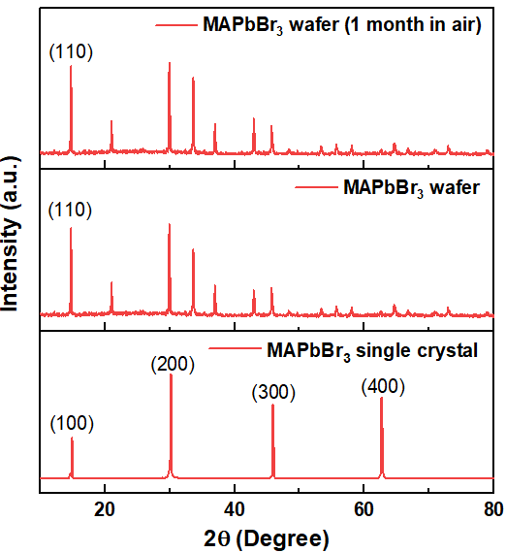
Figure S3. XRD patterns of MAPbBr₃ single crystal, MAPbBr₃ wafer and the same wafer after exposure to air for 1 month.
Figure S3 shows XRD pattern of the MAPbBr₃ wafer after exposure to air for one month (relative humidity RH= 40%). The diffraction pattern matches well with the initial XRD pattern and maintains strong crystallinity. No new diffraction peaks can be observed, indicating that the perovskite wafers are rather stable in ambient air.

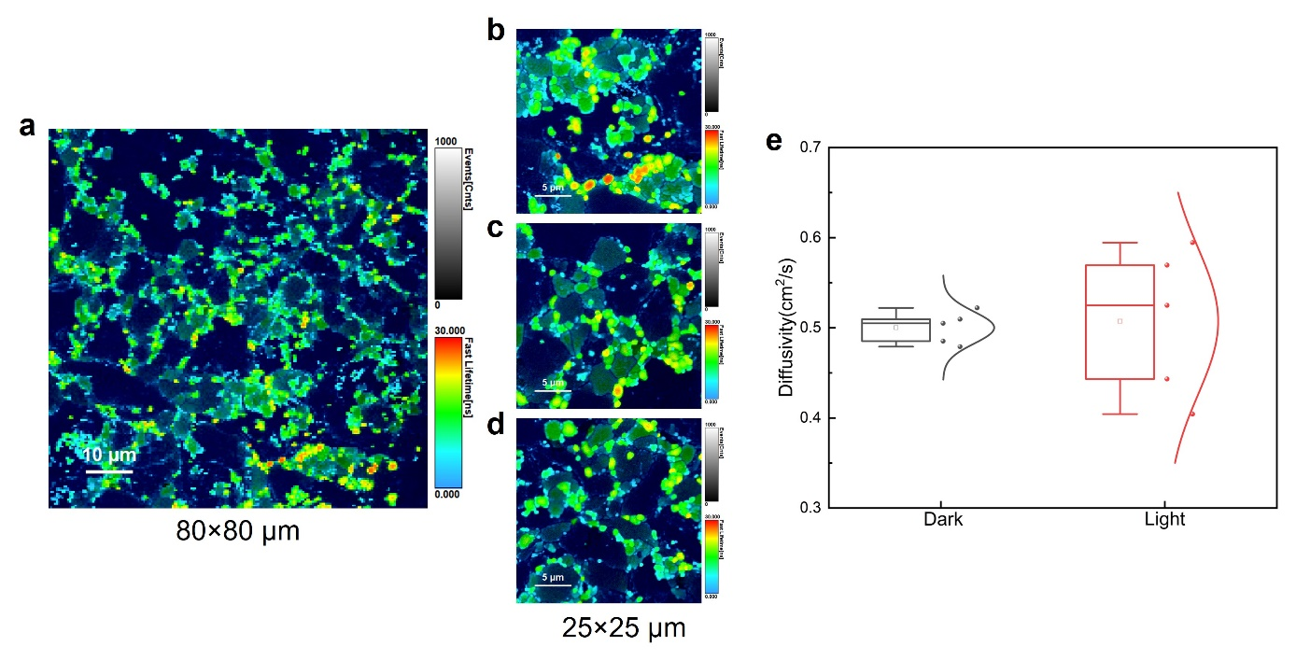
Figure S4. Images for PL mapping of perovskite wafer surface and the diffusivity measured for dark and bright regions. A 2D Gaussian model that describes carrier distribution is used to fit the carriers profile and extract the Full Width at Half Maximum (FWHM) of the fitting curve (σ(t)). The square of σ_{t} evoluton has a linear relationship with time (t) and can be used to estimate the diffusivity (D) of carriers through the equation: ${σ(t)}^{2}=2D(t_{0}+t)$.

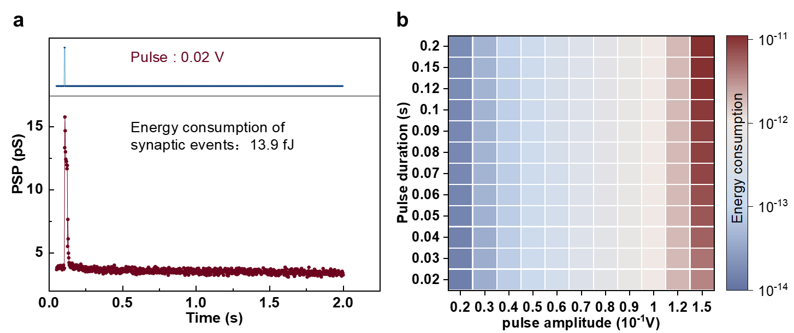
Figure S5. (a) On-state energy consumption of a single synaptic event. (b) Energy consumption per spike as a function of pulse duration and pulse amplitude.

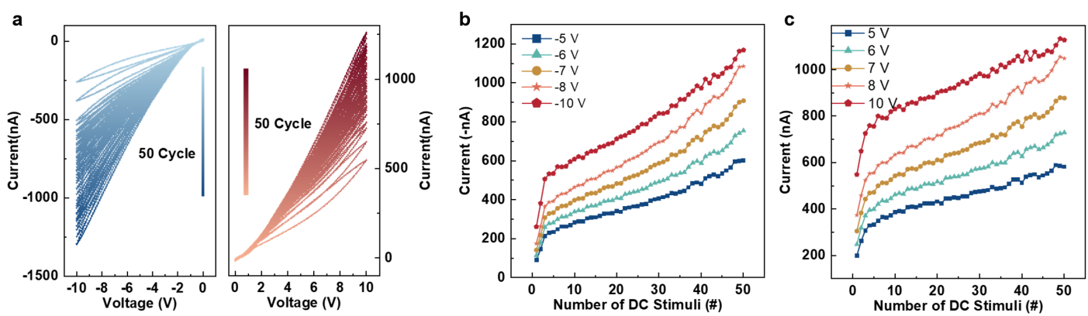
Figure S6. (a) I-V characteristics of the memristor measured under consective positive and negative sweeps. (b-c) Gradual modulation of the memristor conductance via different number of DC stimuli at different positive and negative voltages.
Figure S6a shows typical cyclic current-voltage (I-V) characteristic of the synaptic device measured under continuous scanning of positive (0-10-0V) and negative (0-10-0V) voltages at a scanning rate of 5 V/s. Under positive and negative voltage bias, hysteresis loops are observed, due to the resistive characteristics of memristor devices. The conductance of the device increases monotonically under continuous positive and negative voltage scanning. Figure 6b-c shows the current values at different voltages (±5, ±6, ±7, ±8, ±10 V) extracted from the I-V curves, showing continuous and reliable conduction regulation, which is more conducive to the simulation of synaptic plasticity.

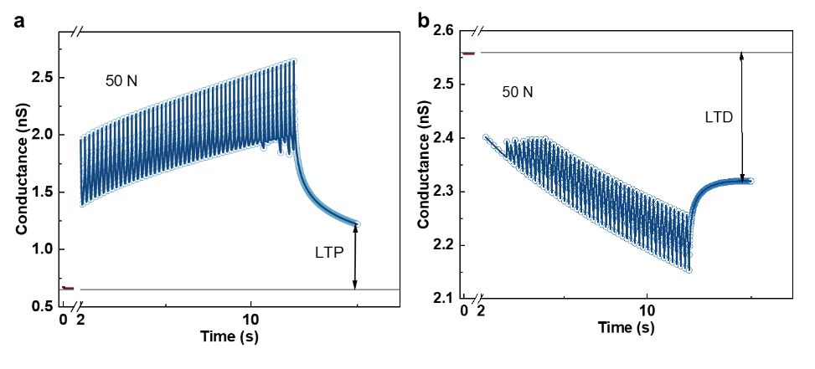
Figure S7. Synaptic weight updating in the (a) potentiation and (b) depressing process. The pulse number in a and b are both 50.
The linearity of weight control process of synaptic device is an important factor that affects parameter matching and overall accuracy in brain-like computation. As a signal recognition and processing system, synaptic array recognizes the conductance value and transfers data to artificial neural network. During the transfer process, the weight value corresponds to the conductance value of the memristor in proportion to each other. The lower the nonlinearity of the device conductance regulation, the higher the degree of matching with the ideal synaptic weight regulation amplitude range. In this way, in the iterative process of the artificial neural network, the smaller the difference between the existing output value and the ideal calibration value, the higher the overall recognition accuracy, and the more stable data processing function is realized.

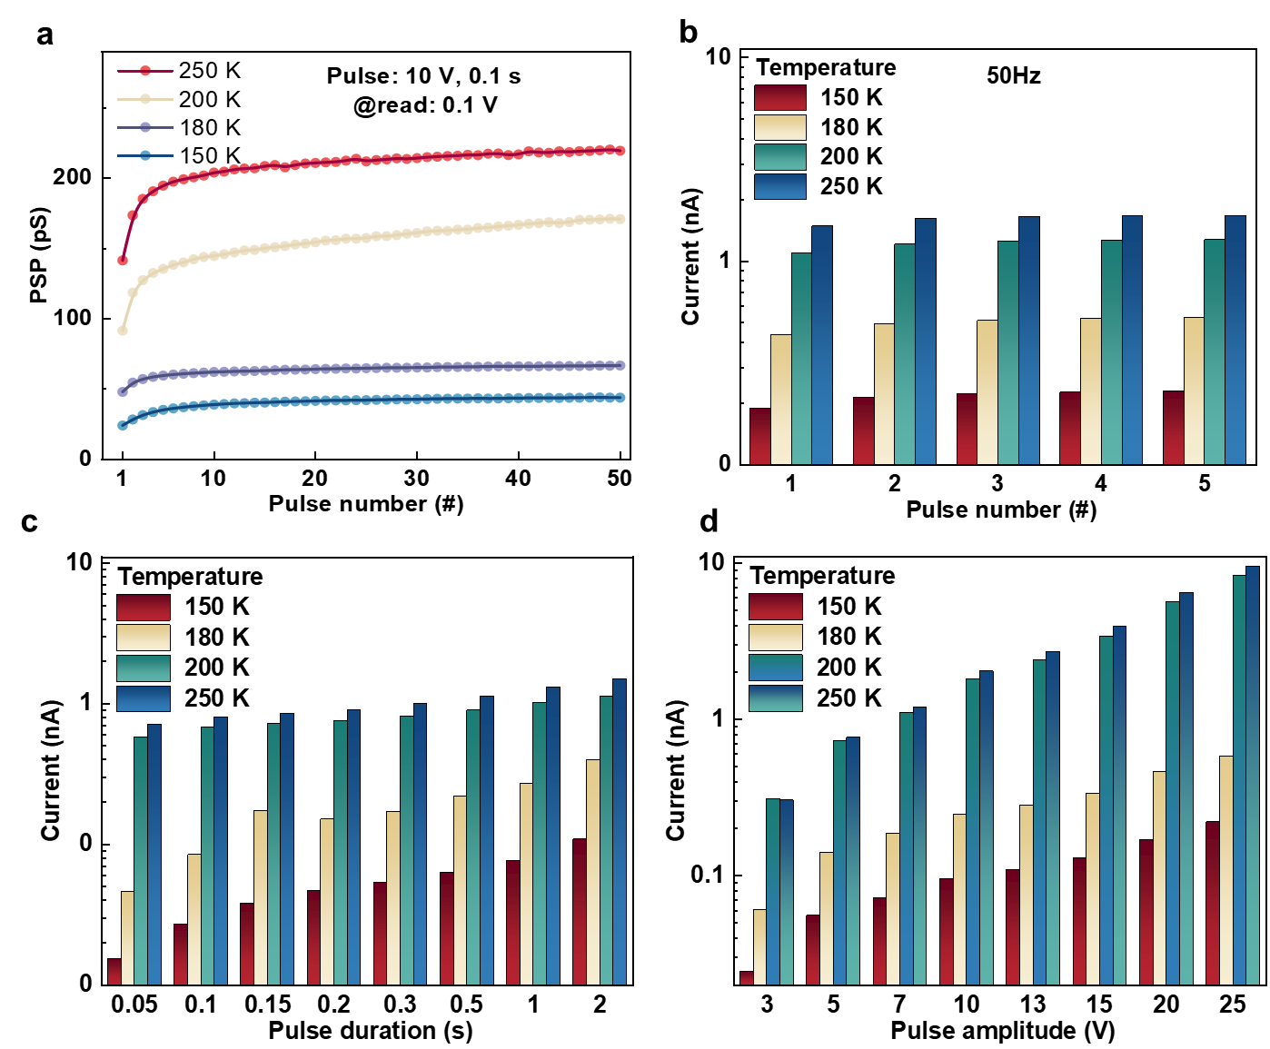
Figure S8. Synaptic plasticity of the device measured at low temperatures. (a) Dependence of the post-synaptic conductance on the pulse number. (b) Spike-number dependent plasticity (SNDP), (c) Spike-duration dependent plasticity (SDDP), and (d) Spike-voltage dependent plasticity (SVDP) measured at different temperatures.

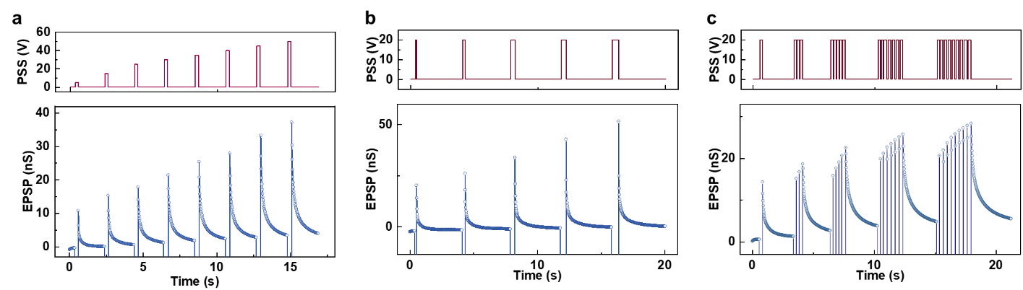
Figure S9. Post-synaptic weights in the artificial synapse as a function of the (a) amplitude, (b) duration and (c) number of the pre-synaptic electric spike. The read voltage is 0.1 V.

Figure S10. Training of the synapse. Increasing presynaptic pulse (a) number, (b) amplitude and (c) duration resulted in higher weight changes, higher retention and slower decay of the memory process.

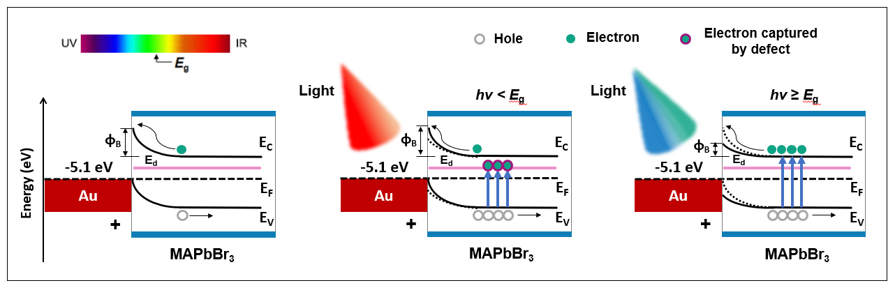
Figure S11. Proposed physical model for the light-wavelength-dependent plasticity in PPW-based synapse.
When exposed to green and blue light (hv ≥ E_{g}), electrons in the perovskite’s valence band are excited to the conduction band, creating holes in the valence band. This process lowers the Schottky barrier (Φ_{B}) at the Au-perovskite interface, altering carrier injection characteristics and increasing device conductivity, which enhances memory retention. In contrast, under red-light stimulation (hv < E_{g}), the photon energy is insufficient to excite electrons to the conduction band. Instead, electrons are more likely to be excited into trap states in the mid-gap, where they are captured by defects, as confirmed by sub-bandgap absorption. In this light, holes will also be created in the valence band, producing positive photoconductivity. Sub-bandgap response has also been identified in perovskite solar cells, giving rise to enhanced photocurrent. However, once defect levels are filled, further pulse excitation no longer increases the current. This explains the observed decrease in photoconductivity and the extinction of memory.

Figure S12. (a) Photocurrent response as a function of light intensity for a PPW synaptic device under red (640 nm), green (520 nm), and blue (470 nm) illumination. (b) Optical pulse response of the PPW synaptic device under a single red (640 nm), green (520 nm), and blue (470 nm) light pulse. (c) Photocurrent response of the PPW synaptic device under a continuous train of green light pulses, showing time-dependent memory decay behavior.

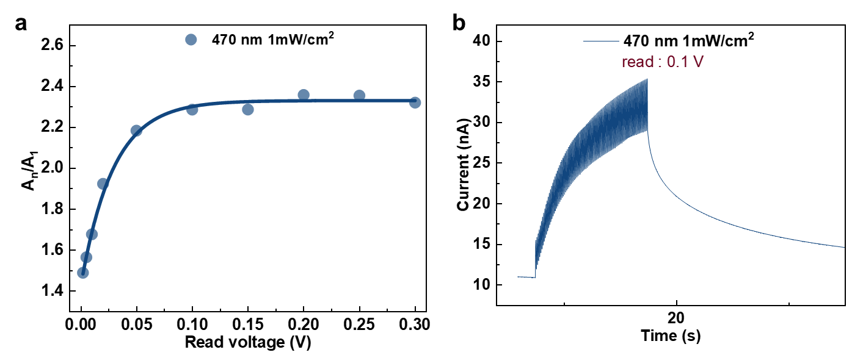
Figure S13. Synaptic function of the device triggered by blue light excitation (wavelength 470 nm). (a) Relationship between the read voltage and the synaptic gain. (b) Synaptic plasticity of the device and memory retention characteristics.
Figure S14. Synaptic function of the device triggered by blue light excitation (wavelength 470 nm). (a) Relationship between the read voltage and the synaptic gain. (b) Synaptic plasticity of the device and memory retention characteristics.
Figure S15. Wavelength-dependent modulation of synaptic weight under optical stimulation: (a,b) Red light (640 nm) induces memory extinction, (c,d) Green light (520 nm) enables memory retention, and (e,f) Blue light (470 nm) leads to enhanced memory reinforcement.

Figure S16. (a) Response of the excitatory postsynaptic currents to a group of spike trains with a frequency sequence (50 Hz→5 Hz→1 Hz→5 Hz→2 Hz). (b) The synaptic device responses to spike trains at different frequencies with a fixed voltage of 0.1 V. (c) Synapse weight changes as a function of spike frequency. Frequency thresholds of BCM curves can be adjusted by different initial conductance states.

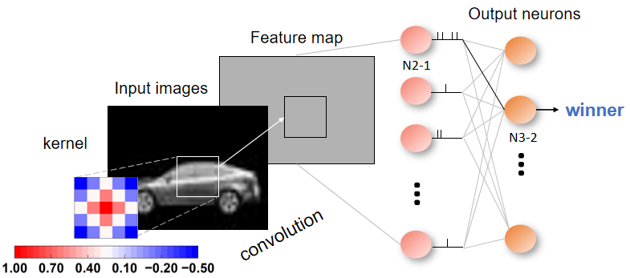
Figure S17. Schematic of image processing followed by SNN simulation.
In the processing of images, we first carried out the operation of removing background from images selected from the Compcars_database. Then, we converted the colored images into gray ones and resize them. For the SNN simulation, convolution is performed on the image to extract features firstly. The convolution kernel is [[-0.5, -0.125, 0.25, -0.125, -0.5], [-0.125, 0.25, 0.625, 0.25, -0.125], [0.25, 0.625, 1., 0.625, 0.25], [-0.125, 0.25, 0.625, 0.25, -0.125], [-0.5, -0.125, 0.25, -0.125, -0.5]]. The potential of each pixel in the image is integrated to simulate the process of neuron stimulation. When the potential exceeds the threshold, the pulse sequence outputs a high level. Otherwise, it outputs a low level. The similarity between the synaptic sequence and the pulse sequence is then calculated. When the similarity of a certain neuron first reaches the threshold (indictaed by N2-1 in Figure S17), the corresponding output neuron (indictaed by N3-2 in Figure S17) is triggered, while other output neurons are inhibited due to the winner-takes-all principle. Thus, one recognition is completed. After each recognition, the network updates the weights by using the spike-timing-dependent plasticity (STDP) rule. This rule uses the relationship between the time difference of the electrical pulse arriving at the device and the device current to simulate the relationship between the connection strength of the neurons before and after the stimulus arrives at the synapse and the two neurons. After each weight update, the next training will have a better recognition effect.
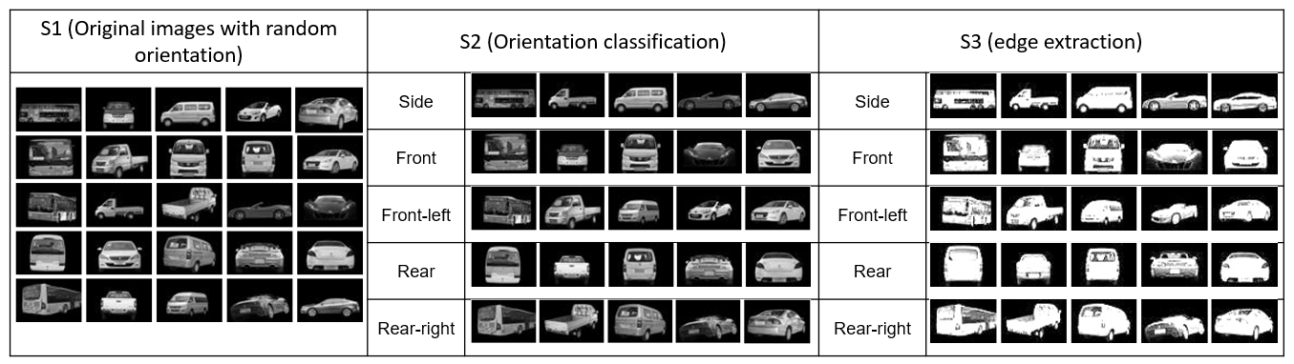
Figure S18. Images used for the training and testing in shape recognition by using the 3 simulations proposed in this experiment.

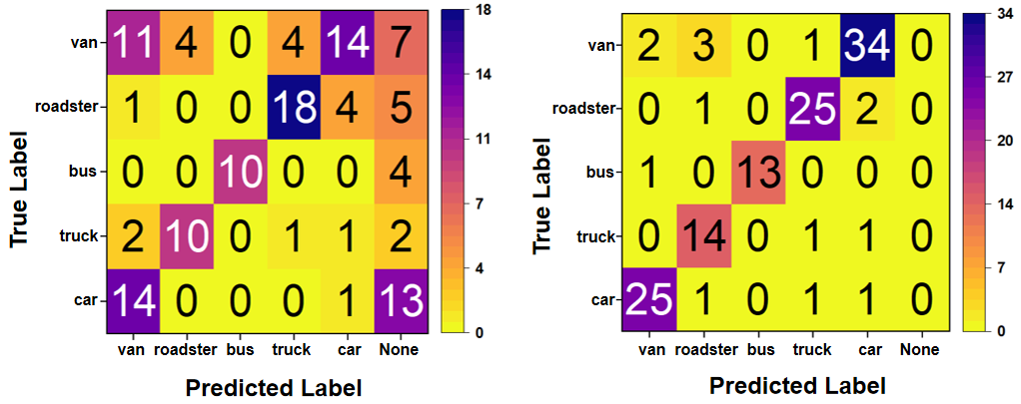
Figure S19. Statistical analysis of the recognition results for all numbers after the first and last training epochs of S3.

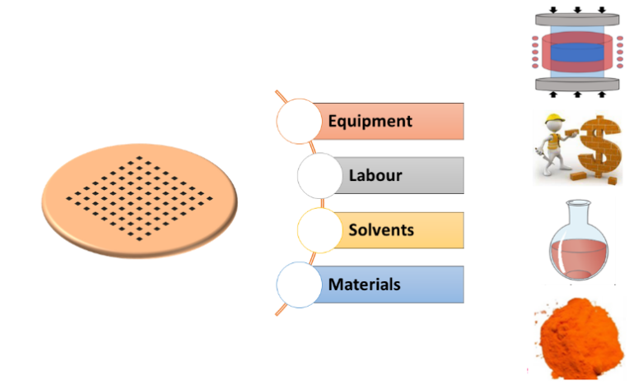
Figure S20. Estimated overall cost for perovskite device fabrication.
To assess the economic viability of the proposed recycling approach for PPW-based neuromorphic hardware, we conducted a technoeconomic analysis. The overall cost for a single device on a perovskite substrate can be estimated by summing up both direct and indirect costs. The overall cost accounts for four aspects: materials, solvents, labor, and equipment. The details below are the cost analysis for producing a perovskite single crystal and a sintered wafer with diameter (d) of 1 mm and thickness (h) of 0.2 mm.
1) The shape is assumed to be spherical for both perovskite single crystal and wafer.
2) Density of bulk MAPbBr₃ = 3.82 g/cm³.
3) Molecular weight of MAPbBr₃ = 478.98 g/mol.
4) The mass of wafer (d = 1 mm, h = 0.2 mm) = π*(0.05)² *0.02*3.83 = 0.06 g.
Table S3 summarizes the main steps involved in the cost analysis model.
Table S4 shows the catalog of materials and solvents price. Solvents including dissolving precursor chemicals and cleaning crystals are DMSO and DMF, which are included in the cost statistics.
For single crystal, a synthesis yield of 20% is adopted. It is reasonable that the efficiency of crystal growth process, loss of material during cutting or polishing, and imperfections could greatly reduce the single crystal yield. The materials cost of single crystal = 0.059974/478.98*(367*0.869+112*12.85)/20% = 1.10 $
While the synthesis yield of powders for sintering wafer is much higher (95%), which lead a relatively low cost. The materials cost of powders = 0.23 $
Table S5 shows the equipment cost, which has been discounted to unit hour expenses. The cost of each part is amplified in different proportions for wafers of different sizes in Table S5 and S6.
For labor cost, a standard China labor rates of $10/h for a skilled employee is used.

Table S3. Process flow for wafer fabrication.
process | materials | equipment
Perovskite microcrystal  growth | DMSO, PbBr₂, MABr | Heater
Powder grinding | MAPbBr₃ microcrystal | Grinder
Hot-pressed sintering | MAPbBr₃ powder | Hydraulic press
Device fabrication | MAPbBr₃ Wafer, Au | Thermal evaporator

Table S4. Materials and solvents price for wafer fabrication.
Component | purity | Cost  ($ g⁻¹)/($ L⁻¹) | Source
PbBr₂ | 99.9% | 0.869 | https://www.macklin.cn/search/L871769-1kg
MABr | 99.5% | 12.85 | https://www.macklin.cn/search/6876-37-5
DMSO | 99.7% | 78.58 | https://www.macklin.cn/products/D821476
DMF | 99.5% | 15.71 | https://www.macklin.cn/products/N807505
C₂H₅OH | 99.7% | 11.67 | https://www.macklin.cn/products/E809061
Au | 99.99% | 84.48 | http://www.ultramet.com.cn/product/53.html

Table S5. Equipment price for device fabrication on the perovskite wafer.
Equipment | Number | Cost ($) | Operating time (h/wafer) | unit price ($ h⁻¹) | Power (kw) | source
Heater | 5 | 72*5 | 24 | 0.02 | 0.5 | https://www.rjmart.cn/
Grinder | 3 | 77*3 | 8 | 0.01 | 0.75 | https://www.rjmart.cn/
Hydraulic press | 3 | 1680*2 | 8 | 0.3 | 2.5 | https://www.szkejing.com/detail-1878.html
Thermal evaporator | 1 | 14000 | 2 | 5 | 5 | https://www.deproducts.com/cpxq/14.html

Table S6. Total costs for the synthesis of perovskite single crystal with different size.
Thickness(mm)  Size (mm) | 0.2 | 0.4 | 0.6 | 0.8 | 1 | 2
5 | 7.96 | 11.41 | 14.13 | 16.47 | 18.56 | 27.06
10 | 16.47 | 23.94 | 29.93 | 35.16 | 39.89 | 59.67
20 | 35.16 | 52.32 | 66.53 | 79.20 | 90.89 | 141.55
30 | 56.07 | 85.14 | 109.78 | 132.12 | 152.99 | 245.64
40 | 79.20 | 122.41 | 159.70 | 193.93 | 226.20 | 371.95
50 | 104.55 | 164.12 | 216.29 | 264.63 | 310.52 | 520.46
60 | 132.12 | 210.27 | 279.54 | 344.21 | 405.94 | 691.19
70 | 161.92 | 260.86 | 349.45 | 432.67 | 512.47 | 884.14
80 | 193.93 | 315.90 | 426.03 | 530.02 | 630.11 | 1099.29
90 | 228.17 | 375.38 | 509.27 | 636.26 | 758.85 | 1336.65
100 | 264.63 | 439.30 | 599.17 | 751.38 | 898.69 | 1596.23

Table S7. Total costs for the synthesis of perovskite wafer with different size.
Thickness (mm)  Size (mm) | 0.2 | 0.4 | 0.6 | 0.8 | 1 | 2
5 | 2.69 | 3.37 | 3.87 | 4.27 | 4.62 | 5.95
10 | 4.27 | 5.48 | 6.39 | 7.16 | 7.84 | 10.65
20 | 7.16 | 9.62 | 11.62 | 13.41 | 15.06 | 22.38
30 | 10.15 | 14.25 | 17.76 | 21.00 | 24.07 | 38.15
40 | 13.41 | 19.59 | 25.06 | 30.20 | 35.14 | 58.33
50 | 17.01 | 25.72 | 33.62 | 41.12 | 48.40 | 83.05
60 | 21.00 | 32.69 | 43.47 | 53.82 | 63.91 | 112.40
70 | 25.39 | 40.53 | 54.67 | 68.33 | 81.70 | 146.42
80 | 30.20 | 49.26 | 67.23 | 84.67 | 101.81 | 185.13
90 | 35.44 | 58.89 | 81.16 | 102.87 | 124.24 | 228.57
100 | 41.12 | 69.43 | 96.48 | 122.93 | 149.01 | 276.75

Figure S21. Cost analysis. (a) A technoeconomic model for estimating the synthesis cost includes equipment, labor, solvents and materials. (b) Overall cost for the solution synthesis of perovskite single crystal. (c) Overall cost for the synthesis of perovskite wafer by recycling and mechanical sintering.
The technoeconomic analysis results highlight that the primary cost driver for perovskite wafer production is the raw materials and labor. In addition, equipment and chemical solvents contribute substantially to the overall cost. Based on price data from leading materials suppliers, our model estimates that the cost per mm thickness of perovskite single-crystal wafer exceeds $800 when the size reaches 100 mm (~4 inches). This indicates that the chemical synthesis method for perovskite single crystals is in fact highly cost-inefficient for industrial-scale production. In contrast, when the proposed sintering strategy is implemented, the wafer cost per mm thickness drops significantly to around $149. This reduction is primarily due to the improve of throughput and yield loss, which in turn minimizes the need for labor, raw materials, and chemical solvents. By recycling used or inferior-quality perovskite materials, the fabrication cost can be further reduced to approximately $45, representing a dramatic cost-saving potential. Together, they make the current perovskite wafer technology commercially viable.
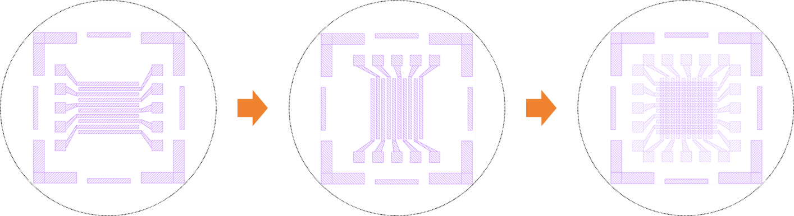
Figure S22. Schematic showing the fabrication processing of PPW-based memristive crossbar arrays.

Reference
(1) Xu, W.; Cho, H.; Kim, Y.; Kim, Y.; Wolf, C.; Park, C.; Lee, T. Organometal Halide Perovskite Artificial Synapses. Adv. Mater. 2016, 28, 5916–5922.
(2) Xiao, Z.; Huang, J. Energy‐Efficient Hybrid Perovskite Memristors and Synaptic Devices. Adv. Elect. Mater. 2016, 2, 1600100.
(3) Tian, H.; Zhao, L.; Wang, X.; Yeh, Y.-W.; Yao, N.; Rand, B. P.; Ren, T.-L. Extremely Low Operating Current Resistive Memory Based on Exfoliated 2D Perovskite Single Crystals for Neuromorphic Computing. ACS Nano 2017, 11, 12247–12256.
(4) John, R. A.; Yantara, N.; Ng, Y. F.; Narasimman, G.; Mosconi, E.; Meggiolaro, D.; Kulkarni, M. R.; Gopalakrishnan, P. K.; Nguyen, C. A.; De Angelis, F.; Mhaisalkar, S. G.; Basu, A.; Mathews, N. Ionotronic Halide Perovskite Drift‐Diffusive Synapses for Low‐Power Neuromorphic Computation. Adv. Mater. 2018, 30, 1805454.
(5) Yang, J.-M.; Choi, E.-S.; Kim, S.-Y.; Kim, J.-H.; Park, J.-H.; Park, N.-G. Perovskite-Related (CH₃ NH₃)₃Sb₂Br₉ for Forming-Free Memristor and Low-Energy-Consuming Neuromorphic Computing. Nanoscale 2019, 11, 6453–6461.
(6) Kim, S.; Lee, Y.; Park, M.; Go, G.; Kim, Y.; Xu, W.; Lee, H.; Kim, H.; Seo, D.; Lee, W.; Lee, T. Dimensionality Dependent Plasticity in Halide Perovskite Artificial Synapses for Neuromorphic Computing. Adv. Elect. Mater. 2019, 5, 1900008.
(7) Cheng, X.; Qian, W.; Wang, J.; Yu, C.; He, J.; Li, H.; Xu, Q.; Chen, D.; Li, N.; Lu, J. Environmentally Robust Memristor Enabled by Lead‐Free Double Perovskite for High‐Performance Information Storage. Small 2019, 15, 1905731.
(8) Xing, J.; Zhao, C.; Zou, Y.; Kong, W.; Yu, Z.; Shan, Y.; Dong, Q.; Zhou, D.; Yu, W.; Guo, C. Modulating the Optical and Electrical Properties of MAPbBr₃ Single Crystals via Voltage Regulation Engineering and Application in Memristors. Light Sci. Appl. 2020, 9, 111.
(9) Gong, J.; Yu, H.; Zhou, X.; Wei, H.; Ma, M.; Han, H.; Zhang, S.; Ni, Y.; Li, Y.; Xu, W. Lateral Artificial Synapses on Hybrid Perovskite Platelets with Modulated Neuroplasticity. Adv. Funct. Mater. 2020, 30, 2005413.
(10) Chen, L.-W.; Wang, W.-C.; Ko, S.-H.; Chen, C.-Y.; Hsu, C.-T.; Chiao, F.-C.; Chen, T.-W.; Wu, K.-C.; Lin, H.-W. Highly Uniform All‐Vacuum‐Deposited Inorganic Perovskite Artificial Synapses for Reservoir Computing. Adv. Intell. Sys. 2021, 3, 2000196.
(11) Lao, J.; Xu, W.; Jiang, C.; Zhong, N.; Tian, B.; Lin, H.; Luo, C.; Travas-sejdic, J.; Peng, H.; Duan, C.-G. An Air-Stable Artificial Synapse Based on a Lead-Free Double Perovskite Cs₂AgBiBr₆ Film for Neuromorphic Computing. J. Mater. Chem. C 2021, 9, 5706–5712.
(12) John, R. A.; Yantara, N.; Ng, S. E.; Patdillah, M. I. B.; Kulkarni, M. R.; Jamaludin, N. F.; Basu, J.; Ankit; Mhaisalkar, S. G.; Basu, A.; Mathews, N. Diffusive and Drift Halide Perovskite Memristive Barristors as Nociceptive and Synaptic Emulators for Neuromorphic Computing. Adv. Mater. 2021, 33, 2007851.
(13) Liu, S.; Guan, J.; Yin, L.; Zhou, L.; Huang, J.; Mu, Y.; Han, S.; Pi, X.; Liu, G.; Gao, P.; Zhou, S. Solution-Processed Synaptic Memristors Based on Halide Perovskite Nanocrystals. J. Phys. Chem. Lett. 2022, 13, 10994–11000.
(14) Assi, D. S.; Haris, M. P. U.; Karthikeyan, V.; Kazim, S.; Ahmad, S.; Roy, V. A. L. Low Switching Power Neuromorphic Perovskite Devices with Quick Relearning Functionality. Adv. Elect. Mater. 2023, 9, 2300285.
(15) Chen, G.; Yu, X.; Gao, C.; Dai, Y.; Hao, Y.; Yu, R.; Chen, H.; Guo, T. Temperature-Controlled Multisensory Neuromorphic Devices for Artificial Visual Dynamic Capture Enhancement. Nano Res. 2023, 16, 7661–7670.
(16) Zhou, L.; Han, S.; Liu, H.; He, Z.; Huang, J.; Mu, Y.; Xie, Y.; Pi, X.; Lu, X.; Zhou, S.; Hou, Y. Energy-Efficient, Stable, and Temperature-Tolerant Neuromorphic Device Based on Single Crystals of Halide Perovskites. Cell Rep. Phys. Sci. 2024, 5, 102078.
(17) Wang, Y.; Lv, Z.; Chen, J.; Wang, Z.; Zhou, Y.; Zhou, L.; Chen, X.; Han, S.-T. Photonic Synapses Based on Inorganic Perovskite Quantum Dots for Neuromorphic Computing. Adv. Mater. 2018, 30, 1802883
(18) John, R. A.; Milozzi, A.; Tsarev, S.; Brönnimann, R.; Boehme, S.C.; Wu, E.; Shorubalko, I.; Kovalenko, M.V., Ielmini, D. Ionic-Electronic Halide Perovskite Memdiodes Enabling Neuromorphic Computing with a Second-Order Complexity. Sci. Adv. 2022, 8, eade0072.
(19) He, Z.; Duan, H.; Zeng, J.; Zhou, J.; Zhong, X.; Wu, Z.; Ni, S.; Jiang, Z.; Xie, G.; Lee, J.Y.; Lu, Y.; Zeng, Y.; Zhang, B.; Ying, W.; Yang, Z.; Zhang, Z.; Liu, G. Perovskite Retinomorphic Image Sensor for Embodied Intelligent Vision. Sci. Adv. 2025, 11, eads2834.
(20) Kim, S.; Im, I.; Baek, J.; Choi, S.; Park, S.; Lee, D.; Kim, J.; Kim, S.; Park, N.G.; Lee, D.; Yang, J.J.; Jang, H.W. Linearly Programmable Two-Dimensional Halide Perovskite Memristor Arrays for Neuromorphic Computing. Nat. Nanotechnol. 2025, 20, 83–92.

