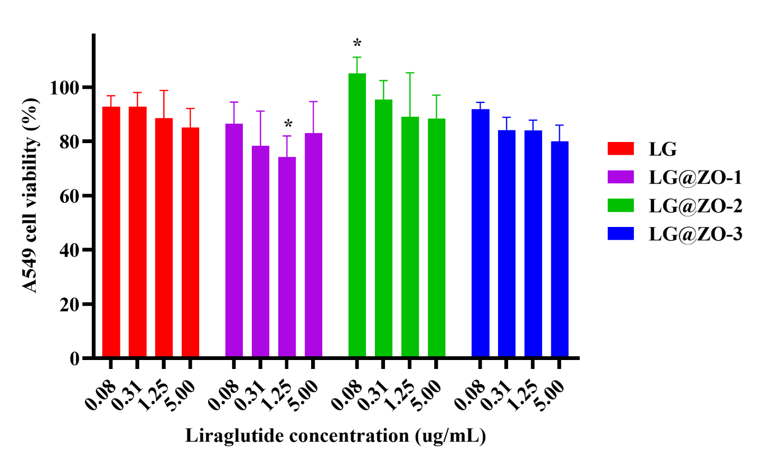
Figure S1. Cell viability of A549 cells treated with liraglutide formulations. Cell viability profile of A549 cells treated with liraglutide (LG) and ZnO-based biointeractive carriers (mean ± SD, n = 9). Statistical analysis was performed using two-way ANOVA followed by Dunnett’s post hoc test against the LG group. Significance threshold was set at p < 0.05.
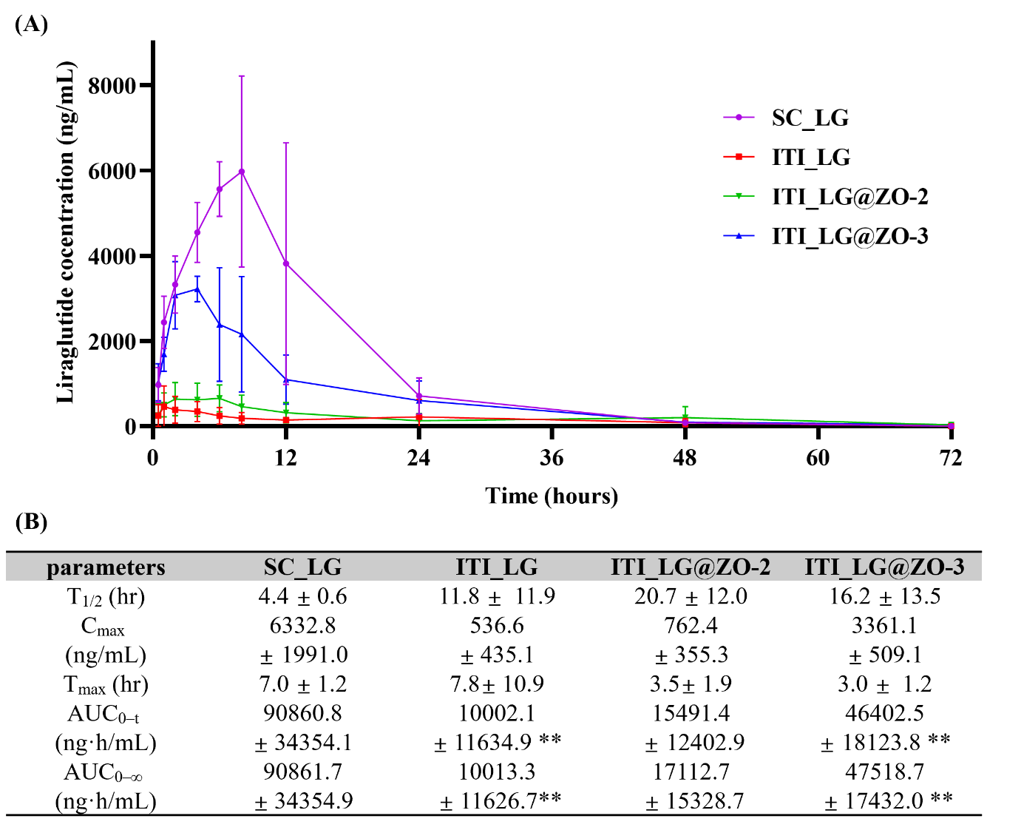
Figure S2. Pharmacokinetic evaluation in the alloxan-induced carbohydrate metabolism disorder model. (A) Pharmacokinetic profiles and (B) pharmacokinetic parameters of liraglutide formulations in the alloxan-induced carbohydrate metabolism disorder rat model (mean ± SD, n = 4). Statistical analysis was performed using two-way ANOVA followed by Tukey’s multiple comparison test against the LG group. p < 0.01.
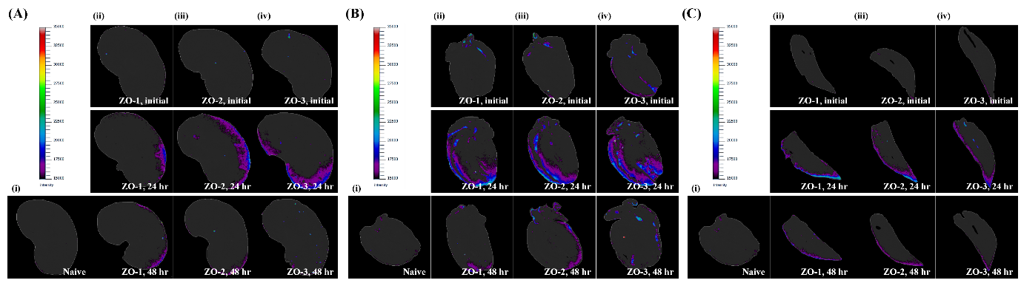
Figure S3. Biodistribution of liraglutide formulations in major organs after pulmonary administration. (A) Fluorescence images of lungs for (i) Naïve, (ii) ZO-1, (iii) ZO-2, and (iv) ZO-3 groups at 0, 24, and 48 h post-administration (top to bottom). (B) Mean pulmonary FITC fluorescence intensity over time. (C) Fluorescence images of kidneys for (i) Naïve, (ii) ZO-1, (iii) ZO-2, and (iv) ZO-3 groups at 0, 24, and 48 h. (D) Fluorescence images of hearts for (i) Naïve, (ii) ZO-1, (iii) ZO-2, and (iv) ZO-3 groups at 0, 24, and 48 h. (E) Fluorescence images of livers for (i) Naïve, (ii) ZO-1, (iii) ZO-2, and (iv) ZO-3 groups at 0, 24, and 48 h (top to bottom).

