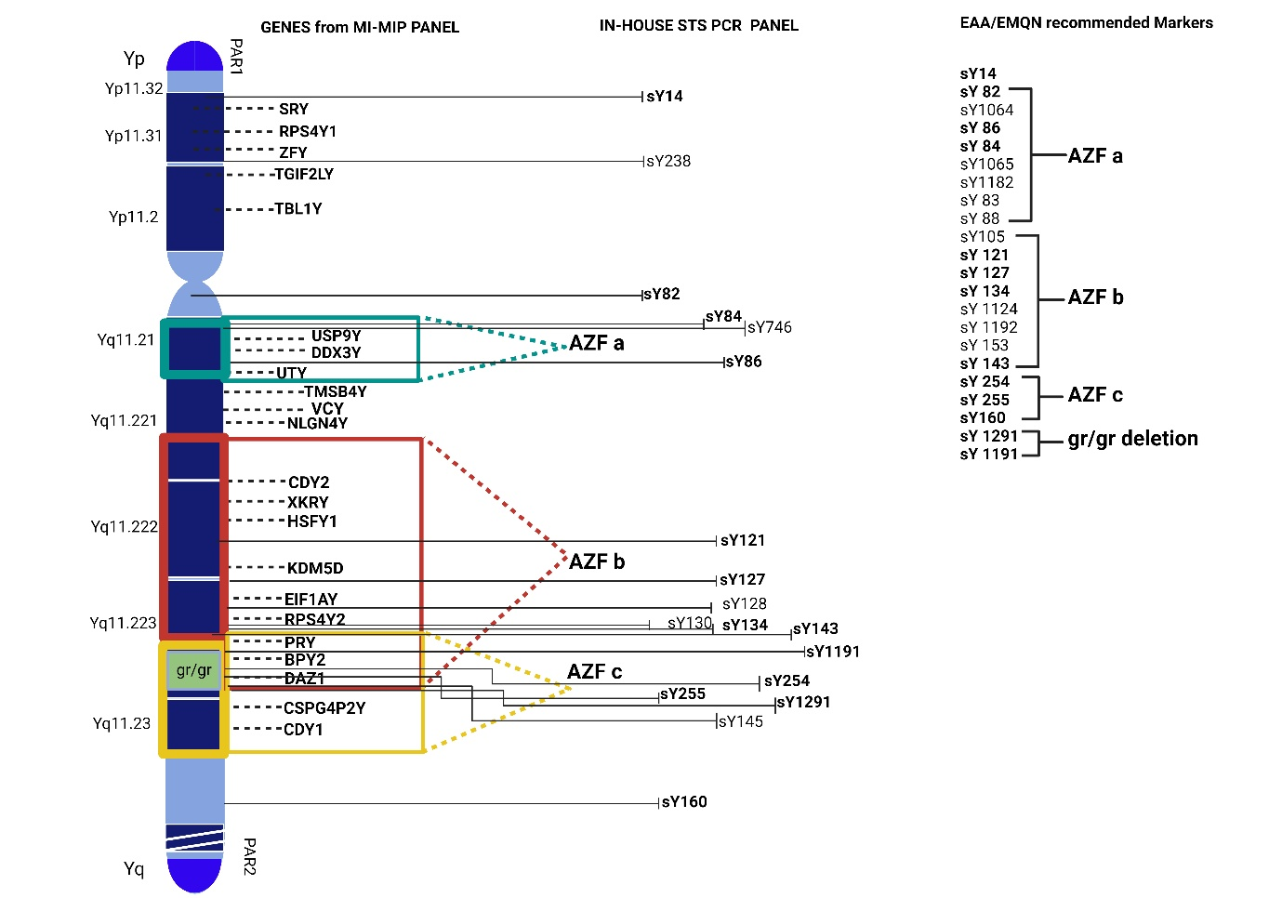
Supplementary File 1: Mapping of Y chromosome microdeletion detection strategies. Schematic representation of the Y chromosome depicting infertility associated genes targeted by the smMIP base targeted sequencing assay. AZF regions: AZFa (blue dotted outline), AZFb (red dotted outline), AZFc (yellow dotted outline), and the gr/gr partial deletion region (green) are delineated according to EAA/EMQN 2023 guidelines. The inclusion of key genes in targeted gene sequencing assay and STS markers ensures concordance with established diagnostic standards for Y-chromosomal microdeletion screening in male infertility.
(Ref: Krausz C, Navarro-Costa P, Wilke M, Tüttelmann F. EAA/EMQN best practice guidelines for molecular diagnosis of Y-chromosomal microdeletions: State of the art 2023. Andrology. 2024 Mar;12(3):487-504. doi: 10.1111/andr.13514. Epub 2023 Sep 6. PMID: 37674303.)

