Supplementary material

Median plasma concentrations of total branched-chain amino acids (T-BCAA) and individual branched-chain amino acids were significantly lower in CKD stage 5 patients than in 44 healthy controls (HC) (Table S1).
The T-BCAA concentrations in CKD patients with and without DM (280 {234 - 334} vs. 281 {232 - 328} μmol/L), CVD (264 {231 – 338}μmol/L vs. 286 {232 – 327} μmol/L) and statin medication (271 {231 – 323) μmol/L vs. 284 {232 - 332} μmol/L), were not significantly different (Fig. S2). Likewise, the concentrations of individual BCAAs, Val, Ile, and Leu, also did not differ significantly between patients with these conditions and their counterparts (Table S2).
On the other hand, plasma concentrations of T-BCAA (Fig. S2) and individual BCAAs were significantly higher in male patients compared to female patients: T-BCAA 292 {247- 367}μmol/L vs. 259 {219 - 305}μmol/L; Val 158 {130 - 191}μmol/L vs. 142 {111 – 165}μmol/L; Ile 60 {50 – 72}μmol/L vs. 47 {39 - 61}μmol/L; Leu 71 {58 – 88}μmol/L vs. 62 {49 – 79}μmol/L, all with p-values <0.0001), respectively. Similarly, the plasma concentration of T-BCAA and individual BCAAs were significantly higher in male compared to female healthy subjects(Fig. S3).
Moreover, 61 patients (19%) received amino acid supplementation (Aminess N®; Recip AB, Stockholm, Sweden, containing per tablet: 45 mg histidine, 135 mg valine, 60 mg isoleucine, 90 mg leucine, 65 mg lysine, 90 mg methionine, 70 mg phenylalanine, 65 mg threonine, 25 mg tryptophan, and 75 mg tyrosine), However, the concentrations of total and individual BCAAs did not differ significantly between those who received amino acid supplements and those who did not (Table S3).

Table S1. Comparison between total (T-BCAA) and individual branched-chain amino acids concentrations in 83 healthy controls (HC) and 328 CKD stage 5 patients.
 | HC | CKD 5 | P-value
T-BCAA, μmol/L | 392 (343-459) | 281 (232-329) | <0.0001
Valine, μmol/L | 219 (190-250) | 152 (126-179) | <0.0001
Leucine, μmol/L | 116 (101-138) | 67 (54-84) | <0.0001
Isoleucine, μmol/L | 58 (50-70) | 56 (43-68) | 0.09
Data presented as median (IQR, interquartile range).

Table S2. Comparison of individual branched-chain amino acid (BCAA) concentrations (μmol/L) in CKD stage 5 patients, analyzed by sex, presence of diabetes mellitus (DM), cardiovascular disease (CVD), and statin use, in relation to their respective counterparts.
 |  | Valine | P-value | Isoleucine | P-value | Leucine | P-value
Sex | Males | 158 (130 - 191) | <0.0001 | 60 (50 – 72) | <0.0001 | 71 (58 – 88) | <0.001
Sex | Females | 142 (111 – 165) | <0.0001 | 47 (39 - 61) | <0.0001 | 62 (49 – 79) | <0.001
DM | Yes | 149 (127 - 177) | 0.84 | 56 (42 – 68) | 0.61 | 72 (55 – 89) | 0.08
DM | No | 152 (125 - 181) | 0.84 | 56 (43 - 69) | 0.61 | 65 (53 - 82 | 0.08
CVD | Yes | 147 (122 – 181) | 0.42 | 54 (43 – 66) | 0.33 | 70 (52 - 87) | 0.59
CVD | No | 152 (128 - 178) | 0.42 | 57 (43 - 70) | 0.33 | 67 (55 – 82) | 0.59
Statin | Yes | 150 (122 - 174) | 0.34 | 55 (41 - 69) | 0.54 | 68 (81 - 85) | 0.88
Statin | No | 153 (126 - 181) | 0.34 | 56 (43 - 68) | 0.54 | 67 (54 - 83) | 0.88
Data presented as median (IQR, interquartile range).

Table S3. Comparison of the concentrations of total and individual branched-chain amino acids (BCAAs) between CKD stage 5 patients on amino acid supplementation and those without supplementation.
 | Aminess | No Aminess | P-value
Number (%) | 61 (19%) | 267 (81%)
BCAAs | 275 (236-334)) | 283 (230-332) | 0.77
Valine | 152 (123-181) | 146 (131-184) | 0.74
Isoleucine | 56 (40-71) | 58 (43-69 | 0.95
Leucine | 70 (55-85) | 66 (53-82) | 0.51
Data presented as median (IQR, interquartile range). Oral amino acid supplementation (Aminess N; Recip AB, Stockholm, Sweden) contains 45 mg histidine, 135 mg valine, 60 mg isoleucine, 90 mg leucine, 65 mg lysine, 90 mg methionine, 70 mg phenylalanine, 65 mg threonine, 25 mg tryptophan, and 75 mg tyrosine.

Table S4. Competing-risk regression analysis models for all-cause and cardiovascular 5-year mortality risk based on tertiles of branched-chain amino acids (BCAAs), valine, isoleucine and leucine, respectively, among 328 CKD stage 5 patients.
 | All-cause mortality |  | Cardiovascular mortality
 | sHR [95% CI] | p-value | sHR [95% CI] | p-value
BCAAs
Low tertile | 1.62 (0.88 - 2.98) | 0.12 | 2.37 (1.08 - 5.21) | 0.03
Middle tertile | 1.01 (0.56 - 1.83) | 0.96 | 0.81 (0.36 - 1.83) | 0.62
Valine
Low tertile | 2.05 (1.10 – 3.79) | 0.02 | 2.46 (1.15 – 5.26) | 0.02
Middle tertile | 1.40 (0.74 – 2.63) | 0.29 | 1.17 (0.51 – 2.69) | 0.69
Isoleucine
Low tertile | 1.20 (0.56 – 2.19) | 0.55 | 1.63 (0.74 – 3.58) | 0.21
Middle tertile | 0.99 (0.57 – 1.73) | 0.96 | 0.97 (0.47 – 1.97) | 0.93
Leucine
Low tertile | 0.66 (0.35 – 1.23) | 0.19 | 0.94 (0.43 – 2.04) | 0.87
Middle tertile | 0.96 (0.56 -1.66) | 0.90 | 1.21 (0.59 – 2.43) | 0.60
Values shown are sub-hazard ratio (sHR) with 95% confidence interval (95% CI). The high tertile served as the reference group. Each model was adjusted for age, sex, diabetes mellitus, cardiovascular diseases, estimated glomerular filtration rate, body mass index, serum albumin, atherogenic index of plasma and plasma insulin. Significant values are marked as bold.

Fig S1. Participant flow chart of incident dialysis patients in Stockholm with planned start of dialysis who were enrolled in cohort study December 1994-October 2005.

Enrollment
ª Source: https://www.medscinet.net/snr/arsrapporter.aspx
Estimated number of patients with planned start of dialysis in catchment area Stockholm region 1994 – 2005 (n≈900)ª

Analysis
Excluded
- Age <18 years
- Age >70 years
- Overt infection or acute vasculitis

Allocation

Follow-Up
Eligible for main cohort study (n=560)

Included
- CKD stage 5 (eGFR-epi <15 ml/min)
- Willing to participate
- Age 18-70 years
Excluded (n=232)
- No analysis of plasma amino acids acids

♦Up to 60 months; median follow-up 29.4 (range 0.9–60) months
♦ Renal transplantation (n= 166); deaths (n=82); lost to follow-up (n=0)

Included (n=328)
♦198 men (60%), median age 54 years, median eGFR 6.3 ml/min/1.73 m²
♦ Causes of CKD: diabetic nephropathy (26%), hypertension/renal vascular disease (21%), chronic glomerulonephritis (25%), other causes (28%)
Statistical analysis
♦ Fine-Gray competing-risk regression analysis.
♦ Restricted cubic spline curve analysis

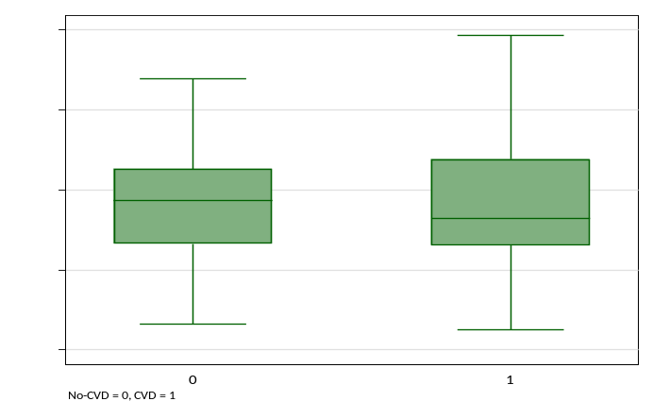
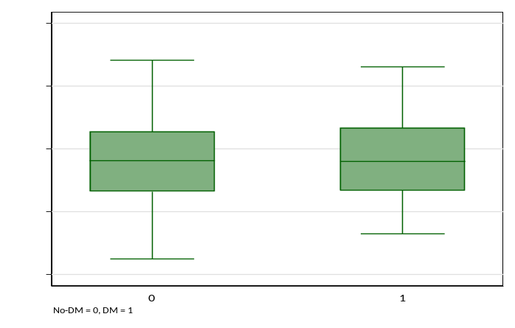
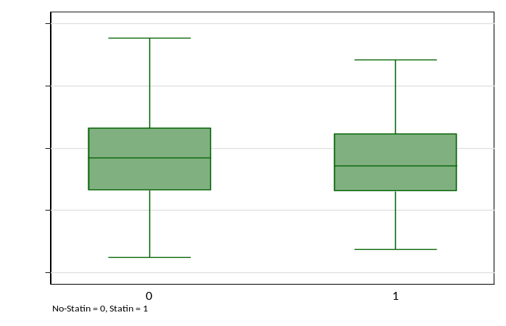
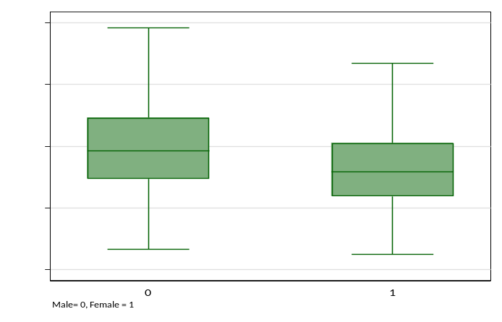
Fig S2. Comparison of total branched-chain amino acids (BCAA) concentration in CKD stage 5 patients without and with diabetes mellitus (A), cardiovascular disease (B), statin medication (C), and male sex (D) compared to their respective counterpart groups.
A
B
C
D
P = ns
P = ns
P = ns
P < 0.0001

Fig S3. Comparison of total branched-chain amino acids (BCAA) and individual BCAA concentrations in in male and female healthy subjects.

