Supporting information for
Long-term fertilization enhances the soil carbon stability by increase the ratio of passive carbon: evidence from four typical croplands
Wei Zhou, Shilin Wen, Yunlong Zhang, Andrew S. Gregory, Minggang Xu, Syed Atizaz Ali Shah, Wenju Zhang, Honghui Wu, Iain P. Hartley

W. Zhou · M.G Xu *· S.A.A Shah ·W. J Zhang · H. H Wu *
Ministry of Key Laboratory of Crop Nutrition and Fertilization / Institute of Agricultural Resources and Regional Planning, Chinese Academy of Agricultural Sciences, Beijing 100081, China
e-mail: xuminggang@caas.cn
e-mail: wuhonghui@caas.cn

S.L Wen
National Experimental Station of Agroecosystem / Institute of Agricultural Resources and Regional Planning, Chinese Academy of Agricultural Sciences, Qiyang 426182, China

Y.L Zhang
College of Grassland Science and Technology, China Agricultural University, Beijing, 100193, China

A. S Gregory
Department of Sustainable Agriculture Sciences, Rothamsted Research, Harpenden, Hertfordshire, AL5 2JQ, UK

M.G Xu
Academy of Ecology and Environments, Shanxi Agricultural University, Taiyuan, 030031, China

I. P Hartley
Geography, College of Life and Environmental Sciences, University of Exeter, Exeter, EX4 4QJ, UK

Contents of this file
Tables S1-S3
Figure S1-S3

Table S1 Brief description of determination method of soil organic carbon fractions
Pool | Methods
Active Carbon  (AC) | Organic carbon oxidizable under 18 N H₂SO₄ ª
Passive Carbon  (PC) | Residual organic carbon after reaction with 18 N H₂SO₄ when compared with the total carbon determined by the CHN analyzer.
ª 18 N H₂SO_{4:} 10 mL 1N K₂Cr₂O₇ + 10 mL H₂SO₄ (36 N), (1:1 ratio), after reaction heat, add 100 mL water and titrate with 1N FeSO₄.7H₂O.

Table S2 Analysis of variance for soil organic carbon (SOC), active carbon (AC) and passive carbon (PC) as affected by site, fertilization treatment, soil depth and their interaction.
 | Source | d.f. | s.s. | m.s. | F value | P value
SOC | Site. Block stratum
 | S | 3 | 9069.5 | 3023.2 | 1882.9 | < 0.001
 | Residual | 8 | 11.9 | 1.5
 | Site. Block. Fertilization stratum
 | T | 3 | 4829.7 | 1609.9 | 1002.7 | < 0.001
 | S * T | 9 | 650.6 | 72.3 | 45.0 | < 0.001
 | Residual | 24 | 25.2 | 1.1
 | Site. Block. Fertilization. Depth stratum
 | D | 2 | 7090.7 | 3545.3 | 2202.8 | < 0.001
 | S * D | 6 | 865.1 | 144.2 | 89.8 | < 0.001
 | T * D | 6 | 430.8 | 71.8 | 44.7 | < 0.001
 | S* T * D | 18 | 915.3 | 50.851 | 31.7 | < 0.001
 | Residual | 64 | 117.1 | 1.8
 | Total | 143 | 24005.1
AC | Site. Block stratum
 | S | 3 | 3114.3 | 1038.1 | 1691.8 | < 0.001
 | Residual | 8 | 5.0 | 0.6
 | Site. Block. Fertilization stratum
 | T | 3 | 858.37 | 286.12 | 466.2 | < 0.001
 | S * T | 9 | 171.2 | 19.0 | 31.0 | < 0.001
 | Residual |  | 11.1 | 0.5
 | Site. Block. Fertilization. Depth stratum
 | D | 2 | 1810.1 | 905.3 | 1475.4 | < 0.001
 | S * D | 6 | 176.1 | 29.34 | 47.8 | < 0.001
 | T * D | 6 | 72.9 | 12.15 | 19.8 | < 0.001
 | S* T * D | 18 | 278.2 | 15.46 | 25.2 | < 0.001
 | Residual | 96 | 42.7 | 0.7
 | Total | 143 | 6540
PC | Site. Block stratum
 | S | 3 | 1559.4 | 519.8 | 713.7 | < 0.001
 | Residual | 8 | 7.9 | 0.9
 | Site. Block. Fertilization stratum
 | T | 3 | 1623.9 | 541.3 | 743.2 | < 0.001
 | S * T | 9 | 159.9 | 17.7 | 24.4 | < 0.001
 | Residual | 24 | 10.4 | 0.4
 | Site. Block. Fertilization. Depth stratum
 | D | 2 | 1802.6 | 901.3 | 1237.4 | < 0.001
 | S * D | 6 | 285.4 | 47.6 | 65.3 | < 0.001
 | T * D | 6 | 171.9 | 28.7 | 39.3 | < 0.001
 | S* T * D | 18 | 211.9 | 11.8 | 16.2 | < 0.001
 | Residual | 64 | 51.7 | 0.8
 | Total | 143 | 5885.1
S - Site, T – Treatment, D – Depth, d.f. - degree of freedom, s.s. - summary square, m.s. - mean square.

Table S3 Soil chemical properties of the soil samples influenced by fertilization across all depth at different sites
Sites | Fertilization | TN (g kg⁻¹) | C/N | Bd (Mg m⁻³)
Sites | Fertilization | mean ± SE | mean ± SE | mean ± SE
Ave | Control (n = 36) | 0.94 ± 0.4 b | 7.40 ± 1.33 c | 1.40 ± 0.08 a
 | NPK (n = 36) | 1.01 ± 0.39 b | 8.74 ± 1.69 b | 1.37 ± 0.09 b
 | NPKM (n = 36) | 1.24 ± 0.57 a | 9.60 ± 2.40 a | 1.35 ± 0.09 b
 | 1.5NPKM (n = 36) | 1.37 ± 0.65 a | 9.69 ± 2.22 a | 1.36 ± 0.10 b
GZL | Control (n = 9) | 1.22 ± 0.24 c | 6.97 ± 1.35 c | 1.33 ± 0.07 a
 | NPK (n = 9) | 1.32 ± 0.23 c | 8.39 ± 0.95 b | 1.34 ± 0.09 a
 | NPKM (n = 9) | 1.75 ± 0.36 b | 8.67 ± 0.64 ab | 1.31 ± 0.11 a
 | 1.5NPKM (n = 9) | 1.95 ± 0.22 a | 9.11 ± 0.80 a | 1.29 ± 0.11 a
ZZ | Control (n = 9) | 0.55 ± 0.14 b | 7.20 ± 1.34 b | 1.45 ± 0.04 a
 | NPK (n = 9) | 0.56 ± 0.14 b | 8.41 ± 2.71 b | 1.42 ± 0.03 b
 | NPKM (n = 9) | 0.67 ± 0.22 ab | 10.52 ± 3.18 a | 1.37 ± 0.03 c
 | 1.5NPKM (n = 9) | 0.74 ± 0.26 a | 10.77 ± 2.94 a | 1.37 ± 0.03 c
CQ | Control (n = 9) | 1.24 ± 0.13 a | 8.24 ± 0.96 c | 1.40 ± 0.02 a
 | NPK (n = 9) | 1.33 ± 0.11 a | 9.98 ± 0.59 b | 1.38 ± 0.05 a
 | NPKM (n = 9) | 1.27 ± 0.16 a | 11.78 ± 0.94 a | 1.34 ± 0.05 b
 | 1.5NPKM (n = 9) | 1.34 ± 0.21 a | 11.40 ± 0.67 a | 1.32 ± 0.07 b
QY | Control (n = 9) | 0.76 ± 0.18 b | 7.19 ± 1.31 b | 1.40 ± 0.11 b
 | NPK (n = 9) | 0.84 ± 0.33 b | 8.18 ± 0.95 b | 1.31 ± 0.13 c
 | NPKM (n = 9) | 1.26 ± 0.72 a | 7.44 ± 0.89 a | 1.40 ± 0.11 b
 | 1.5NPKM (n = 9) | 1.44 ± 0.89 a | 7.49 ± 0.91 b | 1.48 ± 0.04 a
See Table 1 and Table 2 for experimental sites and treatments in detail. TN - total nitrogen; C/N - carbon/nitrogen ratio; Bd - bulk density; n - samples number. Different letters indicate significant difference among fertilization treatments in one site at P < 0.05.

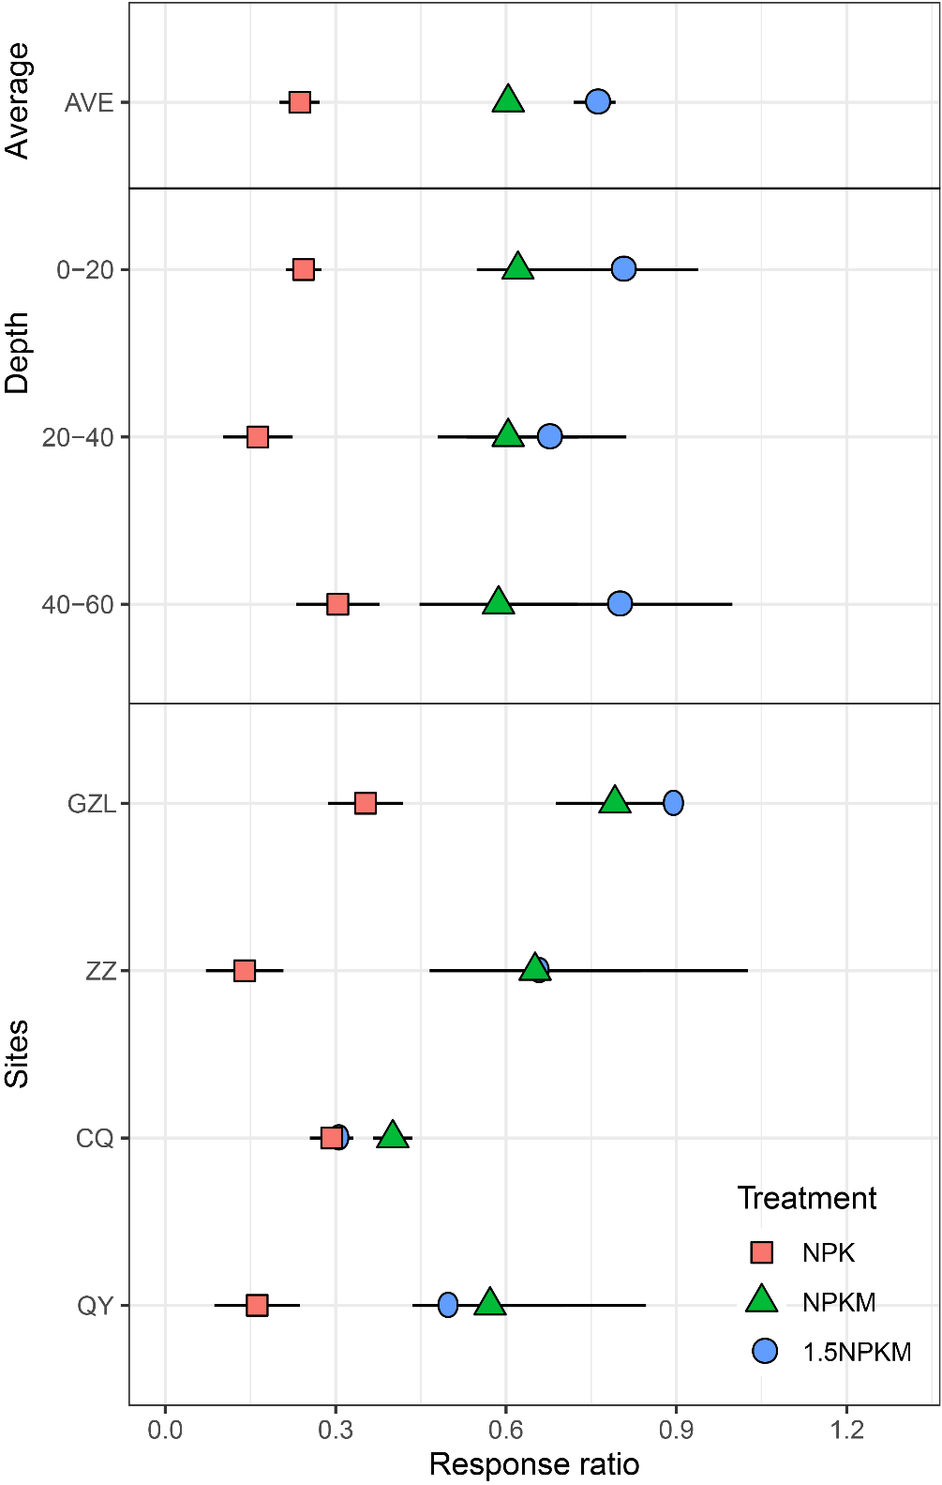
Fig.S1 Effect of fertilization treatments on total soil organic carbon(b) as a response ratio (to Control) at four sites, and as an average across sites. See Table 1 and Table 2 for experimental sites in detail. Error bar in Ave (n = 4) and GZL, ZZ, CQ, QY (n = 9) indicates standard error of the mean. Shapes and colors correspond to different fertilization treatments: NPK (square, red), NPKM (triangle, green), 1.5NPKM (circle, blue).

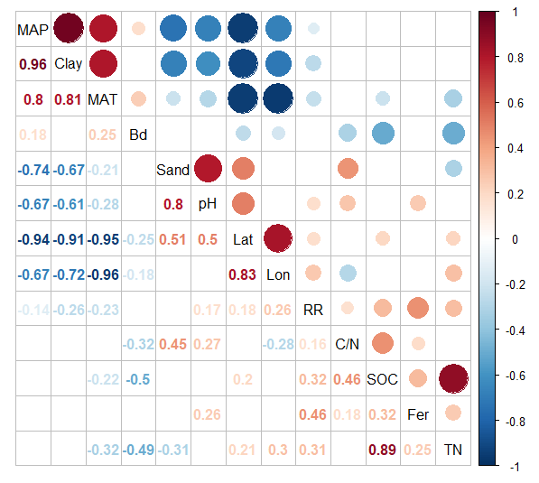
Fig.S2 Relationships between the response ratio (RR) and soil properties, soil texture and climate. The colors of the numbers relate to the strength and direction of the correlation and the blank are indicated no significant effect (P > 0.05). TN - total nitrogen; Bd - bulk density; SOC - soil organic carbon; C/N - carbon/nitrogen ratio; Fer - Fertilization input; MAP - mean annual precipitation; MAT - mean annual temperature; (MAP and MAT are means from 1989 to 2010 from China meteorological sharing service system (https://cdc.cma.gov.cn/)); Lat - latitudinal; Lon - longitude.
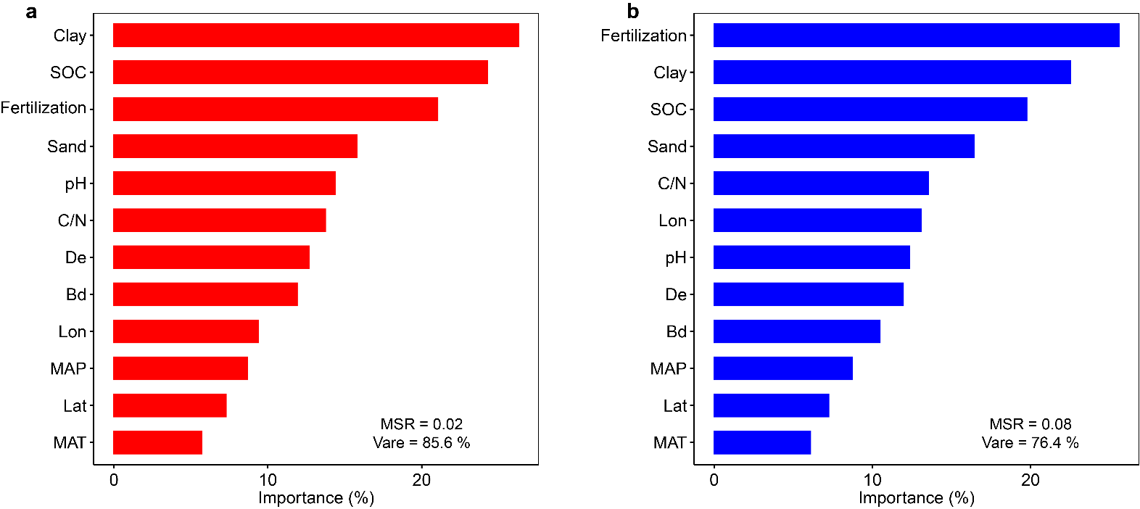
Fig.S3 Selection of soil properties used in the Random Forest classification model for active carbon (a) and passive carbon (b). The colors of the numbers relate to the strength and direction of the correlation and the crosses are indicated no significant effect (P > 0.05). MAP - mean annual precipitation; MAT - mean annual air temperature; Bd - bulk density; C/N - ratio of carbon and nitrogen; De - depth; fertilization - fertilization input; TN - total nitrogen; SOC - soil organic carbon; Lat - latitudinal; Lon - longitude.

