Supplementary Information:

Metabolite trafficking enables programmed terpene secretion by yeast

So-Hee Son^{1,2,†}, Jae-Eung Kim^{1,†}, Gyuri Park³, Young-Joon Ko¹, Bong Hyun Sung⁴, Seung Soo Oh^{2,3, *}, and Ju Young Lee^{1, *}

¹ Research Center for Bio-based Chemistry, Korea Research Institute of Chemical Technology (KRICT), 406-30, Jongga-ro, Jung-gu, Ulsan 44429, Republic of Korea
² School of Interdisciplinary Bioscience and Bioengineering, Pohang University of Science and Technology (POSTECH), Pohang, Gyeongbuk 37673, Republic of Korea
³ Department of Materials Science and Engineering, Pohang University of Science and Technology (POSTECH), Pohang, Gyeongbuk 37673, Republic of Korea
⁴ Synthetic Biology and Bioengineering Research Center, Korea Research Institute of Bioscience and Biotechnology (KRIBB), Daejeon 34141, Republic of Korea

† These authors contributed equally to this work.

* Corresponding authors:
Dr. Ju Young Lee
Phone: +82-52-241-6325
Fax: +82-52-241-6359
E-mail: juylee@krict.re.kr

Prof. Seung Soo Oh
Phone: +82-54-279-2144
Fax: +82-54-279-2399
E-mail: seungsoo@postech.ac.kr
Table of Contents

Supplementary Fig. 1: Crystal structure and amino acid sequence of the supernatant protein factor (SPF)
Supplementary Fig. 2: Schematic representation of the post-translational and co-translational translocation that we exploited for metabolite secretion
Supplementary Fig. 3: HPLC chromatograms of secreted squalene (A) and β-carotene (B)
Supplementary Fig. 4: Subcellular localization of tSPF-GFP fused with different signal peptides
Supplementary Fig. 5: Western blot analysis of cell lysate (top) and culture supernatant (bottom) by overexpression of Suc2-GFP
Supplementary Fig. 6: Semi-continuous fermentation system using SQ strain
Supplementary Fig. 7: The tSPF-mediated β-carotene secretion
Supplementary Fig. 8: Predicted complex structures of SPF A chain and terpene ligands

Supplementary Table 1: Squalene production of tSPF derivative-expressing SQ strain
Supplementary Table 2: 2.3-oxidosqualene production of tSPF derivative-expressing SQ strain
Supplementary Table 3: List of signal peptides in this study
Supplementary Table 4: Semi-continuous fermentation using the SQ strain that overexpresses Suc2-tSPF
Supplementary Table 5: β–Carotene production of BC strain that overexpresses the tSPF or Suc2-tSPF
Supplementary Table 6: Predicted binding energy for 43 different terpenes to a SPF protein
Supplementary Table 7: List of plasmids and strains in this study
Supplementary Table 8: List of primers in this study

Supplementary References
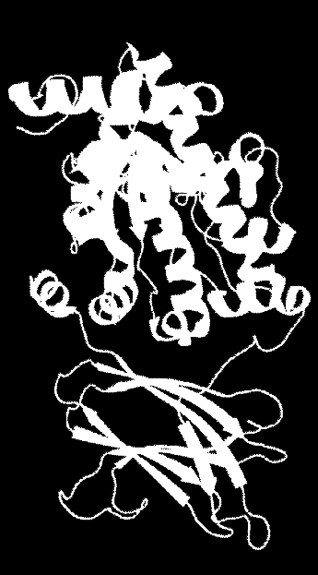
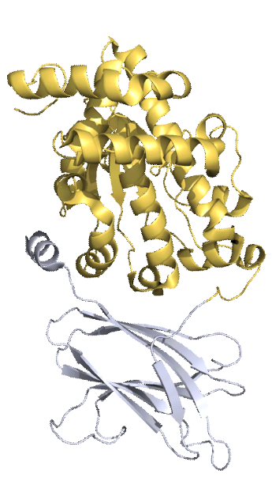
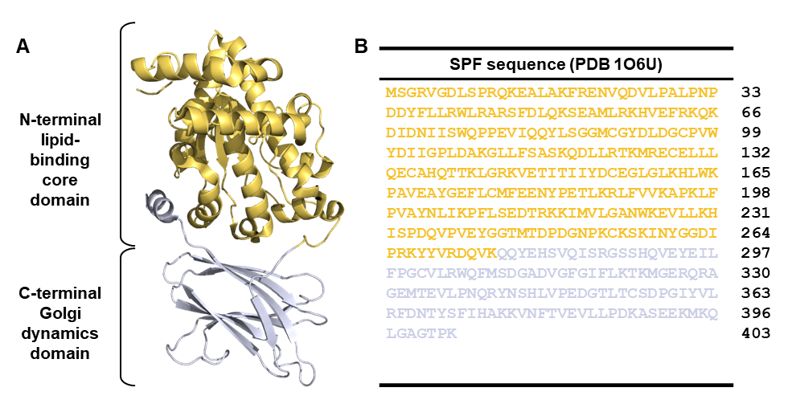
a
b
C
-
terminal
Golgi
dynamic
s domain
N
-
terminal
lipid
-
binding
core
domain
Full_length_SPF
sequence
(PDB 1O6U)
MSGRVGDLSPRQKEALAKFRENVQDVLPALPNP
DDYFLLRWLRARSFDLQKSEAMLRKHVEFRKQK
DIDNIISWQPPEVIQQYLSGGMCGYDLDGCPVW
YDIIGPLDAKGLLFSASKQDLLRTKMRECELLL
QECAHQTTKLGRKVETITIIYDCEGLGLKHLWK
PAVEAYGEFLCMFEENYPETLKRLFVVKAPKLF
PVAYNLIKPFLSEDTRKKIMVLGANWKEVLLKH
ISPDQVPVEYGGTMTDPDGNPKCKSKINYGGDI
PRKYYVRDQVK
QQYEHSVQISRGSSHQVEYEIL
FPGCVLRWQFMSDGADVGFGIFLKTKMGERQRA
GEMTEVLPNQRYNSHLVPEDGTLTCSDPGIYVL
RFDNTYSFIHAKKVNFTVEVLLPDKASEEKMKQ
LGAGTPK
33
66
99
132
165
198
231
264
297
330
363
396
403
Supplementary fig. 1 Crystal structure and amino acid sequence of supernatant protein factor (SPF). A. Overall structure of SPF as a ribbon diagram. The structure of SPF consists of a lipid-binding core domain (yellow) and a C-terminal Golgi dynamics (GOLD) domain (grey). The figure was prepared using PyMOL (http://www.pymol.org). B. Amino acid sequence of SPF (PBD code 1O6U). The amino acid residues of the lipid-binding core domain and the GOLD domain are color-coded in yellow and grey, respectively, in accordance with the colors of the protein structure.
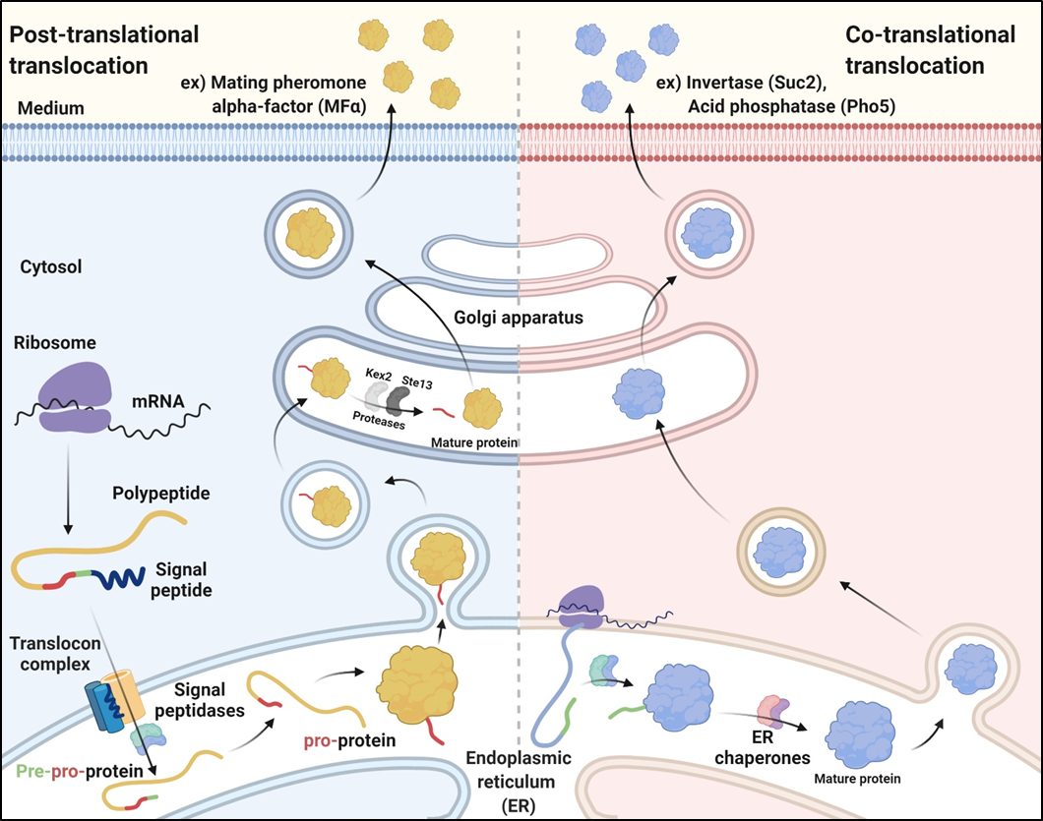
Supplementary fig. 2 Schematic representation of the post-translational and co-translational translocation that we exploited for metabolite secretion. In the post-translational translocation, a complex of ribosome with mRNA initiates and completes the translation of the mRNA in cytosol. Cytosolic chaperones maintain the nascent polypeptide in an unfolded state before it is delivered to a translocon complex in an ER membrane. After cleavage of the signal sequence by signal peptidases, the pre-pro-protein (colored in green, red and yellow, respectively) is released into the ER lumen where it is subject to further processing to form a pro-protein. The “pro” domain is removed in the Golgi apparatus by proteases, such as Kex2 and Ste13, resulting in formation of mature protein, followed by secretion. The yeast α-mating factor (MFα), for example, is secreted into an extracellular milieu by the post-translational translocation. Majority of secretory proteins adopt co-translational translocation. In contrast to the post-translational translocation that results in the delivery of fully translated polypeptide chains to the ER, the co-translational translocation allows translation of secretory proteins, simultaneously translocating the proteins through a channel in the ER membrane. When the nascent polypeptide is released, it is further modified by ER chaperones to form a mature protein. The mature protein is encapsulated into a transport vesicle, which is next transported to the Golgi apparatus. After a sorting process of secretory proteins in the Golgi, the mature protein is exported into an extracellular medium. Secretory proteins, such as invertase (Suc2) and acid phosphatase (Pho5), are secreted using the co-translational translocation.
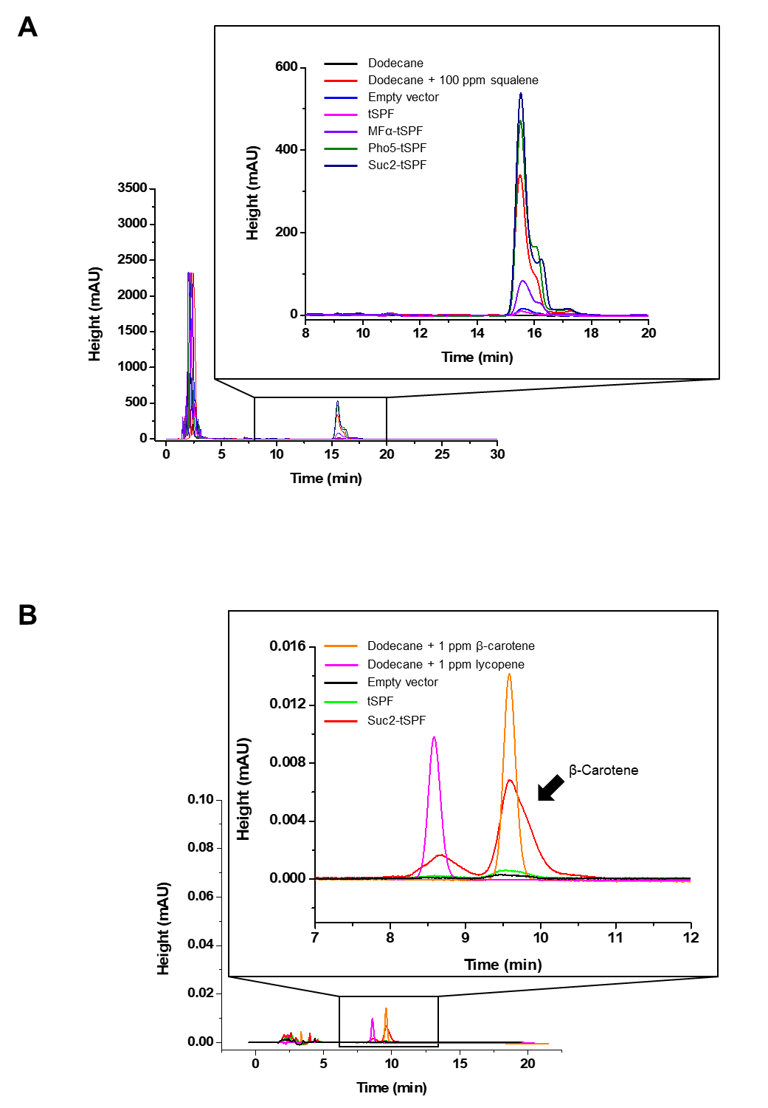
Supplementary fig. 3 HPLC chromatograms of secreted squalene (A) and β-carotene (B). Yeast cells were grown in a defined minimal medium supplemented with 2% (w/v) glucose and 10% (v/v) dodecane at 30°C for 144 h. The retention time was 15.5 min for squalene and 9.5 min for β-carotene.
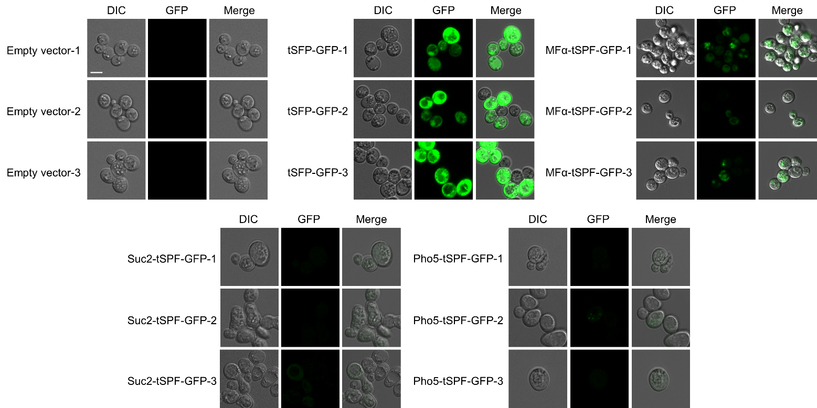
Supplementary fig. 4 Subcellular localization of tSPF-GFP tagged with different signal peptides. The GFP signals were significantly reduced in the cells expressing tSPF-GFP tagged with Suc2 or Pho5 signal peptide, indicating that Suc2-tSPF and Pho5-tSPF were successfully secreted out of cells. Confocal images were processed and analyzed using ZEN imaging software (Zeiss). Scale bar: 5 μm.
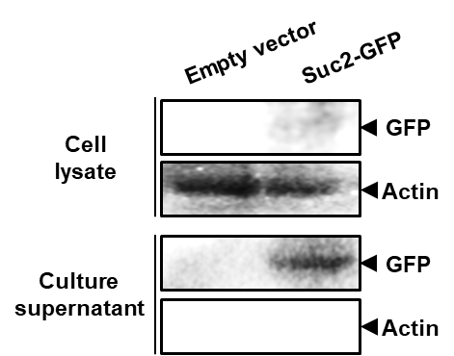
Supplementary fig. 5 Western blot analysis of cell lysate (top) and culture supernatant (bottom) by overexpression of Suc2-GFP. Suc2-GFP was detected using an anti-His antibody. Intracellular endogenous actin from culture supernatant serves as a marker for cell lysis.
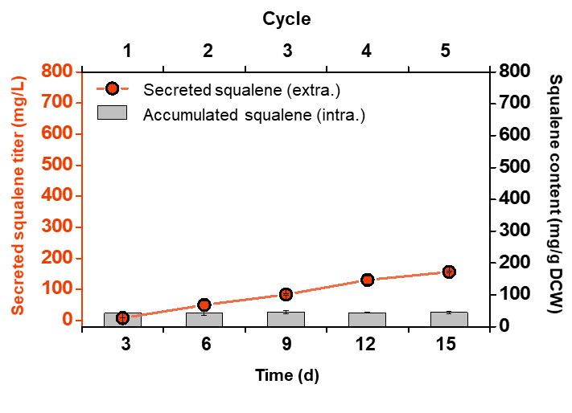
Supplementary fig. 6 Semi-continuous fermentation system using SQ strain. A growth medium was exchanged every 3 days (see method for details) and the levels of intra- and extracellular squalene were monitored over 15 days. All data represent the mean of biological triplicates and error bars show s.d.
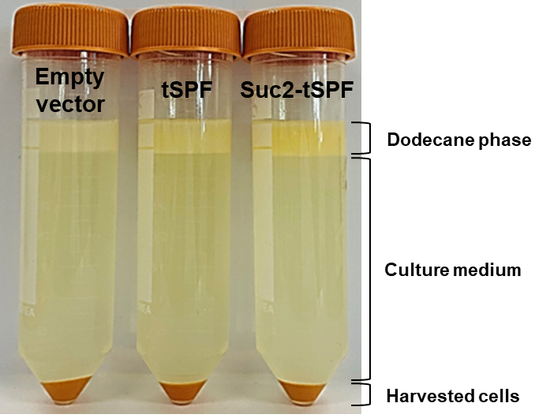
Supplementary fig. 7 The tSPF-mediated β-carotene secretion. The β-carotene-producing strains (BC), concurrent with overexpression of either tSPF or Suc2-tSPF, were grown in a defined minimal medium containing 2% (w/v) glucose and 10% (v/v) dodecane at 30 °C for 144 h. After 144 h cultivation, a noticeable increase of secreted β-carotene in the dodecane layer was observed by using the Suc2-tSPF expressing BC strain. In the culture medium, no β-carotene was detected.
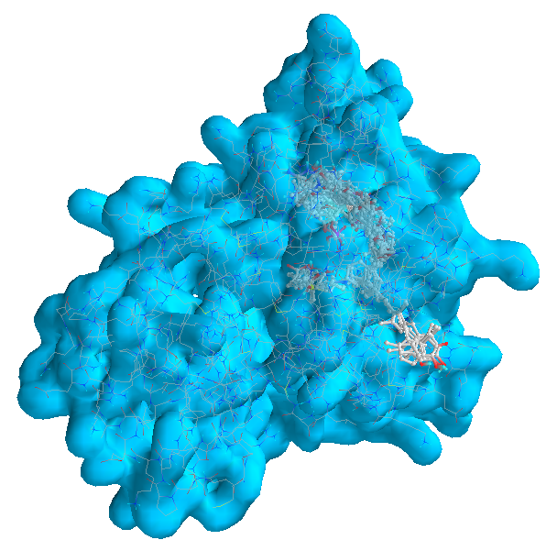
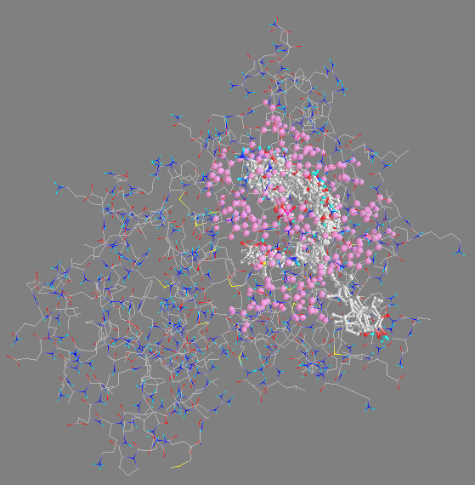

Supplementary fig. 8 Predicted complex structures of SPF A chain and terpene ligands. In a wireframe diagram (left), 43 different terpene ligands are overlappingly positioned within the binding pocket of SPF (PDB ID: 4OMK). The amino acid residues of the binding pocket are shown in magenta. In a surface diagram (right), end groups of several tetra-terpenes such as the isophorone group of zeaxanthin protruded out of the protein surface.
Supplementary Table 1 Squalene production of tSPF derivative-expressing SQ strain.
 | Squalene production
 | 72 h |  |  |  | 144 h
 | Cell growth (OD₆₀₀) | Intracellular  squalene (mg/L) | Intracellular  squalene (mg/g) | Extracellular  squalene (mg/L) |  | Cell growth (OD₆₀₀) | Intracellular  squalene (mg/L) | Intracellular  squalene (mg/g) | Extracellular  squalene (mg/L)
Empty vector | 20.23  (±2.24) | 574.98  (±92.14) | 69.32  (±10.59) | 3.99  (±1.09) |  | 23.92  (±3.91) | 648.03  (±26.69) | 66.07  (6.89) | 8.73  (±0.95)
tSPF | 17.79  (±2.22) | 401.51  (±53.63) | 55.05  (±4.75) | 3.67  (±0.36) |  | 19.91  (±2.68) | 485.04  (±109.94) | 59.43  (±6.69) | 13.82  (±3.96)
Suc2-tSPF | 12.98  (±0.46) | 476.9  (±75.73) | 89.61  (±10.95) | 166.62  (±15.07) |  | 13.87  (±1.63) | 557.03  (±116.14) | 97.93  (±9.96) | 226.51  (±20.62)
Pho5-tSPF | 11.9  (±1.76) | 252.17  (±49.47) | 51.68  (±5.74) | 64.55  (±30.06) |  | 14.38  (±0.48) | 426.85  (±115.13) | 72.39  (±15.28) | 190.09  (±3.12)
MFɑ-tSPF | 11.44  (±3.28) | 210.52  (±117.40) | 44.88  (±14.29) | 4.21  (±0.23) |  | 17.16  (±1.10) | 551.64  (±102.87) | 78.42  (±8.97) | 43.25  (±5.49)
Suc2-GFP | 20.04  (±1.07) | 483.8  (±11.74) | 48.28  (±0.76) | 3.29  (±1.04) |  | 18.94  (±0.03) | 563.06  (±2.03) | 59.52  (±11.74) | 4.71  (±0.62)

Supplementary Table 2 2.3-oxidosqualene production of tSPF derivative-expressing SQ strain.
 | 2.3-oxidosqualene production
 | 72 h |  | 144 h
 | Intracellular  2.3-oxidosqualene (mg/L) | Intracellular  2.3-oxidosqualene  (mg/g) | Intracellular  2.3-oxidosqualene  (mg/L) | Intracellular  2.3-oxidosqualene  (mg/g)
Empty vector | 0.62(±0.62) | 0.07(±0.07) | 0.44(±0.69) | 0.06(±0.07)
tSPF | 0.24(±0.42) | 0.03(±0.06) | ND | ND
Suc2-tSPF | 0.88(±0.27) | 0.15(±0.04) | 0.74(±0.00) | 0.05(±0.06)
Pho5-tSPF | 0.35(±0.35) | 0.06(±0.06) | 0.22(±0.34) | 0.11(±0.00)
MFɑ-tSPF | 0.42(±0.52) | 0.07(±0.09) | ND | ND
Suc2-GFP | ND | ND | ND | ND
*ND, not detected.
Supplementary Table 3 List of signal peptides in this study.
Signal peptide | Sequence | Length of sequence  (amino acids)
Suc2 | MLLQAFLFLLAGFAAKISA | 19
Pho5 | MFKSVVYSILAASLANA | 17
MFɑ | MRFPSIFTAVLFAASSALAAPVNTTTEDETAQIPAEAVIGYSDLEGDFDVAVLPFSNSTNNGLLFINTTIASIAAKEEGVSLEKREAEA | 89

Supplementary Table 4 Semi-continuous fermentation using the SQ strain that overexpresses Suc2-tSPF.
 |  | Squalene production
 | Time (d) | Cell growth (OD₆₀₀) | Intracellular  squalene  (mg/L) | Intracellular  squalene  (mg/g) | Extracellular  squalene  (mg/L)
Empty vector | 3 | 26.86 (±0.93) | 576.10  (±31.34) | 43.01  (±4.44) | 7.89  (±0.26)
Empty vector | 6 | 42.52  (±1.64) | 897.97  (±79.48) | 42.40  (±6.05) | 50.01  (±14.29)
Empty vector | 9 | 54.4  (±1.98) | 1232.04  (±92.62) | 45.44  (±5.74) | 83.74  (±3.45)
Empty vector | 12 | 68.4  (±0.79) | 1496.80  (±33.09) | 43.78  (±1.68) | 130.54  (±11.96)
Empty vector | 15 | 74.76  (±0.28) | 1687.02  (±129.45) | 45.14  (±3.70) | 156.41  (±3.21)
Suc2-tSPF | 3 | 16.04  (±1.53) | 494.39  (±4.65) | 62.17  (±7.81) | 173.32  (±14.14)
Suc2-tSPF | 6 | 27.84  (±1.47) | 828.31  (±48.44) | 59.54  (±0.97) | 363.85  (±10.80)
Suc2-tSPF | 9 | 41  (±0.42) | 1131.53  (±104.86) | 55.17  (±4.32) | 465.31  (±47.52)
Suc2-tSPF | 12 | 49.28  (±1.47) | 1349.04  (±37.75) | 54.83  (±3.85) | 579.39  (±4.07)
Suc2-tSPF | 15 | 52.6  (±2.66) | 1556.72  (±167.24) | 59.57  (±10.62) | 670.10  (±8.48)

Supplementary Table 5 β–Carotene production of BC strain that overexpresses tSPF or Suc2-tSPF.
 | ꞵ-Carotene production
 | 144 h
 | Cell growth (OD₆₀₀) | Intracellular  ꞵ-carotene (mg/L) | Intracellular  ꞵ-carotene (mg/g) | Extracellular  ꞵ-carotene (mg/L)
Empty vector | 22.58 (±0.93) | 9.52 (±0.68) | 0.84 (±0.01) | 0.06 (±0.07)
tSPF | 20.36 (±0.06) | 7.04 (±0.16) | 0.69 (±0.00) | 0.23 (±0.904)
Suc2-tSPF | 18.66 (±0.42) | 7.65 (±0.01) | 0.82 (±0.13) | 1.4 (±0.06)

Supplementary Table 6 Predicted binding energy of 43 different terpenes to a SPF protein. The binding energy was calculated using AutoDock Vina in PyRx.
Name | Molecular Formula | Structure | Binding energy
Pyruvate | C₃H₃O₃ | 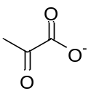 | -3.6
Glutamic acid | C₅H₉NO₄ | 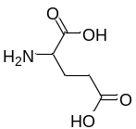 | -4.4
Geraniol | C₁₀H₁₈O | 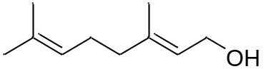 | -6.3
Linalool | C₁₀H₁₈O | 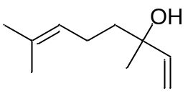 | -6.1
Myrcene | C₁₀H₁₆ | 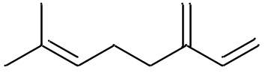 | -6.3
Nerol | C₁₀H₁₈O | 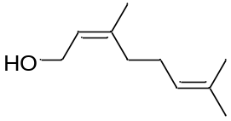 | -6.3
β-Ocimene | C₁₀H₁₆ | 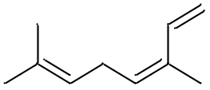 | -6.5
Camphor | C₁₀H₁₆O | 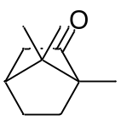 | -7.1
Carvacrol | C₁₀H₁₄O | 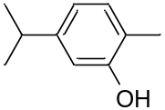 | -7.4
Carvone | C₁₀H₁₄O | 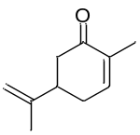 | -6.9
Limonene | C₁₀H₁₆ | 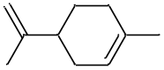 | -6.5
Menthol | C₁₀H₂₀O | 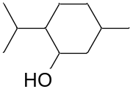 | -6.5
α-Pinene | C₁₀H₁₆ | 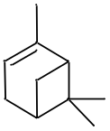 | -6.6
β-Farnesene | C₁₅H₂₄ | 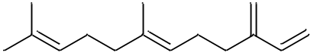 | -7.6
Nerolidol | C₁₅H₂₆O | 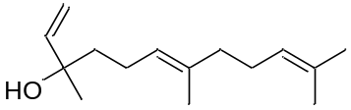 | -7.7
Amorphadiene | C₁₅H₂₄ | 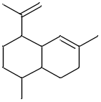 | -8.1
Artemisinin | C₁₅H₂₂O₅ | 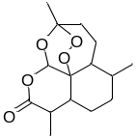 | -9.4
β-Bisabolene | C₁₅H₂₄ | 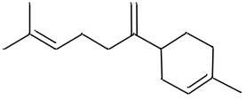 | -8.7
Capsidiol | C₁₅H₂₄O₂ | 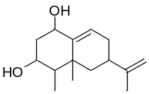 | -7.8
α-Cedrane | C₁₅H₂₆ | 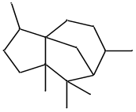 | -8.9
Valencene | C₁₅H₂₄ | 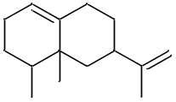 | -8.7
Phytane | C₂₀H₄₂ | 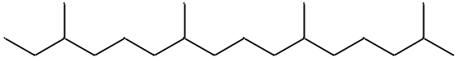 | -7.4
Phytol | C₂₀H₄₀O | 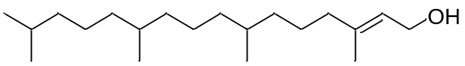 | -7.4
Abietane | C₂₀H₃₆ | 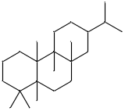 | -10.7
Camphorene | ‎C₂₀H₃₂ | 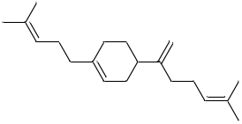 | -9.5
Clerodane | C₂₀H₃₈ | 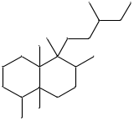 | -9.4
Kaurane | C₂₀H₃₄ | 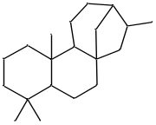 | -10.5
Labdane | C₂₀H₃₈ | 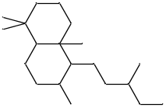 | -9.7
Pimarane | C₂₀H₃₆ | 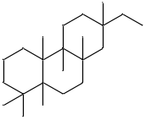 | -10.3
Retinol | C₂₀H₃₀O | 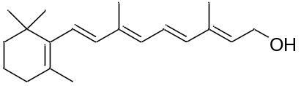 | -9.4
Taxane | C₂₀H₃₆ | 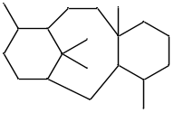 | -7.7
Tigliane | C₂₀H₃₄ | 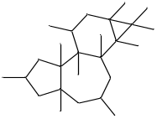 | -9.4
Oxidosqualene | C₃₀H₄₉O | 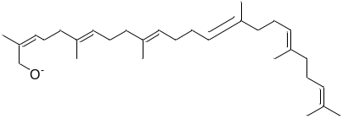 | -10.6
Squalene | C₃₀H₅₀ | 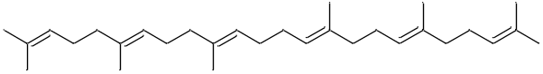 | -10.5
α-Amyrin | C₃₀H₅₀O | 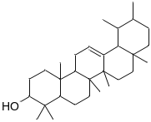 | -6.8
β-Amyrin | C₃₀H₅₀O | 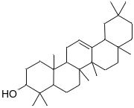 | -6.6
Hopane | C₃₀H₅₂ | 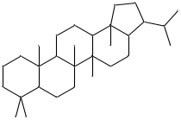 | -6.6
Lanosterol | C₃₀H₅₀O | 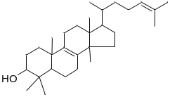 | -10.7
Oleanolic acid | C₃₀H₄₈O₃ | 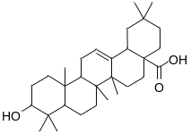 | -6.3
Lycopene | C₄₀H₅₆ | 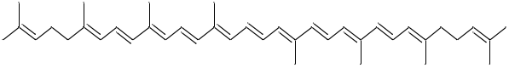 | -9.8
Astaxanthin | C₄₀H₅₂O₄ | 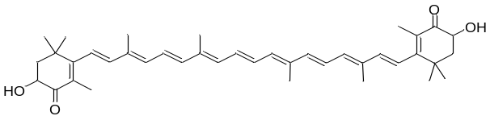 | -6.2
β-Carotene | C₄₀H₅₆ | 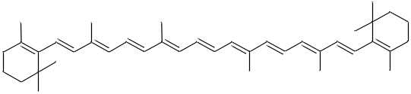 | -7.7
Lutein | C₄₀H₅₆O₂ | 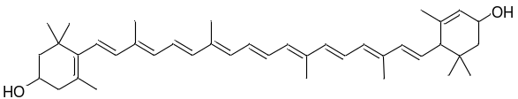 | -7.5
Rubixanthin | C₄₀H₅₆O | 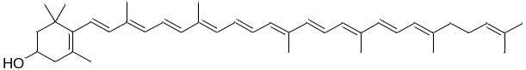 | -7.4
Zeaxanthin | C₄₀H₅₆O₂ | 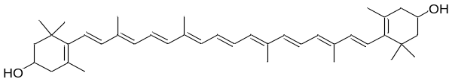 | -6.3

Supplementary Table 7 List of plasmids and strains in this study.
Plasmids / Strains | Description / Genotype | Reference
Plasmids
pJ1214 | Expression vector containing TEF1 promoter, 2µ high-copy origin, URA3 marker, Amp^{R}, and high-copy-number pUC origin of replication | ATUM
pD1214-FAKS | pJ1214 vector containing a secretion signal of MFα for secreted expression | ATUM
pSEC-Suc2-tSPF | Expression of tSPF with N-terminal Suc2 secretion signal and a C-terminal 6 × His tag, in pJ1214-FAKS | This study
pSEC-Pho5-tSPF | Expression of tSPF with N-terminal Pho5 secretion signal and a C-terminal 6 × His tag, in pJ1214-FAKS | This study
pSEC-MFα-tSPF | Expression of tSPF with a C-terminal 6 × His tag, in pJ1214-FAKS | This study
pSEC-tSPF | Expression of tSPF with a C-terminal 6 × His tag, in pJ1214 | This study
pLM494 | Harboring β-carotene biosynthesis genes (crtE, crtI, crtYB, tHMG1), CEN/ARS single-copy origin and URA3 marker | Addgene
p415-GPD | Expression vector containing GPD promoter, CEN/ARS single-copy origin and LEU2 marker | ¹
p415-BC | p415 harboring β-carotene biosynthesis genes (crtE, crtI, crtYB, tHMG1) | This study
p426-TEF1 | Expression vector containing TEF1 promoter, 2µ high-copy origin and URA3 marker | ¹
pSEC-Suc2-tSPF-GFP | Expression of tSPF with N-terminal Suc2 secretion signal and C-terminal GFP with a 6 × His tag, in p426-TEF1 | This study
pSEC-Pho5-tSPF-GFP | Expression of tSPF with N-terminal Pho5 secretion signal and C-terminal GFP with a 6 × His tag, in p426-TEF1 | This study
pSEC-MFα-tSPF-GFP | Expression of tSPF with N-terminal MFα secretion signal and C-terminal GFP with a 6 × His tag, in p426-TEF1 | This study
pSEC-tSPF-GFP | Expression of tSPF fused with GFP at C-terminal with a 6 × His tag, in p426-TEF1 | This study
Strains
CEN.PK2-1D | MATα ura3-52 trp1-289 leu2-3,112 his3Δ1 MAL2-8^{C} SUC2 | Euroscarf
SQ | CEN.PK2-1D Δleu2::P_{TEF1}-ERG20 Δlpp1::P_{GPD}tHMG1 Δopi1 Δdpp1::P_{GPD}tHMG1 Δypl062w::P_{GPD}tHMG1 | ²
Suc2-tSPF/SQ | SQ [pSEC-Suc2-tSPF] | This study
Pho5-tSPF/SQ | SQ [pSEC-Pho5-tSPF] | This study
MFα-tSPF/SQ | SQ [pSEC-MFα-tSPF] | This study
tSPF/SQ | SQ [pSEC-tSPF] | This study
Suc2-tSPF-GFP/SQ | SQ [pSEC-Suc2-tSPF-GFP] | This study
Pho5-tSPF-GFP/SQ | SQ [pSEC-Pho5-tSPF-GFP] | This study
MFα-tSPF-GFP/SQ | SQ [pSEC-MFα-tSPF-GFP] | This study
tSPF-GFP/SQ | SQ [pSEC-tSPF-GFP] | This study
BC | CEN.PK2-1D [p415-BC] | This study
tSPF/BC | CEN.PK2-1D [p415-BC] [pSEC-tSPF] | This study
Suc2-tSPF/BC | CEN.PK2-1D [p415-BC] [pSEC-Suc2-tSPF] | This study

Supplementary Table 8 List of primers in this study.
Primer name | Primer sequence (5’-3’)
SUC2 S.S-mut_F | GGCTGGTTTTGCAGCCAAAATATCTGCAATGGAATTCAGCGGTAGAGTTGG
SUC2 S.S-mut_R | AAAAGGAAAAGGAAAGCTTGCAAAAGCATTTTAAACTTAGATTAGATTGCTATGCTTTC
PHO5 S.S-mut_F | TTTAGCCGCTTCTTTGGCCAATGCAATGGAATTCAGCGGTAGAGTTGG
PHO5 S.S-mut_R | ATTGAATAAACAACAGATTTAAACATTTTAAACTTAGATTAGATTGCTATGCTTTC
S.S-DEL_F | ATGGAATTCAGCGGTAGAG
S.S-DEL_R | TTTAAACTTAGATTAGATTGCTATGC
Null_tSPF_speI_F | CGGACTAGTATGGAATTCAGCGGTAGAG
MFα_tSPF_speI_F | CTAGAACTAGTATGAGATTCCCATCTATTTTCAC
PHO5_tSPF_speI_F | CGGACTAGTATGTTTAAATCTGTTGTTTATTCAATTTTAGC
SUC2_tSPF_speI_F | CGGACTAGTATGCTTTTGCAAGCTTTCC
tSPF_3xGly_XhoI_R | CCGCTCGAGCCCCCCCCCCTTAACTTGATCTCTCACGTAGTAC
GFP_F | GGGTGGTGGTCTCGAGATGTCTAAAGGTGAAGAATTATTCACTG
GFP_R | AATTACATGACTCGAGTCAGTGGTGATGATGGTGATGTTTGTACAATTCATCCATACCATGGGTAATACCAGCAGCAGTAACAAATTCTAAC

Supplementary References
1 Lee, J. Y., Kang, C. D., Lee, S. H., Park, Y. K. & Cho, K. M. Engineering cellular redox balance in Saccharomyces cerevisiae for improved production of L‐lactic acid. Biotechnol. Bioeng. 112, 751-758 (2015).
2 Kim, J. E. et al. Tailoring the Saccharomyces cerevisiae endoplasmic reticulum for functional assembly of terpene synthesis pathway. Metab. Eng. 56, 50-59 (2019).

