Visual and tactile motion cues enhance the categorisation of novel object shapes
Martina A. Seveso¹, Rebecca J. Hirst¹, Alan O’Dowd¹, Ivan Camponagara² and Fiona N. Newell¹

¹School of Psychology and Institute of Neuroscience, Trinity College Dublin, Ireland.
²Department of Psychology, College of Natural and Health Sciences, Zayed University, Abu Dhabi, United Arab Emirates.

Author Note
Correspondence concerning this article should be addressed to Martina A. Seveso, Institute of Neuroscience, Trinity College Dublin, Dublin, Ireland. Email: sevesom@tcd.ie, ORCID: https://orcid.org/0000-0001-6566-4578.

Supplementary Information

Table S1 – Synchrony assessment task analysis and results across Experiments 1A,1B,2A,2B,3.
To assess perceived synchrony across three stimulus onset asynchronies (SOAs: 0 ms, 150 ms, 300 ms), we conducted separate Welch ANOVAs for each experiment. Assumption checks revealed violations of normality and homogeneity of variance in all experiments except Experiment 3 (see Table below). Accordingly, Welch ANOVA was used due to its robustness to such violations.

Experiment | Shapiro–Wilk (Normality) | Levene’s Test (Homogeneity) | Welch ANOVA (F, df) | p | Significant Pairwise Differences | Figure
Exp. 1A | W = 0.910, p < 0.001 | F (2, 483) = 3.85, p = 0.022 | 6.12 (2, 86.87) | 0.003 | 0ms –150 ms (p = 0.016)  0ms –300 ms (p = 0.005)  150ms –300 (p = 0.70, ns) | S5A
Exp. 1B | W = 0.937, p < 0.001 | F (2, 346) = 4.72, p = 0.009 | 13.54 (2, 61.83) | <0.001 | 0ms –150 ms (p < .0001)  0ms –300 ms (p = 0.0003)  150ms –300ms (p = 0.84, ns) | S5B
Exp. 2A | W = 0.930, p < 0.001 | F (2, 343) = 8.17, p < 0.001 | 5.80 (2, 63.88) | 0.005 | 0ms –300 ms (p =0 .003)  0ms –150 ms (p =0 .078, ns)  150ms –300ms (p = 0.46, ns) | S5C
Exp. 2B | W = 0.923, p < 0.001 | F (2, 344) = 6.39, p = 0.002 | 4.82 (2, 63.97) | 0.011 | 0ms –150 ms (p = 0.024)  0ms –300 ms (p = 0.025)  150ms –300ms (p = 0.99, ns) | S5D
Exp. 3 | W = 0.933, p < 0.001 | F (2, 345) = 2.53, p = .080 (ns) | 5.62 (2, 61.76) | 0.006 | 0ms –150 ms (p = 0.025)  0ms –300 ms (p = 0.006)  150ms –300ms (p = 0.80, ns) | S5E

Figure S1 – Predicted categorisation accuracy (on the logit scale) and odds ratios for accuracy by Cue Condition and Exemplar Type for the Experiment 1A and 1B.
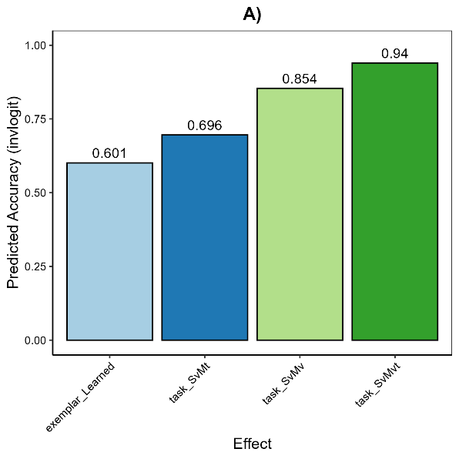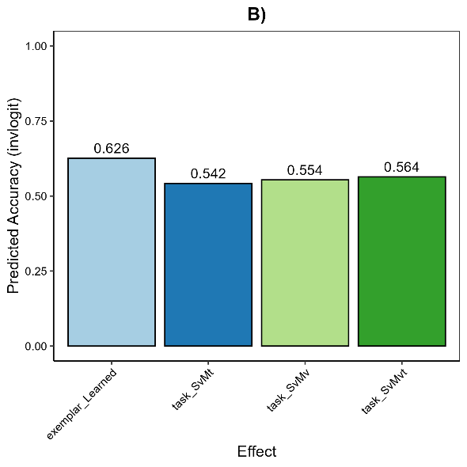
Figure S1.1 - Predicted categorisation accuracy by cue condition and exemplar type for Experiment 1A (Panel A) and Experiment 1B (Panel B), based on a binomial mixed-effects model. Accuracy is shown separately for learned and novel exemplars across four cue conditions (S_{v}, S_{v}M_{v}, S_{v}M_{t} and S_{v}M_{vt}). In the blocked presentation (1A), accuracy increases with the number of cues, indicating a multisensory benefit. In the interleaved presentation (1B), overall accuracy is lower and shows minimal variation across conditions. Points represent model-estimated accuracy with 95% confidence intervals.

- B)
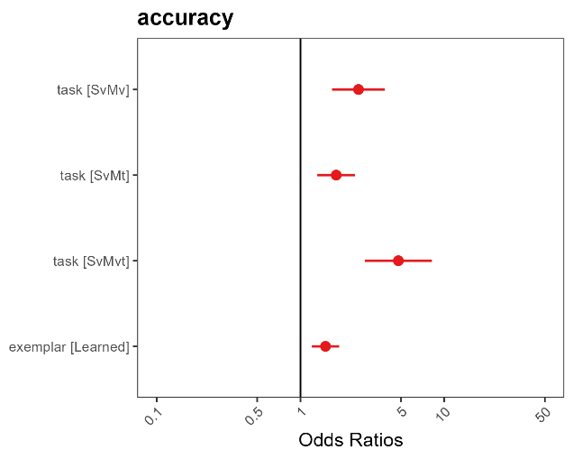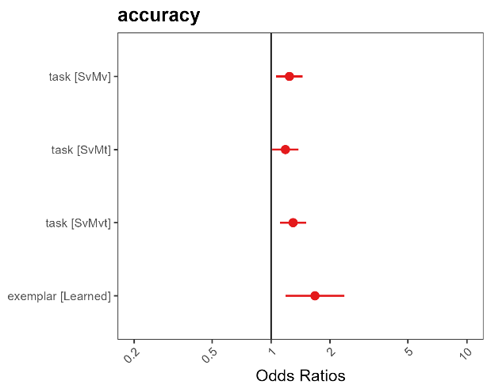
Figure S1.2 - Odds ratios for categorisation accuracy across cue conditions and exemplar types for Experiment 1A (Panel A) and Experiment 1B (Panel B), derived from a binomial mixed-effects model. Points indicate estimated odds ratios; horizontal lines show 95% confidence intervals. The vertical reference line at OR = 1 reflects chance-level performance. In the blocked condition (1a), odds of correct categorisation increase with additional cues. In the interleaved condition (1b), cue effects are attenuated.

Figure S2 – Predicted categorisation accuracy (on the logit scale) and odds ratios for accuracy by Cue Condition and Exemplar Type for the Experiment 2A and 2B.
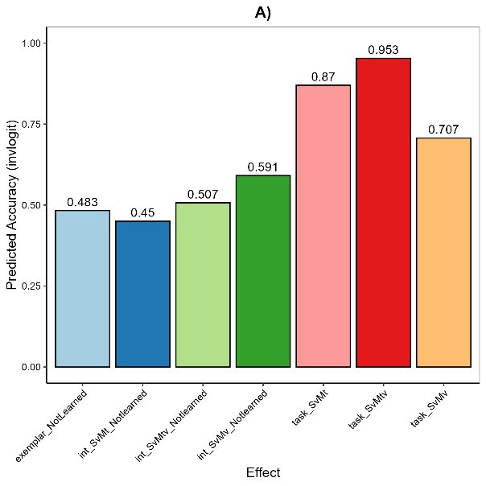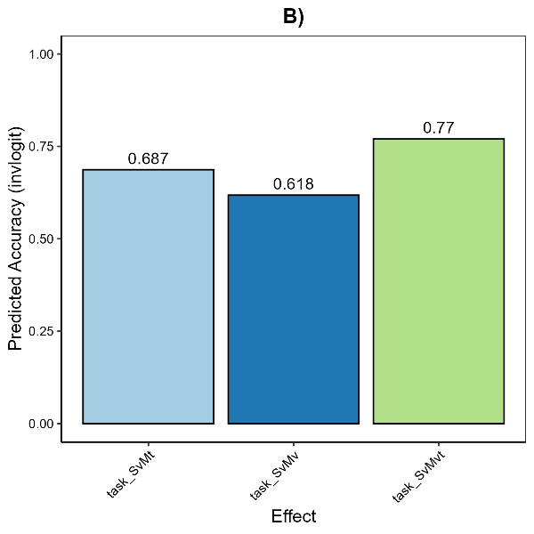
Figure S2.1- Predicted categorisation accuracy by cue condition and exemplar type for Experiment 2A (Panel A, blocked presentation) and Experiment 2B (Panel B, interleaved presentation), based on a binomial mixed-effects model. In Experiment 2A, accuracy increases with additional predictive cues, with the highest accuracy observed in the S_{v}M_{vt} condition, while performance in the S_{v} condition is substantially lower, particularly for novel exemplars. In Experiment 2B, accuracy also improves across conditions but shows reduced sensitivity to cue informativeness, suggesting that interleaved presentation may limit the benefit of multisensory integration.

- B)
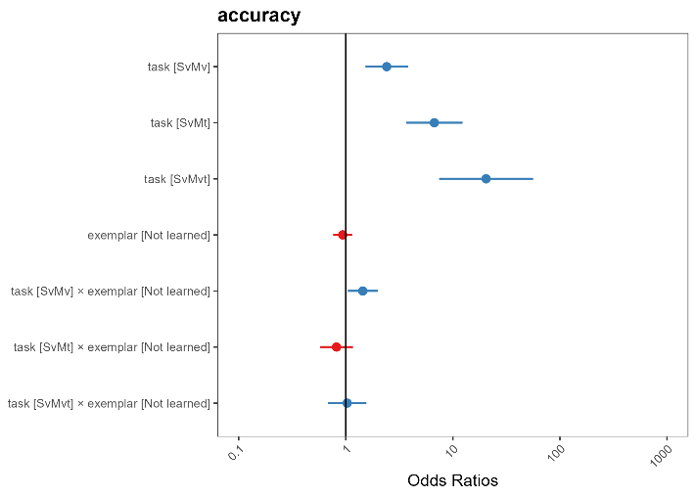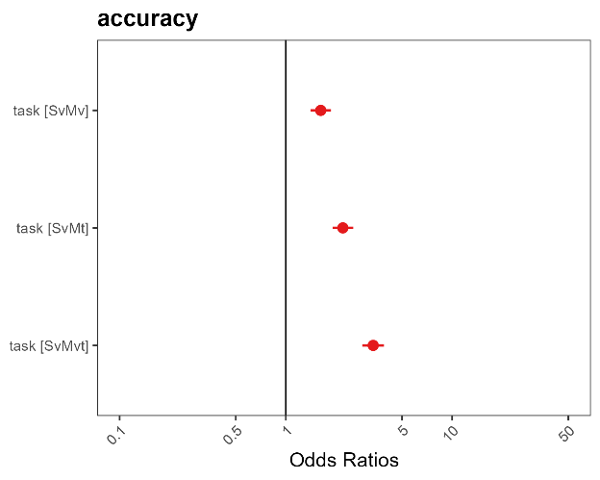
Figure S2.2 - Odds ratios for categorisation accuracy across cue conditions and exemplar types in Experiment 2A (Panel A) and Experiment 2B(Panel B), derived from binomial mixed-effects models. Each point represents the estimated odds ratio for a given condition, and horizontal lines indicate 95% confidence intervals. The vertical dashed line at OR = 1 marks the reference value (no difference). In Experiment 2A, odds ratios increase with additional cues, especially for novel exemplars. In Experiment 2B, cue effects are present but attenuated.

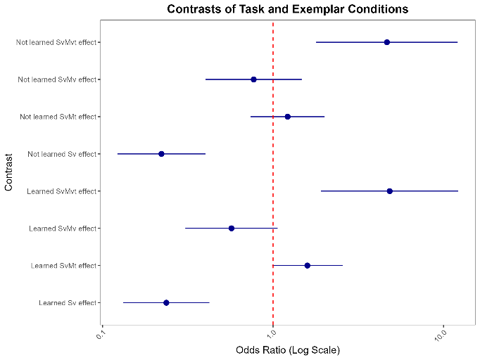
Figure S2.3 - Estimated odds ratios for contrasts between cue conditions and exemplar types in Experiment 2A, plotted on a logarithmic scale. Each point reflects the odds ratio for a specific contrast comparing categorisation accuracy across cue and exemplar combinations (S_{v}, S_{v}M_{v}, S_{v}M_{t} and S_{v}M_{vt}), with horizontal lines denoting 95% confidence intervals. The red dashed line at OR = 1 represents the baseline (no difference). Contrasts are displayed separately for learned and novel exemplars. Odds ratios above 1 indicate improved performance relative to baseline; confidence intervals not crossing the reference line suggest statistically significant effects.

Figure S3 –Predicted categorisation accuracy (on the logit scale) and odds ratios for accuracy by Cue Condition and Exemplar Type for Experiment 3.

- B) C)
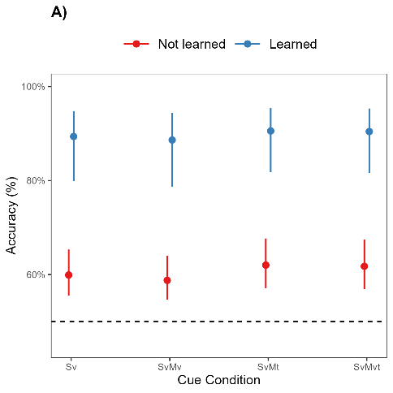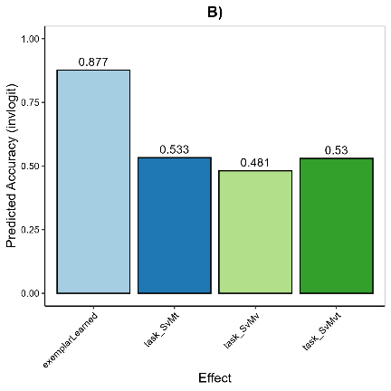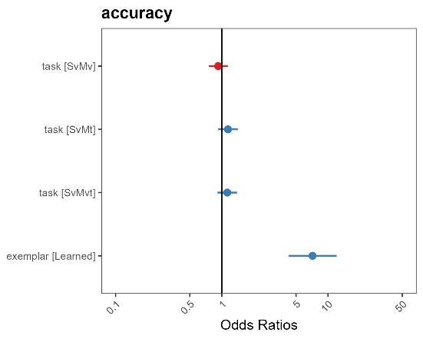

Predicted categorisation accuracy by cue condition (S_{v}, S_{v}M_{v}, S_{v}M_{t} and S_{v}M_{vt}) and exemplar type (learned vs. novel) in Experiment 3. Panel A shows accuracy estimates (%) indicating consistently high performance for learned exemplars across all conditions, with lower and less responsive accuracy for novel exemplars, suggesting limited generalisation and minimal benefit from untrained cues. Panel B presents accuracy on the logit scale, showing that cue condition had little impact on performance, particularly for novel exemplars. Panel C displays odds ratios with 95% confidence intervals from the mixed-effects model; values above 1 reflect improved accuracy relative to baseline, with the vertical line at OR = 1 indicating no effect.

Table S2
Model syntax and key for the final models fit across Experiments 1A, 1B, 2A, 2B and 3.
Model terms | Key
Experiment 1A
Model1<- glmer(accuracy ~ 1 +  task +  exemplar +  (1 + task + exemplar | ID), | Accuracy performance (binomial; 1,0)  Cue condition main effect  Exemplar type main effect  Random effects; random intercept + random Linear trial slope
data = acc_data,  family = binomial(link = "logit"),  control = glmerControl(optimizer = "bobyqa",  optCtrl = list(maxfun = 2e5))) | Data frame + model optimiser.
Experiment 1B
Model1<- glmer(accuracy ~ 1 +  task +  exemplar +  (1 + exemplar | ID), | Accuracy performance (binomial; 1,0)  Cue condition main effect  Exemplar type main effect  Random effects; random intercept + random Linear trial slope
data = acc_data,  family = binomial(link = "logit"),  control = glmerControl(optimizer = "bobyqa",  optCtrl = list(maxfun = 2e5))) | Data frame + model optimiser.
Experiment 2A
Model2<- glmer(accuracy ~ 1 +  task +  exemplar +  task:exemplar +  (1 + task | ID), | Accuracy performance (binomial; 1,0)  Cue condition main effect  Exemplar type main effect  Cue condition * Exemplar type interaction effect  Random effects; random intercept + random Linear trial slope
data = acc_data,  family = binomial(link = "logit"),  control = glmerControl(optimizer = "bobyqa",  optCtrl = list(maxfun = 2e5))) | Data frame + model optimiser.
Experiment 2B
Model4<- glmer(accuracy ~ 1 +  task +  (1 | ID), | Accuracy performance (binomial; 1,0)  Cue condition main effect  Random effects
data = acc_data,  family = binomial(link = "logit"),  control = glmerControl(optimizer = "bobyqa",  optCtrl = list(maxfun = 2e5))) | Data frame + model optimiser.
Experiment 3
Model14 <- glmer(accuracy ~ 0 +  task +  exemplar +  (1+ exemplar | ID), | Accuracy performance (binomial; 1,0)  Cue condition main effect  Exemplar type main effect  Random effects; random intercept + random Linear trial slope
data = acc_data,  family = binomial(link = "logit"),  control = glmerControl(optimizer = "bobyqa",  optCtrl = list(maxfun = 2e5))) | Data frame + model optimiser.

Table S3
Model fit indices across models in Experiments 1A, 1B, 2A, 2B and 3. The final model selected is in bold.
Experiment 1A
 | Likelihood ratio test | AIC | BIC
Model 1 (without interaction) |  | 9712.9 | 9857.0
Model 2 (with interaction) | χ²(3) = 6.40, p = 0.094 | 9712.5 | 9878.2
Model 1
R2 (conditional) | R2 marginal | ICC | RMSE
0.449 (44.9%) | 0.060 (6.0%) | 0.389 | 0.393
Experiment 1B
 | Likelihood ratio test | AIC | BIC
Model 1 (without interaction) |  | 7686.8 | 7741.3
Model 2 (with interaction) | χ²(3) = 1.47, p = 0.689 | 7766.3 | 7766.3
Model 1
R2 (conditional) | R2 marginal | ICC | RMSE
0.327 (32.7%) | 0.015 (1.5%) | 0.31 | 0.440
Experiment 2A
 | Likelihood ratio test | AIC | BIC
Model 1 (without interaction) |  | 6273.4 | 6376.7
Model 2 (with interaction) | χ²(3) = 9.09, p = .028 | 6270.3 | 6394.2
Model 2
R2 (conditional) | R2 marginal | ICC | RMSE
0.561 (56.1%) | 0.165 (16.5%) | 0.396 | 0.367
Experiment 2B
 | Likelihood ratio test | AIC | BIC
Model 2 (with interaction) | χ²(3) = 0.733, p = 0.866 | 8345.8 | 8407.3
Model 1 (without interaction) |  | 8340.5 | 8381.5
Model 3 (no interaction – exemplar main effect) | χ²(1) = 0.953, p = 0.329 | 8339.5 | 8373.6
Model 4 (no interaction – task main effect) | χ²(3) = 276.7, p < 0.001 | 8611.2 | 8631.7
Model 4
R2 (conditional) | R2 marginal | ICC | RMSE
0.165 (16.5%) | 0.49 (49%) | 0.114 | 0.455
Experiment 3
 | Likelihood ratio test | AIC | BIC
Model 2 (with interaction) | χ²(3) = 2.75, p =0 .432 | 4537.7 | 4613.1
Model 1 (without interaction) |  | 4534.5 | 4589.3
Model 3 (no interaction – task main effect) | χ²(3) = 5.251, p = 0.154 | 4533.7 | 4568.0
Model 4 (no interaction – exemplar main effect) | χ²(1) = 34.95, p < 0.001 | 4567.4 | 4615.4
Model 4
R2 (conditional) | R2 marginal | ICC | RMSE
0.121 (12.1%) | 0.551 (55.1%) | 0.431 | 0.312

Table S4
Predicted mean accuracy values per cue condition and exemplar type during test (95% confidence intervals).
 | Experiment 1A
 | Cue condition
 | S_{v} | 0.65 (0.56, 0.72)
 | S_{v}M_{v} | 0.82 (0.74, 0.88)
 | S_{v}M_{t} | 0.76 (0.70, 0.82)
 | S_{v}M_{vt} | 0.90 (0.83, 0.94)
 | Exemplar type
 | Learned | 0.82 (0.75, 0.88)
 | Not learned | 0.75 (0.69, 0.81)
 | Experiment 1B
 | Cue condition
 | S_{v} | 0.69 (0.59, 0.77)
 | S_{v}M_{v} | 0.73 (0.64, 0.80)
 | S_{v}M_{t} | 0.72 (0.63, 0.80)
 | S_{v}M_{vt} | 0.74 (0.65, 0.81)
 | Exemplar type
 | Learned | 0.76 (0.65, 0.84)
 | Not learned | 0.65 (0.59, 0.70)
Experiment 2A
Learned Exemplar x Cue condition
S_{v} |  | 0.61 (0.56, 0.66)
S_{v}M_{v} |  | 0.79 (0.69, 0.86)
S_{v}M_{t} |  | 0.91 (0.85, 0.95)
S_{v}M_{vt} |  | 0.97 (0.92, 0.99)
Not Learned Exemplar x Cue condition
S_{v} |  | 0.60 (0.54, 0.65)
S_{v}M_{v} |  | 0.84 (0.75, 0.90)
S_{v}M_{t} |  | 0.89 (0.89, 0.94)
S_{v}M_{vt} |  | 0.97 (0.92, 0.99)
Experiment 2B
Cue condition
S_{v} |  | 0.52 (0.45, 0.58)
S_{v}M_{v} |  | 0.63 (0.57, 0.69)
S_{v}M_{t} |  | 0.70 (0.65, 0.75)
S_{v}M_{vt} |  | 0.78 (0.73, 0.82)
 | Experiment 3
 | Exemplar type
 | Learned  Not learned | 0.96 (0.91, 0.98)  0.76 (0.70, 0.81)

Figure S4.1- Beta coefficients and 95% confidence intervals for the results of Experiment 1A. From left to right: Model with two-way interactions, model with main effects only.
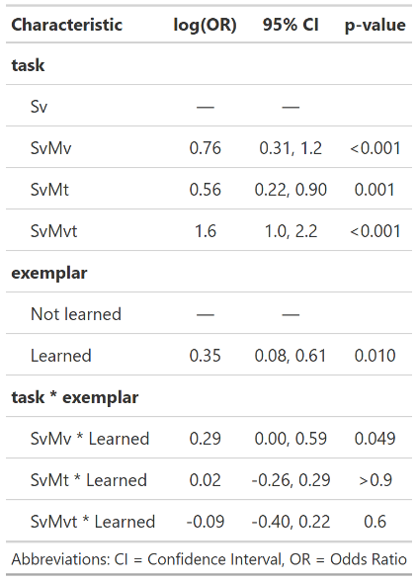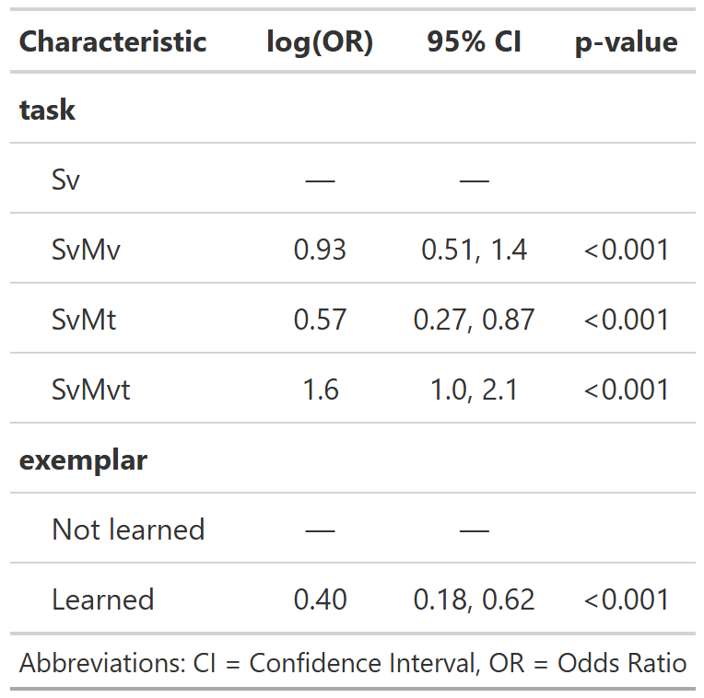
Figure S4.2 - Beta coefficients and 95% confidence intervals for the results of Experiment 1B. From left to right: Model with two-way interactions, model with main effects only.
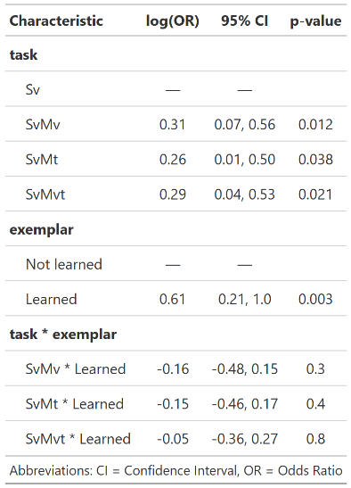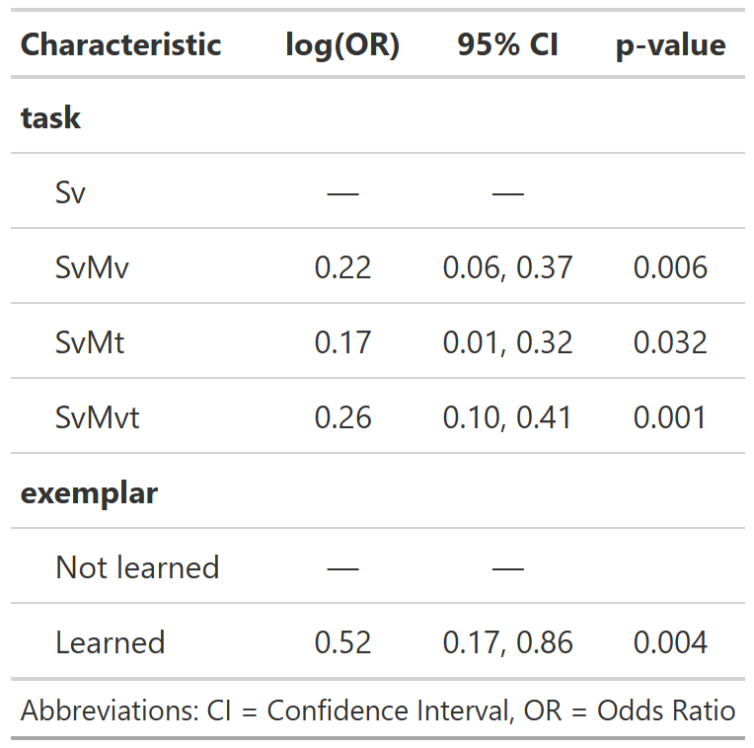
Figure S5.1 - Beta coefficients and 95% confidence intervals for the results of Experiment 2A. From left to right: Model with two-way interactions, model with main effects only.
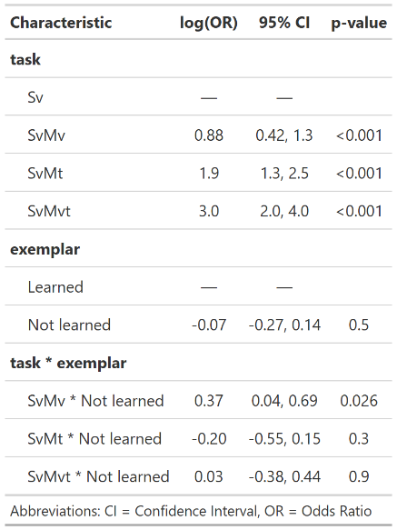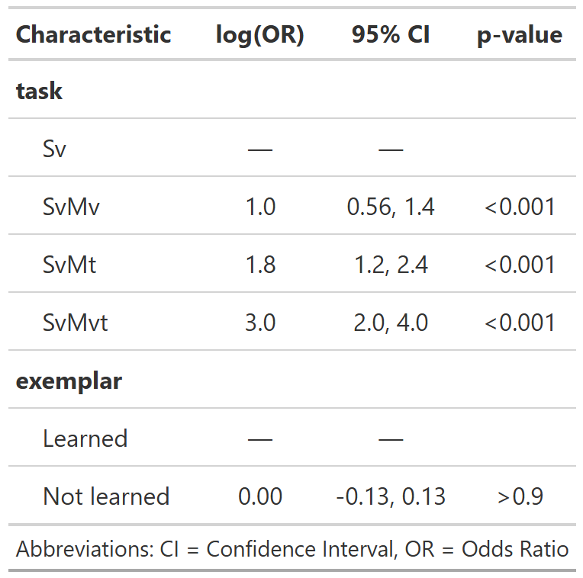

Figure S5.2 - Beta coefficients and 95% confidence intervals for the results of Experiment 2B. From left to right: Model with two-way interactions, model with main effects only.
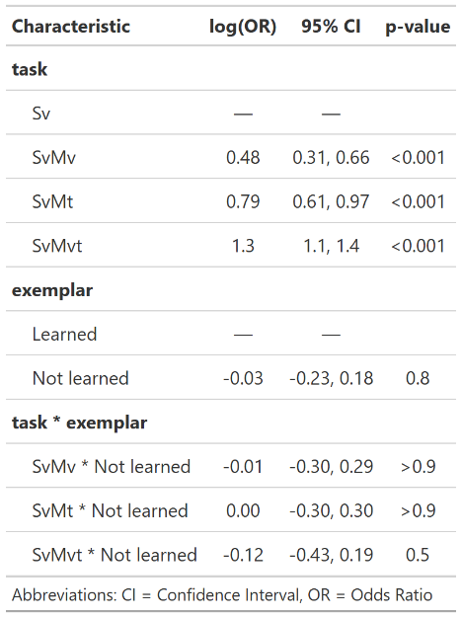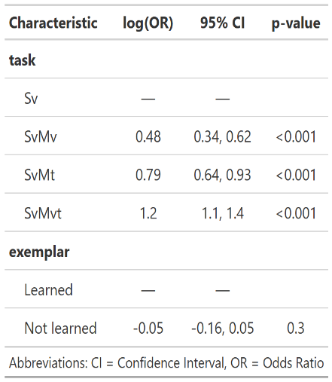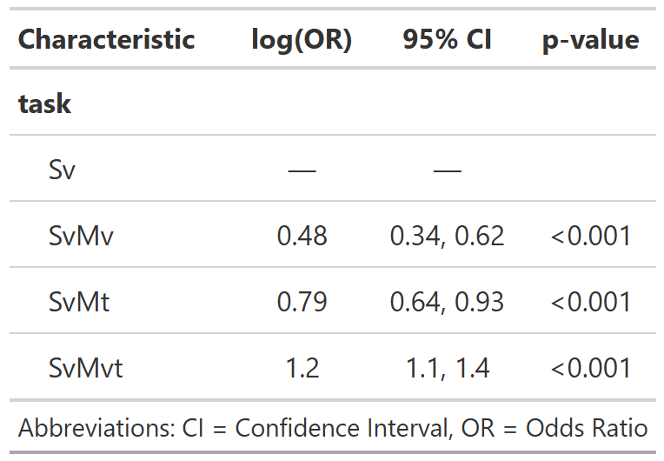
Figure S6 - Beta coefficients and 95% confidence intervals for the results of Experiment 3. From left to right: From left to right: Model with two-way interactions, model with main effects only.
