Supporting Information for

Coordination engineering enables highly selective generation of carbonate radical for enhanced Fenton-like reactions

Yuxiong Huang, Chenyang Huang, Xianjun Tan*

Institute of Environment and Ecology, Tsinghua Shenzhen International Graduate School, Tsinghua University, Shenzhen 518055, China.
*Corresponding author: Xianjun Tan
Email: tanxianjun@sz.tsinghua.edu.cn

Summary: This document includes 61 pages of supporting information, comprising 13 texts, 49 figures, 9 tables, and supporting references.

CONTENTS
Text S1–S13
Figure S1. SEM image of Co-TCN. 13
Figure S2. N₂ adsorption–desorption isotherms and corresponding pore size distribution curves for (a), (c) Co-N/C-T and (b), (d) Co-TCN. 14
Figure S3. Thermogravimetric analysis (TGA) profiles of the Co-TCN. 15
Figure S4. AC-STEM and corresponding EDS element mapping of Co-N/C-T. 16
Figure S5. XRD patterns of Co-TCN and Co-N/C-T. 17
Figure S6. EPR spectra of Co-N/C-T and Co-TCN. 18
Figure S7. XPS spectra for (a–c) Co-N/C-T and (d–f) Co-TCN. 19
Figure S8. XPS spectra of Co 2p regions for Co-N/C-T and Co-TCN. 19
Figure S9. WT analysis of EXAFS for of CoO. 20
Figure S10. FT-EXAFS fitting curves of Co-TCN and Co-N/C-T at R-space. 21
Figure S11. FT-EXAFS fitting curves of (a) Co-N/C-T and (b) Co-TCN at k-space. 21
Figure S12. Structural configurations of CoN₅ and CoN₆. 22
Figure S13. Effect of cobalt loading on SMX degradation efficiency in HCO₃⁻-mediated Fenton-like systems. 23
Figure S14. TOF comparison of Co-TCN-x and Co-N/C-T. 23
Figure S15. (a) EIS analysis and (b) cyclic voltametric curves of Co-N/C-T and Co-TCN. 24
Figure S16. (a) Speciation of H₂O₂-derived species as a function of pH; (b) Variation in equilibrium concentrations of HCO₃⁻ and H₂O₂ with pH. 25
Figure S17. ¹³C NMR spectrum of the reaction mixture containing H¹³CO₃⁻ (10 mM) and H₂O₂ (6 mM). 25
Figure S18. Absorbance changes of H₂O₂ in different systems. 26
Figure S19. Correlation between SMX removal and H₂O₂ consumption in Co-N/C-T/HCO₃⁻/H₂O₂ system. 26
Figure S20. Effects of various parameters on SMX degradation: (a, b) H₂O₂ concentration; (c, d) HCO₃⁻ concentration; (e, f) Catalyst dosage; (g, h) SMX concentration 27
Figure S21. Speciation of HCO₃⁻ in solution as a function of pH. 28
Figure S22. Temporal evolution of pH during the reaction. 28
Figure S23. Effect of initial pH on SMX degradation. 29
Figure S24. Effect of various coexisting anions on SMX removal in the Co-N/C-T/HCO₃⁻/H₂O₂ system. (Experimental conditions: [Catalyst]₀=0.2 g·L⁻¹, [HCO₃⁻]=10 mM, [H₂O₂]=6 mM, [SMX]=10 mg·L⁻¹, [Anion] = 10 mM) 30
Figure S25. Reusability evaluation of the Co-N/C-T system over five consecutive cycles. 31
Figure S26. (a) XRD patterns and (b) FT-IR spectra of fresh and used Co-N/C-T. 31
Figure S27. Configuration of the continuous-flow reactor system with Co-N/C-T/HCO₃⁻/H₂O₂ system. 32
Figure S28. Preliminary evaluation of SMX degradation efficiency in the continuous-flow reactor. 32
Figure S29. Atmosphere-dependent SMX removal performance in the Co-N/C-T/HCO₃⁻/H₂O₂ system. 33
Figure S30. Oxidation pathway of DMPO. 34
Figure S31. Probe experiments using benzoic acid and p-chlorobenzoic acid. 35
Figure S32. UV-vis spectra of ABDA in Co-N/C-T/HCO₃⁻/H₂O₂ and Co-TCN/HCO₃⁻/H₂O₂ system. 36
Figure S33. Effect of D₂O on SMX degradation in the Co-N/C-T/HCO₃⁻/H₂O₂ system. 37
Figure S34. Effect of high-valence metal species quenching on SMX degradation in the Co-N/C-T/HCO₃⁻/H₂O₂ system. 38
Figure S35. PMSO consumption and PMSO₂ formation in the Co-N/C-T/HCO₃⁻/H₂O₂ system. 38
Figure S36. Open-circuit potential measurement of Co-N/C-T. 39
Figure S37. Competitive probe experiments: the effect of the probe on (a) Co-N/C-T and (b) Co-TCN systems; and corresponding quasi-first-order kinetic curves for (c) Co-N/C-T and (d) Co-TCN. 40
Figure S38. Steady-state concentrations of ROS in Co-N/C-T and Co-TCN systems. 41
Figure S39. Optimized adsorption configuration of HCO₄⁻ on CoN₅ and CoN₆ coordination sites. 42
Figure S40. Differential charge density of CoN₅ and CoN₆ coordination structures. 43
Figure S41. PDOS diagram of Co-3d orbits in CoN₅ and CoN₆. 43
Figure S42. ELF maps of CoN₅ and CoN₆ structures. 44
Figure S43. PDOS diagram of Co-3d orbits and O-2p orbits. 44
Figure S44. The speciation of SMX as a function of pH in solution. 45
Figure S45. Optimized molecular configurations of SMX and its deprotonated form SMX⁻. 45
Figure S46. The condensed Fukui function values of SMX and SMX⁻. 46
Figure S47. Toxicity analysis of SMX degradation intermediates. 47
Figure S48. The removal efficiency of various organic pollutants in Co-N/C-T/HCO₃⁻/H₂O₂ system. 48
Figure S49. Electrostatic potential (ESP) distributions of different organic pollutants. 49

Table S1. Co contents of the synthesized Co SACs determined by ICP-OES analysis. 50
Table S2. EXAFS fitting parameters at the Co K-edge for various sample (S₀²=0.74). 51
Table S3. Theoretical parameters of Co-TCN (CoN₅) and Co-N/C-T (CoN₆) models. 52
Table S4. Catalytic performance of reported HCO₃⁻/H₂O₂-based systems. 53
Table S5. TOF values and key catalytic parameters of the catalysts. 54
Table S6. Second-order rate constants for reactions between ROS and quenchers or probe molecules. 55
Table S7. Definition of quantum chemistry descriptors. 56
Table S8. Detailed chemical information of the SMX degradation intermediates. 57
Table S9. Detection conditions of HPLC for different pollutants. 58

- Chemicals and reagents
Urea, melamine, sodium bicarbonate (NaHCO₃), potassium bromide (NaBr) and sodium sulfate (Na₂SO₄) were purchased from Sinopharm (China) Co., Ltd. 30% hydrogen peroxide (H₂O₂) was obtained from Xi Long (China) Co., Ltd. Cobalt nitrate hexahydrate (Co(NO₃)₂·6H₂O), L-histidine (L-his), sodium carbonate (Na₂CO₃), sodium phosphate dodecahydrate (Na₂HPO₄·12H₂O), phosphoric acid (H₃PO₄), sodium fluoride (NaF), sodium nitrate (NaNO₃), Sodium thiosulfate (Na₂S₂O₃), tert-butyl alcohol (TBA), N,N-dimethylaniline (DMA), dimethyl sulfoxide (DMSO), methyl phenyl sulfoxide (PMSO), benzoic acid (BA), p-chlorobenzoic acid (p-CBA), metronidazole (MET), naproxen (NPX), sulfadiazine (SDZ), bisphenol A (BPA), phenol (PhOH), and aniline were obtained from Aladdin (China) Co., Ltd. Methanol (MeOH), isopropanol (IPA), nitrotetrazolium blue chloride (NBT), sodium chloride (NaCl), humic acid (HA), magnesium chloride (MgCl₂), calcium chloride (CaCl₂), 5,5-dimethyl-1-pyrroline N-oxide (DMPO), potassium titanium oxide oxalate dihydrate (PTOOD), acetaminophen (APAP), ofloxacin (OFX), moxifloxacin (MOX), norfloxacin (NOR), ciprofloxacin (CIP) and sulfamethazine (SMZ) were purchased from Macklin (China) Co., Ltd. Sulfamethoxazole (SMX) was obtained from Sigma-Aldrich. Furfuryl alcohol (FFA) was purchased from Adamas (China) Co., Ltd. Acetonitrile was obtained from J.T.Baker (North America) Co., Ltd. 2,2,6,6-tetramethylpiperidin-1-yl oxyl hydrochloride (TEMP) was purchased from Dojindo (Japan) Co., Ltd. Tetracycline hydrochloride (TC) was obtained from Solarbio (China) Co., Ltd.
Ultrapure water (UPW) with a resistivity greater than 18.25 MΩ·cm was used in all experimental procedures. All chemicals were analytical grade or higher, and used as received without further purification.
- Materials synthesis
Synthesis of TCN and NC-T. Briefly, 10.8 g of urea and 1.2 g of melamine were thoroughly mixed in a glass dish, then grind it thoroughly in the mortar until even. The mixture was placed in a corundum crucible and calcined at 550 ℃ for 4 hours with a heating rate of 10 ℃ min⁻¹. After cooling, the material underwent secondary calcination in a tube furnace at 500 °C in Ar atmosphere for 2 hours at a heating rate of 5 °C min⁻¹. The products obtained after each calcination step were washed several times with water and ethanol, then dried overnight in a vacuum oven at 60 °C to obtain TCN and NC-T.
Synthesis of Co₃O₄. 1 g of cobalt nitrate and 1 mL of NH₃·H₂O were thoroughly mixed in 30 mL of deionized water and stirred for 2 hours to allow aging. The resulting precipitate was collected by centrifugation, washed several times with water and ethanol, and dried overnight at 60 °C. The dried solid was then calcined at 300 °C in air atmosphere for 1 hour with a heating rate of 5 °C min⁻¹. The final product was washed again with water and ethanol and dried overnight at 60 °C to obtain Co₃O₄.
- Continuous-flow experiments
For continuous-flow experiments, a 1 L reservoir containing 5 mg L⁻¹ SMX, 50 mM HCO₃⁻, and 30 mM H₂O₂ was used. Preliminary tests confirmed that direct oxidation of SMX by HCO₃⁻ and H₂O₂ to was minimal, with < 10% degradation of 5 mg L⁻¹ SMX observed after 24 h under these conditions.
The reservoir was connected via valve tubing to a Fenton-like filtration column containing 300 mg of Co–N/C–T catalyst mixed with 12 g of silica sand, operated at a flow rate of 60 mL h⁻¹ using a peristaltic pump.
Subsequently, the system’s performance was evaluated for a mixture of five contaminants (SMX, SDZ, SMZ, NOR, and CIP), each at an initial concentration of 500 μg L⁻¹. Effluent samples were collected at designated time points to analyze the removal efficiency of each pollutant.
- Characterization
The material’s microscopic morphology and atomic-level structural characteristics were systematically investigated using multi-scale electron microscopy analysis techniques. Scanning electron microscopy (SEM, Hitachi SU8010) and high-angle annular dark-field scanning transmission electron microscopy (HAADF-STEM, Thermo Scientific Talos F200S + SUPER X) were employed to examine morphology and physical structure, while energy-dispersive spectroscopy (EDS) was used for elemental mapping. The dispersion of metal atoms was further characterized via aberration-corrected scanning transmission electron microscopy (AC-STEM, Thermo Scientific Spectra 300).
Specific surface area and pore size parameters of the material were analyzed using a BET surface area analyzer (ASAP 2020 PLUS). Surface structure and functional groups of were analyzed using X-ray diffraction (XRD, XPert3 Powder), X-ray photoelectron spectroscopy (XPS, Thermo Scientific K-Alpha), and Fourier transform infrared absorption spectroscopy (FT-IR, Bruker tensor 27, Vertex 80v). Cobalt content was quantified by inductively coupled plasma optical emission spectroscopy (ICP-OES, PE Avio 200). Thermogravimetric analysis (TGA, TGA/DSC 1) was conducted to assess thermal stability and compositional changes with temperature. Surface vacancy sites were probed using electron spin resonance spectroscopy (ESR/EPR, Bruker EMX Plus).
The fine structure and coordination environment of cobalt were analyzed using X-ray absorption spectroscopy (XAS, TLS-07A). XAFS data processing was performed with Athena (version 0.9.26), including background subtraction and pre- and post-edge calibration. Fitting parameters included coordination number (CN), bond length (R), Debye–Waller factor (σ²), and energy shift (ΔE₀), with σ² set while other parameters were freely fitted. The k³-weighted fitting employed k-range of 3−14 Å⁻¹ and R range of 1− ~3 Å were used for the fitting of Co foil, and k-range of 3–10.5 Å⁻¹ and R range of 1− ~3 Å for samples. For wavelet transform analysis, χ(k) data exported from Athena was processed using the Hama Fortran code with parameters: R range 1–4 Å, k range 0−12 Å⁻¹, k weight 3, and a Morlet mother wavelet (κ=10, σ=1) to visualize the overall distribution.
- HPLC analysis
The concentration of organic pollutants were determined using an HPLC system (LC-20ADXR, Shimadzu, Japan) equipped with a C18 column (4.6 × 150 mm, 5 μm). For SMX detection, the mobile phase consisted of acetonitrile and 0.1% phosphoric acid solution (v/v = 30:70), with a flow rate of 0.9 mL min⁻¹. The injection volume was 5 μL, and the detection wavelength was set at 270 nm. Detailed analytical parameters for other target compounds are provided in Table S9.
- EPR analysis
Electron paramagnetic resonance (EPR) spectroscopy was employed to identify and analyze the characteristic peaks of the active species in the reaction system. The spin-trapping agent DMPO (50 mM) was used to capture steady-state •OH, CO₃^{•−} and O₂^{•−}, while TEMP (50 mM) was used for ¹O₂ detection.
For •OH and CO₃^{•−} measurements, the procedure followed the batch experiment protocol with the addition of pre-treated DMPO before H₂O₂ was introduced to initiate the reaction. After ~10 minutes of reaction, samples were filtered, drawn into capillary tubes, sealed with plasticine, and placed in paramagnetic tubes for EPR analysis to record the characteristic spectra.
For O₂^{•−} detection, the aqueous medium was replaced with methanol before adding DMPO to the system. For ¹O₂ detection, TEMP replaced DMPO under otherwise identical conditions.
- Electrochemical analysis
Electrochemical measurements were conducted using a CHI660E electrochemical workstation equipped with a conventional three-electrode system. A glassy carbon electrode served as the working electrode, an Ag/AgCl electrode was used as the reference electrode, and a platinum wire acted as the counter electrode. All measurements were performed in 0.1 M Na₂SO₄ aqueous electrolyte.
- NMR analysis
Liquid-state nuclear magnetic resonance (NMR, Bruker 500 MHz) spectroscopy was employed to analyze ¹³C-labeled HCO₃⁻ and to detect the possible formation of peroxymonocarbonate (HCO₄⁻). The test solution was prepared by mixing H¹³CO₃⁻, H₂O₂, D₂O, and water. The resulting mixture was transferred into an NMR tube and vortexed to eliminate air bubbles prior to measurement.
- Determination of H₂O₂ concentration
The concentration of H₂O₂ remaining in solution was determined by the colorimetric method. An aliquot of 0.8 mL of the reaction solution was collected and filtered through a 0.22 μm PTFE syringe filter into a sample tube containing 0.2 mL of excess L-histidine solution. Subsequently, 0.8 mL of PTOOD (0.05 M), 0.8 mL of H₂SO₄ (3 M), and 2.4 mL of ultrapure water were immediately added to the mixture, allowing it to react for 5 min to form a yellow-colored Ti(IV)-complex. The resulting solution was analyzed using a UV–Vis spectrophotometer (UV-2700i, Shimadzu) at its maximum absorbance wavelength (λ_{max}) of 396 nm.
- Kinetic analysis
The degradation efficiencies of SMX and other pollutants in HCO₃⁻-mediated Fenton-like systems were evaluated, and the corresponding reaction kinetics were modeled assuming pseudo-first-order behavior. The kinetic expression is given in Equation S1:
$$\begin{aligned}-\ln\left(\frac{C}{C_{0}}\right)=k_{obs}·t\#\left(S1\right)\end{aligned}$$
where k_{obs} is the apparent rate constant (min⁻¹); t is the reaction time (min); C is the concentration of pollutants at time t; C₀ is the initial concentration.

The normalized apparent reaction rate constant (K_{N}) was calculated using Equation S2:
$$\begin{aligned}K_{N}=\frac{k_{obs}}{\left[Catalyst\right]\left[HCO_{3}^{-}\right]\left[H_{2}O_{2}\right]}\#\left(S2\right)\end{aligned}$$
where K_{N} is normalized apparent reaction rate constant (min⁻¹g⁻³·L³), and [Catalyst], [HCO₃⁻], and [H₂O₂] represent the initial concentrations of catalyst, HCO₃⁻, and H₂O₂, respectively.
- Equilibrium between HCO₃⁻ and H₂O₂
The equilibrium reaction between HCO₃⁻ and H₂O₂, and the resulting equilibrium concentration of HCO₄⁻ can be described by Eqs. S3-S6:
$$\begin{aligned}HCO_{3}^{-}+H_{2}O_{2}→HCO_{4}^{-}+H_{2}O (K_{eq}=0.33M^{-1})\#\left(S3\right)\end{aligned}$$
$$\begin{aligned}K_{eq}=\frac{{\left[HCO_{4}^{-}\right]}_{e}}{{\left[HCO_{3}^{-}\right]}_{e}{\left[H_{2}O_{2}\right]}_{e}}\#\left(S4\right)\end{aligned}$$
Given the low H₂O₂ conversion ([H₂O₂]_{t}<<1), its equilibrium concentration can be approximated by Equation S5:
$$\begin{aligned}{\left[H_{2}O_{2}\right]}_{e}={\left[H_{2}O_{2}\right]}_{0}-{\left[HCO_{4}^{-}\right]}_{e}\#\left(S5\right)\end{aligned}$$
Thus, the equilibrium concentration of HCO₄⁻ can be derived as:
$$\begin{aligned}\left[HCO_{4}^{-}\right]≈\frac{K_{eq}{\left[HCO_{3}^{-}\right]}_{0}{\left[H_{2}O_{2}\right]}_{0}}{1+K_{eq}{\left[HCO_{3}^{-}\right]}_{0}}\#\left(S6\right)\end{aligned}$$
where K_{eq} is the reaction equilibrium constant; [M]_{e} denotes the equilibrium concentration of species M, and [M]₀ is the initial concentration.
- Analysis of steady-state ROS levels and their role in oxidative degradation
The steady state concentrations of ¹O₂ and CO₃^{•−} ([¹O₂]_{s} and [CO₃^{•−}]_{s}) in the Co-N/C-T/HCO₃⁻/H₂O₂ and Co-TCN/HCO₃⁻/H₂O₂ systems were quantified using MET and NPX as probe compounds. The probe compounds are at low concentrations (0.2 mg L⁻¹ for MET and NPX) to ensure minimal interference with SMX degradation. The second-order reaction rate constants between these organic probes and ROS are provided in Table S6.
(1) Determination of steady-state concentrations of ¹O₂ and CO₃^{•−}
The kinetic equations describing the reactions of MET and NPX with ROS are shown in Equation S7 to S10:
$$\begin{aligned}-\frac{d\left[MET\right]}{dt}=k_{MET,^{1}O_{2}}[^{1}O_{2}][MET]+k_{MET,CO_{3}^{∙-}}[CO_{3}^{∙-}][MET]\#\left(S7\right)\end{aligned}$$
$$\begin{aligned}-\frac{d\left[NPX\right]}{dt}=k_{NPX,^{1}O_{2}}[^{1}O_{2}][NPX]+k_{NPX,CO_{3}^{∙-}}[CO_{3}^{∙-}][NPX]\#\left(S8\right)\end{aligned}$$
Integrated forms:
$$\begin{aligned}-\ln{\frac{{\left[MET\right]}_{t}}{{\left[MET\right]}_{0}}}=(k_{MET,^{1}O_{2}}{[^{1}O_{2}]}_{s}+k_{MET,CO_{3}^{∙-}}{\left[CO_{3}^{∙-}\right]}_{s})·t=k_{obs,MET}·t\#\left(S9\right)\end{aligned}$$
$$\begin{aligned}-\ln{\frac{{\left[NPX\right]}_{t}}{{\left[NPX\right]}_{0}}}=(k_{NPX,^{1}O_{2}}{[^{1}O_{2}]}_{s}+k_{NPX,CO_{3}^{∙-}}{\left[CO_{3}^{∙-}\right]}_{s})·t=k_{obs,NPX}·t\#\left(S10\right)\end{aligned}$$
By plotting −ln([MET]_{t}/[MET]₀) and −ln([NPX]_{t}/[NPX]₀) versus time (t), the apparent rate constants k_{obs,MET} and k_{obs,NPX} were obtained via linear fitting. Solving these simultaneous equations yielded the steady-state concentrations of ¹O₂ and CO₃^{•−} ([¹O₂]_{s} and [CO₃^{•−}]_{s}).
(2) Assessment of the oxidative contribution of ¹O₂ and CO₃^{•−}
The contribution of individual ROS to SMX degradation were assessed using the calculated steady-state concentrations and SMX reaction kinetics, expressed in Equation S11:
$$\begin{aligned}-\frac{d\left[SMX\right]}{dt}=k_{SMX,^{1}O_{2}}[^{1}O_{2}][SMX]+k_{SMX,CO_{3}^{∙-}}[CO_{3}^{∙-}][SMX]\#\left(S11\right)\end{aligned}$$
$$\begin{aligned}-\ln{\frac{{\left[SMX\right]}_{t}}{{\left[SMX\right]}_{0}}}=(k_{SMX,^{1}O_{2}}{[^{1}O_{2}]}_{s}+k_{SMX,CO_{3}^{∙-}}{\left[CO_{3}^{∙-}\right]}_{s})·t=k_{obs,SMX}·t\#\left(S12\right)\end{aligned}$$
$$\begin{aligned}k_{obs,^{1}O_{2}}=k_{SMX,^{1}O_{2}}{[^{1}O_{2}]}_{s}\#\left(S13\right)\end{aligned}$$
$$\begin{aligned}k_{obs, CO_{3}^{·-}}=k_{SMX,CO_{3}^{∙-}}{\left[CO_{3}^{∙-}\right]}_{s}\#\left(S14\right)\end{aligned}$$
$$\begin{aligned}Contribution (\%)=\frac{k_{obs, ROS}}{k_{obs,SMX}}×100\%\#\left(S15\right)\end{aligned}$$
By plotting −ln([SMX]_{t}/[SMX]₀) versus time (t), the apparent rate constant k_{obs,SMX} can was determined. Using Equations S13-S15, the individual apparent rate contributions of ¹O₂ and CO₃^{•−} and their percentage contributions to SMX degradation were calculated.
- Theocratical calculation methods
Density functional theory (DFT) calculations were performed by using vienna ab initio simulation package (VASP) and Gaussian modules.
All spin-polarized density functional theory (DFT) calculations were performed using the Vienna Ab initio Simulation Package (VASP) within the generalized gradient approximation (GGA) framework, employing the Perdew–Burke–Ernzerhof (PBE) functional. The projected augmented wave (PAW) potentials were used to describe ionic cores, with a plane-wave basis set and a kinetic energy cutoff of 450 eV to account for valence electrons. Partial occupancies of Kohn–Sham orbitals were treated using Gaussian smearing with a width of 0.05 eV. Electronic self-consistency was achieved when the energy change was below 10⁻⁵ eV. The Monkhorst–Pack k-point mesh was set to 4 × 3 × 1 for both surface and adsorbed models. Geometry optimization was considered converged when the force on each atom was less than 0.02 eV/Å. The CoN₅ and CoN₆ surface models were constructed on g-C₃N₄ slabs with a 20 Å vacuum layer to eliminate interactions between periodic images. Grimme’s DFT-D3 methodology was employed to account for dispersion interactions in all adsorption models.
The minimum-energy conformations of all molecules studied were optimized using the Gaussian 16 program with density functional theory. Geometry optimizations employed the B3LYP-D3(BJ) functional with dispersion correction and the 6-31+G(d,p) basis set.^{1,2} Frequency calculations were performed at the same level of theory to confirm the absence of imaginary frequencies, ensuring convergence to local minima. Single-point energy calculations were subsequently carried out using the B3LYP-D3(BJ) functional with the larger 6-311+G(d,p) basis set. Solvent effects of water were included using the SMD solvation model.³
Additionally, the highest occupied molecular orbital (HOMO) and lowest unoccupied molecular orbital (LUMO) were analyzed using the Multiwfn 3.8 wavefunction analysis program.⁴ Electronic descriptors (including electrophilicity index, nucleophilicity index, softness, hardness, and Fukui functions) were calculated within the framework of conceptual density functional theory (CDFT). To visualize molecular orbitals, electrostatic potential (ESP) distributions, and Fukui functions, color-filled contour plots were generated using the Visual Molecular Dynamics (VMD) program.^{5,6}
The condensed Fukui function values for each atom were calculated as follows:
$$\begin{aligned}f_{A}^{+}=q_{N}^{A}-q_{N+1}^{A}\#\left(S16\right)\end{aligned}$$
$$\begin{aligned}f_{A}^{-}=q_{N-1}^{A}-q_{N}^{A}\#\left(S17\right)\end{aligned}$$
$$\begin{aligned}f_{A}^{0}={(q}_{N-1}^{A}-q_{N+1}^{A})/2\#\left(S18\right)\end{aligned}$$
where $f_{A}^{+}$, $f_{A}^{-}$, $f_{A}^{0}$ represent the Fukui index of electrophilic attack, nucleophilic attack and radical attack, respectively, and $q_{N}^{A}$, $q_{N+1}^{A}$, $q_{N-1}^{A}$ represent the atomic charges of atom A in the neutral, anionic, and cationic states, respectively.

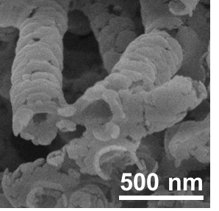
Figure S1. SEM image of Co-TCN.
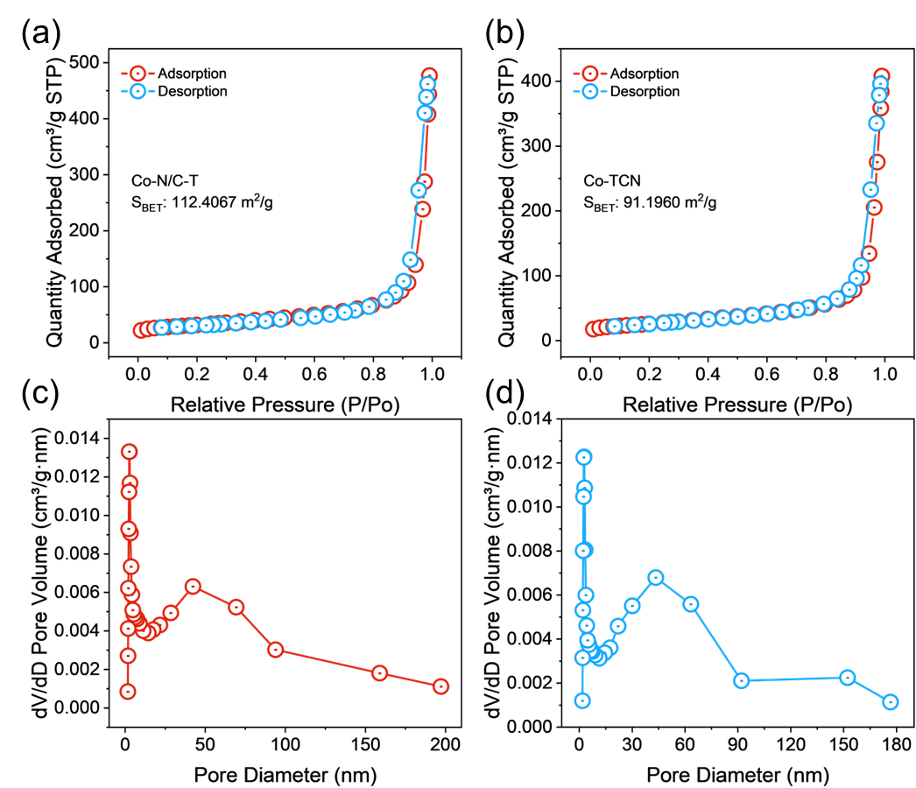
Figure S2. N₂ adsorption–desorption isotherms and corresponding pore size distribution curves for (a), (c) Co-N/C-T and (b), (d) Co-TCN.

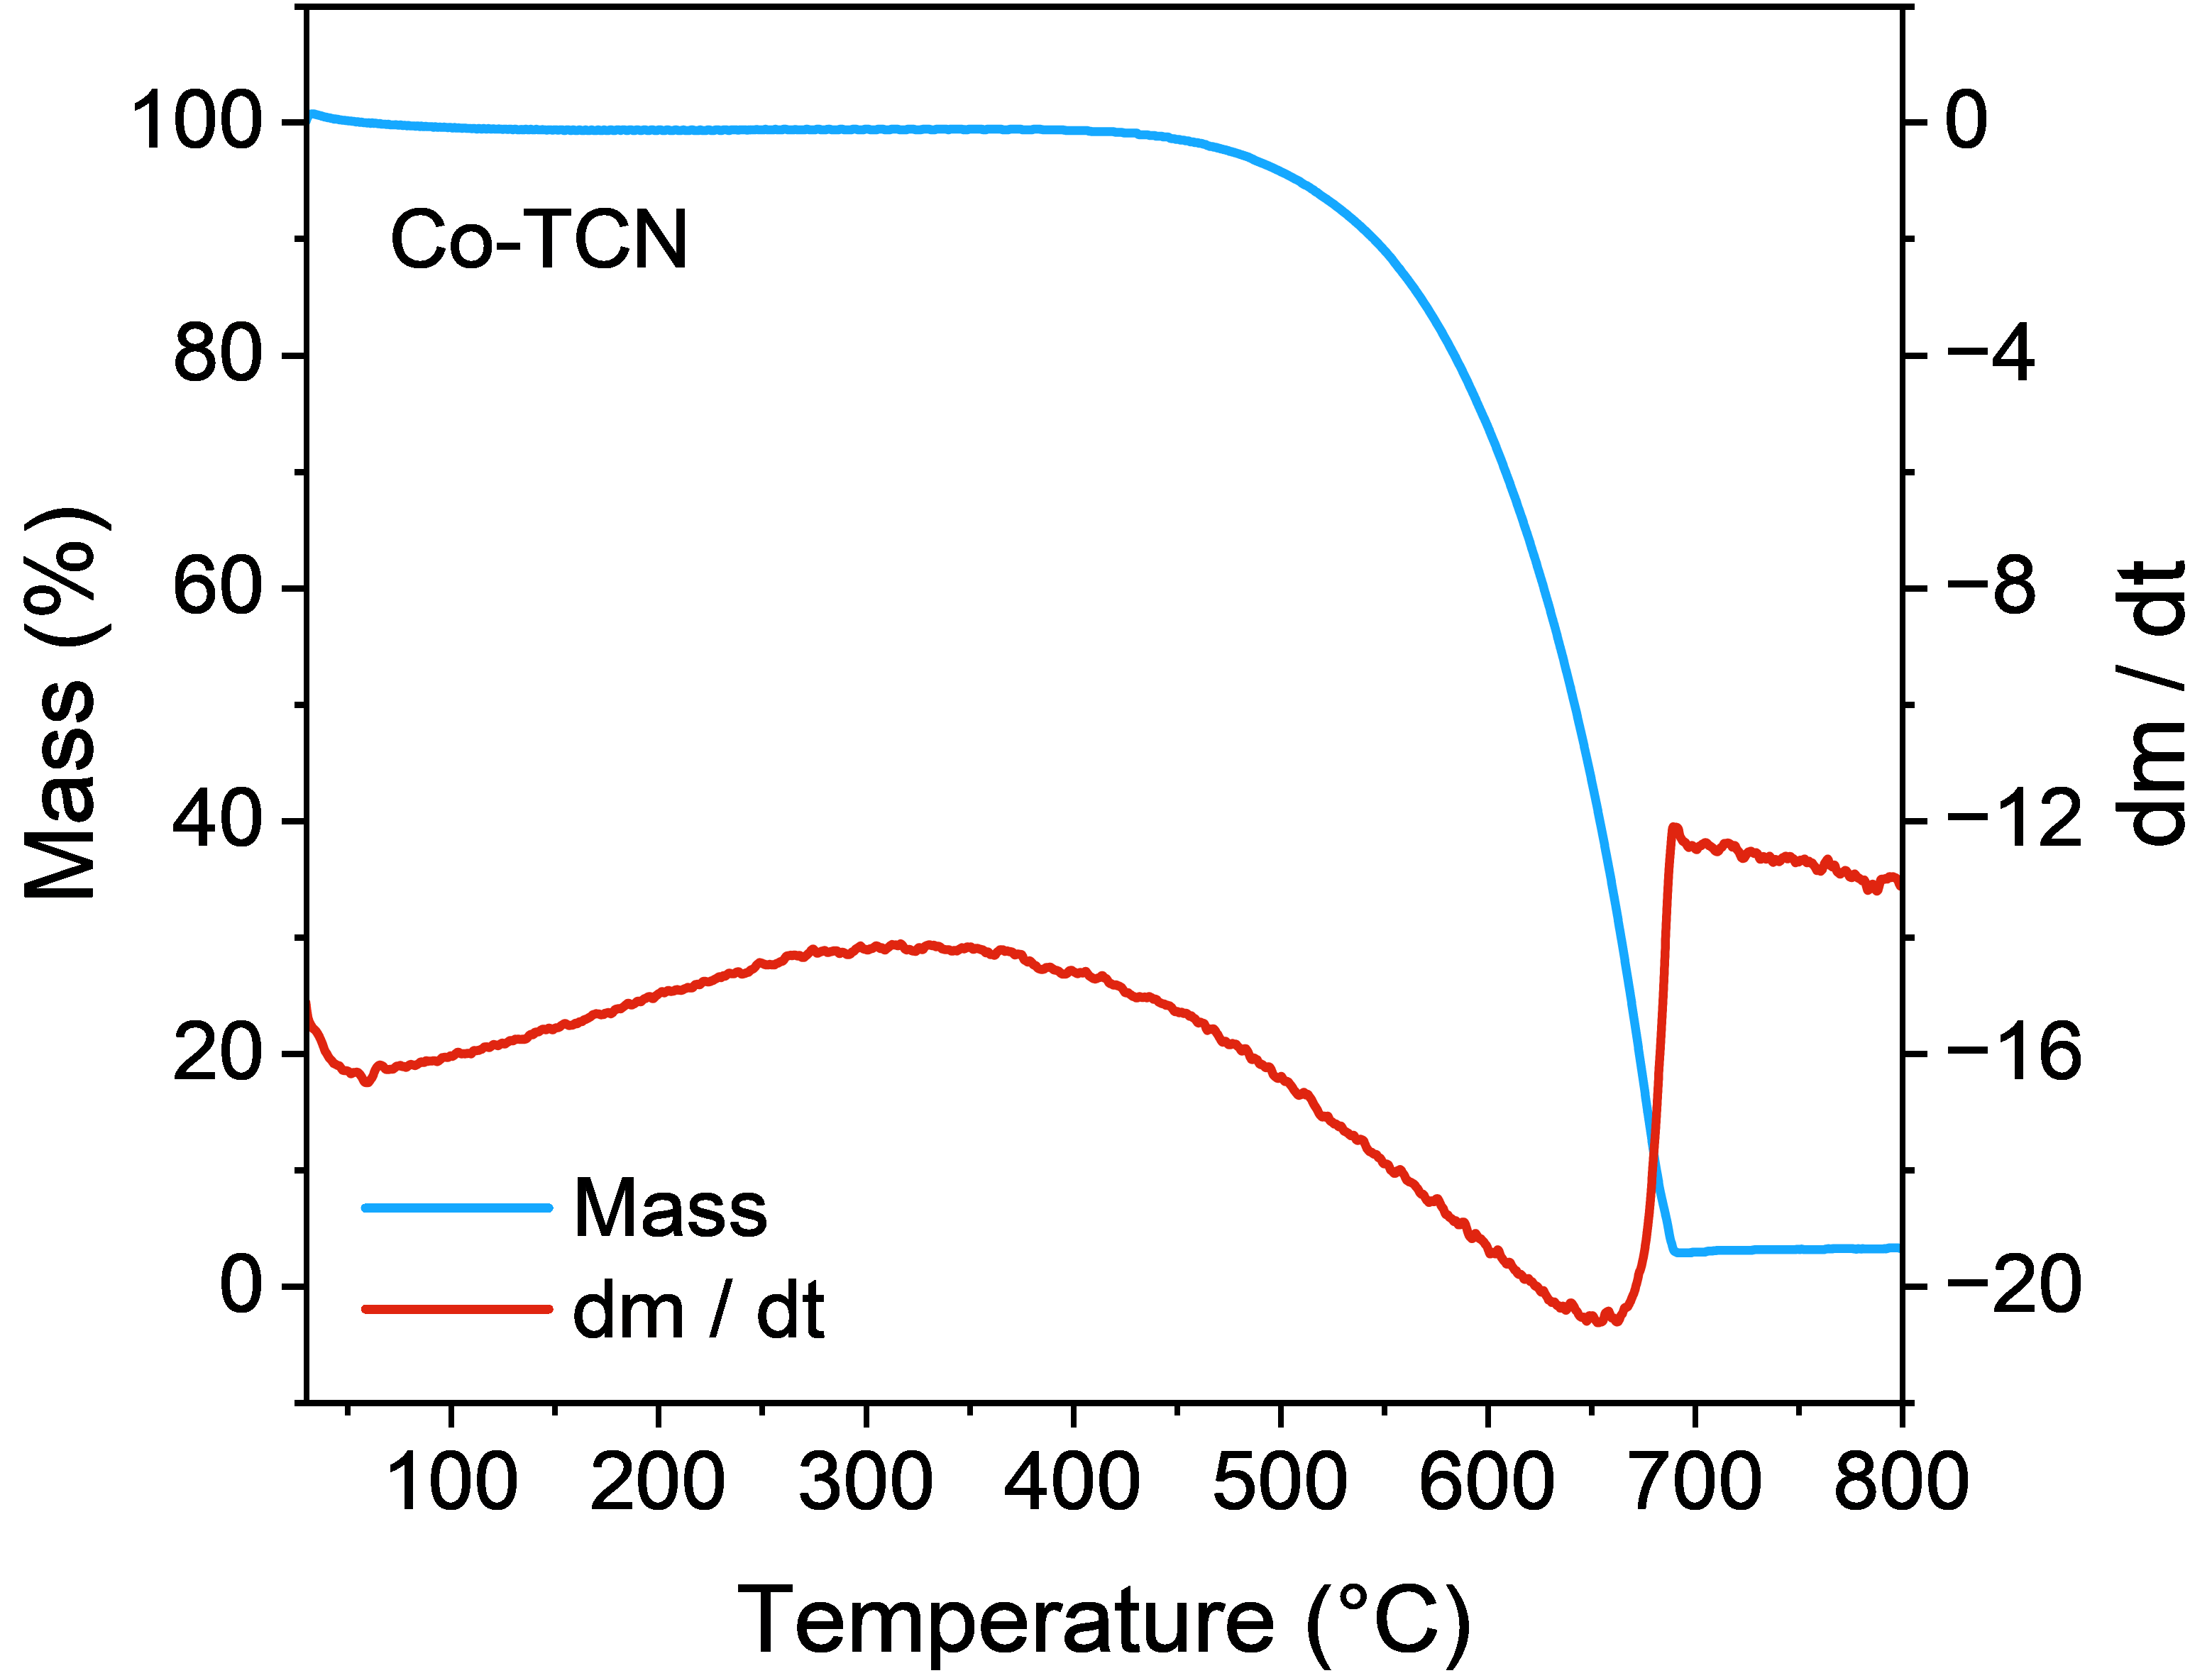
Figure S3. Thermogravimetric analysis (TGA) profiles of the Co-TCN.

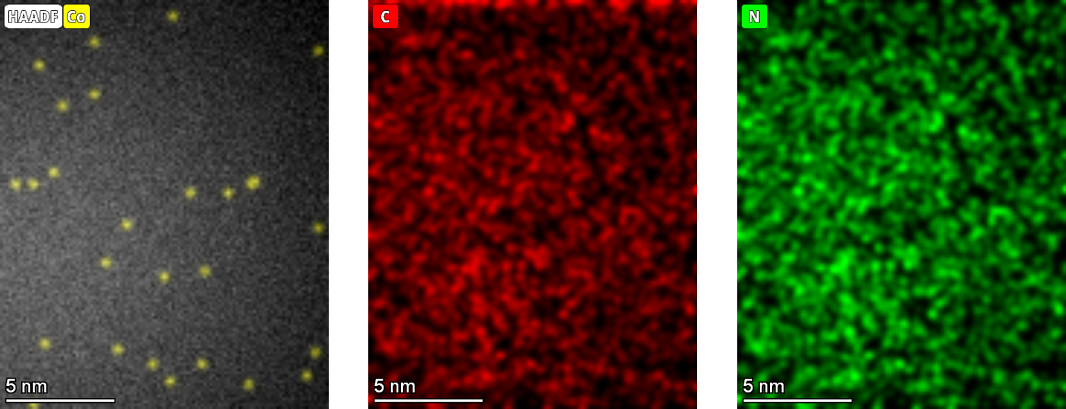
Figure S4. AC-STEM and corresponding EDS element mapping of Co-N/C-T.

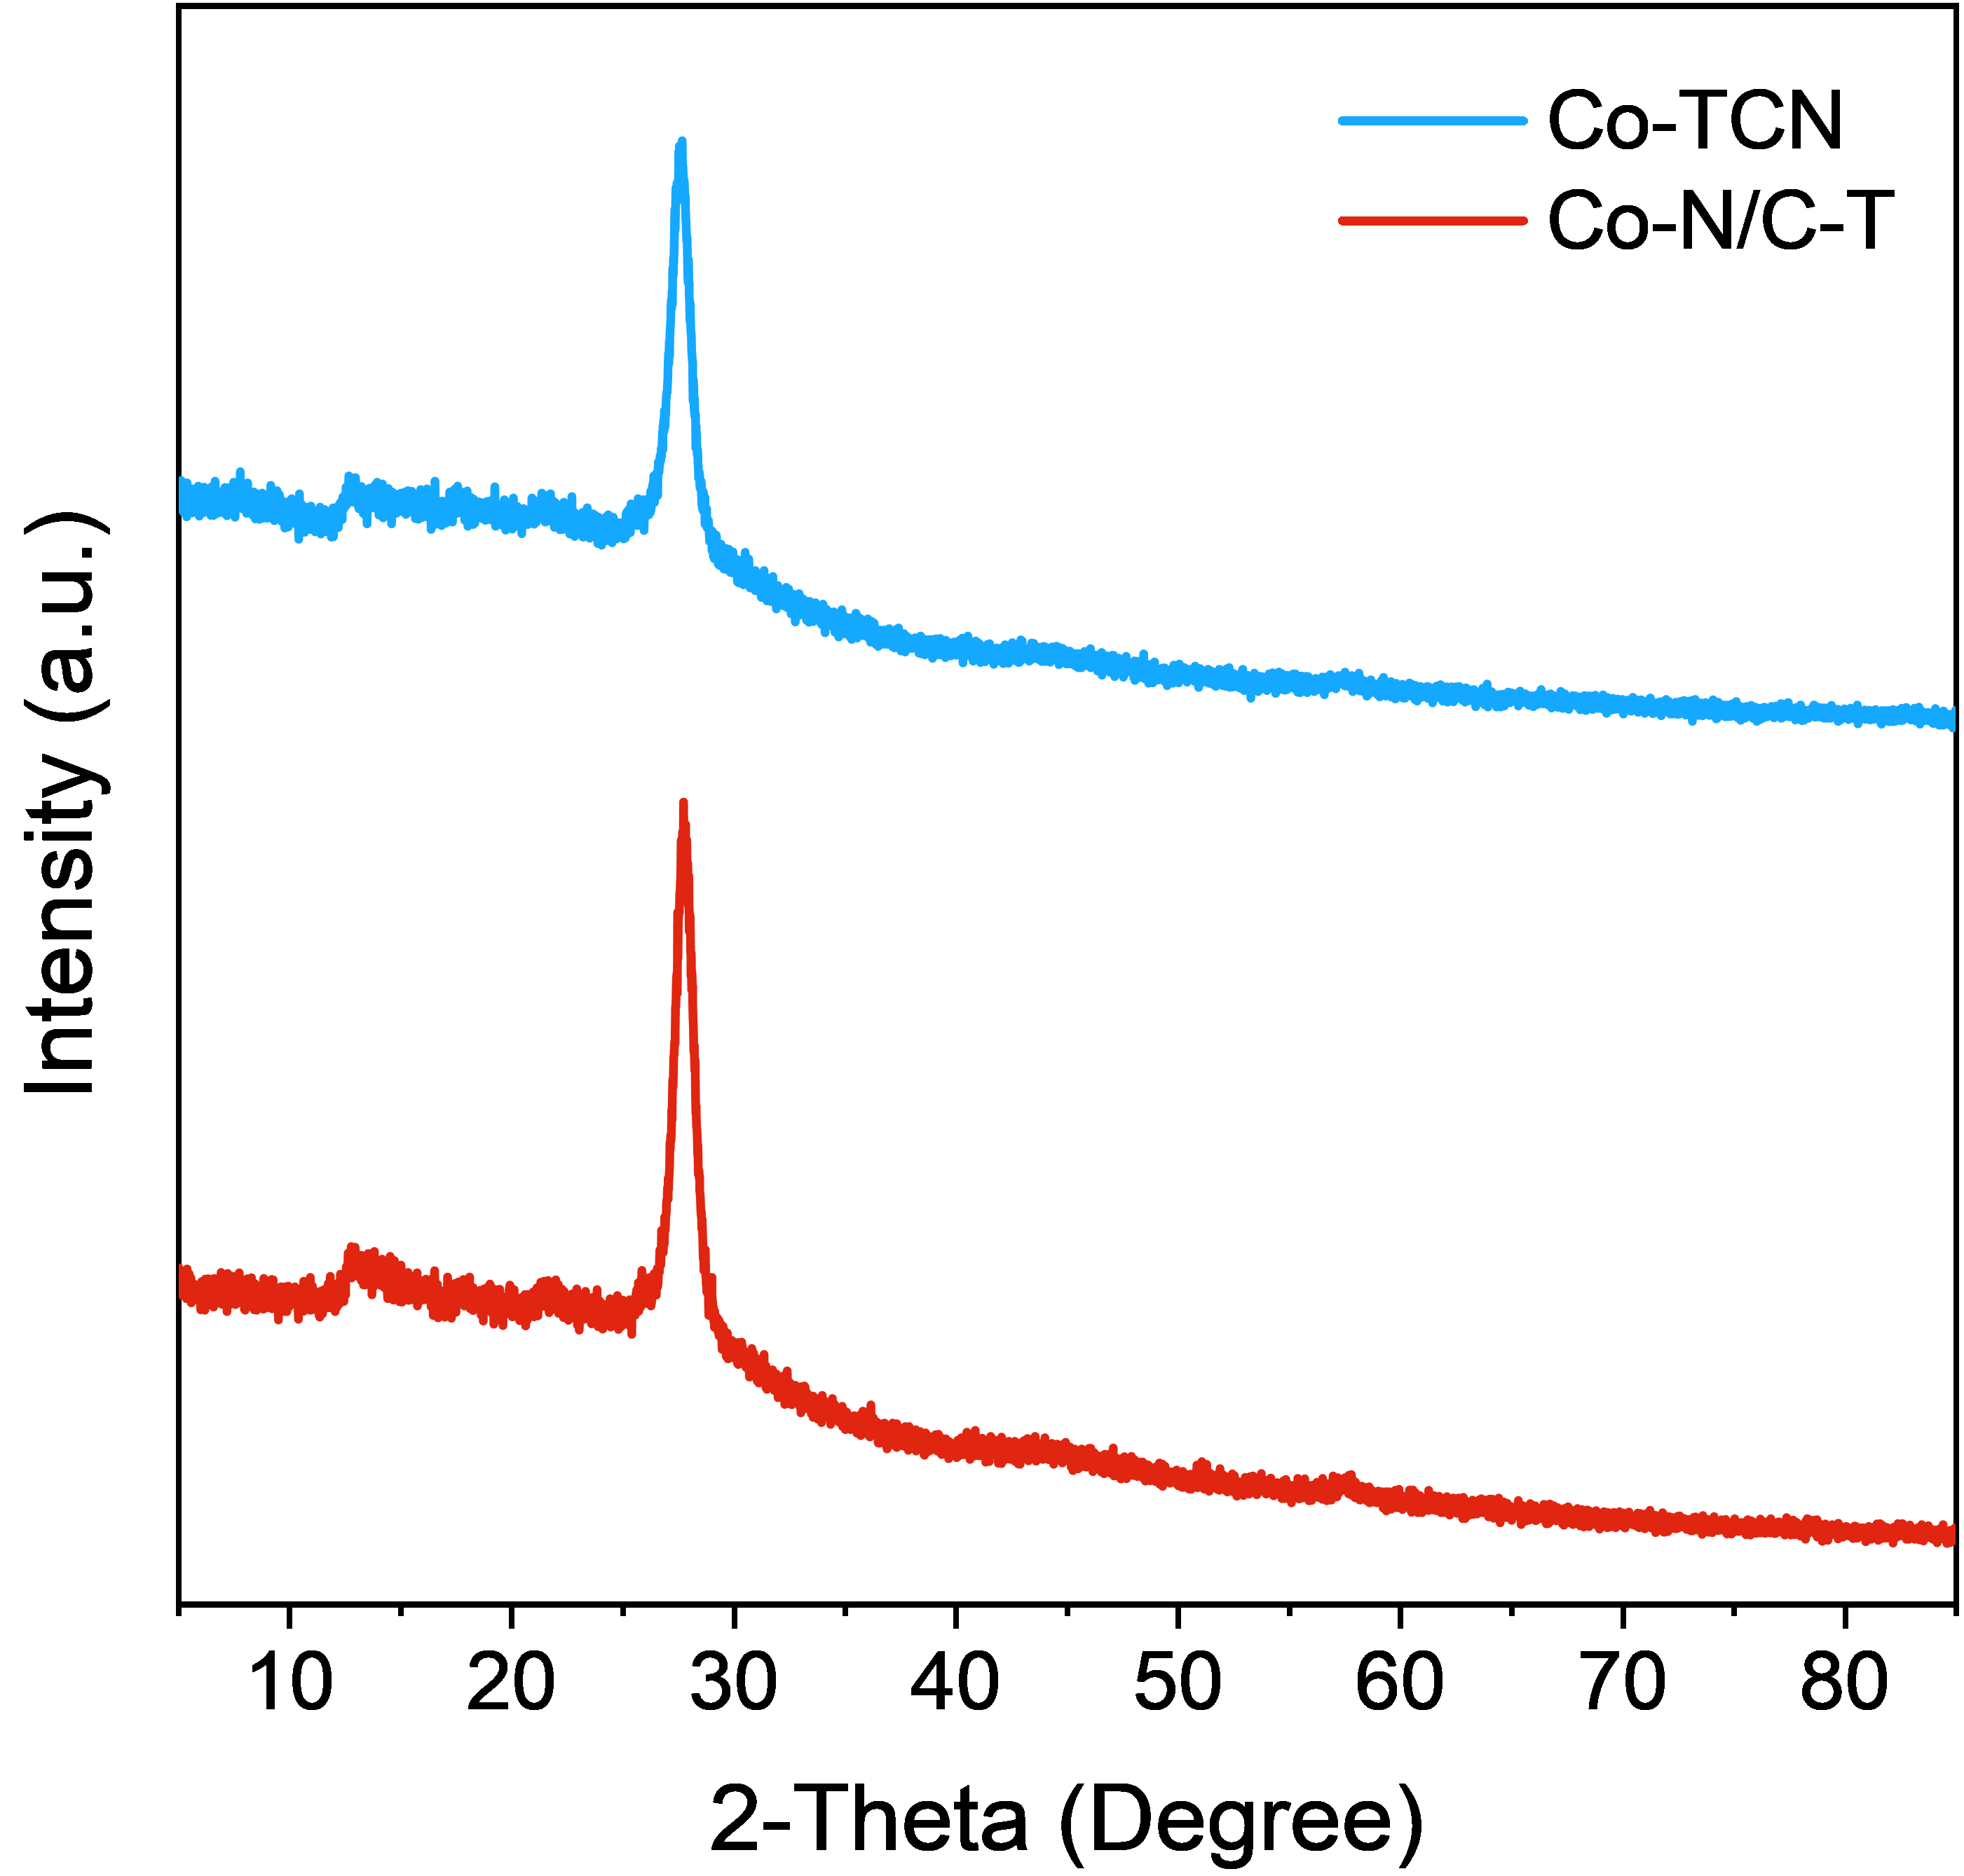
Figure S5. XRD patterns of Co-TCN and Co-N/C-T.

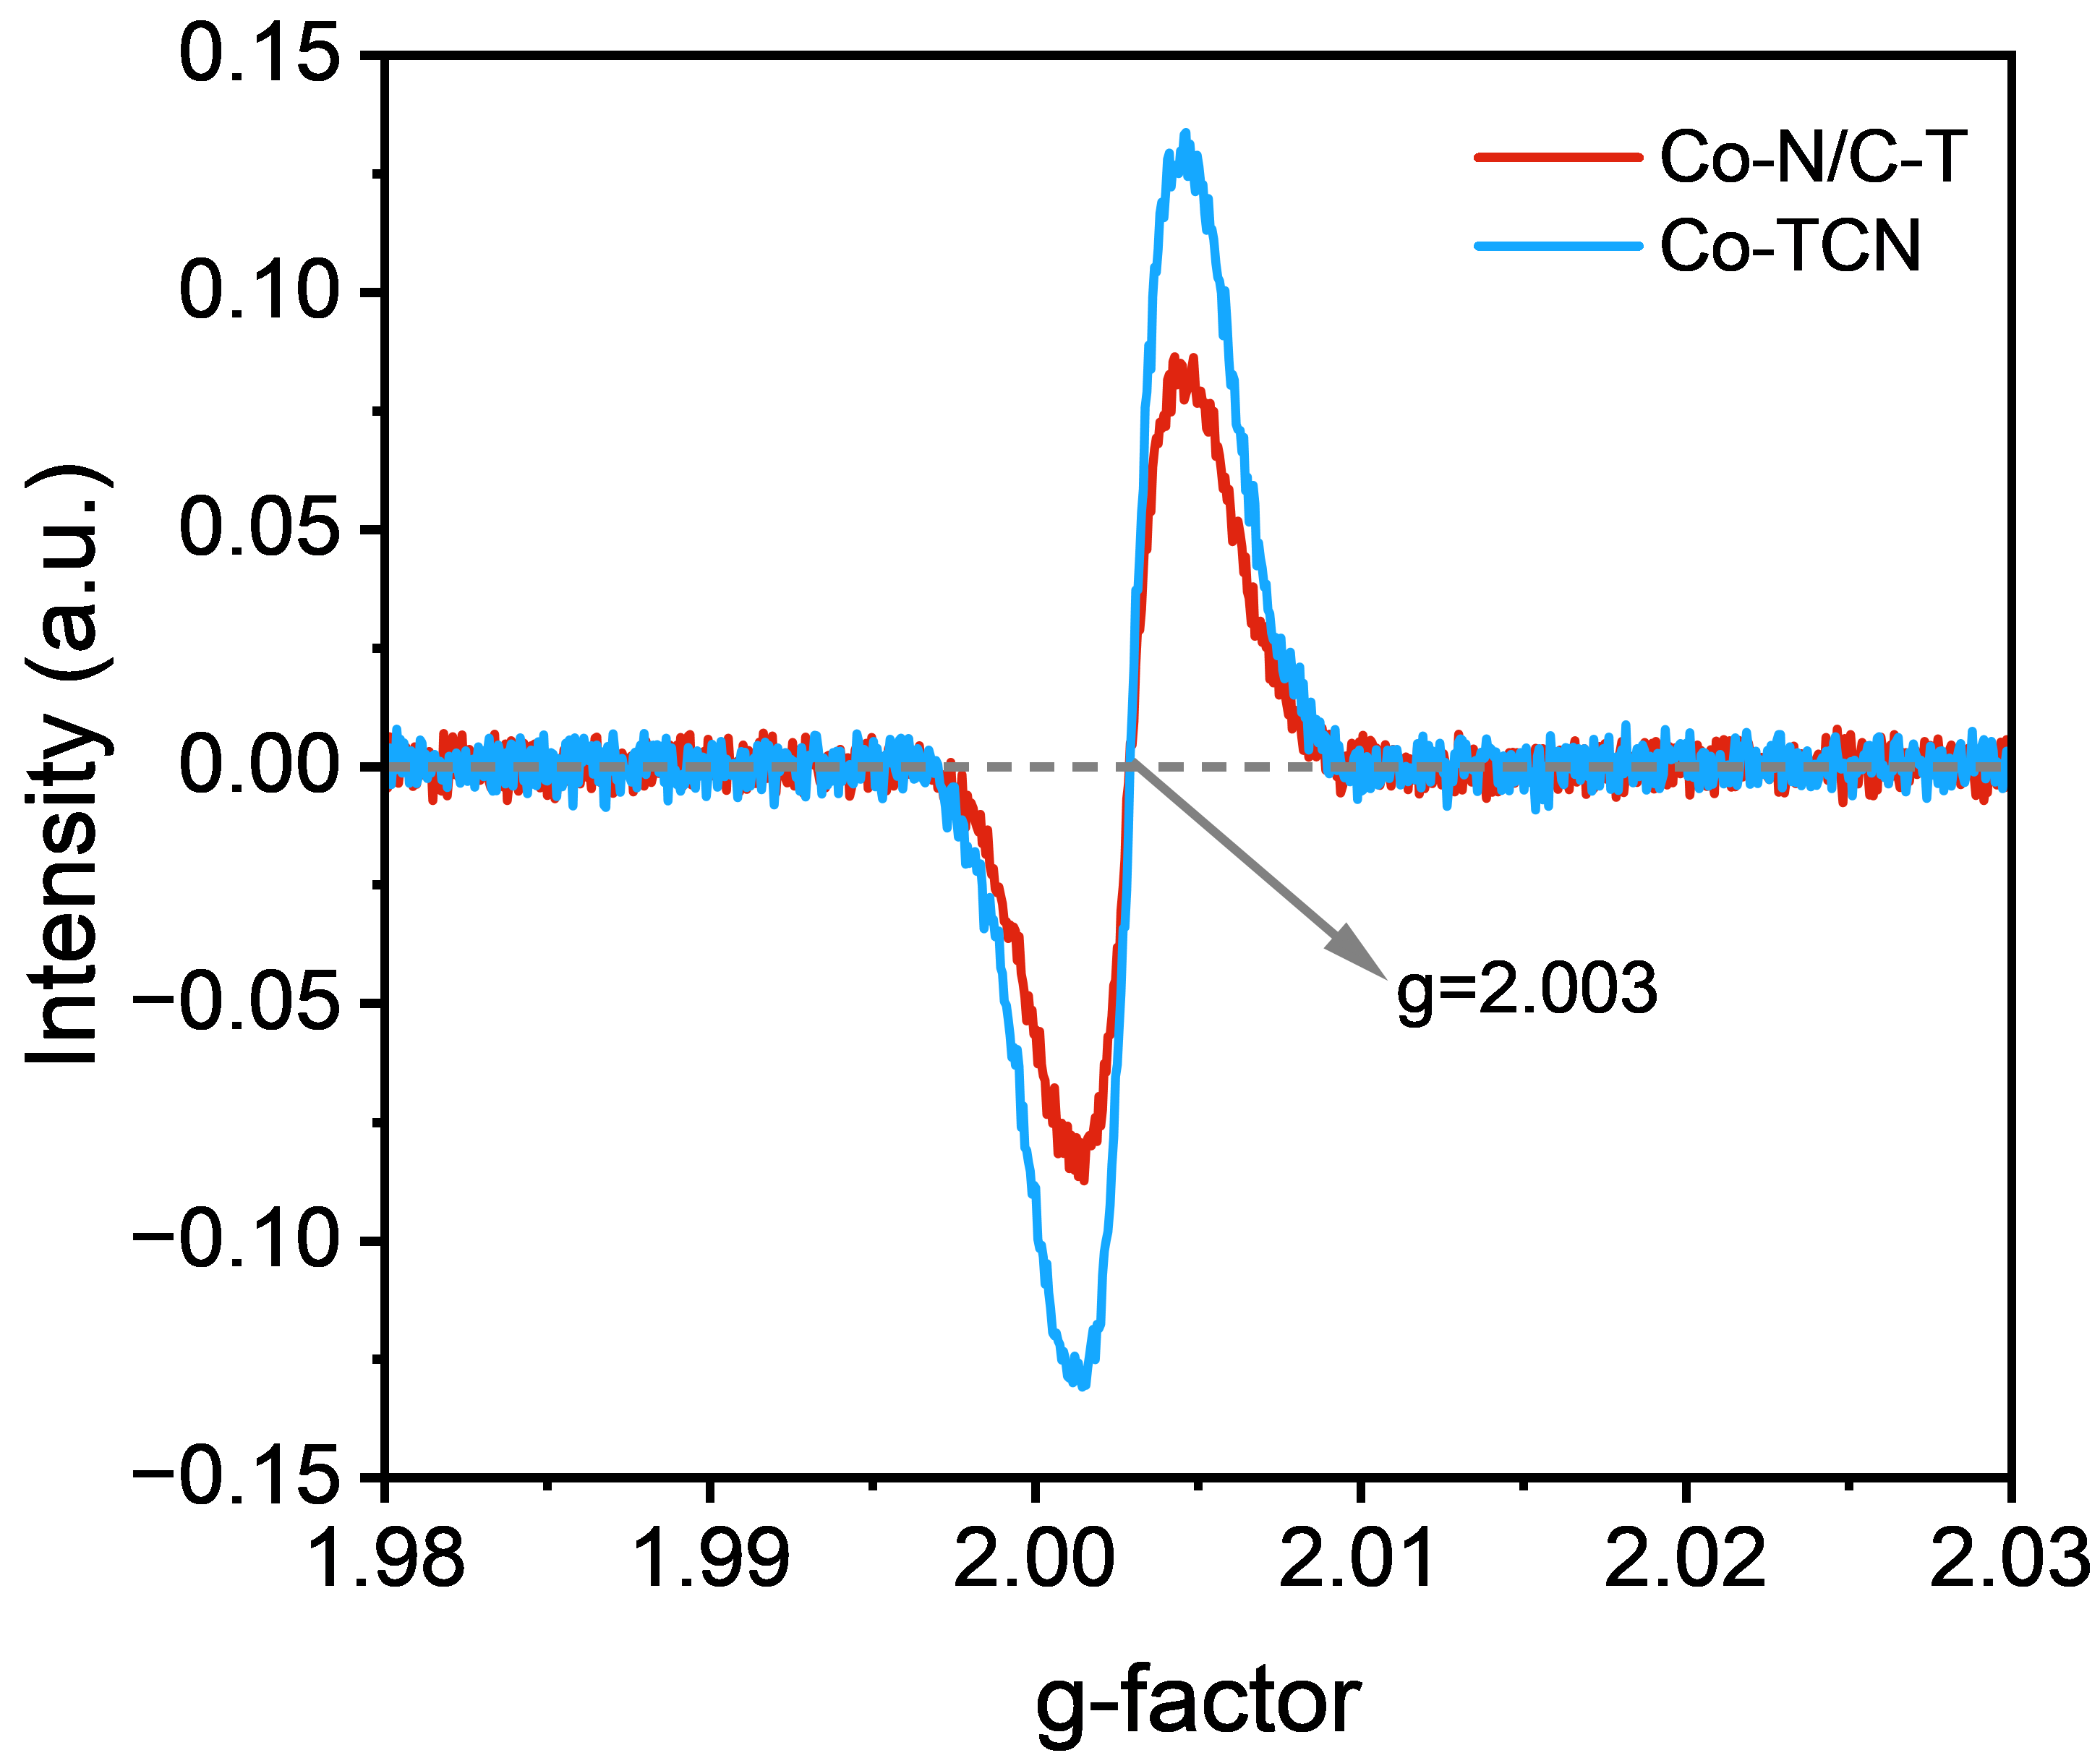
Figure S6. EPR spectra of Co-N/C-T and Co-TCN.

Figure S7. XPS spectra for (a–c) Co-N/C-T and (d–f) Co-TCN.

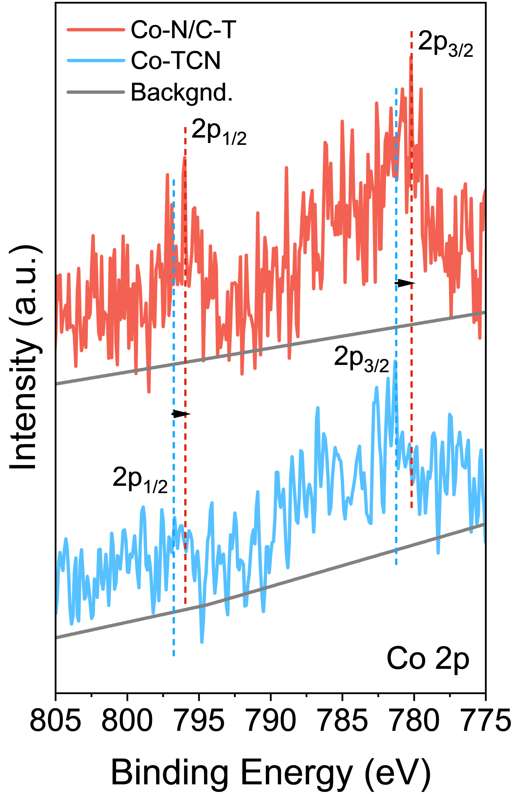
Figure S8. XPS spectra of Co 2p regions for Co-N/C-T and Co-TCN.

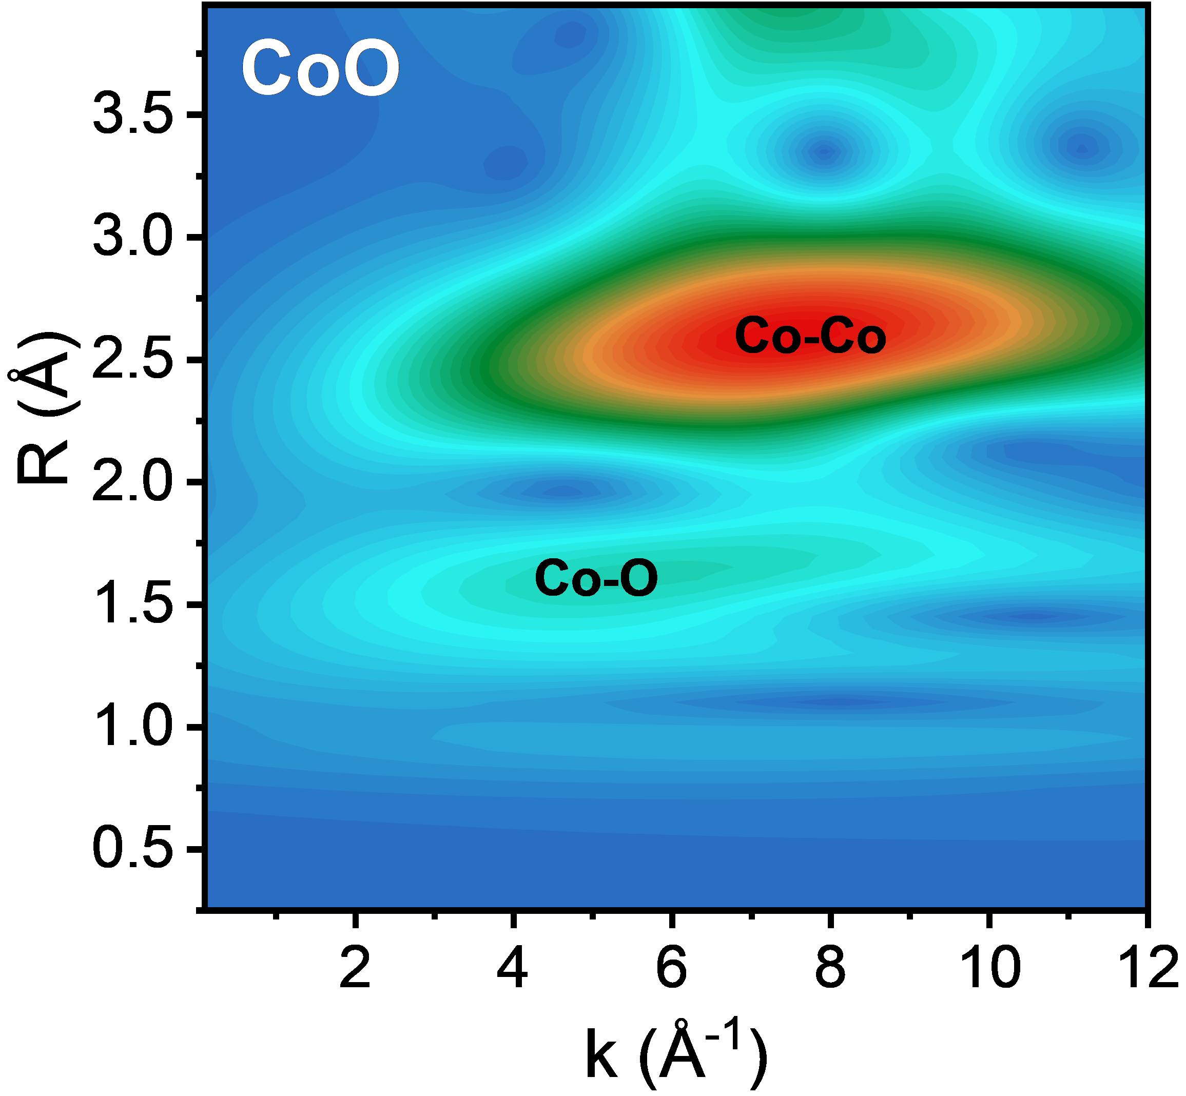
Figure S9. WT analysis of EXAFS for of CoO.

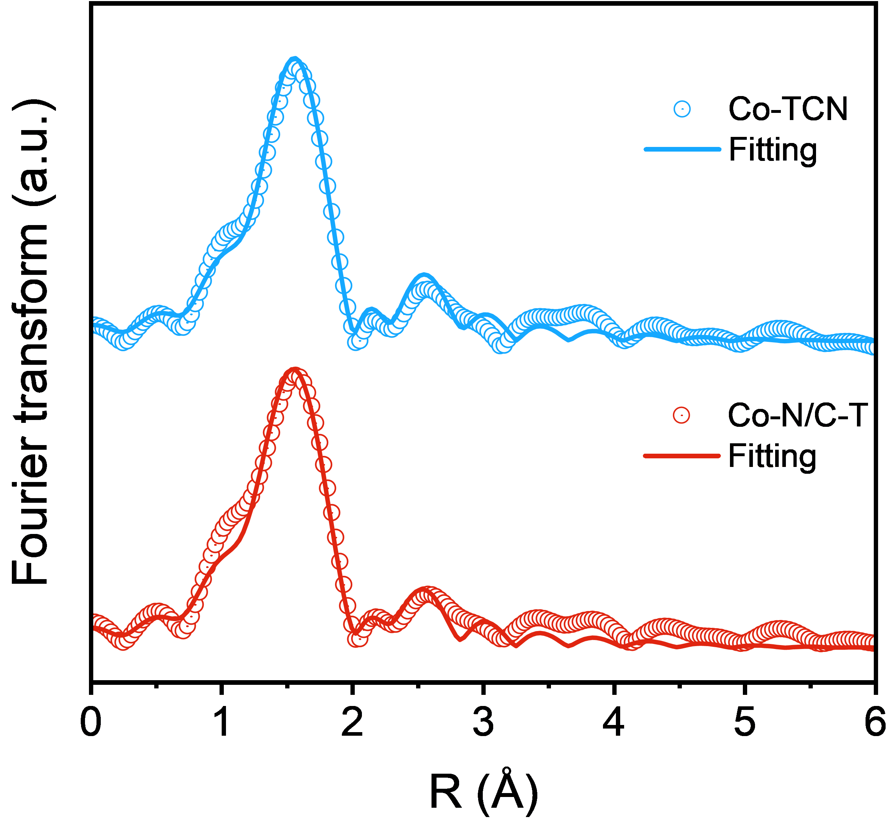
Figure S10. FT-EXAFS fitting curves of Co-TCN and Co-N/C-T at R-space.

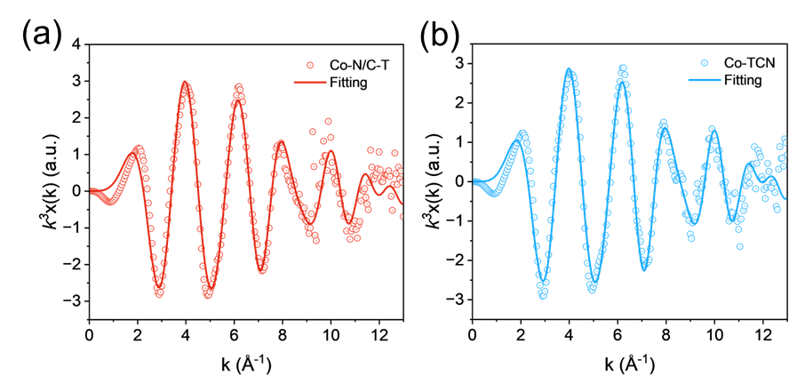
Figure S11. FT-EXAFS fitting curves of (a) Co-N/C-T and (b) Co-TCN at k-space.

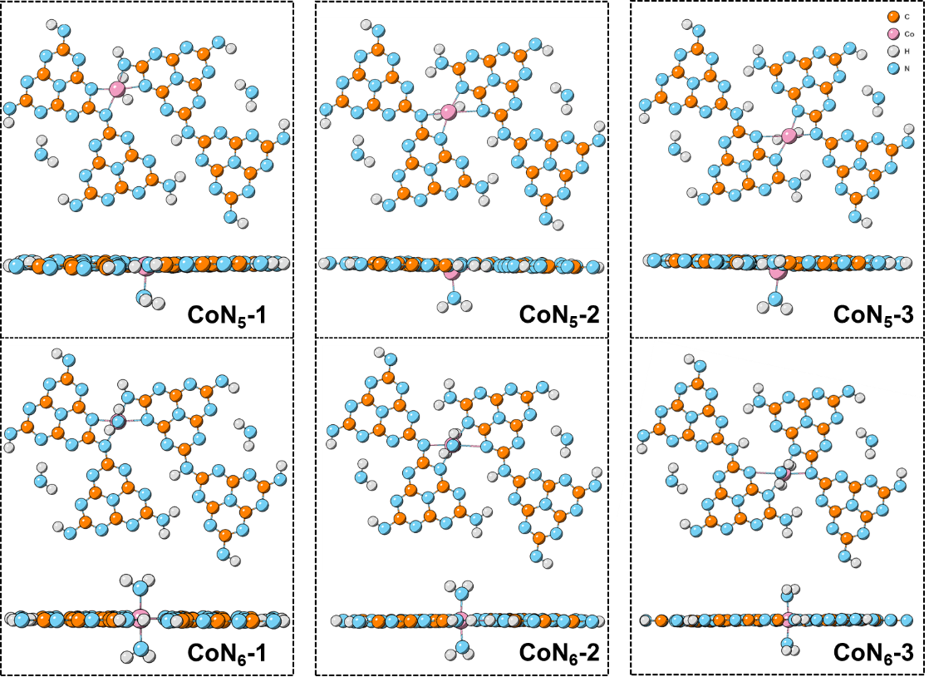
Figure S12. Structural configurations of CoN₅ and CoN₆.

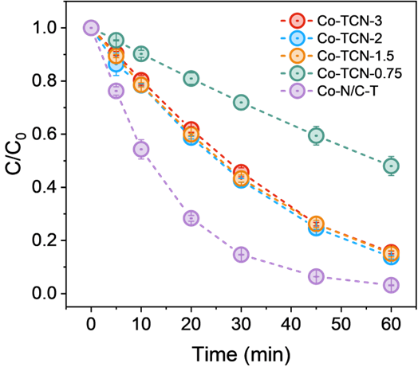
Figure S13. Effect of cobalt loading on SMX degradation efficiency in HCO₃⁻-mediated Fenton-like systems.
(Experimental conditions: [Catalyst]₀=0.2 g·L⁻¹, [HCO₃⁻]=10 mM, [H₂O₂]=6 mM, [SMX]=10 mg·L⁻¹)

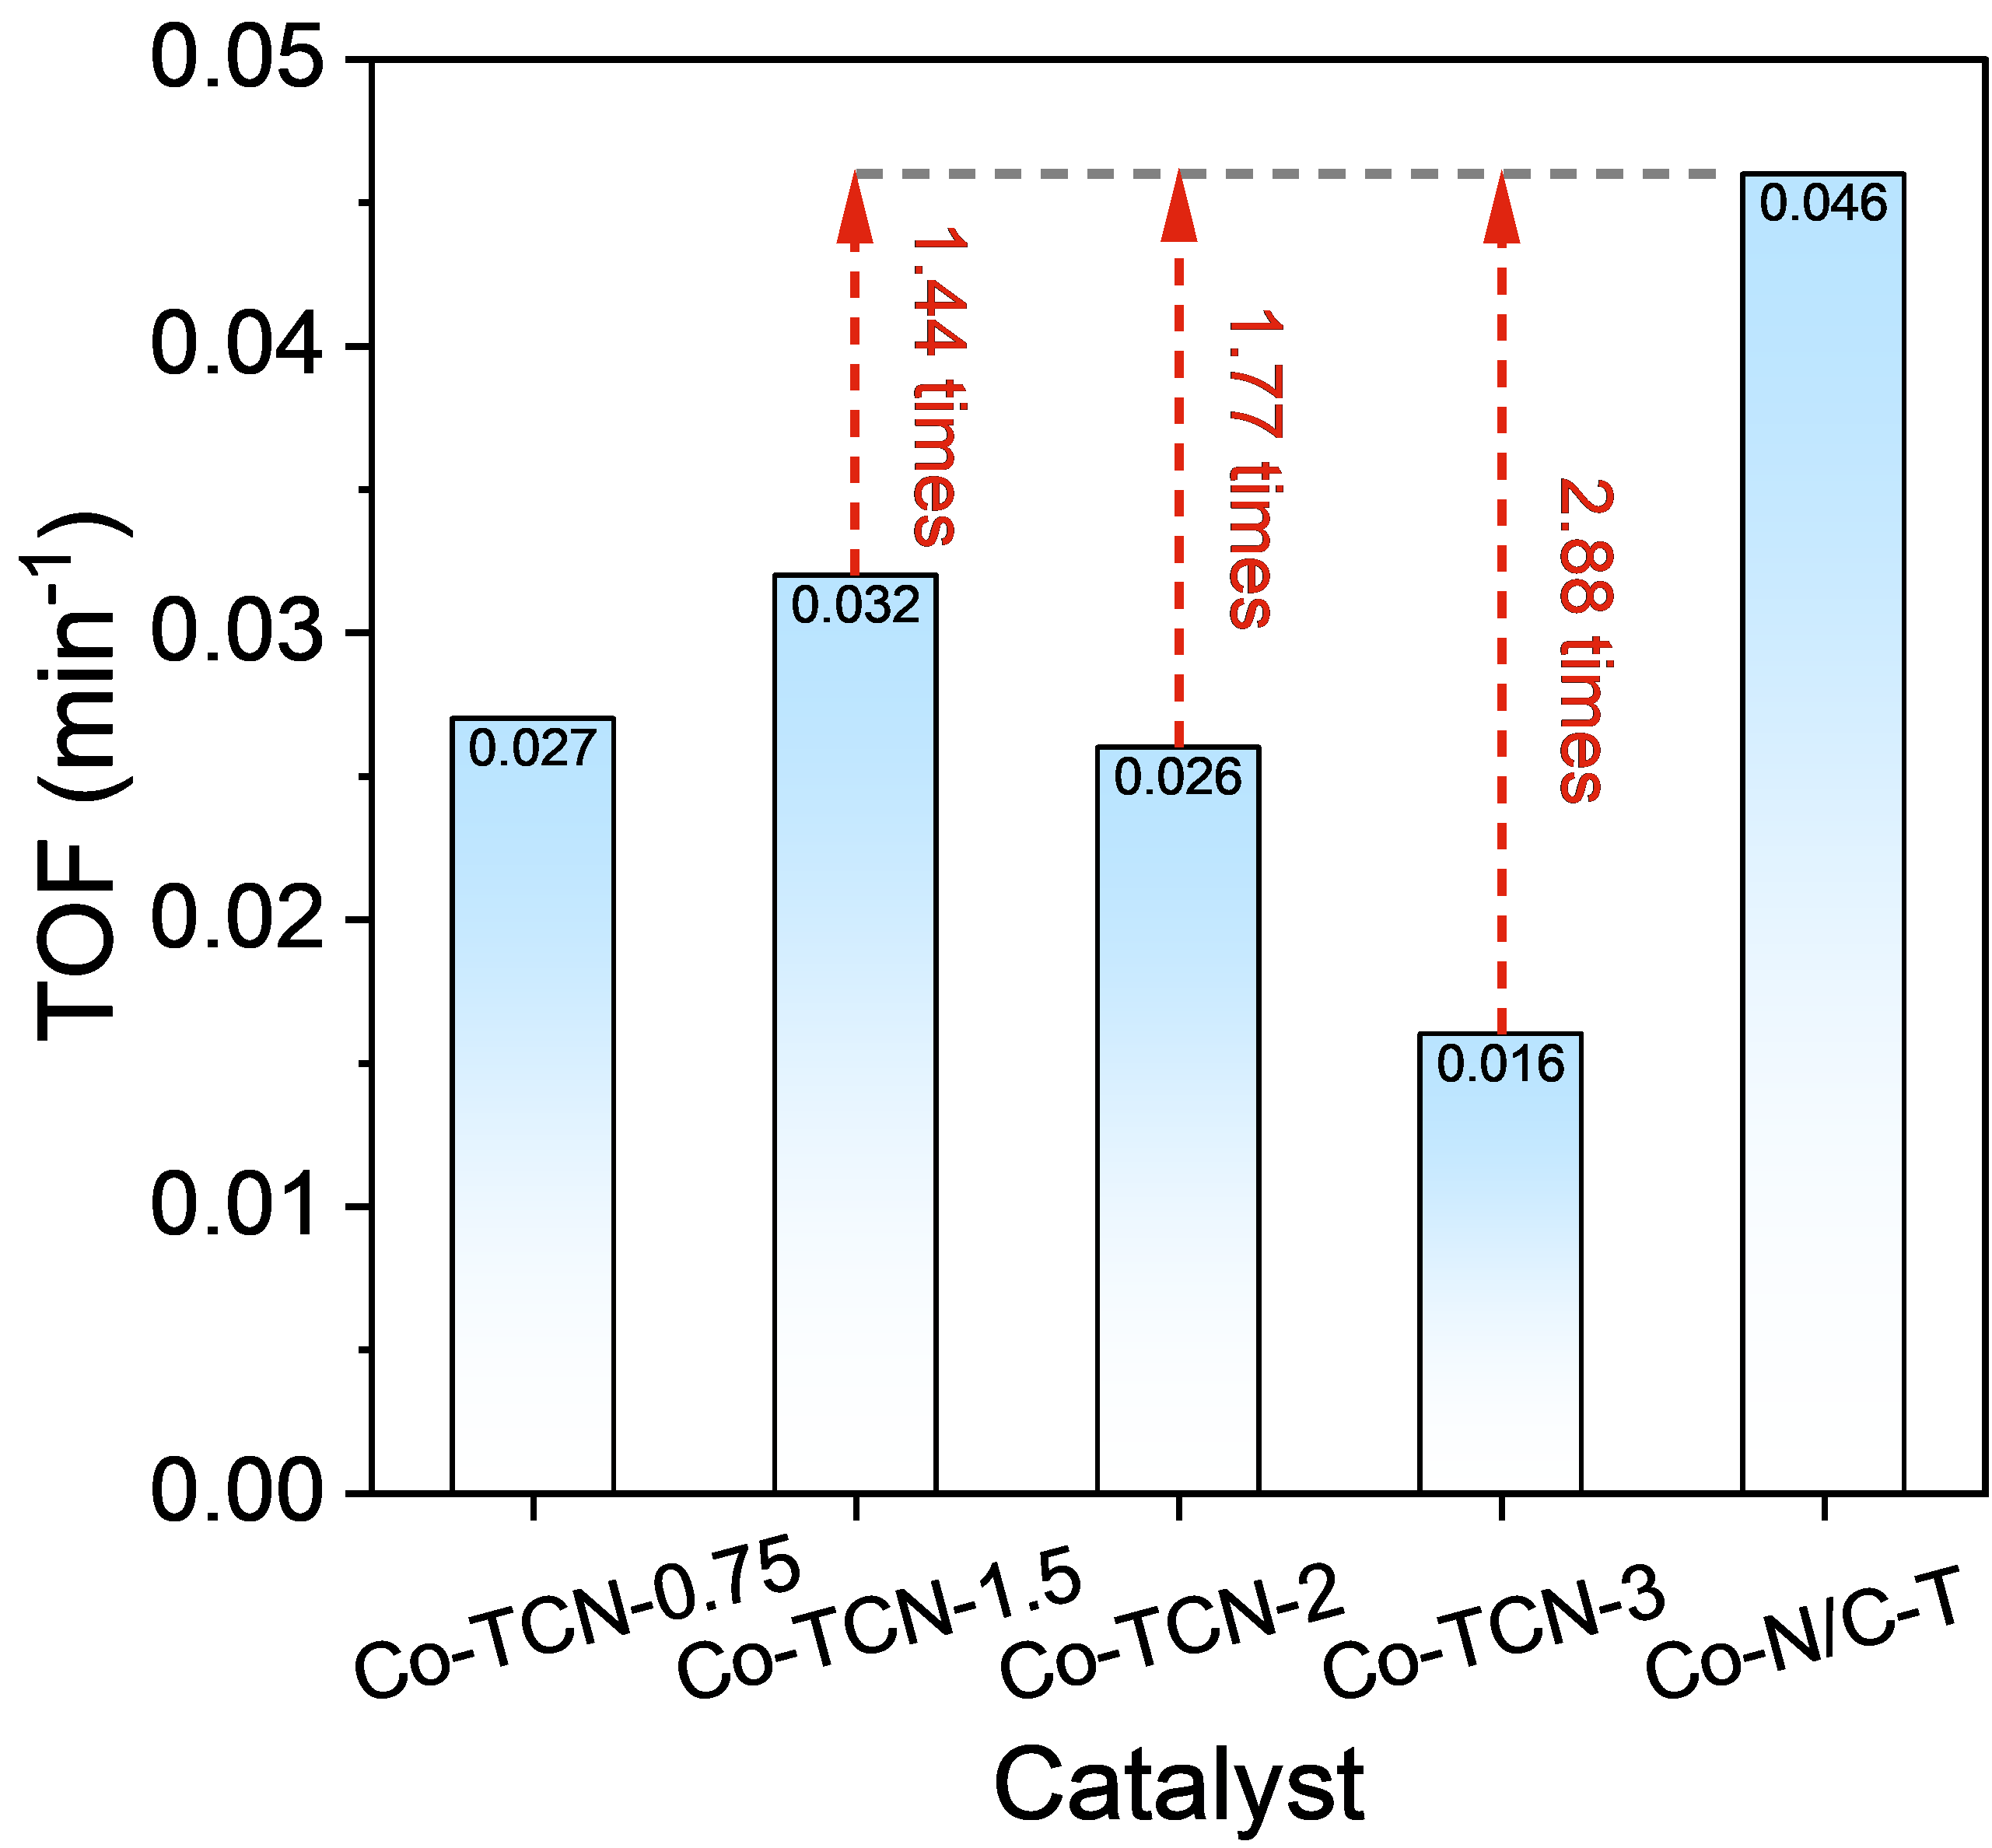
Figure S14. TOF comparison of Co-TCN-x and Co-N/C-T.
(Experimental conditions: [Catalyst]₀=0.2 g·L⁻¹, [HCO₃⁻]=10 mM, [H₂O₂]=6 mM, [SMX]=10 mg·L⁻¹)

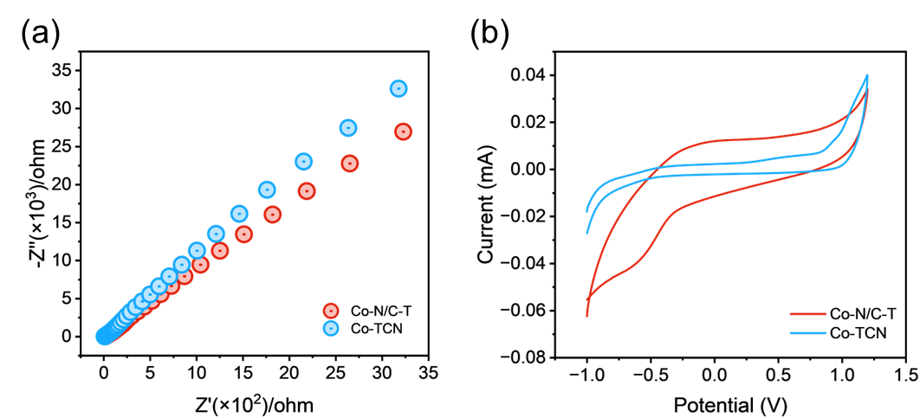
Figure S15. (a) EIS analysis and (b) cyclic voltametric curves of Co-N/C-T and Co-TCN.

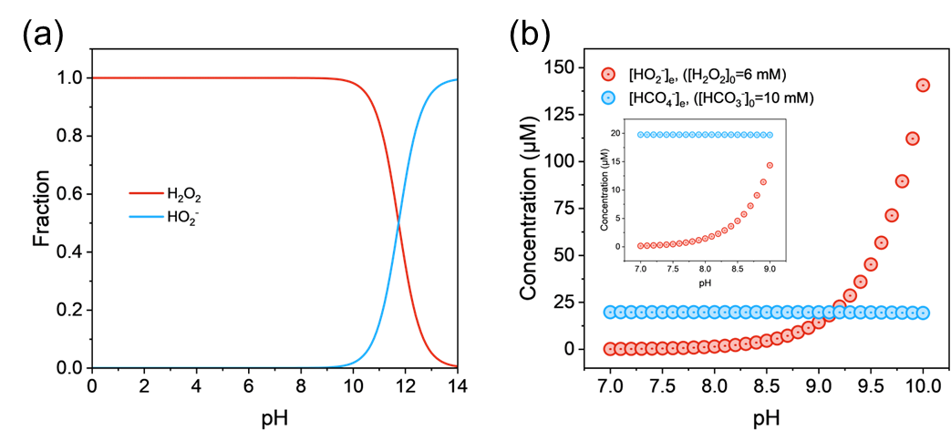
Figure S16. (a) Speciation of H₂O₂-derived species as a function of pH; (b) Variation in equilibrium concentrations of HCO₃⁻ and H₂O₂ with pH.

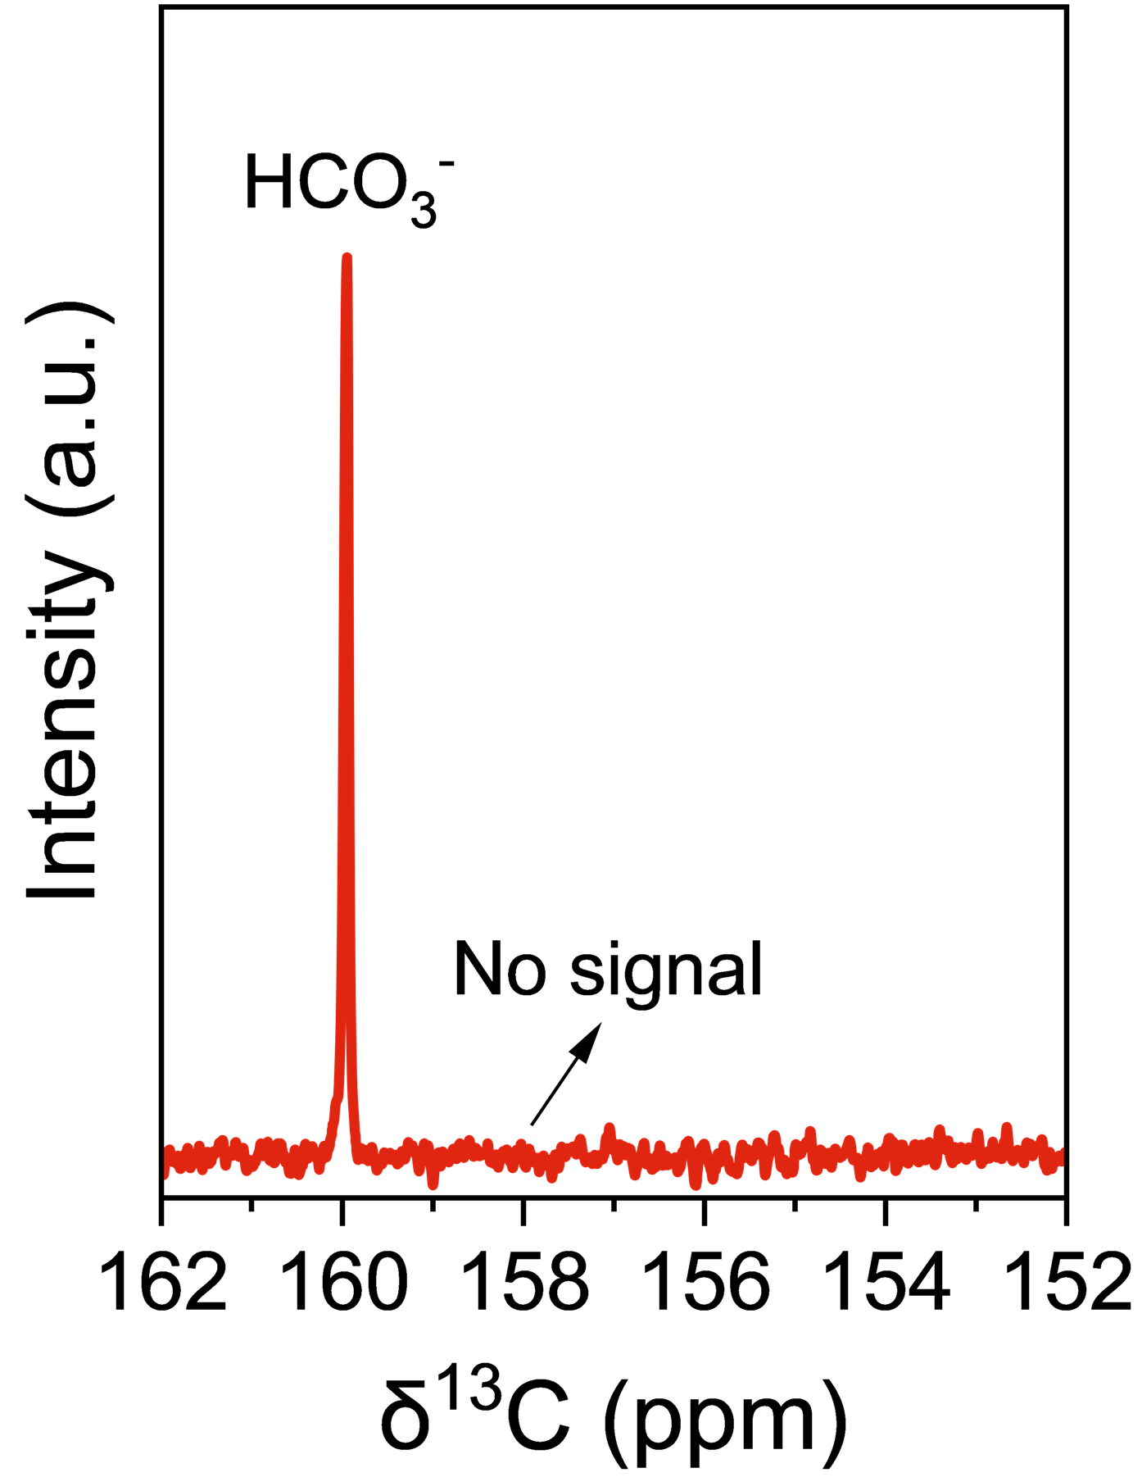
Figure S17. ¹³C NMR spectrum of the reaction mixture containing H¹³CO₃⁻ (10 mM) and H₂O₂ (6 mM).

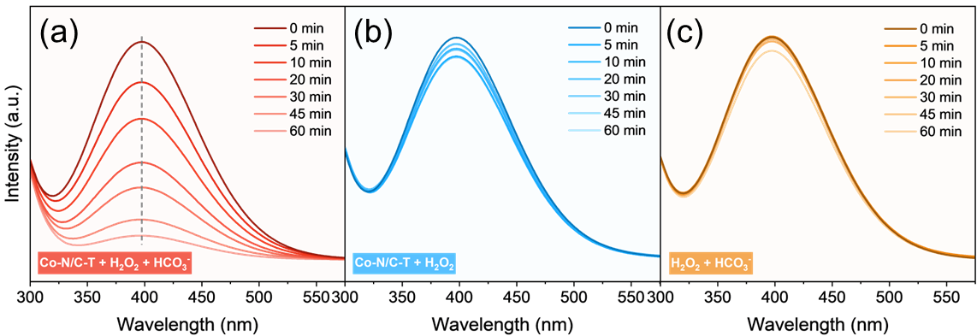
Figure S18. Absorbance changes of H₂O₂ in different systems.
(Experimental conditions: [Catalyst]₀=0.2 g·L⁻¹, [HCO₃⁻]=10 mM, [H₂O₂]=6 mM)

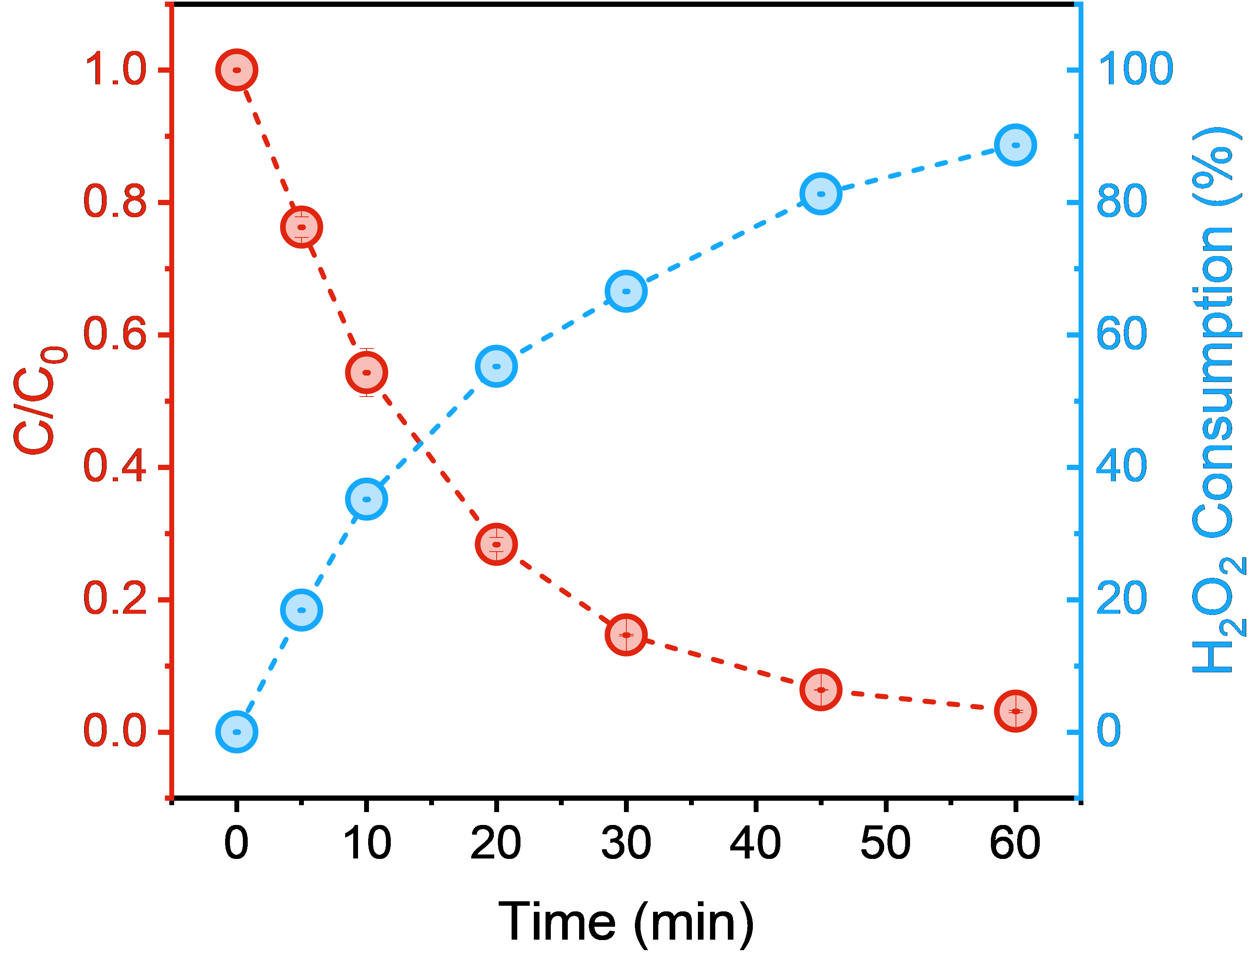
Figure S19. Correlation between SMX removal and H₂O₂ consumption in Co-N/C-T/HCO₃⁻/H₂O₂ system.
(Experimental conditions: [Catalyst]₀=0.2 g·L⁻¹, [HCO₃⁻]=10 mM, [H₂O₂]=6 mM, [SMX]=10 mg·L⁻¹)

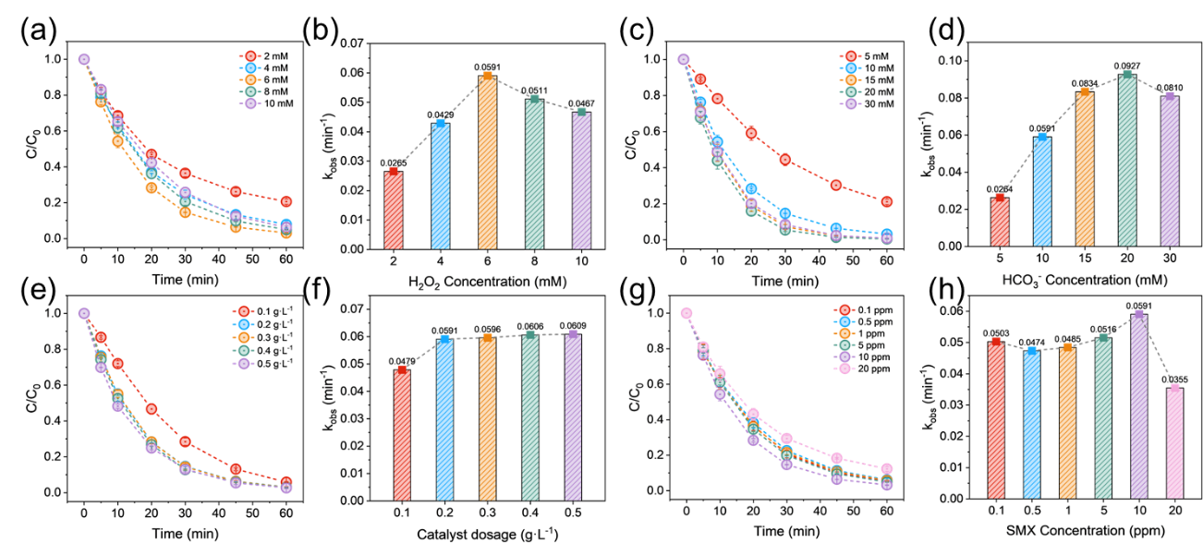
Figure S20. Effects of various parameters on SMX degradation: (a, b) H₂O₂ concentration; (c, d) HCO₃⁻ concentration; (e, f) Catalyst dosage; (g, h) SMX concentration
(Experimental conditions: [Catalyst]₀=0.2 g·L⁻¹, [HCO₃⁻]=10 mM, [H₂O₂]=6 mM, [SMX]=10 mg·L⁻¹)

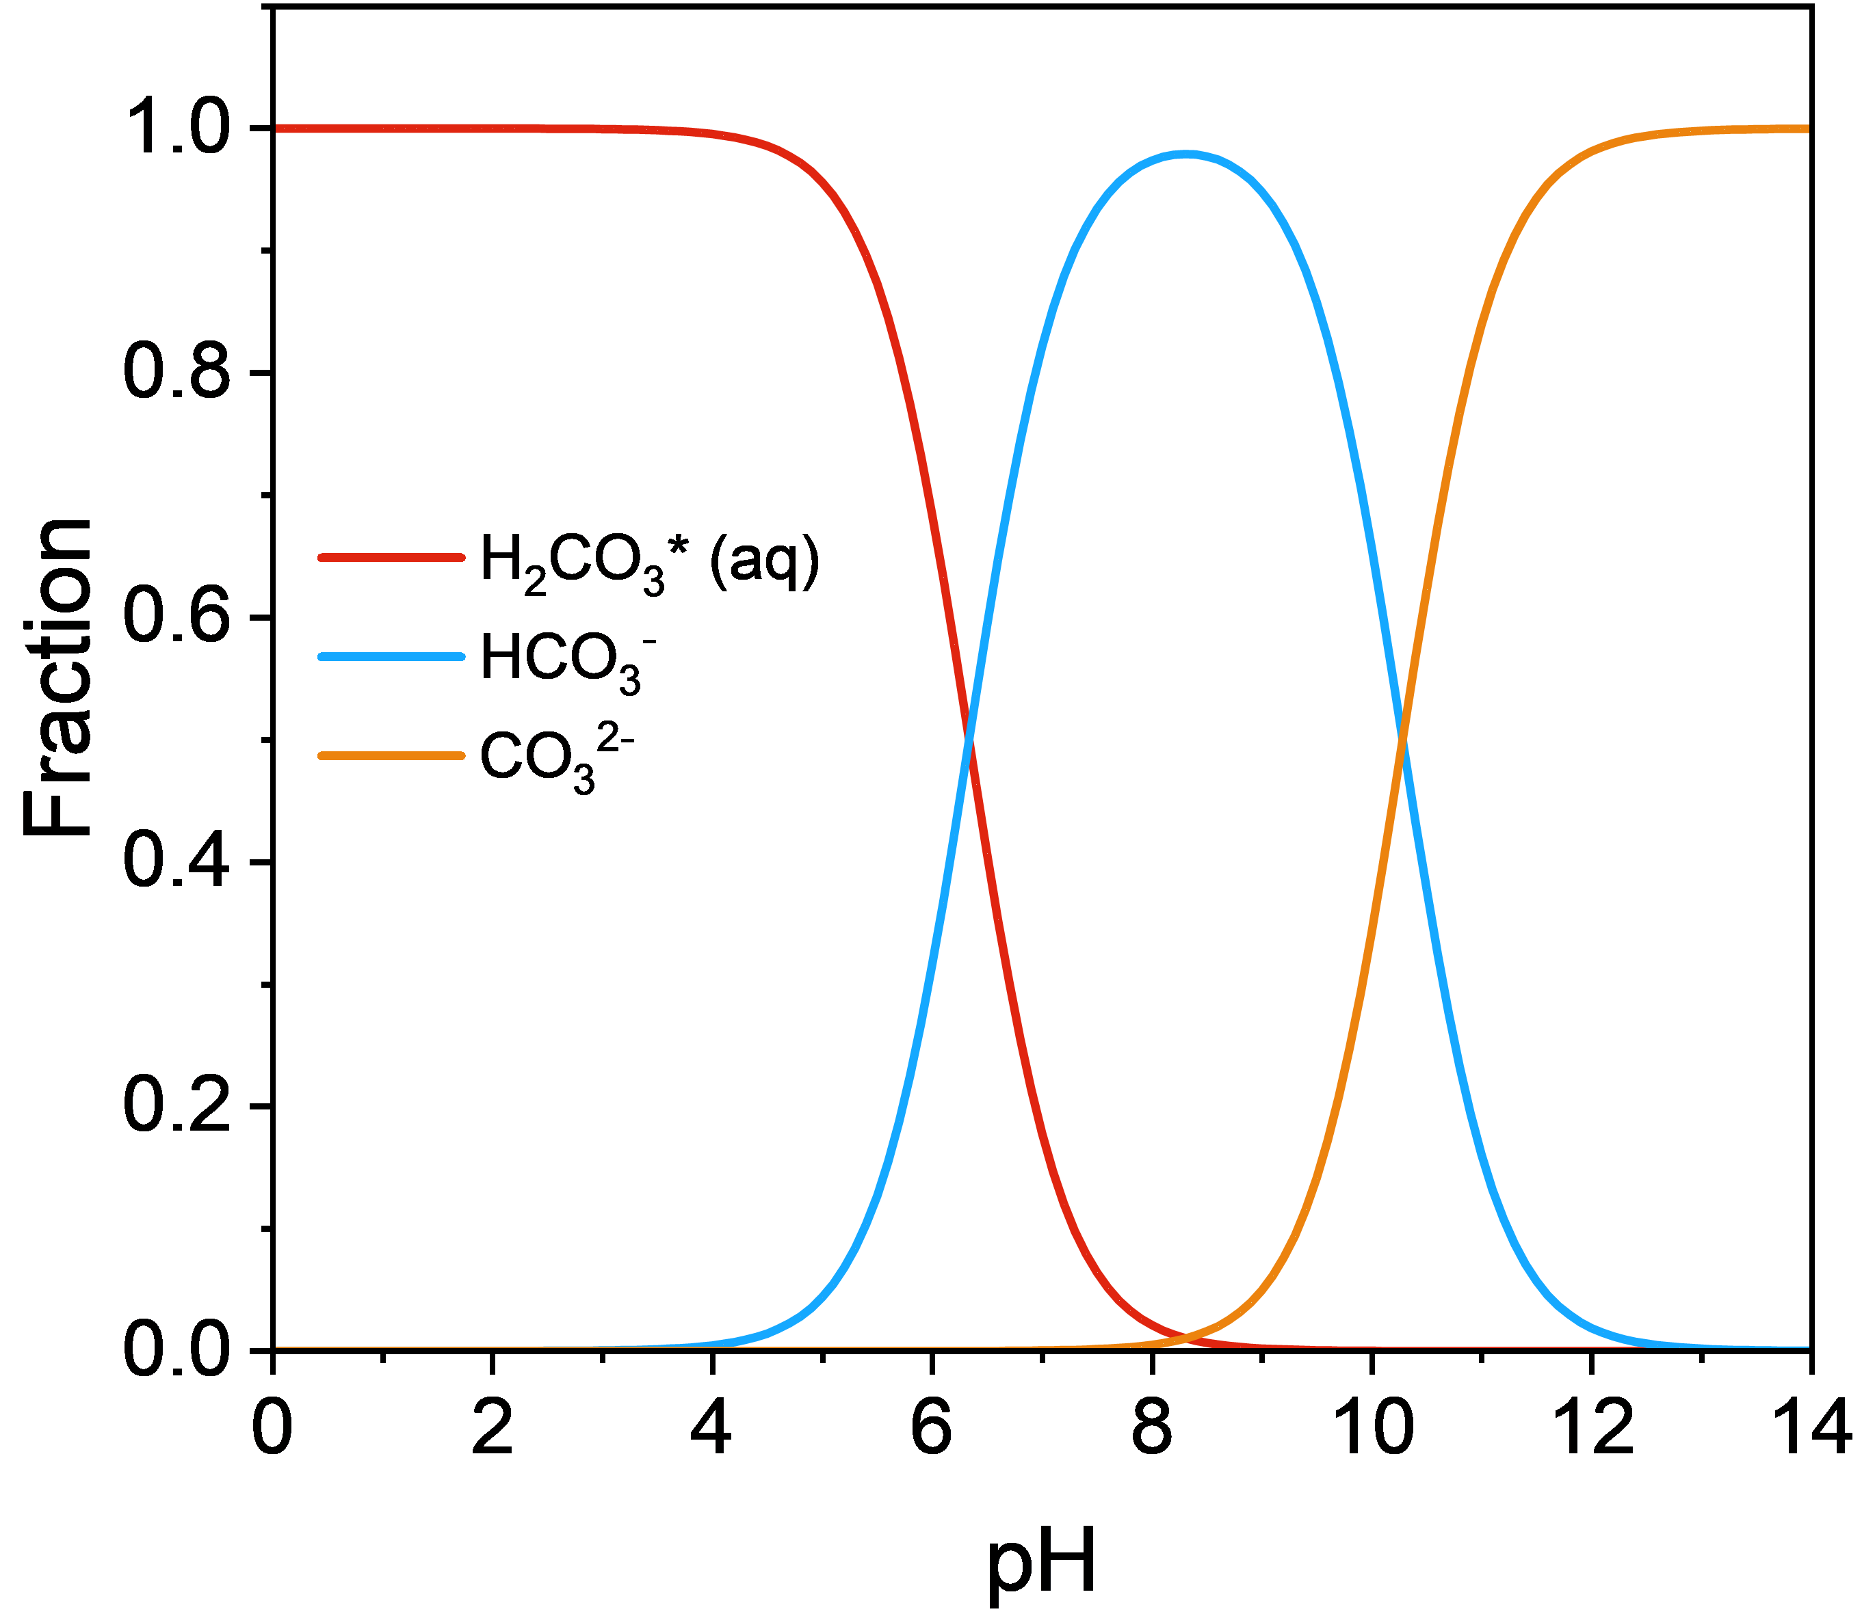
Figure S21. Speciation of HCO₃⁻ in solution as a function of pH.

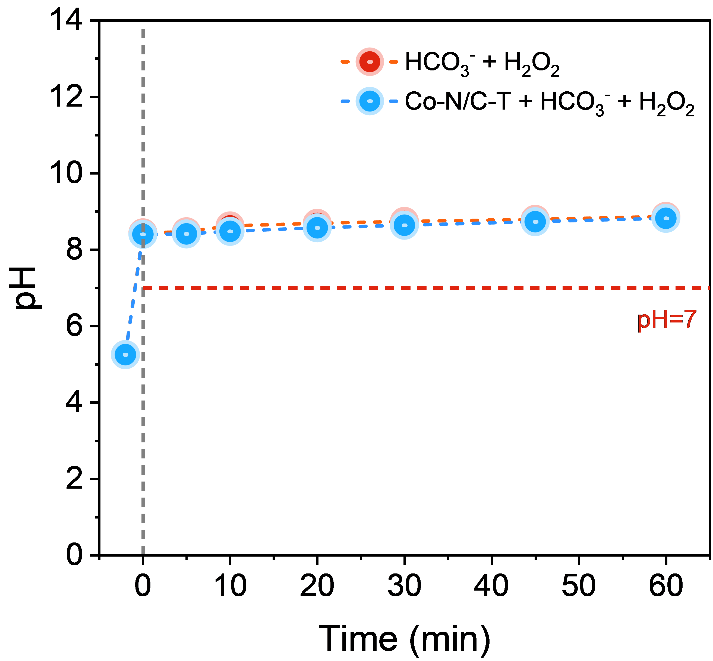
Figure S22. Temporal evolution of pH during the reaction.
(Experimental conditions: [Catalyst]₀=0.2 g·L⁻¹, [HCO₃⁻]=10 mM, [H₂O₂]=6 mM).

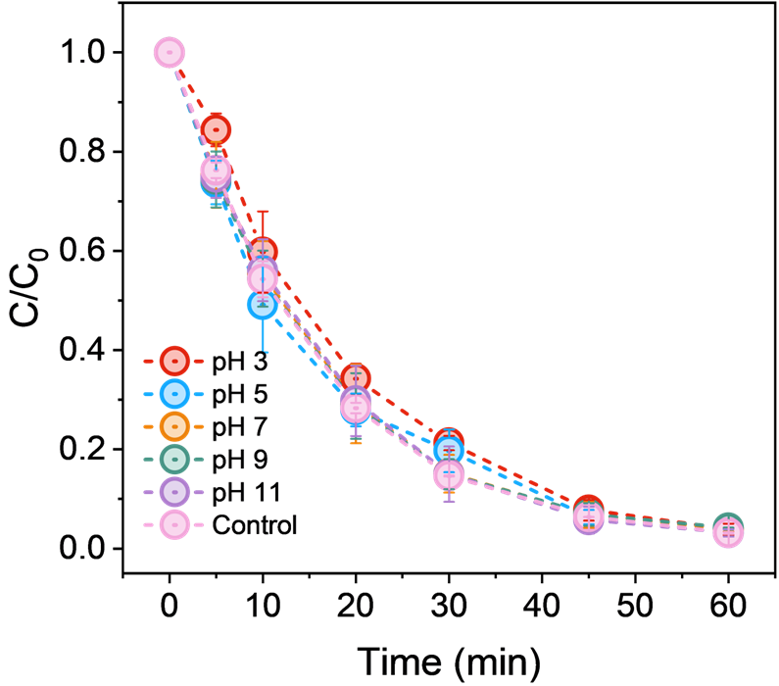
Figure S23. Effect of initial pH on SMX degradation.
(Experimental conditions: [Catalyst]₀=0.2 g·L⁻¹, [HCO₃⁻]=10 mM, [H₂O₂]=6 mM, [SMX]=10 mg·L⁻¹, no buffer solution; pH adjusted prior to bicarbonate addition).

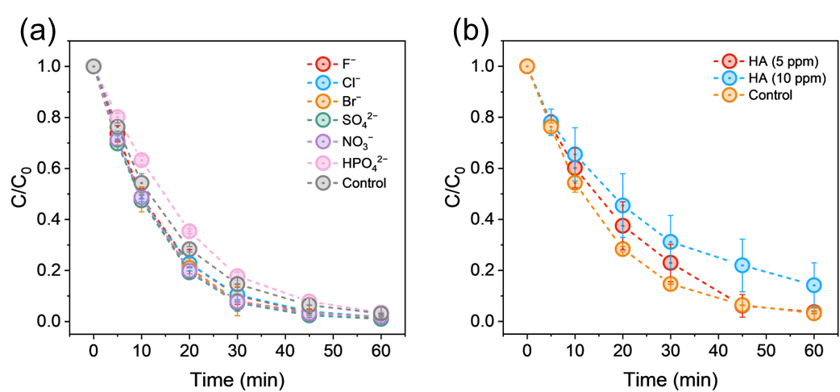
Figure S24. Effect of various coexisting anions on SMX removal in the Co-N/C-T/HCO₃⁻/H₂O₂ system. (Experimental conditions: [Catalyst]₀=0.2 g·L⁻¹, [HCO₃⁻]=10 mM, [H₂O₂]=6 mM, [SMX]=10 mg·L⁻¹, [Anion] = 10 mM)

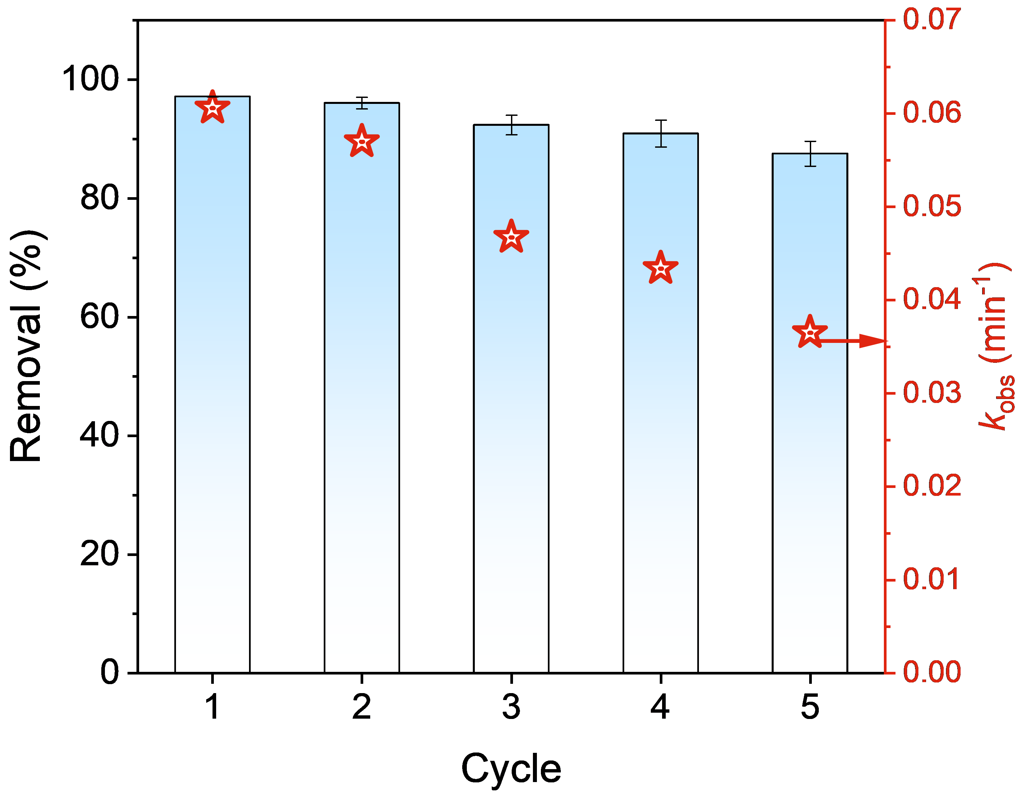
Figure S25. Reusability evaluation of the Co-N/C-T system over five consecutive cycles.
(Experimental conditions: [Catalyst]₀=0.2 g·L⁻¹, [HCO₃⁻]=10 mM, [H₂O₂]=6 mM, [Anion]=10 mM, [SMX]=10 mg·L⁻¹)

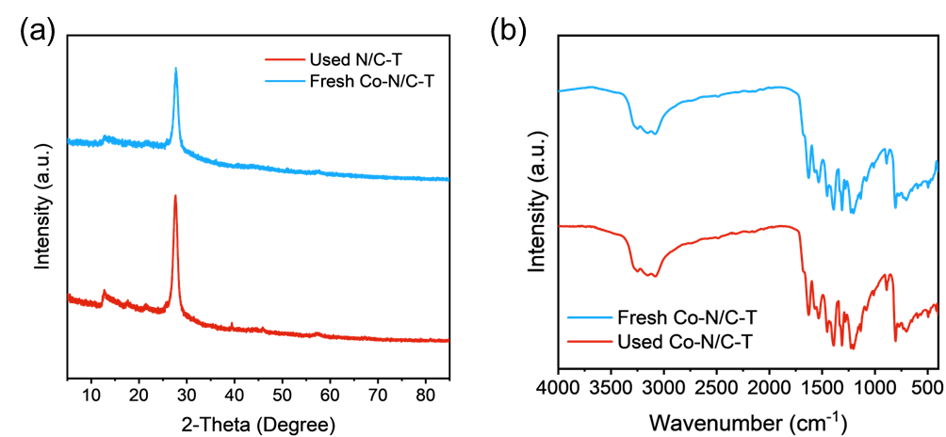
Figure S26. (a) XRD patterns and (b) FT-IR spectra of fresh and used Co-N/C-T.

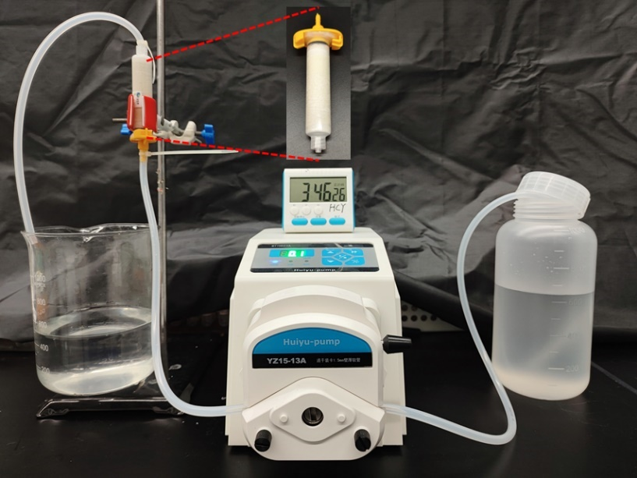
Figure S27. Configuration of the continuous-flow reactor system with Co-N/C-T/HCO₃⁻/H₂O₂ system.

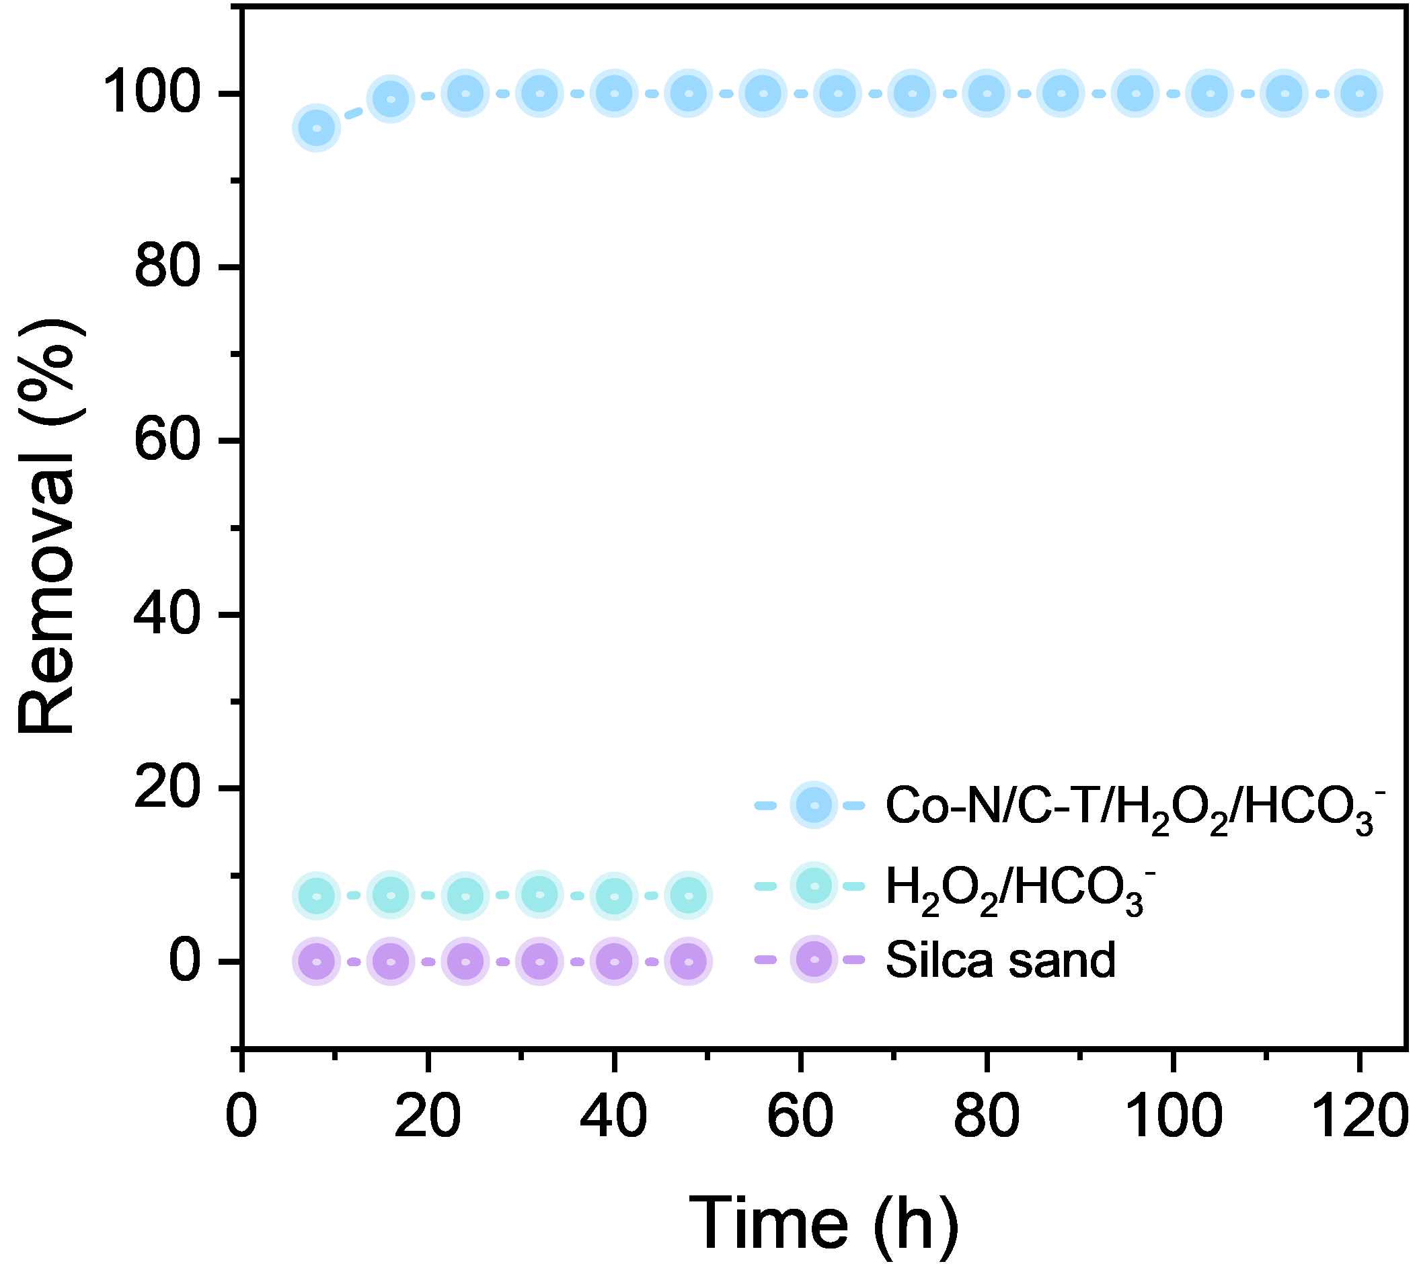
Figure S28. Preliminary evaluation of SMX degradation efficiency in the continuous-flow reactor.
(Experimental conditions: [Catalyst]₀=2 wt%, [HCO₃⁻]=50 mM, [H₂O₂]=30 mM, [SMX]=5 mg·L⁻¹)
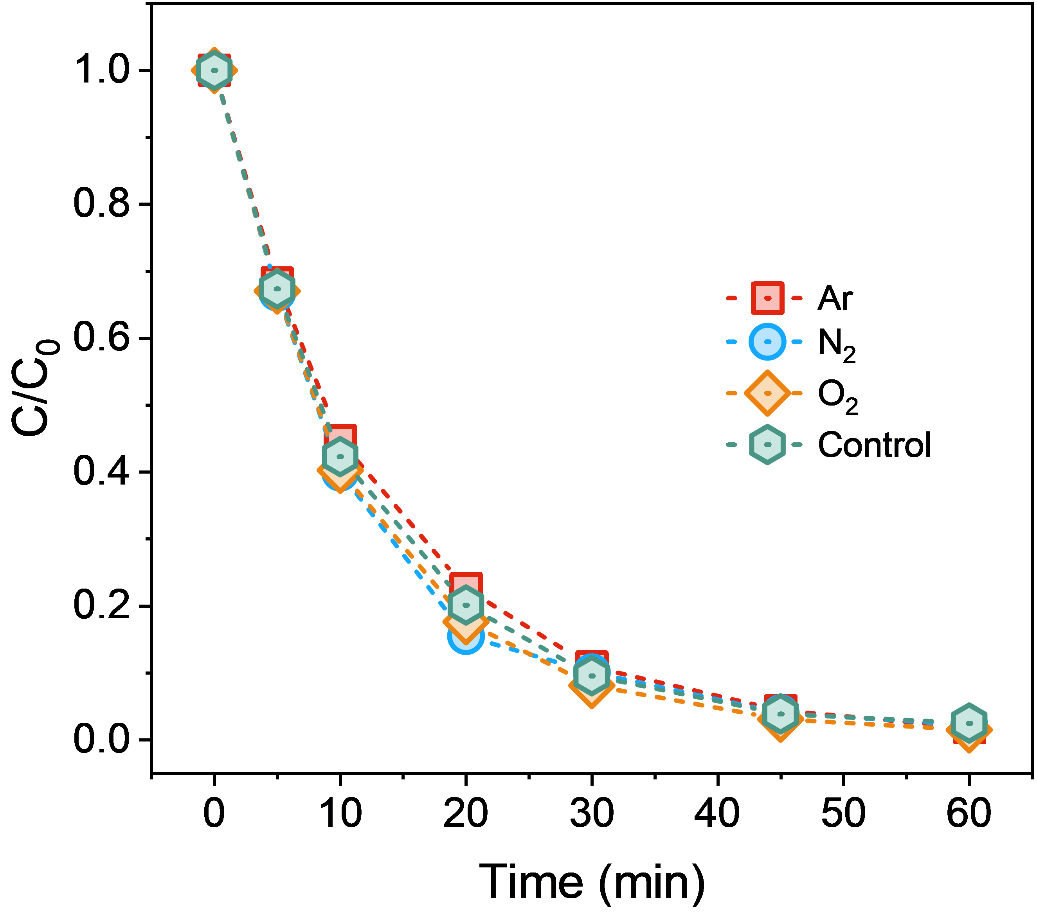
Figure S29. Atmosphere-dependent SMX removal performance in the Co-N/C-T/HCO₃⁻/H₂O₂ system.
(Experimental conditions: [Catalyst]₀=0.2 g·L⁻¹, [HCO₃⁻]=10 mM, [H₂O₂]=6 mM, [SMX]=10 mg·L⁻¹)

Figure S30. Oxidation pathway of DMPO.

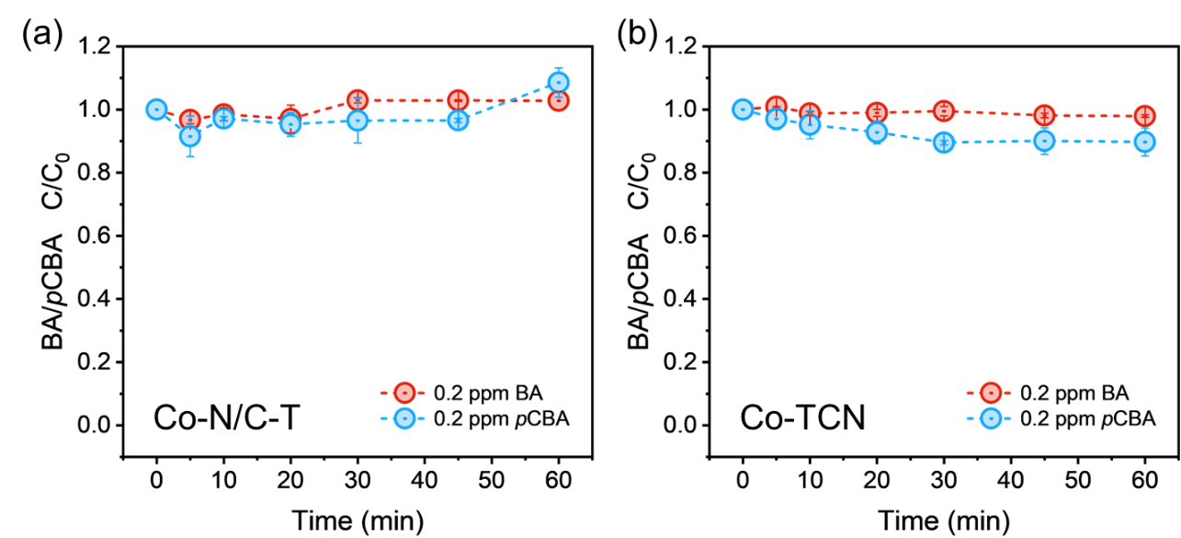
Figure S31. Probe experiments using benzoic acid and p-chlorobenzoic acid.
(Experimental conditions: [Catalyst]₀=0.2 g·L⁻¹, [HCO₃⁻]=10 mM, [H₂O₂]=6 mM, [BA]=[p-CBA]=0.2 mg·L⁻¹)

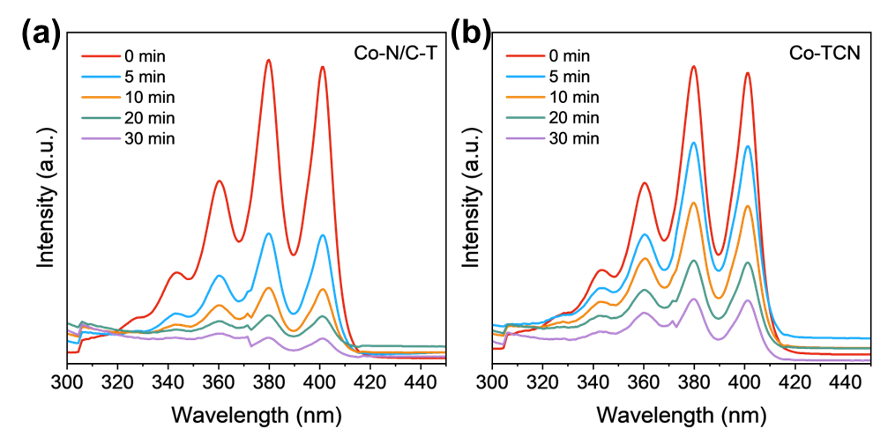
Figure S32. UV-vis spectra of ABDA in Co-N/C-T/HCO₃⁻/H₂O₂ and Co-TCN/HCO₃⁻/H₂O₂ system.
(Experimental conditions: [Catalyst]₀=0.2 g·L⁻¹, [HCO₃⁻]=10 mM, [H₂O₂]=6 mM, [ABDA]=10 μM)

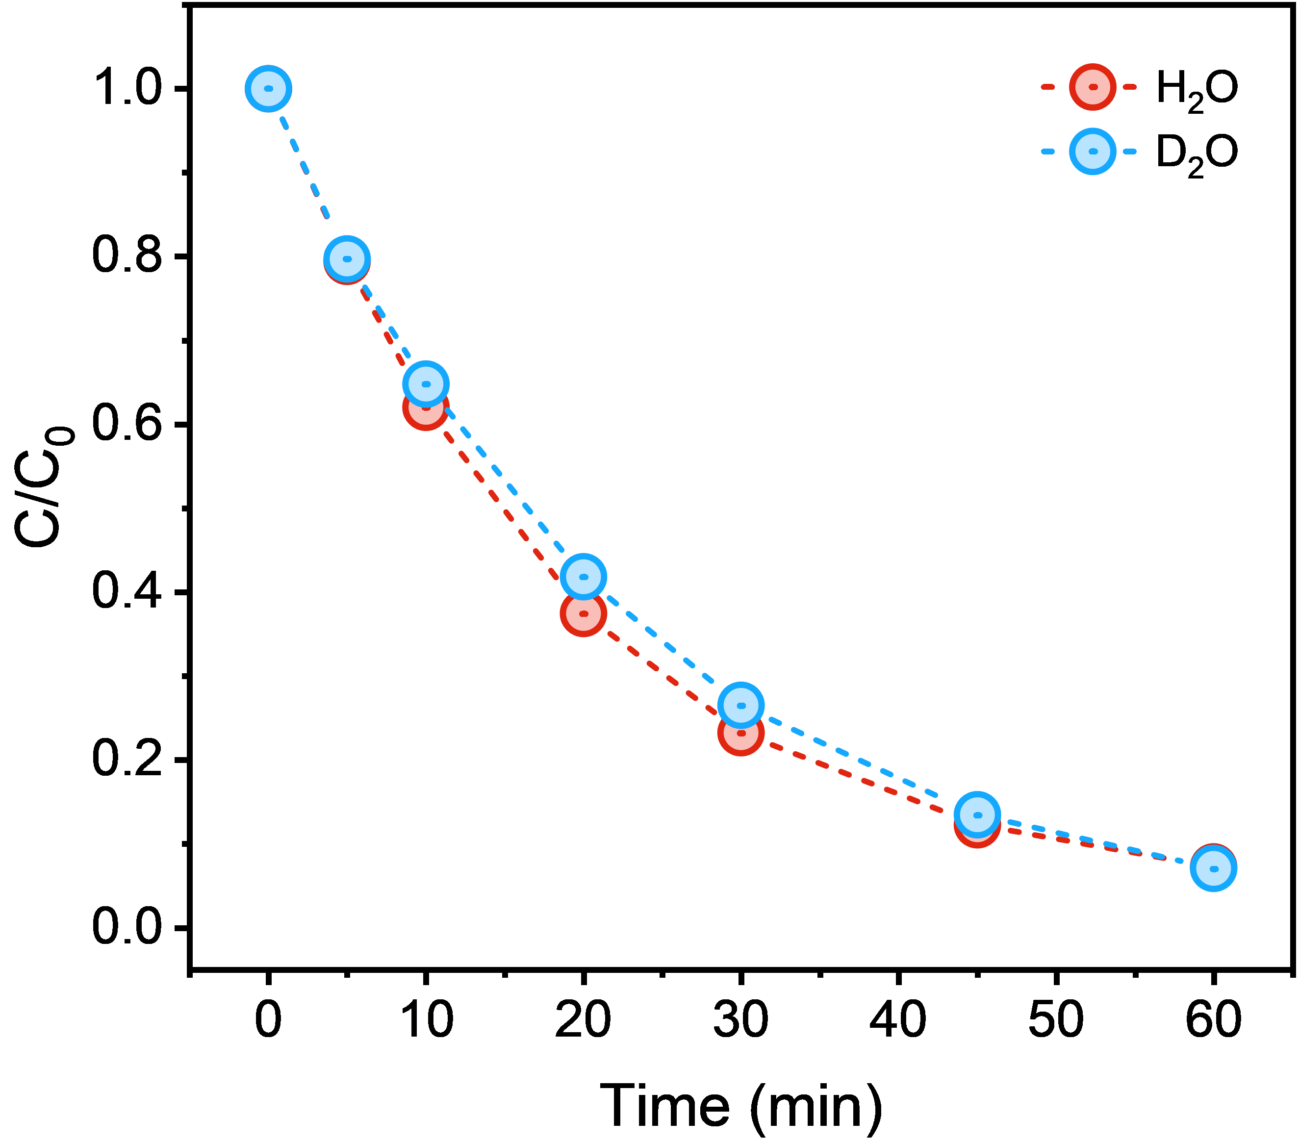
Figure S33. Effect of D₂O on SMX degradation in the Co-N/C-T/HCO₃⁻/H₂O₂ system.
(Experimental conditions: [Catalyst]₀=0.2 g·L⁻¹, [HCO₃⁻]=10 mM, [H₂O₂]=6 mM, [SMX]=10 mg·L⁻¹)
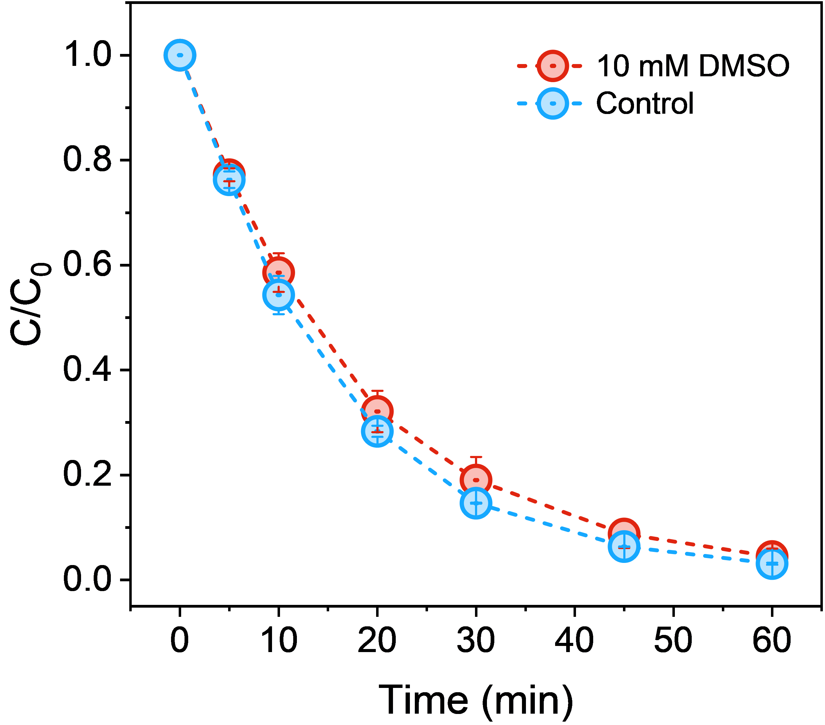
Figure S34. Effect of high-valence metal species quenching on SMX degradation in the Co-N/C-T/HCO₃⁻/H₂O₂ system.
(Experimental conditions: [Catalyst]₀=0.2 g·L⁻¹, [HCO₃⁻]=10 mM, [H₂O₂]=6 mM, [SMX]=10 mg·L⁻¹)

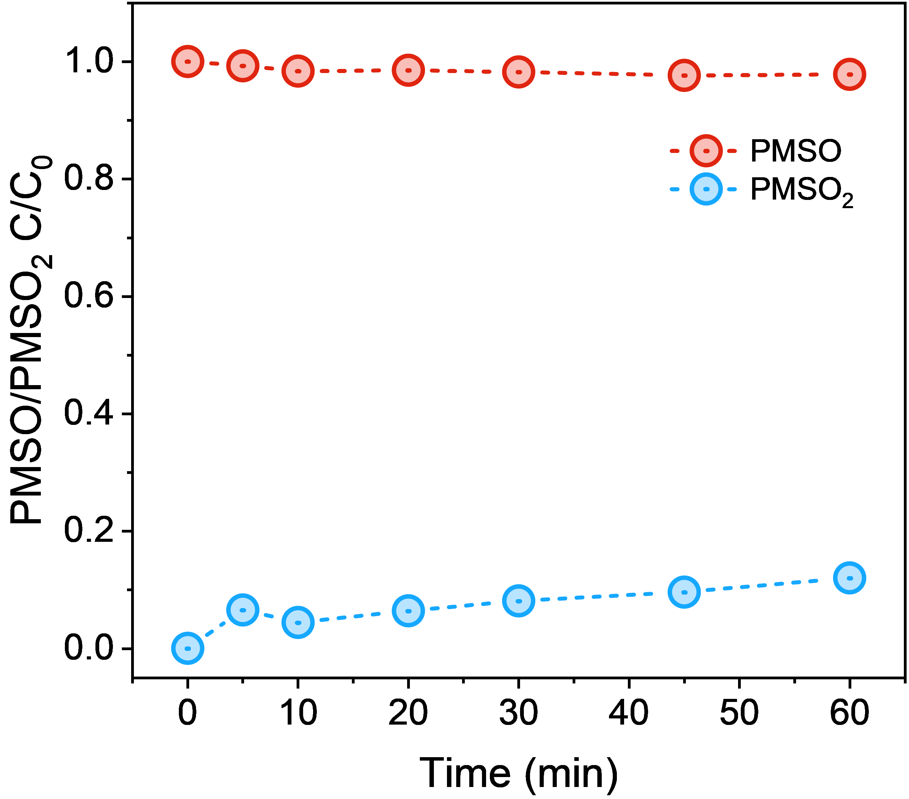
Figure S35. PMSO consumption and PMSO₂ formation in the Co-N/C-T/HCO₃⁻/H₂O₂ system.
(Experimental conditions: [Catalyst]₀=0.2 g·L⁻¹, [HCO₃⁻]=10 mM, [H₂O₂]=6 mM, PMSO=50 μM)

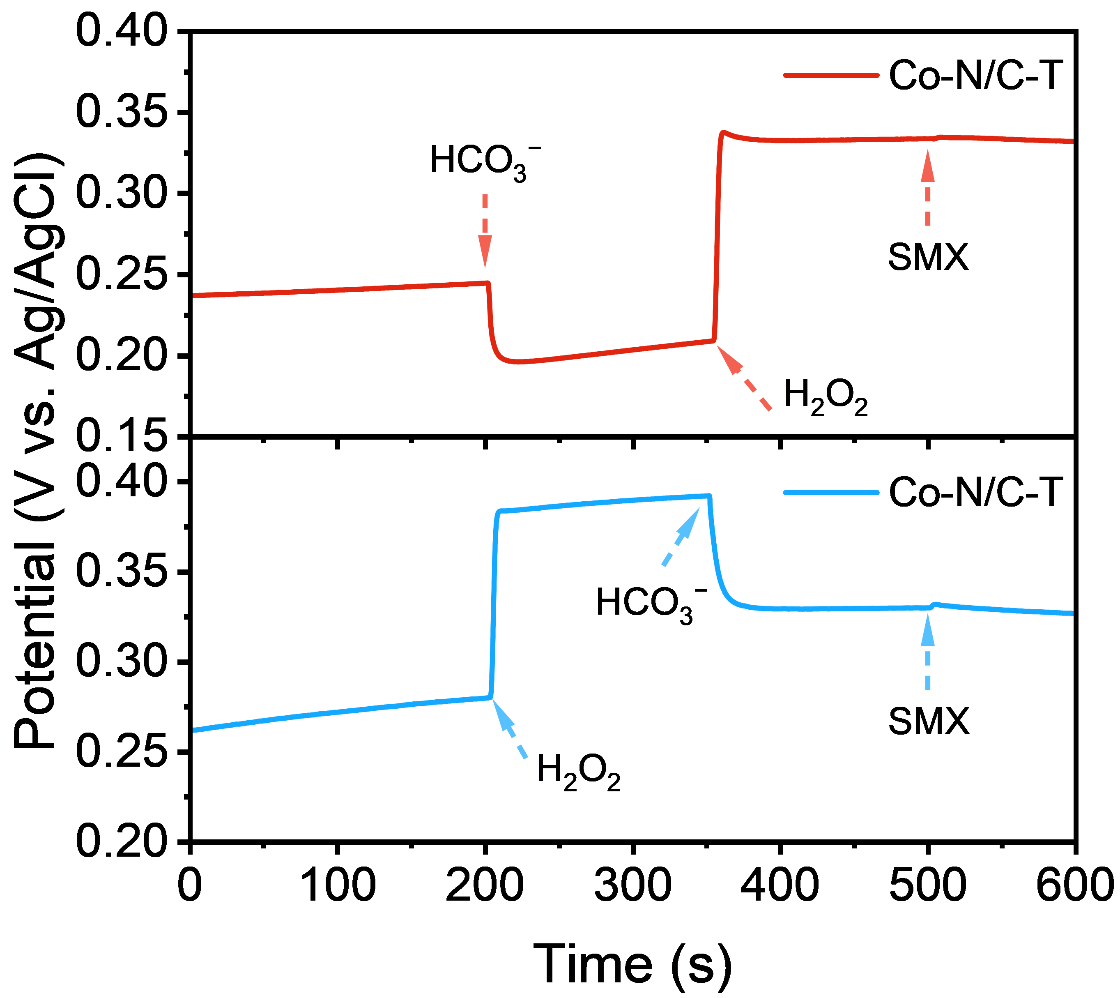
Figure S36. Open-circuit potential measurement of Co-N/C-T.

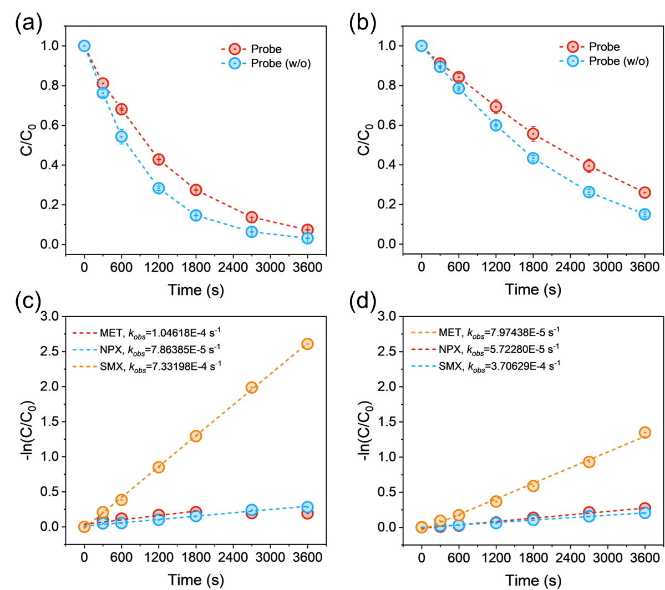
Figure S37. Competitive probe experiments: the effect of the probe on (a) Co-N/C-T and (b) Co-TCN systems; and corresponding quasi-first-order kinetic curves for (c) Co-N/C-T and (d) Co-TCN.
(Experimental conditions: [Catalyst]₀=0.2 g·L⁻¹, [HCO₃⁻]=10 mM, [H₂O₂]=6 mM, [Probe]=0.2 mg·L⁻¹)

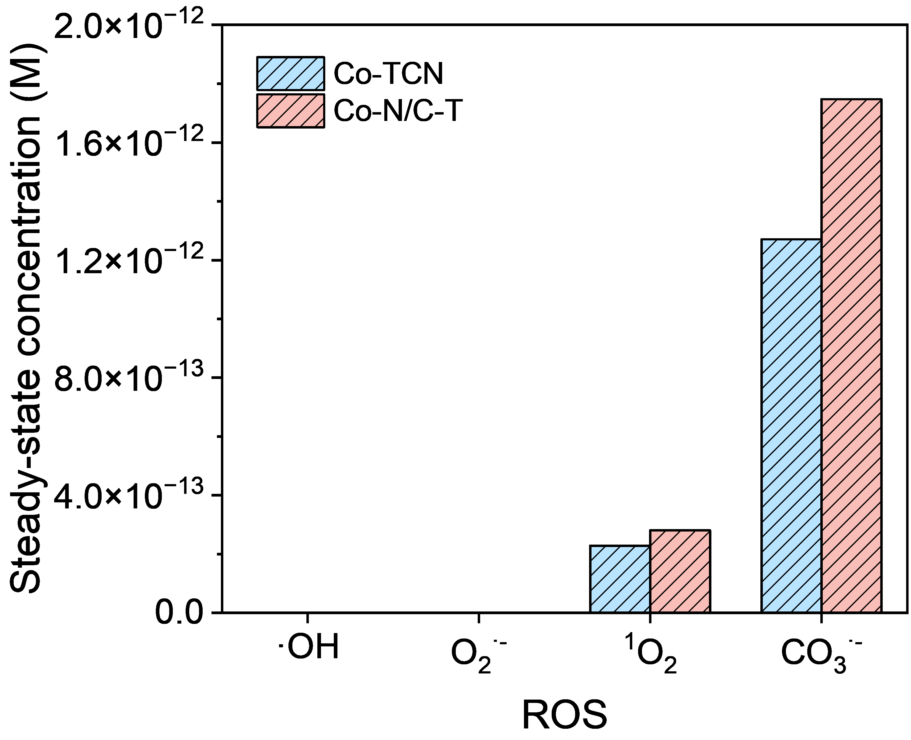
Figure S38. Steady-state concentrations of ROS in Co-N/C-T and Co-TCN systems.
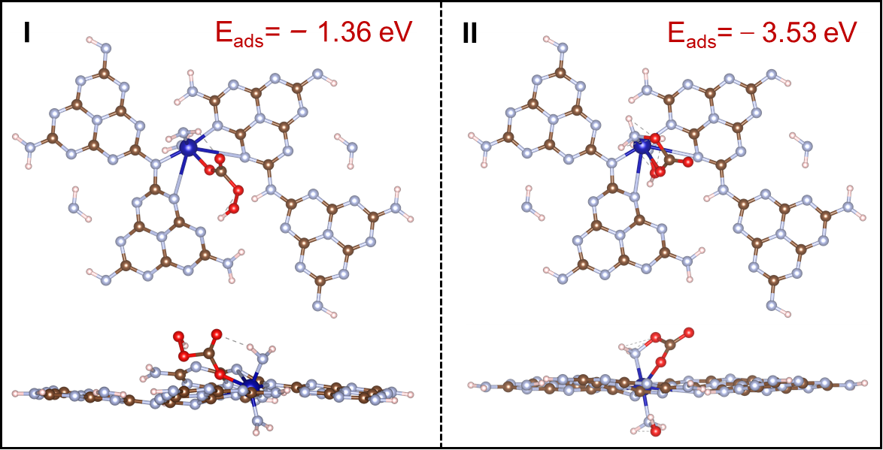
Figure S39. Optimized adsorption configuration of HCO₄⁻ on CoN₅ and CoN₆ coordination sites.

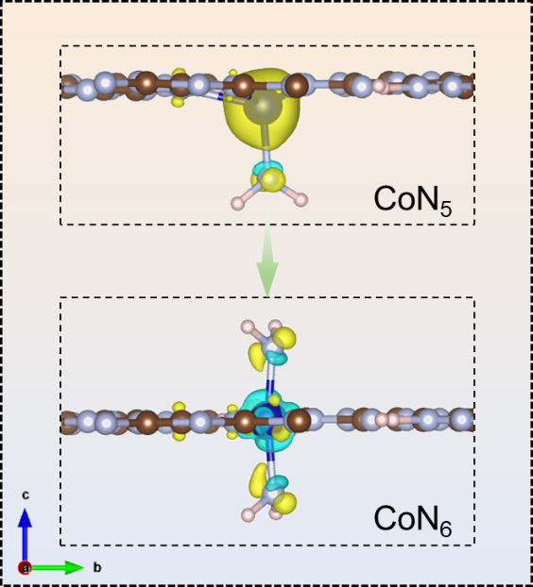
Figure S40. Differential charge density of CoN₅ and CoN₆ coordination structures.

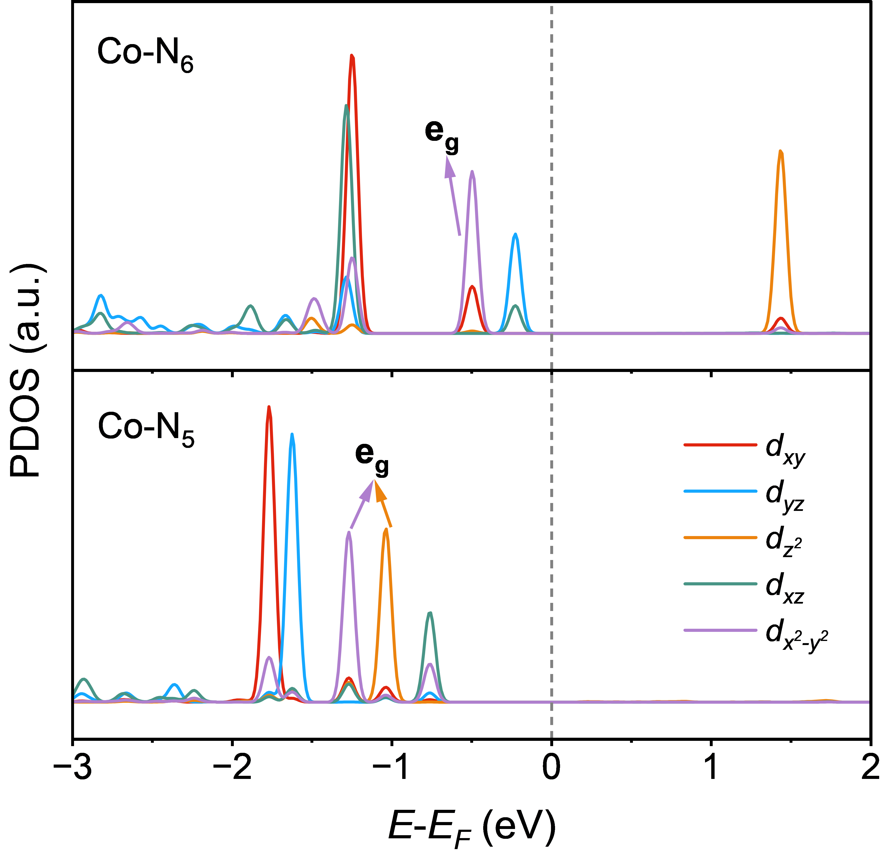
Figure S41. PDOS diagram of Co-3d orbits in CoN₅ and CoN₆.

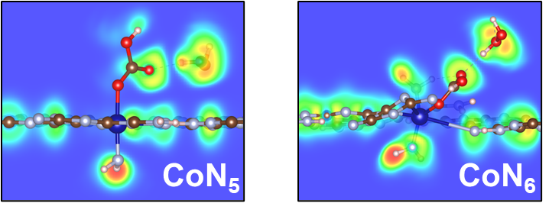
Figure S42. ELF maps of CoN₅ and CoN₆ structures.

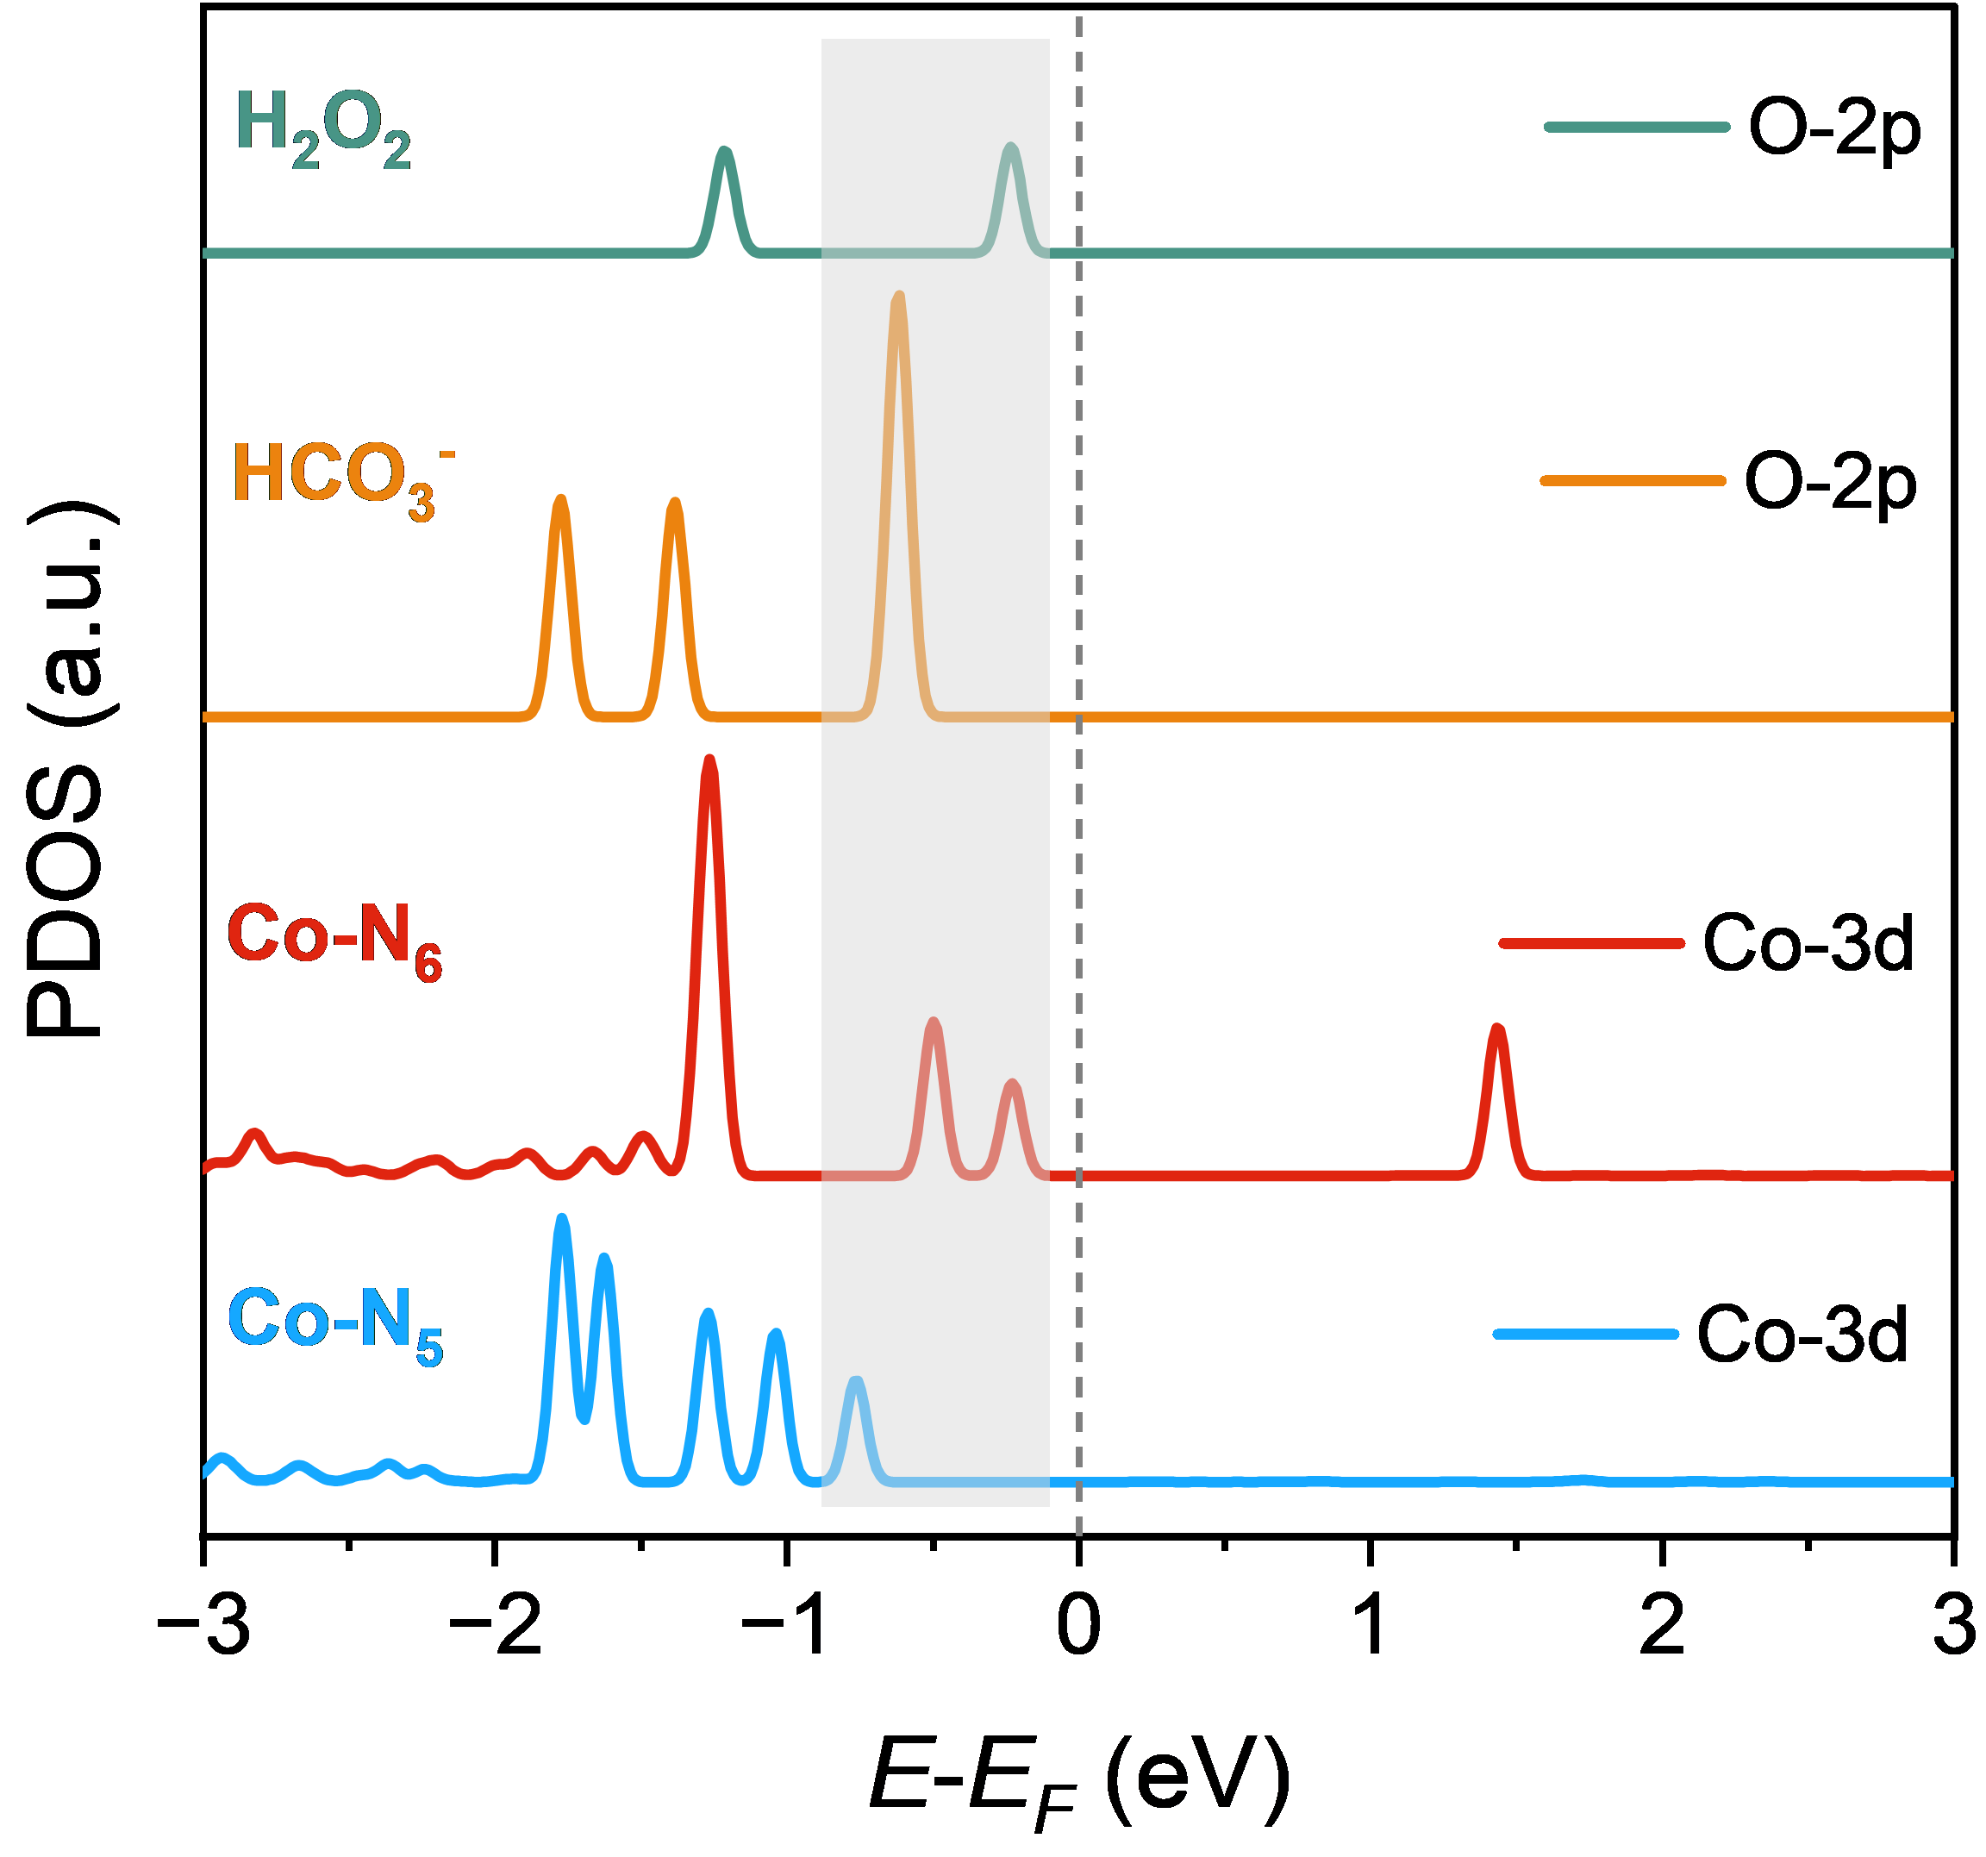
Figure S43. PDOS diagram of Co-3d orbits and O-2p orbits.

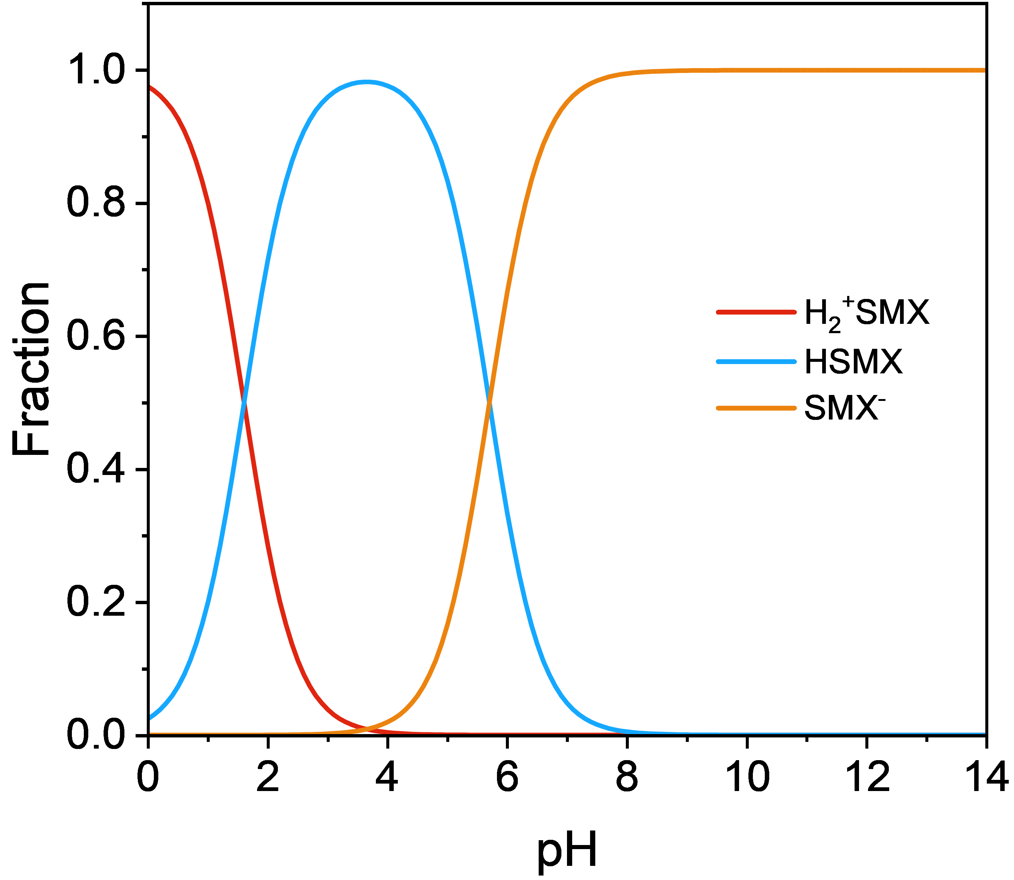
Figure S44. The speciation of SMX as a function of pH in solution.

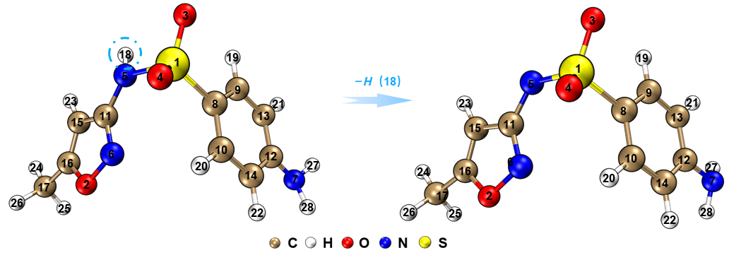
Figure S45. Optimized molecular configurations of SMX and its deprotonated form SMX⁻.

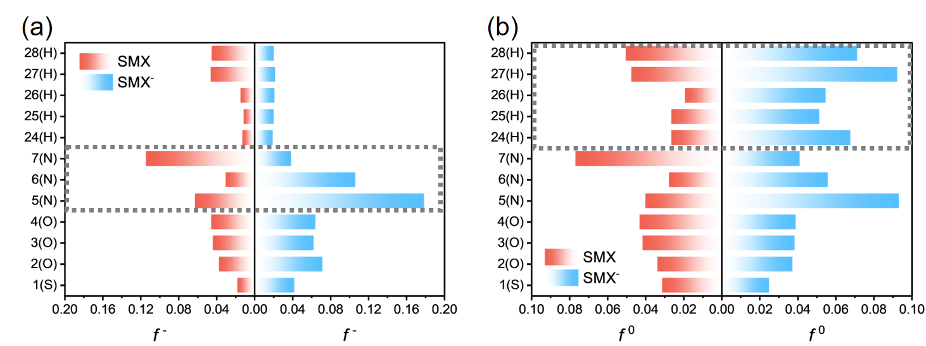
Figure S46. The condensed Fukui function values of SMX and SMX⁻.

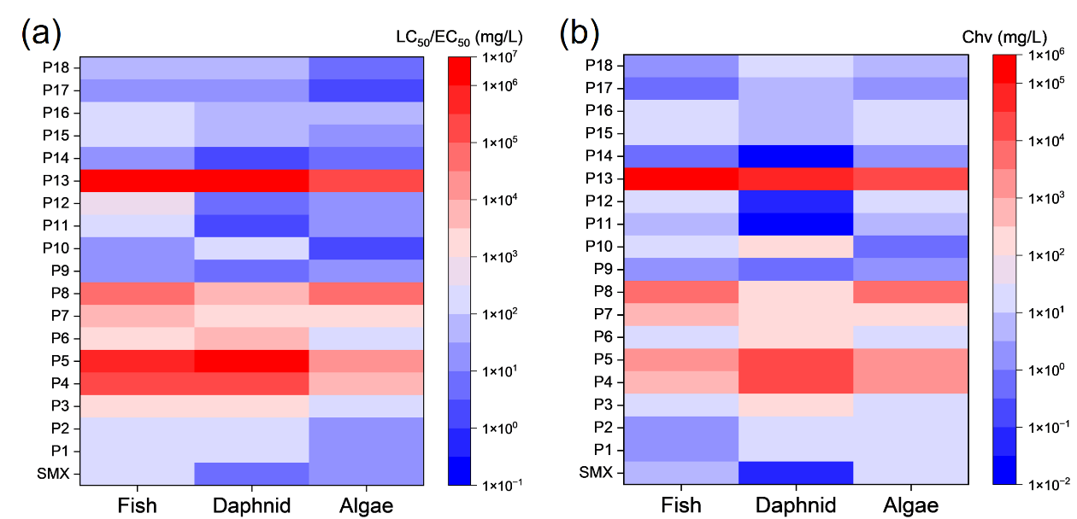
Figure S47. Toxicity analysis of SMX degradation intermediates.

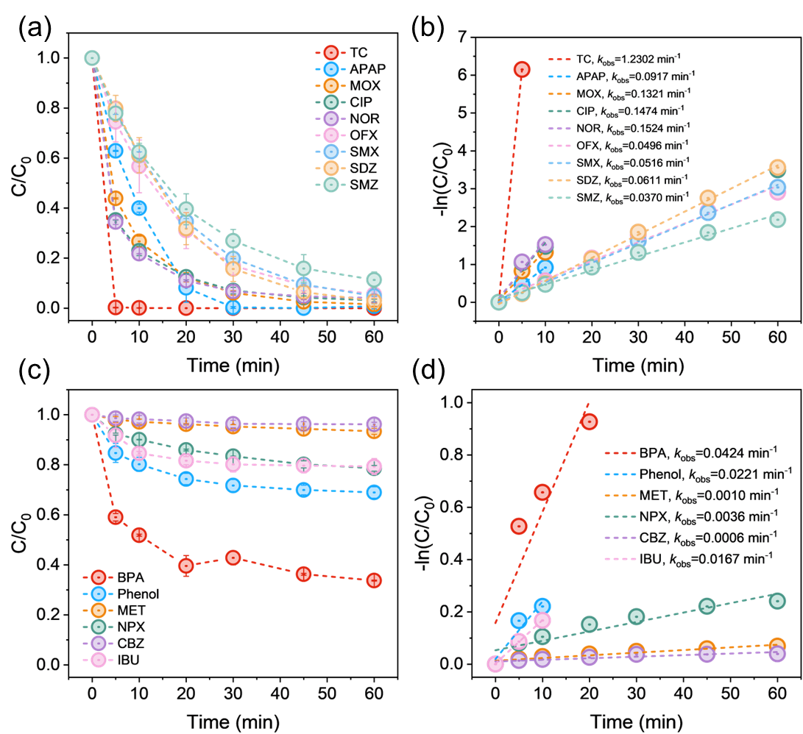
Figure S48. The removal efficiency of various organic pollutants in Co-N/C-T/HCO₃⁻/H₂O₂ system.
(Experimental conditions: [Catalyst]₀=0.2 g·L⁻¹, [HCO₃⁻]=10 mM, [H₂O₂]=6 mM, [Pollutant]=5 mg·L⁻¹)

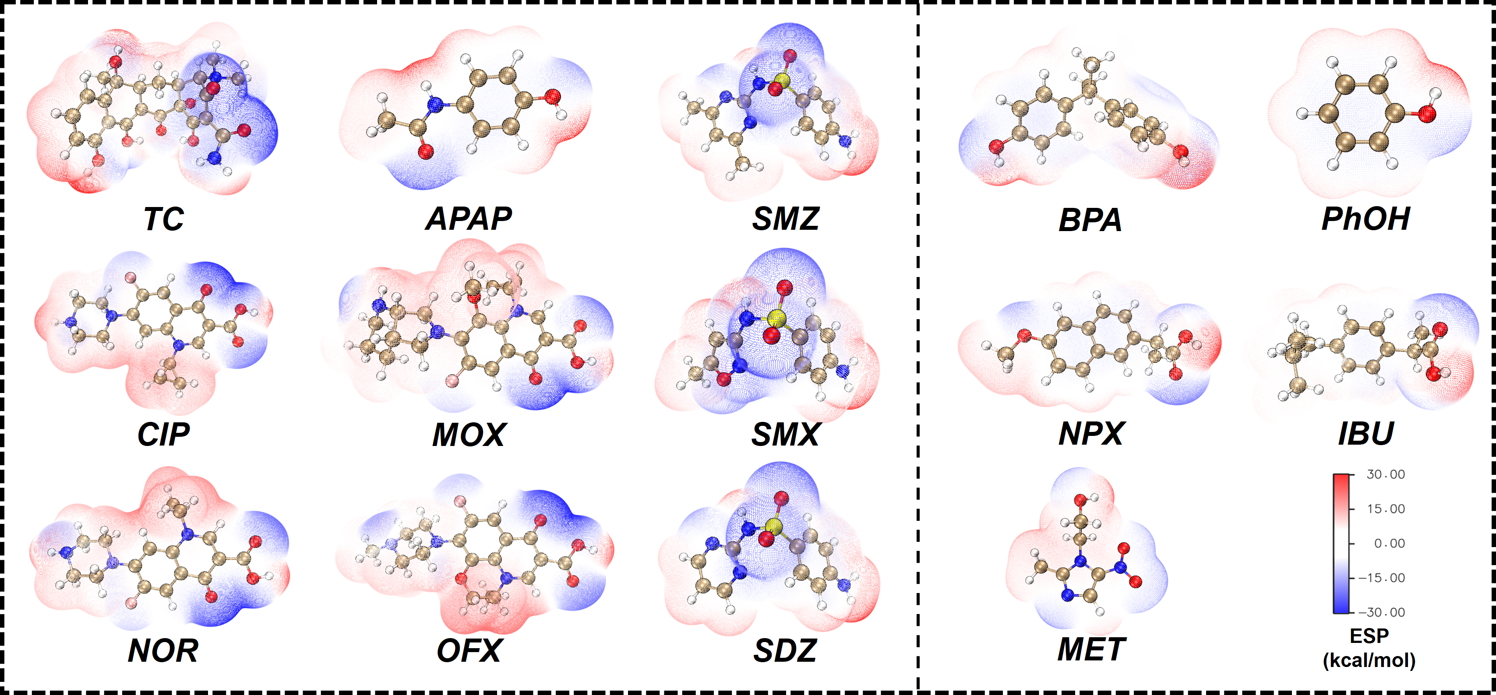
Figure S49. Electrostatic potential (ESP) distributions of different organic pollutants.
The nine molecules on the left exhibit pronounced polarity, characterized by strongly electronegative regions that are prone to participate in electron transfer during the reaction process. Representative compounds such as tetracycline (TC), ciprofloxacin (CIP), and sulfamethoxazole (SMX) possess multiple polar functional groups (e.g., carboxyl, amino, and amide groups) and active hydrogen atoms, forming electron-rich sites that enhance their chemical reactivity. In contrast, the five molecules on the right display relatively uniform electrostatic potential distributions. Despite the presence of aromatic rings, their limited electron-donating functionality or the diminished influence of such groups due to long aliphatic chains results in lower electron density and attenuated reactivity.

Table S1. Co contents of the synthesized Co SACs determined by ICP-OES analysis.
Sample | Co contents (wt%)
Co-TCN-3 | 2.24
Co-TCN-2 | 1.48
Co-TCN-0.75 | 0.52
Co-TCN-1.5 | 1.16
Co-N/C-T | 1.49

Table S2. EXAFS fitting parameters at the Co K-edge for various sample (S₀²=0.74).
Sample | Shell | Nª | R(Å)^{b} | σ²(Å²)^{c} | ΔE₀(eV)^{d} | R factor  (%)
Co foil | Co−Co | 12* | 2.49±0.01 | 0.0064 | 7.9±0.3 | 0.17
Co-TCN | Co−N | 5.2±0.3 | 2.04±0.01 | 0.0085 | -2.1±1.2 | 0.92
Co-N/C-T | Co−N | 5.9±0.3 | 2.04±0.01 | 0.0097 | -3.0±1.5 | 1.26
ªN: coordination numbers; ^{b}R: bond distance; ^{c}σ²: Debye-Waller factors; ^{d} ΔE₀: the inner potential correction; R factor: goodness of fit.
Ѕ₀² was set to 0.74, according to the experimental EXAFS fit of Co foil reference by fixing CN as the known crystallographic value.
Table S3. Theoretical parameters of Co-TCN (CoN₅) and Co-N/C-T (CoN₆) models.
Model | Coordination | Average bond length (Co−N) (Å) | Formation energy  (eV) | Coordination | Average bond length (Co−N)  (Å) | Formation energy  (eV)
1 | CoN₅ | 1.9529 | 1.1717 | CoN₆ | 1.9583 | −0.7023
2 | CoN₅ | 2.1438 | −0.1111 | CoN₆ | 2.0886 | −2.3028
3 | CoN₅ | 2.1456 | −0.1097 | CoN₆ | 2.0903 | −2.3026

Table S4. Catalytic performance of reported HCO₃⁻/H₂O₂-based systems.
Catalyst | Catalyst dosage  (g·L⁻¹) | HCO₃⁻ dosage  (g·L⁻¹) | H₂O₂ dosage  (g·L⁻¹) | k_{obs}  (min⁻¹) | Pollutant | K_{N}  (×10⁻² min⁻¹g⁻³·L³) | Ref
Co/Cu@CS | 0.3 | 0.61 | 0.34 | 0.037 | NOR  (10 mg·L⁻¹) | 2.02 | ⁷
Co/Cu@CS | 0.3 | 0.61 | 0.34 | 0.023 | SMX  (10 mg·L⁻¹) | 1.26 | ⁷
Co/Cu@CS | 0.3 | 0.61 | 0.34 | 0.022 | OTC  (10 mg·L⁻¹) | 1.20 | ⁷
Co@MOFs | 0.1 | 1.525 | 0.34 | 0.0646 | SMX  (40 μM) | 1.69 | ⁸
Co@MOFs | 0.1 | 1.525 | 0.34 | 0.0573 | CIP  (40 μM) | 1.50 | ⁸
Co@MOFs | 0.1 | 1.525 | 0.34 | 0.1057 | NOR  (40 μM) | 2.77 | ⁸
Mn_{1.23}Co_{1.77}O₄ | 0.1 | 0.305 | 2.04 | 0.01324 | 2,4-DCP  (10 mg·L⁻¹) | 8.68 | ⁹
CoMgAl-SHTs | 0.03 | 1.83 | 1.02 | 0.25679 | 4-CP  (100 mg·L⁻¹) | 15.59 | ¹⁰
CuCoO_{x}–LDH | 0.5 | 1.83 | 0.85 | 0.06878 | 4-CP  (200 mg·L⁻¹) | 0.25 | ¹¹
SC@CuFeO₂ | 0.3 | 0.915 | 1.7 | 0.037 | SMX  (10 mg·L⁻¹) | 0.90 | ¹²
CuFeS₂ | 0.05 | 1.525 | 2.04 | 0.0206 | 4-CP  (10 v) | 1.08 | ¹³
CuO-MgO | 0.5 | 0.915 | 1.02 | 0.06057 | Phenol  (0.5 mM) | 0.88 | ¹⁴
Co-N/C-T | 0.2 | 0.61 | 0.204 | 1.23016 | TC  (5 mg·L⁻¹) | 100.83 | This work
Co-N/C-T | 0.2 | 0.61 | 0.204 | 0.09169 | APAP  (5 mg·L⁻¹) | 7.52 | This work
Co-N/C-T | 0.2 | 0.61 | 0.204 | 0.05905 | SMX  (10 mg·L⁻¹) | 4.84 | This work

Table S5. TOF values and key catalytic parameters of the catalysts.
Sample  Parameters | Co-TCN | Co-N/C-T
Catalyst dosage  (g·L⁻¹) | 0.2 | 0.2
k_{obs}  (min⁻¹) | 0.03168 | 0.05905
S_{BET}  (m²·g⁻¹) | 91.1960 | 112.4067
Co contents | 1.16 | 1.49
TOF  (min⁻¹) | 0.032 | 0.046

Calculation of turnover frequencies (TOF):
TOF for SMX removal were calculated on a per-Co atom basis using Equation S16:
$$\begin{aligned}TOF=k_{obs}×\frac{{\left[SMX\right]}_{0}}{m_{cat}×w_{cat}}\#\left(S16\right)\end{aligned}$$
where k_{obs} is the apparent reaction rate constant of SMX degradation, min⁻¹; [SMX]₀ is the initial concentration of SMX, 39.5 μM; m_{cat} is the dosage of catalyst, μM; w_{cat} is the doping amount of cobalt in the catalyst, wt%.
Table S6. Second-order rate constants for reactions between ROS and quenchers or probe molecules.
Compounds | Reaction rate constant (M⁻¹ s⁻¹)
Compounds | •OH | O₂^{•−} | ¹O₂ | CO₃^{•−} | Ref
TBA | 6×10⁸ | N/A | 1.8×10³ | N/A | ^{15–21}
MeOH | 9.7×10⁸ | N/A | 3.89×10³ | N/A | ^{15–21}
IPA | 1.9×10⁹ | N/A | 3.48×10³ | N/A | ^{15–21}
p-BQ | N/A | 9.0×10⁸ | N/A | N/A | ^{15–21}
FFA | 1.5×10¹⁰ | 3.5×10³ | 1.2×10⁸ | N/A | ^{15–21}
L-his | 7.1×10⁹ | N/A | 3.2×10⁷ | N/A | ^{15–21}
DMA | N/A | N/A | N/A | 1.8×10⁹ | ^{15–21}
BA | 1.2×10⁹ | N/A | N/A | N/A | ^{22–28}
p-CBA | 5×10⁹ | 8.6×10⁷ | 1.4×10⁷ | N/A | ^{22–28}
MET | 3.54×10⁹ | N/A | 1.5×10⁸ | 3.58×10⁷ | ^{22–28}
NPX | 8.61×10⁹ | N/A | 1.1×10⁵ | 4.5×10⁷ | ^{22–28}
SMX | 8.5×10⁹ | 5.51×10⁵ | 2×10⁴ | 4.15×10⁸ | ^{22–28}

Table S7. Definition of quantum chemistry descriptors.
Descriptor | Symbol | definition | Unit
Vertical ionization potential | VIP | The energy absorbed when losing one electron | eV
Softness | S | The sensitivity of molecule to charge changes | eV⁻¹
Highest occupied molecular orbital energy | E_{HOMO} | The highest energy level that is fully occupied by electrons in a molecule | eV
Lowest unoccupied molecular orbital energy | E_{LUMO} | The lowest energy level that is not occupied by electrons in a molecule | eV
Molecular orbital gap | ΔE_{gap} | The difference between E_{HOMO} and E_{LUMO} | eV

Table S8. Detailed chemical information of the SMX degradation intermediates.
Compound | RT  (min) | m/z | Formula | Proposed structure |  |  | Compound | RT  (min) | m/z | Formula | Proposed structure
SMX | 4.596 | 254.05 | C₁₀H₁₁N₃O₃S |  |  |  | P10 | 2.673 | 109.04 | C₆H₆O₂
P1 | 8.981 | 284.03 | C₁₀H₉N₃O₅S |  |  |  | P11 | 3.004 | 97.05 | C₄H₆N₂O
P2 | 8.443 | 298.03 | C₁₀H₉N₃O₆S |  |  |  | P12 | 2.689 | 113.05 | C₄H₆N₂O₂
P3 | 5.732 | 268.05 | C₁₀H₁₁N₃O₄S |  |  |  | P13 | 2.142 | 177.00 | C₄H₆N₂O₄S
P4 | 8.443 | 298.02 | C₁₀H₉N₃O₆S |  |  |  | P14 | 9.031 | 92.06 | C₆H₇N
P5 | 1.769 | 329.02 | C₁₁H₁₀N₂O₈S |  |  |  | P15 | 6.304 | 106.04 | C₆H₅NO
P6 | 2.573 | 171.03 | C₆H₈N₂O₂S |  |  |  | P16 | 4.248 | 122.03 | C₆H₅NO₂
P7 | 6.287 | 154.00 | C₆H₅NO₂S |  |  |  | P17 | 10.814 | 501.07 | C₂₀H₁₈N₆O₆S₂
P8 | 6.304 | 173.00 | C₆H₆O₄S |  |  |  | P18 | 10.631 | 517.07 | C₂₀H₁₈N₆O₇S₂
P9 | 2.25 | 93.04 | C₆H₆O

Table S9. Detection conditions of HPLC for different pollutants.
Pollutants | Mobile phase ratio | Flow rate  (mL/min) | Detection wavelength  (nm)
TC | 30:70 | 0.5 | 268
APAP | 30:70 | 0.5 | 246
OFX | 30:70 | 0.4 | 294
MOX | 30:70 | 0.8 | 295
NOR | 30:70 | 0.6 | 279
CIP | 30:70 | 0.6 | 278
SMX | 30:70 | 0.9 | 270
SDZ | 30:70 | 0.6 | 268
SMZ | 30:70 | 0.6 | 266
MET | 40:60 | 0.5 | 318
Aniline | 50:50 | 0.7 | 234
PhOH | 30:70 | 0.9 | 270
BPA | 50:50 | 0.7 | 278
IBU | 30:70 | 0.8 | 262
NPX | 50:50 | 0.9 | 268
BA | 40:60 | 0.6 | 228
p-CBA | 30:70 | 0.6 | 237
Note: All mobile phases are acetonitrile and 0.1% phosphoric acid solution.

Reference
(1) Frisch, M. J.; Trucks, G. W.; Schlegel, H. B.; Scuseria, G. E.; Robb, M. A.; Cheeseman, J. R.; Scalmani, G.; Barone, V.; Petersson, G. A.; Nakatsuji, H.; Li, X.; Caricato, M.; Marenich, A. V.; Bloino, J.; Janesko, B. G.; Gomperts, R.; Mennucci, B.; Hratchian, H. P.; Ortiz, J. V.; Izmaylov, A. F.; Sonnenberg, J. L.; Williams; Ding, F.; Lipparini, F.; Egidi, F.; Goings, J.; Peng, B.; Petrone, A.; Henderson, T.; Ranasinghe, D.; Zakrzewski, V. G.; Gao, J.; Rega, N.; Zheng, G.; Liang, W.; Hada, M.; Ehara, M.; Toyota, K.; Fukuda, R.; Hasegawa, J.; Ishida, M.; Nakajima, T.; Honda, Y.; Kitao, O.; Nakai, H.; Vreven, T.; Throssell, K.; Montgomery Jr., J. A.; Peralta, J. E.; Ogliaro, F.; Bearpark, M. J.; Heyd, J. J.; Brothers, E. N.; Kudin, K. N.; Staroverov, V. N.; Keith, T. A.; Kobayashi, R.; Normand, J.; Raghavachari, K.; Rendell, A. P.; Burant, J. C.; Iyengar, S. S.; Tomasi, J.; Cossi, M.; Millam, J. M.; Klene, M.; Adamo, C.; Cammi, R.; Ochterski, J. W.; Martin, R. L.; Morokuma, K.; Farkas, O.; Foresman, J. B.; Fox, D. J. Gaussian 16 Rev. C.01, 2016.
(2) Stephens, P. J.; Devlin, F. J.; Chabalowski, C. F.; Frisch, M. J. Ab Initio Calculation of Vibrational Absorption and Circular Dichroism Spectra Using Density Functional Force Fields. J. Phys. Chem. 1994, 98 (45), 11623–11627. https://doi.org/10.1021/j100096a001.
(3) Marenich, A. V.; Cramer, C. J.; Truhlar, D. G. Universal Solvation Model Based on Solute Electron Density and on a Continuum Model of the Solvent Defined by the Bulk Dielectric Constant and Atomic Surface Tensions. J. Phys. Chem. B 2009, 113 (18), 6378–6396. https://doi.org/10.1021/jp810292n.
(4) Lu, T.; Chen, F. Multiwfn: A Multifunctional Wavefunction Analyzer. Journal of Computational Chemistry 2012, 33 (5), 580–592. https://doi.org/10.1002/jcc.22885.
(5) Lu, T.; Chen, F. Quantitative Analysis of Molecular Surface Based on Improved Marching Tetrahedra Algorithm. Journal of Molecular Graphics and Modelling 2012, 38, 314–323. https://doi.org/10.1016/j.jmgm.2012.07.004.
(6) Humphrey, W.; Dalke, A.; Schulten, K. VMD: Visual Molecular Dynamics. Journal of Molecular Graphics 1996, 14 (1), 33–38. https://doi.org/10.1016/0263-7855(96)00018-5.
(7) Liu, Y.; Zhang, B.-T.; Yan, Z.; Chen, Z.; Ren, H.; Du, W. Activation of Peroxymonocarbonate by Magnetic Bimetal in Porous Carbon Spheres for Effective Norfloxacin Degradation. Separation and Purification Technology 2023, 322, 124337. https://doi.org/10.1016/j.seppur.2023.124337.
(8) Zhang, B.-T.; Yan, Z.; Zhao, J.; Chen, Z.; Liu, Y.; Fan, M.; Du, W. Peroxymonocarbonate Activation via Co Nanoparticles Confined in Metal–Organic Frameworks for Efficient Antibiotic Degradation in Different Actual Water Matrices. Water Res 2023, 243, 120340. https://doi.org/10.1016/j.watres.2023.120340.
(9) Pi, L.; Yang, N.; Han, W.; Xiao, W.; Wang, D.; Xiong, Y.; Zhou, M.; Hou, H.; Mao, X. Heterogeneous Activation of Peroxymonocarbonate by Co-Mn Oxides for the Efficient Degradation of Chlorophenols in the Presence of a Naturally Occurring Level of Bicarbonate. Chemical Engineering Journal 2018, 334, 1297–1308. https://doi.org/10.1016/j.cej.2017.11.006.
(10) Jawad, A.; Lu, X.; Chen, Z.; Yin, G. Degradation of Chlorophenols by Supported Co–Mg–Al Layered Double Hydrotalcite with Bicarbonate Activated Hydrogen Peroxide. J. Phys. Chem. A 2014, 118 (43), 10028–10035. https://doi.org/10.1021/jp5085313.
(11) Jawad, A.; Li, Y.; Guo, L.; Khan, A.; Chen, Z.; Wang, J.; Yang, J.; Liu, W.; Yin, G. Bimetallic Synergistic Degradation of Chlorophenols by CuCoOx–LDH Catalyst in Bicarbonate-Activated Hydrogen Peroxide System. RSC Adv. 2016, 6 (76), 72643–72653. https://doi.org/10.1039/C6RA10402A.
(12) Dai, C.; Tian, X.; Feng, S.; Nie, Y.; Li, Y.; Lu, L. Insight into Bicarbonate Involved Efficient Heterogeneous Fenton-like Degradation of Sulfamethoxazole over a CuFeO2 Based Composite under Alkaline Conditions. Environ. Sci.: Nano 2021, 8 (5), 1296–1307. https://doi.org/10.1039/D1EN00055A.
(13) Xu, X.; Tang, D.; Cai, J.; Xi, B.; Zhang, Y.; Pi, L.; Mao, X. Heterogeneous Activation of Peroxymonocarbonate by Chalcopyrite (CuFeS2) for Efficient Degradation of 2,4-Dichlorophenol in Simulated Groundwater. Appl Catal B-environ 2019, 251, 273–282. https://doi.org/10.1016/j.apcatb.2019.03.080.
(14) Li, Y.; Guo, L.; Huang, D.; Jawad, A.; Chen, Z.; Yang, J.; Liu, W.; Shen, Y.; Wang, M.; Yin, G. Support-Dependent Active Species Formation for CuO Catalysts: Leading to Efficient Pollutant Degradation in Alkaline Conditions. Journal of Hazardous Materials 2017, 328, 56–62. https://doi.org/10.1016/j.jhazmat.2016.12.063.
(15) Ding, D.; Yang, S.; Qian, X.; Chen, L.; Cai, T. Nitrogen-Doping Positively Whilst Sulfur-Doping Negatively Affect the Catalytic Activity of Biochar for the Degradation of Organic Contaminant. Applied Catalysis B: Environmental 2020, 263, 118348. https://doi.org/10.1016/j.apcatb.2019.118348.
(16) Zhu, S.; Jin, C.; Duan, X.; Wang, S.; Ho, S.-H. Nonradical Oxidation in Persulfate Activation by Graphene-like Nanosheets (GNS): Differentiating the Contributions of Singlet Oxygen (1O2) and Sorption-Dependent Electron Transfer. Chemical Engineering Journal 2020, 393, 124725. https://doi.org/10.1016/j.cej.2020.124725.
(17) Ding, L.; Hou, Y.; Liu, H.; Peng, J.; Cao, Z.; Zhang, Y.; Wang, B.; Cao, X.; Chang, Y.; Wang, T.; Liu, G. Alcohols as Scavengers for Hydroxyl Radicals in Photocatalytic Systems: Reliable or Not? ACS EST Water 2023, 3 (11), 3534–3543. https://doi.org/10.1021/acsestwater.3c00271.
(18) Zhai, P.; Liu, H.; Sun, F.; Chen, T.; Zou, X.; Wang, H.; Chu, Z.; Wang, C.; Liu, M.; Chen, D. Carbonization of Methylene Blue Adsorbed on Palygorskite for Activating Peroxydisulfate to Degrade Bisphenol A: An Electron Transfer Mechanism. Applied Clay Science 2022, 216, 106327. https://doi.org/10.1016/j.clay.2021.106327.
(19) Ren, D.; Huang, B.; Bi, T.; Xiong, D.; Pan, X. Effects of pH and Dissolved Oxygen on the Photodegradation of 17α-Ethynylestradiol in Dissolved Humic Acid Solution. Environ. Sci.: Processes Impacts 2016, 18 (1), 78–86. https://doi.org/10.1039/C5EM00502G.
(20) Li, J.; Zheng, W.; Meng, S.; Wang, S.; Zhan, S.; Sun, Y.; Hu, W.; Li, Y. Modulated Fe Central Spin State in FeCu4 Alloy Nanoparticles for Efficient and Selective Activation of H2O2. Advanced Functional Materials n/a (n/a), 2417538. https://doi.org/10.1002/adfm.202417538.
(21) Wojnárovits, L.; Tóth, T.; Takács, E. Rate Constants of Carbonate Radical Anion Reactions with Molecules of Environmental Interest in Aqueous Solution: A Review. Science of The Total Environment 2020, 717, 137219. https://doi.org/10.1016/j.scitotenv.2020.137219.
(22) Zhang, Y.; Guo, Y.; Fang, J.; Guo, K.; Yu, G.; Wang, Y. Characterization of UV/Chlorine Process for Micropollutant Abatement by Probe Compound-Based Kinetic Models. Water Research 2023, 237, 119985. https://doi.org/10.1016/j.watres.2023.119985.
(23) Gao, L.; Guo, Y.; Zhan, J.; Yu, G.; Wang, Y. Assessment of the Validity of the Quenching Method for Evaluating the Role of Reactive Species in Pollutant Abatement during the Persulfate-Based Process. Water Research 2022, 221, 118730. https://doi.org/10.1016/j.watres.2022.118730.
(24) Guo, Y.; Zhang, Y.; Yu, G.; Wang, Y. Revisiting the Role of Reactive Oxygen Species for Pollutant Abatement during Catalytic Ozonation: The Probe Approach versus the Scavenger Approach. Applied Catalysis B: Environmental 2021, 280, 119418. https://doi.org/10.1016/j.apcatb.2020.119418.
(25) Cong, J.; Wen, G.; Huang, T.; Deng, L.; Ma, J. Study on Enhanced Ozonation Degradation of Para-Chlorobenzoic Acid by Peroxymonosulfate in Aqueous Solution. Chemical Engineering Journal 2015, 264, 399–403. https://doi.org/10.1016/j.cej.2014.11.086.
(26) Guo, Y.; Long, J.; Huang, J.; Yu, G.; Wang, Y. Can the Commonly Used Quenching Method Really Evaluate the Role of Reactive Oxygen Species in Pollutant Abatement during Catalytic Ozonation? Water Research 2022, 215, 118275. https://doi.org/10.1016/j.watres.2022.118275.
(27) Li, Y.; Pan, Y.; Lian, L.; Yan, S.; Song, W.; Yang, X. Photosensitized Degradation of Acetaminophen in Natural Organic Matter Solutions: The Role of Triplet States and Oxygen. Water Research 2017, 109, 266–273. https://doi.org/10.1016/j.watres.2016.11.049.
(28) Hong, W.; Zou, J.; Zhao, M.; Yan, S.; Song, W. Development of a Five-Chemical-Probe Method to Determine Multiple Radicals Simultaneously in Hydroxyl and Sulfate Radical-Mediated Advanced Oxidation Processes. Environ. Sci. Technol. 2024. https://doi.org/10.1021/acs.est.4c00669.

