Table 4. ROC characteristics of the pEVs proteins identified in the Kaplan Meier analysis. Patients with negative and positive AD pathology (A-T- / A+T+) were selected as “Controls” and “Cases” respectively.

pEVs protein | Cut Off value (Z_score) | Sensitivity  [95% CI] (%) | Specificity  [95% CI] (%) | PPV  [95% CI] (%) | NPV  [95% CI] (%) | Prevalence  [95% CI] (%) | LP savings (%) | Youden Index | True positives False positives | True negatives False negatives
Testing cohort
CHMP1A | > -0.5895 | 89.7  [77.4 to 96.9] | 72.0  [52.2 to 85.7] | 83.3  [67.3 to 91.0] | 81.8  [66.2 to 90.4] | 60.9  [45.0 to 75.1] | 34.4 | 61.7 | 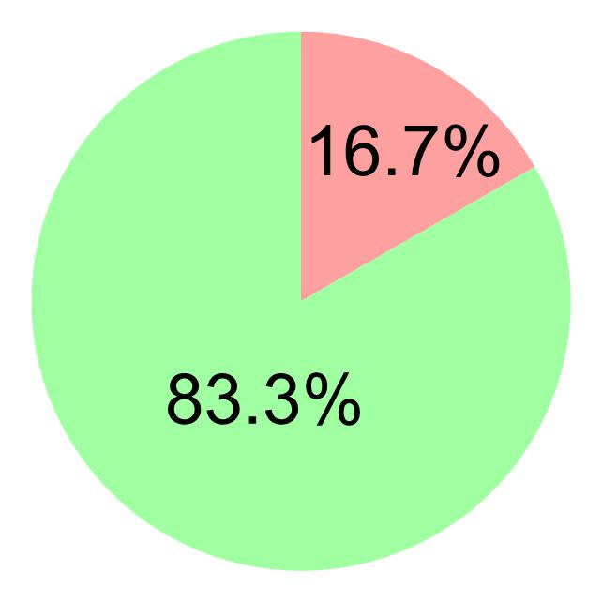 | 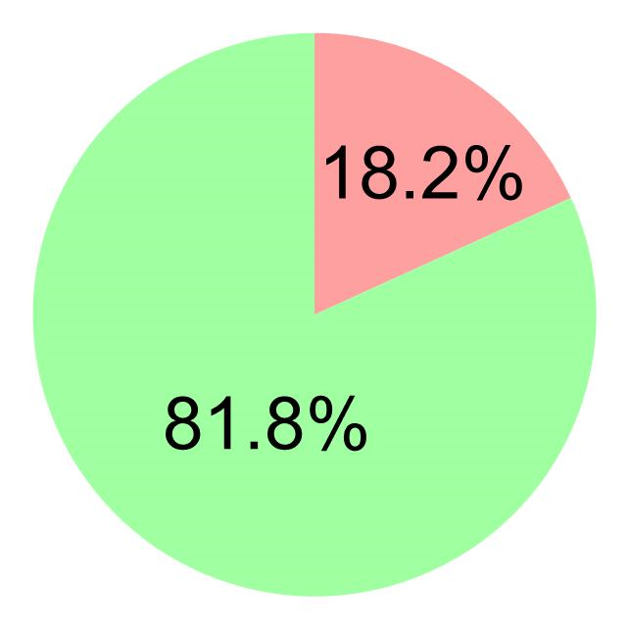
CCS | > -1.0600 | 89.8  [77.0 to 95.3] | 36.0  [20.2 to 55.5] | 71.9  [57.4 to 82.7] | 64.2  [48.6 to 75.5] | 64.7  [49.0 to 76.1] | 19.7 | 25.1 | 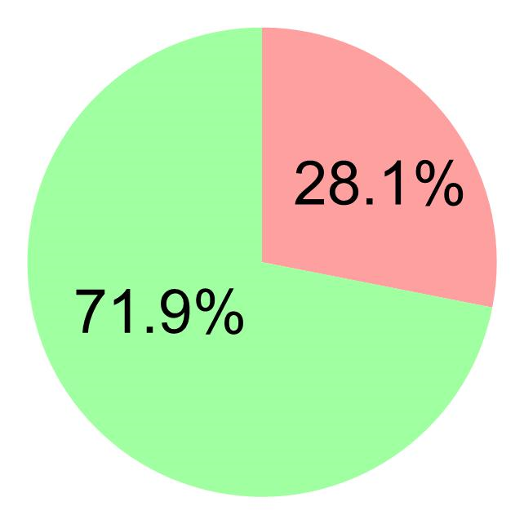 | 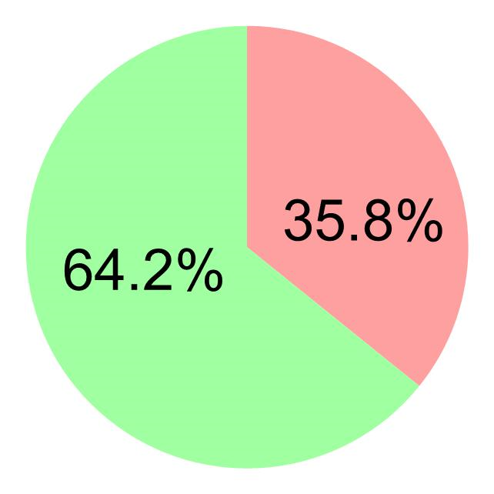
MAX | > -0.7366 | 90.7  [78.4 to 96.3] | 40.0  [23.4 to 59.3] | 72.2  [57.3 to 83.2] | 71.4  [55.9 to 81.7] | 63.2  [47.9 to 75.6] | 20.6 | 30.7 | 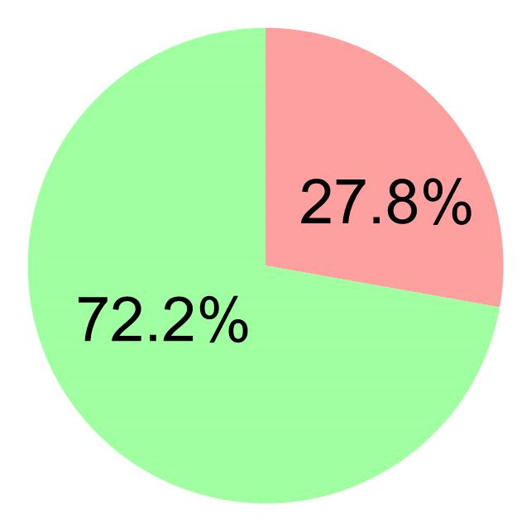 | 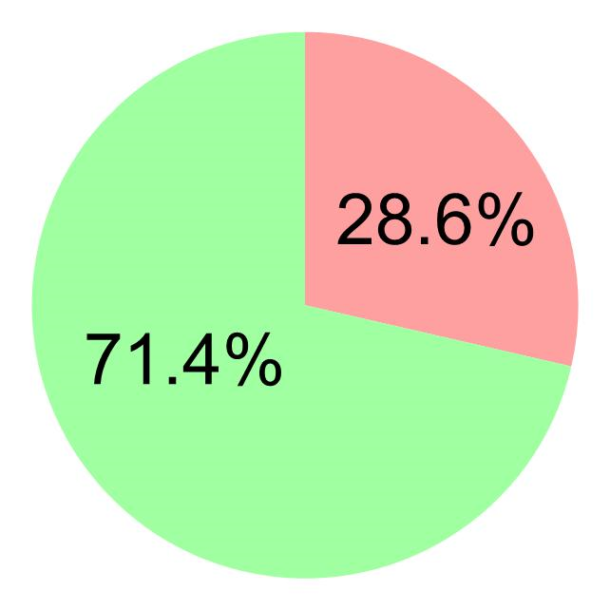
APP | > -1.2000 | 89.6  [77.0 to 95.3] | 16.0  [6.4 to 34.6] | 66.1  [50.3 to 76.1] | 44.4  [26.7 to 62.9] | 64.7  [44.5 to 79.7] | 12.6 | 5.1 | 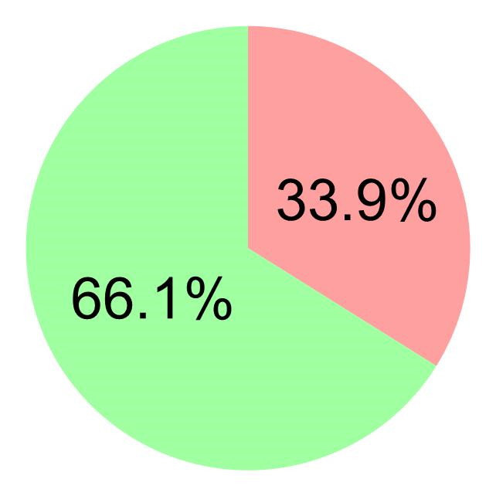 | 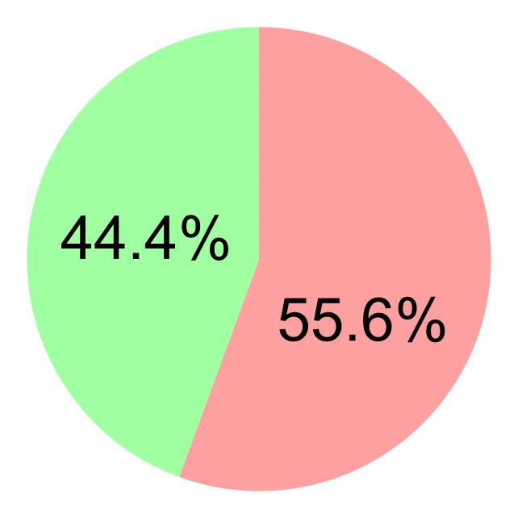
Validation cohort
CHMP1A | > -0.7080 | 88.7  [75.5 to 94.9] | 76.0  [57.1 to 88.3] | 77.6  [63.2 to 87.9] | 73.7  [58.1 to 84.6] | 63.2  [49.2 to 76.4] | 27.9 | 44.4 | 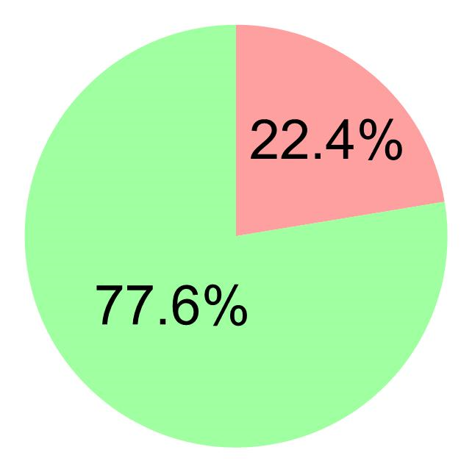 | 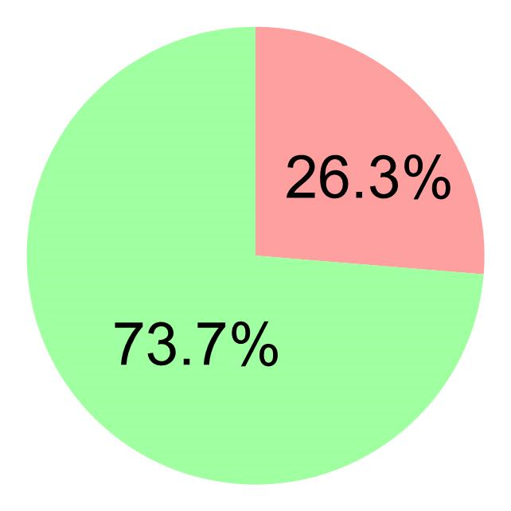
CCS | > -1.0210 | 89.1[76.9 to 95.2] | 64.0  [44.5 to 79.7] | 82.0  [69.3 to 90.9] | 76.2  [62.1 to 86.1] | 64.8  [44.7 to 79.9] | 29.6 | 53,1 | 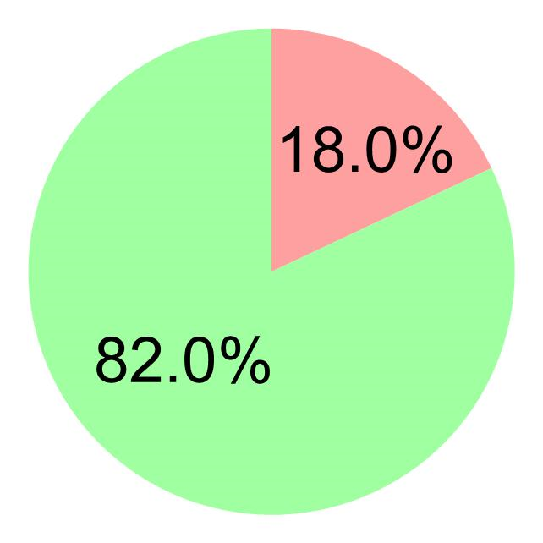 | 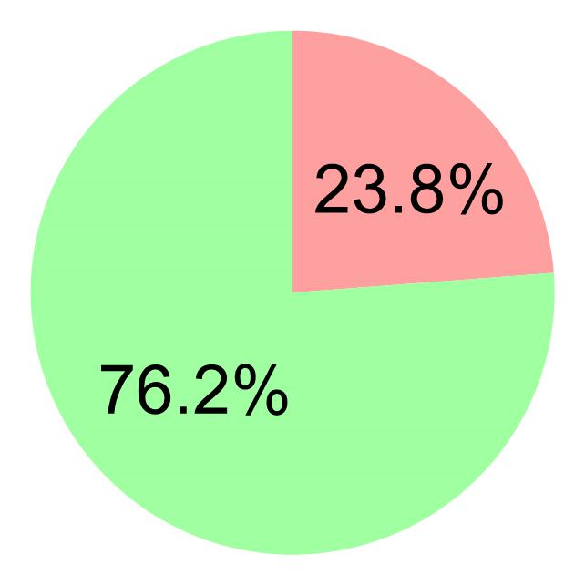
MAX | > -0.9500 | 88.9  [76.5 to 95.2] | 52.0  [33.5 to 70.0] | 76.9  [62.8 to 86.1] | 72.2  [52.4 to 85.7] | 64.3  [49.8 to 76.8] | 25.7 | 40.9 | 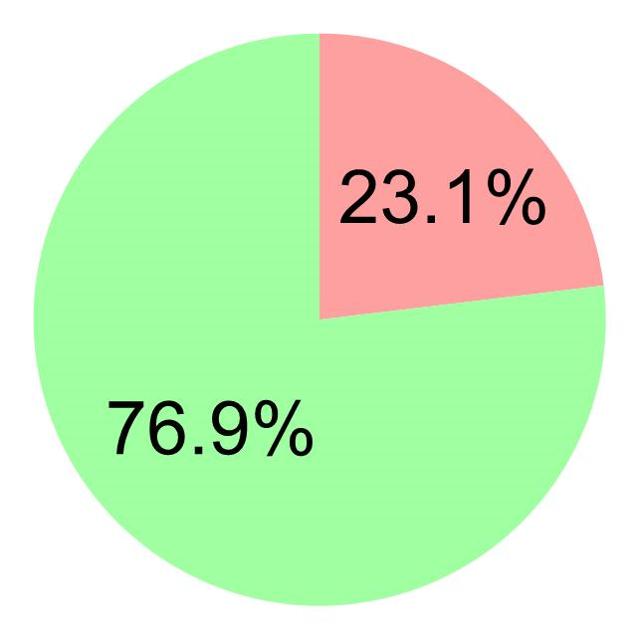
APP | > -1.2910 | 89.4  [77.4 to 95.4] | 40.0  [23.4 to 59.4] | 73.7  [60.2 to 84.1] | 66.7  [52.9 to 78.3] | 65.3  [51.7 to 77.8] | 20.8 | 29.4 | 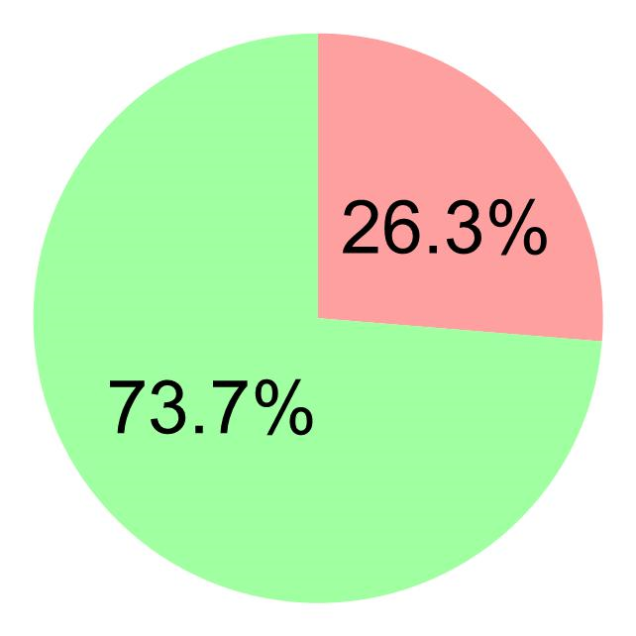 | 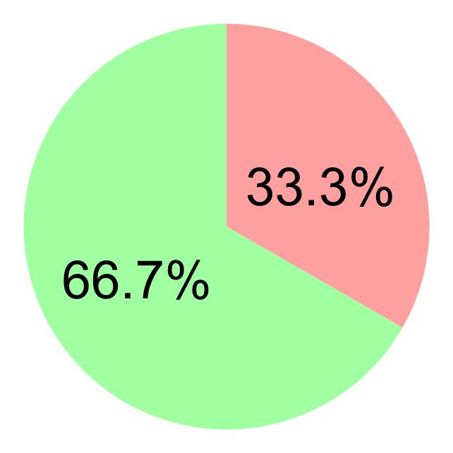
* Selected proteins had an AUC > 0.85 in the ROC analysis.

