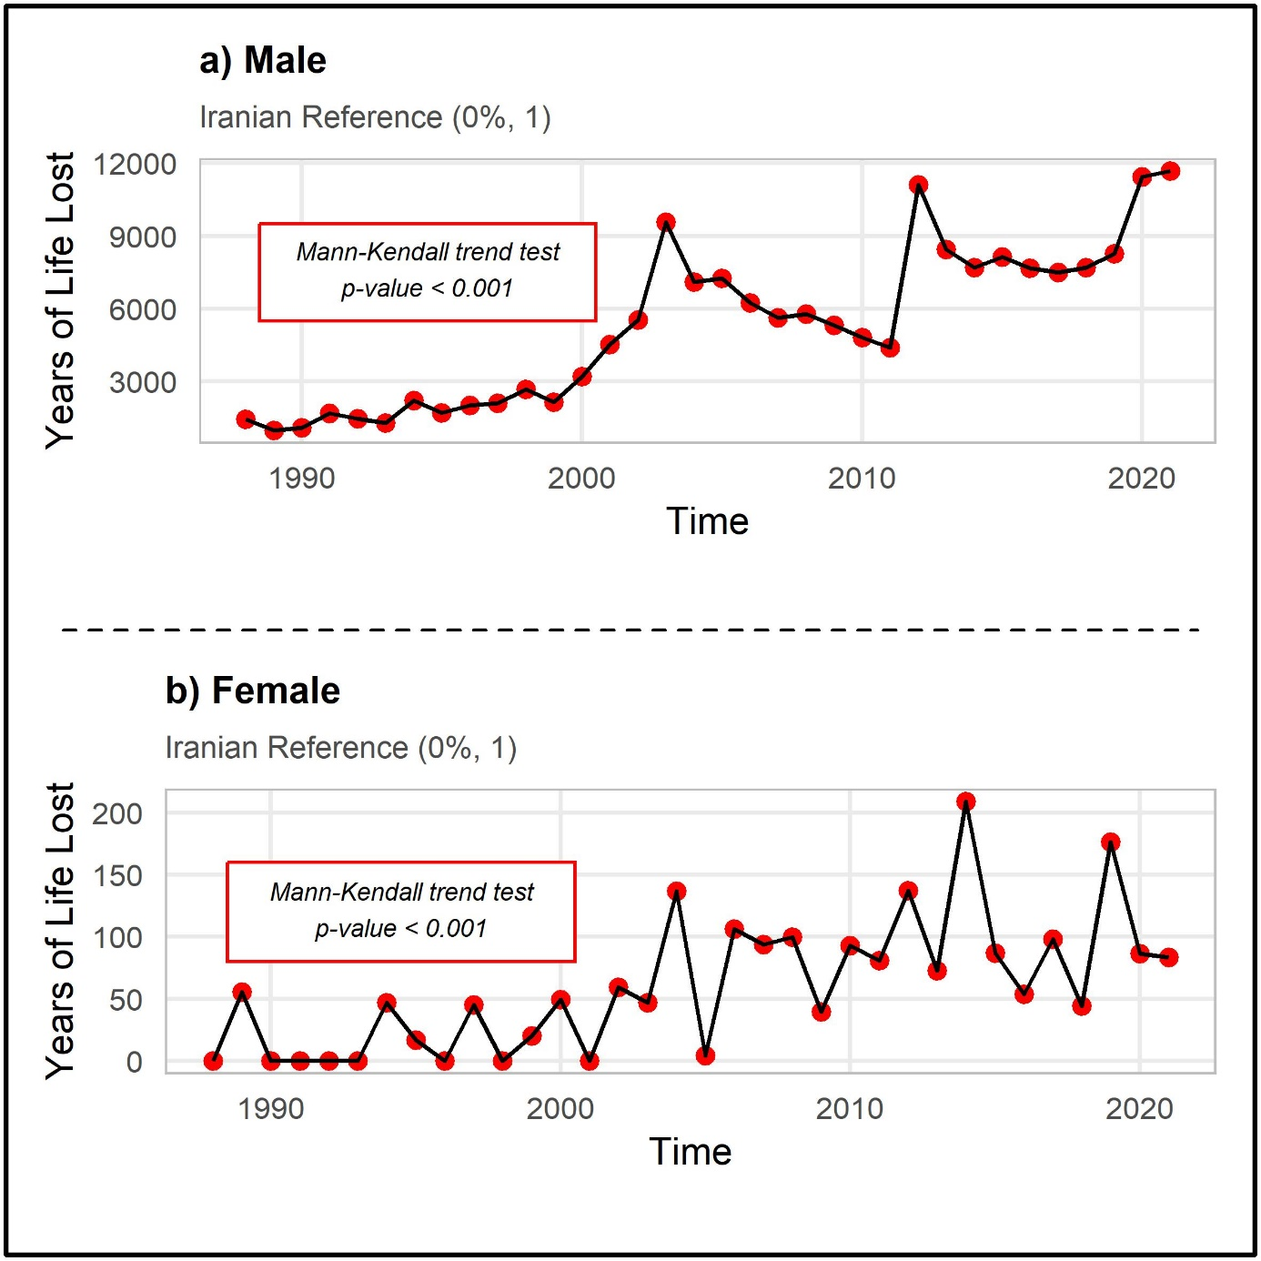
Supplementary Figure S1: Temporal Trends in Years of Life Lost by sex Using Iranian Reference (0%, 1)

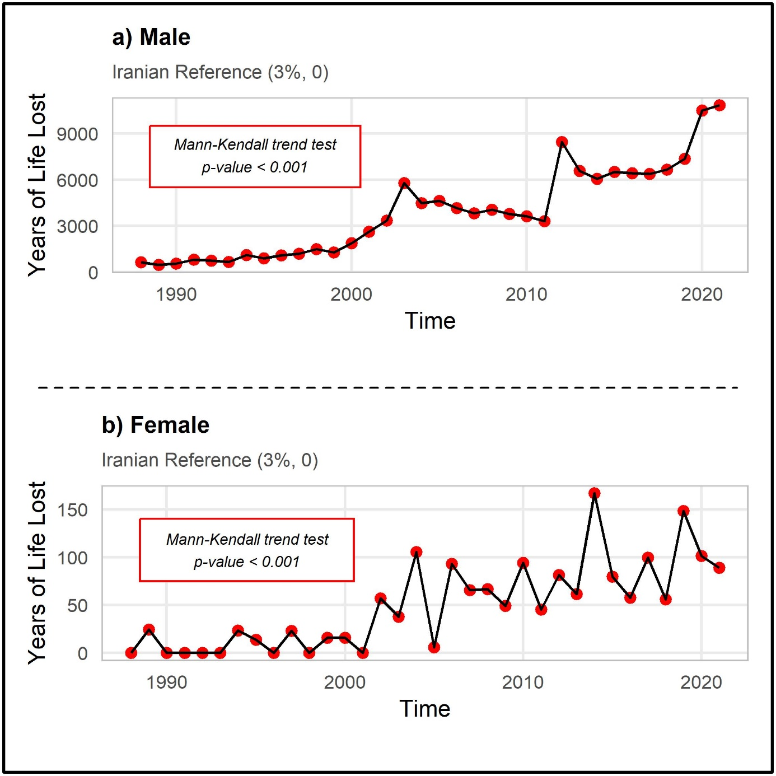
Supplementary Figure S2: Temporal Trends in Years of Life Lost by sex Using Iranian Reference (3%, 0)

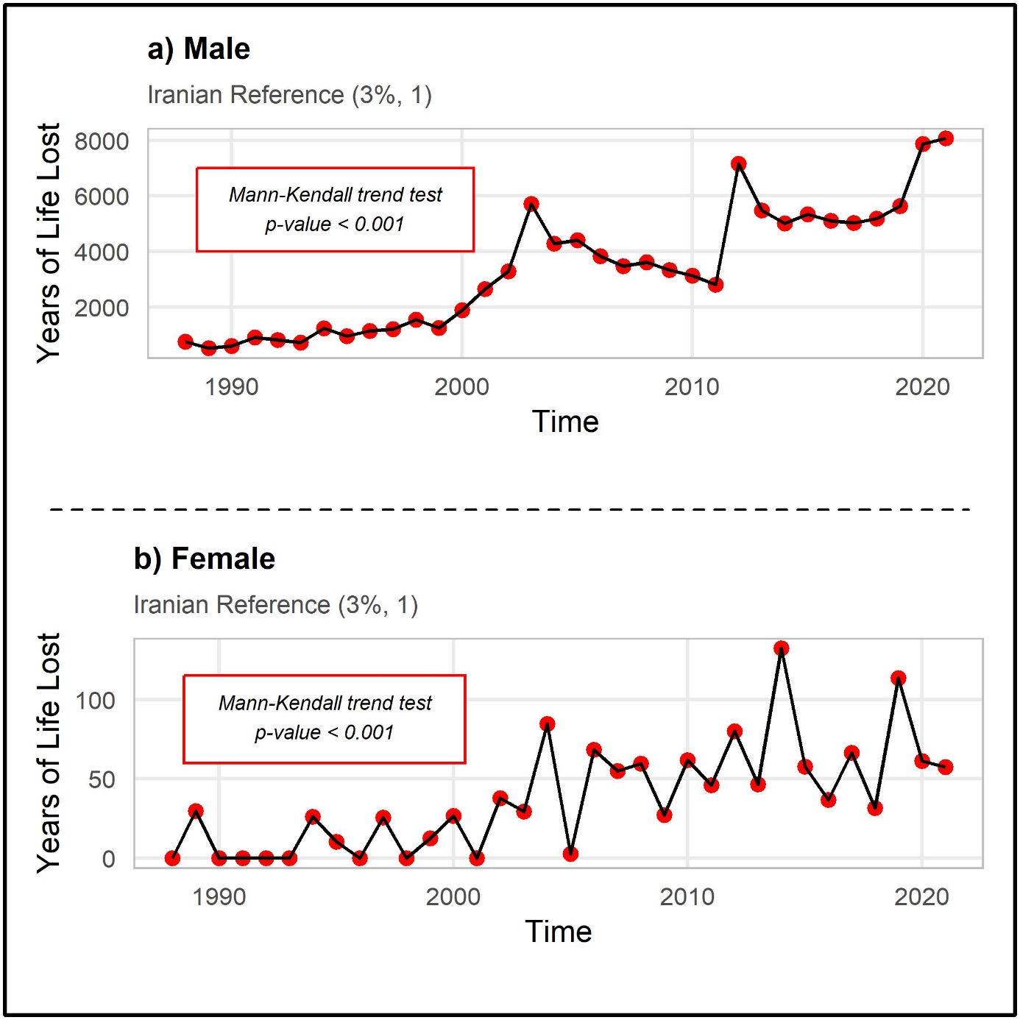
Supplementary Figure S3: Temporal Trends in Years of Life Lost by sex Using Iranian Reference (3%, 1)

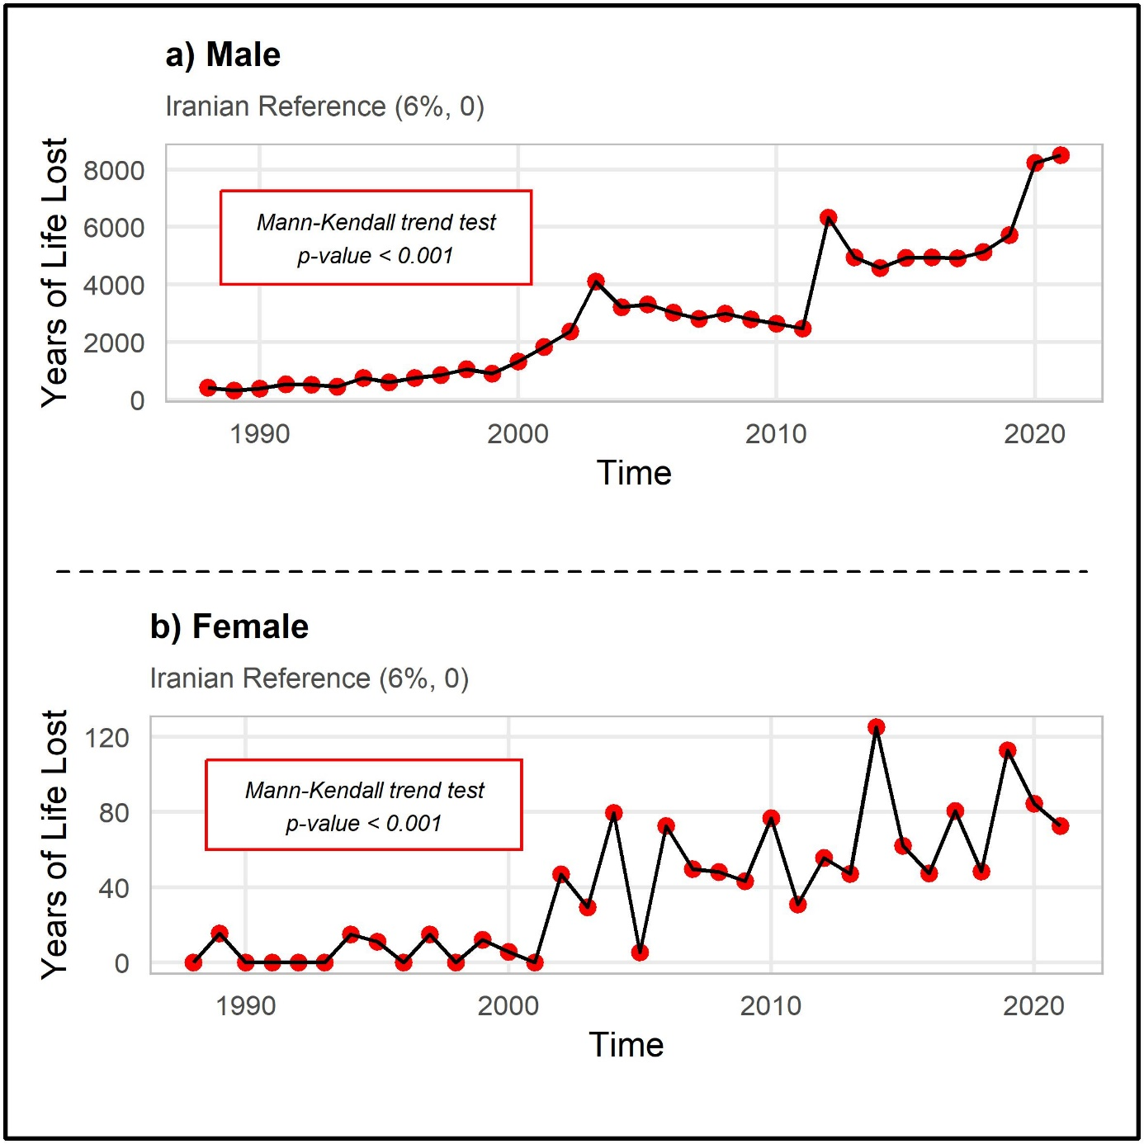
Supplementary Figure S4: Temporal Trends in Years of Life Lost by sex Using Iranian Reference (6%, 0)

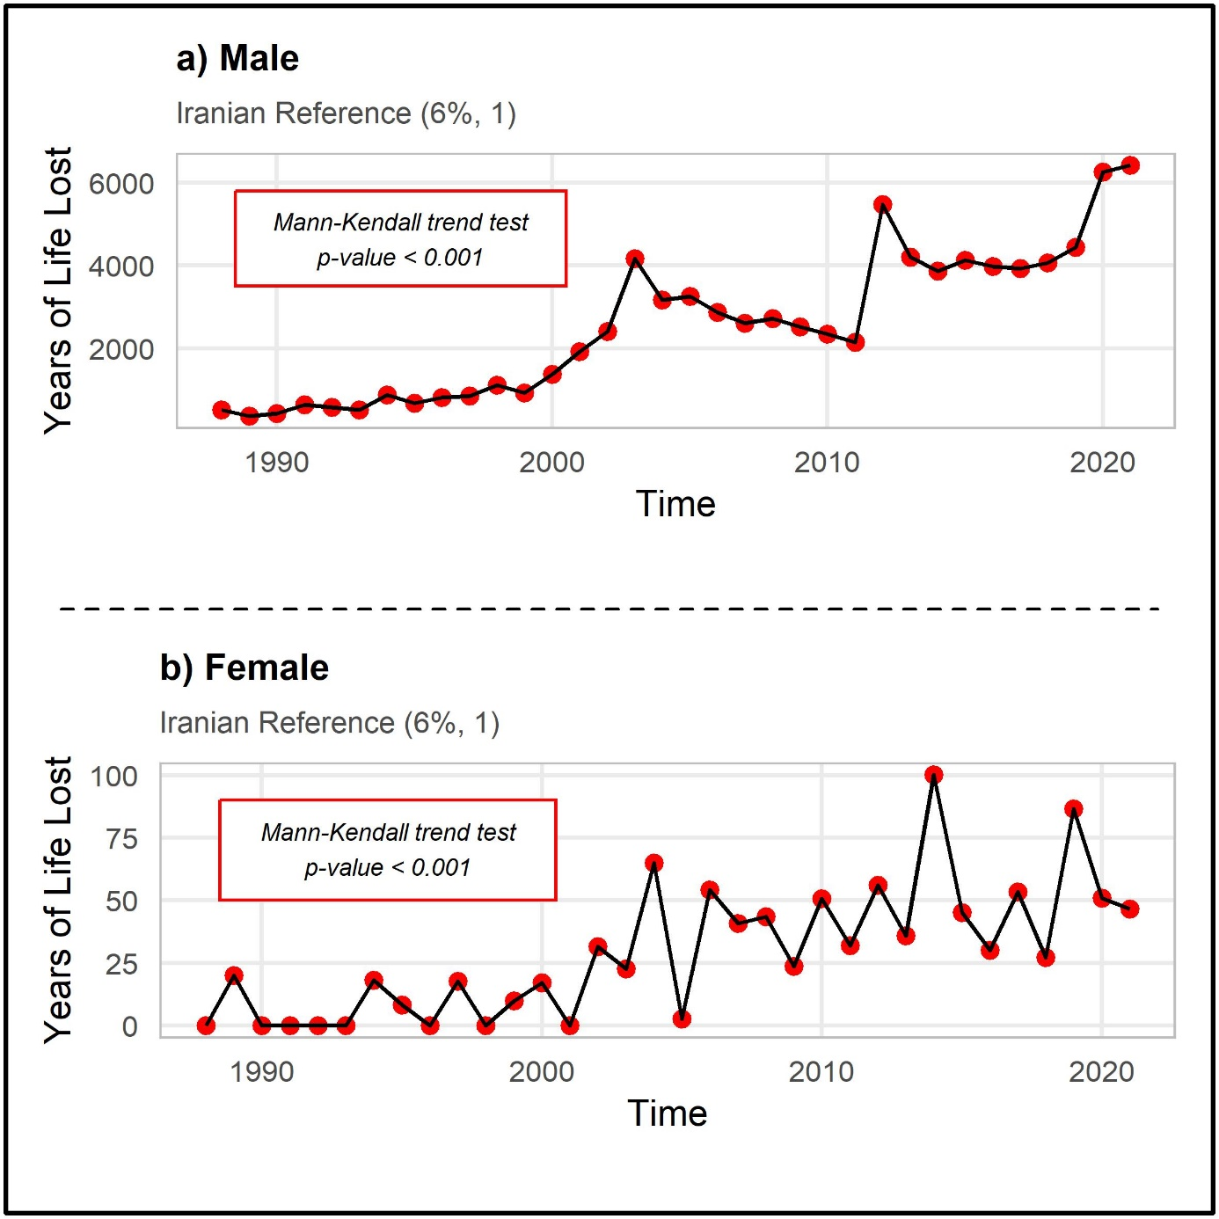
Supplementary Figure S5: Temporal Trends in Years of Life Lost by sex Using Iranian Reference (6%, 1)

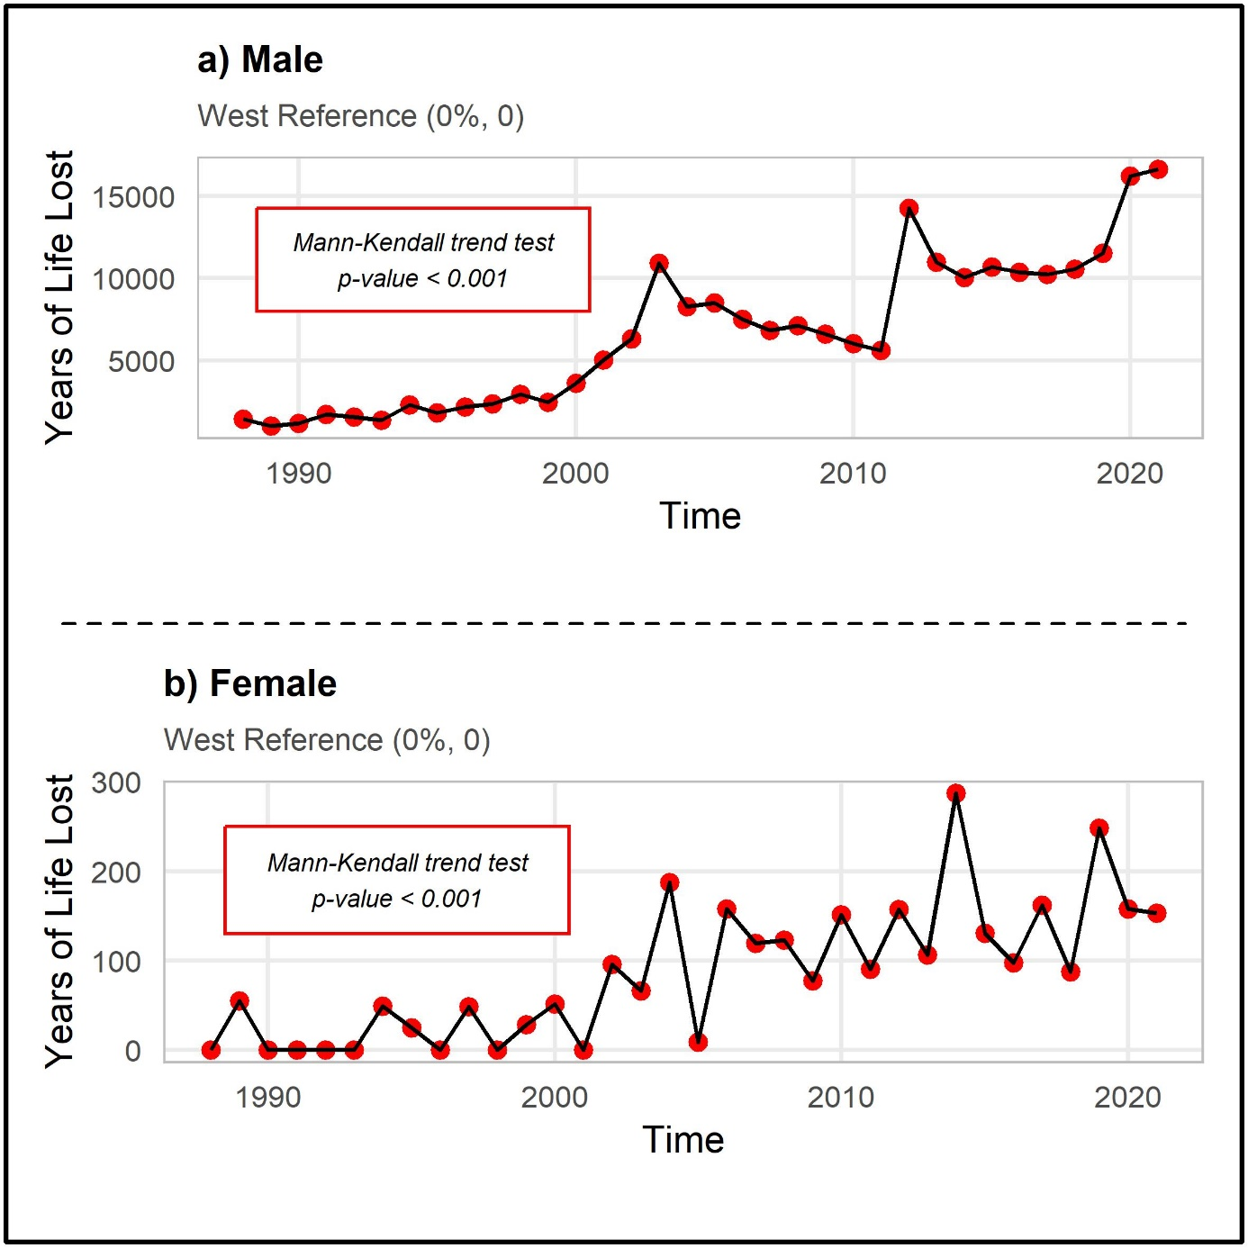
Supplementary Figure S6: Temporal Trends in Years of Life Lost by sex Using West Reference (0%, 0)

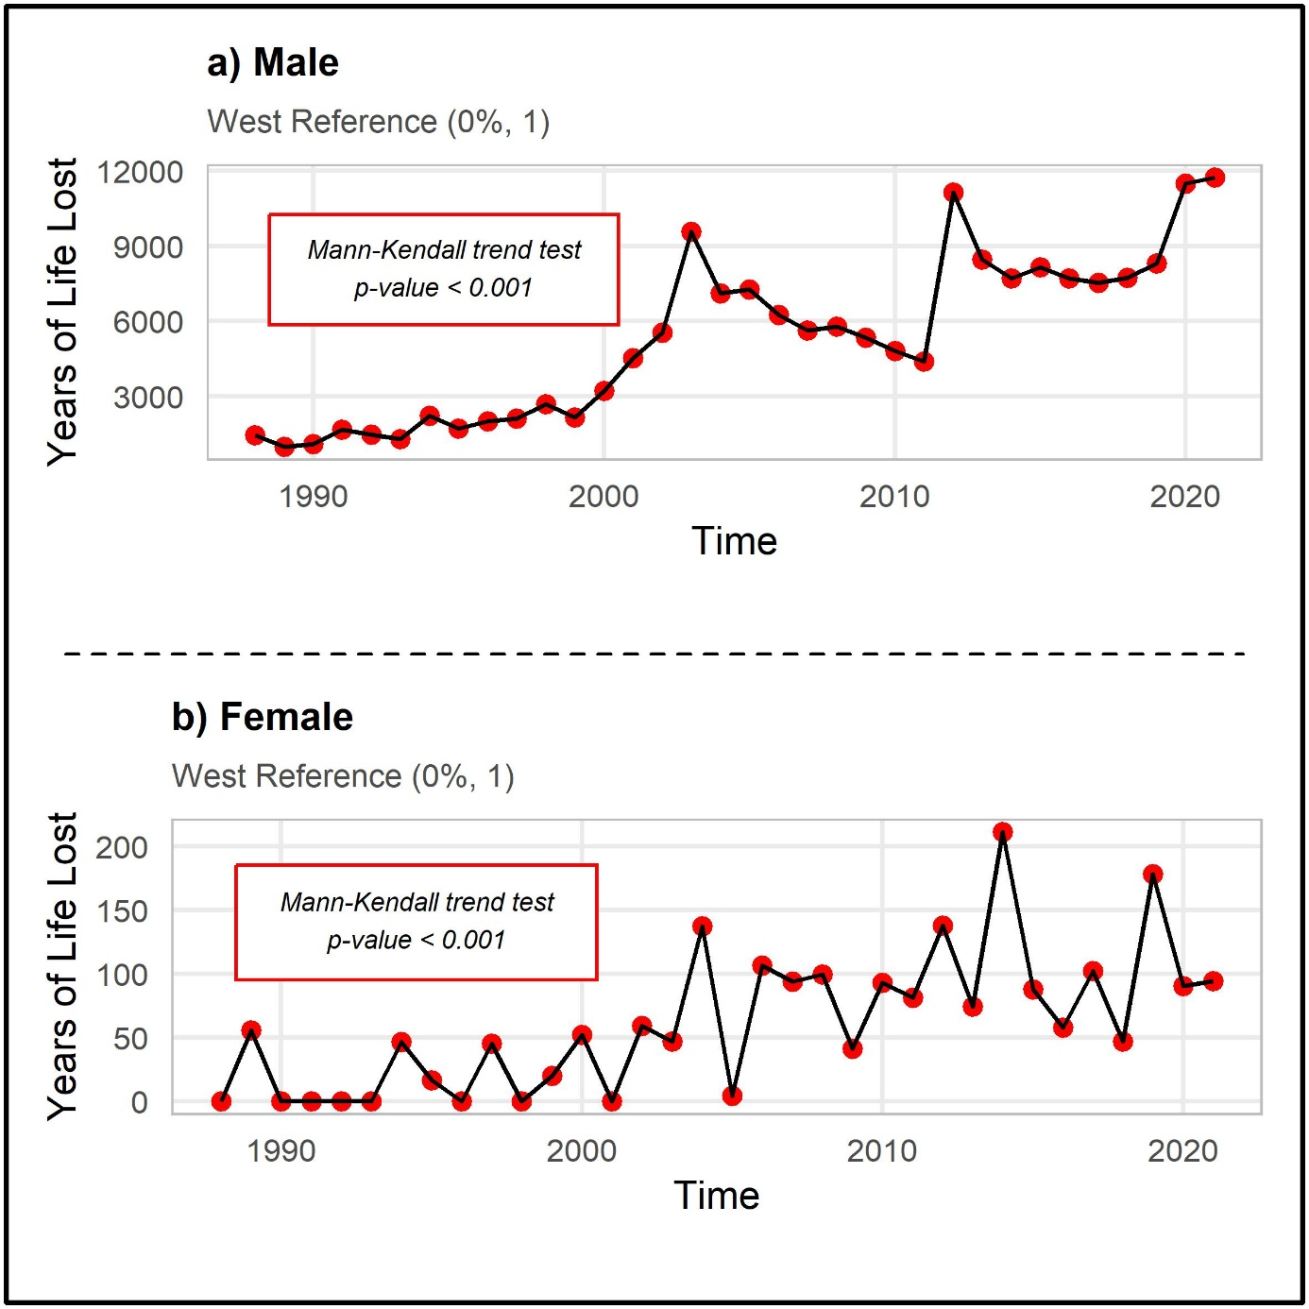
Supplementary Figure S7: Temporal Trends in Years of Life Lost by sex Using West Reference (0%, 1)

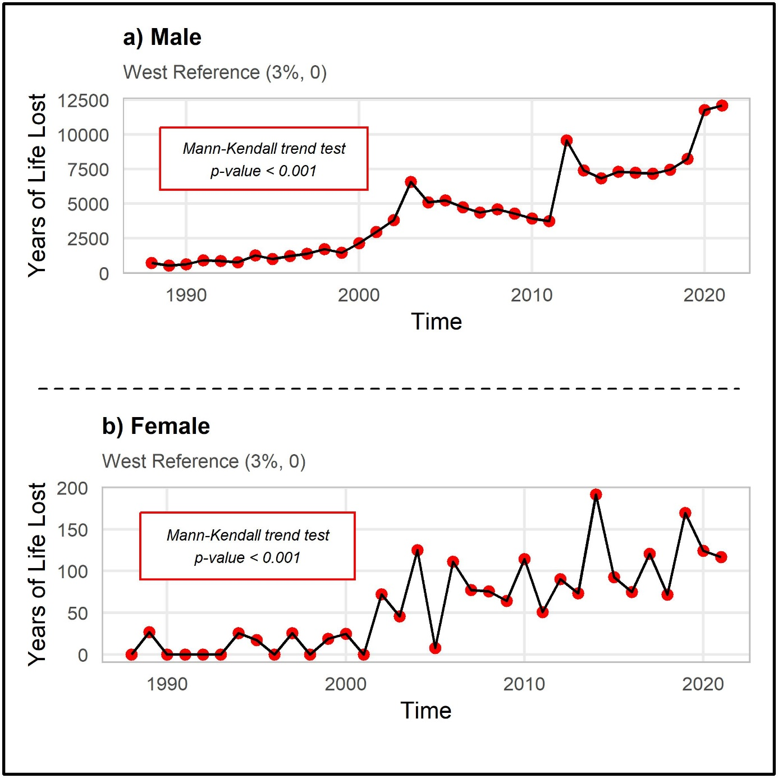
Supplementary Figure S8: Temporal Trends in Years of Life Lost by sex Using West Reference (3%, 0)

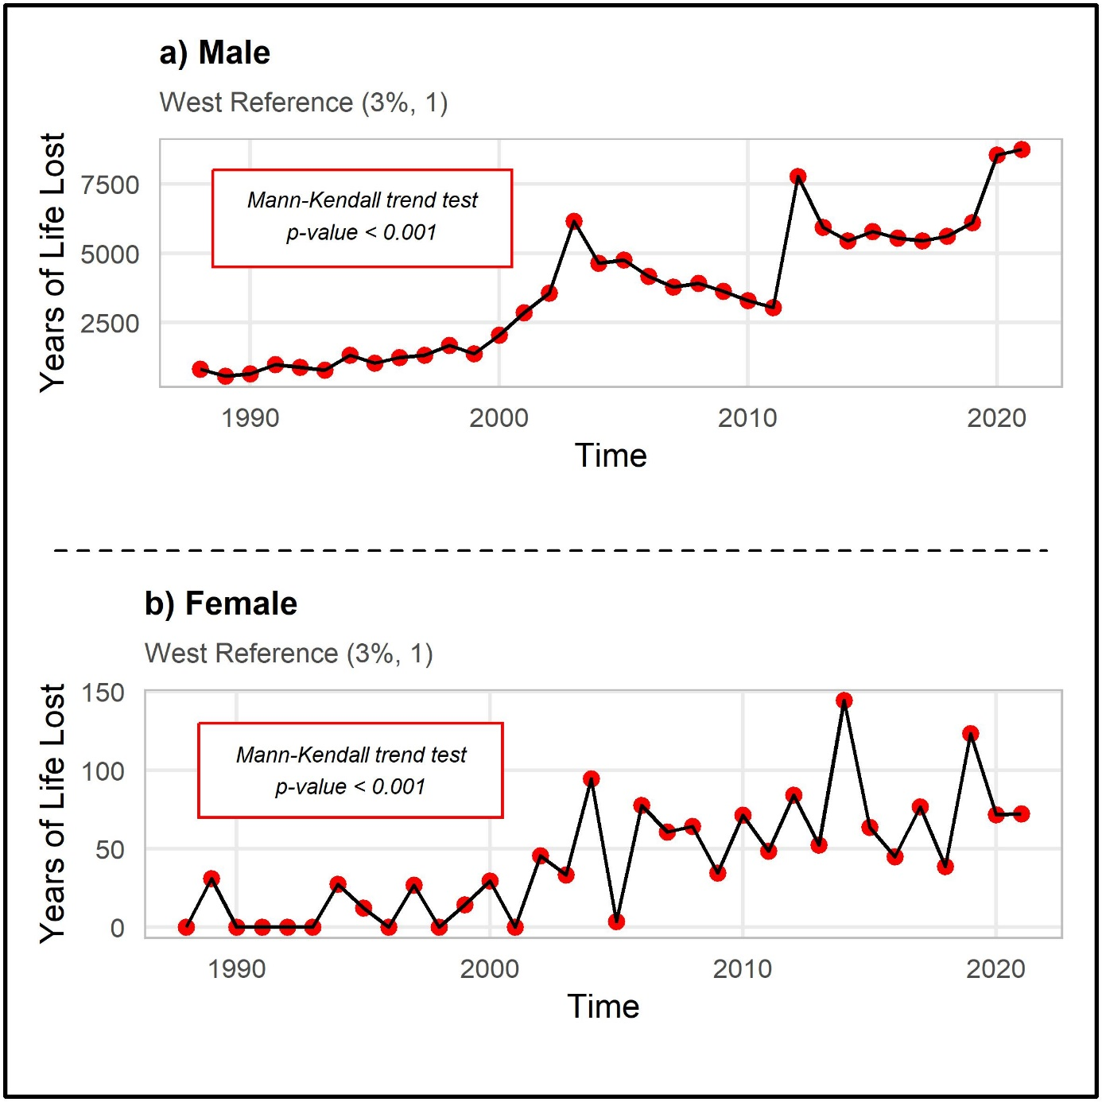
Supplementary Figure S9: Temporal Trends in Years of Life Lost by sex Using West Reference (3%, 1)

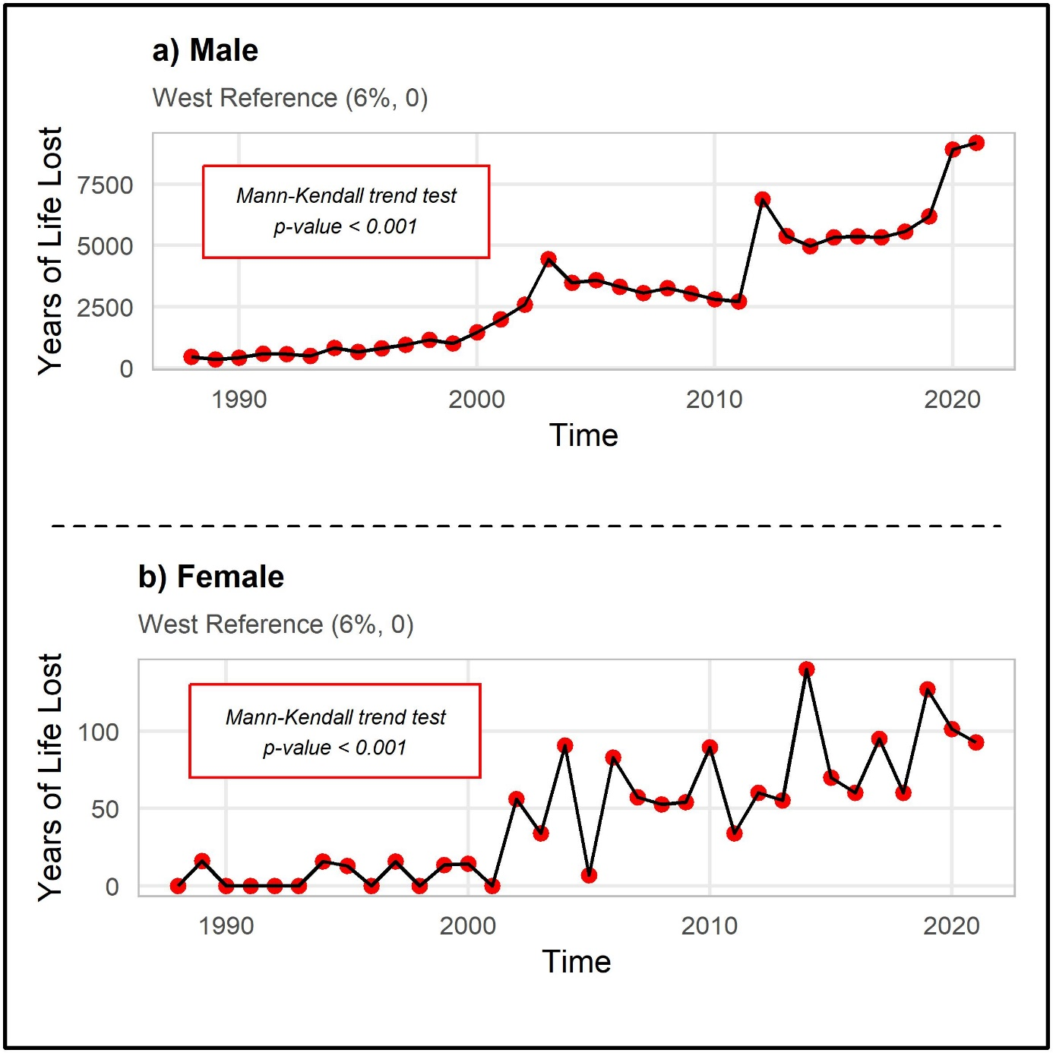
Supplementary Figure S10: Temporal Trends in Years of Life Lost by sex Using West Reference (6%, 0)

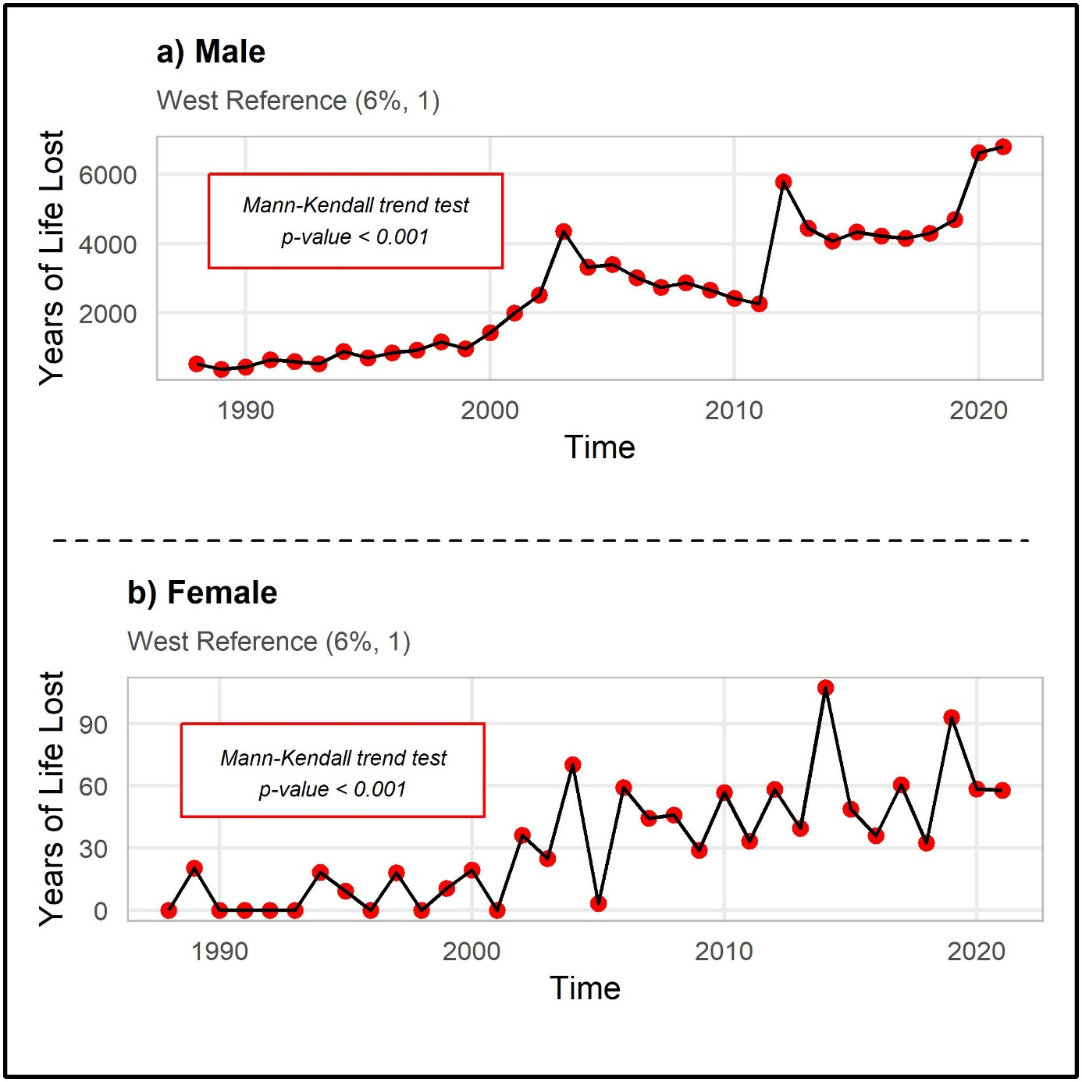
Supplementary Figure S11: Temporal Trends in Years of Life Lost by sex Using West Reference (6%, 1)

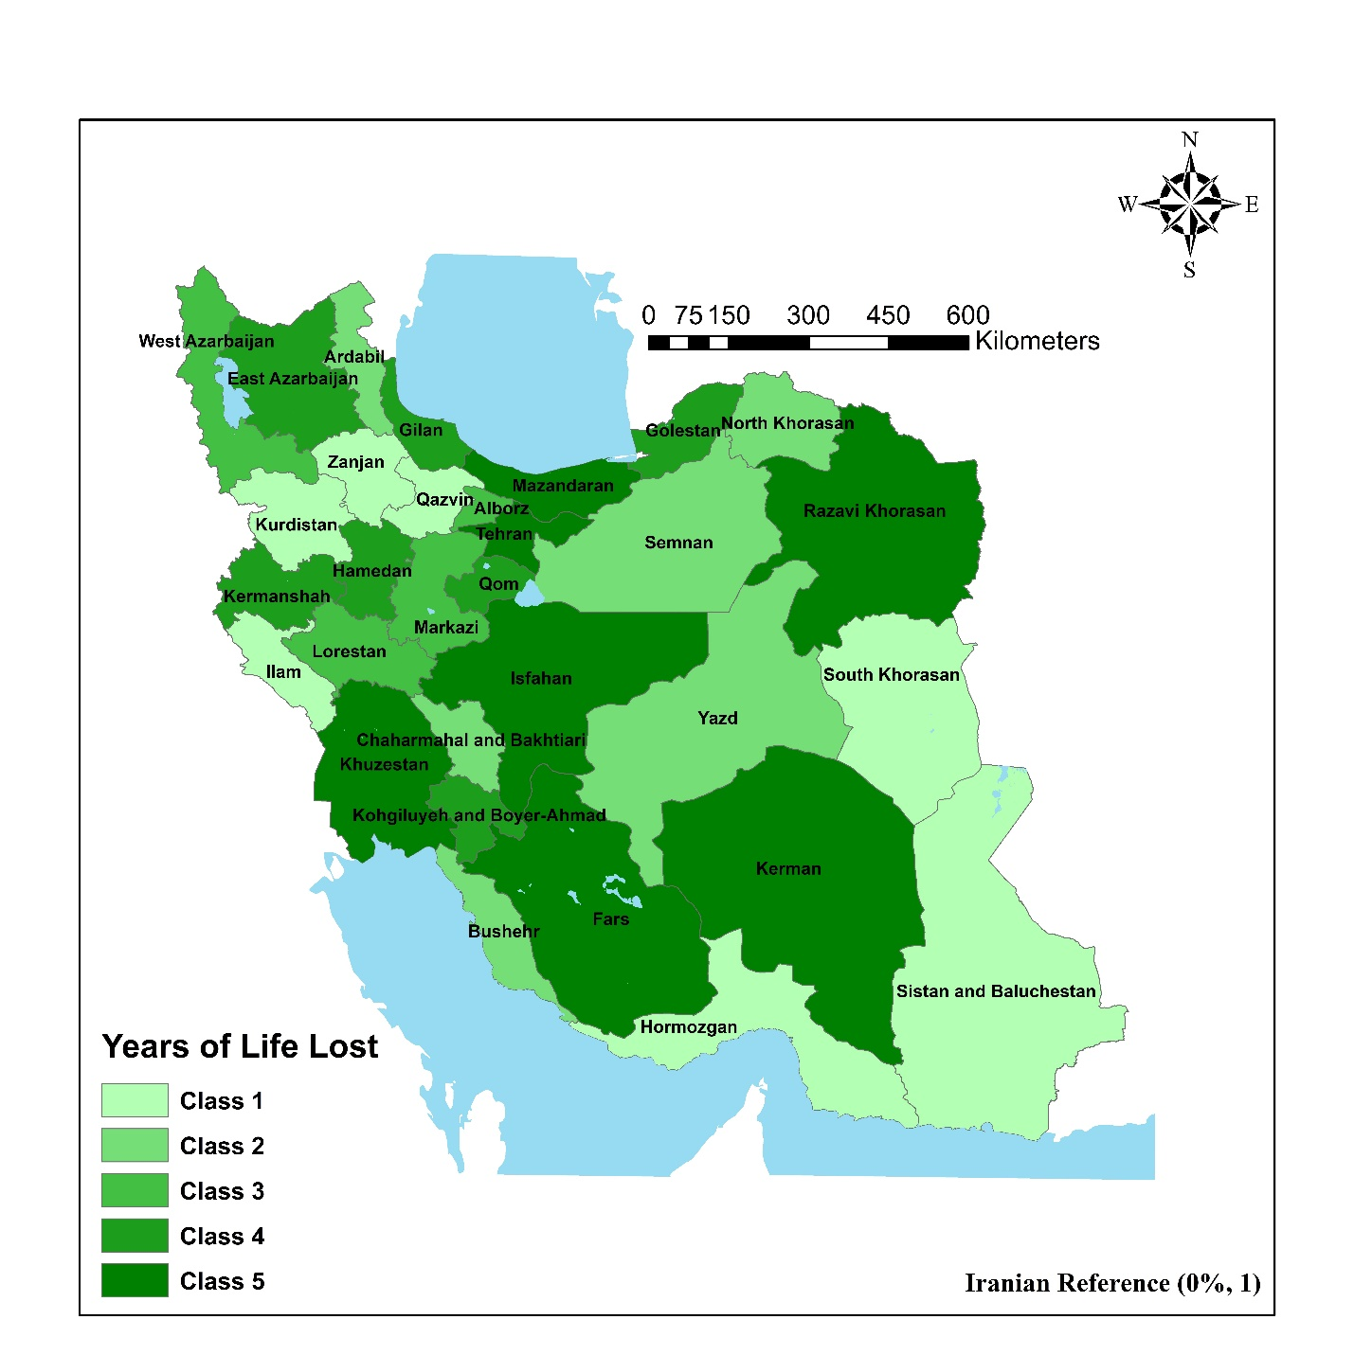
Supplementary Figure S12: Geographic Distribution of Years of Life Lost across Iranian Provinces using Iranian Reference (0%, 1)

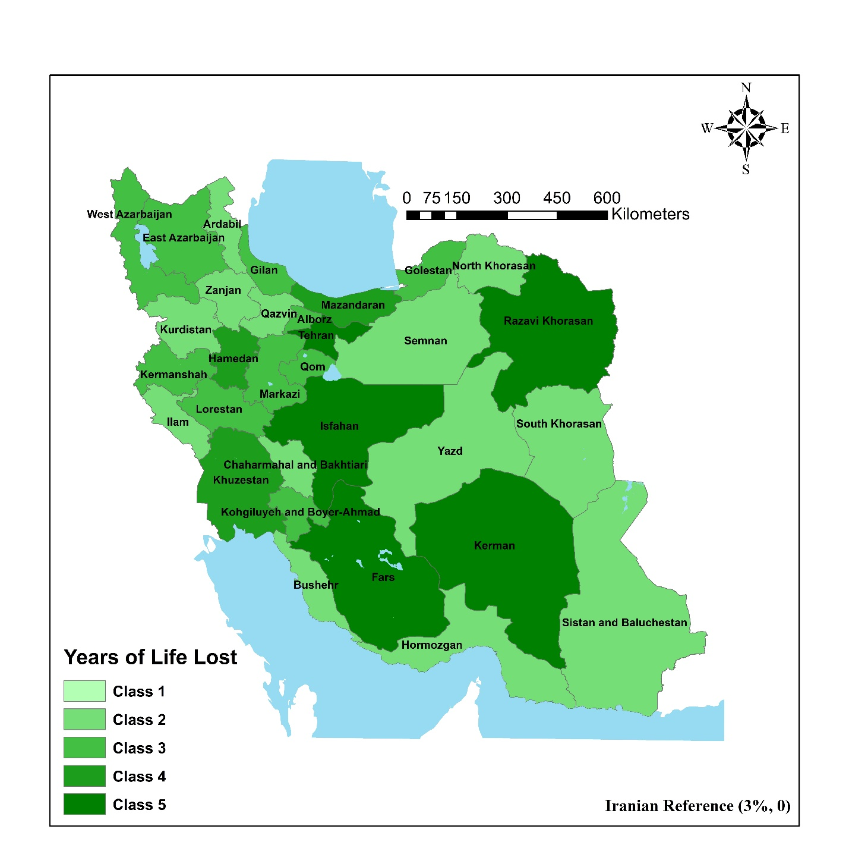
Supplementary Figure S13: Geographic Distribution of Years of Life Lost across Iranian Provinces using Iranian Reference (3%, 0)

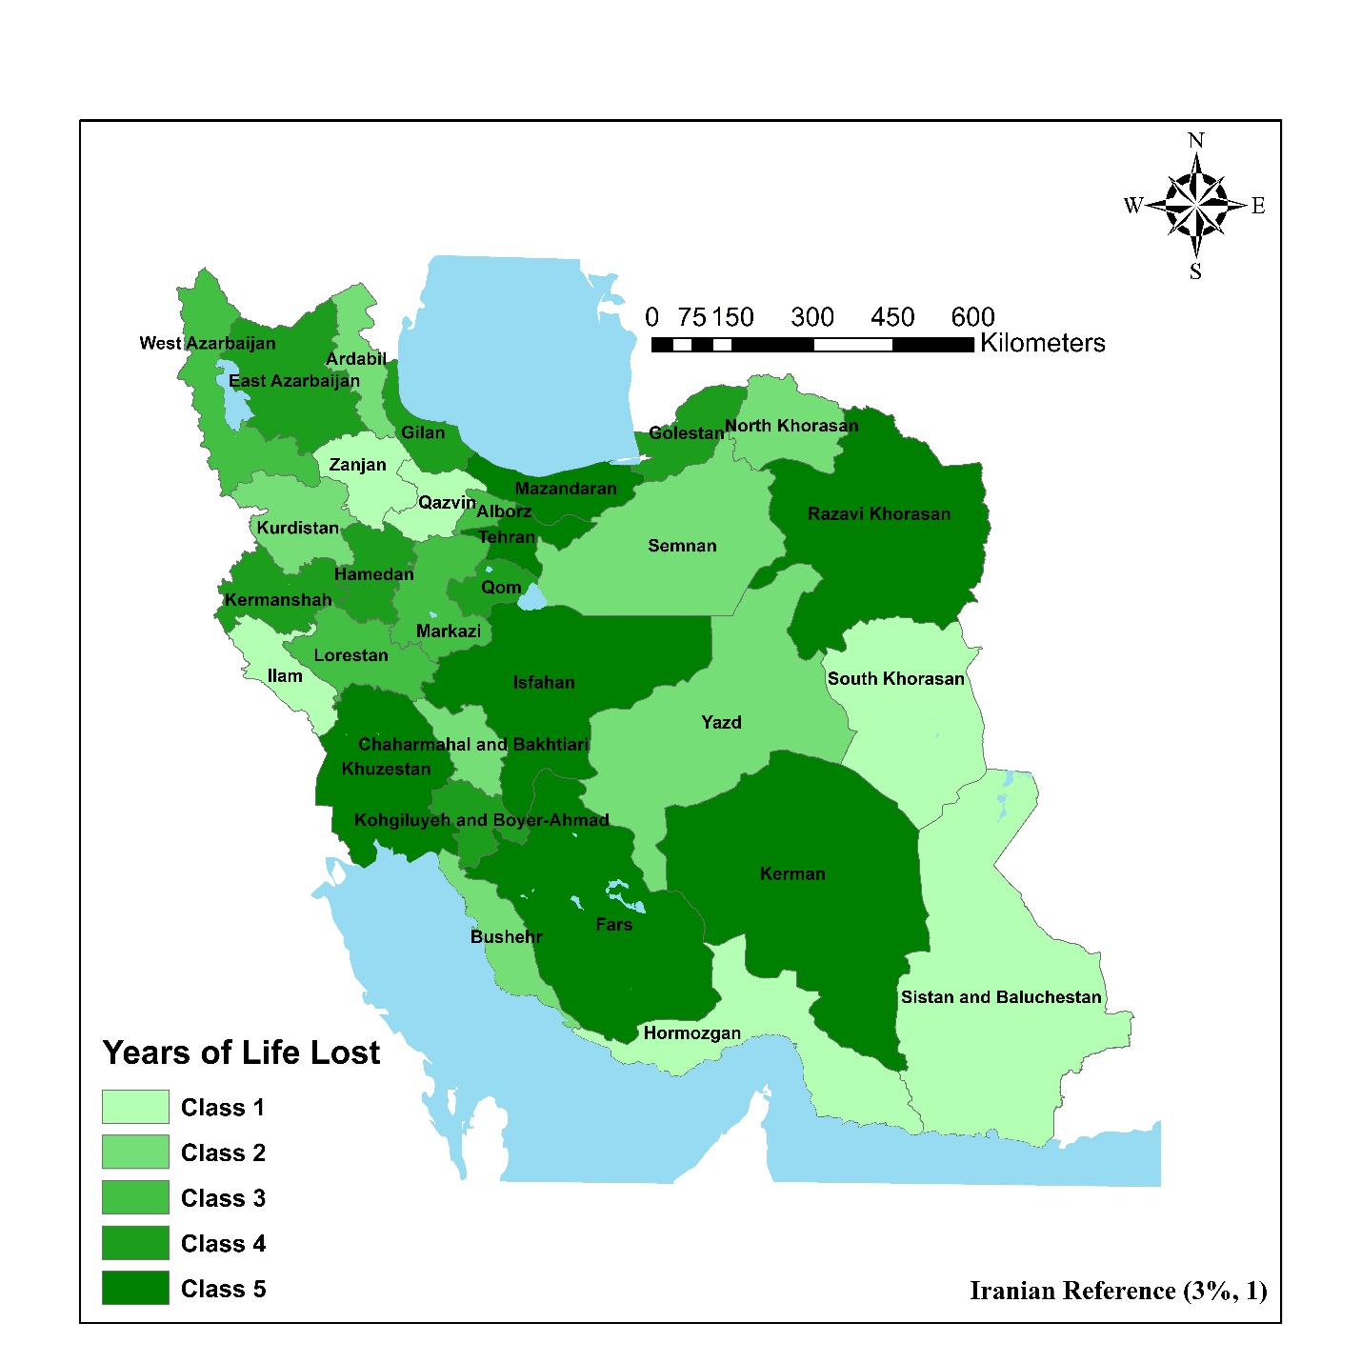
Supplementary Figure S14: Geographic Distribution of Years of Life Lost across Iranian Provinces using Iranian Reference (3%, 1)

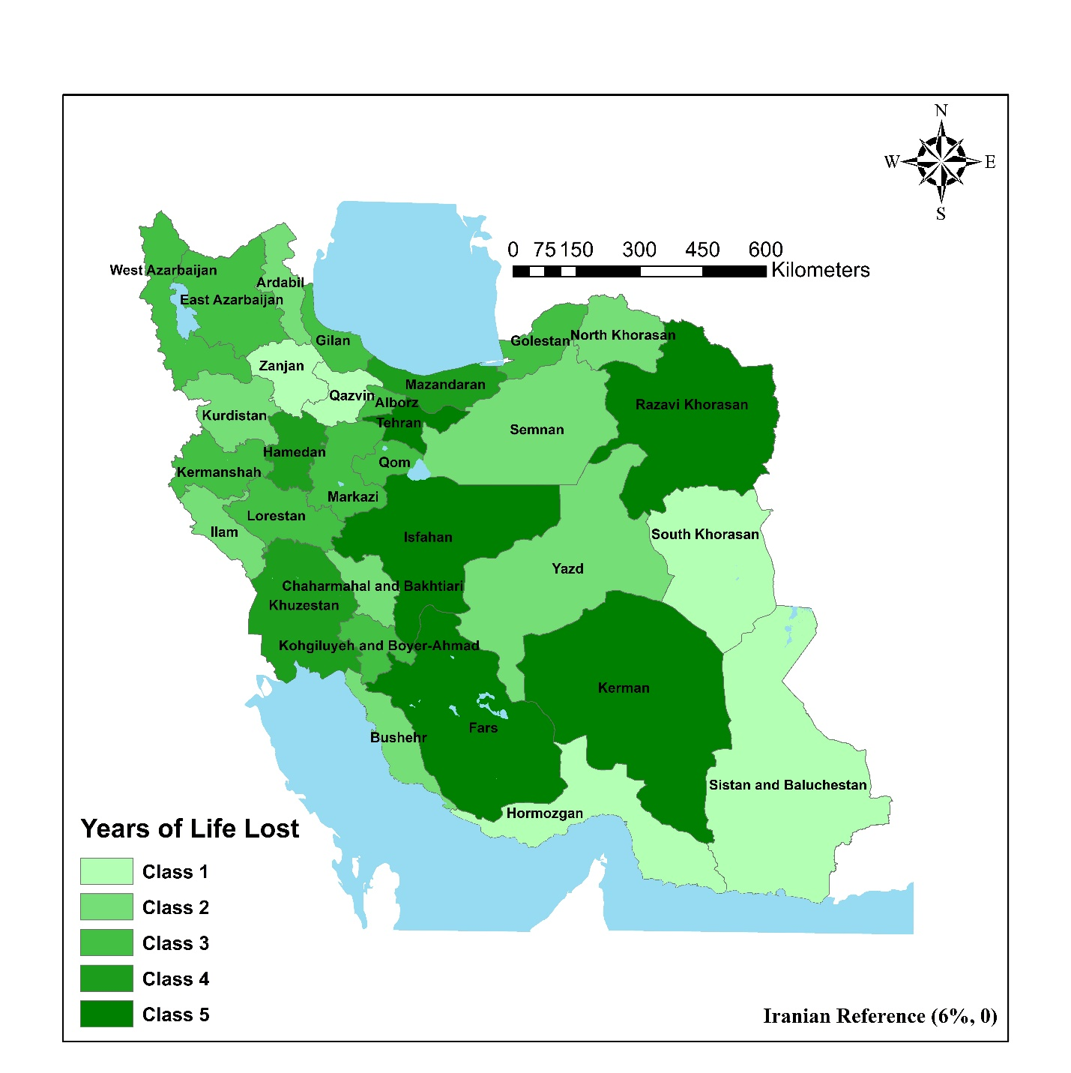
Supplementary Figure S15: Geographic Distribution of Years of Life Lost across Iranian Provinces using Iranian Reference (6%, 0)

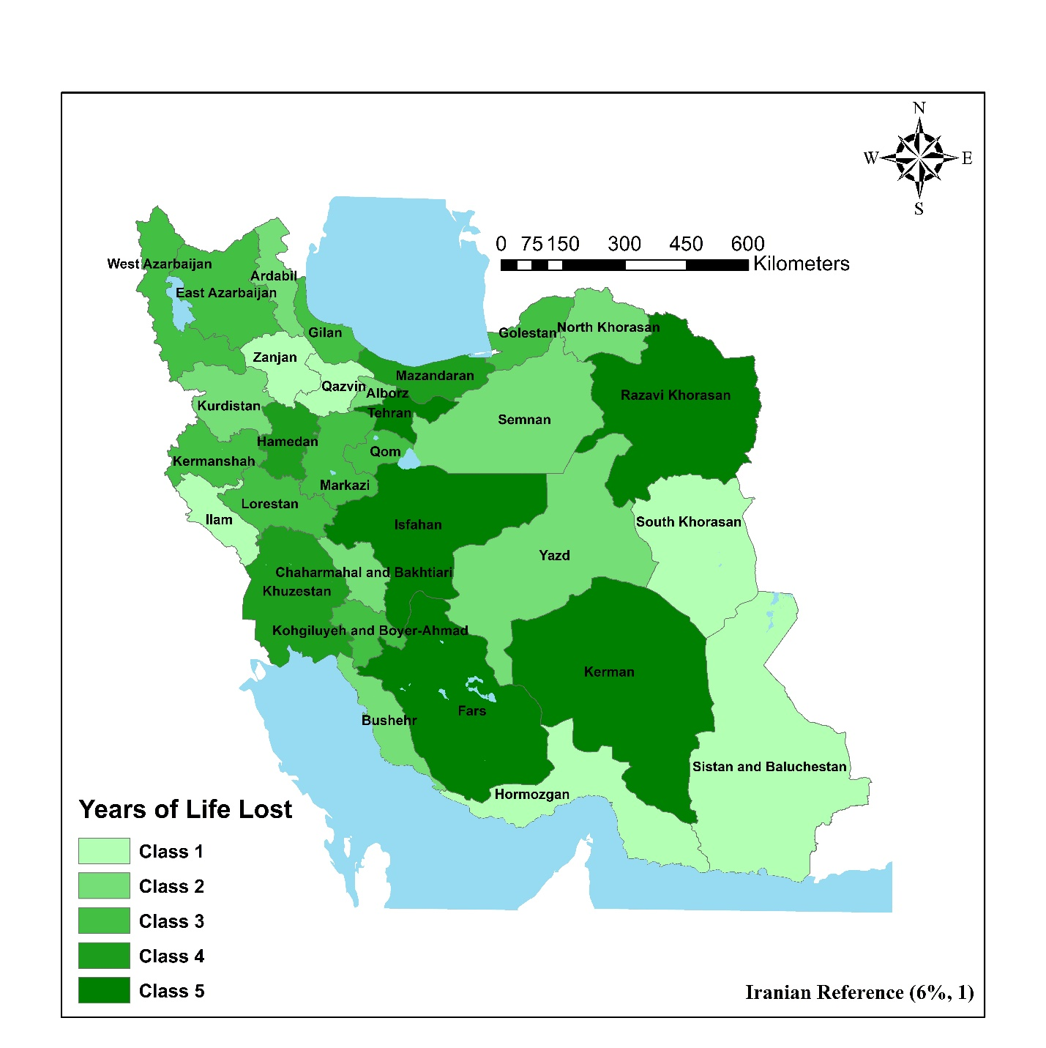
Supplementary Figure S16: Geographic Distribution of Years of Life Lost across Iranian Provinces using Iranian Reference (6%, 1)

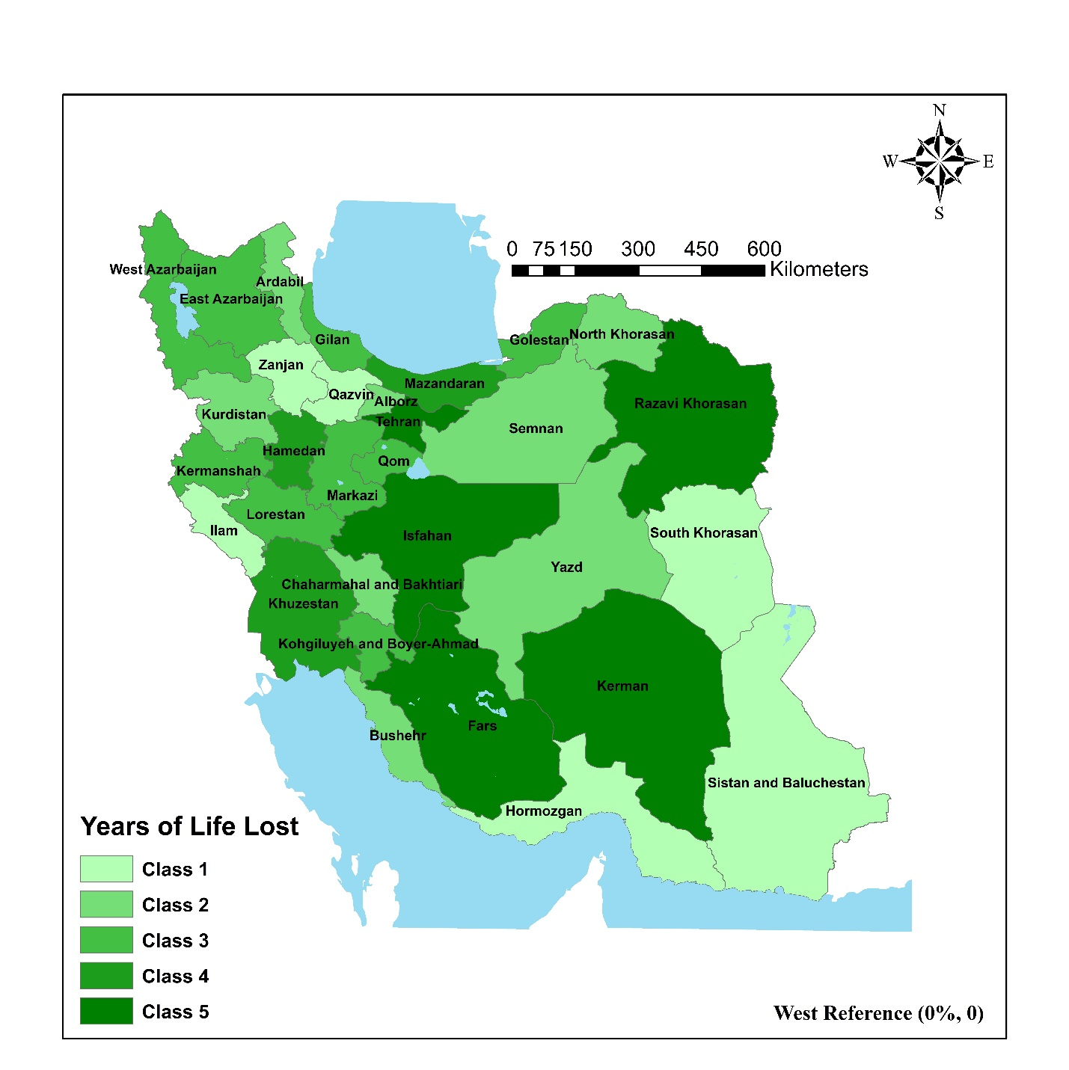
Supplementary Figure S17: Geographic Distribution of Years of Life Lost across Iranian Provinces using West Reference (0%, 0)

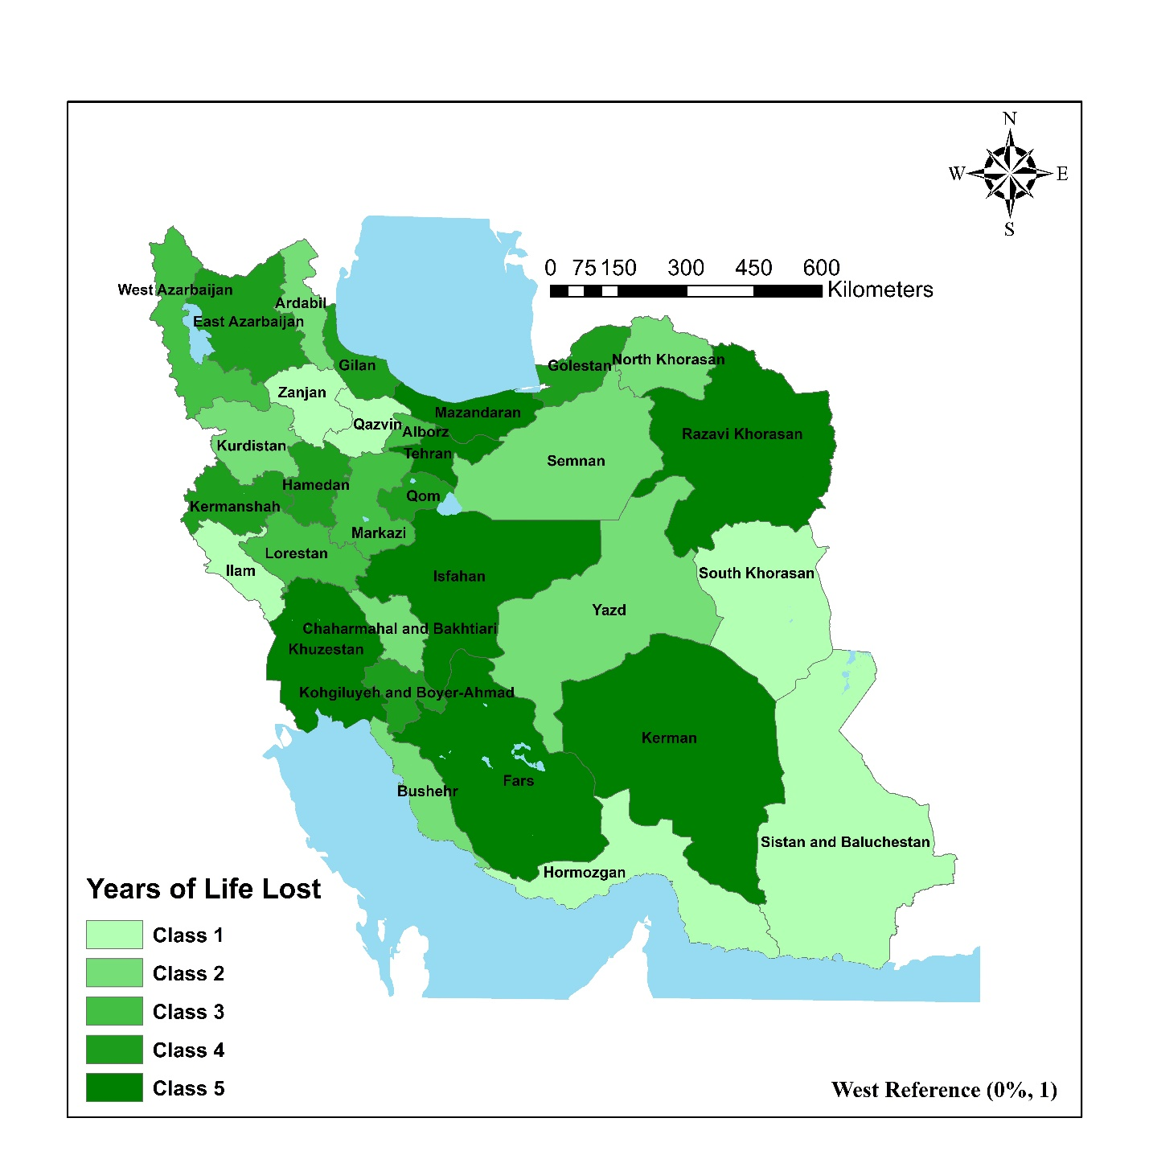
Supplementary Figure S18: Geographic Distribution of Years of Life Lost across Iranian Provinces using West Reference (0%, 1)

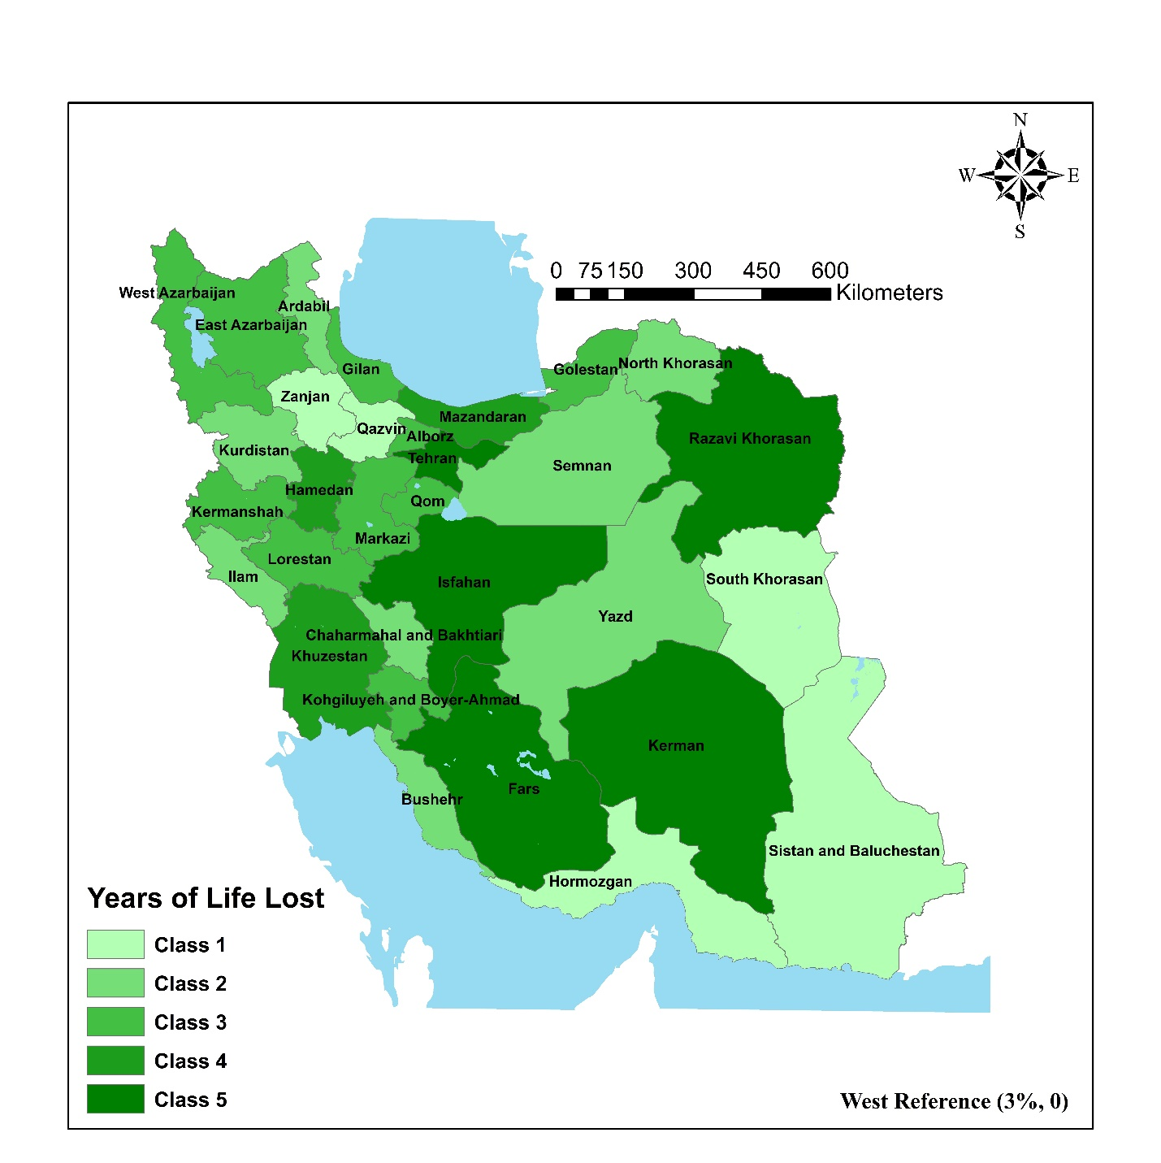
Supplementary Figure S19: Geographic Distribution of Years of Life Lost across Iranian Provinces using West Reference (3%, 0)

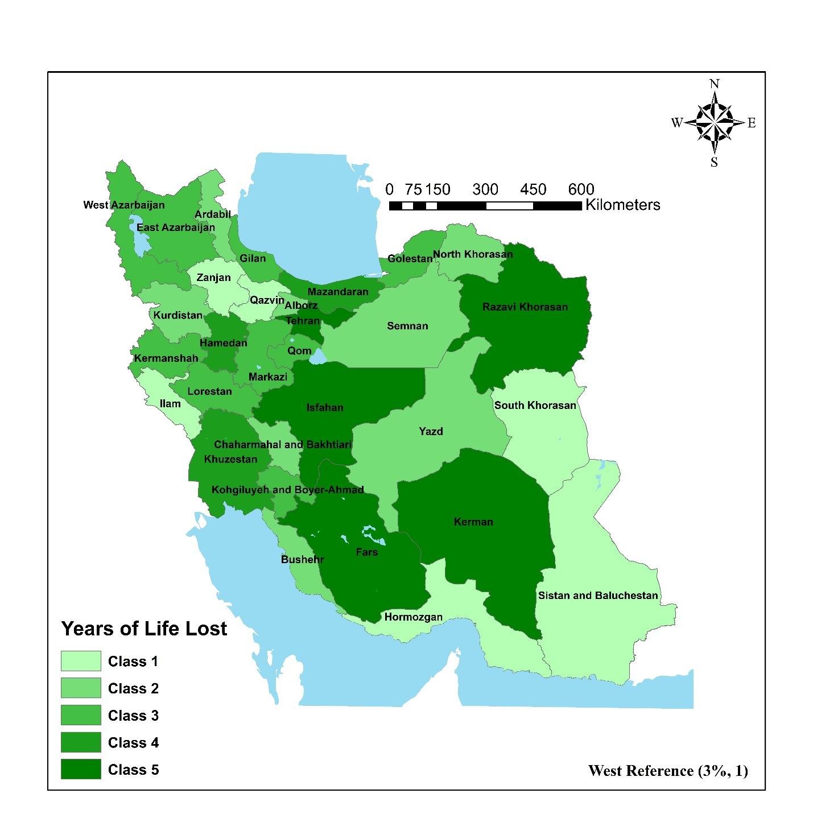
Supplementary Figure S20: Geographic Distribution of Years of Life Lost across Iranian Provinces using West Reference (3%, 1)

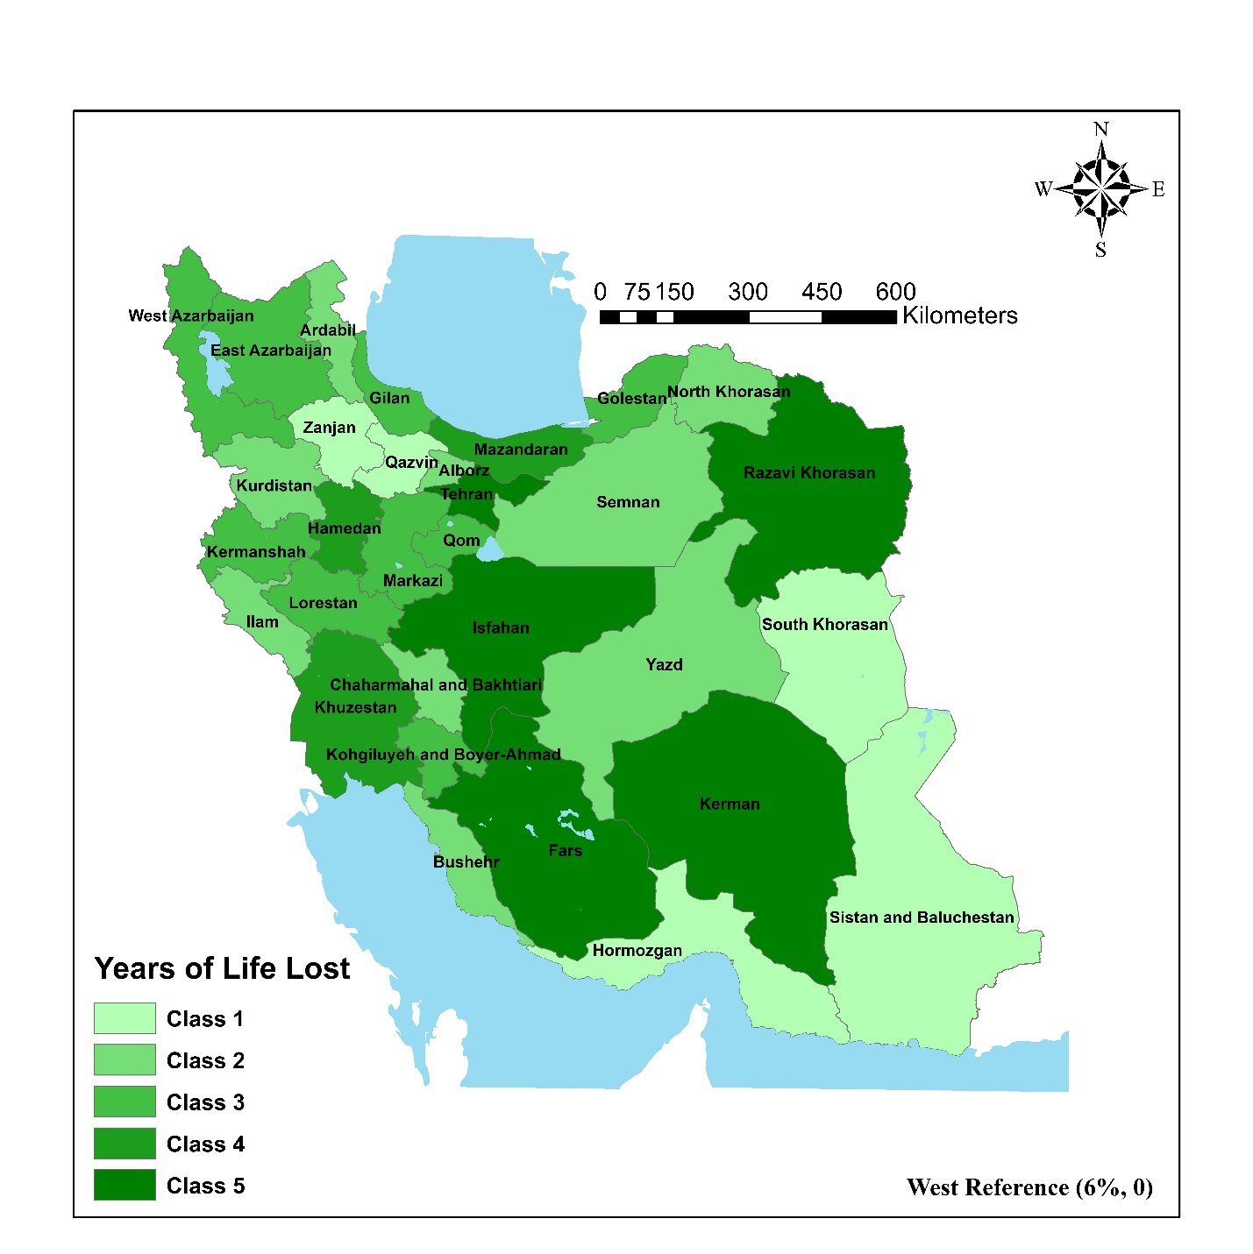
Supplementary Figure S21: Geographic Distribution of Years of Life Lost across Iranian Provinces using West Reference (6%, 0)

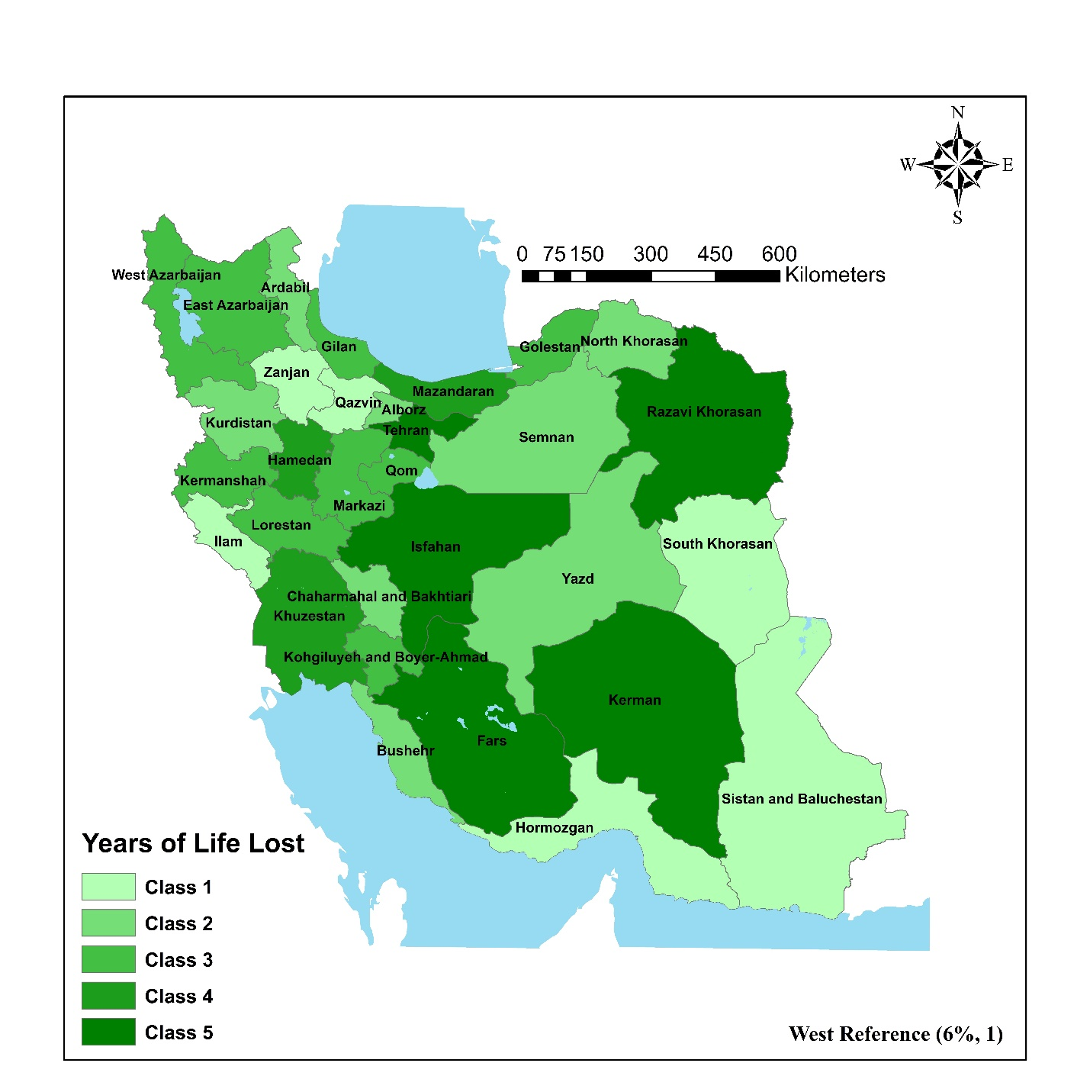
Supplementary Figure S22: Geographic Distribution of Years of Life Lost across Iranian Provinces using West Reference (6%, 1)

