Supplementary Materials

Cost-optimal vs. policy-driven scenarios for a decarbonised European energy system

Natasha Frilingou, Dirk-Jan Van de Ven, Jon Sampedro, Alexandre Torné, Evelina Trutnevyte, Russell Horowitz, Clàudia Rodés-Bachs, Konstantinos Koasidis, Shivika Mittal, George Xexakis, and Alexandros Nikas.

NECP data
Table S1: Fossil CO₂ emissions by EU member state and EU-wide from Eurostat [1] (2015, 2019, and 2021), and from NECPs.
 | 2015 | 2019-2021 | 2025 | 2030
 | Observed CO₂ emissions |  | Target CO₂ emissions
Austria | 66.4 | 66.9 | 56.4 | 46.1
Belgium | 101.3 | 97.3 | 84.5 | 71.6
Bulgaria | 48.2 | 42.3 | 35.6 | 28.9
Croatia | 17.8 | 17.6 | 15.8 | 14.0
Cyprus | 7.0 | 7.2 | 5.9 | 4.7
Czech Republic | 105.8 | 99.5 | 76.1 | 52.7
Denmark | 35.5 | 30.5 | 22.1 | 13.7
Estonia | 15.8 | 11.3 | 11.2 | 11.1
Finland | 44.2 | 40.2 | 36.6 | 33.0
France | 341.3 | 320.0 | 269.7 | 219.5
Germany | 800.8 | 694.3 | 563.3 | 432.3
Greece | 74.9 | 61.6 | 49.9 | 38.3
Hungary | 46.6 | 48.7 | 42.6 | 36.4
Ireland | 38.7 | 37.4 | 32.1 | 26.8
Italy | 361.9 | 339.4 | 333.9 | 328.5
Latvia | 7.3 | 7.5 | 5.8 | 4.1
Lithuania | 13.1 | 13.8 | 10.8 | 7.8
Luxembourg | 9.3 | 9.1 | 6.7 | 4.4
Malta | 1.7 | 1.6 | 1.3 | 1.0
Netherlands | 164.2 | 146.5 | 123.0 | 99.4
Poland | 313.3 | 324.8 | 297.8 | 270.7
Portugal | 52.4 | 44.1 | 33.6 | 23.2
Romania | 77.8 | 76.9 | 58.4 | 39.9
Slovakia | 34.6 | 34.6 | 32.8 | 31.0
Slovenia | 13.6 | 13.5 | 12.3 | 11.0
Spain | 270.7 | 239.8 | 199.8 | 159.8
Sweden | 43.4 | 39.7 | 37.6 | 35.6
EU-wide | 3107.7 | 2866.3 | 2455.7 | 2045.2

Table S2: The share of Renewable Energy Sources (RES) in final energy use by EU member state and EU-wide, as assumed/applied in the NECP_POLICY and FF55_POLICY scenarios respectively
 | 2015 | 2020 | 2025 | 2030
 | Observed % RES in final energy |  | Target % RES in final energy
Austria | 33.5% | 34.3% | 43.8% | 57.0%
Belgium | 8.1% | 11.5% | 15.8% | 21.7%
Bulgaria | 18.3% | 20.5% | 26.6% | 35.0%
Croatia | 29.0% | 29.9% | 35.2% | 42.5%
Cyprus | 9.9% | 16.4% | 23.4% | 33.0%
Czech Republic | 15.1% | 16.9% | 22.4% | 30.0%
Denmark | 30.5% | 39.4% | 45.9% | 55.0%
Estonia | 29.0% | 34.5% | 47.3% | 65.0%
Finland | 39.2% | 42.8% | 50.9% | 62.0%
France | 14.8% | 18.2% | 27.9% | 41.3%
Germany | 14.9% | 18.3% | 27.8% | 41.0%
Greece | 15.7% | 20.8% | 30.1% | 43.0%
Hungary | 14.5% | 13.4% | 20.3% | 30.0%
Ireland | 9.1% | 12.5% | 25.3% | 43.0%
Italy | 17.5% | 18.5% | 21.7% | 26.2%
Latvia | 37.5% | 41.5% | 50.1% | 62.0%
Lithuania | 25.7% | 26.8% | 38.6% | 55.0%
Luxembourg | 5.0% | 9.4% | 20.9% | 37.0%
Malta | 5.1% | 10.4% | 16.5% | 25.0%
Netherlands | 5.7% | 11.0% | 22.7% | 39.0%
Poland | 11.9% | 15.5% | 21.5% | 29.8%
Portugal | 30.5% | 32.3% | 40.1% | 51.0%
Romania | 24.8% | 24.1% | 30.0% | 38.3%
Slovakia | 12.9% | 17.2% | 20.4% | 25.0%
Slovenia | 22.9% | 23.5% | 27.5% | 33.0%
Spain | 16.2% | 19.2% | 31.3% | 48.0%
Sweden | 52.2% | 59.2% | 62.4% | 67.0%
EU-wide | 17.8% | 21.0% | 30.0% | 42.5%

Table S3: Total consumption of final energy by EU member state and EU-wide, as assumed/applied in the NECP_POLICY and FF55_POLICY scenarios respectively, in Million Tons of Oil Equivalent (Mtoe).
 | 2015 |  | 2020 |  | 2025 |  | 2030
 | Observed Mtoe final energy use |  |  | Targeted Mtoe final energy use
Austria | 25.9 | 26.6 |  | 24.7 |  | 21.6
Belgium | 34.5 | 33.4 |  | 32.1 |  | 29.9
Bulgaria | 9.5 | 9.9 |  | 9.5 |  | 8.8
Croatia | 6.6 | 6.8 |  | 6.4 |  | 5.9
Cyprus | 1.7 | 1.7 |  | 1.7 |  | 1.8
Czech Republic | 23.3 | 24.6 |  | 23.0 |  | 20.2
Denmark | 14.1 | 13.8 |  | 13.8 |  | 13.7
Estonia | 2.8 | 2.8 |  | 2.8 |  | 2.9
Finland | 23.7 | 23.8 |  | 23.4 |  | 22.8
France | 145.4 | 134.7 |  | 124.5 |  | 106.9
Germany | 207.1 | 200.2 |  | 183.7 |  | 155.5
Greece | 16.6 | 14.9 |  | 15.0 |  | 15.2
Hungary | 17.0 | 18.4 |  | 18.1 |  | 17.7
Ireland | 11.3 | 11.3 |  | 11.0 |  | 10.5
Italy | 115.3 | 111.4 |  | 111.3 |  | 111.0
Latvia | 3.8 | 4.0 |  | 3.9 |  | 3.7
Lithuania | 4.9 | 5.5 |  | 5.4 |  | 5.2
Luxembourg | 4.0 | 4.0 |  | 3.7 |  | 3.2
Malta | 0.6 | 0.6 |  | 0.6 |  | 0.7
Netherlands | 47.1 | 44.7 |  | 42.4 |  | 38.4
Poland | 61.4 | 72.7 |  | 67.5 |  | 58.5
Portugal | 16.0 | 15.4 |  | 15.0 |  | 14.4
Romania | 21.8 | 24.6 |  | 23.8 |  | 22.5
Slovakia | 9.6 | 10.1 |  | 9.5 |  | 8.5
Slovenia | 4.7 | 4.6 |  | 4.5 |  | 4.3
Spain | 80.2 | 77.5 |  | 75.4 |  | 71.7
Sweden | 31.2 | 30.6 |  | 30.4 |  | 30.1
EU-wide | 940.0 | 928.7 |  | 883.1 |  | 805.6

GCAM-Europe
Input data, assumptions and mathematical formulations of GCAM are openly accessible through its online repository. The regional aggregation of GCAM-Europe can be seen in Figure S1.
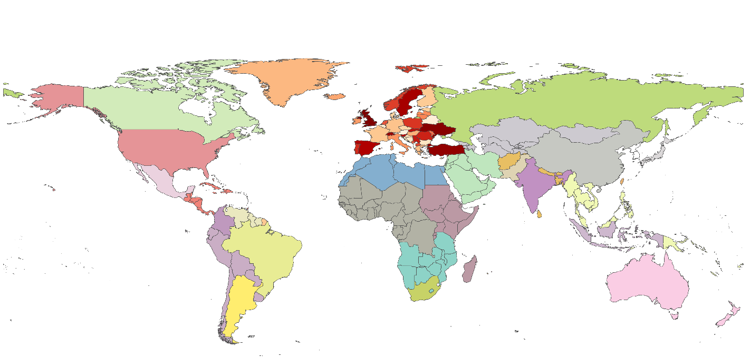
Figure S1: Regional disaggregation of GCAM-Europe. Orange-to-red represent the regional groups that are explicitly disaggregated for this model (from 5 regions to 39 countries). All other colours represent the 27 regional groups that were part of the original model and are also part of GCAM-Europe.

National CO₂ emissions
Figure S2 presents national CO₂ emission trajectories in GCAM-Europe and NECP CO₂ targets in selected European countries. At the national level, modelled trajectories under both NECP and Fit-for-55 scenarios broadly reproduce the downward trend in emissions implied by the NECP targets. Most Member States are on track to reach or closely approach their 2030 targets, confirming that EU-wide and national policies, combined with structural changes in the power and end-use sectors, are sufficient to deliver compliance in most cases. In the case of e.g., Poland, the NECP projections seem to be more conservative on the abatement potential in of the country, which the model phases down more rapidly than assumed in the NECP.
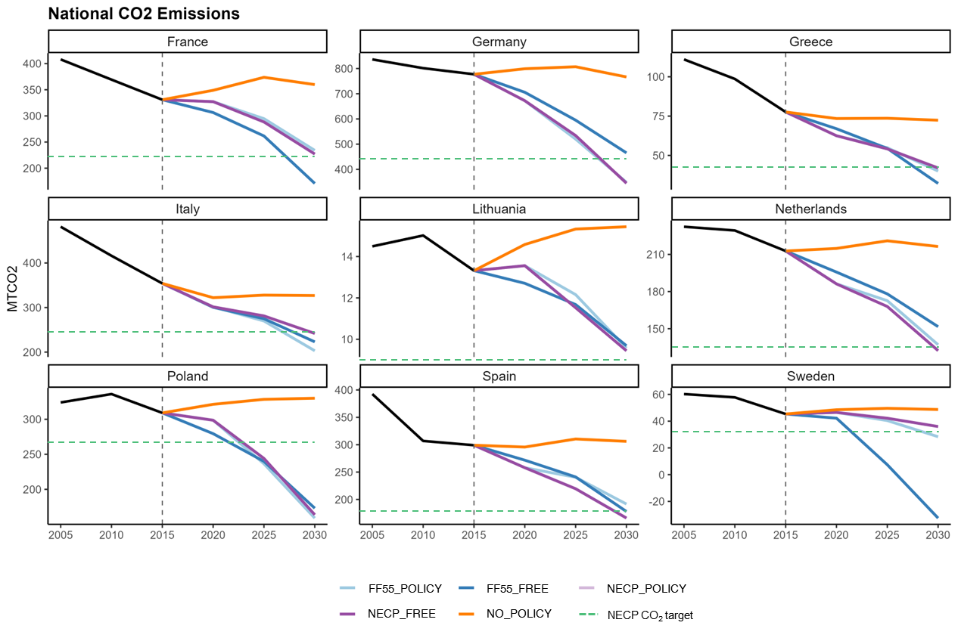
Figure S2: CO₂ emissions [MTCO₂] by country and scenario in GCAM-Europe. Fossil CO₂ emissions in selected EU-27 countries by 2050

EXPANSE
Input data, assumptions, mathematical formulation, and the cost minimisation objective function of EXPANSE can be found in the Supplementary Information of Sasse et. al. [2]. To accommodate more ambitious emissions and renewable power generation targets than in previous publications, further flexibility is allowed in EXPANSE by allowing the expansion of transmission lines capacity to three times the today’s levels and by allowing flexible fossil fuel-based technologies and firm renewable technologies to operate at the full range of their capacity, instead of at least 40% of their nominal capacity.

Electricity dispatch
Figure S3 illustrates Europe-wide electricity dispatch across the four scenarios in 2035, showcasing how different technologies contribute to meeting demand throughout the year. The consistent orange band across all panels reflects a high and stable contribution from nuclear power, which operates as baseload due to its low marginal cost and limited flexibility. Wind (in blue) and solar (in yellow) dominate the variable renewable contribution, with wind providing a more constant but fluctuating supply and solar peaking during summer months. The POLICY scenarios show more pronounced storage activity, indicating a greater reliance on flexibility to integrate higher shares of intermittent renewables while meeting stricter emissions and renewable energy targets. To this purpose, nuclear power in the summer months is ramped down to accommodate increased solar generation. This is contrasted with the FREE scenarios, where the system leans more on dispatchable generation and slightly less on storage, consistent with cost-optimised, constraint-light planning. The use of fossil fuels varies between the scenarios, reflecting the impact of policy constraints on generation choices. In the FREE scenarios, fossil fuels, particularly gas (red) and to a lesser extent lignite and coal (brown and grey), contribute more visibly throughout the year. Oil is almost not used in any of the scenarios due to the high fuel cost. Cost-optimal scenarios are designed to achieve the same CO₂ reductions as the policy-driven ones but without mandates on renewable shares or energy efficiency, allowing the system to rely more on cost-effective but carbon-intensive dispatchable sources during periods of low renewable output or high demand.
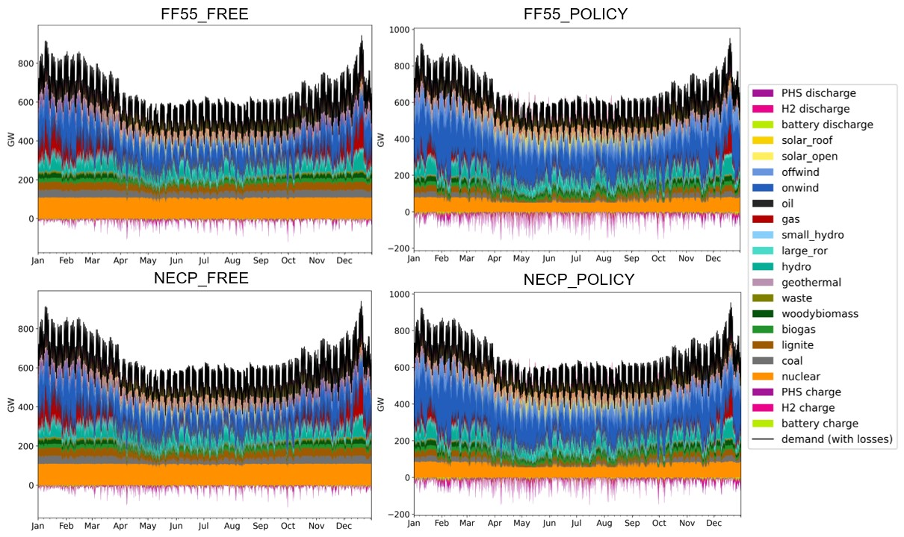
Figure S3: Electricity dispatch [GW] in EXPANSE. Hourly electricity dispatch by technology and scenario for the entire Europe in 2035.

Supplementary References
[1] Eurostat. Greenhouse gas emissions by source sector [Data set]. 2025 2025. https://ec.europa.eu/eurostat/databrowser/view/env_air_gge__custom_15374149/default/table?lang=en (accessed October 1, 2025).
[2] Sasse JP, Trutnevyte E. A low-carbon electricity sector in Europe risks sustaining regional inequalities in benefits and vulnerabilities. Nature Communications 2023 14:1 2023;14:1–15. https://doi.org/10.1038/s41467-023-37946-3.

https://jgcri.github.io/gcam-doc/toc.html

