Appendix (Supplementary Material)

Resilience and post-traumatic stress symptoms in grandparents following their grandchild’s cancer diagnosis from a multicenter cohort study in Switzerland (The GROkids Project)

Authors
Peter Francis Raguindin¹, Anne Maas¹, Anica Ilic^{1,2}, Cristina Priboi^{1, 3,}, Katharina Roser¹, Ahmed Farrag^{4,5}, Freimut Schilling⁴, Ursula Tanriver⁶, Tamara Diesch-Furlanetto⁶, Katrin Scheinemann^{1,7}, Gisela Michel¹

Affiliations
¹ Faculty of Health Sciences and Medicine, University of Lucerne, Lucerne, Switzerland
² Institute of Basic Medical Sciences, Faculty of Medicine, University of Oslo, Oslo, Norway
³ Veterinary Public Health Institute, University of Bern, Bern, Switzerland
⁴ Division of Pediatric Hematology and Oncology, Department of Pediatrics,
Children’s Hospital of Central Switzerland, Lucerne, Switzerland
⁵ Pediatric Oncology Department, South Egypt Cancer Institute, Assiut University, Assiut, Egypt
⁶ Department of Pediatric Oncology and Hematology, University Children’s Hospital Basel, Basel, Switzerland
⁷ Division of Hematology-Oncology, Children’s Hospital of Eastern Switzerland, St Gallen, Switzerland

Corresponding author
Prof. Dr. Gisela Michel
Faculty of Health Sciences and Medicine
University of Lucerne
Alpenquai 4, 6005 Lucerne
Email: gisela.michel@unilu.ch

Keywords/MeSH: resilience, post-traumatic stress, grandparents, family, cancer, childhood cancer

Table S1. Tools and time points at which they were measured
Construct | Tool | T1 | T2 | T3 | T4
Primary outcome
Resilience | Connor-Davidson Resilience Scale (CD-RISC 10) | X | X | X | X
Post-traumatic stress symptoms | Impact of Event Scale (IES-R) |  |  | X | X
Covariates
Sociodemographic information | Adaptation of the questionnaire from the Swiss Federal Statistical Office | X
Clinical information | Details on the cancer diagnosis and therapy |  |  |  | X
Information needs | Grandparents Information Needs Questionnaire | X
General wellbeing | First question of the Short-Form 36 | X
Health literacy | European Health Literacy Survey Questionnaire (HLS-EU-Q12) |  |  | X
Partnership quality | Relationship-specific Attachment Scale for Adults  (Beziehungsspezifische Bindungsskalen fur Erwachsene) | X
Perceived social support | Multidimensional Scale of Perceived Social Support (MSPSS) | X |  | X

Table S2. Summary of item and item response by the participants in CD-RISC 10 (Resilience)
 | T1  (3 months) | T2  (6 months) | T3  (12 months) | T4  (24 months)
I am able to adapt when changes occur. (Positivity)
Not at all | - | - | 1 (2.9%) | -
Rarely true | 1 (2.6%) | 1 (3.0%) | - | -
Sometime true | 4 (10.3%) | 3 (9.1%) | 4 (11.8%) | 8 (26.7%)
Often true | 11 (28.2%) | 6 (18.2%) | 8 (23.5%) | 4 (13.3%)
Always true | 23 (59.0%) | 23 (69.7%) | 21 (61.8%) | 18 (60.0%)
I can deal with whatever comes my way. (Positivity)
Not at all | 1 (2.6%) | - | 1 (2.9%) | -
Rarely true | 2 (5.1%) | 1 (3.0%) | 1 (2.9%) | -
Sometime true | 9 (23.1%) | 9 (27.3%) | 6 (17.6%) | 10 (33.3%)
Often true | 12 (30.8%) | 15 (45.5%) | 16 (47.1%) | 14 (46.7%)
Always true | 15 (38.5%) | 8 (24.2%) | 10 (29.4%) | 6 (20.0%)
I try to see the humorous side of things when I am faced with problems. (Resistance)
Not at all | 3 (7.7%) | 3 (9.1%) | 3 (9.1%) | -
Rarely true | 4 (10.3%) |  | 6 (18.2%) | 3 (10.0%)
Sometime true | 13 (33.3%) | 12 (36.4%) | 11 (33.3%) | 11 (36.7%)
Often true | 10 (25.6%) | 12 (36.4%) | 9 (27.3%) | 9 (30.0%)
Always true | 9 (23.1%) | 6 (18.2%) | 4 (12.1%) | 7 (23.3%)
Having to cope with stress can make me stronger. (Resistance)
Not at all | 2 (5.1%) | - | 2 (6.1%) | 2 (6.7%)
Rarely true | 3 (7.7%) | 5 (15.2%) | 3 (9.1%) | 3 (10.0%)
Sometime true | 8 (20.5%) | 8 (24.2%) | 10 (30.3%) | 6 (20.0%)
Often true | 18 (46.2%) | 14 (42.4%) | 9 (27.3%) | 15 (50.0%)
Always true | 8 (20.5%) | 6 (18.2%) | 9 (27.3%) | 4 (13.3%)
I tend to bounce back after illness, injury or other hardships. (Positivity)
Not at all | 1 (2.6%) | - | 1 (2.9%) | -
Rarely true | 1 (2.6%) | 1 (3.0%) | 1 (2.9%) | 1 (3.3%)
Sometime true | - | 1 (3.0%) | 3 (8.8%) | 5 (16.7%)
Often true | 14 (35.9%) | 12 (36.4%) | 10 (29.4%) | 13 (43.3%)
Always true | 23 (59.0%) | 19 (57.6%) | 19 (55.9%) | 11 (36.7%)
I believe I can achieve my goals, even if there are obstacles. (Competence)
Not at all | - | - | 1 (2.9%) | -
Rarely true | 3 (7.9%) | - | 1 (2.9%) | 1 (3.3%)
Sometime true | 9 (23.7%) | 8 (24.2%) | 8 (23.5%) | 8 (26.7%)
Often true | 12 (31.6%) | 9 (27.3%) | 11 (32.4%) | 11 (36.7%)
Always true | 14 (36.8%) | 16 (48.5%) | 13 (38.2%) | 10 (33.3%)
Under pressure, I stay focused and think clearly. (Resistance)
Rarely true | 6 (15.4%) | 3 (9.1%) | 3 (9.1%) | 3 (10.0%)
Sometime true | 5 (12.8%) | 4 (12.1%) | 5 (15.2%) | 5 (16.7%)
Often true | 19 (48.7%) | 13 (39.4%) | 14 (42.4%) | 14 (46.7%)
Always true | 9 (23.1%) | 13 (39.4%) | 11 (33.3%) | 8 (26.7%)
I am not easily discouraged by failure. (Competence)
Not at all | 1 (2.6%) | 2 (6.1%) | 3 (8.8%) | 1 (3.3%)
Rarely true | 5 (12.8%) | 3 (9.1%) | 3 (8.8%) | 4 (13.3%)
Sometime true | 9 (23.1%) | 8 (24.2%) | 6 (17.6%) | 9 (30.0%)
Often true | 15 (38.5%) | 11 (33.3%) | 11 (32.4%) | 8 (26.7%)
Always true | 9 (23.1%) | 9 (27.3%) | 11 (32.4%) | 8 (26.7%)
I think of myself as a strong person when dealing with life’s challenges and difficulties. (Competence)
Not at all | 1 (2.6%) | - | - | -
Rarely true | 1 (2.6%) | 2 (6.1%) | 2 (6.1%) | 1 (3.3%)
Sometime true | 6 (15.4%) | 4 (12.1%) | 4 (12.1%) | 8 (26.7%)
Often true | 16 (41.0%) | 9 (27.3%) | 9 (27.3%) | 10 (33.3%)
Always true | 15 (38.5%) | 18 (54.5%) | 18 (54.5%) | 11 (36.7%)
I am able to handle unpleasant or painful feelings like sadness, fear, and anger. (Resistance)
Not at all | - | 1 (3.0%) | 2 (5.9%) | -
Rarely true | 5 (12.8%) | 2 (6.1%) | 1 (2.9%) | 3 (10.0%)
Sometime true | 9 (23.1%) | 8 (24.2%) | 10 (29.4%) | 9 (30.0%)
Often true | 10 (25.6%) | 9 (27.3%) | 10 (29.4%) | 8 (26.7%)
Always true | 15 (38.5%) | 13 (39.4%) | 11 (32.4%) | 10 (33.3%)

Briefly, the definitions of CD-RISC subscales (shown in parenthesis) are as follows:
- Competence was defined as belief in one’s ability, having high standards, and tenacity.
- Resistance corresponds to trust in one’s instincts, tolerance of negative affect, and strengthening effects of stress.
- Positivity was a construct that relates to the positive acceptance of change, and secure relationships.

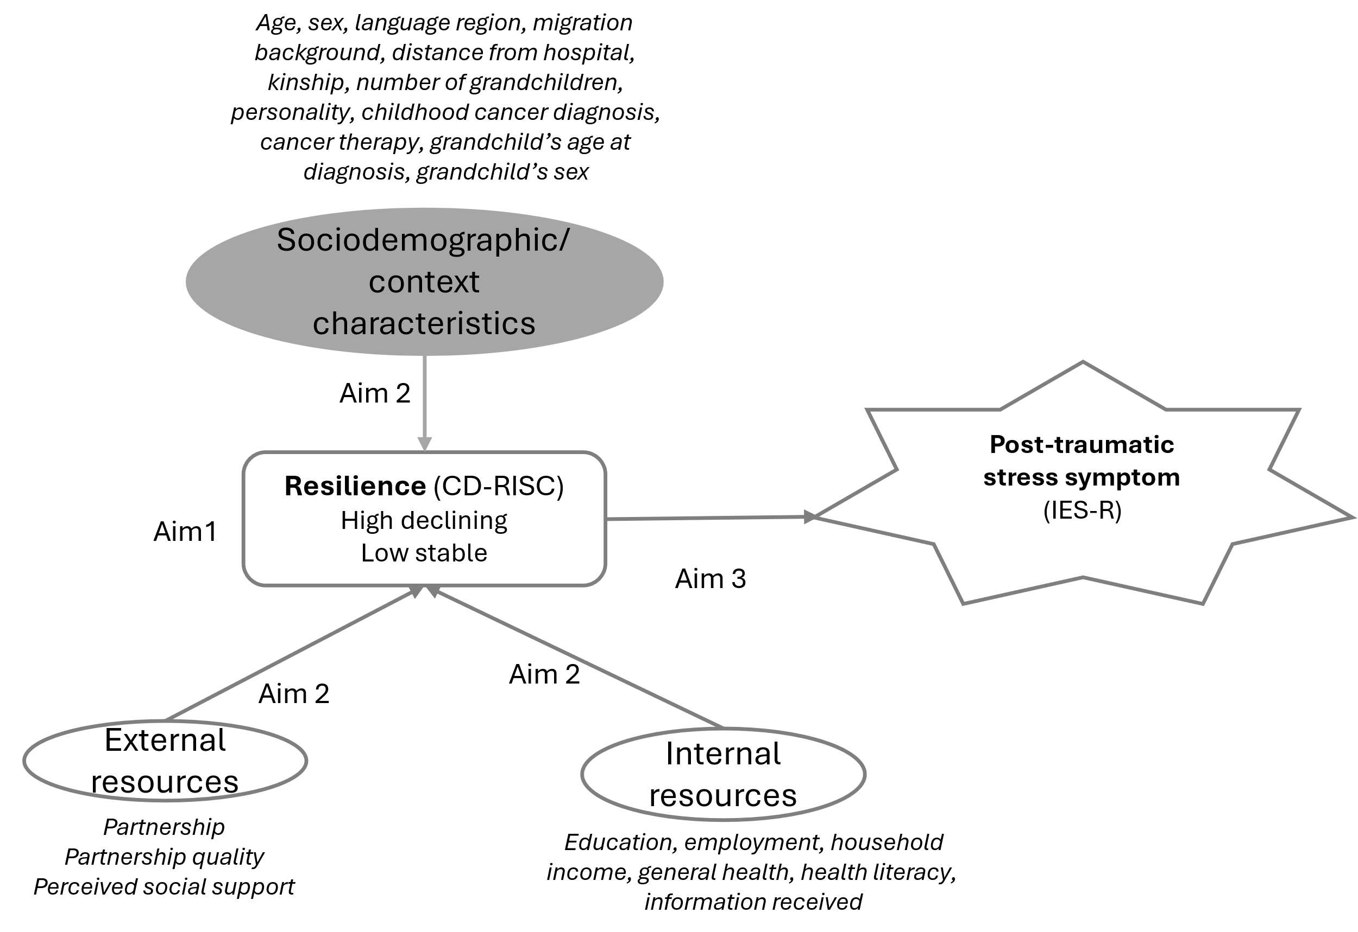

Figure S1. Analysis framework

Table S3. Model fit indices on the trajectories of resilience
TWO GROUP MODELS
 | Beta (SE) | Intercept | p value | AIC | BIC | Entropy
A. Linear - Linear
Group 1 - Linear | -0.02 (0.54) | 23.7 | 0.968 | -425.96 | -431.02 | 0.859
Group 2 - Linear | -1.15 (0.46) | 37.3 | 0.013*
B. Linear-Quadratic
Group 1 - Linear | -0.01 (0.54) | 23.6 | 0.985 |  |  | 0.858
Group 2 - Quadratic | -0.43 (0.51) | 35.0 | 0.394 | -426.95 | -432.86
C. Quadratic - Linear
Group 1 - Quadratic | -0.07 (0.62) | 23.4 | 0.907 | -426.95 | -432.86 | 0.858
Group 2 - Linear | -1.15 (0.46) | 37.3 | 0.014*
D. Quadratic-Quadratic
Group 1 - Quadratic | -0.05 (0.62) | 23.4 | 0.926 | -427.57 | -434.33 | 0.857
Group 2 - Quadratic | -0.43 (0.51) | 35.1 | 0.397
THREE GROUP MODELS
 | Beta (SE) | Intercept | p value | AIC | BIC | Entropy
A. 3 Linear
Group 1 - Linear | 0.25 (0.51) | 21.9 | 0.616 | -411.33 | -418.93 | 0.881
Group 2 - Linear | -0.89 (0.46) | 33.6 | 0.054
Group 3 - Linear | -2.60 (1.58) | 45.9 | 0.103
B. 3 Quadratic
Group 1 - Quadratic | 0.001 (0.58) | 21.8 | 0.995 | -414.06 | -424.19 | 0.871
Group 2 - Quadratic | -0.22 (0.48) | 32.3 | 0.640
Group 3 - Quadratic | -0.44 (0.48) | 42.4 | 0.581
C. 3 Cubic
Group 1 - Cubic | 0.04 (0.88) | 21.4 | 0.958 | -416.97 | -429.64 | 0.871
Group 2 - Cubic | 0.05 (0.72) | 31.7 | 0.939
Group 3 - Cubic | 0.45 (1.27) | 37.6 | 0.721
D. Different shapes
Group 1 - Linear | 0.26 (0.51) | 21.8 | 0.612 | -413.06 | -422.35 | 0.871
Group 2 - Quadratic | -0.22 (0.48) | 32.3 | 0.639
Group 3 - Quadratic | -0.44 (0.80) | 37.6 | 0.580
E. Different shapes
Group 1 - Linear | 0.26 | 21.8 | 0.616 | -413.98 | -424.11 | 0.871
Group 2 - Quadratic | -0.22 | 32.3 | 0.634
Group 3 - Cubic | 0.45 | 37.6 | 0.717
Abbreviations: AIC, Akaike Information Criterion, BIC, Bayesian Information Criterion.
Model in gray is the chosen model.

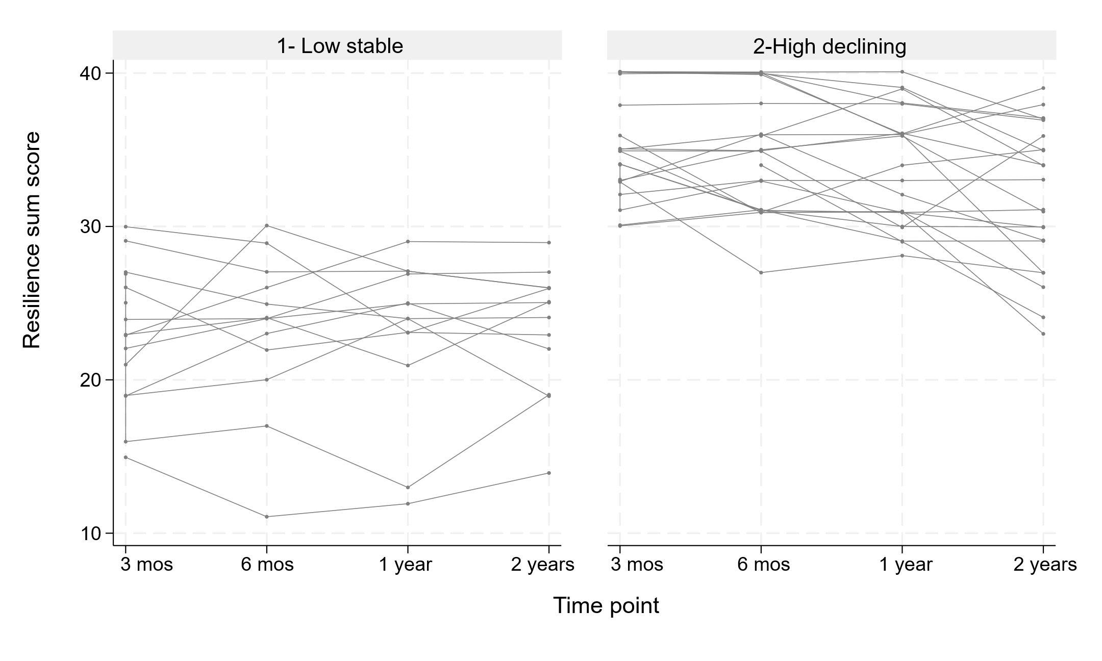

Figure S2. Trajectory plot of each participant divided into trajectory of resilience.
*Each line represents one participant with each point is a measure for each time point.

Table S4. Association of resilience trajectories (low-stable vs high-declining) and post-traumatic stress symptoms.*

 | Crude |  |  | Adjusted¹
 | beta | 90% CI | p-value | beta | 90% CI | p-value
IES-R mean score difference | -19.80 | -29.16, -10.43 | <0.001 | -19.19 | -29.26, -9.13 | <0.001
Intercept | 40.79 | 33.65, 47.95 | <0.001 | 59.36 | 6.04, 112.6 | 0.029

*Regression using IES-R sum score as dependent variable and resilience trajectory group (Low-stable as reference) as independent variable. Linear mixed model fitted using individual as cluster and random-intercept model.
¹Adjusted by age and sex.
Abbreviation: IES-R, Impact of Event Scale Revised

