SI Supplementary text

S01. Supplementary data description
ADNI dataset
Additional information about the Alzheimer's Disease Neuroimaging Initiative (ADNI) dataset is available at http://adni.loni.usc.edu/wp-content/uploads/how_to_apply/ADNI_Acknowledgement_List.pdf. The clinical information at baseline was used in this study (https://ida.loni.usc.edu/pages/access/studyData.jsp). Ethical approval for the ADNI study was obtained from the medical ethics committees of all participating institutions, and written informed consent was obtained from all participants. This retrospective study involving human participants adhered to the ethical standards set forth by the institutional and national research committees and followed the principles outlined in the Helsinki Declaration.
Data collection and sharing for this project were funded by the Alzheimer’s Disease Neuroimaging Initiative (ADNI) (National Institutes of Health Grant U01 AG024904) and DOD ADNI (Department of Defense award number W81XWH-12-2-0012). ADNI is funded by the National Institute on Aging, the National Institute of Biomedical Imaging and Bioengineering, and generous contributions from AbbVie, Alzheimer’s Association; Alzheimer’s Drug Discovery Foundation; Araclon Biotech; BioClinica, Inc.; Biogen; Bristol-Myers Squibb Company; CereSpir, Inc.; Cogstate; Eisai Inc.; Elan Pharmaceuticals, Inc.; Eli Lilly and Company; EuroImmun; F. Hoffmann-La Roche Ltd, and its affiliated company Genentech, Inc.; Fujirebio; GE Healthcare; IXICO Ltd.; Janssen Alzheimer Immunotherapy Research & Development, LLC.; Johnson & Johnson Pharmaceutical Research & Development LLC.; Lumosity; Lundbeck; Merck & Co., Inc.; Meso Scale Diagnostics, LLC.; NeuroRx Research; Neurotrack Technologies; Novartis Pharmaceuticals Corporation; Pfizer Inc.; Piramal Imaging; Servier; Takeda Pharmaceutical Company; and Transition Therapeutics. The Canadian Institutes of Health Research provides funds to support ADNI clinical sites in Canada. Private sector contributions are facilitated by the Foundation for the National Institutes of Health (www.fnih.org). The grantee organization is the Northern California Institute for Research and Education, and the study is coordinated by the Alzheimer’s Therapeutic Research Institute at the University of Southern California. The ADNI data are disseminated by the Laboratory for Neuro Imaging at the University of Southern California.
AIBL dataset
The Australian Imaging, Biomarker & Lifestyle Flagship Study of Ageing (AIBL) is a study to discover which biomarkers, cognitive characteristics, and health and lifestyle factors determine the subsequent development of symptomatic AD. The AIB dataset was initiated in 2006 with an initial cohort of 1,112 older adults aged 60 and above, comprising participants with AD, mild cognitive impairment, and cognitively healthy controls. Data collection occurs at 18-month intervals, and up to eight or more longitudinal timepoints have been acquired. This study includes 193 subjects’ longitudinal T1w MRIs from the AIBL dataset^{1,2}. The longitudinal data were collected at 36 and 72 months after the baseline visit, encompassing transitions such as CN to CN (M36:N=111scans, M72:N=53 scans), CN to MCI (N=29 scans), MCI to MCI (M36:N=20 scans, M72:N=16 scans), MCI to AD (N=13 scans), and AD to AD(M36:N=20 scans, M72: N=7 scans). The baseline MRIs from the AIBL dataset was used to evaluate the Fork-SE-based brain age model³.
Cam-CAN dataset
The Cambridge Centre for Ageing and Neuroscience (Cam-CAN) is a large-scale collaborative research project at the University of Cambridge, launched in October 2010, with substantial initial funding from the Biotechnology and Biological Sciences Research Council (BBSRC), followed by support from the Medical Research Council (MRC) Cognition & Brain Sciences Unit (CBU) and the European Union Horizon 2020 LifeBrain project. The Cam-Can project uses epidemiological, cognitive, and neuroimaging data to understand how individuals can best retain cognitive abilities into old age. Cam-Can study is conducted in compliance with the Helsinki Declaration, and has been approved by the local ethics committee, Cambridgeshire 2 Research Ethics Committee (reference: 10/H0308/50)¹.

S02 Supplementary method
To predict $x_{t-1}^{'}$, the diffusion GAN model parameterizes the denoising model by $p_{θ}\left(x_{t-1} | x_{t}\right)≔q\left(x_{t-1} | x_{t},x_{0}^{'}\right)$. $x_{0}^{'}$ is estimated using the conditional GAN generator $G_{μ}$, and $x_{t-1}^{'}$ is sampled by the posterior distribution $q\left(x_{t-1} | x_{t},x_{0}^{'}\right).$ The pseudo-code of the training procedure of IP-DDGAN is provided in Algorithm 1.
Algorithm 1 Training procedure of IP-DDGAN
Input: Longitudinal MRI scans $\left(x_{bl},x_{0}\right),$ age $a,$ sex $s,$ and diagnosis label $k$
Parameter: Generator $G_{μ},$discriminator $D_{σ}$, a metadata encoder $τ_{φ}$
Definition: $α_{t}=1-β_{t}, {\overline{α}}_{t}=\prod_{i=0}^{t}{α_{i}}$, where $β_{t}$is a fixed variance schedule
while $μ,σ,φ$ have not converged do
$z_{t}\sim N\left(0,I\right),c=concat\left(τ_{φ}\left(a,s,k\right),x_{bl}\right) , t\sim U\left(1,T\right)$ and $ε\sim N\left(0,I\right)$
$x_{t}=\sqrt{{\overline{α}}_{t}}x_{0}+\sqrt{1-{\overline{α}}_{t}}ϵ$
Step Ⅰ: update $D_{σ}$
Real samples $x_{t-1}\sim q\left(x_{t-1} | x_{t}\right)$
Fake samples $x_{t-1}^{'}\sim p_{θ}\left(x_{t-1} | x_{t}\right)$
Update $D_{σ}$ by $\min_{θ}\sum_{t≥1}{E_{q\left(x_{t}\right)}\left[E_{q\left(x_{t-1} | x_{t}\right)}\left[-log\left(D_{σ}\left(x_{t-1},x_{t},t\right)\right)\right]\right]}+E_{p_{θ}}\left[E_{p_{θ}\left(x_{t-1} | x_{t}\right)}\left[-log\left(D_{σ}\left(x_{t-1},x_{t},t\right)\right)\right]\right]$
Step Ⅱ: Update $G_{μ}$
$x_{0}^{'}=G_{μ}\left(x_{t},z_{t},c,t\right)$
Fake sample $x_{t-1}^{'}\sim p_{θ}\left(x_{t-1} | x_{t},x_{0}^{'}\right)$
Update $G_{μ}$ by $\max_{μ}\sum_{t≥1}{E_{q\left(x_{0}\right)}E_{p_{θ}\left(x_{t-1} | x_{t}\right)}\left[log\left(D_{σ}\left(x_{t-1},x_{t},t\right)\right)\right]}$
end while
return $G_{μ}, D_{σ}, τ_{φ}$
To generate realistic identity-preserving MRIs, the metadata such as age a, sex s, diagnosis label k, and baseline MRI $x_{bl}$ are introduced as conditions during the inference stage. After T steps of non-Gaussian distribution and posterior sampling, we can obtain the target MRI. The pseudo-code of the sampling procedure of IP-DDGAN is provided in Algorithm 2.
Algorithm 2 Sampling procedure of IP-DDGAN
Input: MRI scan $x_{bl},$ age $a,$ sex $s,$ and diagnosis label $k$
Parameter: Generator $G_{μ}$, metadata extractor $τ_{φ}$
$$x_{T}\sim N\left(0,I\right)$$
for t in $T,T-1,⋯,do$
$ε\sim N\left(0,I\right)$, if $t>1,$ else $ε=0$
$z_{t}\sim N\left(0,I\right),c=concat\left(τ_{φ}\left(a,s,k\right),x_{bl}\right)$
$x_{t-1}←q\left(x_{t-1} | x_{t},G_{μ}\left(x_{t},z_{t},c,t\right)\right)$
end for
return $x_{0}$

S03 The number of parameters, computational FLOPs, the inference time of IP-DDGAN compared with competing methods
Supplementary Table 1. Model specifications of different generative methods including a (M), FLOPs (GB), memory usage (GB), and sampling time (s) on a single 3090 GPU for one sample.
Method | Params | FLOPs | MEM | Sampling time
CGAN | 41.59 M | 56.19 G | 0.61 G | 0.09 s
CycleGAN | 72.50 M | 97.80 G | 1.04 G | 0.09 s
SAGAN | 23.40 M | 160.21 G | 2.78 G | 0.15 s
DDPM | 19.87 M | 413.87 G | 0.09 G | 190 s
LDM | 41.55 M | 141.58 G | 0.33 G | 102 s
IP-DDGAN(ours) | 54.47 M | 2047.76 G | 4.33 G | 1.05 s

S04 Morphological evaluation.
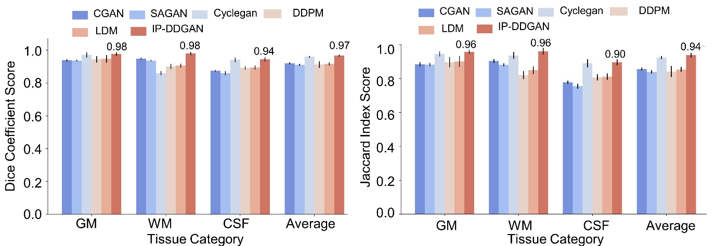
Supplementary Figure 1. Comparable performance of various generative models in brain tissue segmentation in terms of (left) Dice coefficient and (right) Jaccard index score.
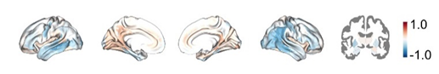
Supplementary Figure 2. The effect size (Cohen’s d) of the gray matter volume difference between real and synthetic MRIs.

S05 Detailed information of study participants.
We used Longitudinal T1w MRIs from 1038 subjects in the ADNI dataset to train IP-DDGAN. Each subject underwent multiple T1-weighted MRI scans over two to six years. We evaluated our method on 193 subjects’ longitudinal T1w MRIs from the AIBL dataset. We trained the Fork-SE-based brain age prediction model based on the Cam-CAN dataset.
Supplementary Table 2. Characteristics of study participants.
Dataset | ADNI |  |  | AIBL |  |  | Cam-CAN
Category | CN | MCI | AD | CN | MCI | AD | CN
#of subjects | 382 | 539 | 117 | 362 | 88 | 74 | 707
#of sessions | 1255 | 1696 | 359 | 643 | 137 | 128 | -
Sex(F/M) | 177/205 | 330/209 | 59/58 | 204/158 | 45/33 | 45/29 | 358/349
Age at baseline | 76.11±6.32 | 74.87±8.18 | 76.54±9.56 | 72.32±6.42 | 74.79±7.23 | 73.53±7.97 | 54.60±18.60
MMSE at baseline | 29.24±1.15 | 27.89±1.86 | 23.45±2.16 | 28.70±1.23 | 27.07±2.06 | 20.27±5.51 | -

S06 The style-based ResNet block.
Inspired by StyleGAN⁴, we introduced a latent variable $z\sim N\left(0,I\right)$ to modulate the attributes of generated MRIs. A mapping network $f:z→ω$ learns a nonlinear transformation of z into a style vector ω which is then injected into the generator through adaptive instance normalization (AdaIN) layers. Unlike conventional instance normalization, AdaIN extends instance normalization by adaptively learning the normalization parameters based on the input, rather than keeping them static or solely relying on group statistics. The learned normalization parameters are not fixed but instead depend on the style or content of the image. The formula for AdaIN is as follows:
$$\hat{x}=\frac{x-μ}{σ}×γ_{adapeive}+β_{adaptive}$$ | (1)
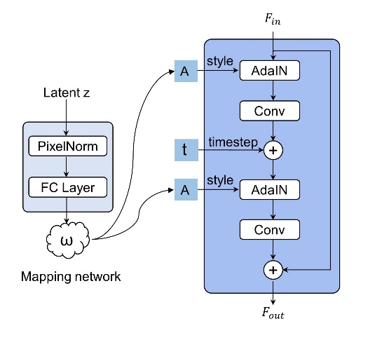
where x is the input. $μ$ and $σ$ are the mean and variance of the group. $γ_{adapeive}$ and $β_{adaptive}$ are learned scale and shift parameters, which vary with the style or content of the image. Each AdaIN layer outputs the scale and shift parameters for each channel, which are used to apply affine transformations to feature maps. The style-based ResNet block takes an input feature map and applies two convolutional layers, each preceded by an AdaIN layer modulated by a style vector derived from the latent code z. A timestep embedding t is injected between the two layers to provide temporal conditioning.
Supplementary Figure 3. The style-based ResNet block.

References
1 Zhao, K. et al. Macroscale connectome topographical structure reveals the biomechanisms of brain dysfunction in Alzheimer's disease. Science Advances 10 (2024). https://doi.org:ARTN eado88310.1126/sciadv.ado8837
2 Zhao, K. et al. A neuroimaging biomarker for Individual Brain-Related Abnormalities In Neurodegeneration (IBRAIN): a cross-sectional study. eClinicalMedicine 65 (2023). https://doi.org:10.1016/j.eclinm.2023.102276
3 Zuo, N. et al. Different Regional Patterns in Gray Matter-based Age Prediction. Neuroscience Bulletin 39, 984-988 (2023). https://doi.org:10.1007/s12264-022-01016-3
4 Karras, T., Laine, S. & Aila, T. in Proceedings of the IEEE/CVF conference on computer vision and pattern recognition. 4401-4410.

