Supplementary Materials

Supplementary Methods

Study Population
This study adhered to the ethical standards of the 1975 Declaration of Helsinki. The data used in this study were obtained from the Phenobank (https://www.phenobank.org.cn/). Ethical approval for the collection of phenotypic data and biological samples was granted by the local research ethics committee (No.BE1828). Written informed consent was obtained from all participants. The description of distribution of dataset can be found in Supplementary Table 1.
Clinical Phenotype Definition
We selected nine major phenotypes of the cardiac region (ventricles) as evaluation targets for the clinical application performance of Segmentation Foundation Models. The definitions and quantification of these phenotypes are shown below.
Cardiac Phenotype Definition
Denote ${\text{V}}_{\text{EDLV}}$,${\text{V}}_{\text{EDRV}}$,${\text{V}}_{\text{ESLV}}$,${\text{V}}_{\text{ESRV}}$ as the volume (mL) of the region EDLV, EDRV, ESLV and ESRV of cardiac respectively.
Then:
LV_{EDV} = ${\text{V}}_{\text{EDLV}}$, LV_{ESV} = ${\text{V}}_{\text{ESLV}}$, RV_{EDV} = ${\text{V}}_{\text{EDRV}}$, RV_{ESV} = ${\text{V}}_{\text{ESRV}}$,
LV_{SV} =LV_{EDV} - LV_{ESV} , RV_{SV} =RV_{EDV} - RV_{ESV}
LV_{EF} =LV_{SV}/LV_{EDV}×100 , RV_{EF} =RV_{SV}/RV_{EDV}×100
LV_{CO} = LV_{SV}×lpha×10^{^-3}
alpha = 60.0/duration/cycle
where duration/cycleis the time period required for a complete heartbeat and can be read from the header file of the ‘NIFTI’ data.

Error Distribution Computation
Algorithm: Spatial segmentation error distribution visualization among sample groups
Initialization: Denote o as the organ to for visualization, o in {kidney, liver, spleen, lung, AO}. For each organ o, the mask of one sample in the data set is selected as the reference, which is defined as Ref_{o}.
Input: sample d_{j}, j=1,..., 701, from Dataset D and segmentation results S_{j} of Segmentation Foundation Models with annotations L_{j}.
Output: Overall distribution of segmentation error of Segmentation Foundation Models for organ o in D。
For d_{j} in D:
Transfer S_{j}, L_{j} into data of stl format further into point cloud data as SP_{j}, LP_{j}。
Compute point to point distance as Distance_{SL}, from SP_{j} to LP_{j}。
Compute point to point distance as Distance_{LS}, from LP_{j}to SP_{j} 。
P₉₅ = Percentile([Distance_{SL,}Distance_{LS}], 95)
Distance_{SL}[Distance_{SL}>P₉₅] = P₉₅
Distance_{LS}[Distance_{LS}>P₉₅] = P₉₅
Count_{IDX} = 1
For point_{SP} in SP_{j:}
IDX_{SPtoLP} = find_nearest(LP_{j}, point_{SP})
Distance_{SL}[IDX_{SPtoLP}] = Distance_{SL}[IDX_{SPtoLP}] + Distance_{LS}[point_{SP}]
Count[IDX_{SPtoLP}] = Count[IDX_{SPtoLP}] +1
For point_{LP} in LP_{j:}
Distance_{SL}[IDX_{SPtoLP}] = Distance_{SL}[IDX_{SPtoLP}] /Count[IDX_{SPtoLP}]
IDX_{LPtoRef}= find_nearest(Ref_{o}, point_{LP})
Ref_{o}[IDX_{LPtoRef}].distance = Distance_{SL}[point_{LP}]
For point_{Ref} in Ref_{o:}
Ref_{o}[IDX_{LPtoRef}].distance / =701

Supplementary Figures
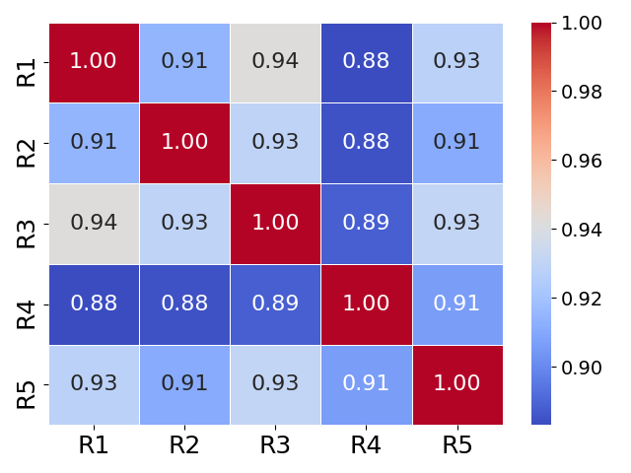
Supplementary Figure 1. Overall segmentation consistence among the annotations from 5 experienced radiologists (R1, R2, R3, R4, R5) for 16 organs. The values in the heatmap represent the kappa coefficients between the segmentation results of each pair of radiologists on the same dataset. We averaged the kappa values across all 16 organs for presentation. Considering the workload of repeated annotations, we selected 30 subjects from the total sample for comparative analysis.

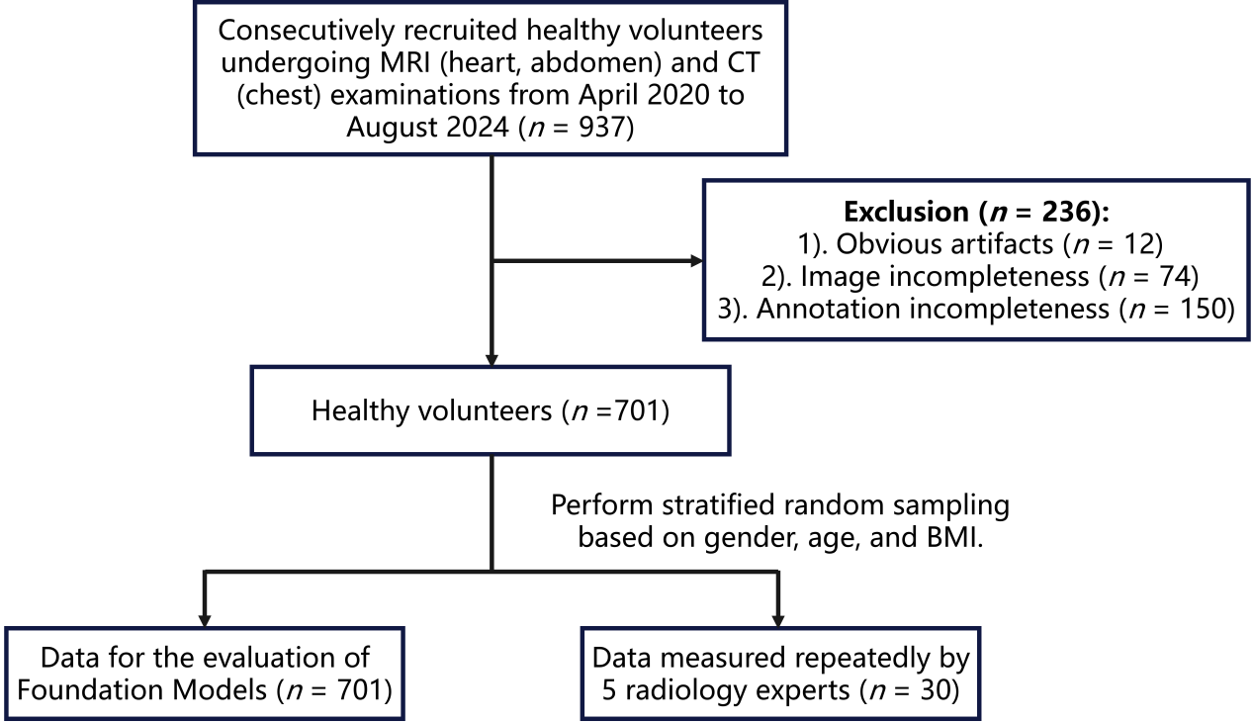
Supplementary Figure 2. Diagram of participants inclusion and exclusion.

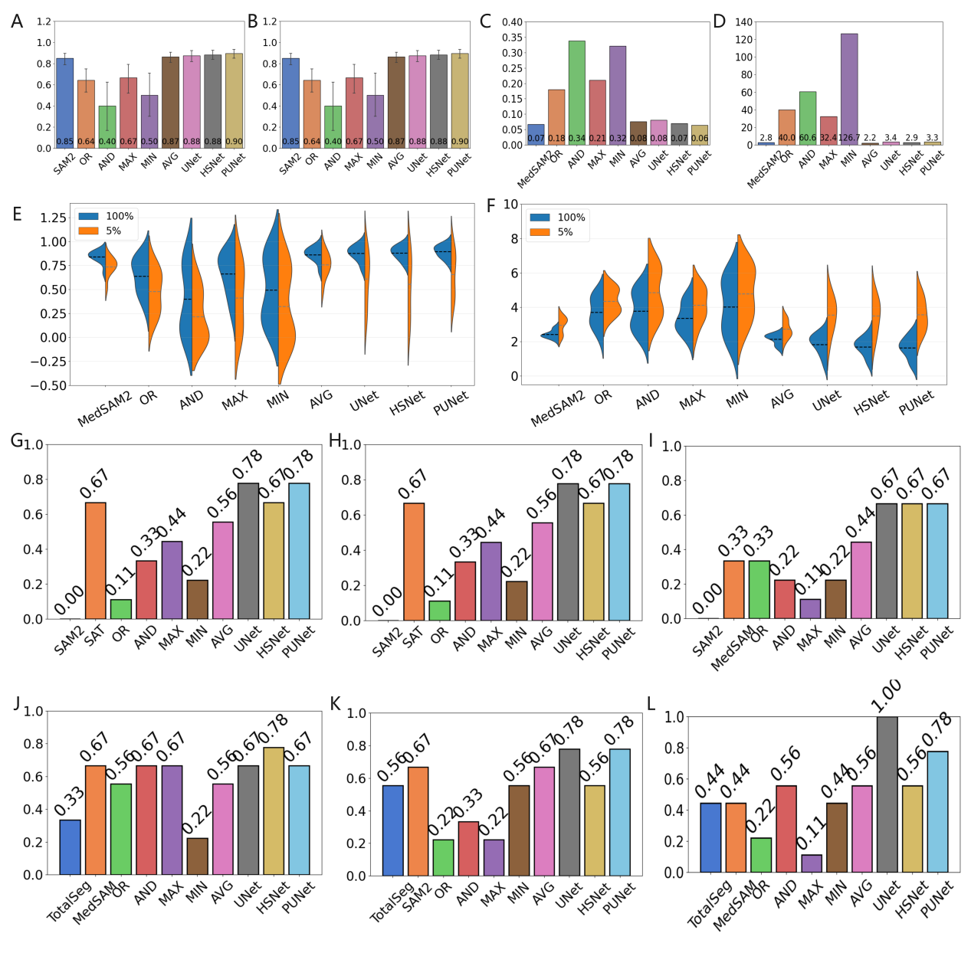
Supplementary Figure 3. Comparison of different ensemble learning strategies for multi-organ segmentation performances. Ensemble learning strategies resolves performance trade-offs and dominates individual models in 9 organ segmentation. Performance of ensemble strategies of five post-processing fusion and two multi-source distillation was compared against the best-performing individual models across all evaluation dimensions. A,B, The AVG ensemble and models of distillation achieve the highest overall accuracy (DSC and HD95). C,D, It also exhibits the lowest performance variance across organs, indicating superior generalization. E,F, For robustness, AVG maintains the highest accuracy on the most challenging 5% of cases. G-I, Crucially, the AVG ensemble and models of distillation maintain competitive fairness across gender, age, and BMI attributes, effectively resolving the accuracy-fairness trade-off. M,N, A holistic performance summary visually confirms that the ensemble learning strategy provides the best overall balance, dominating all other approaches across accuracy, robustness, fairness and generalization.

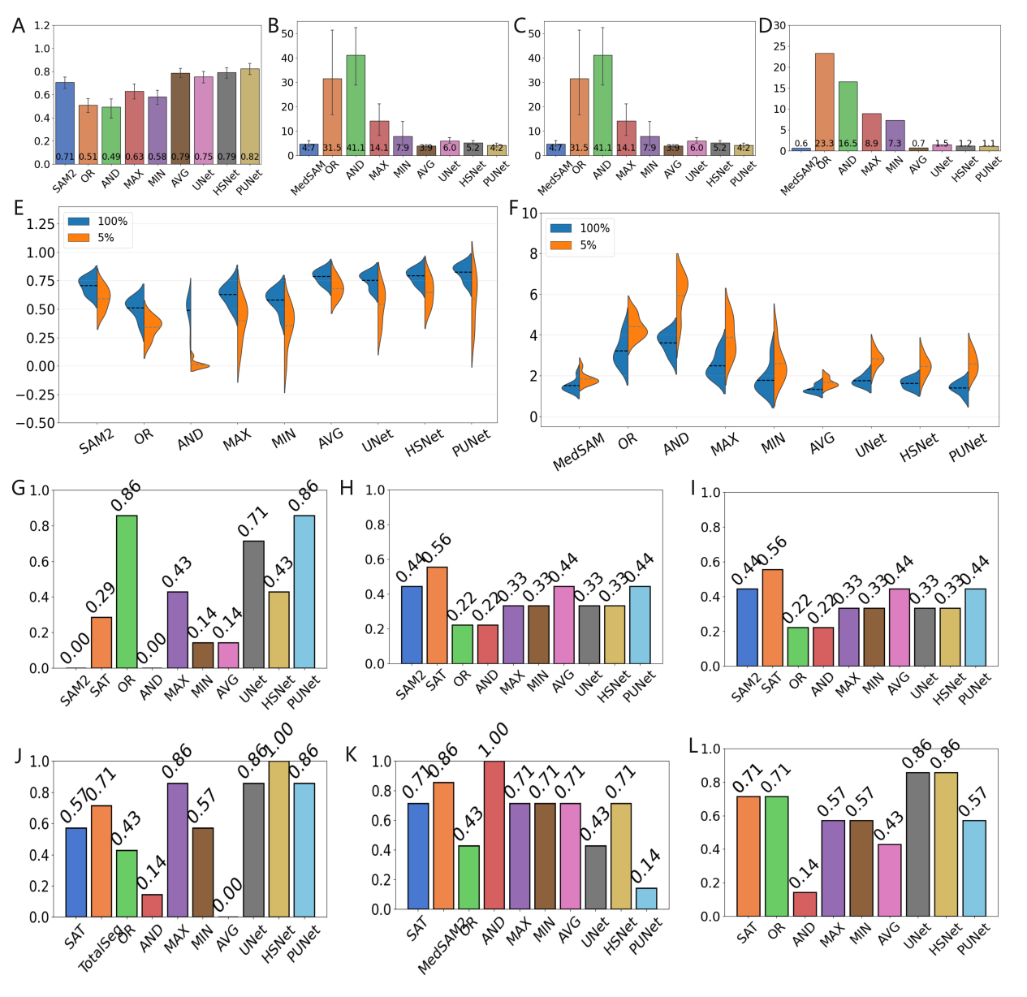
Supplementary Figure 4. Ensemble learning strategies resolves performance trade-offs and dominates individual models in 7 vessel segmentation. Performance of ensemble strategies of five post-processing fusion and two multi-source distillation was compared against the best-performing individual models across all evaluation dimensions. A,B, The AVG ensemble and models of distillation achieve the highest overall accuracy (DSC and HD95). C,D, It also exhibits the lowest performance variance across organs, indicating superior generalization. E,F, For robustness, AVG maintains the highest accuracy on the most challenging 5% of cases. G-I, Crucially, the AVG ensemble and models of distillation maintain competitive fairness across gender, age, and BMI attributes, effectively resolving the accuracy-fairness trade-off. M,N, A holistic performance summary visually confirms that the ensemble learning strategy provides the best overall balance, dominating all other approaches across accuracy, robustness, fairness and generalization.

Supplementary Tables

Supplementary Table 1. Dataset attribute description with population characteristics.
Attribute | Total | Male | Female
Samples (n) | 701 | 288 | 413
Age (years; mean, SD) | 35.09 (11.76) | 35.09 (11.42) | 35.09 (11.99)
Height (m; mean, SD) | 1.66 (0.09) | 1.73 (0.06) | 1.61 (0.06)
Weight (kg; mean, SD) | 63.65 (12.06) | 71.57 (10.52) | 58.24 (9.83)
BMI (kg/m²;mean, SD) | 23.07 (3.47) | 23.79 (3.13) | 22.56 (3.61)
Kidney volume (mL, mean, SD) | 282.92 (50.00) | 310.05 (47.44) | 263.97 (42.41)
Liver volume (mL, mean, SD) | 1243.27 (279.96) | 1402.82 (262.00) | 1131.25 (234.43)
Pancreas volume (mL, mean, SD) | 62.91 (16.97) | 70.11 (17.04) | 57.83 (14.97)
Spleen volume (mL, mean, SD) | 195.26 (73.32) | 230.73 (78.73) | 170.39 (57.56)
EDLV volume (mL, mean, SD) | 135.01 (32.94) | 153.76 (35.91) | 121.91 (22.85)
ESLV volume (mL, mean, SD) | 53.21 (18.73) | 60.77 (21.18) | 47.92 (14.64)
EDRV volume (mL, mean, SD) | 142.23 (40.30) | 165.21 (43.99) | 126.16 (27.87)
ESRV volume (mL, mean, SD) | 71.43 (26.11) | 85.29 (27.71) | 61.68 (19.82)
IVC (mL, mean, SD) | 39.11 (17.34) | 42.92 (18.65) | 36.38 (15.81)
Lung (mL, mean, SD) | 4283.11 (1046.36) | 5084.58 (915.66) | 3723.23 (714.95)
AO (mL, mean, SD) | 114.82 (37.02) | 133.30 (36.74) | 101.98 (31.26)
L_INV (mL, mean, SD) | 8.93 (2.92) | 10.47 (3.04) | 7.86 (2.30)
BCT (mL, mean, SD) | 2.66 (1.44) | 3.25 (1.17) | 2.25 (1.47)
R_INV (mL, mean, SD) | 4.19 (1.40) | 4.79 (1.55) | 3.77 (1.12)
SVC (mL, mean, SD) | 11.22 (3.23) | 12.90 (3.52) | 10.05 (2.40)
LSA (mL, mean, SD) | 2.06 (0.79) | 2.52 (0.80) | 1.73 (0.60)
*SD: standard deviation. EDLV, End-Diastolic Left Ventricle; ESLV, End-Systolic Left Ventricle; EDRV, End-Diastolic Right Ventricle; ESRV, End-Systolic Right Ventricle; IVC, Inferior Vena Cava; AO, Aorta; L_INV, left brachiocephalic vein; BCT, Brachiocephalic Trunk; R_INV, right brachiocephalic vein; SVC, Superior Vena Cava; LSA, Left Subclavian Artery.

Supplementary Table 2. Details of the Segmentation Foundation Models for multi-organs segmentation used in this study.
Model name | Backbone | Download url
SAM | Vision Transformer-Huge | https://github.com/facebookresearch/segment-anything
SAM2 | Hierarchical Transformer-Large | https://github.com/facebookresearch/sam2
MedSAM | Vision Transformer-Base | https://github.com/bowang-lab/MedSAM
MedSAM2 | Hierarchical Transformer-Tiny | https://github.com/bowang-lab/MedSAM2
SAT | UNet | https://github.com/zhaoziheng/SAT
TotalSegmentator | nnUNet | https://github.com/wasserth/TotalSegmentator

Supplementary Table 3. Overall segmentation accuracy (with metric of DSC) of ensemble (average) strategy and baselines.
 | Kidney | Liver | Pancreas | Spleen | EDLV | EDRV | ESLV | ESRV | IVC | Lung | AO | L_INV | BCT | R_INV | SVC | LSA
SAM | 0.89 | 0.87 | 0.59 | 0.83 | 0.90 | 0.89 | 0.83 | 0.80 | 0.78 | 0.96 | 0.77 | 0.63 | 0.58 | 0.72 | 0.74 | 0.61
SAM2 | 0.87 | 0.90 | 0.62 | 0.88 | 0.87 | 0.91 | 0.84 | 0.84 | 0.77 | 0.94 | 0.79 | 0.68 | 0.61 | 0.72 | 0.76 | 0.62
MedSAM | 0.88 | 0.78 | 0.46 | 0.81 | 0.68 | 0.50 | 0.65 | 0.52 | 0.72 | 0.89 | 0.64 | 0.66 | 0.56 | 0.60 | 0.66 | 0.54
MedSAM2 | 0.80 | 0.90 | 0.67 | 0.86 | 0.87 | 0.88 | 0.84 | 0.83 | 0.67 | 0.90 | 0.79 | 0.66 | 0.58 | 0.66 | 0.69 | 0.56
SAT | 0.89 | 0.90 | 0.51 | 0.84 | 0.55 | 0.30 | 0.36 | 0.14 | 0.34 | 0.94 | 0.72 | 0.78 | 0.63 | 0.72 | 0.65 | 0.50
TotalSeg | 0.82 | 0.91 | 0.24 | 0.85 | 0.16 | 0.19 | 0.21 | 0.20 | 0.54 | 0.97 | 0.73 | 0.79 | 0.70 | 0.77 | 0.68 | 0.50
Manual annotation | 0.97 | 0.98 | 0.87 | 0.96 | 0.96 | 0.94 | 0.86 | 0.89 | 0.83 | 1.00 | 0.96 | 0.92 | 0.82 | 0.91 | 0.92 | 0.86
Ensemble AVG | 0.91 | 0.93 | 0.69 | 0.90 | 0.89 | 0.85 | 0.84 | 0.81 | 0.81 | 0.96 | 0.86 | 0.77 | 0.70 | 0.80 | 0.84 | 0.73

Supplementary Table 4. Significant levels of heterogenicity of Segmentation Foundation Models’ overall accuracy between organs and vessels.
 | SAM | SAM2 | MedSAM | MedSAM2 | SAT | TotalSeg
p-value (DSC) | 0.0080 (**) | 0.0040 (**) | 0.3827 (N.S.) | 0.0002 (***) | 0.8841 (N.S.) | 0.2646 (N.S.)
p-value (HD95) | 0.0609 (N.S.) | 0.0163 (*) | 0.0037 (**) | 0.0003 (***) | 0.3491 (N.S.) | 0.0881 (N.S.)
The statistical test between groups was performed using analysis of variance (ANOVA). Statistical significance: * p<0.05; ** p<0.01; *** p<0.001; **** p<0.0001; N.S., not significant.

Supplementary Table 5. Significance levels of heterogenicity of overall accuracy (with metric of DSC) cross Segmentation Foundation Models.
 | SAM | SAM2 | MedSAM | MedSAM2 | SAT | TotalSeg
SAM | 1.0000 (N.S.) | 0.7144 (N.S.) | 0.0155 (*) | 0.7556 (N.S.) | 0.0206 (*) | 0.0191 (*)
SAM2 | 0.7144 (N.S.) | 1.0000 (N.S.) | 0.0050 (**) | 0.4850 (N.S.) | 0.0108 (*) | 0.0111 (*)
MedSAM | 0.0155 (*) | 0.0050 (**) | 1.0000 (N.S.) | 0.0277 (*) | 0.4759 (N.S.) | 0.3236 (N.S.)
MedSAM2 | 0.7556 (N.S.) | 0.4850 (N.S.) | 0.0277 (*) | 1.0000 (N.S.) | 0.0309 (*) | 0.0271 (*)
SAT | 0.0206 (*) | 0.0108 (*) | 0.4759 (N.S.) | 0.0309 (*) | 1.0000 (N.S.) | 0.7481 (N.S.)
TotalSeg | 0.0191 (*) | 0.0111 (*) | 0.3236 (N.S.) | 0.0271 (*) | 0.7481 (N.S.) | 1.0000 (N.S.)
The statistical test between groups was performed using analysis of variance (ANOVA). Statistical significance: * p<0.05; ** p<0.01; *** p<0.001; **** p<0.0001; N.S., not significant.

Supplementary Table 6. Significance levels of heterogenicity of overall accuracy (with metric of HD95) cross Segmentation Foundation Models.
 | SAM | SAM2 | MedSAM | MedSAM2 | SAT | TotalSeg
SAM | 1.0000 (N.S.) | 0.5487 (N.S.) | 0.6446 (N.S.) | 0.7135 (N.S.) | 0.0025 (**) | 0.0127 (*)
SAM2 | 0.5487 (N.S.) | 1.0000 (N.S.) | 0.9826 (N.S.) | 0.7827 (N.S.) | 0.0030 (**) | 0.0136 (*)
MedSAM | 0.6446 (N.S.) | 0.9826 (N.S.) | 1.0000 (N.S.) | 0.8368 (N.S.) | 0.0032 (**) | 0.0138 (*)
MedSAM2 | 0.7135 (N.S.) | 0.7827 (N.S.) | 0.8368 (N.S.) | 1.0000 (N.S.) | 0.0027 (**) | 0.0132 (*)
SAT | 0.0025 (**) | 0.0030 (**) | 0.0032 (**) | 0.0027 (**) | 1.0000 (N.S.) | 0.1812 (N.S.)
TotalSeg | 0.0127 (*) | 0.0136 (*) | 0.0138 (*) | 0.0132 (*) | 0.1812 (N.S.) | 1.0000 (N.S.)

