Appendix A
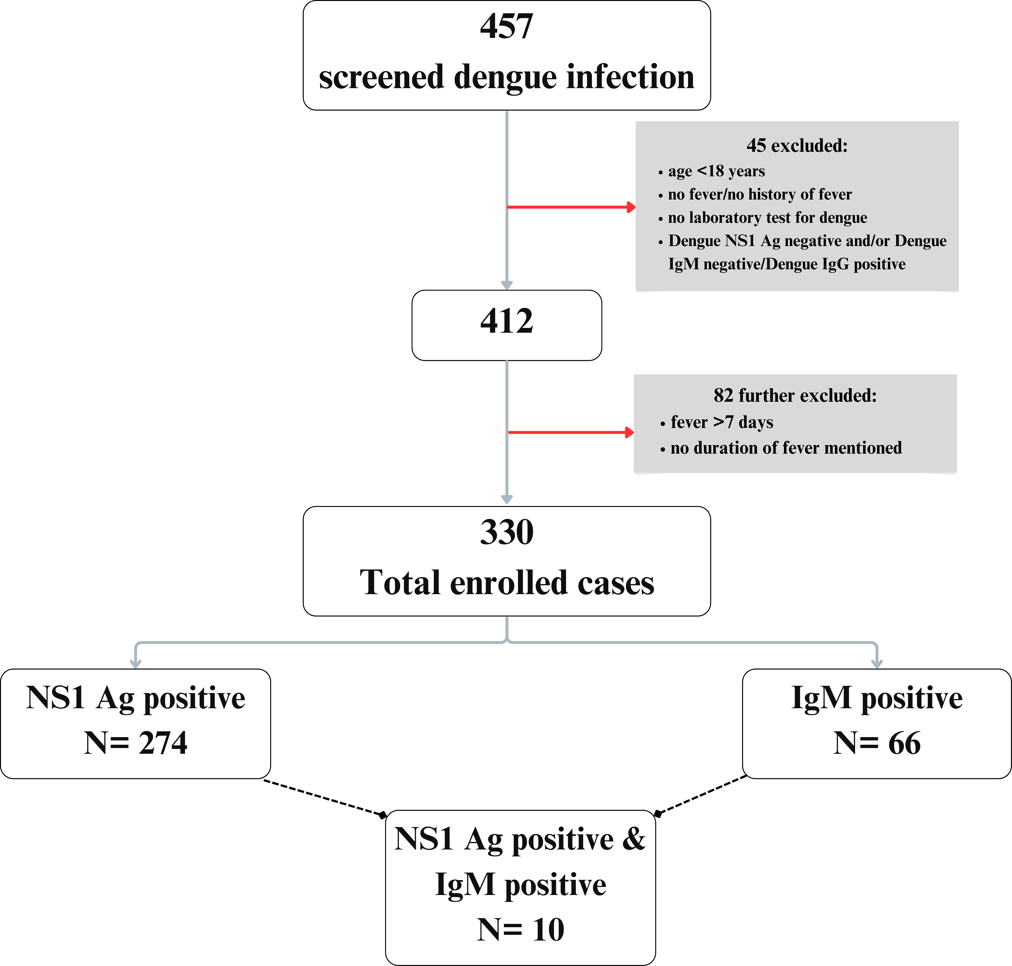
Figure A1: Schematic for enrolment of subjects
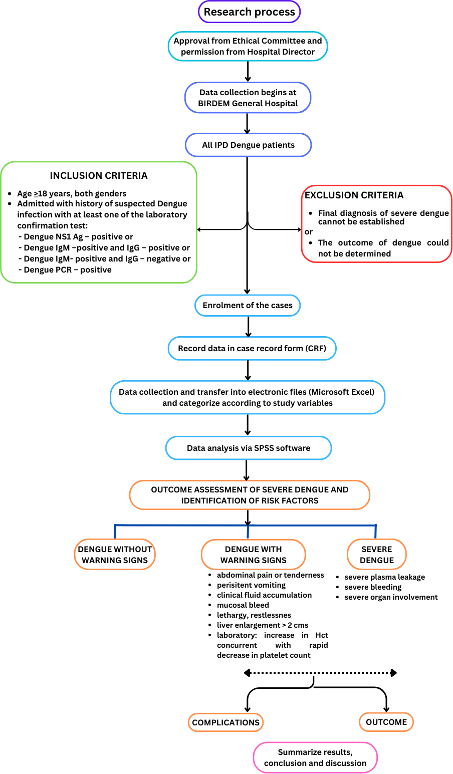
Figure A2: Schematic of study design.

