Supporting Information
Printable Newtonian fluid photocatalysts for scale-up solar CO₂ conversion

Ziyang Lu, Yu Cheng, Yangrui Xu, Liguang Tang, Hongping Li, Tianhua Zhou, Kan Zhang, Weidong Shi

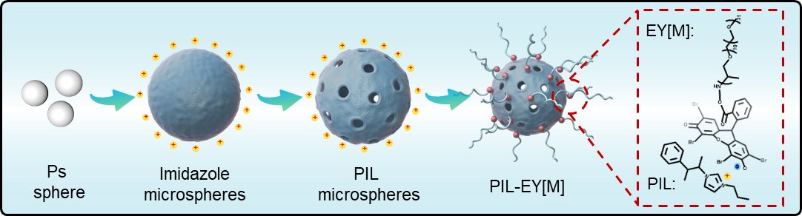
Fig.S1 The preparation process of PIL-EY[M].

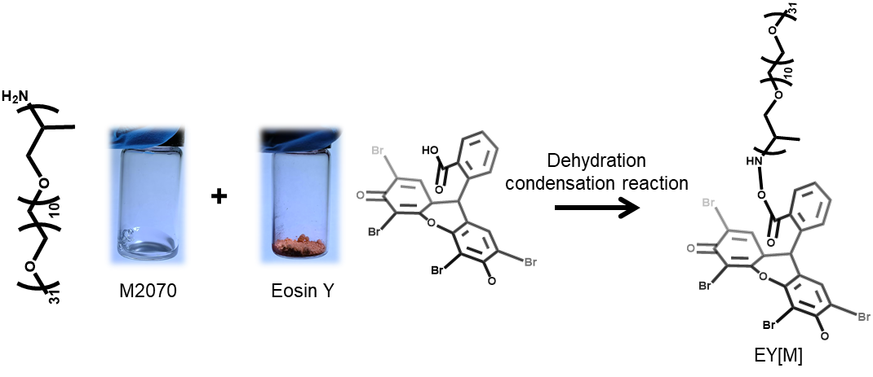
Fig.S2 The preparation process of EY[M] by dehydration condensation reaction.

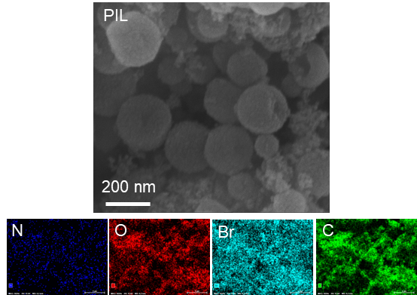
Fig.S3 Search Engine Marketing (SEM) and mapping images of PIL.
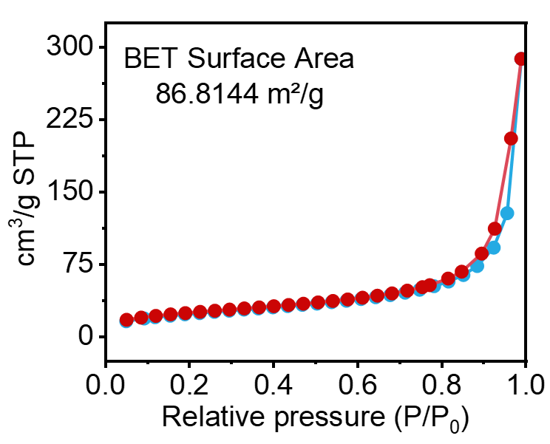
Fig.S4 N₂ adsorption-desorption isotherms of PIL.
The PIL hollow sphere has a large specific surface area (86.81 m²/g), and the isotherm is the typical type I, indicating that the PIL has a multi-microporous structure (aperture < 2 nm), which prevents the liquid end of the large volume and long chain from entering the cavity interior.

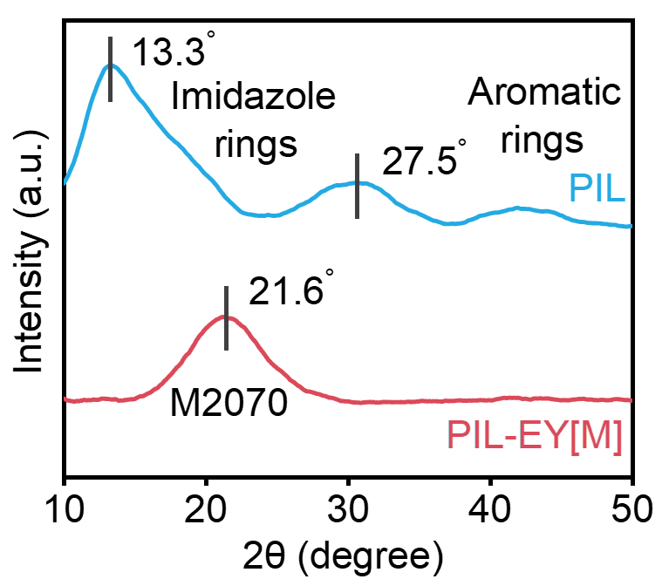
Fig.S5 The X-ray diffraction (XRD) pattern of PIL and PIL-EY[M].

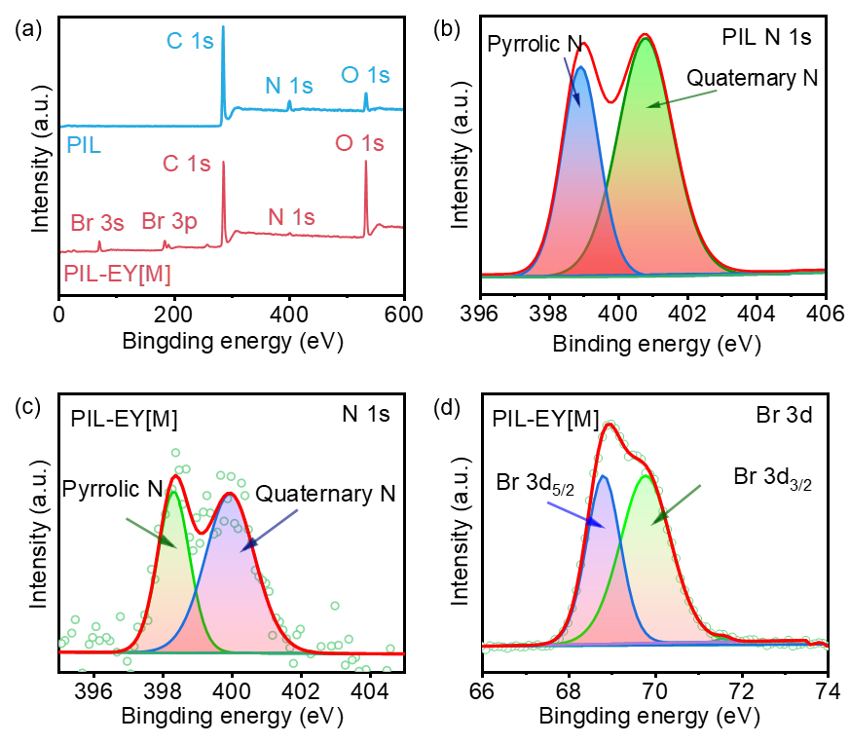
Fig.S6 The X-ray photoelectron spectroscopy (XPS) of PIL and PIL-EY[M].
In addition, the N1s XPS spectra of PIL and PIL-EY[M] showed two peaks at 400.8 eV and 398.9 eV, respectively attributed to the quaternary and pyrrole N of PIL, while the peaks corresponding to Br 3d3/2 and Br 3d5/2 of EY were located at 68.9 eV and 70.4 eV, respectively.

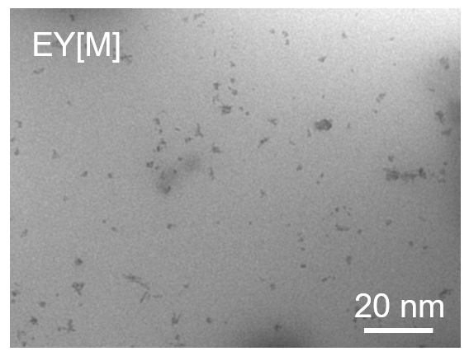
Fig.S7 The TEM image of EY[M].

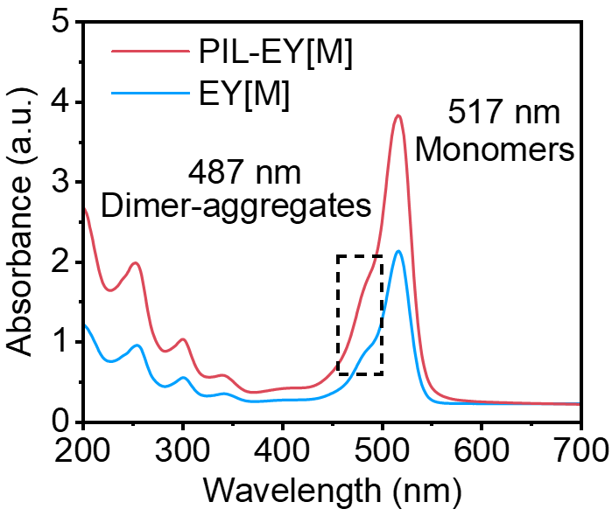
Fig.S8 The UV–Visible absorption spectra of EY[M].
The UV–Visible absorption spectra of EY[M] show peaks at 517 and 487 nm, indicating that the nanoclusters are formed by monomers and aggregates of EY.

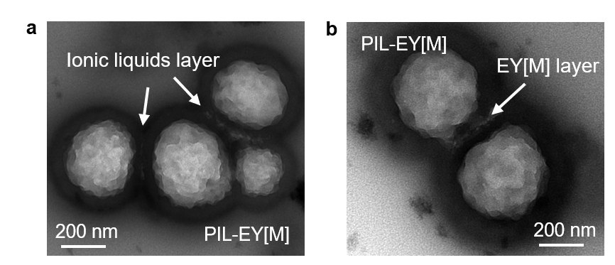
Fig.S9 TEM images of PIL-EY[M].

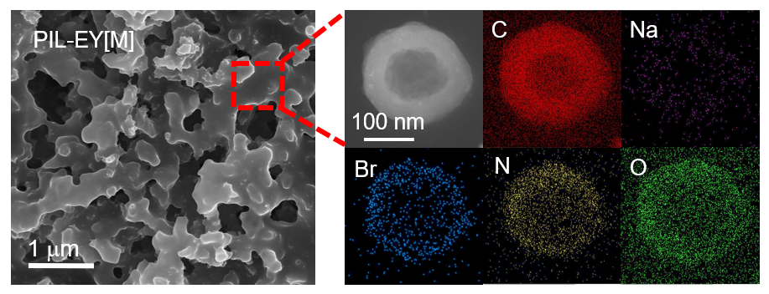
Fig.S10 SEM and high-resolution TEM mapping images of PIL-EY[M].
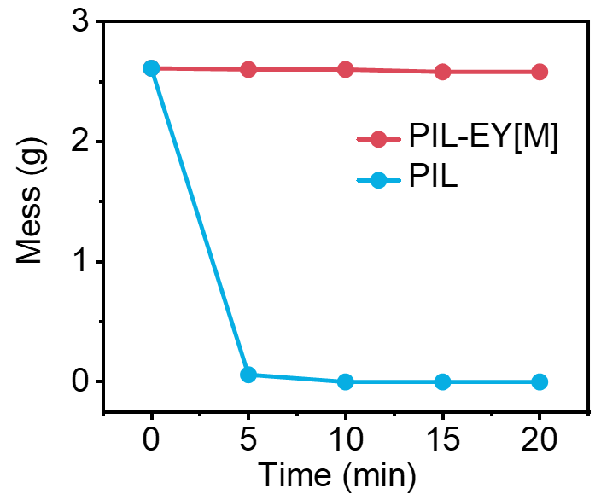
Fig.S11 The photocatalysts mess in a simulated open environment with a 18m/s wind speed.

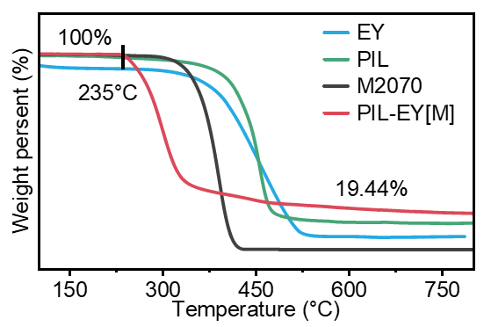
Fig.S12 The thermogravimetric analysis (TGA) of samples.

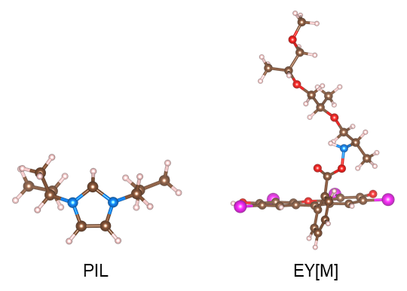
Fig.S13 The DFT calculations model of PIL and EY[M].

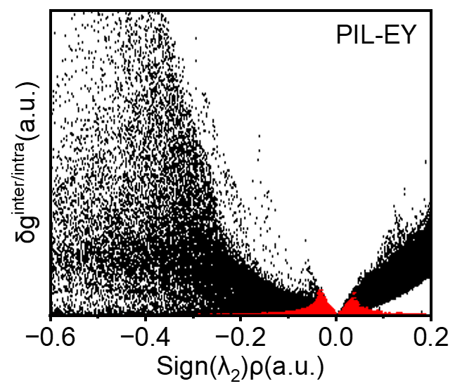
Fig.S14 The IGM analysis of PIL and EY[M].

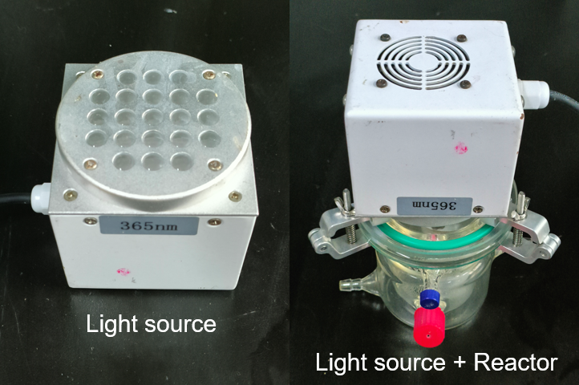
Fig.S15 The light source information of photocatalytic CO₂ reduction.

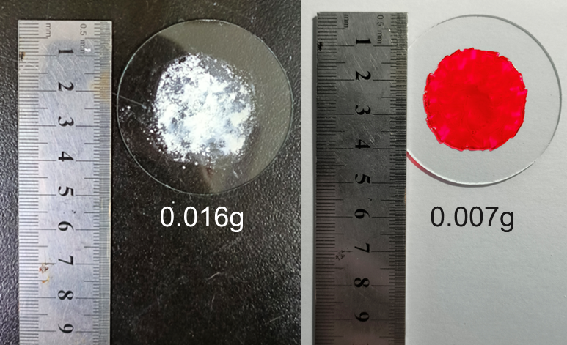
Fig.S16 The PIL and PIL-EY[M] were coated on the surface of the carrier.
Significantly, uniform dispersion on a 1m² carrier requires the consumption of 5.66g PIL. However, the PIL has a large specific surface area and cavity structure. In comparison, 5.66g of nano-liquid photocatalysts can be evenly applied on a 2.28 m² carrier, which is less than other commonly used powder photocatalysts, greatly saving catalyst usage costs.

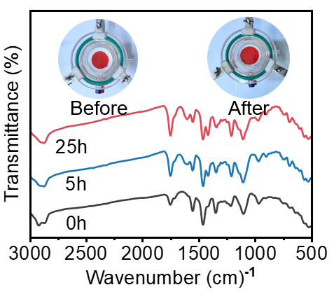
Fig.S17 The FT-IR spectroscopy of PIL-EY[M] before and after CO₂ reduction.

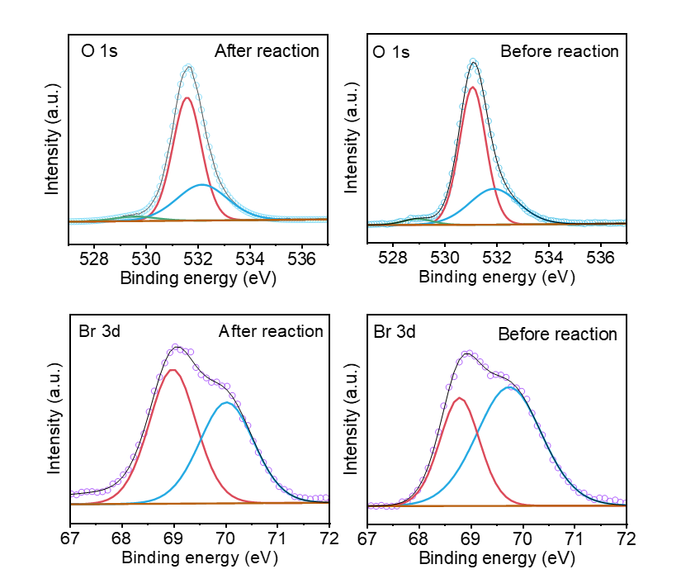
Fig.S18 The XRD spectroscopy of PIL-EY[M] before and after CO₂ reduction.

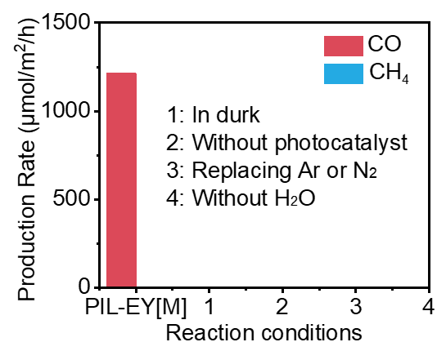
Fig.S19 The CO₂ reduction control experiment in different reaction conditions.

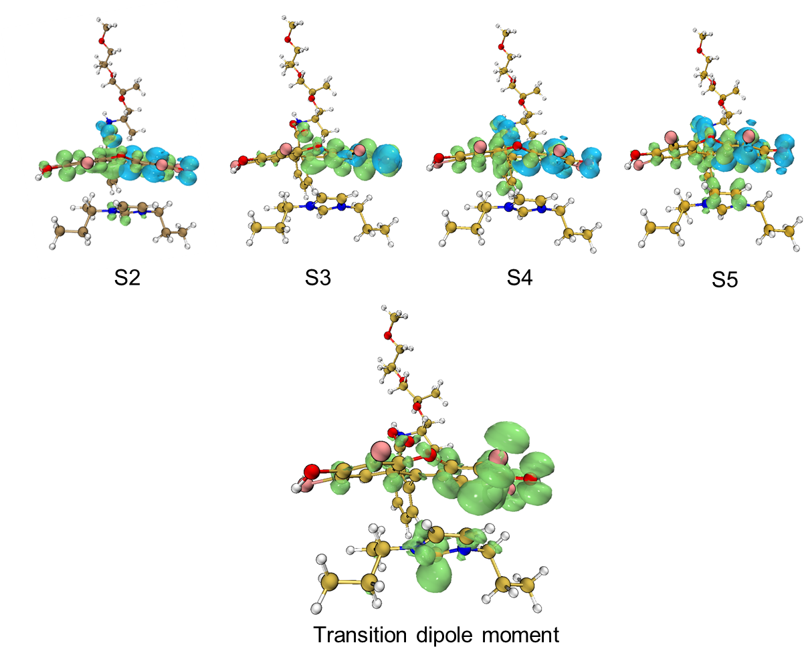
Fig.S20 The TDDFT calculations on the optimized structure of PIL-EY[M].
The electron-hole distribution of the five lowest energy excited states of PIL-EY [M] was calculated using TDDFT. Among them, S2, S3, and S4 have shorter charge transfer distances for local excitation, while S1 and S5 have longer electron-hole center distances for charge transfer excitation.

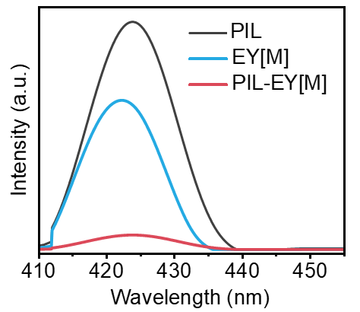
Fig.S21 The PL spectrum of PIL, EY[M] and PIL-EY[M].

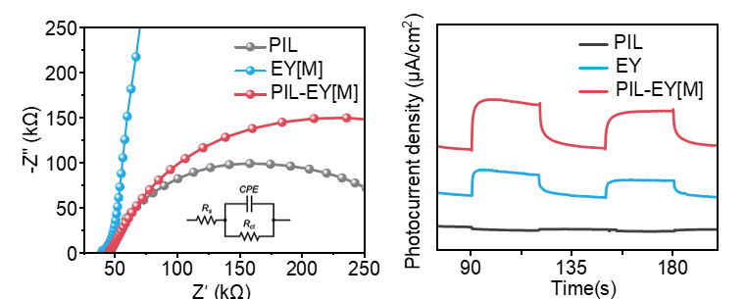
Fig.S22 The electrochemical properties of PIL, EY[M] and PIL-EY[M].

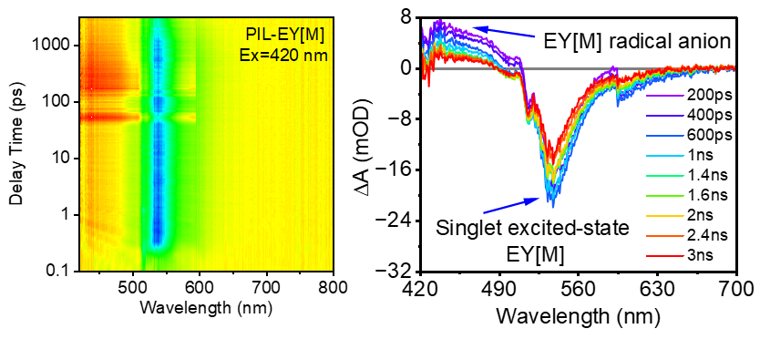
Fig.S23 The TAS spectroscopy of PIL-EY[M].

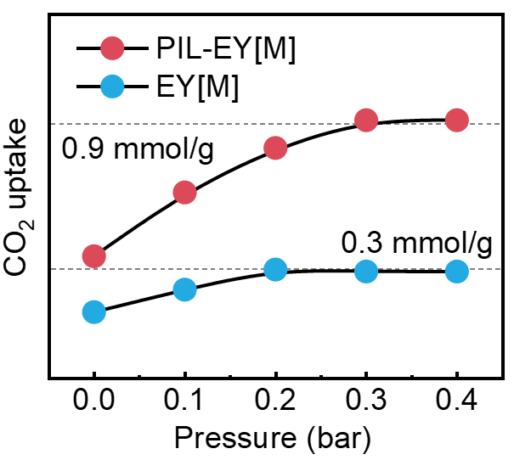
Fig.S24 CO₂ uptake experiment of EY[M] and PIL-EY[M].

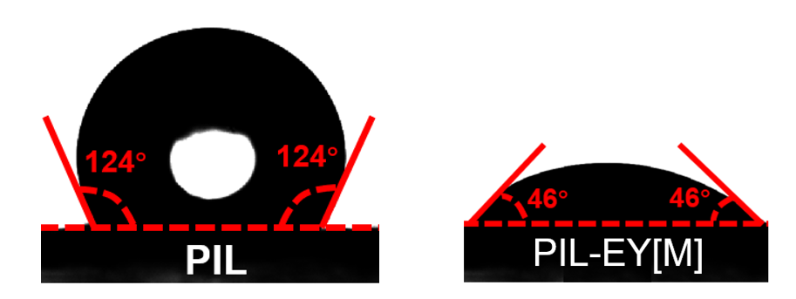
Fig.S25 Water contact angle of PIL and PIL-EY[M].

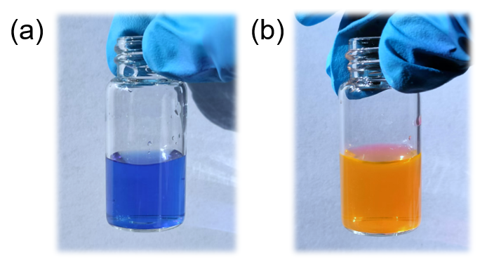
Fig.S26 (a) The thymolphthalein in aqueous solutions. (b) the PIL-EY[M] solutions.

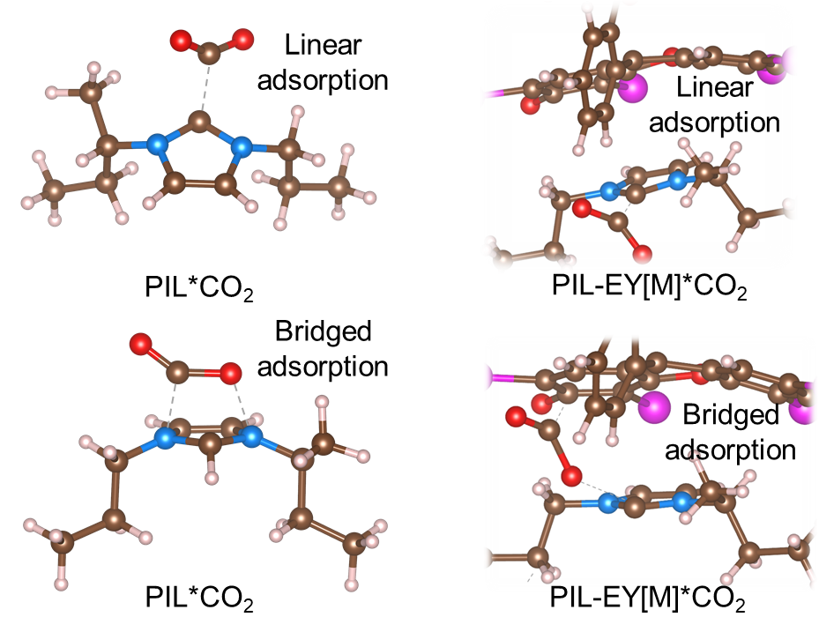
Fig.S27 The bridged and linear adsorption model of PIL and PIL-EY[M].

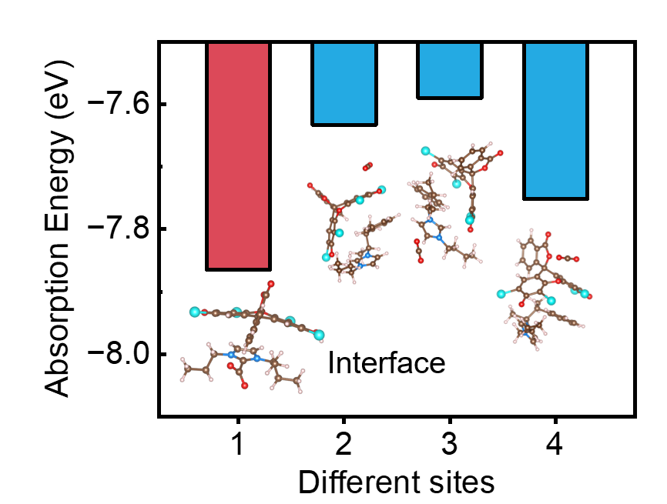
Fig.S28 The adsorption energy of CO₂ in different sites.

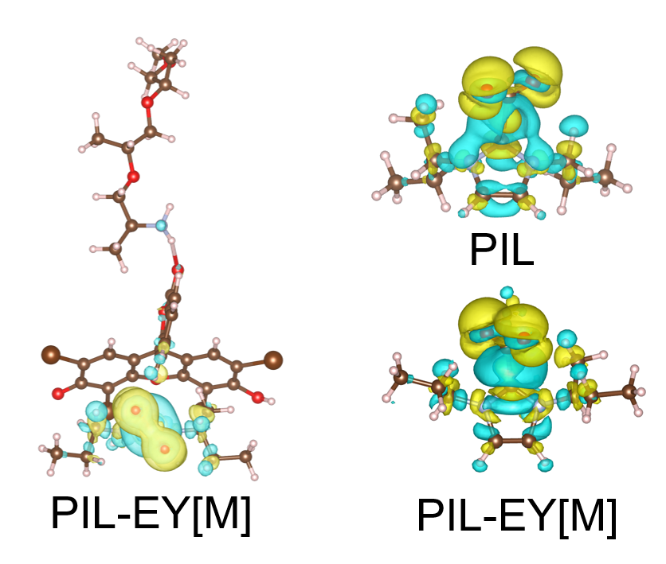
Fig.S29 The differential charge calculations of PIL and PIL-EY[M].
After the adsorption of CO₂ by PIL and PIL-EY[M], under the same adsorption mode (linear adsorption), the volume of electron accumulation (yellow) and depletion (blue) of CO₂ at the imidazole sites of PIL-EY[M] is larger than that of PIL, indicating that the sites have more electron transfer capacity for CO₂ and are more conducive to CO₂ conversion.

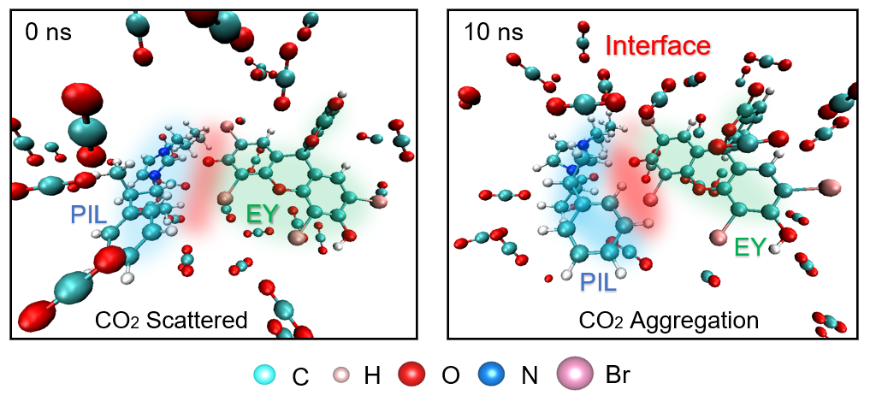
Fig.S30 The CO₂ adsorption kinetics of the interface between PIL and EY.
Saturated CO₂ molecules are randomly placed into the reaction system to simulate the catalytic environment. 10000 times of kinetic adsorption were simulated, each calculation was set at 1ps, and the adsorption environment changes were recorded at each 1ps. When the simulation was carried out to 10 ns, it was found that the overall energy tended to be balanced, and the scattered CO₂ molecules tended to approach the PIL and EY[M] interface.

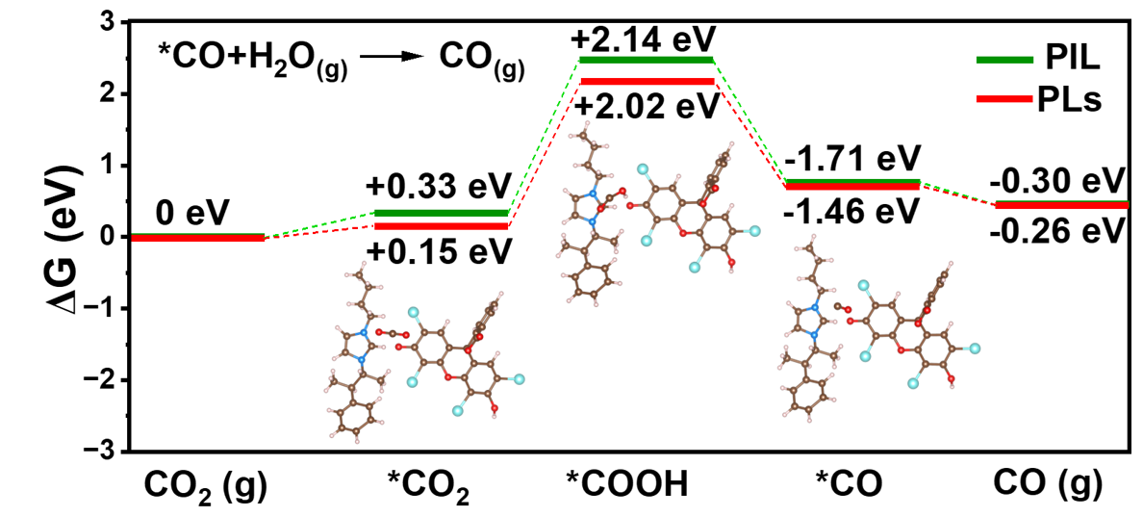
Fig.S31 The Gibbs free energy barriers of PIL and PIL-EY[M].
As shown in Figure, the PIL-EY[M]*CO₂ has a smaller energy barrier than PIL*CO₂, indicating that the solid-liquid interface is more conducive to the adsorption and activation of CO₂. Additionally, the generation energy barrier of *COOH is 2.17 eV, which is smaller than that of PIL. The decrease in the generation barrier indicates that the solid-liquid interface facilitates dynamic charge transfer between the EY adsorption sites and the imidazole reaction sites on the conjugated plane.

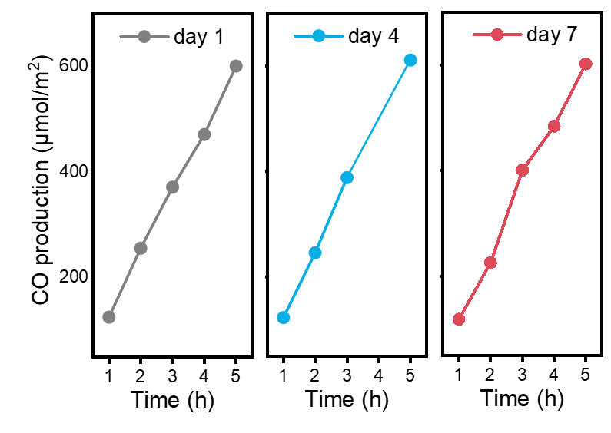
Fig.S32 Continuous experiment for one week in 36L square glass reactor

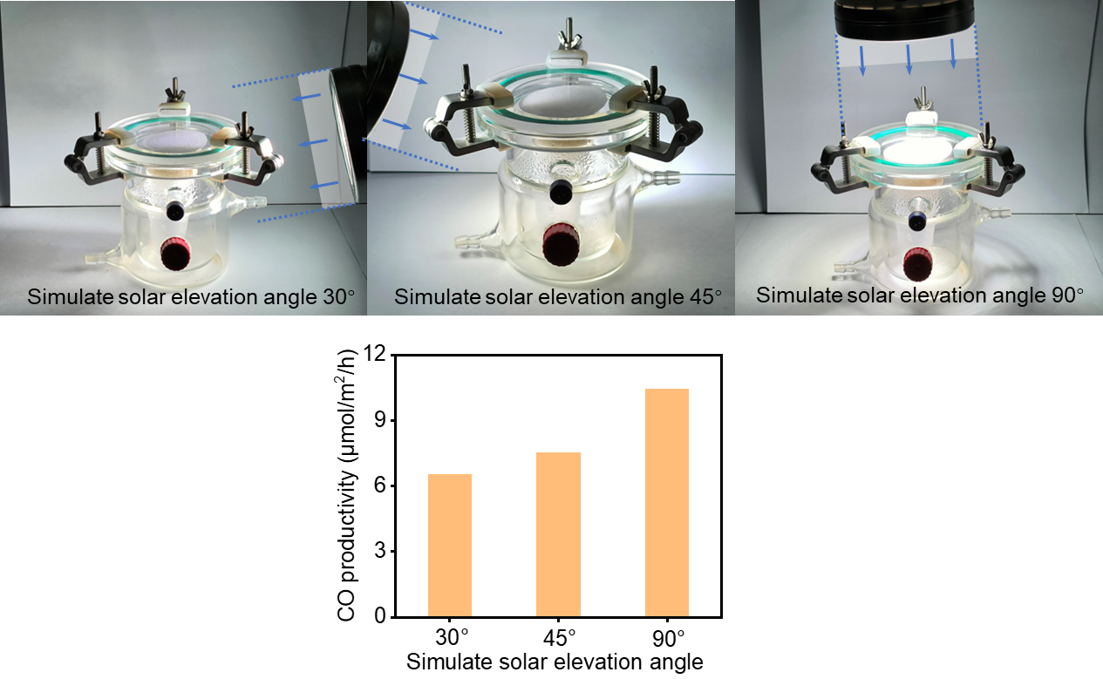
Fig.S33 The performance of PIL in the variation in simulated solar elevation angle alters.

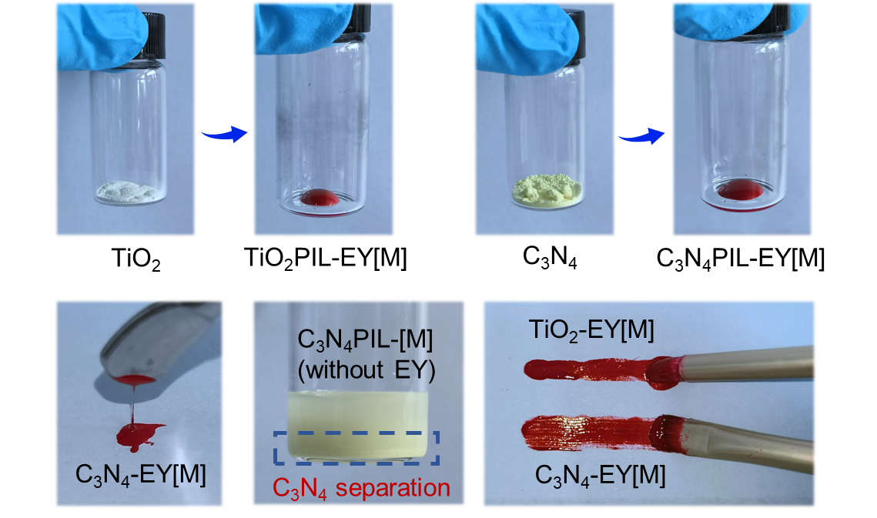
Fig.S34 The Optical image of TiO₂PIL-EY[M] and C₃N₄PIL-EY[M].

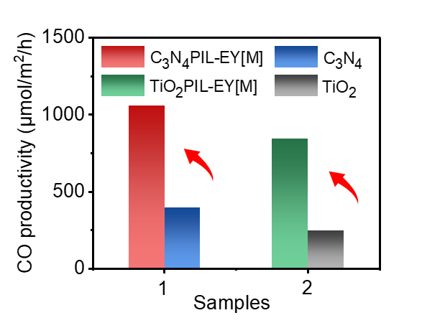
Fig.S35 The CO productivity of TiO₂PIL-EY[M] and C₃N₄PIL-EY[M].

Tab.S1 The Zeta potential measure results of PIL and EY[M].
Samples | T | ZP | Mob | Cond
PIL | 25℃ | +32.6 mV | 2.556 μm cm/Vs | 0.0172 mS/cm
PIL | 25℃ | +31.7 mV | 2.488 μm cm/Vs | 0.0127 mS/cm
PIL | 25℃ | +32.8 mV | 2.575 μm cm/Vs | 0.0128 mS/cm

Samples | T | ZP | Mob | Cond
EY[M] | 25℃ | -32.5 mV | -2.545 μm cm/Vs | 0.0226 mS/cm
EY[M] | 25℃ | -32.3 mV | -2.529 μm cm/Vs | 0.0220 mS/cm
EY[M] | 25℃ | -31.7 mV | -2.486 μm cm/Vs | 0.0268 mS/cm

Tab.S2 Comparison of performance increased multiplier factors between PIL-EY[M] and similar imidazole photocatalysts and ionic composite photocatalysts.
Samples |  | Properties | Increased multiplier | Ref.
PIL |  | 1228.7 μmol/h/m² | 57.8 times | This work
Comparison of Imidazole Photocatalysts | ZIF-67/DCD/Ru | 189.9 μmol/h/m² | 12.2 times | ¹
Comparison of Imidazole Photocatalysts | SmL | 0.7 mmol | 5.5 times | ²
Comparison of Imidazole Photocatalysts | TiO₂/NiIP-NSs | 54.9 mmol/g/h | 4.3 times | ³
Comparison of Imidazole Photocatalysts | Ni-TCPP-TPyP | 309.3 μmol/g/h | 11.1 times | ⁴
Comparison of Imidazole Photocatalysts | 3DOM Co-SNS | 347.3 μmol/h | 8.0 times | ⁵
Comparison of Imidazole Photocatalysts | PFC-73-Ni/Cu/Zn | 14.7 μmol/g/h | 1.5 times | ⁶
Comparison of Imidazole Photocatalysts | 3DOM Ag₂S-CoOx/NC | 66.0 μmol/g/h | 1.8 times | ⁷
Comparison of ion composite photocatalysts | Cu/a-In₂O₃ NSs | 798.7 μmol/g/h | 5.8 times | ⁸
Comparison of ion composite photocatalysts | TiO₂/CsPbBr₃ | 23.9 μmol/g/h | 1.8 times | ⁹
Comparison of ion composite photocatalysts | ZnSe-CsSnCl₃ | 57 μmol/g/h | 5.0 times | ¹⁰
Comparison of ion composite photocatalysts | [Co(qpy)(OH₂)₂]²⁺ | 11.6 μmol | 13.0 times | ¹¹
Comparison of ion composite photocatalysts | [Fe(qpy)(OH₂)₂](ClO₄)₂ | 62.5 μmol | 7.4 times | ¹²
Comparison of ion composite photocatalysts | PRGO/TP-COF | 48.8 μmol/g | 1.7 times | ¹³
Comparison of ion composite photocatalysts | IL/Co-bCN | 20.6 μmol/g/h | 42.0 times | ¹⁴

Tab.S3 Comparison of performance increased multiplier factors between PIL-EY[M] and different types of photocatalysts.
Prinstin  materials | Modified materials | Improvement approach | Catalytic methods | Selectivity | Increased multiplier | Ref.
PIL | PIL-EY[M] | Nano-liquid | Photocatalysts | 100% | 57.8 times | This work
Ru/MnOx | Ru/(TiOx)MnO | Oxide surface patches | Selective hydrogenation catalysts | / | 3.3 times | ¹⁵
Planar-Cu | Cu-DAC | Atomic-level Cu active sites | Electroreduction | / | ~2.3 times | ¹⁶
Cu_{CO} | Cu_{CO2} | Distinct Cu sites | Electroreduction | / | 6.0 times | ¹⁷
MnO_{x} | Ru/MnO_{x} | Metal-support interaction | Photo-thermal coupling | 99.5% | 29.0 times | ¹⁸
PCN-250-Fe2Co | ILs@MOFs | New type of host-guest | Photocatalysts | 100% | 25.5 times | ¹⁹
Ag/TiO₂ | Cu-Ag/TiO₂ | Cu–Ag alloy synergistic effect | Photocatalysts | 49.1 | ~40.0 times | ²⁰
CuIn₅S₈ | V_{S}-CuIn₅S₈ | Cu–In dual sites | Photocatalysts | 100% | 5.4 times | ²¹
Cu-HITP + [Ru(phen)₃] ²⁺, | Ru@Cu-HHTP | Electrostatic Attraction-Driven | Photocatalysts | CO | 13.1 times | ²²
CMP-nBr | CMP-nTB | Intramolecular Electric Field | Photocatalysts | 85.7 | 9.2 times | ²³
COF-5 | LaNi-Phen/COF-5 | La-Ni bimetallic sites | Photocatalysts | 98.2 | 15.2 times | ²⁴
Ni²⁺ without CB | CB[7]:Ni 1:4 | Engineering Single Ni Sites | Photocatalysts | 97.9 | 12.1 times | ²⁵
p-CSON | c-CSON | Accessing parity-forbidden d-d transitions | Photocatalysts | 84.23 | 1.2 times | ²⁶
CCH | Cu-CCH | Dual Jahn–Teller Sites | Photocatalysts | 92.62 | 4.2 times | ²⁷
BFO | BFO-SF40 | Strain Engineering | Photocatalysts | 100 | 12.8 times | ²⁸

Reference
1. Dai, F., et al. Highly efficient CO₂ photoreduction by ultralow-Ru-Loading ZIF-67. Appl. Catal., B 336, 122934 (2023).
2. Bhimpuria, R., Tomar, M., Thapper, A., Ahlquist, M.&Borbas, K. E. Photocatalytic product-selective reduction of CO₂, CO, and carbonates. Chem, 10.1016/j.chempr.2025.102450.
3. Wu, C., et al. Highly Efficient Photocatalytic CO₂-to-CO on Ni-Based Cationic Polymer with TiO₂-Assisted Exfoliation and Stabilization. Angew. Chem., Int. Ed. 64, e202423200 (2025).
4. Zhang, Y., et al. Precisely Constructing Molecular Junctions in Hydrogen-Bonded Organic Frameworks for Efficient Artificial Photosynthetic CO₂ Reduction. Angew. Chem., Int. Ed. 63, e202413131 (2024).
5. Lyu, W., Liu, Y., Chen, D., Wang, F.&Li, Y. Engineering the electron localization of metal sites on nanosheets assembled periodic macropores for CO₂ photoreduction. Nat. Commun. 15, 10589 (2024).
6. Yin, Q., et al. Metallization-Prompted Robust Porphyrin-Based Hydrogen-Bonded Organic Frameworks for Photocatalytic CO₂ Reduction. Angew. Chem., Int. Ed. 61, e202115854 (2022).
7. Mo, S., et al. Hierarchically ordered microporous Ag₂S QDs-CoOx/NC nanostructures for enhancing photocatalytic CO₂ reduction to chemical fuels. Fuel 358, 130113 (2024).
8. Pan, R., et al. Amorphization-Induced Cation Exchange in Indium Oxide Nanosheets for CO₂-to-Ethanol Conversion. Nano Lett. 23, 10004-10012 (2023).
9. Xu, F., et al. Unique S-scheme heterojunctions in self-assembled TiO₂/CsPbBr₃ hybrids for CO₂ photoreduction. Nat. Commun. 11, 4613 (2020).
10. Li, N., et al. ZnSe Nanorods–CsSnCl₃ Perovskite Heterojunction Composite for Photocatalytic CO₂ Reduction. ACS Nano 16, 3332-3340 (2022).
11. Ho, P.-Y., et al. Light-Driven Reduction of CO₂ to CO in Water with a Cobalt Molecular Catalyst and an Organic Sensitizer. ACS Catal. 13, 5979-5985 (2023).
12. Wang, J.-W., et al. Homoleptic Al(III) Photosensitizers for Durable CO₂ Photoreduction. J. Am. Chem. Soc 145, 676-688 (2023).
13. Liu, Y., Wang, Y., Shang, J., Peng, J.&Zhu, T. Construction of a novel metal-free heterostructure photocatalyst PRGO/TP-COF for enhanced photocatalytic CO₂ reduction. Appl. Catal. B Environ. 350, 123937 (2024).
14. Liu, Y., et al. Improving CO₂ photoconversion with ionic liquid and Co single atoms. Nat. Commun. 14, 1457 (2023).
15. Kang, H., et al. Generation of oxide surface patches promoting H-spillover in Ru/(TiOx)MnO catalysts enables CO₂ reduction to CO. Nat. Catal. 6, 1062-1072 (2023).
16. Fan, L., et al. Atomic-level Cu active sites enable energy-efficient CO₂ electroreduction to multicarbon products in strong acid. Nat. Synth. 4, 262-270 (2025).
17. Gao, W., Xu, Y., Fu, L., Chang, X.&Xu, B. Experimental evidence of distinct sites for CO₂-to-CO and CO conversion on Cu in the electrochemical CO₂ reduction reaction. Nat. Catal. 6, 885-894 (2023).
18. Zhai, J., et al. Photo-thermal coupling to enhance CO₂ hydrogenation toward CH₄ over Ru/MnO/Mn₃O₄. Nat. Commun. 15, 1109 (2024).
19. Wang, Y., et al. Artificial photosynthetic system for diluted CO₂ reduction in gas-solid phase. Nat. Commun. 15, 8818 (2024).
20. Yu, Y., He, Y., Yan, P., Wang, S.&Dong, F. Boosted C–C coupling with Cu–Ag alloy sub-nanoclusters for CO₂-to-C₂H₄ photosynthesis. Proc. Natl. Acad. Sci. U. S. A. 120, e2307320120 (2023).
21. Li, X., et al. Selective visible-light-driven photocatalytic CO₂ reduction to CH₄ mediated by atomically thin CuIn₅S₈ layers. Nat. Energy 4, 690-699 (2019).
22. Huang, N.-Y., et al. Electrostatic Attraction-Driven Assembly of a Metal–Organic Framework with a Photosensitizer Boosts Photocatalytic CO₂ Reduction to CO. J. Am. Chem. Soc 143, 17424-17430 (2021).
23. Tang, Z., et al. Reaction Site Designation by Intramolecular Electric Field in Tröger's-Base-Derived Conjugated Microporous Polymer for Near-Unity Selectivity of CO₂ Photoconversion. Adv. Mater. 35, 2210693 (2023).
24. Zhou, M., et al. Photocatalytic CO₂ reduction using La-Ni bimetallic sites within a covalent organic framework. Nat. Commun. 14, 2473 (2023).
25. Wang, J., et al. Engineering Single Ni Sites on 3D Cage-like Cucurbit[n]uril Ligands for Efficient and Selective CO₂ Photocatalytic Reduction. Angew. Chem., Int. Ed. 64, e202417384 (2025).
26. Li, X., et al. Accessing parity-forbidden d-d transitions for photocatalytic CO₂ reduction driven by infrared light. Nat. Commun. 14, 4034 (2023).
27. Liu, H., et al. Construction of Asymmetrical Dual Jahn–Teller Sites for Photocatalytic CO₂ Reduction. Angew. Chem., Int. Ed. 62, e202304562 (2023).
28. Zhou, G., et al. Enhancing d/p-2π* Orbitals Hybridization via Strain Engineering for Efficient CO₂ Photoreduction. Angew. Chem., Int. Ed. 63, e202411794 (2024).

