Supplemental Materials
Results

Specific Measure | F-statistic (1, 29) | p-value | Effect Size  (η²_{p}; η²_{G}; Cohen’s d) | Bonferroni Corrected p-value
HR Time Effect | 0.067 | 0.798 | 0.002; 1.21x10⁻⁴ | N/A
HR Condition Effect | 0.284 | 0.598 | 0.01; 0.009 | N/A
HR Time × Condition | 0.5184 | 0.447 | 0.018; 8.661x10⁻⁴ | N/A
HRV Time Effect | 0.257 | 0.616 | 0.009; 0.001 | N/A
HRV Condition Effect | 3.14 | 0.087 | 0.098; 0.083 | N/A
HRV Time × Condition | 0.117 | 0.735 | 0.004; 6.423x10⁻⁴ | N/A

Supplemental Table 1. Physiology changes pre- to post-intervention
For HR, no significant main effect of time (F(1, 29) = 0.067, p = 0.798, η²_{p} = 0.002) or significant interaction between time and group (F(1, 29) = 0.5184, p = 0.447, η²_{p} = 0.018) were observed. Additionally, the two groups were not significantly different overall (F(1, 29) = 0.284, p = 0.598, η²_{p} = 0.01). For HRV, no significant main effect of time (F(1, 29) = 0.257, p = 0.616, η²_{p} = 0.009) or significant interaction between time and group (F(1, 29) = 0.117, p = 0.735, η²_{p} = 0.004) were observed. Additionally, the two groups were not significantly different overall (F(1, 29) = 3.14, p = 0.087, η²_{p} = 0.098). The two groups showed no statistical difference in post-rest HR (t(29) = -0.665, p = 0.511, d = -0.24) or post-rest HRV (t(29) = 1.81, p = 0.08, d = 0.655.

Measure | F-statistic (1, 64) | p-value | Effect Size  (η²_{G}; Cohen’s d*) | Bonferroni Corrected p-value
Alpha Time Effect | 0.102 | 0.750 | 3.915x10⁻⁵ | N/A
Alpha Condition Effect | 4.151 | 0.046 | 0.060; 0.496 [95% CI, 0.002 – 0.989] | 0.82
Alpha Time x Condition Effect | 0.156 | 0.69 | 5.9 x 10⁻⁵ | N/A
Theta Time Effect | 0.451 | 0.505 | 2.8 x 10⁻⁴ | N/A
Theta Condition Effect | 1.95 | 0.167 | 0.028 | N/A
Theta Time x Condition Effect | 0.164 | 0.687 | 1.02 x 10⁻⁴ | N/A
Supplemental Table 2. EEG power band changes pre- to post-intervention.
Analysis of EEG band powers revealed marginally significant differences in post-rest alpha power (t(64) = 2.08, p = 0.044, d = 0.50 [95% CI, 0.0091 – 0.9895]), however, this did not survive Bonferroni correction (p_{bonf} = 0.26). There was also no significant difference in post-rest theta power between groups was found (t(64) = 1.42, p = 0.169, d = 0.34 [95% CI, -0.144 – 0.829]).

Looking at EEG band power ratios, significant differences in post-rest alpha power, alpha/beta power, and gamma/alpha power were found between the two groups. The analysis revealed a significant difference in post-rest alpha power (t(64) = 2.08, p = 0.044, d = 0.50 [95% CI, 0.009 – 0.989]) and alpha/beta power (t(64) = 2.12, p = 0.041, d = 0.51 [95% CI, 0.018 – 0.999]). The two groups also showed a significant difference in gamma/alpha power (t(64) = -2.51, p = 0.017, d = -0.6 [95% CI, -1.094 – -0.1069]). However, these differences did not survive Bonferroni correction (p_{Bonf} = 0.26, 0.24, and 0.10, respectively). No significant differences were observed in theta power (t(64) = 1.42, p = 0.169, d = 0.34 [95% CI, -0.144 – 0.829]), theta/beta power (t(64) = 0.26, p = 0.79, d = 0.064 [95% CI, -0.419 – 0.5467]), or (alpha+theta)/(beta+gamma) power (t(64) = -0.025, p = 0.98, d = -0.006 [95% CI, -0.489 – 0.476]). See Supplementary Materials: Table 3.

Measure | t-statistic | p-value | Effect size (Cohen’s d) | Bonferroni Corrected p-value
Heart Rate (HR) | t(29) = -0.665 | 0.511 | -0.24 | 0.57
Heart Rate Variability (HRV) | t(29) = 1.81 | 0.08 | 0.66 | 0.20
Alpha Power | t(64) = 2.08 | p = 0.044 | 0.50 [95% CI, 0.0091 – 0.9895] | 0.26
Theta Power | t(64) = 1.42 | p = 0.169 | 0.34 [95% CI, -0.144 – 0.829] | 0.97
Alpha/Beta Power | t(64) = 2.12 | p = 0.041 | 0.51 [95% CI, 0.018 – 0.999] | 0.24
Theta/Beta Power | t(64) =0.26 | p = 0.79 | 0.064 [95% CI, -0.419 – 0.5467] | 1.0
Gamma/Alpha Power | t(64) = -2.51 | p = 0.017 | -0.6 [95% CI, -1.094 – -0.1069 | 0.10
(Alpha+Theta)/(Beta/Gamma) | t(64) = -0.025 | p = 0.98 | -0.006 [95% CI, -0.489 – 0.476] | 1.0
Supplemental Table 3. Results physiological and EEG group effect analyses.

Measure | Time Effect | Group Effect | Time x Group Interaction | Key Finding
Alpha/Beta Power | F(1, 64) = 0.158, p = 0.69,  η²_{p} = 0.0025,  η²_{G} = 0.0 | F(1, 64) = 3.94,  p = 0.052,  p_{FDR} = 0.982  η²_{p} = 0.058,  η²_{G} = 0.053 | F(1, 64) = 0.553,  p = 0.459,  η²_{p} = 0.0086,  η²_{G} = 0.0001 | No significant differences
Gamma/Alpha Power | F(1, 64) = 0.2335,  p = 0.631,  η²_{p} = 0.0036,  η²_{G} = 0.0001 | F(1, 64) = 4.99,  p_{FDR} = 0.052,  η²_{p} = 0.072,  η²_{G} = 0.068 | F(1, 64) = 0.81,  p = 0.3707,  η²_{p} = 0.0125,  η²_{G} = 0.0002 | No significant differences
(Alpha+Theta)/(Beta+Gamma) | F(1, 64) = 1.44,  p = 0.235,  η²_{p} = 0.022,  η²_{G} = 0.0003 | F(1, 64) = 0.0007,  p = 0.973,  η²_{p} = 0.0,  η²_{G} = 0.0 | F(1 ,64) = 0.0503,  p = 0.823,  η²_{p} = 0.0008,  η²_{G} = 0.0 | No significant differences
Theta/Beta Power | F(1, 64) = 0.0016,  p = 0.968,  η²_{p} = 0.0,  η²_{G} = 0.0 | F(1, 64) = 0.0071,  p = 0.933,  η²_{p} = 0.0001,  η²_{G} = 0.0 | F(1, 64) = 0.808,  p = 0.372,  η²_{p} = 0.0125,  η²_{G} = 0.0002 | No significant differences
Supplemental Table 4. EEG band power ratio changes from pre- to post-intervention.

EEG Pre vs. Post
Repeated measures ANOVA were also utilized for the EEG band power and band power ratio analyses pre- and post-intervention. Alpha power had a significant difference between groups pre-post measurements (F(1, 64) = 4.15, p = 0.046, η²_{p} = 0.061). No significant main effect of time (F(1, 64) = 0.102, p = 0.750, η²_{p} = 0.002) or interaction between time and group (F(1, 64) = 0.156, p = 0.694, η²_{p} = 0.002) were found. No significant main effect of time or interaction with groups were observed for theta power.

For the power band ratios, the analysis revealed a marginally significant difference between the Alpha and Theta groups for alpha/beta power looking at pre-rest and post-rest together (F(1, 64) = 3.94, p = 0.052, η²_{p} = 0.058). No significant main effect of time or interaction with groups were observed for alpha/beta power. Similarly, for gamma/alpha power, the two groups were significantly different overall (F(1, 64) = 4.99, p = 0.029, η²_{p} = 0.072). However, no significant main effect of time or interaction with groups were observed for gamma/alpha power. Looking at (alpha+theta)/(beta+gamma) power band ratio, there were no significant main effect of time (F(1, 64) = 1.4398, p = 0.235, η²_{p} = 0.022) or interaction between time and group (F(1, 64) = 0.0503, p = 0.823, η²_{p} = 0.001). Additionally, the two groups were not significantly different overall (F(1, 64) = 6.8x10-4, p = 0.979, η²_{p} = 0.000). For anxiolytic effects in the theta/beta power band, there were no significant main effect of time (F(1, 64) = 0.0434, p = 0.836, η²_{p} = 0.001) or interaction between time and group (F(1, 64) = 0.5265, p = 0.471, η²_{p} = 0.008). Additionally, the two groups were not significantly different overall (F(1, 64) = 0.982, p = 0.326, η²_{p} = 0.015).

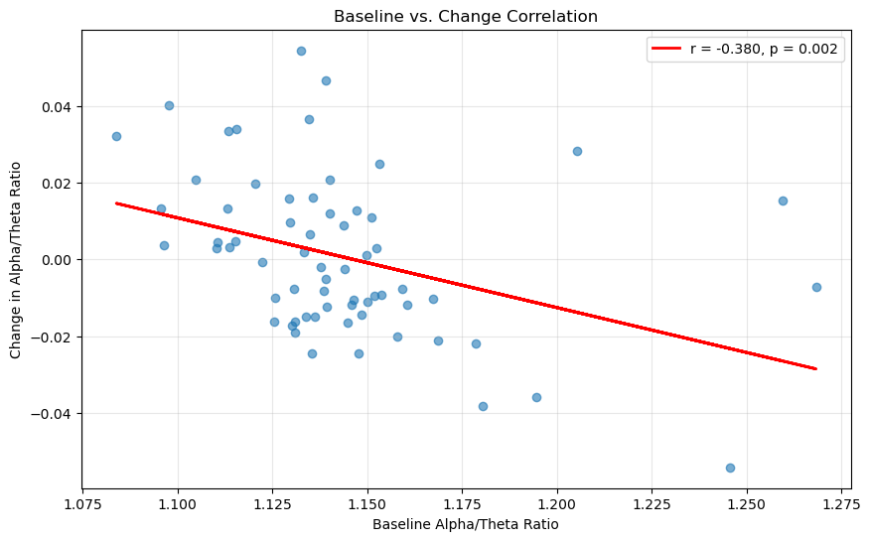
Figure 1. Baseline Alpha/Theta pre-rest vs. Change Correlation. Scatterplot shows a significant negative correlation (r = -0.380, p = 0.002) between pre-intervention alpha/theta ratios and change scores. Participants with higher baseline ratios experienced greater decreases, while those with lower baseline ratios showed greater increases, suggesting a regression-to-the-mean effect where the intervention normalizes alpha/theta ratios rather than producing uniform directional changes.

EEG Interactions
No significant EEG × condition interaction effects survived correction for multiple comparisons (all p_{FDR} > 0.05). At the uncorrected level, several interaction patterns emerged that suggested potential moderation of treatment outcomes by baseline neurophysiological state. For example, alpha/theta ratio predicted POMS Anger delta scores more strongly in the theta condition (β = -78.99, p = 0.019, R² = 17.6%) than in the alpha condition (β = -8.16, p = 0.591, R² = 0.9%), indicating that participants with higher baseline alpha/theta ratios showed greater anger reduction in the theta group. Similarly, exploratory moderation effects were observed for POMS Confusion (β = -55.689, p = 0.037, R² = 9.2%), POMS Total Mood Disturbance (β = 13.522, p = 0.039, R² = 6.9%), and POMS Vigor (β = -3.682, p = 0.045, R² = 7.2%).
However, after applying False Discovery Rate (FDR) correction, none of these effects retained statistical significance (all p_{FDR} > 0.42). Thus, these findings should be regarded as exploratory patterns rather than confirmatory evidence. While the effect sizes (R² = 6–18%) and consistency of directionality suggest possible mechanisms by which baseline alpha/theta ratios could moderate treatment response, firm conclusions cannot be drawn. Future studies with larger samples and greater power to withstand correction for multiple comparisons are needed to determine whether these preliminary patterns reflect genuine neurophysiological moderators of treatment outcomes.
To determine whether intervention effects on alpha/theta ratios reflected uniform directional changes or instead depended on participants’ initial neurophysiological state, we examined the relationship between baseline alpha/theta ratios and subsequent changes across the intervention. This analysis provides insight into whether the intervention acts as a general enhancer/suppressor of oscillatory activity or functions as a normalizing mechanism, shifting extreme values toward the group mean.
Baseline-Change Relationship correlation analysis examined the relationship between baseline alpha/theta ratios and intervention-related changes in alpha/theta ratios. The results, shown in Figure 6, revealed a significant negative correlation (r = -.38, p = 0.002, 95% CI [-.572, -.148]), indicating that participants with higher baseline alpha/theta ratios demonstrated greater decreases following the intervention, while those with lower baseline ratios showed greater increases.

This pattern suggests a regression-to-the-mean effect, where the intervention may normalize alpha/theta ratios rather than uniformly increasing them across all participants. Alpha/Theta Change and Anxiety Outcomes To examine whether changes in alpha/theta ratios were directly associated with therapeutic benefits, we analyzed the correlation between alpha/theta change scores and STAI State anxiety changes. Results showed no significant relationship (r = .087, p = .495, 95% CI [-.162, .326]), suggesting that the magnitude of alpha/theta change was not predictive of anxiety reduction. These findings indicate that baseline neurophysiological state may be more important than intervention-induced changes in predicting treatment outcomes. The lack of correlation between alpha/theta changes and anxiety improvements, combined with the regression-to-the-mean pattern, suggests that the intervention's therapeutic mechanism may involve normalizing brain states rather than producing uniform directional changes in alpha/theta ratios.

