Extended Data

Young children have limited mucosal immunity when stimulated with an influenza vaccine in tonsil organoids.

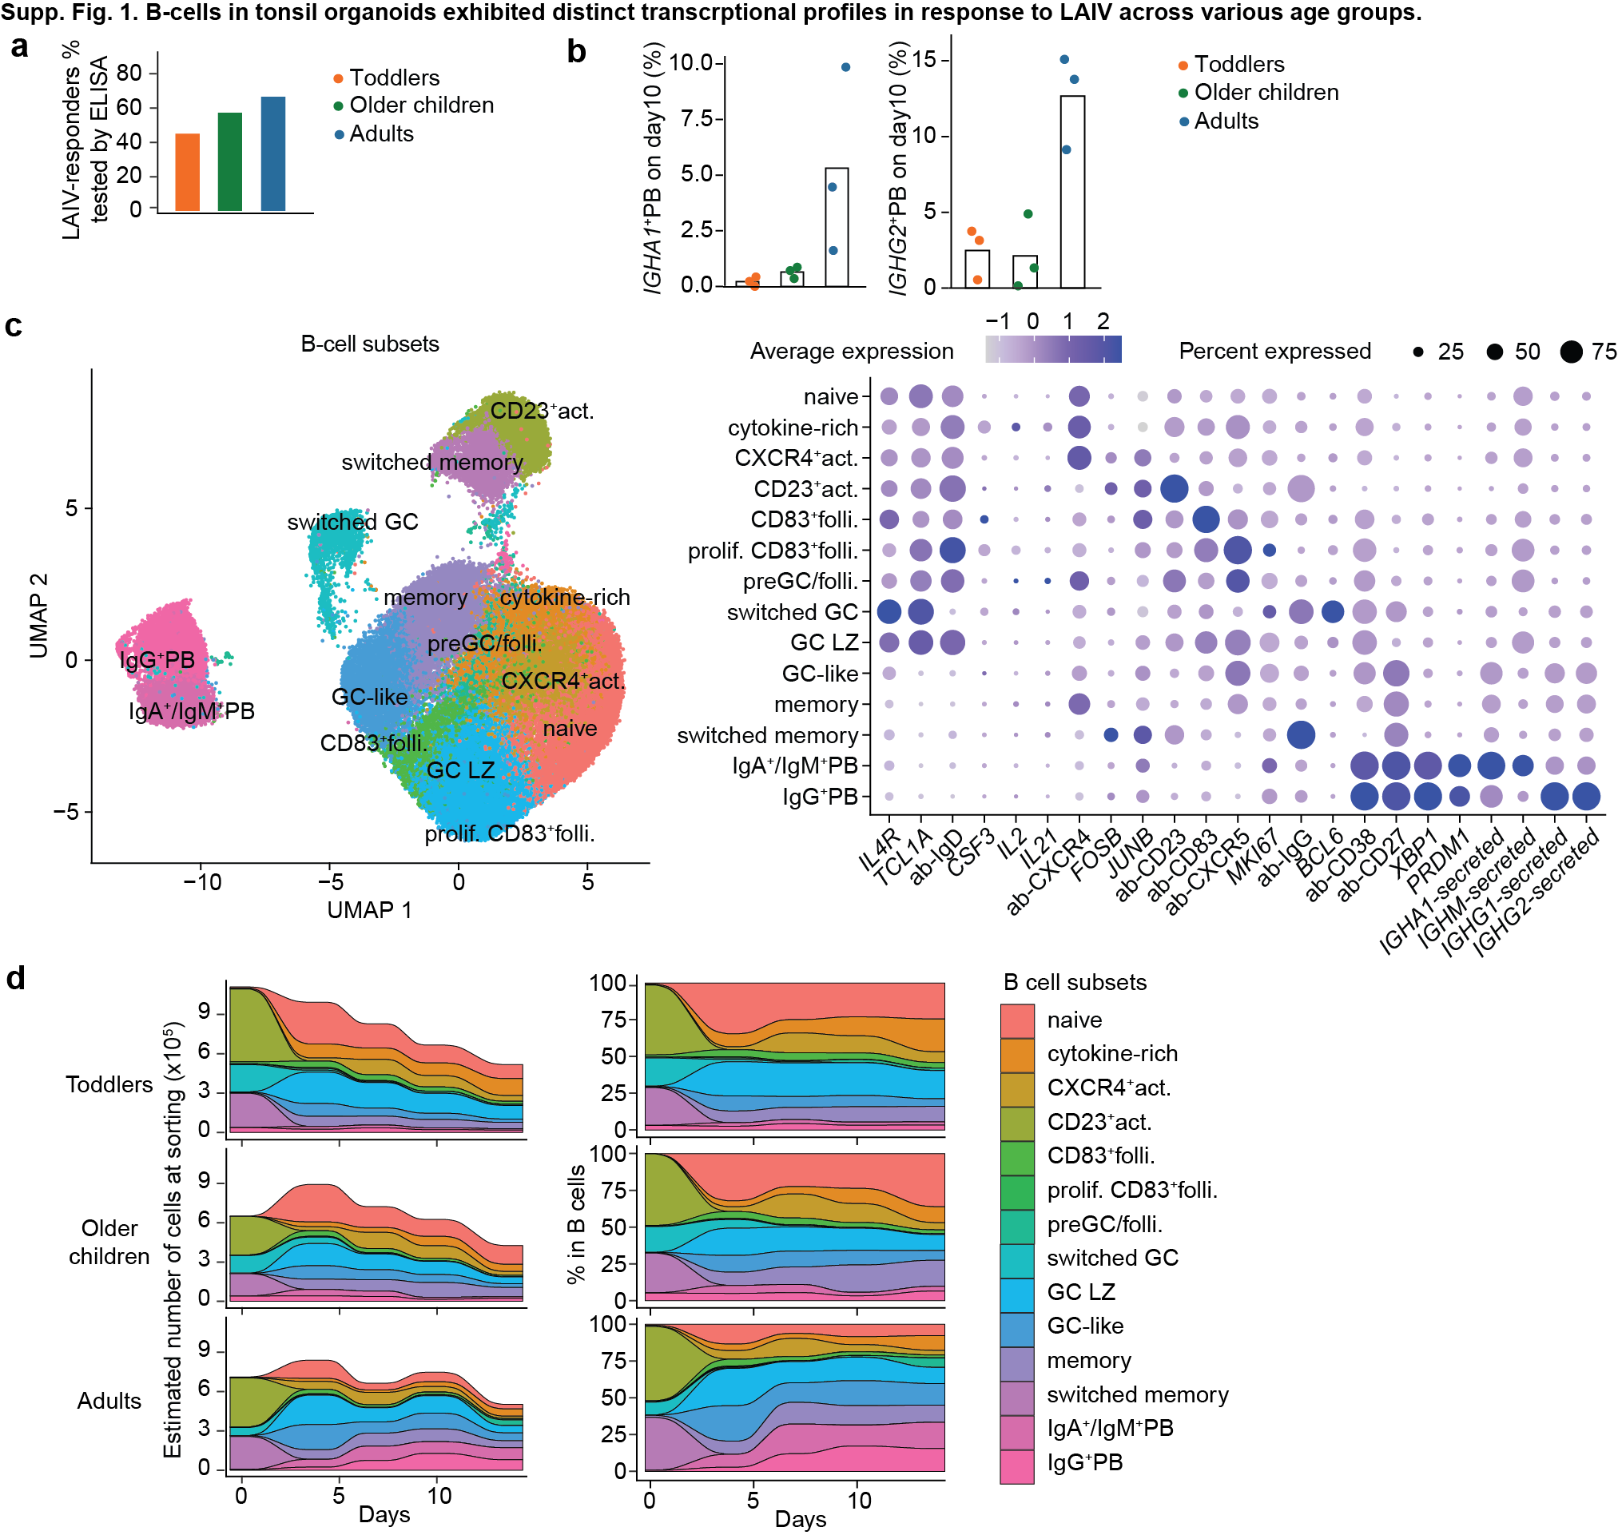
Extended Data Fig. 1. B-cells in tonsil organoids exhibit distinct transcriptional profiles in response to LAIV across various age groups. (a) Bar plot showing the percentage of LAIV responders in each age group, as measured by influenza-specific antibody levels in ELISA assays. (b) Bar plots depicting the PB isotype cell subsets within each age group, derived from scRNA-seq data. (c) UMAP plot illustrating the diversity of B-cell phenotypes in tonsil organoids stimulated by LAIV, as characterized by scRNA-seq data, with a dot plot displaying the top-expressed marker profiles within each B-cell subset. (d) Flow plots depicting the dynamics of B-cell subsets within each age group, derived from scRNA-seq data as in c.
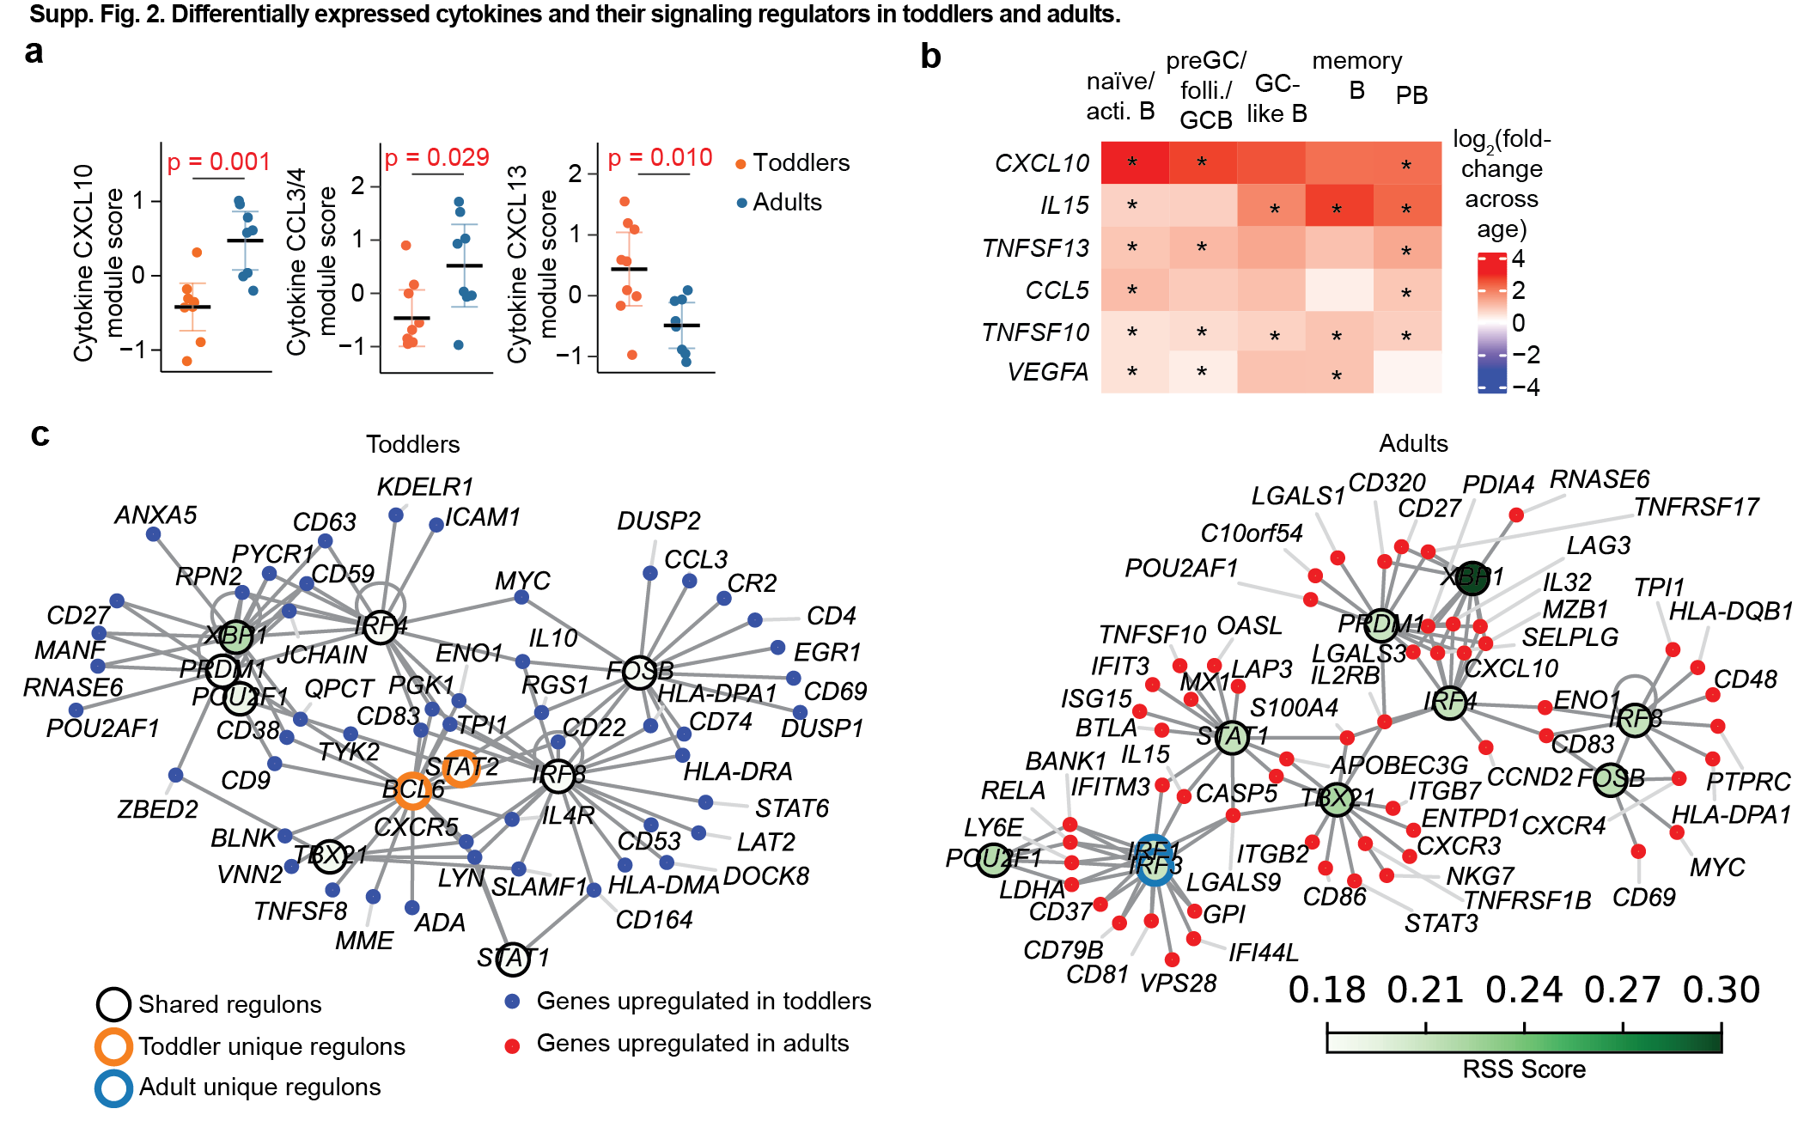
Extended Data Fig. 2. Differentially expressed cytokines and their signaling regulators in toddlers and adults. (a) Module analysis of secreted cytokines in the supernatants collected from tonsil organoids revealed several age-dependent cytokine modules. The CXCL10-cytokine module, upregulated in adults, included correlated cytokines: CCL27, FLT3L, CX3CL1, IL12p40, IL15, IL17F, IL2, IL9, CXCL10, CXCL9, CCL5, TNFB, TNFSF10, VEGF, and CCL21. Conversely, the CXCL13-cytokine module, upregulated in toddlers, consisted of correlated cytokines: CXCL13, IL16, LEPTIN, and CCL13. Statistical significance was calculated using two-sided Student’s tests. (b) Differential gene expression analysis from scRNA-seq data showed lower cytokine expression levels in B cell subsets in toddlers compared to adults. Statistical significance was calculated using two-sided Wilcoxon rank-sum tests and adjusted by the false discovery rate method. (c) Regulon analysis using SCENIC identified downstream genes regulated by the top 10 regulons in PBs based on scRNA-seq data. Upregulated DEGs were selected based on |log2(FC)| > 0.25 and P value <0.05.

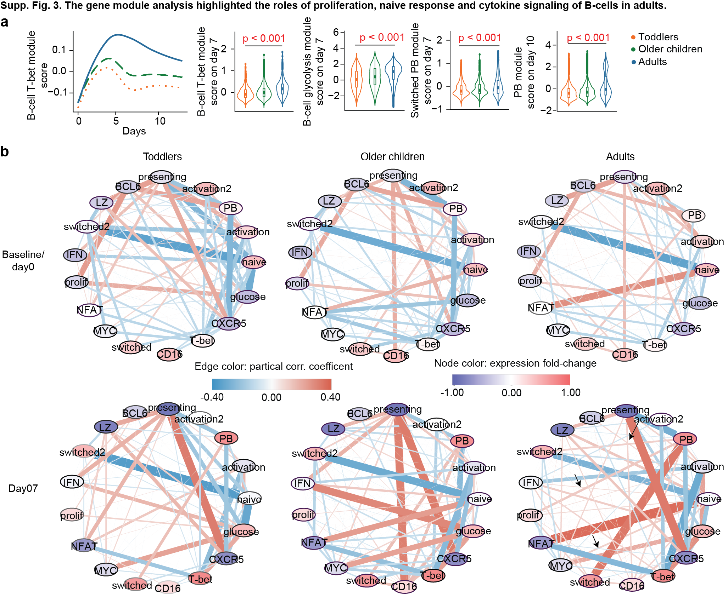
Extended Data Fig. 3. Gene module analysis highlights the roles of proliferation, naive response and cytokine signaling in B cells in adults. (a) Gene module analysis from scRNA-seq data revealed that toddlers exhibited lower scores for B-cell T-bet, glycolysis and PB gene modules compared to adults. Statistical significance was calculated using two-sided Wilcoxon rank-sum tests and adjusted by the false discover rate method. (b) Partial correlation networks depicted the interactions among gene modules for each age group at specific time points, with baseline and day 7 chosen for representation. Arrows in the day 7 adult network highlight the primary interactions, which were significantly more pronounced in adults compared to toddlers and were absent at baseline. Significance was calculated using permutation tests and adjusted by the false discover rate method. The edge weight and color represent the partial correlation coefficient, while the node color represents the fold-change of gene module expressions between adults and toddlers, normalized by the standard deviation of all donors.

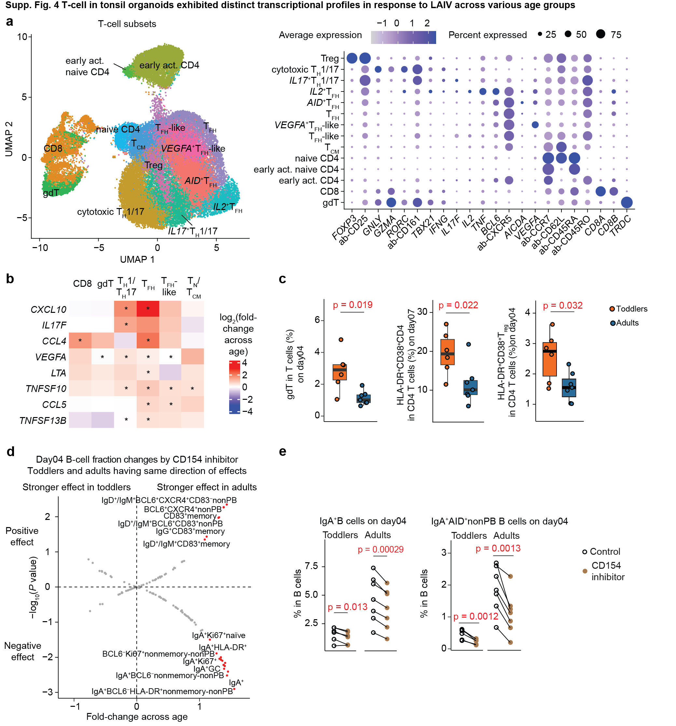
Extended Data Fig. 4 T cells in tonsil organoids exhibit distinct transcriptional profiles in response to LAIV across various age groups. (a) UMAP plot displaying the diversity of T cell phenotypes in tonsil organoids stimulated by LAIV, as characterized by scRNA-seq data, with a dot plot displaying the top-expressed marker profiles within each T cell subset. (b) Differential gene expression analysis from scRNA-seq data revealed lower cytokine expression levels in B cell subsets when comparing toddlers and adults. (c) Flow cytometry showing that activated CD4 (HLA-DR⁺CD38⁺), activated Treg, and gdT cells were more pronounced in toddlers compared to adults. (d) Volcano plot depicting the differences in cell fraction changes in B cells induced by the CD154 inhibitor, anti-CD154 antibody, between toddlers and adults, as measured by flow cytometry. These changes in cell fraction were determined by subtracting the control cell fraction from the fraction affected by inhibition. The fold change represents the ratio of the difference in cell fraction changes between the two age groups, normalized by the standard deviation of these changes. A positive fold-change indicates a stronger effect of inhibition in adults relative to the toddlers. Red, B-cell subsets with P value < 0.05. (e) Flow cytometry showing that CD154 inhibition induced changes in IgA⁺B, and IgA⁺AID⁺B cells. Statistical significance in b was calculated using two-sided Wilcoxon rank-sum tests and adjusted by the false discovery rate method. Significance in c-e was determined by two-sided Student’s t-tests.
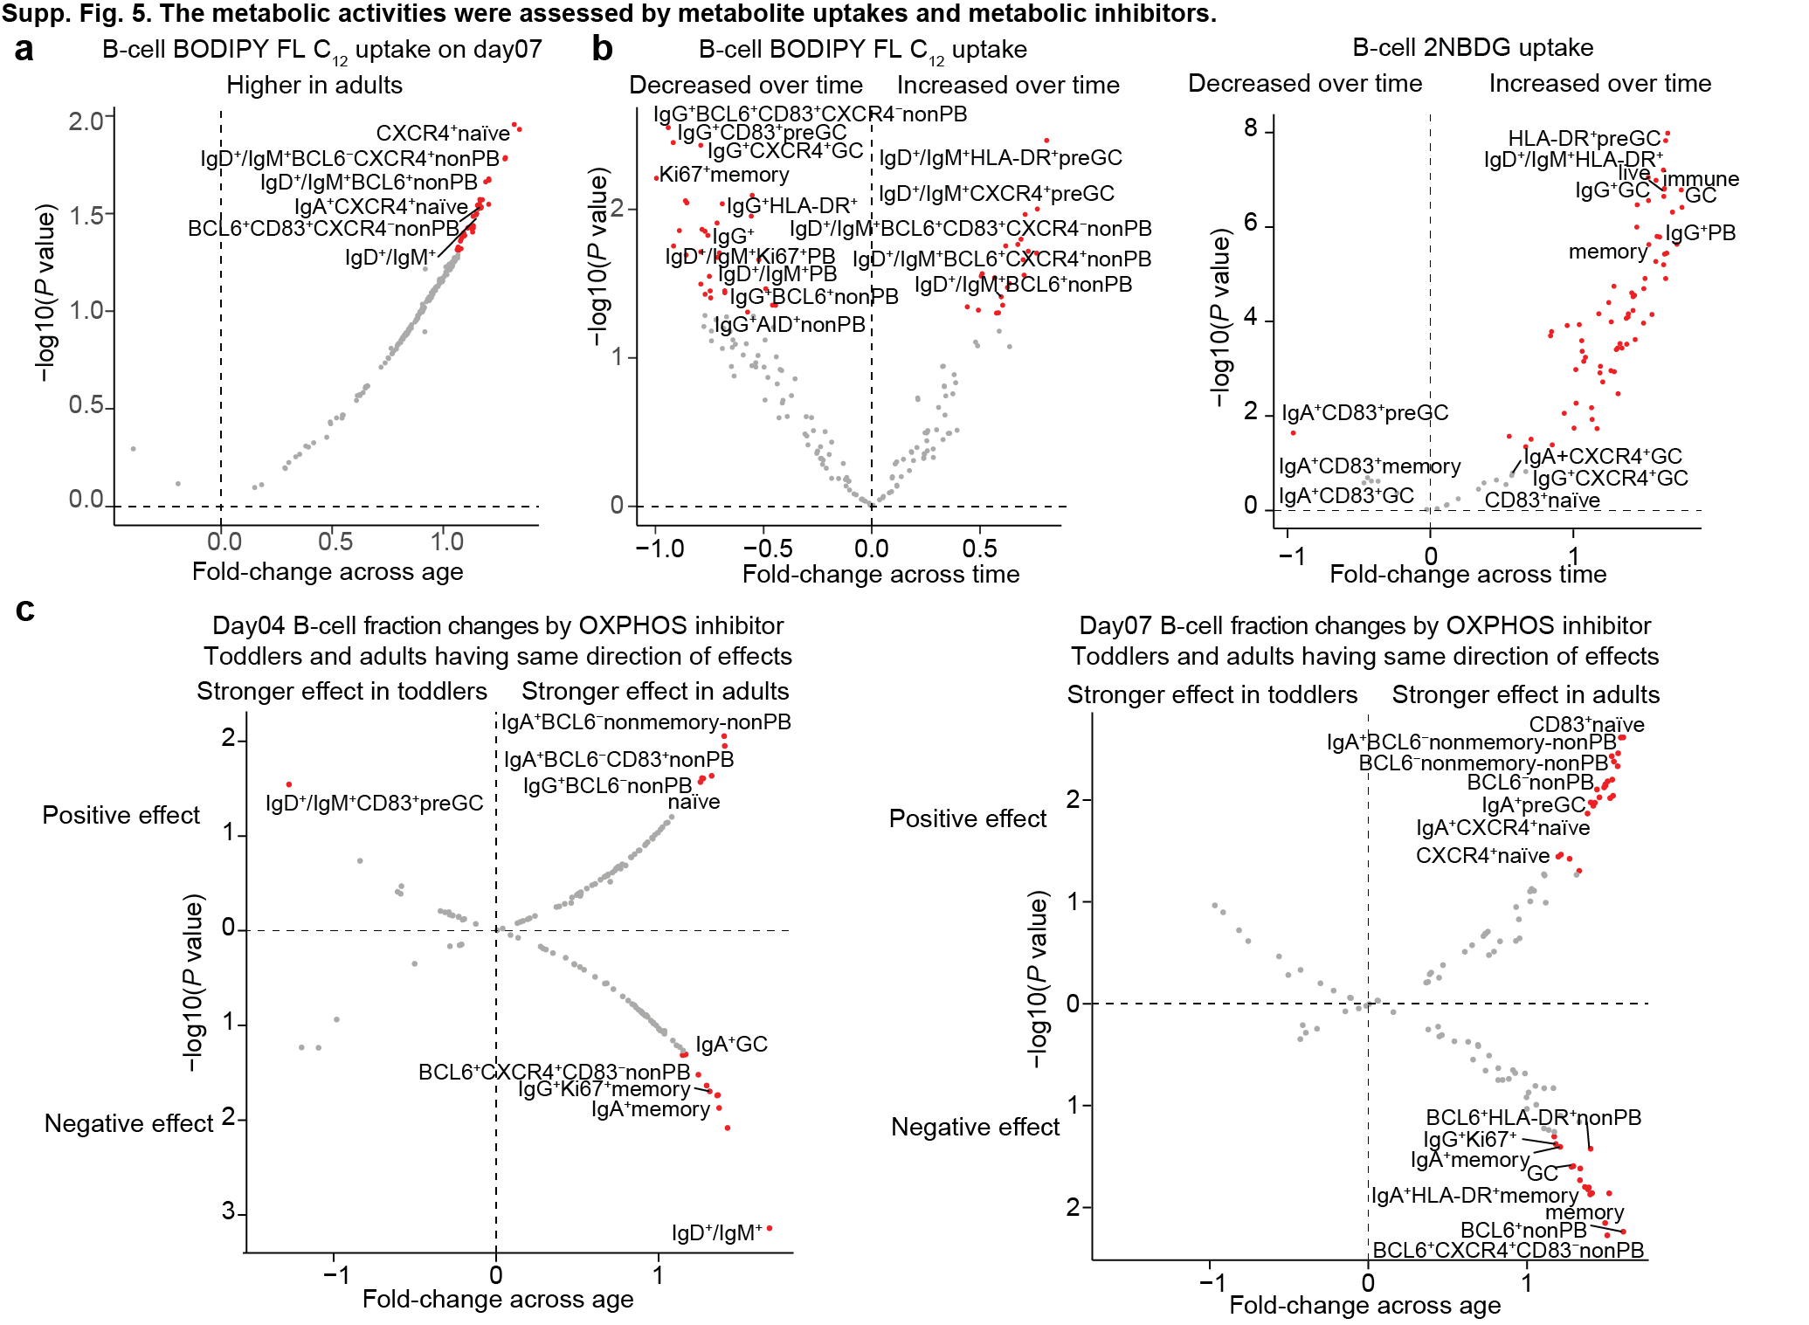
Extended Data Fig. 5. Metabolic activities assessed by metabolite uptakes and metabolic inhibitors. (a) Volcano plot showing differences in cellular metabolite mean fluorescence intensities (MFI) from flow cytometry between toddlers and adults. The fold change represents the ratio of metabolite MFI differences between adults and toddlers, normalized by their standard deviation. A positive fold-change indicates higher cellular metabolite MFI levels in adults relative to the toddlers. (b) Volcano plots showing differences in cellular metabolite MFI between day 4 and day 7 among all donors, as in a. The fold-change represents the ratio of metabolite MFI difference between day 7 and day 4, normalized by their standard deviation. A positive fold-change indicated higher cellular metabolite MFI levels on day 7 relative to day 4. (c) Volcano plots showing the differences of cell fraction changes in B cells induced by the OXPHOS inhibitor, Oligomycin, between toddlers and adults, as measured by flow cytometry. These changes in cell fractions were determined by subtracting the control cell fraction from the fraction affected by Oligomycin. The fold change represents the ratio of the difference in cell fraction changes between the two age groups, normalized by the standard deviation of these changes. A positive fold-change indicates stronger effects of Oligomycin in adults relative to the toddlers. Red, B-cell subsets with P value < 0.05. Statistical significance in a, b and c were calculated using the two-sided Student’s t-tests.

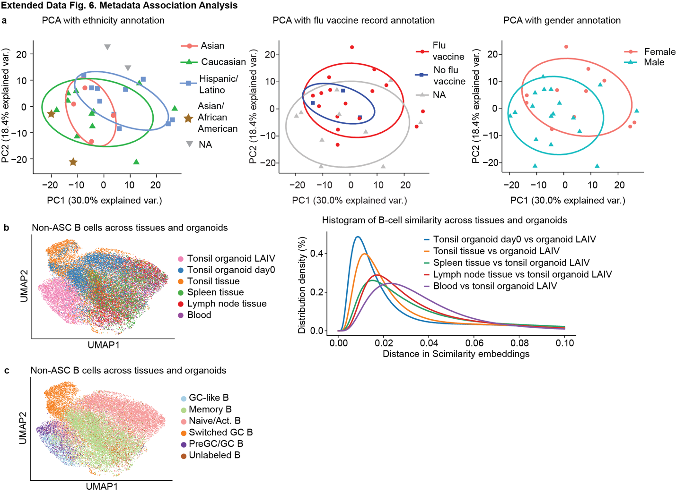
Extended Data Fig. 6. Metadata Association Analysis. (a) PCA plots showing that the donor information including ethnicity, flu vaccine record, and gender, did not contribute apparently to the top variances. (b) UMAP plot showing the non-antibody-secreting-cell (non-ASC) B cell phenotype overlaps from different immune compartments and organoid models with cell-pairwise distance from the Scimilarity embeddings. (c) UMAP plot showing the non-ASC B cell phenotype overlaying with cell subset annotations.

