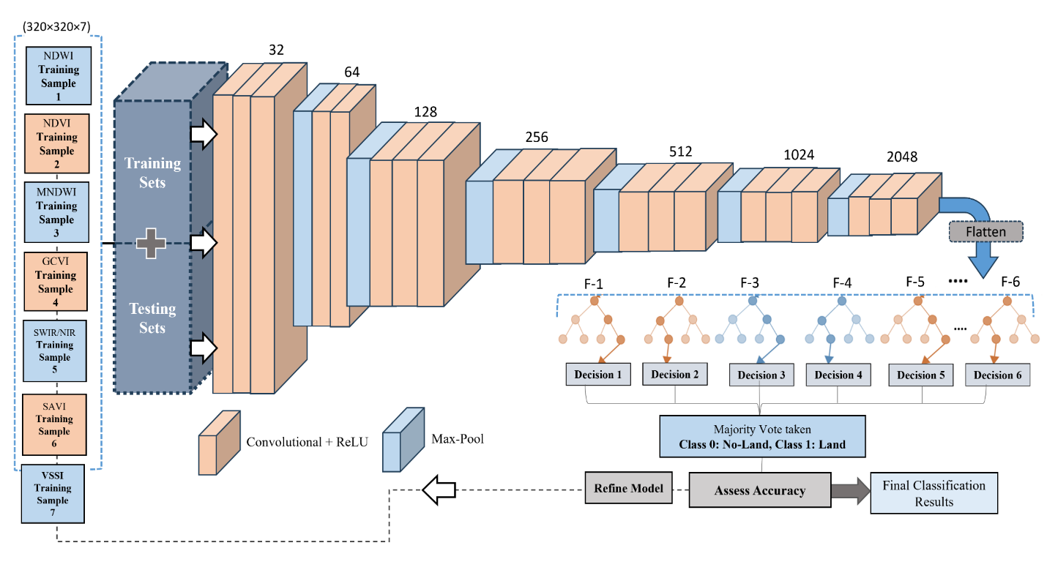
Fig. S1. CNN for feature extraction of multi-spectral datasets, followed by Random Forest.
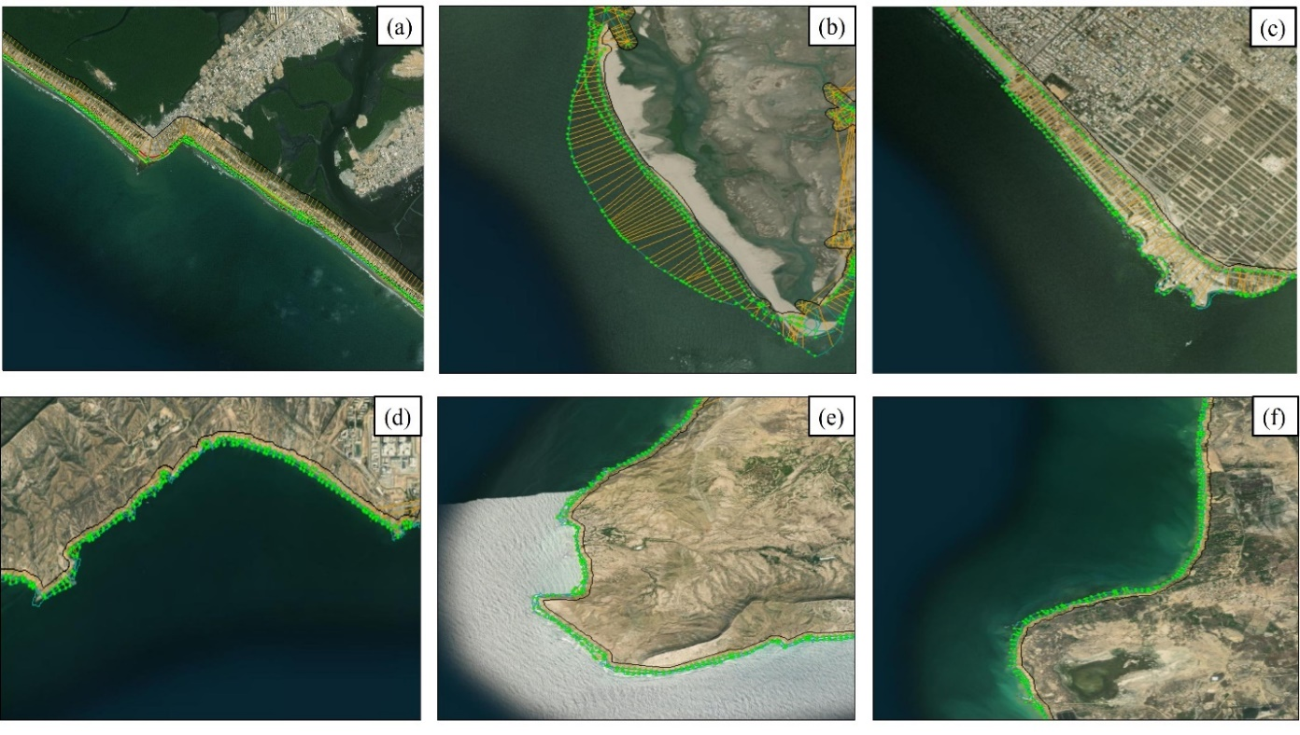
Fig. S2. Measured point selection and transect generation along the major coastal aquifers: (a) Eastern Indus Delta, (b) Central Indus Delta, (c) Sandspit, (d) Sonmiani, (e) Ormara, and (f) Kalmat Khor. The transects are drawn parallel to the baseline along the coastline for distance calculations.
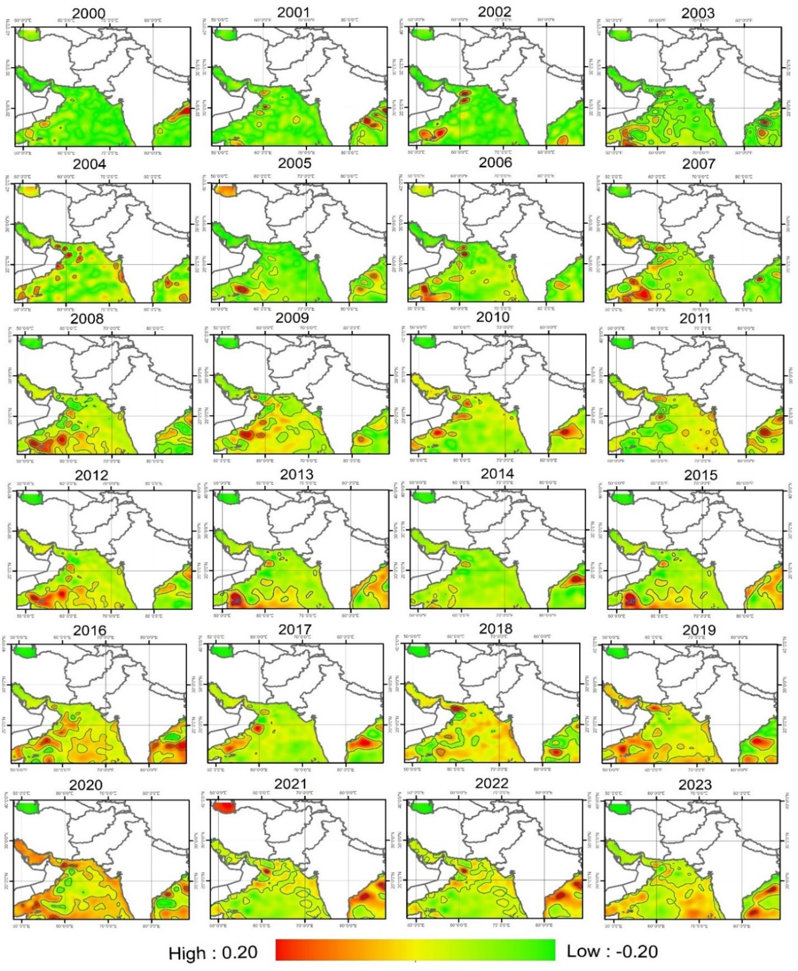
Fig. S3. Multi-temporal annual spatial variations in SLR (m) baseline period of (1993-2012) obtained from C3S for the period 2000-2023.
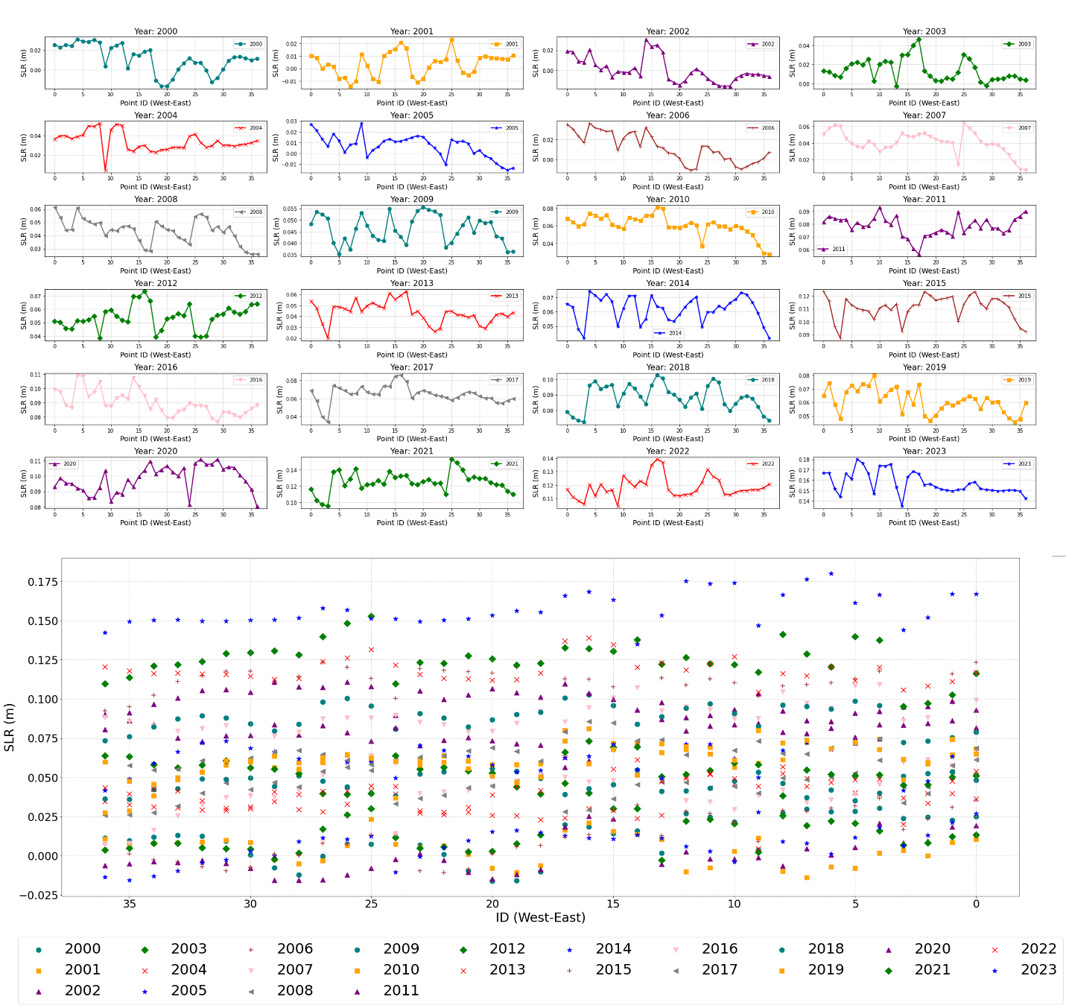
Fig. S4. Inter coastal zonal variations and trend of SLR along major coastal sites of Pakistan from east to west, covering the transects ID of Indus Delta (0-10), Sominiani Aquifer (15-20), Ormara Port (20-25), Kalmat Ghotr (25-30), and Gwadar Port (30-40) derived from C3S (baseline: 1993-2012).
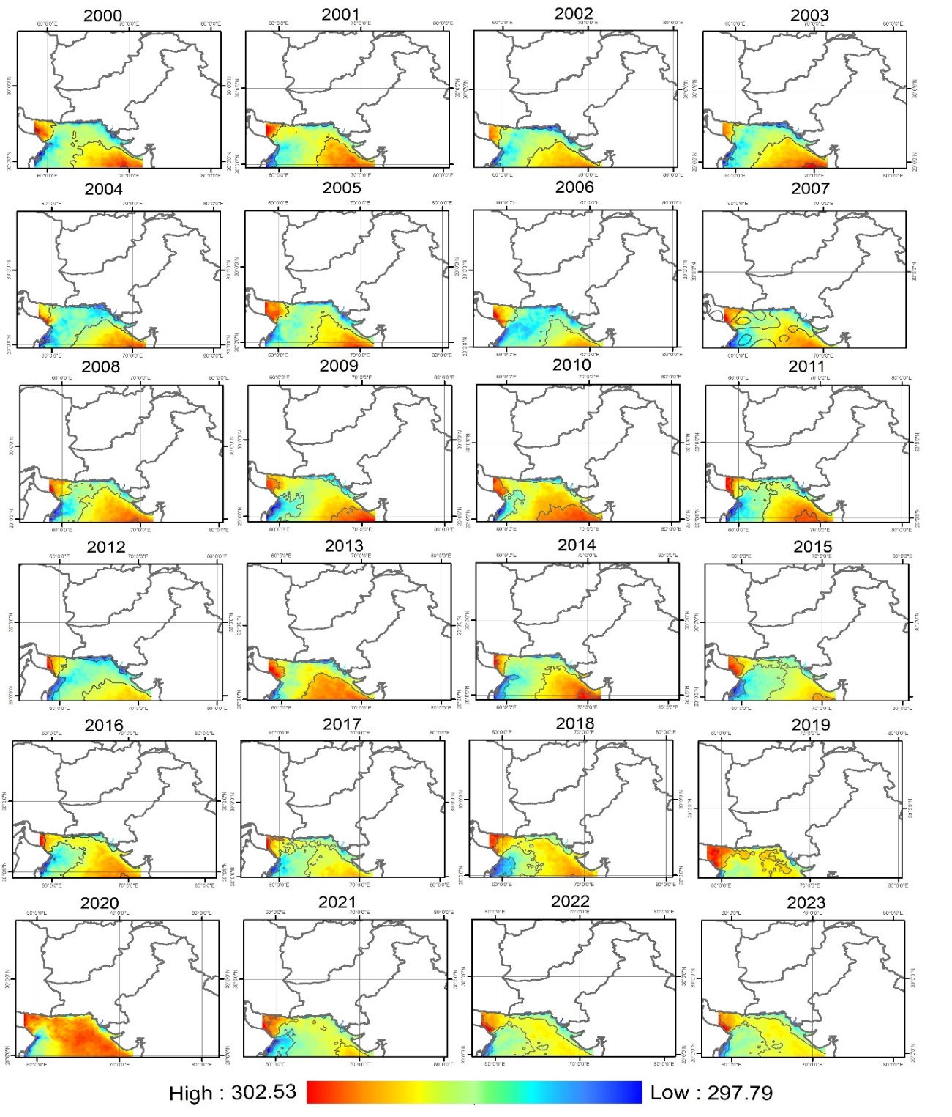
Fig. S5. Spatio-temporal variability of Sea Surface Temperature (SST) derived from the NOAA along the Arabian Sea coastline of Pakistan during 2000-2023.

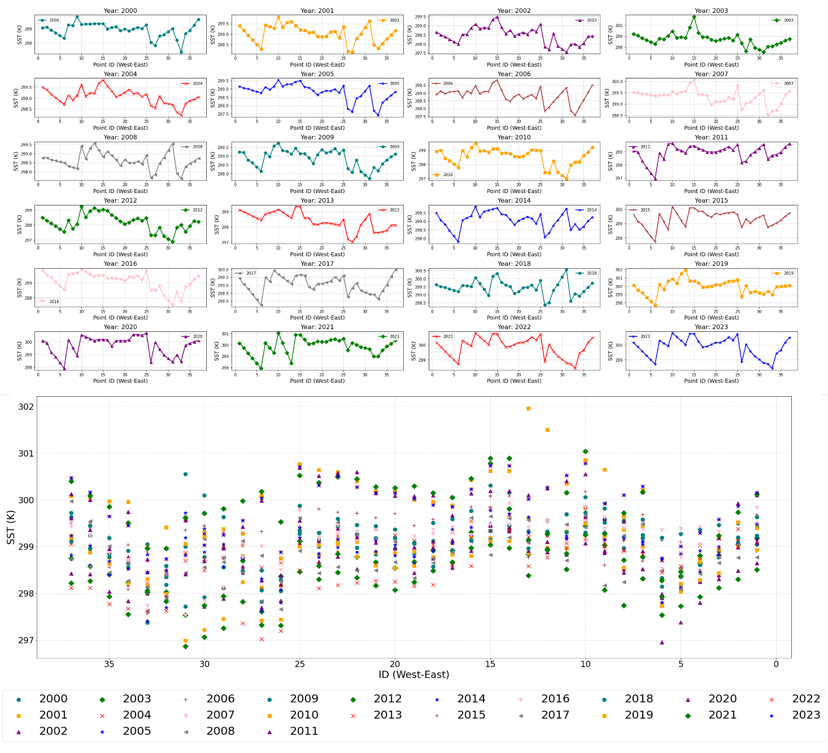
Fig. S6. Inter coastal zonal variations and trend of SST along major coastal sites of Pakistan from east to west, covering the transects ID of Indus Delta (0-10), Sominiani Aquifer (15-20), Ormara Port (20-25), Kalmat Ghotr (25-30), and Gwadar Port (30-40) derived from NOAA.
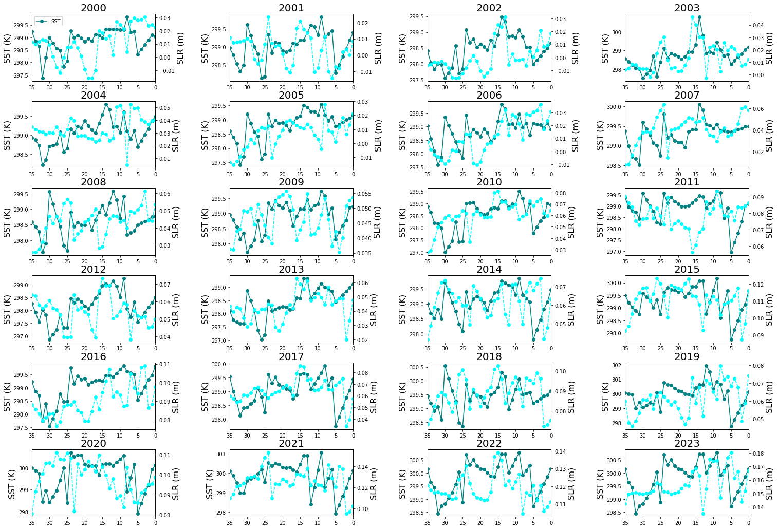
Fig. S7. Comparative Analysis of SLR and SST from 2000 to 2023 across west-east transects along Pakistan's coastline with transects ID of Indus Delta (0-10), Sominiani Aquifer (15-20), Ormara Port (20-25), Kalmat Ghotr (25-30), and Gwadar Port (30-40).
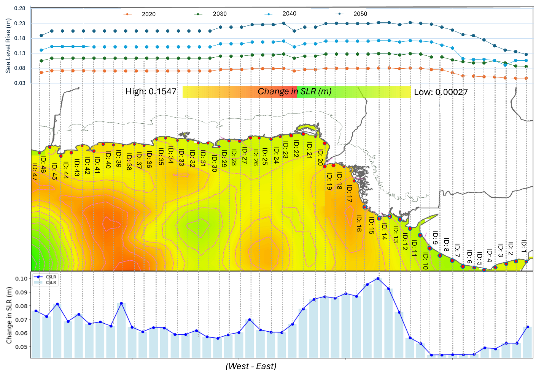
Fig. S8. ΔSLR (m) along west to east transects of Pakistan’s coastline (2020-2050), along with predicted SLR for 2020, 2030, 2040, and 2050.
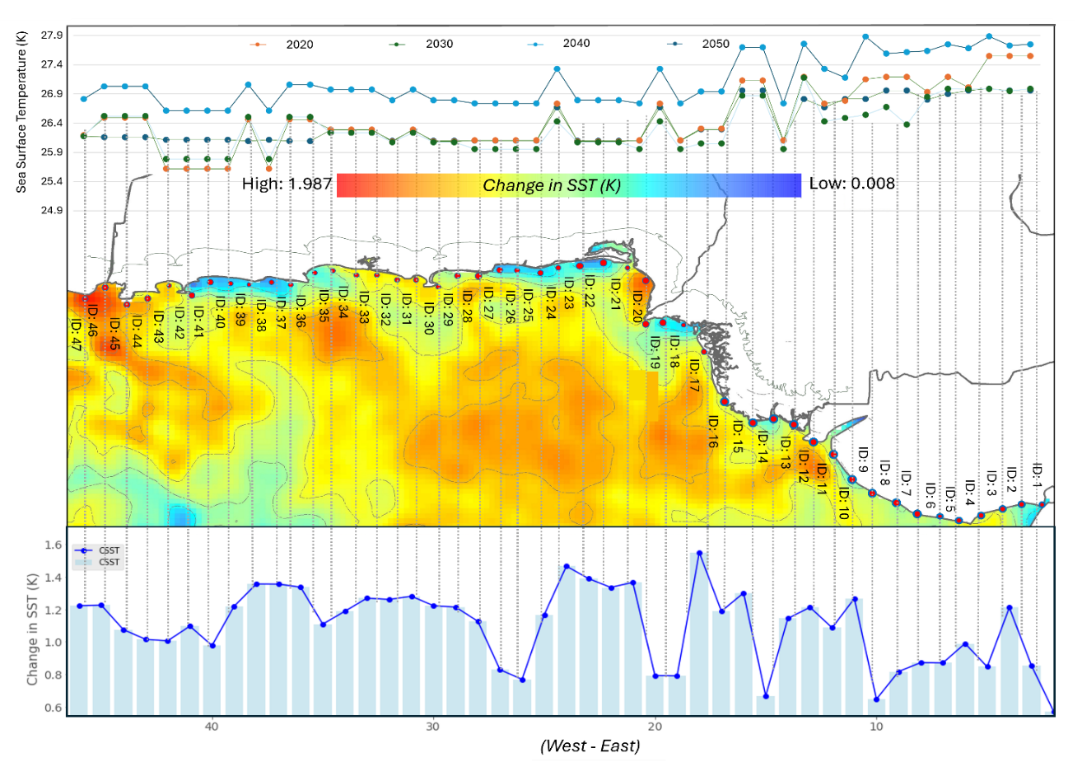
Fig. S9. ΔSST (K) along west to east transects of Pakistan’s coastline (2020-2050), including all major aquifers and predicted average SST for the years 2020, 2030, 2040, and 2050.
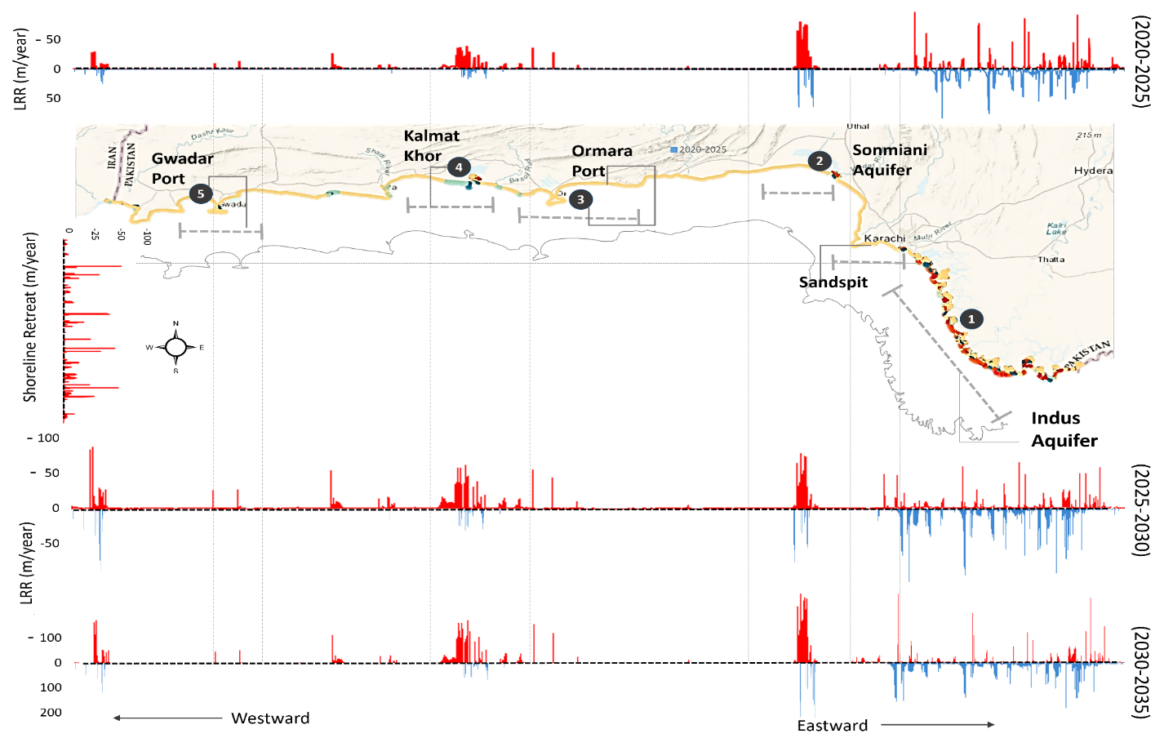
Fig. S10. Projected erosion and accretion along Pakistan’s coastline from (2020-2025), (2025-2030), (2030-2035) coastline red areas - erosion, blue areas – accretion.
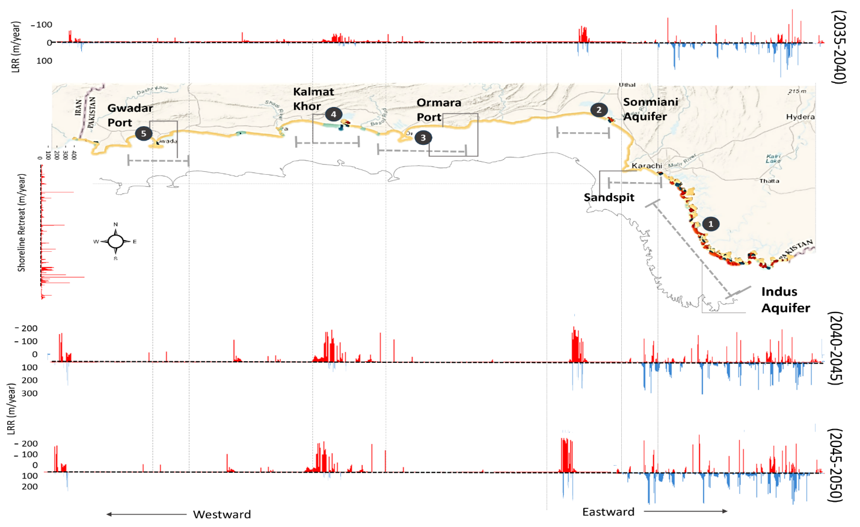

Fig. S11. Projected erosion and accretion along Pakistan’s coastline from (2035-2040), (2040-2045), (2045-2050) coastline red areas - erosion, blue areas – accretion.

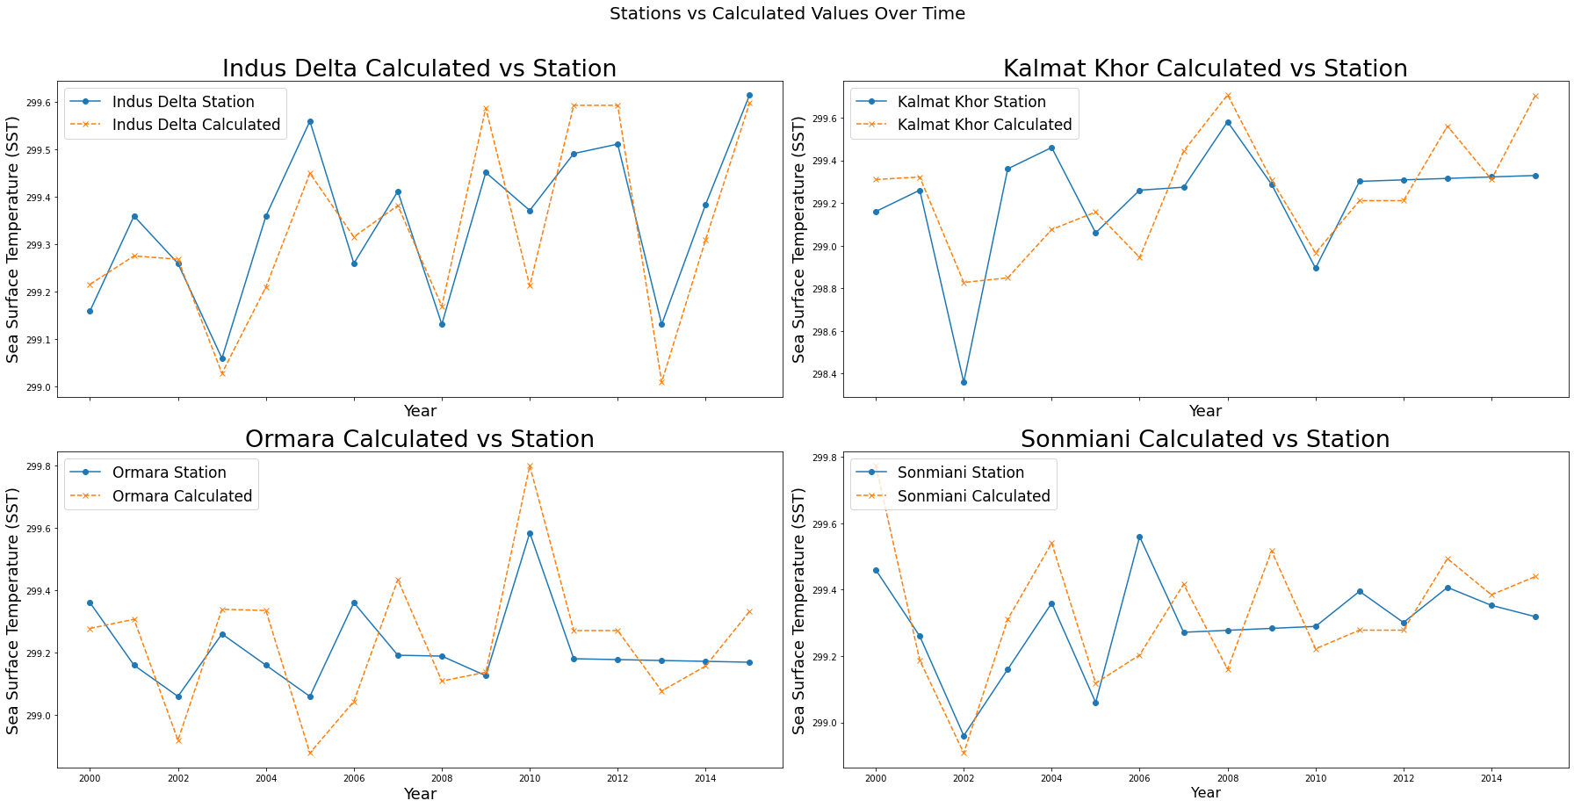 Fig. S12. Comparison of SST calculated from NOAA and with tidal gauge measurements e.g., Indus Delta, Sonmiani, Kalmat Khor, Ormara, and Gawadar.

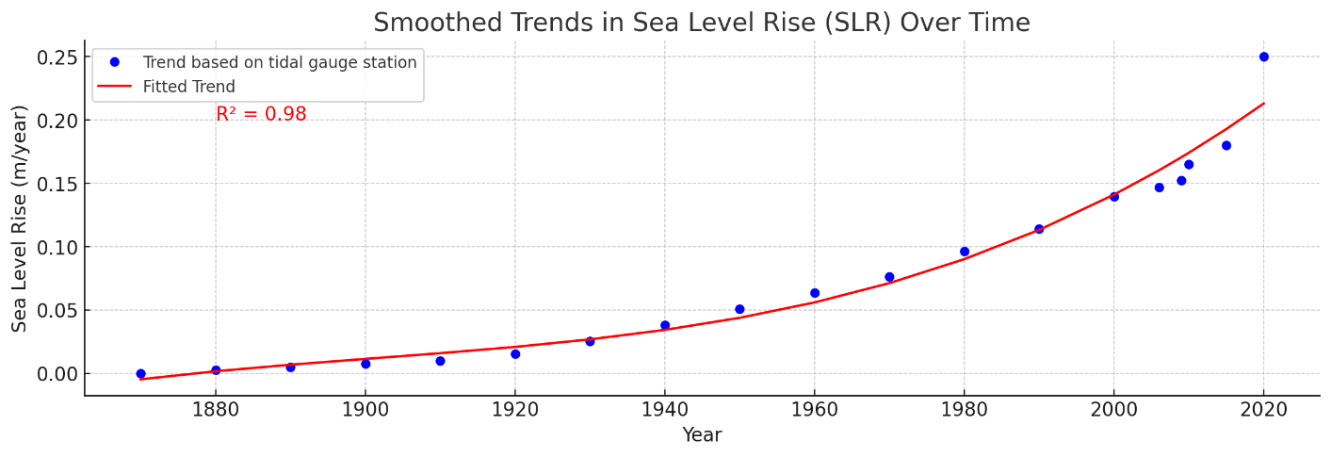
Fig. S13. Observed and fitted trends of SLR over time, as blue dots represent the SLR rates measured at tidal gauge stations from 1880 to 2020.

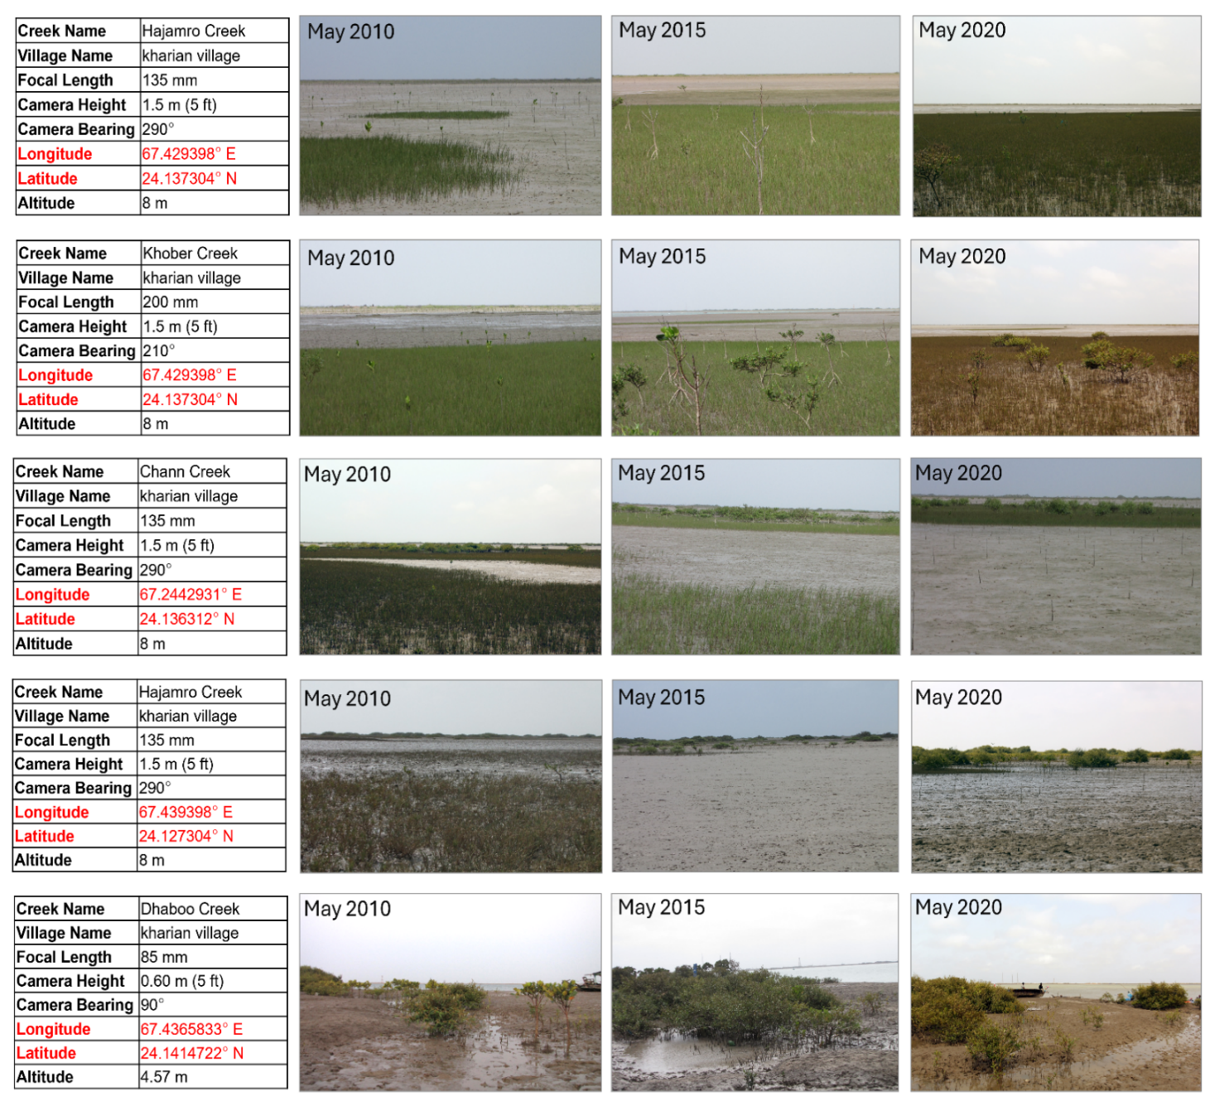
Fig. S14. Fixed Point Photography (FPP) along various creeks for the years 2010, 2015, and 2020, highlighting areas affected by SWI.

