Supplementary Appendix

Table S1: Detailed search strings for each database
Database | Search string | Records retrieved
PubMed/MEDLINE | (("Inflammatory Bowel Diseases"[MeSH Terms] OR "Crohn Disease"[MeSH Terms] OR "colitis, ulcerative"[MeSH Terms] OR (("inflammatories"[All Fields] OR "inflammatory"[All Fields]) AND ("bowel s"[All Fields] OR "bowell"[All Fields] OR "intestines"[MeSH Terms] OR "intestines"[All Fields] OR "bowel"[All Fields] OR "bowels"[All Fields]) AND "disease*"[All Fields]) OR "IBD"[All Fields] OR "crohn*"[All Fields] OR ("colitis, ulcerative"[MeSH Terms] OR ("colitis"[All Fields] AND "ulcerative"[All Fields]) OR "ulcerative colitis"[All Fields] OR ("ulcerative"[All Fields] AND "colitis"[All Fields]))) AND ("Tumor Necrosis Factor-alpha"[MeSH Terms] OR "antibodies, monoclonal"[MeSH Terms] OR "anti-TNF"[All Fields] OR ("TNF"[All Fields] AND "inhibitor*"[All Fields]) OR ("TNF"[All Fields] AND "antagon*"[All Fields]) OR ("TNF"[All Fields] AND "blocker*"[All Fields]) OR ("infliximab"[Supplementary Concept] OR "infliximab"[All Fields] OR "infliximab"[MeSH Terms] OR "infliximab s"[All Fields]) OR ("adalimumab"[Supplementary Concept] OR "adalimumab"[All Fields] OR "adalimumab"[MeSH Terms]) OR ("certolizumab pegol"[Supplementary Concept] OR "certolizumab pegol"[All Fields] OR "certolizumab"[All Fields] OR "certolizumab pegol"[MeSH Terms] OR ("certolizumab"[All Fields] AND "pegol"[All Fields])) OR "certolizumab pegol"[All Fields] OR ("golimumab"[Supplementary Concept] OR "golimumab"[All Fields] OR "golimumab s"[All Fields])) AND ("withdraw*"[All Fields] OR "discontinu*"[All Fields] OR "cessat*"[All Fields] OR "stop*"[All Fields] OR "de escalat*"[All Fields] OR "deescalat*"[All Fields] OR "taper*"[All Fields] OR "drug holiday"[All Fields])) AND (randomizedcontrolledtrial[Filter]) | 114
Embase | ('inflammatory bowel disease'/exp OR 'crohn disease'/exp OR 'ulcerative colitis'/exp  OR "inflammatory bowel disease*" OR IBD OR Crohn* OR "ulcerative colitis")  AND  ('tumor necrosis factor alpha'/exp OR 'tumor necrosis factor antibody'/exp OR 'tumor necrosis factor inhibitor'/exp  OR "anti tnf" OR "tnf inhibitor*" OR "tnf antagon*" OR "tnf blocker*"  OR infliximab OR adalimumab OR certolizumab OR "certolizumab pegol" OR golimumab)  AND  (withdraw* OR discontinu* OR cessat* OR stop* OR de-escalat* OR deescalat* OR taper* OR "drug holiday") AND (randomizedcontrolledtrial[Filter]) | 673
Cochrane Central Register of RCTs | ("inflammatory bowel disease" OR IBD OR "Crohn" OR "ulcerative colitis")  AND  ("anti-TNF" OR "TNF inhibitor" OR infliximab OR adalimumab OR certolizumab OR "certolizumab pegol" OR golimumab)  AND  (withdraw OR discontinuation OR cessation OR stop OR de-escalation OR taper OR "drug holiday") | 591
Clinicaltrials.gov | ("inflammatory bowel disease" OR IBD OR Crohn OR "ulcerative colitis")  AND  (infliximab OR adalimumab OR certolizumab OR "certolizumab pegol" OR golimumab OR "anti-TNF" OR "TNF inhibitor") | 29

Figure S1: PRISMA flowchart showing the screening and study selection process

Records removed before screening
Duplicate records removed (n = 458)

Records identified from
PubMed/MEDLINE (n = 114)
Embase (n = 673)
Cochrane Central Register of RCTs (n = 591)
Clinicaltrials.gov (n = 29)
Total (n= 1407)

Identification

Records screened
(n = 949)
Records excluded
(n = 911)

Reports sought for retrieval
(n = 38)

Screening

Reports assessed for eligibility
(n = 38)
Reports excluded:
Single-arm studies, reviews, editorials, observational studies, and others (n = 34)

Studies included in qualitative synthesis
(n = 4)
Studies included in quantitative synthesis
(n = 4)
Included

Figure S2: Subgroup analysis (placebo control versus no placebo) for risk of relapse.
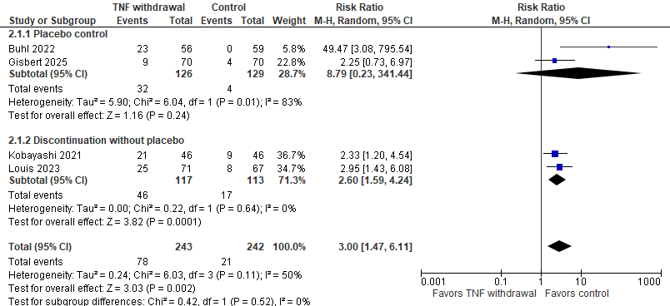

Figure S3: Subgroup analysis (placebo control versus no placebo) for sustained clinical remission.
