SUPPLEMENTAL APPENDIX:

Individualized Antisense Oligonucleotides for SCN2A Related Disorders

NONCLINICAL METHODS AND DATA
Using patients’ whole genome sequencing, individualized allele-selective antisense oligonucleotides (ASOs) were designed to knock down the mutant but not wildtype mRNA copy for each patient. A benign single nucleotide polymorphism (SNP) on the wild-type allele of each patient was used to develop a selective ASO for the mutant allele. The respective ASOs were run through potency and selectivity in vitro assays in patient-derived iPSCs, proinflammatory and off target evaluation, non-GLP single and GLP repeat dose toxicology studies in rodents, and GMP drug substance and drug product manufacturing, for subsequent first in-human intrathecal delivery of ASOs to the cerebrospinal fluid in parallel individualized FDA-authorized clinical trials.
ASOs were designed to promote selective degradation of the mutant SCN2A transcript through recruitment of RNase H1 to the RNA-ASO heteroduplex.^{11, 12} Over 500 2’MOE gapmers with mixed backbone (PS/PO) were designed to single nucleotide differences between the two SCNA2A alleles in the patients SCN2A gene. ASOs targeted either the SNP or consensus sequence phased to the pathogenic allele as previously described. ⁷ Mapping heterozygous SNPs common to both patients identified a subset of ASOs that could also be screened in the other patient cells, expediting the discovery process overall. Multiple potent, allele selective ASOs identified in a single dose in vitro assay in each patient’s iPSC derived neurons were tested on a dose response assay. ASOs meeting minimal criteria for potency and selectivity were further assessed for their potential to trigger innate immunity by measuring CCL22 levels in BJAB cells treated with high ASO concentrations (up to 8 µM) ¹³ In silico characterization followed by in vitro confirmation of the specificity of each ASO for SCN2A with no demonstratable effects on any other human genes with partial complementarity (“off targets”) was performed.
ASOs were then assessed for in vivo tolerability in two non-Good Laboratory Practices (non-GLP) studies (an 8-week single intracerebroventricular [ICV] dose study in mice and an 8-week single intrathecal [IT] dose study in rats). ^{14, 15} These steps led to the identification of an optimal ASO for each patient. The lead ASOs were then evaluated in 2 distinct 13-week GLP repeat dose toxicology studies in which 10 rats/sex were given 0, 0.3 or 1 mg/dose by intrathecal administration on Days 1, 29, 57, and 85, with necropsy performed on Day 92. In both studies, the ASOs were considered to be well tolerated, with transient postdose clinical and neurobehavioral observations of abnormal gait, incoordination, limited usage and/or decreased grip strength, low carriage/arousal/alertness/rearing events/body temperature, decreased body tone, impaired tail pinch response/tactile reflex and/or decreased activity noted at 1 mg/dose which recovered within 24 hours. Microscopic findings were observed at ≥ 0.3 mg/dose and included vacuolated macrophages and mononuclear or mixed cell infiltration in the spinal cord, injection site, meninges, nerve roots, brain, liver, dorsal root ganglion, and/or kidney. In addition, basophilic granules and/or tubular degeneration/regeneration were noted in the kidney, and minimal to mild nerve fiber degeneration was observed in the spinal cord, nerve roots and/or injection site. All findings were considered nonadverse, and similar to what has been observed in commercial ASOs, and the NOAEL was established at 1 mg/dose for both ASOs.
Supplemental Table 1: All adverse events reported for both patients through study duration.
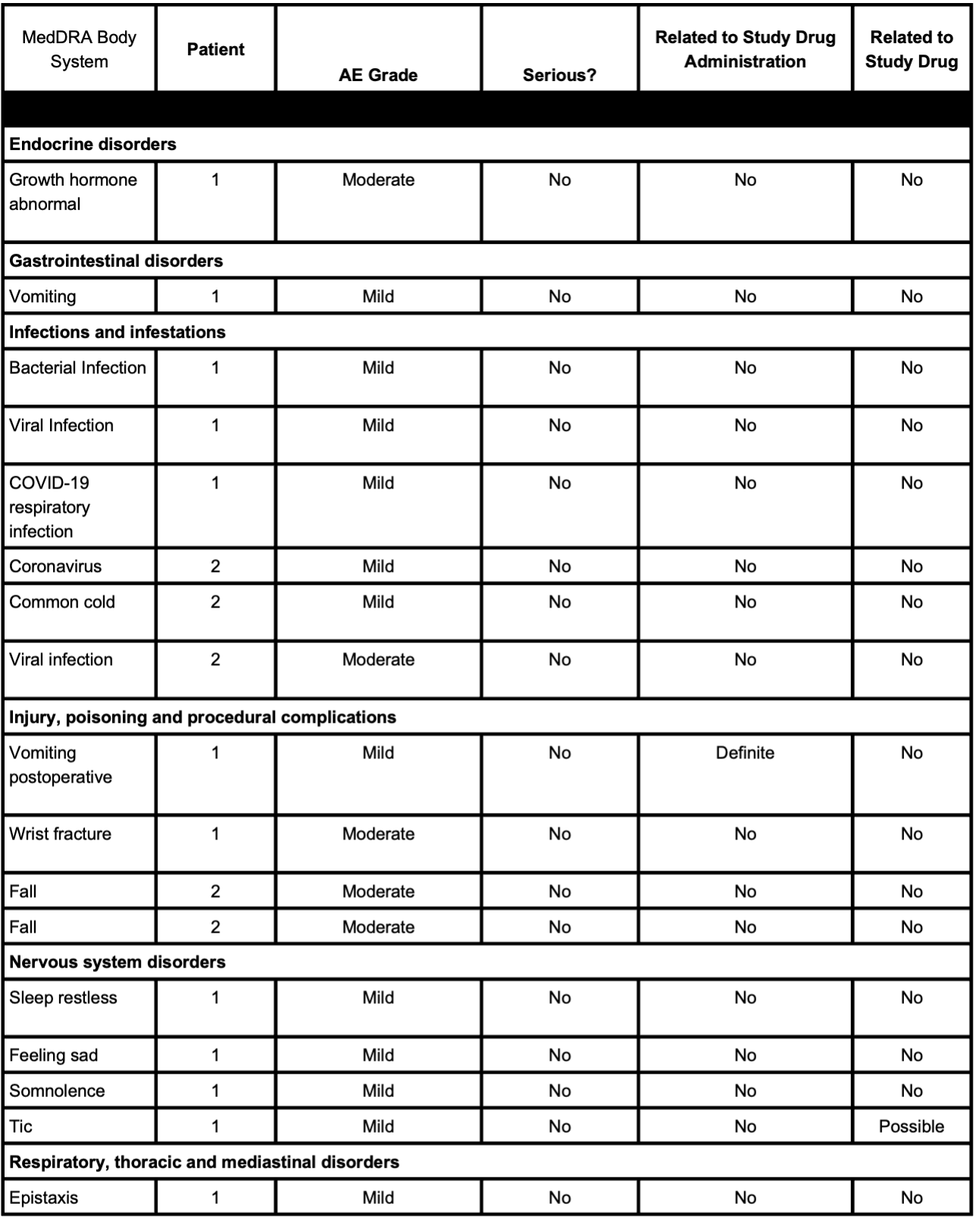

Supplemental Figure 1: Dose-response curve of ASO for Patient 1 (a) and Dose-response curve of ASO for Patient 2 (b)

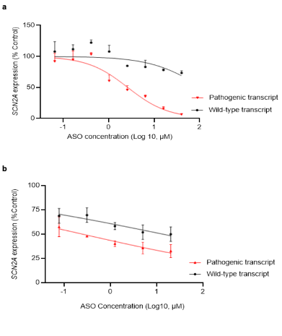
Legend for Supplemental Figure 1: In vitro potency and allele-selectivity were determined following a dose response of each lead ASO in patient iPSc-derived neurons free uptake at concentrations of 0.065 µM, 0.16 µM, 0.4 µM, 1.024 µM, 2.56 µM, 6.4 µM, 16 µM, and 40 µM Patient 1 (a) or 0.078, 0.3125, 1.25, 5, and 20 µM Patient 2 (b) for 5-7 days. Cells were harvested and RNA isolated using RNA easy 96 well kit (Qiagen) according to the manufacturer’s instructions. Expression of each allele was then measured using tagged probes (“Wild-type transcript” tagged in black and “Pathogenic transcript” tagged in red). SCN2A mRNA was quantified using quantitative RT-PCR (TaqMan) assay on an Applied Biosystems 7900H Fast or QuantStudio 7 Real-Time PCR system.
Supplemental Figure 2: ASO Design (a) and ASO Sequence and chemistry (b)
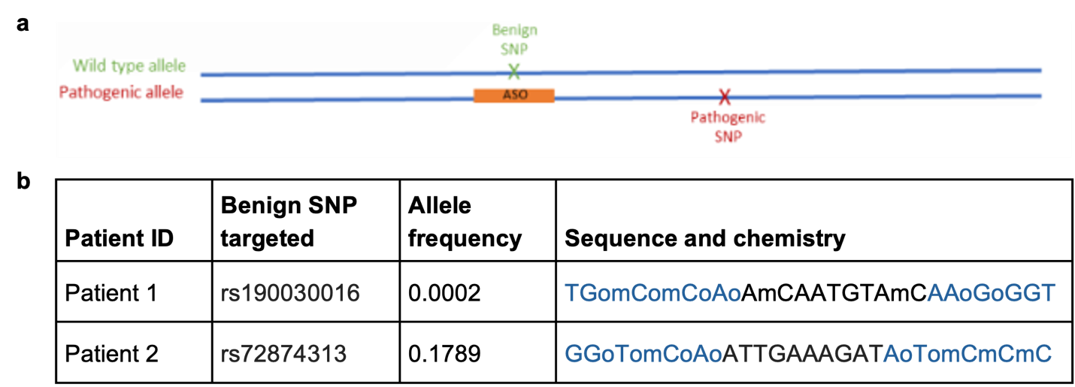

Legend for Supplemental Figure 2: (a) graphic representation of where the ASO binds relative to the pathogenic mutations, utilizing a benign SNP identified on the wild-type allele. (b) Specific sequence and chemistry of the 2 allele-selective ASOs designed for Patient 1 and Patient 2. Allele frequency in the global population from 1000Genomes as per https://www.ncbi.nlm.nih.gov/snp/rs190030016/ and https://www.ncbi.nlm.nih.gov/snp/rs72874313/. Key for ASO chemical modifications: black = unmodified deoxyribose; blue = 2 methoxyethyl (MOE). Unmarked backbone linkages = phosphorothioate (PS); linkages marked with o = normal phosphodiester (PO). mC = 5-methylcytosine
Supplemental Figure 3: Additional Endpoints in Patient 1
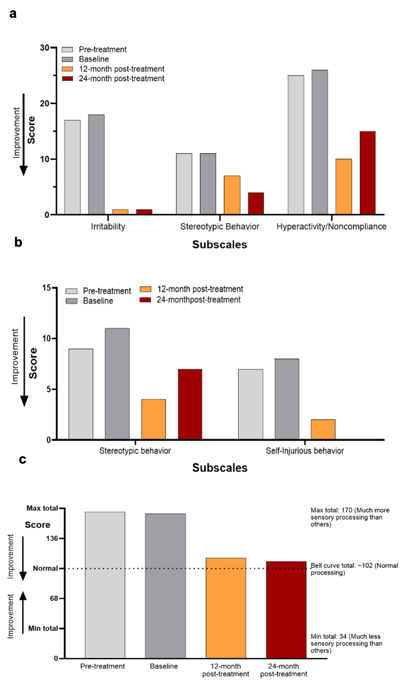
Legend for Supplemental Figure 3: Communication, aberrant behavior, and sensory processing in Patient 1. Patient 1 had improvements in (a) irritability and hyperactivity, (b) stereotyped behavior and self-injurious behavior, and (c) improved sensory processing ability.

Supplemental Figure 4: Additional Endpoints in Patient 2
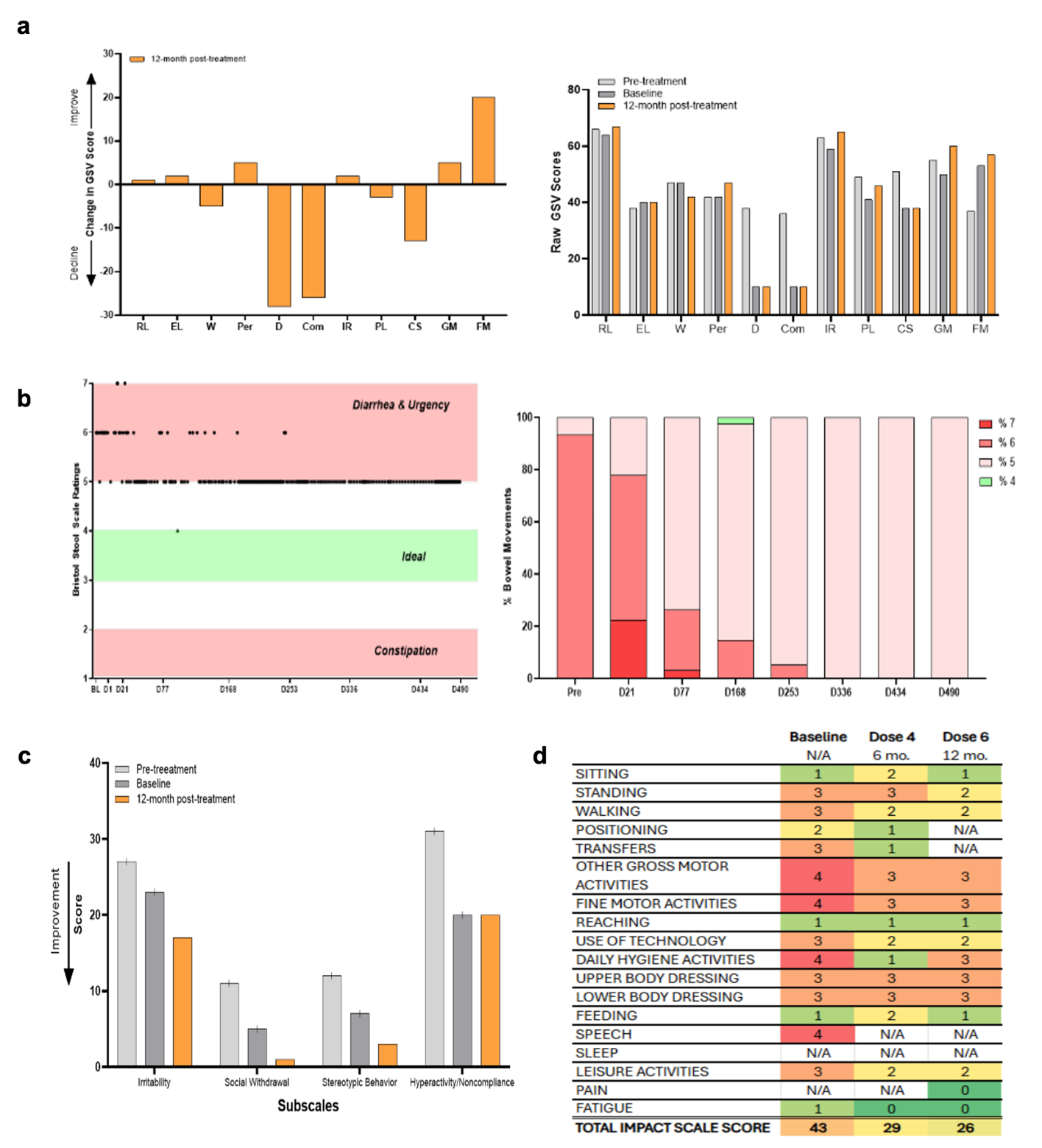

Legend for Supplemental Figure 4:
a. Vineland Adaptive Behavior Scales – Version 3 (Vineland-3) The Vineland-3 is a valid and reliable measure of a person's adaptive level of functioning from birth to 90 years of age. In addition to standard scores and age-equivalents, growth score values (GSVs, person ability scores) are available for all subdomain scores allowing reliable assessment of change even in
those who floor the measure or appear to make no progress when using standard scores due to functional level far below chronological age. Cog = cognitive, EL = expressive language, RL = receptive language, FM = fine motor, GM = gross motor, W = written, Per = personal, D = Domestic, Com = community, IR = interpersonal relationships, PL = play and leisure, CS = coping skills.
b. Bristol Stool Form Scale The Bristol stool scale is a diagnostic medical tool designed to classify the form of human feces into seven categories. It has been used to track and diagnose irritable bowel syndrome and is sensitive to change in intestinal transit time following several medications. Post-ASO, Patient 2 showed improvement in bowel movements, specifically with respect to irritable bowel and intestinal transit. A score of 3-4 on this scale represents normal bowel movements, while 7 is indicative of diarrhea and 1 is indicative of constipation. Patient 2 had normalized bowel movements (Score of 5) and required minimal suppository use.
c. ABC Aberrant Behavior Checklist – Community Edition (ABC-C) The Aberrant Behavior Checklist- Community Edition (ABC-C) is a 58-item parent/caregiver rating scale used to assess the severity of a range of problem behaviors commonly observed in individuals with intellectual disability across five dimensions or subscales: irritability, hyperactivity, lethargy/withdrawal, stereotypy, and inappropriate speech [59]. At 12-month post-treatment, Patient 2 exhibited improvements in irritability, social withdrawal, and stereotyped behavior.
d. Dyskinetic Cerebral Palsy Functional Impact Scale (D-FIS)
The D-FIS is a parent-reported measure used to assess the impact of abnormal muscle tone, such as spasticity (increased tone or stiffness), floppiness (decreased tone), or dyskinesia (fluctuating tone) on the patient’s ability to perform daily activities. Over time, Patient 2 exhibited improvement in different domains of the D-FIS scale.
Supplemental Figure 5: Electroencephalography (EEG) Acquisition and Preprocessing

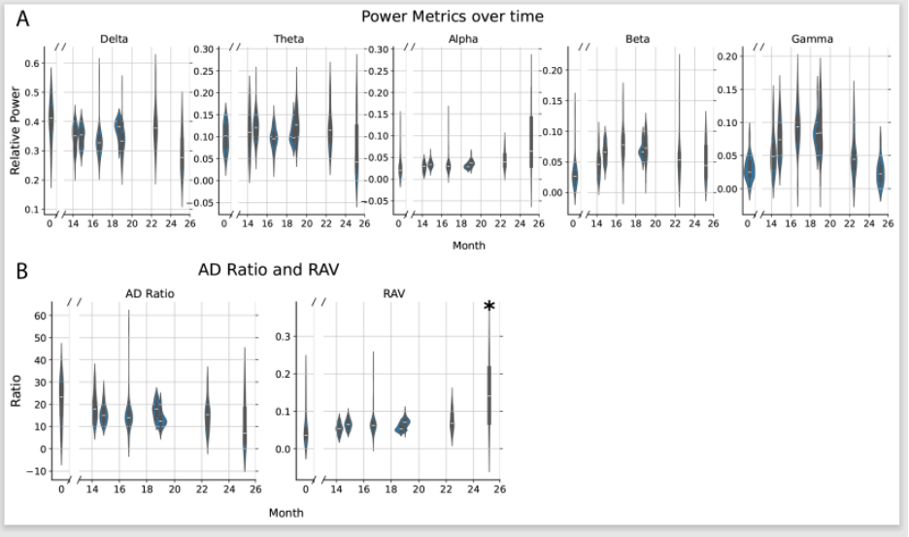
Legend for Supplemental Figure 5 :
(A) EEG metrics across each session (0=baseline). EEG was calculated from 5 minute epochs for each session. Metrics included relative power in canonical frequency bands: delta (1–4 Hz), theta (4–8 Hz), alpha (8–13 Hz), beta (13–30 Hz), and gamma (30–50 Hz) (A) as well as alpha/delta (AD) ratio and relative alpha variability (RAV) (B). Violin plots, which display the median, interquartile range, and 1.5x interquartile range along with a kernel density estimation are shown. *indicates significance of RAV (β = 0.087, SE = 0.040, z = 2.20, p = 0.028, 95% CI [0.009, 0.165]). EEG data were collected using Natus and Nihon Kohden systems, with session 0 as a baseline and after ASO administration. Recordings employed a standard international 10-20 montage at 256 Hz (Natus) or 200 Hz (Nihon Kohden) sampling rate. The resulting signals were bandpass filtered (1–70 Hz, FIR) and notch filtered at 60 Hz to attenuate line noise. Each EEG was manually reviewed by Board-certified epileptologists and significant artifact as well as sleep were annotated and removed from analysis. Spectral features were computed from non-overlapping 5-minute epochs using Welch’s method. A mixed effects linear model was fit with each metric as the dependent variable and each 5 minute epoch nested within each session, with each session modeled as a random effect. The relative power as well as ADR and RAV values are shown with violin plots, which display the median, interquartile range, and 1.5x interquartile range along with a kernel density estimation. No significant difference was seen between the relative power in all frequency bands (A) nor was there a significant difference between the ADR (Figure B). There was, however, significant increased RAV for the EEG collected after the last session (β = 0.087, SE = 0.040, z = 2.20, p = 0.028, 95% CI [0.009, 0.165]) (B). The EEG frequency analysis suggests an increase in relative alpha variability at the last session, which may suggest an improvement in cortical function.

