Appendix A. Supplementary Data

Table S1. Single and total complex pollution indices.
Index | Formula | References
Enrichment factor(EF) | EF=(C_{n}/C_{ref})/(B_{n}/B_{ref(Al)}) (1) | Reimann and de Caritat (2000), Sutherland (2000), Kowalska et al. (2018)
Geoaccumulation index (I_{geo}) | I_{geo}=log₂(C_{n}/1.5xB_{n}) (2) | Müller (1969), Loska et al. 2003); Ji et al. (2008), Lu and Bai 2010).
Contamination factor (Cf) | C_{f}=C_{m}/C_{np} (3) | Hakanson (1980), Loska et al. (2004)
Degree of contamination (Cdeg) | $C_{deg}=\sum_{i=1}^{n}{ }C_{f}^{i}$ (4) | Hakanson (1980), Caeiro et al. (2005)
Modified degree of contamination (mCd) | ${mC}_{deg}=\frac{1}{n}x\sum_{i=1}^{n}{ }C_{f}^{i}$ (5) | Abrahim and Parker (2008)
Modified Pollution Index (MPI) | $MPI=\sqrt{\frac{{\left({EF}_{average}\right)}^{2}+{\left({EF}_{max}\right)}^{2}}{2}}$ (6) | Brady et al. (2015)

Table S2. Classes of single Igeo, EF, CF and total complex indices Cdeg, mCdeg, MPI.
Single Indices | Value | Quality
EF | EF < 2  EF = 2–5  EF = 5–20  EF = 20–40  EF > 40 | Deficiency to minimal mineral enrichment  Moderate enrichment  Significant enrichment  Very high enrichment  Extremely high enrichment
I_{geo} | Igeo ≤ 0  0 ≤ I_{geo} < 1  1 ≤ I_{geo} < 2  2 ≤ I_{geo} < 3  3 ≤ I_{geo} < 4  4 ≤ I_{geo} < 5  I_{geo} > 5 | Uncontaminated  Uncontaminated to moderately contaminated  Moderately contaminated  Moderately to strongly contaminated  Strongly contaminated  Strongly to extremely contaminated  Extremely high contaminated
CF | CF < 1  1 ≤ CF ≤ 3  3 ≤ CF ≤ 6  6 ≤ CF | Low contamination factor  Moderate contamination factor  Considerable contamination factor  Very high contamination factor
Cdeg | C_{deg} < 8  8 ≤ C_{deg} ≤ 16  16 ≤ C_{deg} ≤ 32  32 ≤ C_{deg} | Low degree of contamination  Moderate degree of contamination  Considerable degree of contamination  Very high degree of contamination
mCdeg | mCdeg ≤ 1.5  1.5 ≤ mCdeg ≤ 2  2 ≤ mCdeg ≤ 4  4 ≤ mCdeg ≤ 8  8 ≤ mCdeg ≤ 16  16 ≤ mCdeg ≤ 32  32 ≤ mCdeg | Nil to Very low contamination  Low contamination  Moderate contamination  High contamination  Very high contamination  Extremely high contamination  Ultra high contamination
MPI | MPI<1  1 <MPI <2  2<MPI <3  3<MPI <5  5 <MPI <10  MPI> 10 | Unpolluted  Slightly polluted  Moderately polluted  Moderately heavily polluted  Heavily polluted  Extremely polluted

Table S3. Classification of sediment quality guidelines (SQGs) and its effects.
SQGs |  | Effect | Toxicity (%) | References
TEL and PEL guidelines | <TEL | Not associated with adverse biological effects | 9 | MacDonald et al. (2000)  Québec (2007).
TEL and PEL guidelines | TEL to PEL | Adverse biological effects occur occasionally | 22 | MacDonald et al. (2000)  Québec (2007).
TEL and PEL guidelines | >PEL | Adverse biological effects occur frequently | 56 | MacDonald et al. (2000)  Québec (2007).
ERL and ERM guidelines | <ERL | Minimal effects | 25 | Long et al. (1995).
ERL and ERM guidelines | ERL to ERM | Occasionally | 25-75 | Long et al. (1995).
ERL and ERM guidelines | >ERM | Frequently | 75-100 | Long et al. (1995).

Table S4. Pearson coefficients between trace element contents and sediment properties.
 | Al | As | Ba | Ca | Co | Cr | Cu | Fe | Mn | Mo | Nb | Ni | Pb | Rb | S | Sb | Sn | Sr | V | Zn | Sand | Silt | Clay | Carb. | OC
Al | 1
As | 0.19 | 1
Ba | .43** | -0.09 | 1
Ca | -.92** | -.36** | -.25* | 1
Co | .77** | .36** | -0.05 | -.81** | 1
Cr | .60** | .37** | -0.01 | -.70** | .79** | 1
Cu | .68** | .29* | -0.09 | -.72** | .71** | .47** | 1
Fe | .86** | .38** | 0.07 | -.88** | .92** | .71** | .79** | 1
Mn | .55** | .40** | 0.03 | -.59** | .66** | .59** | .33** | .67** | 1
Mo | 0.06 | 0.05 | 0.15 | -0.13 | -0.04 | -0.07 | .17 | -0.04 | -0.16 | 1
Nb | .92** | 0.12 | .47** | -.86** | .65** | .48** | .63** | .76** | .43** | 0.14 | 1
Ni | .59** | .38** | -0.19 | -.70** | .86** | .91** | .61** | .76** | .59** | -0.04 | .45** | 1
Pb | .54** | 0.12 | 0.18 | -.52** | .27* | 0.00 | .62** | .43** | 0.12 | .28* | .52** | 0.10 | 1
Rb | .71** | 0.16 | .28* | -.71** | .52** | .34** | .44** | .54** | .42** | 0.16 | .74** | .43** | .54** | 1
S | -.50** | -0.22 | -0.19 | .44** | -.58** | -.61** | -0.17 | -.55** | -.59** | .47** | -.41** | -.56** | .24* | -.25* | 1
Sb | .36** | .71** | -0.19 | -.44** | .53** | .34** | .54** | .51** | .35** | 0.09 | .31** | .50** | .37** | .38** | -0.24 | 1
Sn | .60** | 0.10 | 0.15 | -.60** | .39** | 0.22 | .64** | .56** | .25* | 0.15 | .59** | .24* | .68** | .39** | 0.08 | 0.21 | 1
Sr | -.83** | -.45** | -0.07 | .95** | -.85** | -.75** | -.69** | -.88** | -.66** | -0.04 | -.75** | -.78** | -.42** | -.67** | .49** | -.50** | -.50** | 1
V | .87** | .36** | 0.22 | -.88** | .84** | .69** | .72** | .94** | .57** | 0.08 | .77** | .68** | .44** | .50** | -.48** | .41** | .59** | -.85** | 1
Zn | .67** | .32** | -0.22 | -.76** | .77** | .56** | .86** | .85** | .53** | 0.02 | .59** | .68** | .57** | .48** | -.25* | .52** | .68** | -.79** | .77** | 1
Sand | -.54** | -.24* | .27* | .63** | -.59** | -.48** | -.76** | -.62** | -.35** | -0.14 | -.45** | -.65** | -.52** | -.46** | 0.11 | -.50** | -.54** | .64** | -.56** | -.77** | 1
Silt | .56** | 0.15 | -.24* | -.64** | .59** | .52** | .72** | .61** | .33** | 0.11 | .47** | .67** | .49** | .48** | -0.17 | .43** | .49** | -.65** | .56** | .74** | -.96** | 1
Clay | .39** | .38** | -0.18 | -.47** | .44** | .30* | .66** | .47** | .35** | 0.15 | .30* | .45** | .47** | .29* | 0.00 | .50** | .55** | -.47** | .43** | .62** | -.74** | .560** | 1
Carb. | -.92** | -.31* | -.31** | .96** | -.77** | -.67** | -.69** | -.84** | -.58** | -0.14 | -.86** | -.64** | -.50** | -.66** | .44** | -.40** | -.59** | .89** | -.85** | -.70** | .59** | -.60** | -.44** | 1
OC | -.33** | -0.13 | -.25* | 0.23 | -.31* | -.40** | 0.15 | -.31** | -.53** | .46** | -0.19 | -.29* | .24* | -0.12 | .76** | -0.08 | 0.10 | .25* | -.28* | -0.02 | -0.12 | 0.08 | 0.11 | .25* | 1
**. Correlation is significant at the 0.01 level (2-tailed).
*. Correlation is significant at the 0.05 level (2-tailed).

Table S5. Rotated component matrix for data of Edremit Gulf
(PCA loadings>0.4 are shown in bold).
Element | Component
Element | FAC1 | FAC2 | FAC3 | FAC4 | FAC5
Al | 0.48 | 0.42 | 0.71 | 0.08 | -0.18
As | 0.15 | 0.07 | 0.04 | 0.90 | -0.04
Ba | -0.15 | -0.25 | 0.85 | -0.14 | -0.01
Ca | -0.59 | -0.44 | -0.59 | -0.21 | 0.06
Co | 0.73 | 0.35 | 0.26 | 0.29 | -0.23
Cr | 0.87 | 0.06 | 0.14 | 0.21 | -0.19
Cu | 0.42 | 0.75 | 0.20 | 0.20 | 0.08
Fe | 0.59 | 0.49 | 0.40 | 0.27 | -0.28
Mn | 0.48 | 0.16 | 0.24 | 0.34 | -0.45
Mo | 0.07 | -0.01 | 0.25 | 0.12 | 0.87
Nb | 0.38 | 0.37 | 0.77 | 0.04 | -0.06
Ni | 0.88 | 0.24 | 0.01 | 0.27 | -0.14
Pb | -0.10 | 0.76 | 0.44 | 0.07 | 0.22
Rb | 0.32 | 0.32 | 0.60 | 0.14 | 0.06
S | -0.54 | 0.17 | -0.24 | -0.14 | 0.68
Sb | 0.22 | 0.35 | 0.04 | 0.78 | 0.00
Sn | 0.04 | 0.78 | 0.40 | -0.03 | 0.01
Sr | -0.67 | -0.40 | -0.42 | -0.29 | 0.12
V | 0.56 | 0.43 | 0.51 | 0.21 | -0.17
Zn | 0.48 | 0.76 | 0.13 | 0.20 | -0.11
Sand | -0.52 | -0.75 | 0.04 | -0.13 | -0.12
Silt | 0.61 | 0.66 | -0.01 | 0.00 | 0.12
Clay | 0.21 | 0.70 | -0.02 | 0.33 | 0.07
CaCO₃ | -0.56 | -0.40 | -0.62 | -0.16 | 0.07
OC | -0.25 | 0.28 | -0.25 | -0.09 | 0.75
Eigenvalue | 13.38 | 3.35 | 2.45 | 1.33 | 1.02
% Of variance explained | 51.5 | 12.9 | 9.5 | 5.3 | 3.9
% Of cumulative | 51.5 | 64.4 | 73.9 | 79.2 | 83.1
Extraction method: principal component analysis.
Rotation method: varimax with Kaiser normalization.

Table S6. Calculated pollution indices related to heavy metal concentrations.
Pollution Indices | Elements | Value | Degree of contamination
CF | As | 1.62 | Moderate contamination
CF | Cr | 0.84 | Low contamination
CF | Cu | 0.82 | Low contamination
CF | Ni | 0.71 | Low contamination
CF | Pb | 0.99 | Low contamination
CF | Zn | 0.86 | Low contamination
PLI |  | 0.99 | Not polluted
C_{deg} |  | 5.84 | Low degree of cont.
mC_{deg} |  | 0.97 | Nil to very low cont.

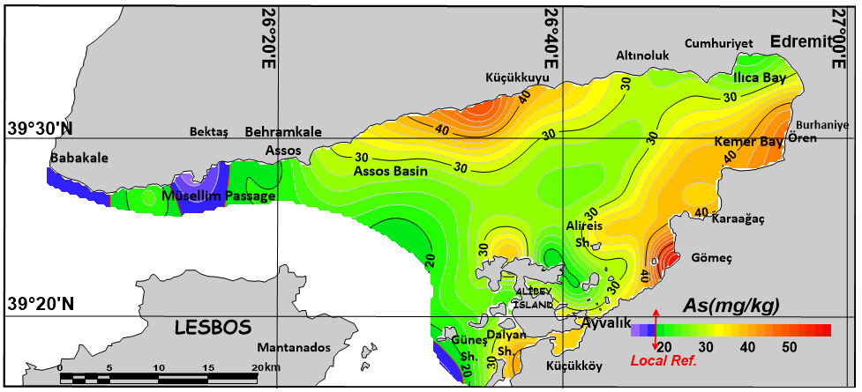
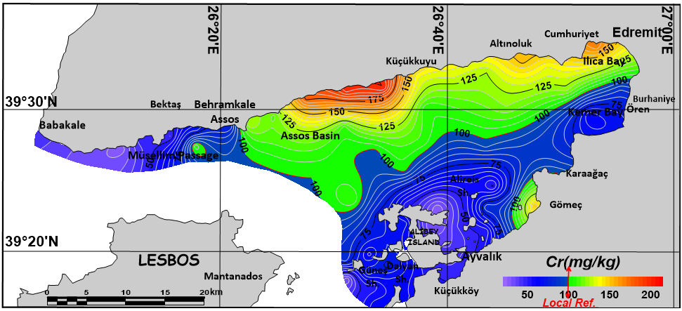
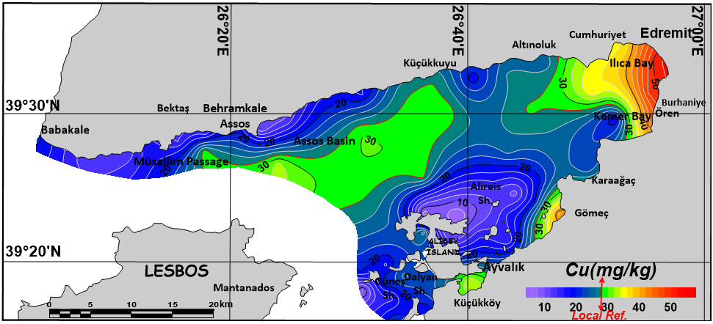
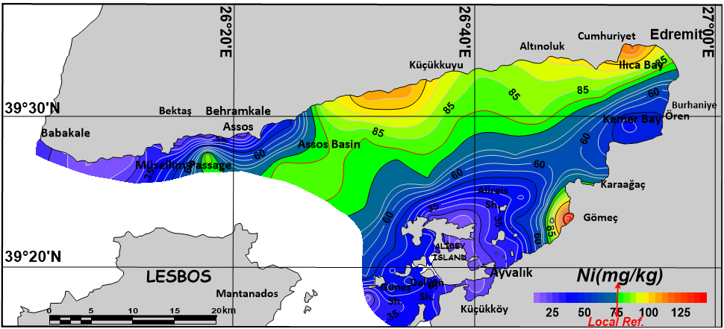
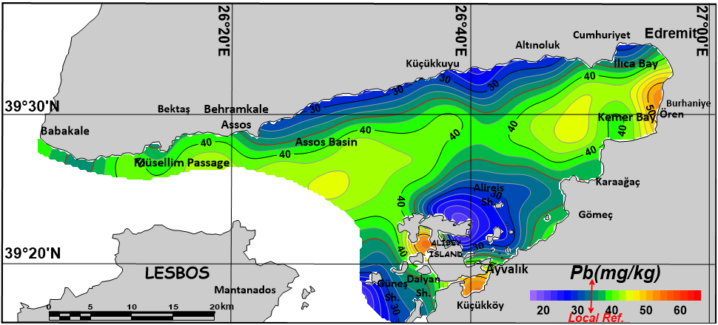
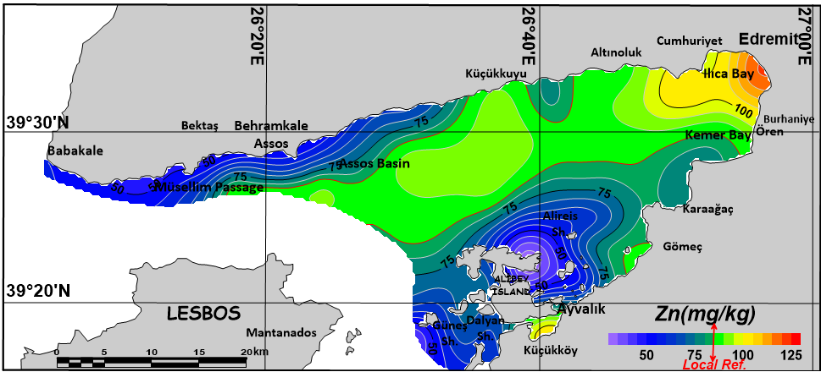
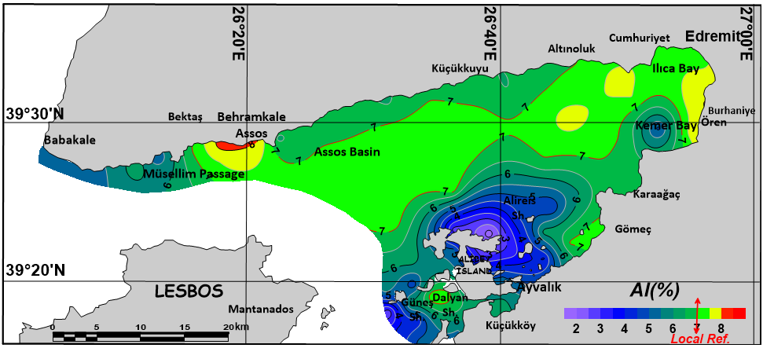
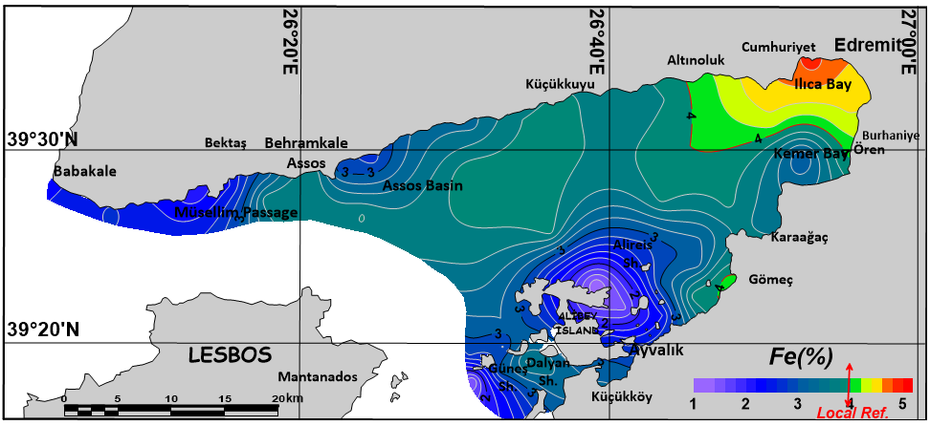

Fig S1. Spatial distribution of trace elements in the Edremit Gulf.

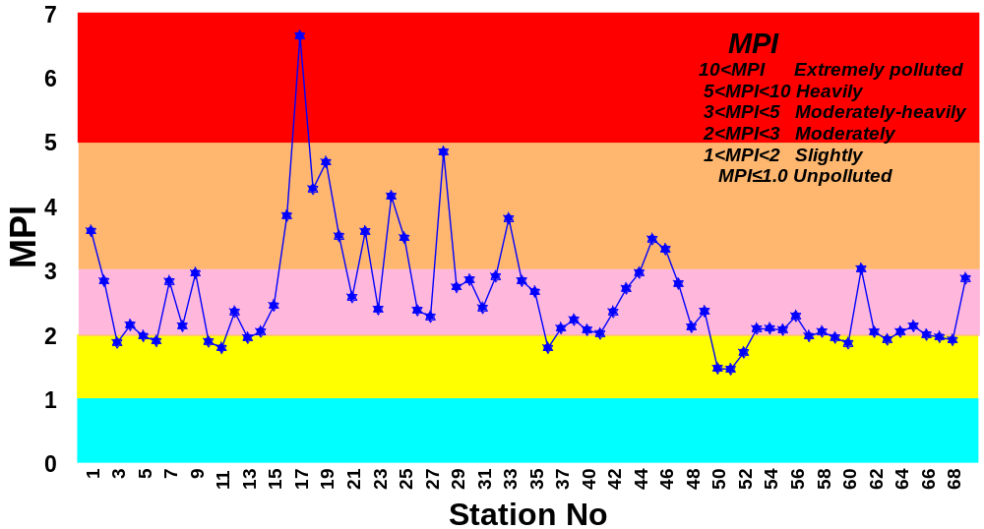

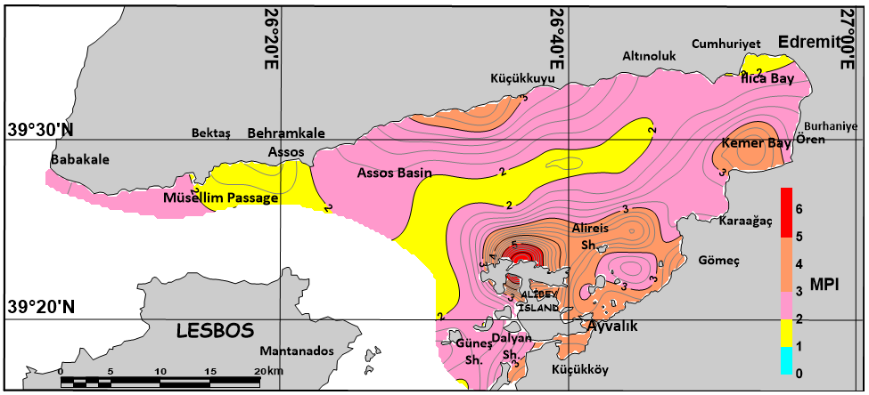

Fig. S2. Stationary (top) and areal distribution (below) of the Modified Pollution Index (MPI).

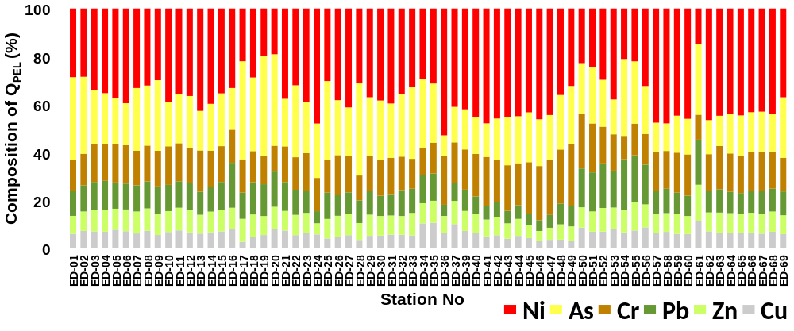
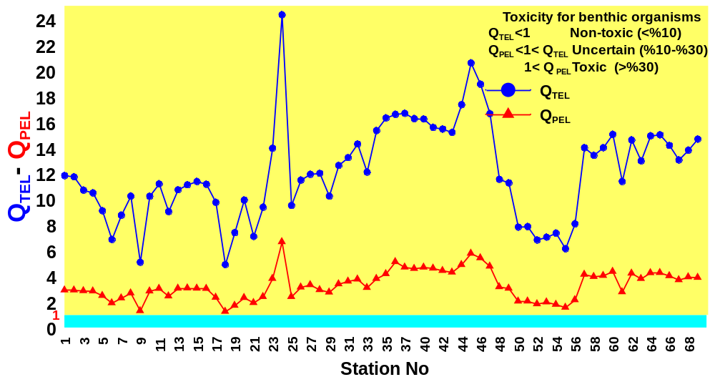

Fig. S3. Stationary distribution of Q_{TEL} and Q_{PEL} values (top) calculated based on metal concentrations and the contribution of six heavy metals to the total risk quotients (Q_{PEL}) (below) of the sediments of the Gulf of Edremit.

References

Abrahim, G.M.S., Parker, R.J. (2008). Assessment of heavy metal enrichment factors and the degree of contamination in marine sediments from Tamaki Estuary, Auckland, New Zealand. Environmental Monitoring and Assessment, 136(1–3), 227–238.
Brady, J. P., Ayoko, G. A., Martens, W. N., & Goonetilleke, A. (2015). Development of a hybrid pollution index for heavy metals in marine and estuarine sediments. Environ Monit Assess., 187(5), 306.
Caeiro, S., Costa, M. H., Ramos, T. B., Fernandes, F., Silveira, N., Coimbra, A., Medeiros, G., & Painho, M. (2005). Assessing heavy metal contamination in Sado estuary sediment: an index analysis approach. Ecological Indicators, 5(2), 151–169.
Hakanson, L. (1980). An ecological risk index for aquatic pollution control.a sedimentological approach. Water Research, 14(8), 975–1001.
Ji, Y., Feng, Y.,Wu, J., Zhu, T., Bai, Z., Duan, C. (2008). Using geoaccumulation index to study source profiles of soil dust in China. Journal of Environmental Sciences, 20(5), 571–578.
Kowalska, J.B., Mazurek, R., Gasiorek, M., Zaleski, T. (2018). Pollution indices as useful tools for the comprehensive evaluation of the degree of soil contamination–A review. Environmental Geochemistry and Health, 40, 2395–2420.
Long, E.R., McDonald, D.D., Smith S.L., Calder, F.D. (1995). Incidence of Adverse Biological Effects Within Range of Chemical Concentrations in Marine and Estuarine Sediments. Environmental Management, 19(1), 81–97.
Loska, K.,Wiechula, D., Barska, B., Cebula, E., Chojnecka, A. (2003). Assessment of arsenic enrichment of cultivated soils in southern Poland. Polish Journal of Environmental Studies, 12(2), 187–192.
Loska, K.,Wiechuła, D., Korus, I. (2004). Metal contamination of farming soils affected by industry. Environment International, 30(2), 159–165.
Lu, S.G., Bai, S.Q. (2010). Contamination and potential mobility assessment of heavy metals in urban soils of Hangzhou, China: Relationship with different land uses. Environmental Earth Sciences, 60(7), 1481–1490.
MacDonald, D.D., Ingersoll, C.G., Berger, T.A. (2000). Development and Evaluation of Consensus-Based Sediment Quality Guidelines for Freshwater Ecosystems. Archives of Environmental Contamination and Toxicology, 39, 20–31.
Müller, G. (1969). Index of geoaccumulation in sediments of the Rhine River. GeoJournal, 2, 108–118.
Québec (2007). Criteria for the Assessment of Sediment Quality in Quebec and Application Frameworks: Prevention, Dredging and Remediation, 39 pp
Reimann, C., de Caritat, P. (2000). Intrinsic flaws of element enrichment factors (EFs) in environmental geochemistry. Environmental Science and Technology, 34(24), 5084–5091.
Sutherland, R. A. (2000). Bed sediment-associated trace metals in an urban stream, Oahu, Hawaii. Environmental Geology, 39(6), 611–627.

