Multi-omics characterisation of Daphnia magna exposed to PFAS and microplastics: transcriptome and gut microbiome datasets

Muhammad Abdullahi¹, Sam Benktwitz-Bedford¹, Tayebeh Soltanighias¹, Abubakar Umar², Luisa Orsini¹

Affiliations
¹School of Biosciences and Centre for Environmental Research and Justice (CERJ), University of Birmingham, Birmingham, UK
²School of Geography, Earth & Environmental Sciences, University of Birmingham, Birmingham, UK

Corresponding author(s): Luisa Orsini (l.orsini@bham.ac.uk)

Supplementary table and figures
Supplementary Table 1. Gene read counts by day, treatment, and replicate. Read counts for all genes identified in the dataset, separated by sampling day, treatment, and replicate. Tab 1 contains data for genotype LRV0_1; Tab 2 contains data for genotype LRII36_01.

See Abdullahi et al. Supplementary Table 1

Supplementary Table 2. ASV counts by day, treatment, and replicate. Counts for all ASV in the dataset, separated by sampling day, treatment, and replicate. Tab 1 contains data for genotype LRV0_1; Tab 2 contains data for genotype LRII36_01.

See Abdullahi et al. Supplementary Table 2

Figure S1. Principal Component Analysis (PCA) by treatment and sampling day for the Daphnia transcriptome. PCA plots are shown separately for each exposure condition (PFOS, PFOA, PET, PFOS+PFOA, PFOS+PET, PFOA+PET, PFOS+PFOA+PET) and treatment day, including both genotypes—LRV0_1 (black) and LRII36_1 (red)—with their biological replicates. Control samples are represented by open symbols, while treated samples are represented by filled symbols.
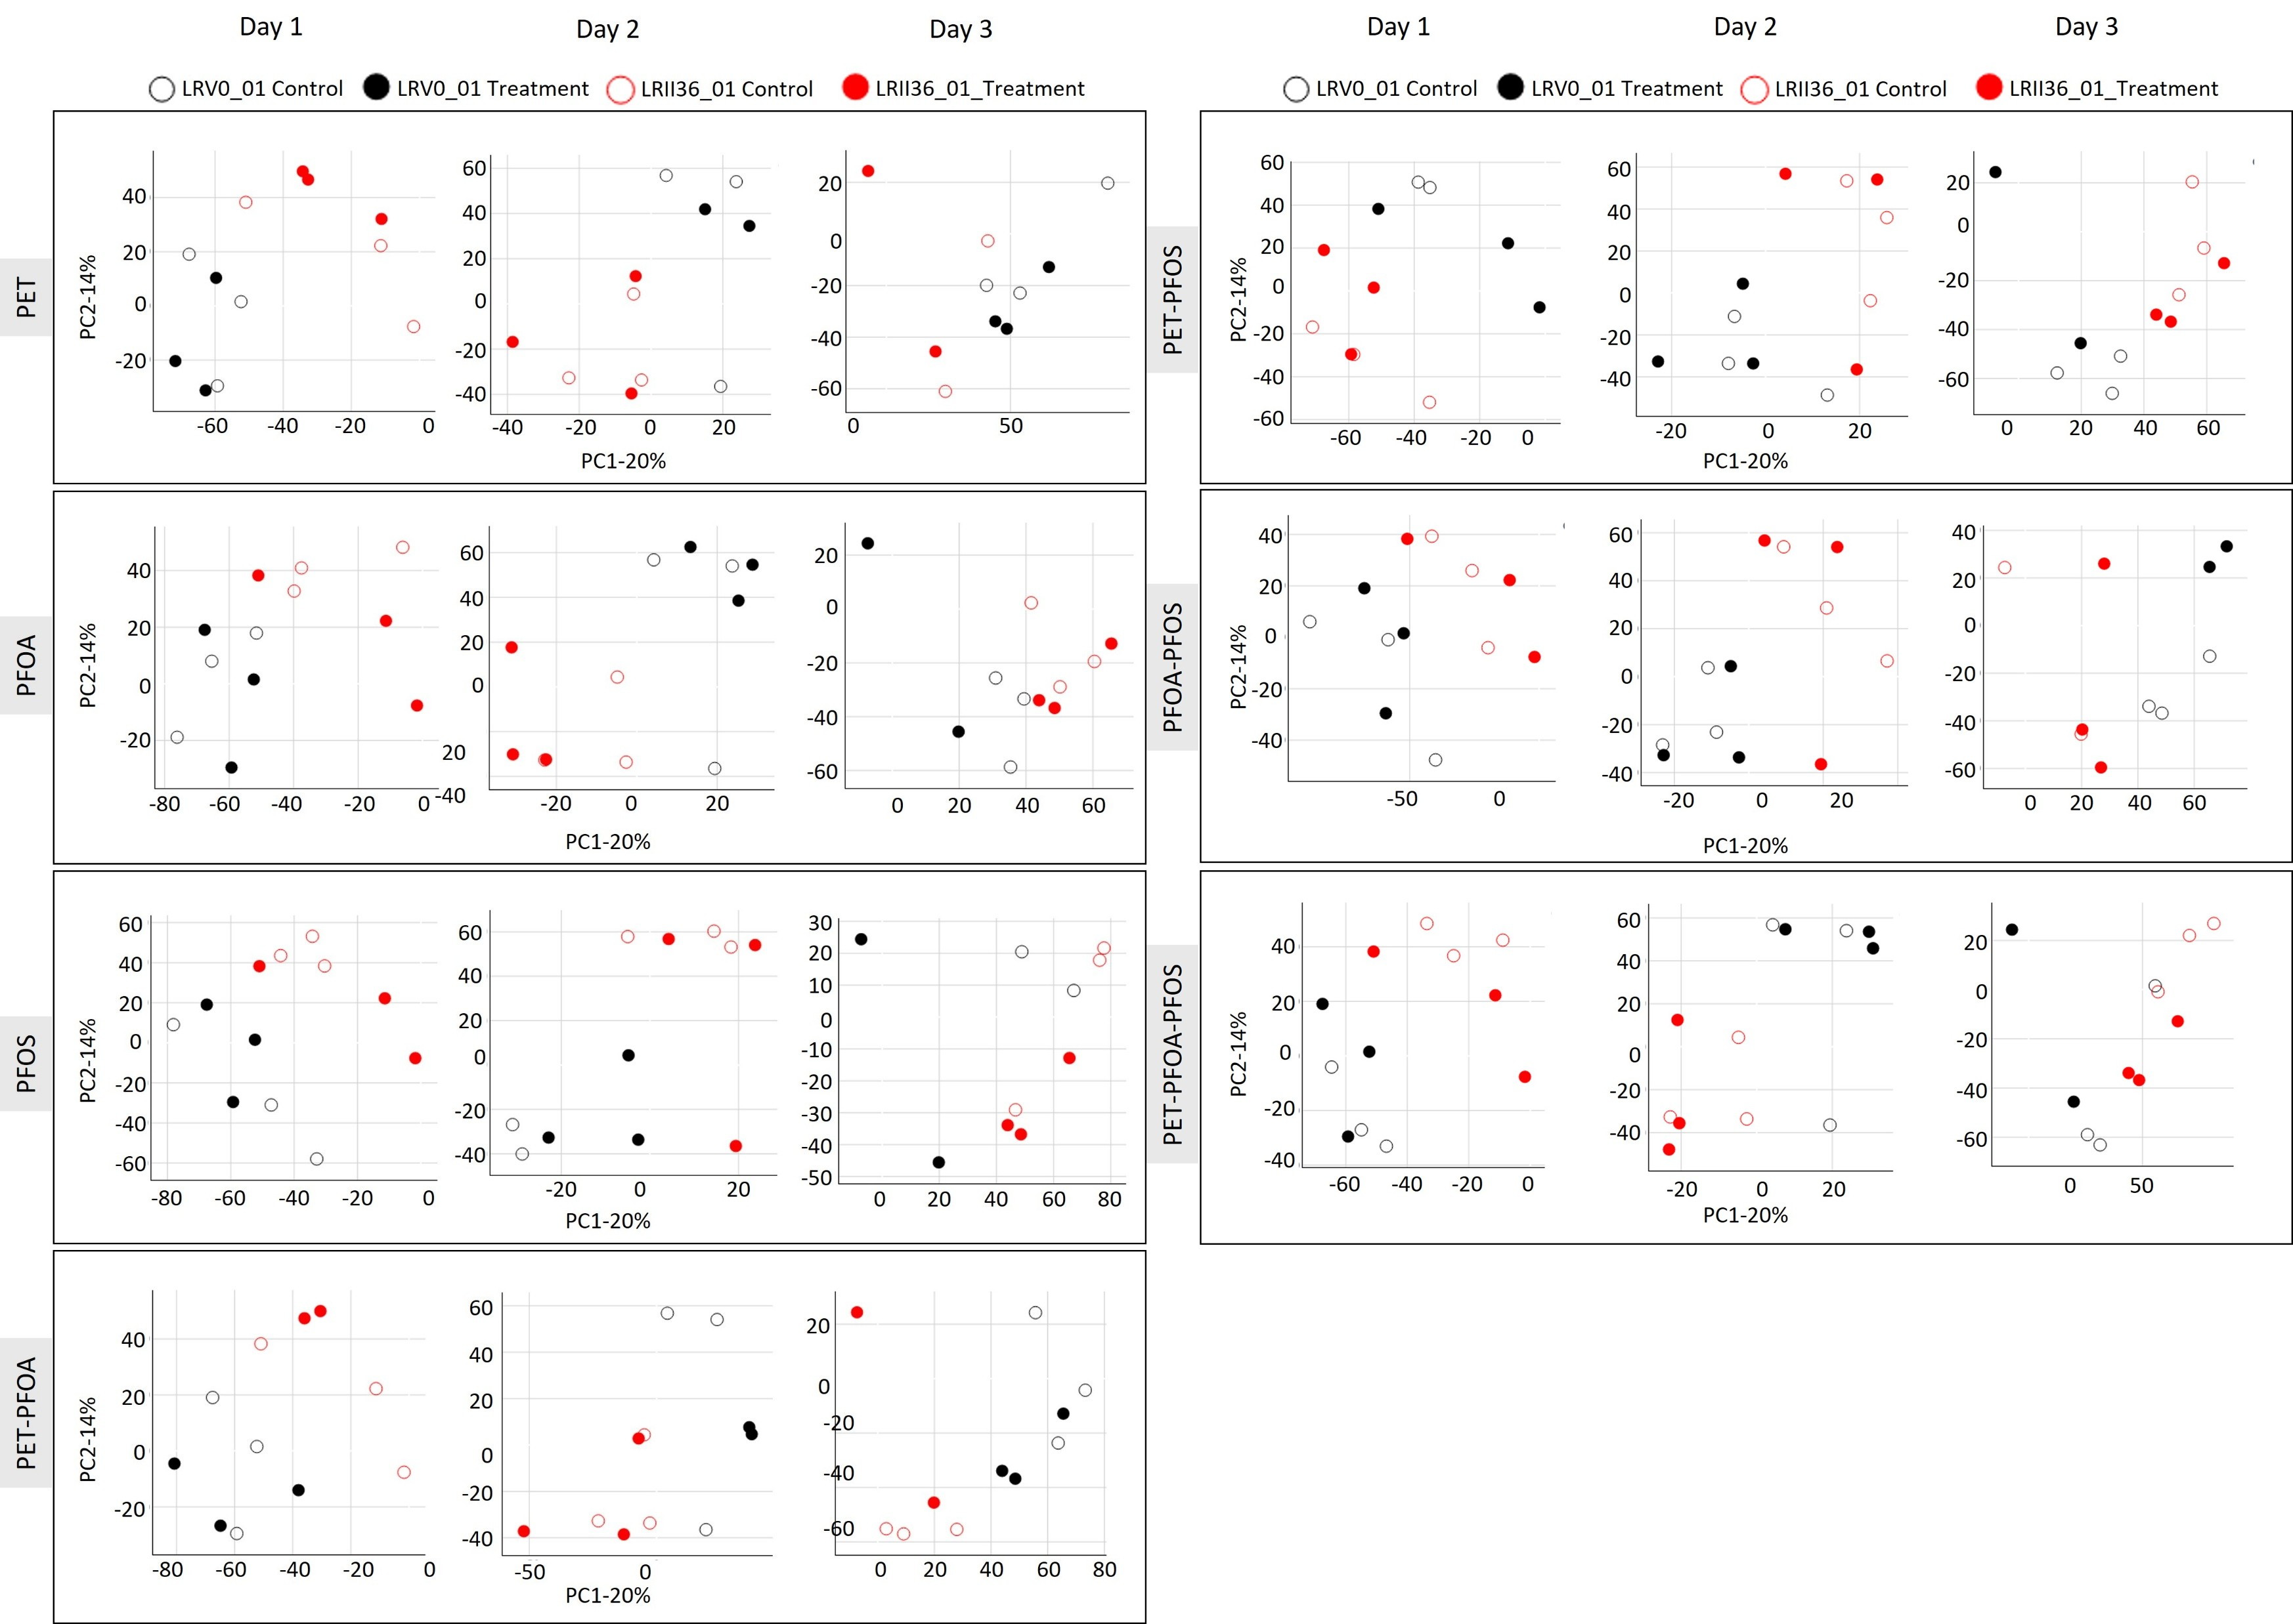

Figure S2. Alpha diversity. Alpha diversity between control (shaded pattern) and treatment (solid patterns) of the two D. magna genotypes—LRV0_1 (black) and LRII36_01 (red)—shown with their biological replicates, displayed by treatment and day. The paired Wilcoxon tests (P<0.05) was non-significant for all pairwise comparisons.
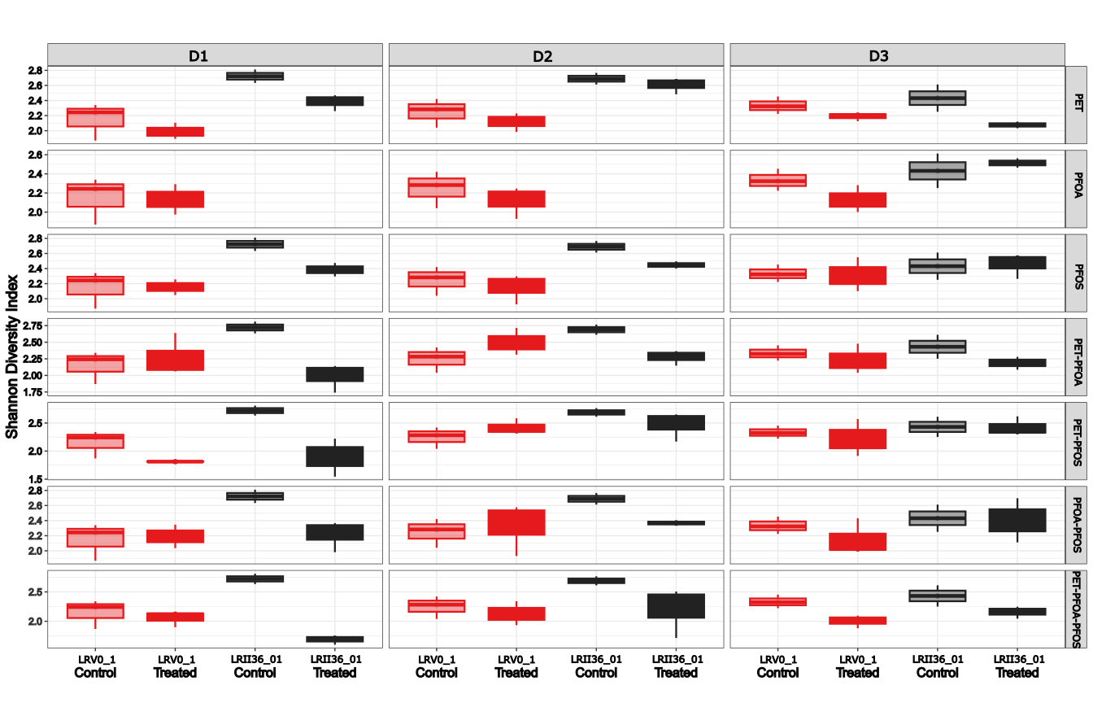

Figure S3. Principal Coordinates Analysis (PCoA) of microbiome profiles across three sampling days. PCoA plots of beta diversity between control and exposed Daphnia genotypes —LRV0_1 (black) and LRII36_01 (red)—shown for each exposure condition (PFOS, PFOA, PET, PFOS+PFOA, PFOS+PET, PFOA+PET, PFOS+PFOA+PET) and treatment day. Control samples are represented by open symbols, while treated samples are represented by filled symbols.
