Additional file 1

- Fig.S1 The deaths rate per 100,000 population of GBTC aged 55 years and above globally and in 5 territories from 1990 to 2021.
- Fig.S2 The DALYs rate per 100,000 population of GBTC aged 55 years and above globally and in 5 territories from 1990 to 2021.
- Fig.S3 The deaths rate per 100,000 population of GBTC aged 55 years and above globally, across 5 territories and 21 GBD regions in 1990 and 2021.
- Fig.S4 The DALYs rate per 100,000 population of GBTC aged 55 years and above globally, across 5 territories and 21 GBD regions in 1990 and 2021.
- Fig.S5 Percentage change in death cases of GBTC aged 55 years and above across 204 countries in 1990 and 2021.
- Fig.S6 Percentage change in DALYs cases of GBTC aged 55 years and above across 204 countries in 1990 and 2021.
- Fig.S7 EAPC of incident rates of GBTC aged 55 years and above burden across 204 countries from 1990 to 2021.
- Fig.S8 EAPC of DALYs rates of GBTC aged 55 years and above across 204 countries from 1990 to 2021.
- Fig.S9 Death cases of GBTC aged 55 years and above in 9 age groups (55–95+ years, 5-year intervals) from 1990 to 2021 globally and in 5 territories (low to high SDIs).
- Fig.S10 Incident cases of GBTC aged 55 years and above in 9 age groups (55–95+ years, 5-year intervals) from 1990 to 2021 globally and in 5 territories (low to high SDIs).
- Fig.S11 DALYs cases of GBTC burden aged 55 years and above in 9 age groups (55–95+ years, 5-year intervals) from 1990 to 2021 globally and in 5 territories (low to high SDIs).
- Fig.S12 Percentage change in incident cases of GBTC aged 55 years and above across 9 age groups globally and in 5 territories in 1990 and 2021.
- Fig.S13 Percentage change in death cases of EAPC among individuals GBTC aged 55 years and above across 9 age groups globally and in 5 territories in 1990 and 2021.
- Fig.S14 EAPC of incident rates of GBTC burden aged 55 years and above across 9 age groups globally and in 5 territories from 1990 to 2021.
- Fig.S15 EAPC of DALYs rates of GBTC burden aged 55 years and above across 9 age groups globally and in 5 territories from 1990 to 2021.
- Fig.S16 The distribution of incident cases of GBTC burden aged 55 years and above across 7 age groups as percentages globally, in 5 territories, and 21 GBD regions in 1990 and 2021.
- Fig.S17 The distribution of death cases of GBTC burden aged 55 years and above across 7 age groups as percentages globally, in 5 territories, and 21 GBD regions in 1990 and 2021.
- Fig.S18 The distribution of DALY cases of GBTC burden aged 55 years and above across 7 age groups as percentages globally, in 5 territories, and 21 GBD regions in 1990 and 2021.
- Fig.S19 The associations between the SDI and death rates per 100,000 population of GBTC aged 55 years and above across 21 GBD regions.
- Fig.S20 The associations between the SDI and incident rates per 100,000 population of GBTC aged 55 years and above across 21 GBD regions.
- Fig.S21 The associations between the SDI and DALYs rates per 100,000 population of GBTC aged 55 years and above across 21 GBD regions.

Fig.S1 The deaths rate per 100,000 population of GBTC aged 55 years and above globally and in 5 territories from 1990 to 2021.

Fig.S2 The DALYs rate per 100,000 population of GBTC aged 55 years and above globally and in 6 territories from 1990 to 2021.
Fig.S3 The deaths rate per 100,000 population of GBTC aged 55 years and above globally, across 5 territories and 21 GBD regions in 1990 and 2021.
Fig.S4 The DALYs rate per 100,000 population of GBTC aged 55 years and above globally, across 5 territories and 21 GBD regions in 1990 and 2021.

Fig.S5 Percentage change in death cases of GBTC aged 55 years and above across 204 countries in 1990 and 2021.
Fig.S6 Percentage change in DALYs cases of GBTC aged 55 years and above across 204 countries in 1990 and 2021.
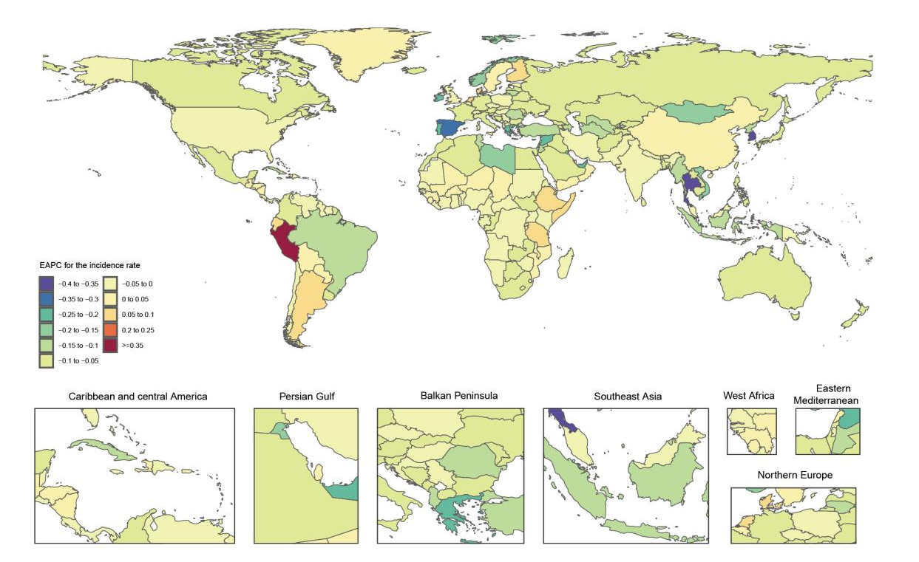
Fig.S7 EAPC of incident rates of GBTC aged 55 years and above burden across 204 countries from 1990 to 2021.
Fig.S8 EAPC of DALYs rates of GBTC aged 55 years and above across 204 countries from 1990 to 2021.
Fig.S9 Death cases of GBTC aged 55 years and above in 9 age groups (55–95+ years, 5-year intervals) from 1990 to 2021 globally and in 5 territories (low to high SDIs).
Fig.S10 Incident cases of GBTC aged 55 years and above in 9 age groups (55–95+ years, 5-year intervals) from 1990 to 2021 globally and in 5 territories (low to high SDIs).

Fig.S11 DALYs cases of GBTC burden aged 55 years and above in 9 age groups (55–95+ years, 5-year intervals) from 1990 to 2021 globally and in 5 territories (low to high SDIs).
Fig.S12 Percentage change in incident cases of GBTC aged 55 years and above across 9 age groups globally and in 5 territories in 1990 and 2021.
Fig.S13 Percentage change in death cases of EAPC among individuals GBTC aged 55 years and above across 9 age groups globally and in 5 territories in 1990 and 2021.
Fig.S14 EAPC of incident rates of GBTC burden aged 55 years and above across 9 age groups globally and in 5 territories from 1990 to 2021.
Fig.S15 EAPC of DALYs rates of GBTC burden aged 55 years and above across 9 age groups globally and in 5 territories from 1990 to 2021.
Fig.S16 The distribution of incident cases of GBTC burden aged 55 years and above across 7 age groups as percentages globally, in 5 territories, and 21 GBD regions in 1990 and 2021.
Fig.S17 The distribution of death cases of GBTC burden aged 55 years and above across 7 age groups as percentages globally, in 5 territories, and 21 GBD regions in 1990 and 2021.

Fig.S18 The distribution of DALY cases of GBTC burden aged 55 years and above across 7 age groups as percentages globally, in 5 territories, and 21 GBD regions in 1990 and 2021.

Fig.S19 The associations between the SDI and death rates per 100,000 population of GBTC aged 55 years and above across 21 GBD regions.
Fig.S20 The associations between the SDI and incident rates per 100,000 population of GBTC aged 55 years and above across 21 GBD regions.
Fig.S21 The associations between the SDI and DALYs rates per 100,000 population of GBTC aged 55 years and above across 21 GBD regions.

