Supplementary Material (Appendix)

A. Note for Training Process of Our Generative AI

Our generative AI was trained using only normal (calcification-free) data. We utilized 1121 FFDM images from our institution, ensuring areas without calcifications were marked as ground truth. From this dataset, we extracted 512x512 pixel patches, each containing no calcifications. Using a stride of 32, we ensured each patch contained unique information. We employed an automatic segmentation technique to ensure patches included breast tissue, resulting in 52,433 unique calcification-free patches.
These patches were used to train our generative AI, based on the transformer model. We followed the training method proposed in [1], generating random masks for each 512x512 input patch. These masks were applied as blind spots, and the network learned to reproduce the original patch, minimizing reconstruction loss to inpaint the masked areas accurately. No calcification data was used during training to avoid bias and overfitting. The masks, generated as random curves and bounding boxes of various sizes, typically covered areas larger than actual calcifications, presenting a more challenging task for the network. This approach ensures that during inference, the network can accurately transform only the calcification-positive areas.
Recent diffusion-based denoising generative AIs have been reported to produce artifacts, making them unsuitable for distortion-free image transformation. To address this, we chose a transformer-based image inpainting/translation technique, which claims fewer distortions, as our primary generative AI technology. However, we anticipate using other generative AI technologies in the future.
The main contribution of our research lies not in the novelty of the generative AI backbone but in the innovative two-stage process that combines unsupervised generative AI with non-generative (e.g., general segmentation) AI results in the inference phase. This method uses the non-generative AI output as a mask for the generative AI, proving its effectiveness as a refinement tool. This simple but unique approach demonstrates that unsupervised generative AI can be effectively integrated with non-generative AI results for improved and precise anomaly detection and localization.

B. Note for Setup Details of Refinement Methods and Expansion Process of Patch Results into FFDM Results

Figure A1 illustrates the methodology for expanding patch-based outputs of the implemented algorithms (Figure 3(a)) to the FFDM image level. It also compares traditional signal processing refinement methods with our generative AI-based refinement approach, highlighting similarities and differences.
Specifically, Figure A1 refers to the methods in Stages 1 and 2 (details in Figure 3(a)). Stage 1 uses a supervised learning-based typical segmentation AI network (i.e., SegAI [2, 3]) to output a pixel-level calcification presence probability map (=$P_{local}^{SegAI}$) for a local patch $(=I_{local}^{})$ extracted from the original FFDM image. All refinement techniques in this study enhance this calcification map (=$P_{local}^{SegAI}$) to a new, refined map ($=P_{local}^{Refine}$) as shown in Eq. (1).

$$P_{local}^{Refine}=R(P_{local}^{SegAI},I_{local}^{})$$ | Eq. (1)

Here, the R function represents the refinement technique, divided into traditional signal processing-based methods (i.e., $R_{base}$ = SegAI+R:SP1 or SegAI+R:SP2) and our proposed generative AI-based method (i.e., $R_{ours}$ = SegAI+R:GenAI).
Traditional signal processing-based refinement methods are expressed as shown in Eq. (2).

$$R_{base}\left(P_{local}^{SegAI},I_{local}^{}\right)≔N_{P_{local}^{SegAI}}(E_{SP}(I_{local}^{}))$$ | Eq. (2)

Here, $E_{SP}\left(I_{local}^{}\right)$ represents the traditional calcification probability map obtained using signal processing techniques like SP1 or SP2. Function $N_{P_{local}^{SegAI}}$ updates this map using the AI-generated map (=$P_{local}^{SegAI}$). Specifically, we applied a local average pooling convolutional filter to the map, assigning unique weights at each stride, and multiplying these weights by the map to create a new map. These weights match the filter values at corresponding positions in $P_{local}^{SegAI}$. The resulting map maintains the high-level distribution of $P_{local}^{SegAI}$ (e.g., pixels where $P_{local}^{SegAI}$is 0 remain 0) but reflects the original signal processing values $E_{SP}\left(I_{local}^{}\right)$ in positive probability micro-local areas. This approach effectively deactivates false positives from the signal processing map where no calcifications exist, while enhancing the accuracy of the AI map in true calcification areas, resulting in a more precise calcification probability map ($=P_{local}^{Refine}$).
Our proposed generative AI-based refinement technique can be expressed as shown in Eq. (3).

$$R_{ours}\left(P_{local}^{SegAI},I_{local}^{}\right)≔N(I_{local}^{}-G_{θ}(M(P_{local}^{SegAI}{) ∙ I}_{local}^{}))$$ | Eq. (3)

Here, $M(P_{local}^{SegAI}{) ∙ I}_{local}^{}$ represents a mask obtained by binarizing the calcification map ${(=P}_{local}^{SegAI}$) from the segmentation AI results. This mask is applied to the original image patch $I_{local}^{}$, blinding the masked parts in the original. Our generative AI ($=G_{θ}$) takes this as input and generates a calcification-free virtual image patch of the original $I_{local}^{}$. The difference between this output and the original is then normalized as a probability distribution to produce a new calcification map (${=P}_{local}^{Refine}$).
We described how to obtain the refined Stage 2 result ${(=P}_{local}^{Refine})$ from the Stage 1 result $(=P_{local}^{SegAI})$. Each result is a patch-level calcification probability map. These results are combined for the entire FFDM area by calculating the frequency of overlapping patch-level maps for each pixel and averaging them, as shown in Eqs. (4) and (5) where $l$ is the indicator function (which provides 1 for each pixel if the input statement for that pixel is true otherwise 0). This yields the final calcification probability map for the entire FFDM area.

$$P_{global}^{SegAI}≔ \frac{\sum_{i=1}^{k}{P_{local}^{SegAI}(i)}}{\sum_{i=1}^{k}{l(P_{local}^{SegAI}\left(i\right)>0)}}$$ | Eq. (4)

$$P_{global}^{Refine}≔ \frac{\sum_{i=1}^{k}{P_{local}^{Refine}(i)}}{\sum_{i=1}^{k}{l(P_{local}^{Refine}\left(i\right)>0)}}$$ | Eq. (5)

Our generative AI-based visualization results ${(=P}_{global}^{Refine})$ are shown on the right side of Figure A1. These results demonstrate that the refined map ${(=P}_{global}^{Refine})$ effectively eliminates the numerous false positives present in the segmentation AI-based result ${(=P}_{global}^{SegAI})$.

C. Note for Additional Findings in Table 1

- SP1 and SP2 were determined to be ineffective, as the activation rate exceeded 20%, resulting in overactivation 100 times greater than the actual area.
- Conventional segmentation AI algorithm, SegAI, demonstrated high sensitivity (98%) while simultaneously reducing the activation rate to approximately 1%. This represents a more than 20-fold improvement over the 20% activation rate typically observed with conventional signal processing techniques. However, there remains a limitation as the algorithm still exhibits an Activation rate that is more than 30 times larger than the actual Activation rate of 0.03%.
- Our generative AI algorithm, SegAI+R:GenAI, maintained high sensitivity (over 95%) while achieving the lowest recorded activation rate of 0.43%. This represents a successful refinement effect, reducing the activation rate of SegAI by approximately threefold (from 1.22% to 0.43%). Furthermore, the results of other conventional techniques used to refine SegAI outcomes (i.e., SegAI+R:SP1 or SegAI+R:SP2) showed statistically significant lower sensitivity and higher activation rates compared to SegAI+R:GenAI (p<0.05), thereby demonstrating the superiority of our generative AI-based refinement approach over conventional refinement ones.

D. Note for Additional Findings in Figure 6 and Table 3

- Our generative AI-based refinement technique has demonstrated superior patient-level calcification detection performance for patients with particularly small calcification object sizes, compared to conventional refinement techniques. As shown in Figure 6(a) and Table 3, for patients with calcification object pixel sizes of 50 or less, the generative AI exhibited an anomaly/calcification patient detection accuracy of 94.69%, while other techniques achieved less than 72.57%. Therefore, in these cases, the generative AI proved to have an enhanced patient-level calcification detection capability by more than 5.17 times for error reduction (from 27.43(=100-72.57)% to 5.31(=100-94.69)%). Additionally, the generative AI maintained a consistently high performance of over 90% for all patient groups regardless of their calcification object size, as shown in Figure 6(a).
- In patients with high exterior density and simultaneously small calcification object sizes (e.g., x-axis values of 50), as shown in Figure 6(b) and Table 3, our generative AI demonstrated an anomaly/calcification patient detection accuracy of 87.18%, whereas other techniques exhibited less than 46.15%. Therefore, in these cases, the generative AI proved to have an enhanced patient-level calcification detection capability by more than 4.20 times for error reduction (from 53.85(=100-46.15)% to 12.82(=100-87.18)%).
- In patients with low interior density and simultaneously small calcification object sizes (e.g., x-axis values of 50), as shown in Figure 6(c) and Table 3, our generative AI demonstrated an anomaly/calcification patient detection accuracy of 77.91%, whereas other techniques exhibited less than 36.05% detection capability. Therefore, in these cases, the generative AI proved to have an enhanced detection capability by more than 2.89 times for error reduction (from 63.95(=100-36.05)% to 22.09(=100-77.91)%).
- From these results, we have demonstrated for the first time that our generative AI can effectively address the typical performance limitations of conventional technologies, specifically the reduction in detection capability for small (Figure 6(a)) and low-density (Figure 6(b)) of calcification objects, as well as the decreased ability to detect calcifications when the tissue density around the object is high (Figure 6(c)).

E. Note for Setup Details of Tables 1 and 2

- [Table 1] ‘Signal Processing (SP) Algorithms 1 and 2 without Refinement’ (SP1 and SP2) represent the traditional computer vision-based methods for microcalcification extraction: the Gaussian blur difference (GBD) and the Top-hat transform (THT), respectively.
- [Table 1] ‘Non-generative AI Algorithm without Refinement’ (SegAI [2, 3]) is a separate non-generative (e.g., segmentation) AI network that was trained under supervised learning (SL) by using the training data with pixel-level microcalcification annotated (i.e., European Radiology Mammography dataset). SegAI provides the microcalcification (segmentation probability) map for full-field digital mammography (i.e., our generative AI method uses this result in the second stage to update/refine it as shown in Figure 4(a)).
- [Table 1] ‘Refinement of SegAI by GenAI’ (SegAI+R:GenAI) represents our proposed generative AI approach. This consists of two stages as shown in Figure 4(a); the first stage is to provide the microcalcification map of SegAI and the second stage is to update this map of SegAI by inputting it to our generative AI network, which outputs the refined map of SegAI. Specifically, our generative AI provides virtual normal pixels for the active area of SegAI's map. A new microcalcification map is obtained by calculating the pixel difference between this virtual normal image generated by our generative AI and the original image. This refinement of SegAI's microcalcification segmentation map (e.g., refinement from (b) to (c) in Figure 2) effectively reduces SegAI's false positives through our generative AI (i.e., improves PPV as shown in Table 1).
- [Table 1] To compare segmentation performance of our generative AI-based refinement with other refinements, we show the refinement results of SegAI by conventional refinement methods SP1 and SP2 (named as SegAI+R:SP1 and SegAI+R:SP2), respectively, instead of generative AI (ours, i.e., SegAI+R:GenAI).
- [Table 2] In Table 2, our generative AI takes the SL-based mask results (i.e., SegAI's microcalcification segmentation map) as input, updates the activation rate, and produces a new segmentation map. Table 2 compares the performance of our generative AI using this SL-based mask with a modified version that does not use it (i.e., conventional generative AI methods [4-9]). We set up this modified version by referencing existing mask-based generative AI methods that use a random grid mask to generate virtual normal images [4-9]. Without the SL-based mask, a fixed-size (256x256 pixels) rectangular mask is sequentially allocated to all areas of the original image in a grid manner, generating virtual normal images for each masked area. These generated areas are then combined to create a complete virtual normal image for the entire FFDM region. All other conditions were kept identical to ensure a fair performance comparison between our original generative AI (with the SL-based mask) and its modified version without using the SL-based mask. For both methods, the final microcalcification segmentation map is obtained by calculating the pixel difference between the virtual normal image and the original FFDM.
- [Tables 1 and 2] Sensitivity is defined as the ratio of the area of calcification pixels correctly identified by the model to the total area of actual calcification pixels in FFDM. PPV/Precision is the ratio of the area of microcalcification pixels predicted by the model to the total actual calcification pixel area in FFDM. We also used conventional Dice score to evaluate the similarity between a predicted segmentation mask and the truth segmentation mask. The activation rate is the ratio of pixel areas predicted by the model as calcification-positive to the total pixel areas of the entire breast. The true activation rate, which is the ratio of actual calcification-positive pixel area to the entire breast's pixel area. All evaluation indices were calculated as the average value across all test image samples.
- We utilized ‘European Radiology Mammography’ dataset [20] of 81 mammograms for training the SegAI model and our institutional dataset of 1121 mammograms for training our generative AI model, respectively. We also used the distinct dataset of ‘InBreast’ [22] with 126 mammograms for performance test for all models.

F. Note for Setup Details of Figure 6 and Table 3

- This evaluation assessed the binary classification performance on the InBreast test dataset, where each patient's mammography image was deemed abnormal if the model successfully detected at least one calcification object within the image, and normal if it failed to detect any objects. The evaluation was specifically conducted on the regions within each mammography image of the InBreast dataset that contained actual calcification objects, using the presence of model-predicted positive pixels in these regions as the criterion. Only regions where the actual calcification object size was below a certain pixel count threshold were included in the evaluation. This threshold was defined in terms of pixel count and set as the value on the x-axis of the plot. This approach allowed us to ascertain the sensitivity of each model in detecting small-sized calcification objects below the specified pixel threshold.
- Figure 6(a) was designed specifically to compare the anomaly detection performance of different refinement techniques based on the size of calcification objects. In Figure 6(a), we included only those regions where each actual calcification object size was below a certain pixel count threshold (threshold value shown on the x-axis) for the evaluation.
- Figures 6(b) and 6(c) aimed to compare the anomaly detection performance of different refinement techniques based on not only the size of calcification objects but also their density. For this purpose, two types of densities were defined, as illustrated in Figure 6(d): Interior density, defined as the average pixel value within each calcification object, is represented in purple; exterior density, defined as the average pixel value of the local area surrounding each calcification object, is represented in yellow. Figure 6(b) evaluated the performance differences among refinement techniques for patients with calcification objects that are small in size and have high exterior density. For this, we included only those regions where each actual calcification object size was below a certain pixel count threshold (threshold value shown on the x-axis) and where the exterior density exceeded a specified threshold. Similarly, Figure 6(c) focused on patients with calcification objects that are small with low interior density, to compare the anomaly detection performance of refinement techniques. Here, we included only regions where each actual calcification object size was below a specified pixel count (threshold value shown on the x-axis) and where the interior or exterior density was below or above a certain threshold (i.e., 1750) respectively for evaluation.
- We compared the patient-level anomaly/calcification detection performance among three refinement techniques as presented in Stage 2 in Figure 4(a). Specifically, we evaluated the performance of our proposed generative AI-based refinement technique (SegAI+R:GenAI) against two typical signal processing-based refinement techniques (SegAI+R:SP1 and SegAI+R:SP2).

Appendix Tables

Table A1. Comparison of key distinguishing features between our and the other AI studies
Related AI Study | [Q1] Show generative AI model for normal synthesis? | [Q2] Use SL-based segmentation result? | [Q3] Goal is to improve the SL-based result? | [Q4] If yes for Q3, is the refinement for that improvement is based on generative AI? | [Q5] If yes for Q3, does it show that the proposed refinement outperforms the other refinement? | [Q6] Goal is to detect pixel-level microcalcification in FFDM?
CL Bercea et al. [5] | Y | N | N | (N/A) | (N/A) | N
Behrendt et al. [4] | Y | N | N | (N/A) | (N/A) | N
Iqbal et al. [6] | Y | N | N | (N/A) | (N/A) | N
Xu et al. [8] | Y | N | N | (N/A) | (N/A) | N
Wolleb et al. [7] | Y | N | N | (N/A) | (N/A) | N
He et al. [9] | Y | N | N | (N/A) | (N/A) | N
Marasinou et al. [10] | N | Y | Y | N | N | N
Ours | Y | Y | Y | Y | Y | Y

Note. Table A1 highlights the distinctions between our research and related AI studies. While some generative AI studies provide normal patient images as output like ours (Q1), they have not demonstrated that generative AI can outperform the gold standard segmentation AI for pixel-level anomaly detection (Q3). Unlike other generative AI methods, we use generative AI as novel application as refinement for segmentation AI’s result, by updating their results to effectively reduce their false positives while preserving high sensitivity (Q4 in Table A1 / rows 3,6 in Table 1). This is the first study to show that generative AI results can surpass the gold standard segmentation AI-based results. Additionally, we also demonstrate that our generative AI-based refinement outperforms other typical refinement methods by improving their side effect issues of low sensitivity (Q5 in Table A1 / rows 4,5,6 in Table 1 / Table 3).

Appendix Figures

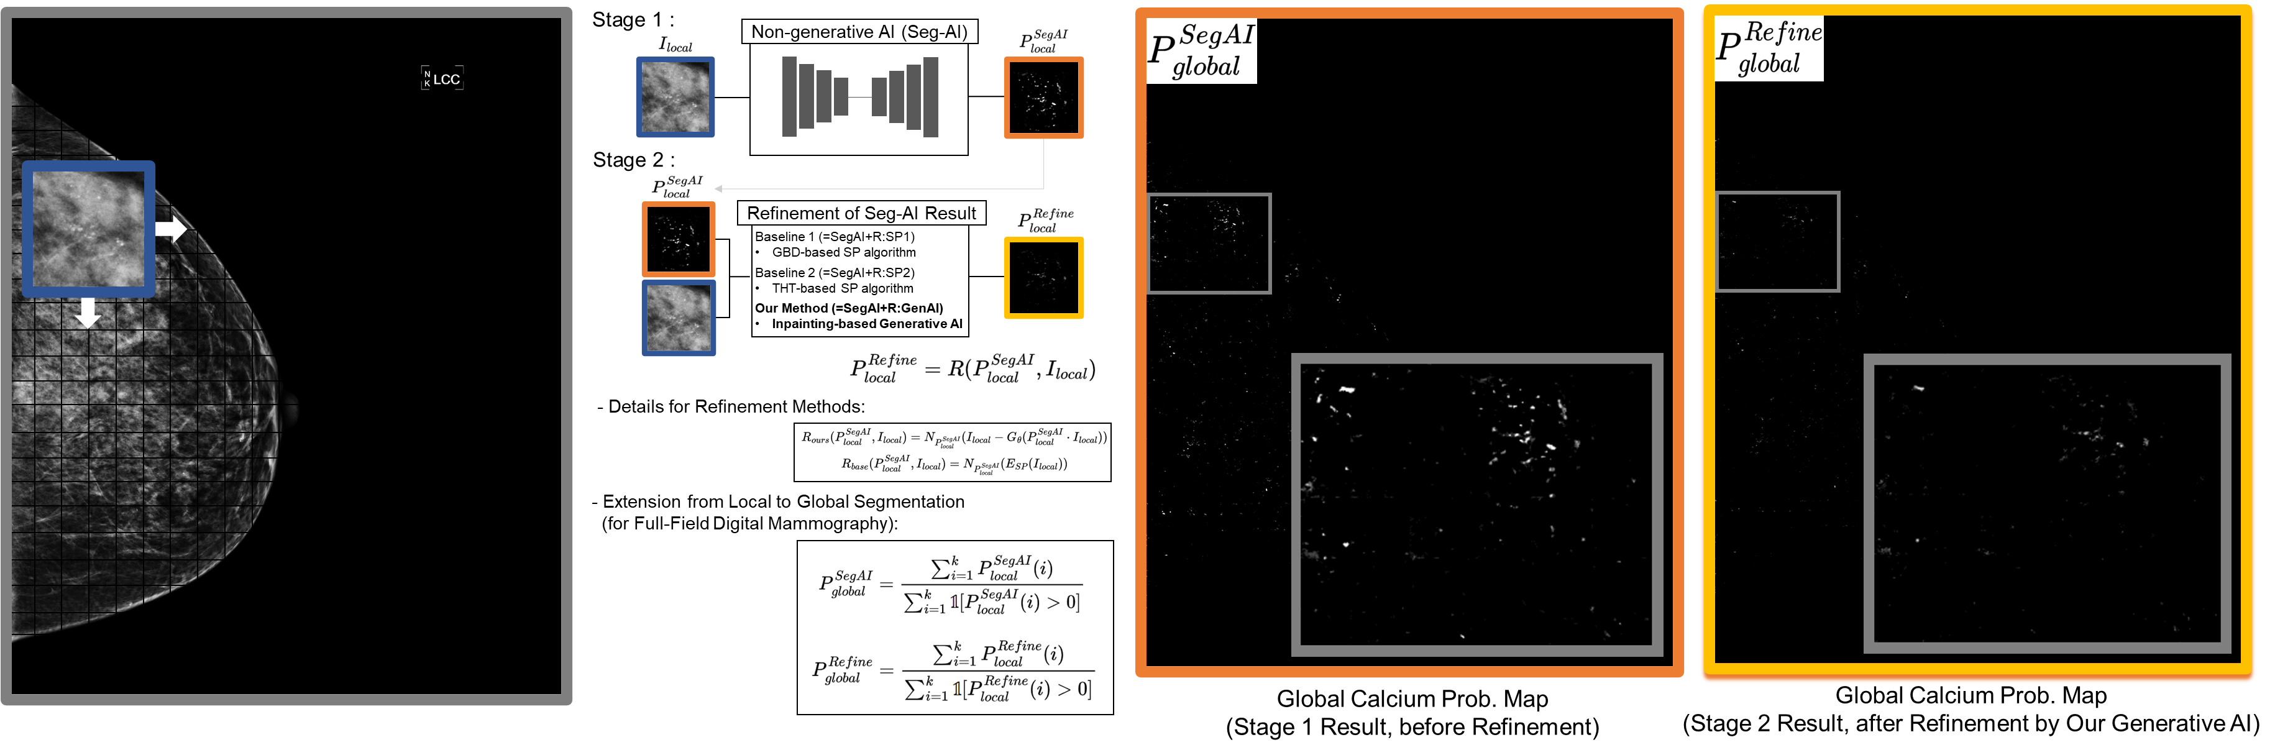
Figure A1. Details on the refinement method and the expansion process of patch results into FFDM results. This figure illustrates the FFDM-level expansion mathematical process of the refinement technologies covered in this study. The result after our generated AI-based refinement ${(=P}_{global}^{Refine})$ shows reduced false positives compared to the result before refinement ${(=P}_{global}^{SegAI})$.

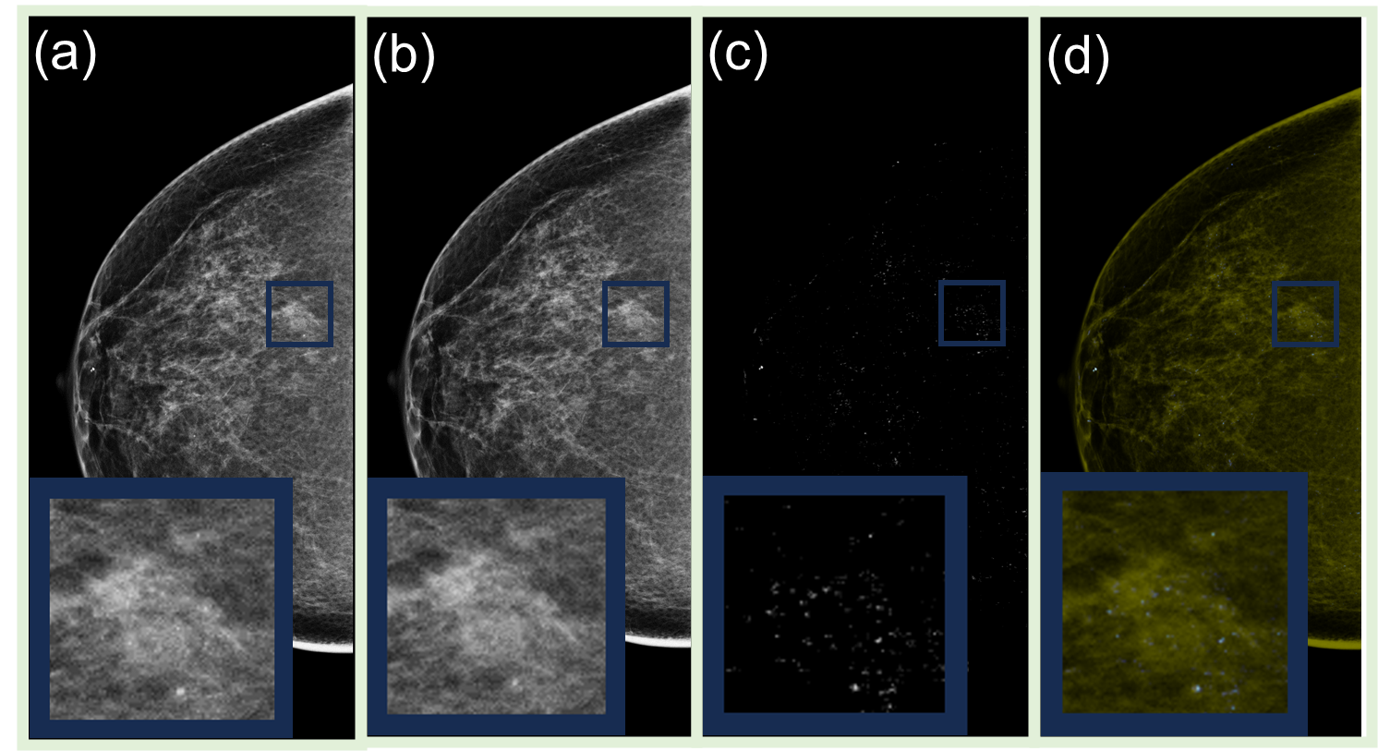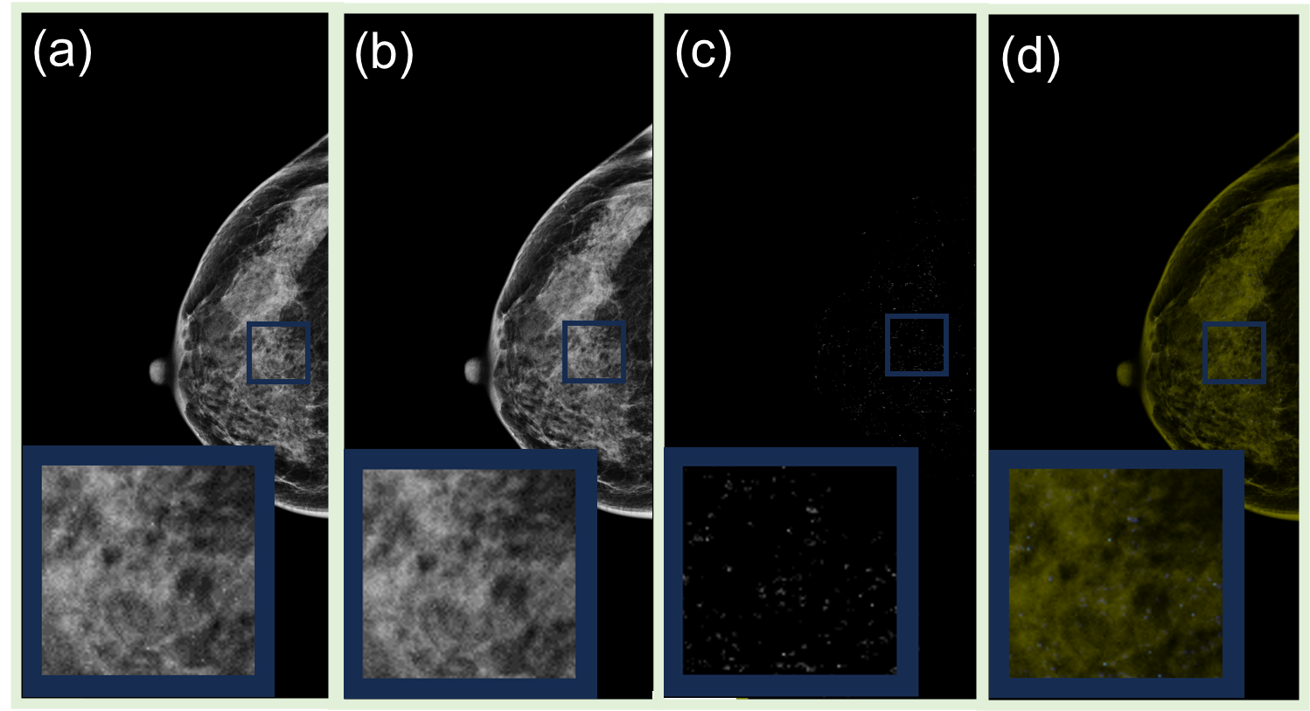
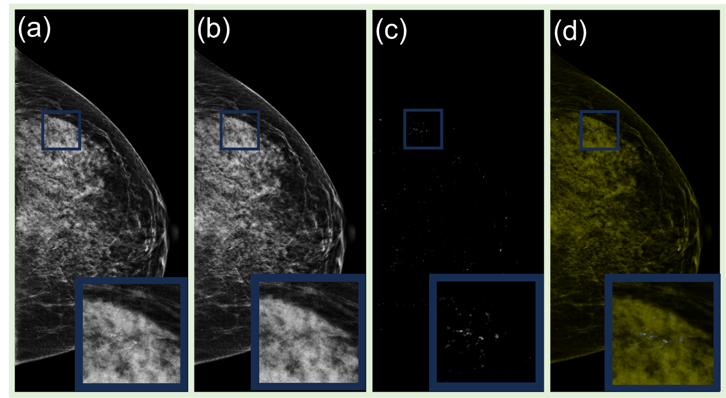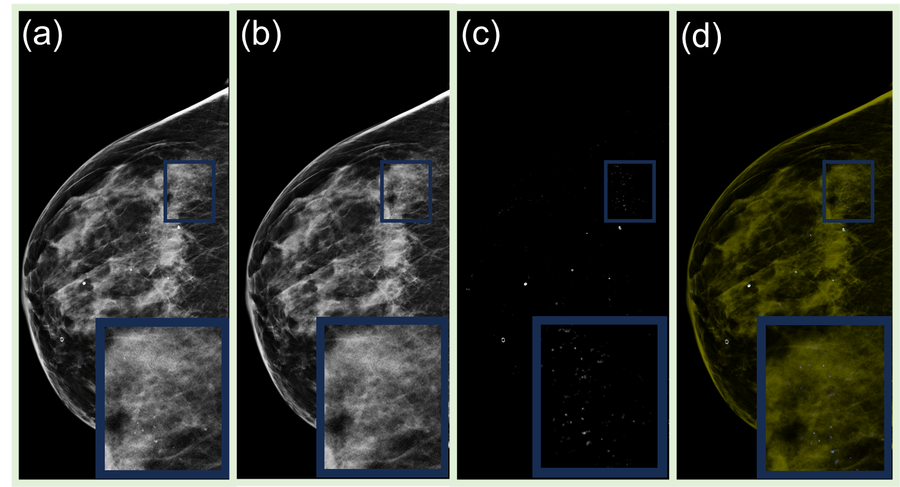
Figure A2. Additional qualitative results of our generative AI technology. In addition to the results shown in Figure 1, we present additional ones. These demonstrate that our generative AI technology can accurately detect and extract small calcification objects even within high-density breast tissue (c or d), while providing a novel pixel-level matched virtual normal FFDM reference (b): (a) shows the original full-field digital mammography image. (b) displays a virtual normal full-field image generated by our generative AI, where only calcium areas are modified to appear normal, serving as a new reference for radiologists to improve calcium diagnosis. (c) presents a calcium segmentation mask created by the pixel-level difference between a and b, with higher confidence areas in whiter shades. (d) depicts the calcium segmentation mask overlaid in white on the original brown image, highlighting only the calcium areas in white.
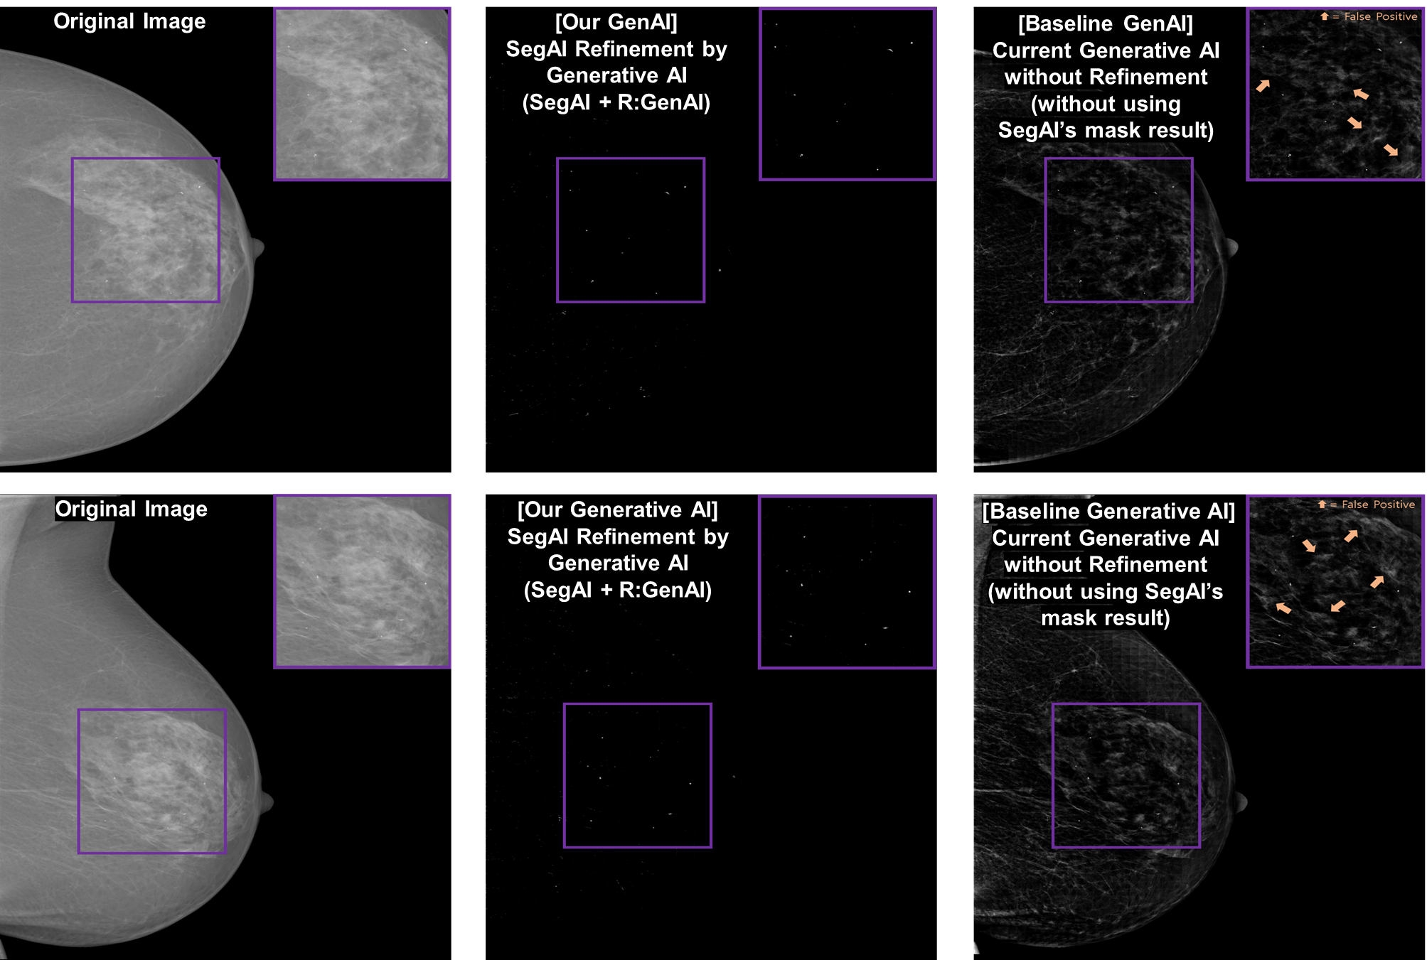 Figure A3. Qualitative performance comparison between our generative AI and the existing generative AI algorithms (i.e., qualitative results for Table 2): Our generative AI method (SegAI+R:GenAI) significantly enhances the performance of the existing latest generative AI method by reducing false positives.
Figure A4. Additional qualitative performance comparison of algorithms (i.e., the additional qualitative results for Table 1 and Figure 5): Our generative AI method (SegAI+R:GenAI) achieves better results (reduced false positives) than conventional segmentation AI (SegAI) and also shows improved results (reduced false negatives) compared to other refinement methods (SegAI+R:SP1 or SegAI+R:SP2).

References
1. Li, W., et al. Mat: Mask-aware transformer for large hole image inpainting. in Proceedings of the IEEE/CVF conference on computer vision and pattern recognition. 2022.
2. Gerbasi, A., et al., DeepMiCa: Automatic segmentation and classification of breast MIcroCAlcifications from mammograms. Computer Methods and Programs in Biomedicine, 2023. 235: p. 107483.
3. Wu, X., D. Hong, and J. Chanussot, UIU-Net: U-Net in U-Net for infrared small object detection. IEEE Transactions on Image Processing, 2022. 32: p. 364-376.
4. Behrendt, F., et al., Patched diffusion models for unsupervised anomaly detection in brain MRI. arXiv 2023. arXiv preprint arXiv:2303.03758.
5. Bercea, C.I., et al., Diffusion Models with Implicit Guidance for Medical Anomaly Detection. arXiv preprint arXiv:2403.08464, 2024.
6. Iqbal, H., et al. Unsupervised anomaly detection in medical images using masked diffusion model. in International Workshop on Machine Learning in Medical Imaging. 2023. Springer.
7. Wolleb, J., et al., Binary Noise for Binary Tasks: Masked Bernoulli Diffusion for Unsupervised Anomaly Detection. arXiv preprint arXiv:2403.11667, 2024.
8. Xu, R., Y. Wang, and B. Du, MAEDiff: Masked Autoencoder-enhanced Diffusion Models for Unsupervised Anomaly Detection in Brain Images. arXiv preprint arXiv:2401.10561, 2024.
9. He, Y., et al., Disorder-Free Data Are All You Need—Inverse Supervised Learning for Broad-Spectrum Head Disorder Detection. NEJM AI, 2024. 1(4): p. AIoa2300137.
10. Marasinou, C., et al., Improving the Quantitative Analysis of Breast Microcalcifications: A Multiscale Approach. Journal of digital imaging, 2023. 36(3): p. 1016-1028.

