A radar object-based examination of rain system climatology and including climate variability (Supplemental materials)
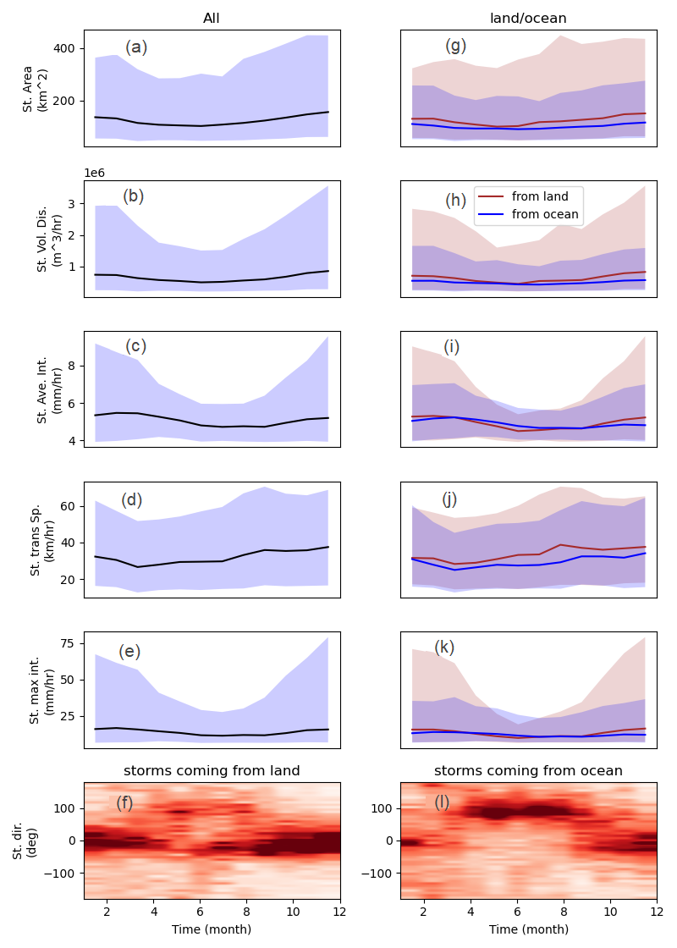
Fig. S1 Annual cycle of storm properties overall (black; panels a-e). and categorized based on their origination locations (panels e-l). In panels g-k, brown/blue colour shows the annual cycle of the storm properties for storms originating on land/ocean, and the shaded area shows the range from 5-95% and the solid lines show the median.

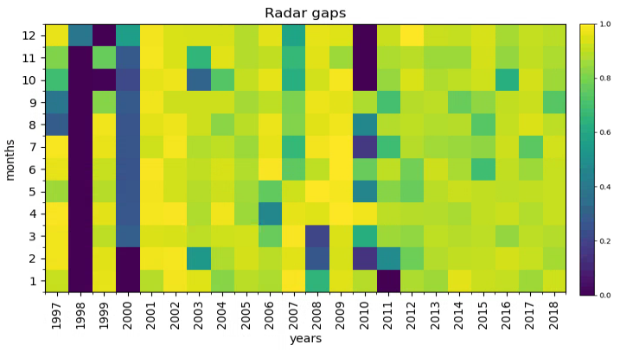
Fig. S2. The ratio of radar data availability ranging between 0-1. zero means there is no data available at the related month, and one means there is no gap in radar data at that month.

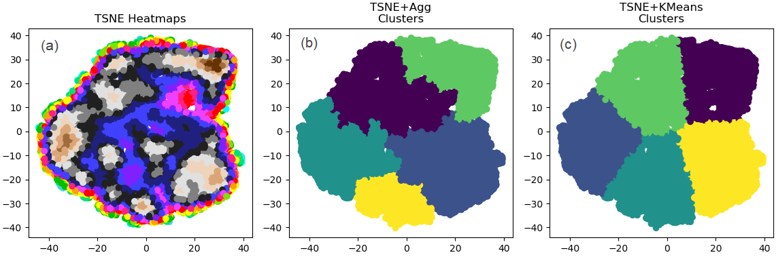
Fig. S3. Clustering the storms over the study area using KMeans (panel b) and Agglomerative (panel c) techniques after projecting the 5-dimensional storm data on a 2d map using the t-SNE algorithm (panel a)

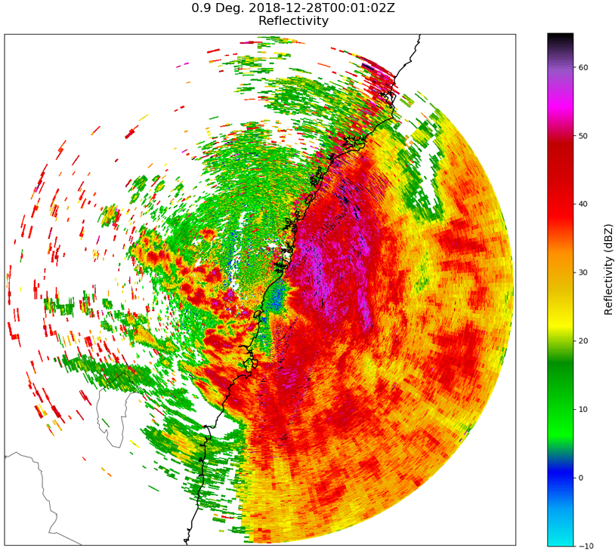

Fig. S4. An example of the effect of anomalous propagation over the ocean in maximum daily radar reflectivity data.

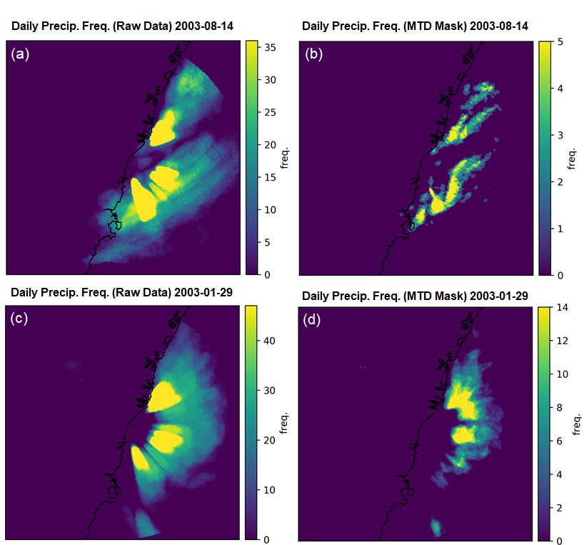
Fig. S5 Daily precipitation frequency for Raw data (panels a and c) and for detected objects using MTD (panels b and d). Panel b represents the acceptable performance of MTD in removing the anomalous propagation during the cold season, which is not the case in extreme cases during the warm season (panel d).

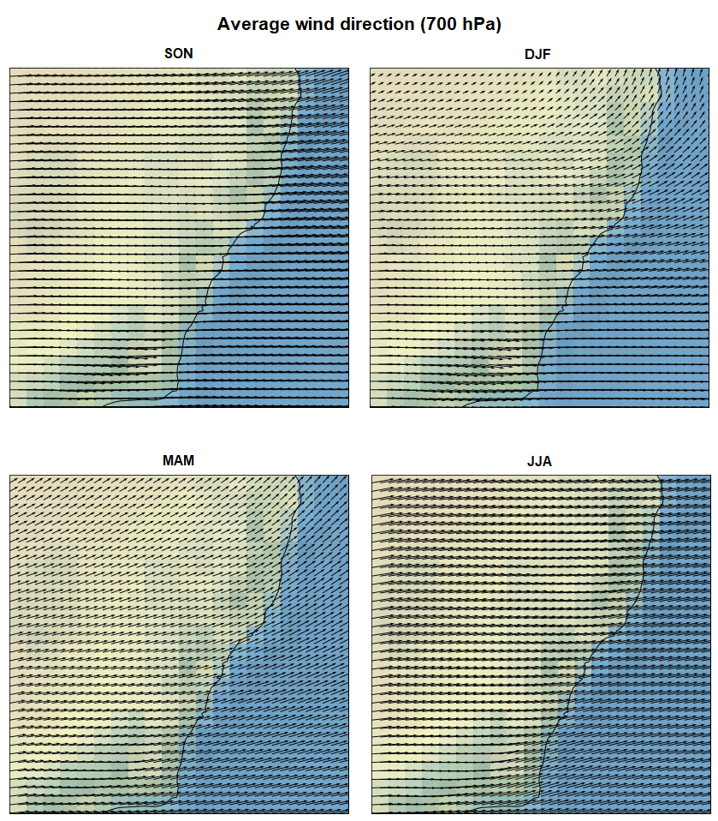
Fig. S6 Average wind directions at 700 hPa in different seasons extracted from ERA5 during the rainy days based on Wollongong radar data
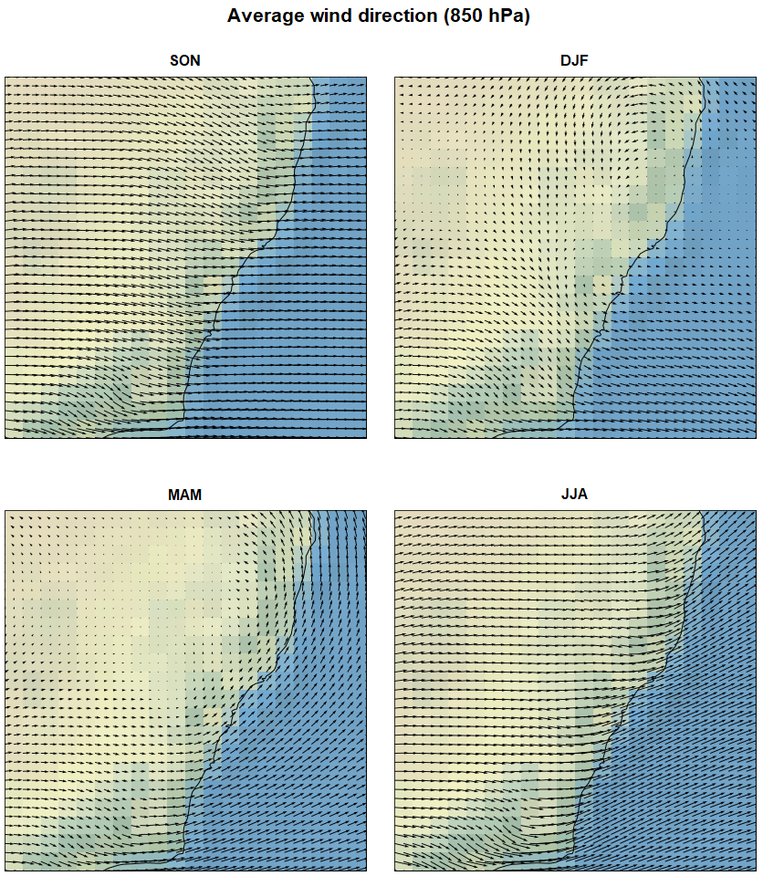
Fig. S7 The same as figure S5 but for 850 hPa.

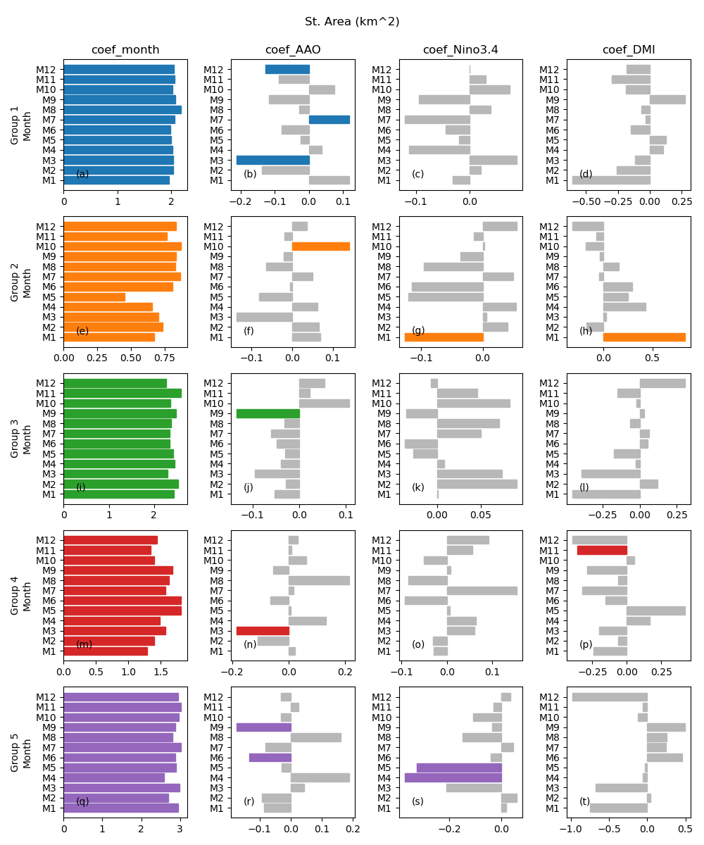
Fig. S8 Calculated climate mode indices coefficients for the storms’ areas in different months. The coloured bars show the normalized coefficients that are significantly different from zero. Note that the colours represent the storm groups and are matched with the groups’ colours in figure 8.

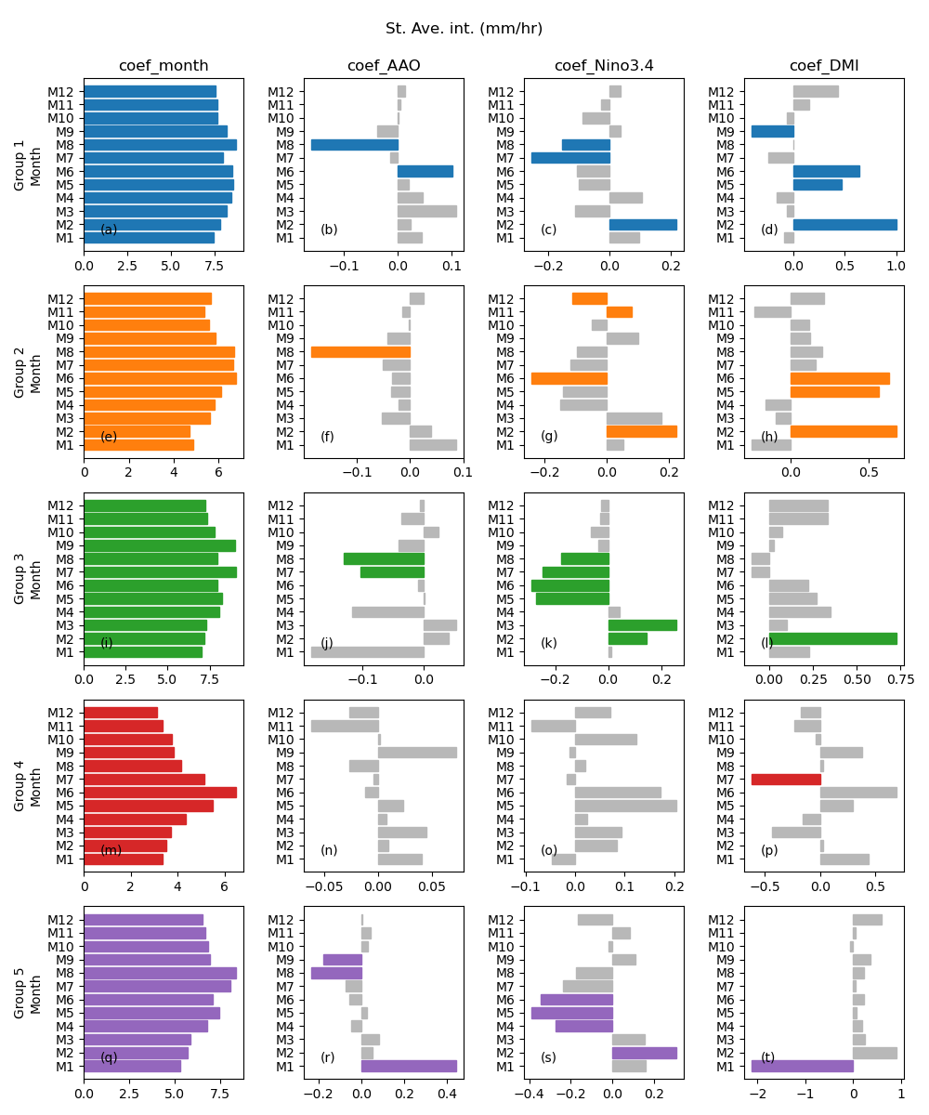
Fig. S9 The same is figure S7 but for storm average intensity

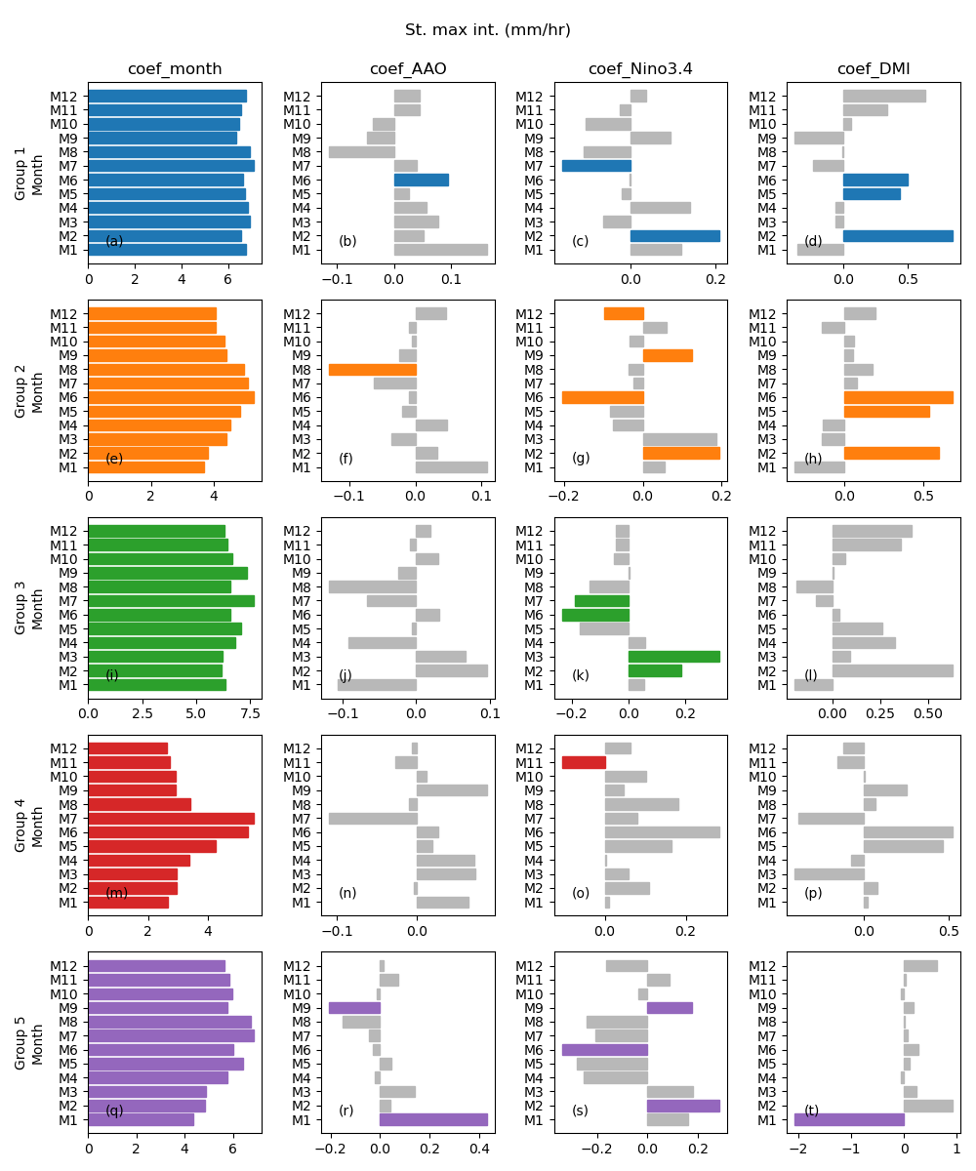
Fig. S10 The same is figure S7 but for storm maximum intensity
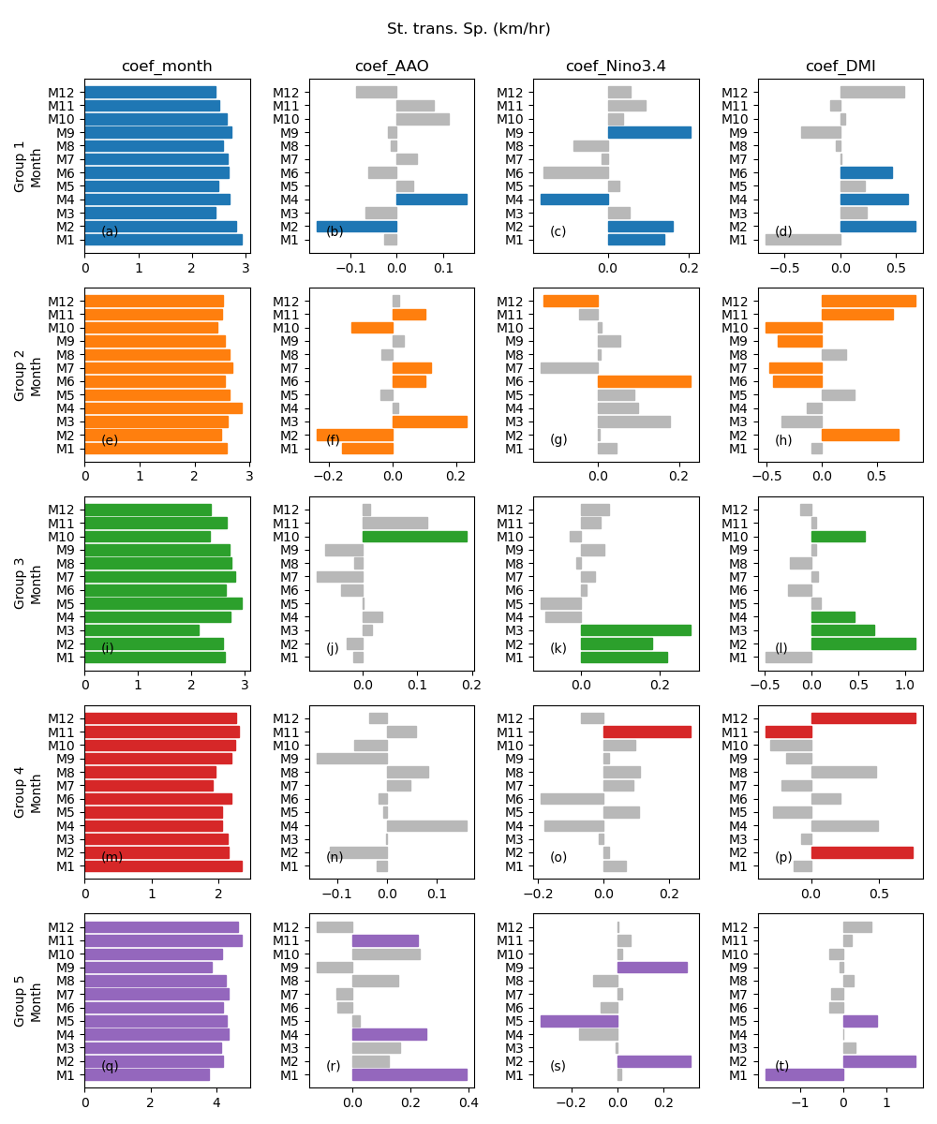

Fig. S11 The same is figure S7 but for storm translation speed

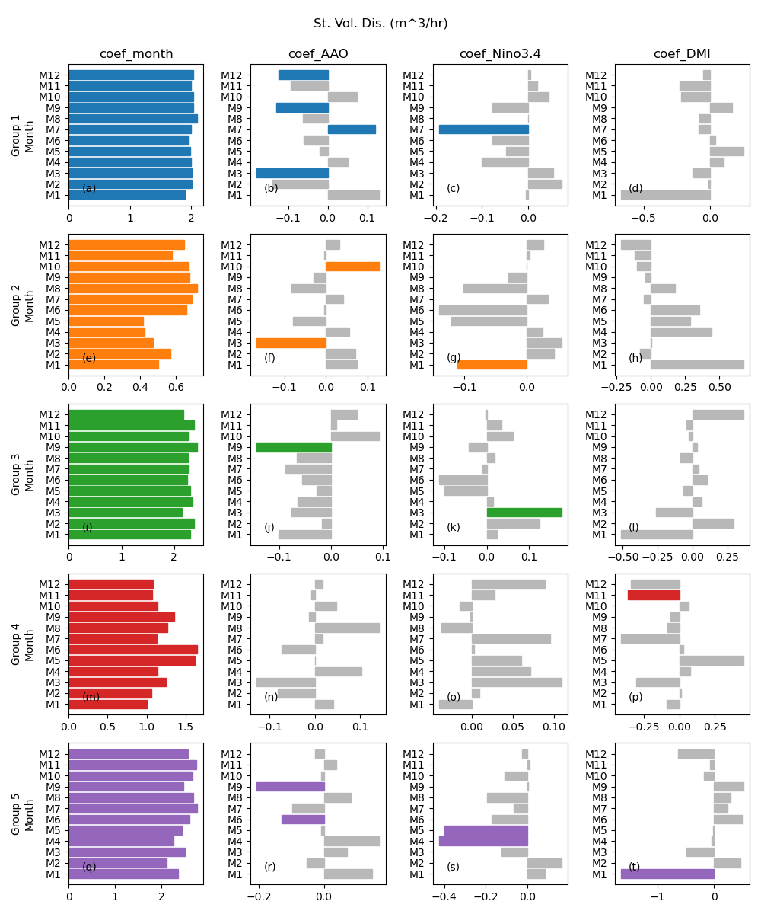
Fig. S12 The same is figure S7 but for storm volume discharge.

Video S1 This animation illustrates the typical detected storms of each cluster. Every panel shows a cluster/storm-type and the typical storms have been highlighted in each panel. The red lines show the 3D-object tracks

