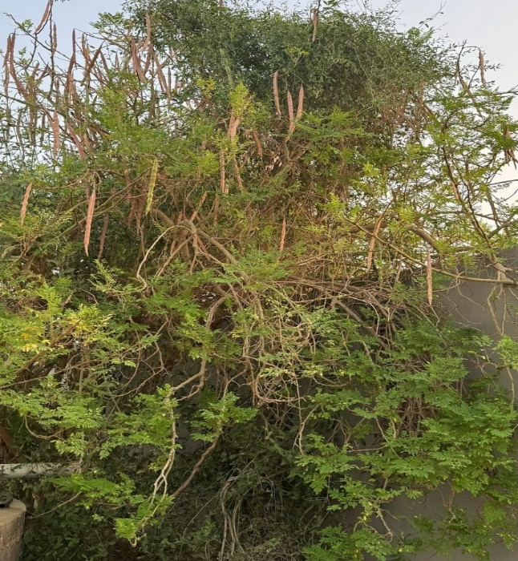
Moringa oleifera
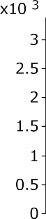

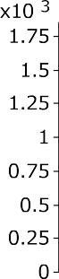

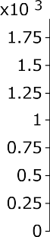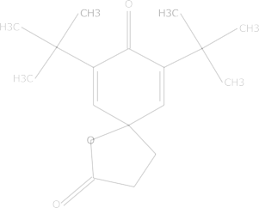

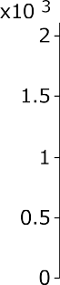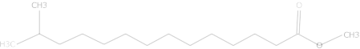

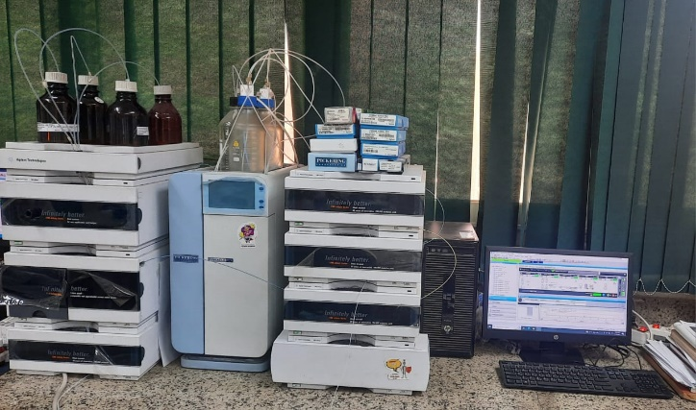
High Performance Liquid Chromatography device (used in this study)
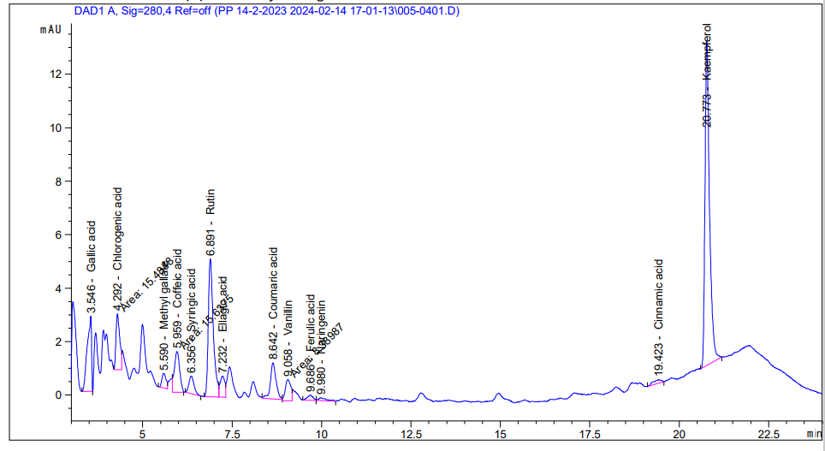
Polyphenol constituents of Moringa oleifera seed extract by HPLC.

.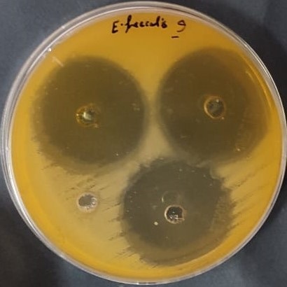
Inhibitions zones (in mm) by Moringa oleifera ethanoic seed extracts against Enterococcus faecalis
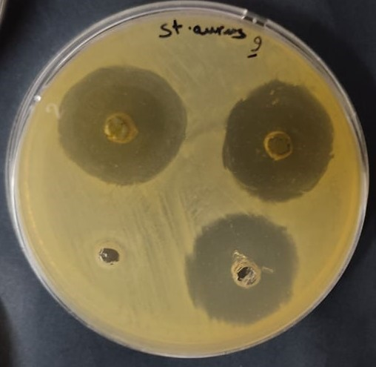
Inhibitions zones (in mm) by Moringa oleifera ethanoic seed extracts against Staph aureus
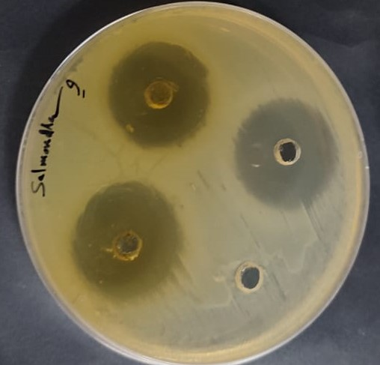
Inhibitions zones (in mm) by Moringa oleifera ethanoic seed extracts against Salmonella typhi
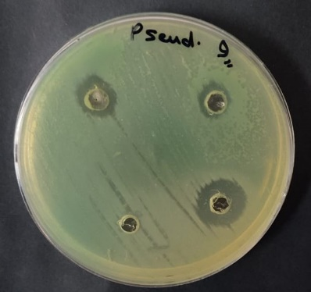
Inhibitions zones (in mm) by Moringa oleifera ethanoic seed extracts against Pseudomonas aeruginosa
.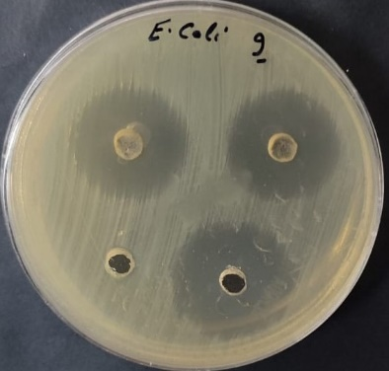
Inhibitions zones (in mm) by Moringa oleifera ethanoic seed extracts against Escherichia coli.
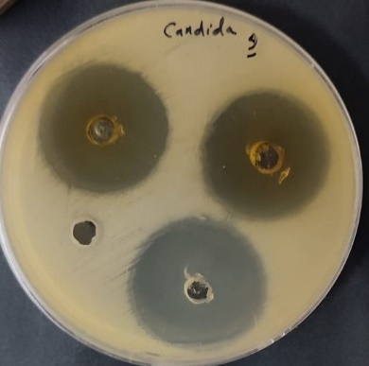
Inhibitions zones (in mm) by Moringa oleifera ethanoic seed extracts against fungi Candida albicans.
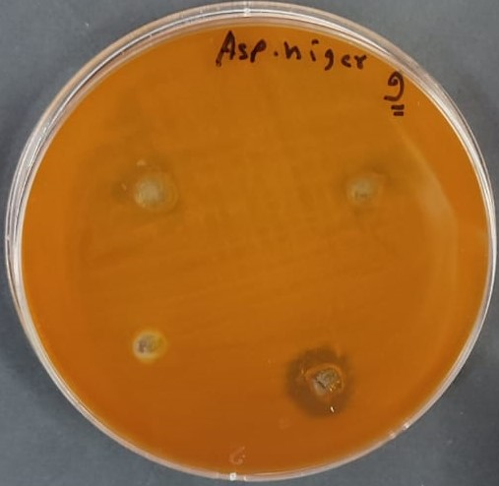
Inhibitions zones (in mm) by Moringa oleifera ethanoic seed extracts against fungi Aspergillus niger.

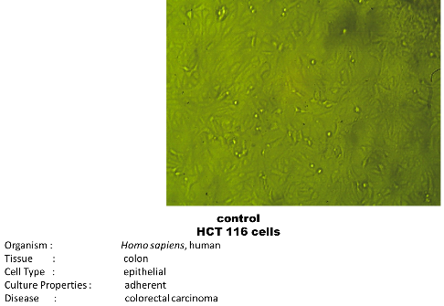
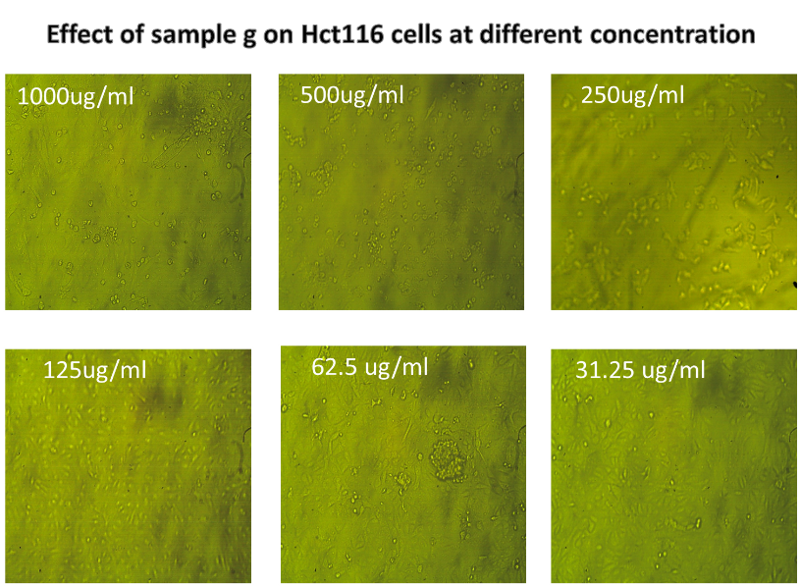
Effect of Moringa oleifera seed extracts against colon cancer (HCT116 at different concentration.
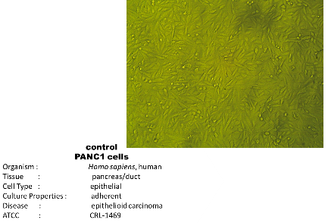
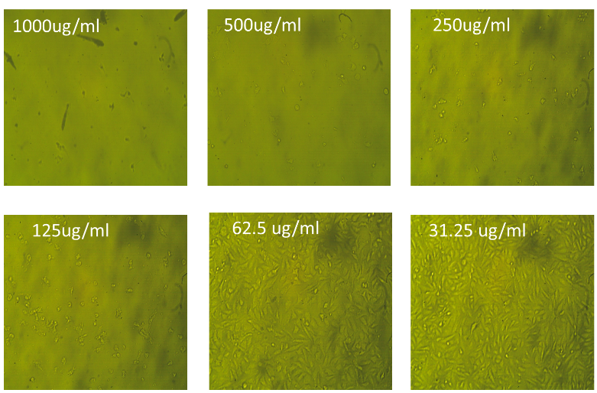
Effect of Moringa oleifera seed extracts against Effect of Moringa oleifera seed extract against PANC1 at different concentration.

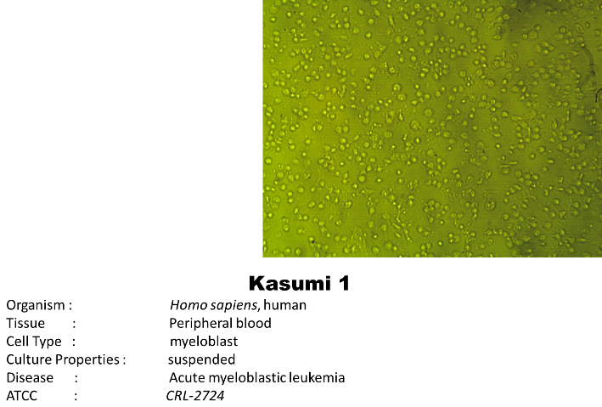
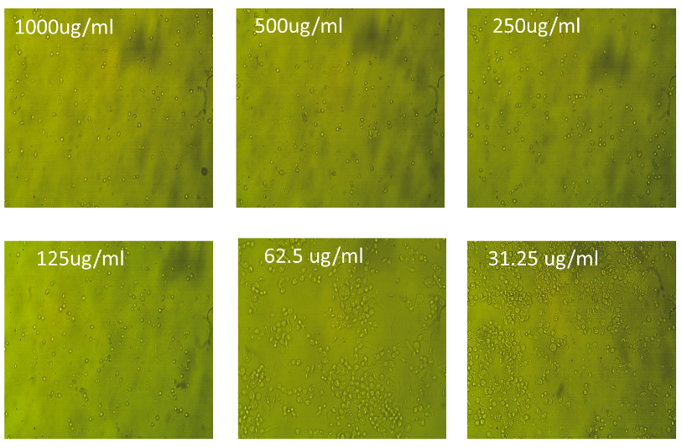
Effect of Moringa oleifera seed extract against Kasumi1 cell at different concentration.

