Supplementary material
Supplementary Table S1. Characteristics of the training and internal validation sets.
Characteristic |  | Training set |  | Internal validation set |  | P value
 |  | (n=240) |  | (n=61)
Sex |  |  |  |  |  | 0.408
Male |  | 95 (39.6) |  | 20 (32.8)
Female |  | 145 (60.4) |  | 41 (67.2)
Age (years) |  | 64.00 (57.00, 70.00) |  | 65.00 (57.00, 71.00) |  | 0.558
CRP, mg/L |  | 26.20 (9.81, 54.83) |  | 25.50 (9.23, 66.60) |  | 0.646
ESR, mm/h |  | 58.00 (34.75, 80.25) |  | 62.00 (39.00, 86.00) |  | 0.272
RF, IU/ml |  | 360.50 (80.42, 686.50) |  | 553.00 (82.70, 718.00) |  | 0.460
WBC, x 10⁹/L |  | 7.76 (6.10, 9.61) |  | 7.64 (6.56, 10.01) |  | 0.874
P_LCR, % |  | 27.60 (21.37, 32.82) |  | 26.40 (20.00, 36.80) |  | 0.843
Monocyte, % |  | 6.75 (5.27, 8.30) |  | 6.00 (5.20, 7.40) |  | 0.089
Monocyte, x10⁹/L |  | 0.51 (0.39, 0.68) |  | 0.48 (0.37, 0.63) |  | 0.277
RBC, x 10⁹/L |  | 4.07 (3.68, 4.44) |  | 3.94 (3.54, 4.47) |  | 0.677
RDW-CV, % |  | 13.90 (13.20, 15.00) |  | 14.30 (13.50, 15.30) |  | 0.225
RDW-SD, fl |  | 45.80 (43.40, 48.90) |  | 46.30 (43.90, 48.90) |  | 0.578
HCT, % |  | 37.00 (32.58, 40.23) |  | 35.90 (30.90, 40.70) |  | 0.392
Lymphocyte, % |  | 19.45 (14.90, 25.70) |  | 18.90 (13.50, 27.00) |  | 0.563
Lymphocyte, x 10⁹/L |  | 1.47 (1.13, 1.95) |  | 1.54 (1.11, 1.86) |  | 0.695
MCV, fl |  | 91.25 (87.80, 95.00) |  | 90.00 (85.40, 95.70) |  | 0.595
MCH, pg |  | 29.45 (27.70, 30.60) |  | 29.10 (27.00, 30.50) |  | 0.567
MCHC, g/L |  | 321.00 (314.00, 327.00) |  | 320.00 (312.00, 328.00) |  | 0.620
MPV, fl |  | 10.20 (9.40, 11.00) |  | 10.20 (9.20, 11.40) |  | 0.749
Basophil, % |  | 0.40 (0.20, 0.60) |  | 0.30 (0.20, 0.50) |  | 0.386
Basophil, x 10⁹/L |  | 0.03 (0.02, 0.04) |  | 0.03 (0.02, 0.04) |  | 0.853
Eosinophil, % |  | 1.70 (0.80, 2.90) |  | 1.30 (0.80, 2.70) |  | 0.231
Eosinophil, x 10⁹/L |  | 0.13 (0.06, 0.22) |  | 0.10 (0.07, 0.22) |  | 0.525
HGB, g/L |  | 119.00 (103.75, 130.00) |  | 117.00 (97.00, 132.00) |  | 0.325
PDW, % |  | 15.00 (11.60, 16.12) |  | 14.60 (11.60, 16.20) |  | 0.697
PLT, x 10⁹/L |  | 257.00 (208.75, 324.25) |  | 257.00 (211.00, 323.00) |  | 0.902
PCT, % |  | 0.27 (0.22, 0.32) |  | 0.27 (0.22, 0.31) |  | 0.676
Neutrophil, % |  | 69.70 (63.08, 76.23) |  | 70.30 (63.60, 77.60) |  | 0.349
Neutrophil, x 10⁹/L |  | 5.36 (4.00, 6.92) |  | 5.22 (4.30, 7.11) |  | 0.524
GGT, U/L |  | 24.35 (16.55, 39.00) |  | 23.60 (16.60, 32.30) |  | 0.621
ALT, U/L |  | 16.20 (11.30, 22.72) |  | 14.20 (11.10, 19.90) |  | 0.469
Cr, umol/L |  | 64.20 (55.18, 74.65) |  | 61.00 (51.60, 71.00) |  | 0.193
ALP, U/L |  | 90.00 (77.00, 107.00) |  | 100.00 (73.00, 117.00) |  | 0.351
Urea, mmol/L |  | 5.80 (4.74, 6.98) |  | 6.00 (4.82, 6.99) |  | 0.430
UA, mmol/L |  | 313.00 (247.75, 370.50) |  | 296.00 (235.00, 337.00) |  | 0.105
AST, U/L |  | 21.70 (17.30, 27.63) |  | 20.80 (18.10, 25.10) |  | 0.903
CRP: c-reactive protein; ESR: erythrocyte sedimentation rate; RF: rheumatoid factors; WBC: white blood cell count; P_LCR: large platelet cell ratio; RBC: red blood cell count; RDW-CV: erythrocyte volume distribution width-coefficient of variation: RDW-SD: erythrocyte volume distribution width-standard deviation; HCT: hematocrit; MCV: mean cell volume; MCH: mean cell haemoglobin; MCHC: mean corpuscular haemoglobin concentration; MPV: mean platelet volume; HGB: hemoglobin; PDW: platelet distribution width; PLT: platelet count; PCT: plateletcrit; GGT: glutamyl transpeptidase; ALT: alanine aminotransferase; AST: aspartate transaminase; Cr: creatinine; ALP: alkaline phosphatase; UA: uric acid.

Supplementary Table S2. Univariate logistic regression on variables for the prediction of ILD pattens in RA patients.
Characteristic |  | Univariable analysis |  | P value
 |  | OR (95%CI)
Sex |  | 2.658 (1.637-4.377) |  | < 0.001
Age (years) |  | 0.982(0.960-1.004) |  | 0.104
CRP, mg/L |  | 0.997(0.993-1.002) |  | 0.287
ESR, mm/h |  | 0.993(0.985-1.001) |  | 0.069
RF, IU/ml |  | 1.000(1.000-1.000) |  | 0.339
WBC, x 10⁹/L |  | 0.876(0.799-0.955) |  | 0.004
P_LCR, % |  | 1.000(0.978-1.023) |  | 0.989
Monocyte, % |  | 1.02 0(0.921-1.129) |  | 0.707
Monocyte, x10⁹/L |  | 0.326(0.111-0.926) |  | 0.038
RBC, x 10⁹/L |  | 0.979(0.671-1.428) |  | 0.912
RDW-CV, % |  | 1.004(0.88-1.145) |  | 0.947
RDW-SD, fl |  | 0.992(0.942-1.044) |  | 0.752
HCT, % |  | 0.994(0.954-1.036) |  | 0.788
Lymphocyte, % |  | 1.03 0(1.000-1.061) |  | 0.051
Lymphocyte, x 10⁹/L |  | 0.841(0.581-1.209) |  | 0.352
MCV, fl |  | 1.004(0.975-1.035) |  | 0.794
MCH, pg |  | 0.999(0.919-1.087) |  | 0.989
MCHC, g/L |  | 1.006(0.985-1.027) |  | 0.602
MPV, fl |  | 0.964(0.829-1.118) |  | 0.624
Basophil, % |  | 0.917(0.406-2.036) |  | 0.831
Basophil, x 10⁹/L |  | 0.077(0.000-62.312) |  | 0.489
Eosinophil, % |  | 1.008(0.952-1.069) |  | 0.771
Eosinophil, x 10⁹/L |  | 0.752(0.305-1.662) |  | 0.497
HGB, g/L |  | 0.999(0.987-1.011) |  | 0.825
PDW, % |  | 0.995(0.915-1.082) |  | 0.904
PLT, x 10⁹/L |  | 0.999(0.997-1.001) |  | 0.382
PCT, % |  | 0.448(0.030-6.325) |  | 0.554
Neutrophil, % |  | 0.980(0.957-1.003) |  | 0.089
Neutrophil, x 10⁹/L |  | 0.876(0.792-0.964) |  | 0.008
GGT, U/L |  | 0.995(0.987-1.003) |  | 0.261
ALT, U/L |  | 1.002(0.985-1.018) |  | 0.847
Cr, umol/L |  | 1.000(0.991-1.009) |  | 0.986
ALP, U/L |  | 0.998(0.992-1.004) |  | 0.578
Urea, mmol/L |  | 1.030(0.916-1.158) |  | 0.622
UA, mmol/L |  | 1.002(0.999-1.004) |  | 0.144
AST, U/L |  | 1.003(0.990-1.018) |  | 0.663
Supplementary Figure S1: Research workflow of radiomics analysis. Feature extraction was performed using the AI Platform of the First Affiliated Hospital of Army Medical University. The platform's U-net model segmented lungs and extraction volume of interest (VOI) automatically. Radiomics features were extracted from VOI, including first-order features, shape features, texture features, and filtering features. Variance threshold method, univariate selection method and LASSO method were used for feature selection. Three kinds of machine learning (MLP, LR, RF) were used to construct the model. The performance and clinical utility of the diagnostic models were evaluated using receiver operating characteristic, nomogram, and decision curve analysis. MLP: multi-layer perceptron, LR: logistic regression, RF: Random forest.
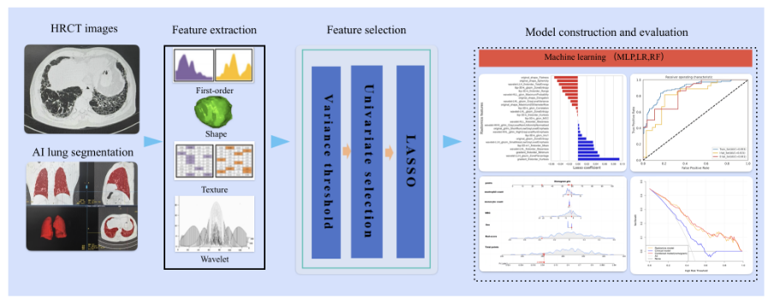

Supplementary Figure S2: Example of VOI on HRCT image of a patient with RA-ILD. A: automatic lung segmentation of HRCT images of UIP patients, the red area represents whole-lung segmentation; B: automatic lung segmentation of HRCT images of NSIP patients, the red area represents whole-lung segmentation.
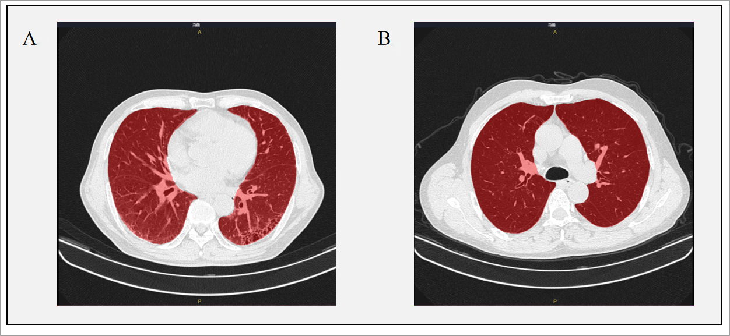

Supplementary Figure S3: ROC curves of clinical models constructed based on three machine learning algorithms in training set, internal validation set, and external validation set. A: ROC curves for clinical modeling based on MLP; B: ROC curves for clinical modeling based on LR; C: ROC curves for clinical modeling based on RF. AUC: area under curve, ROC: receiver operating characteristic,MLP: multi-layer perceptron, LR: logistic regression,RF: Random forest. Train_Set: training set,I-Val_Set: internal validation set,E-Val_Set: external validation set.
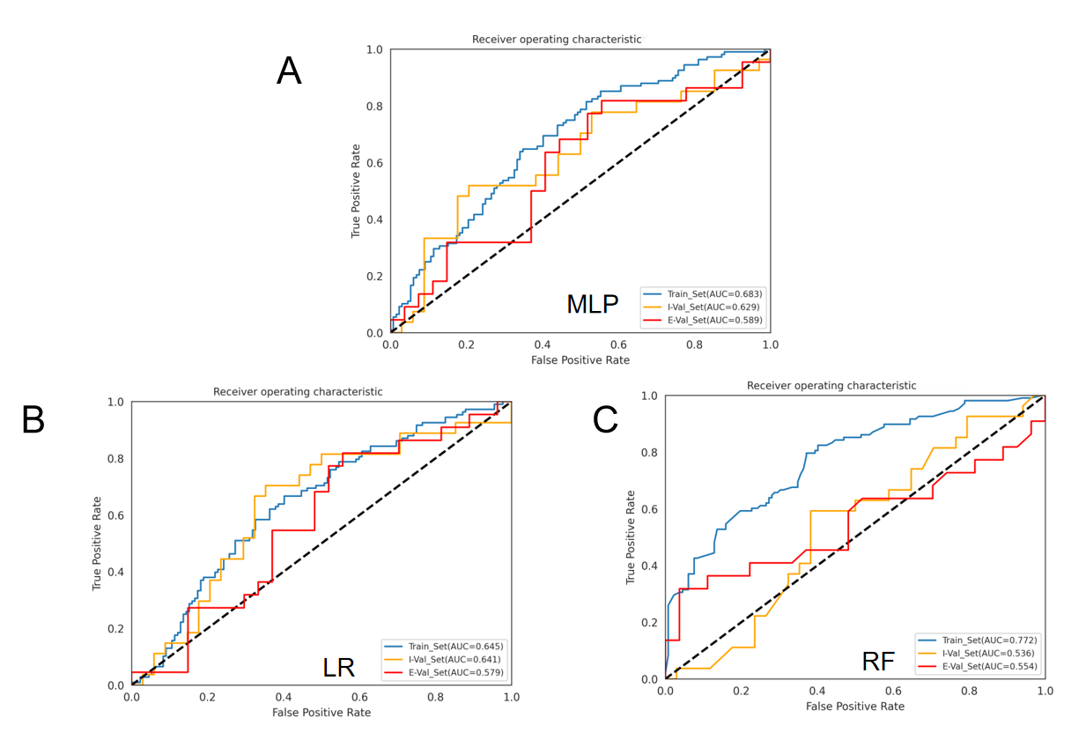

Supplementary Figure S4: ROC curves of radiomics models constructed based on three machine learning algorithms in training set, internal validation set, and external validation set. A: ROC curves for radiomics modeling based on MLP; B: ROC curves for radiomics modeling based on LR; C: ROC curves for radiomics modeling based on RF. AUC: area under curve, ROC: receiver operating characteristic,MLP: multi-layer perceptron, LR: logistic regression,RF: Random forest. Train_Set: training set,I-Val_Set: internal validation set,E-Val_Set: external validation set.

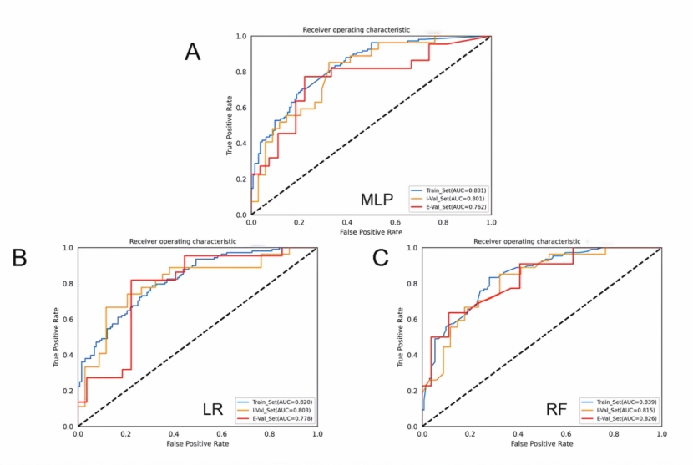

Supplementary Figure S5: Radiomics-clinical combined models constructed based on three algorithms in the training set, internal validation set, and external validation set. A: ROC curves for radiomics-clinical models based on the MLP; B: ROC curves for radiomics-clinical models based on LR; C: ROC curves for radiomics-clinical models based on RF. AUC: area under curve, ROC: receiver operating characteristic,MLP: multi-layer perceptron, LR: logistic regression,RF: Random forest. Train_Set: training set,I-Val_Set: internal validation set,E-Val_Set: external validation set.
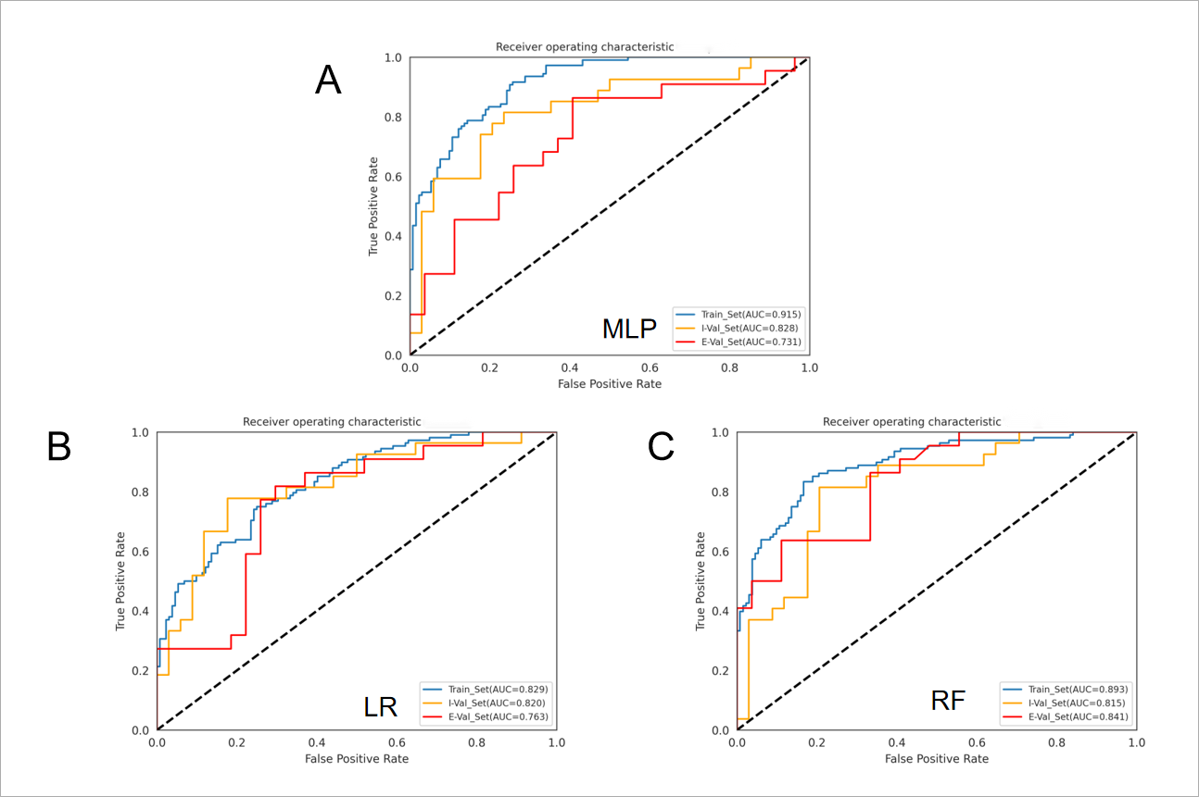

Blood sample collection
Morning fasting blood samples were collected from each participant and centrifuged at 3500 rpm for 10 minutes, followed by transferring the supernatant to a 1.5 ml EP tube and centrifuging at high speed for 12,000 rpm for 10 minutes. Finally, aspirated the supernatant into another EP tube and stored at -80°C in the refrigerator until use.

LC-MS/MS analysis
100 µL of liquid sample was added to a 1.5 mL centrifuge tube, followed by 400µL of extraction solution (acetonitrile: methanol = 1:1), mixed for 30 s and then extracted by low-temperature sonication for 30 min (5°C, 40 KHz), the sample was left at -20°C for 30 min, centrifuged at 4°C, 13000 g for 15 min, the supernatant was removed, blown dry under nitrogen, 120 µL of re-solution ( acetonitrile: water = 1:1), low-temperature ultrasonic extraction for 5 min (5°C,40 KHz), centrifugation at 13,000 g for 5 min at 4°C, and transferring the supernatant to the injection vial with internal cannula for analysis. In the on-line analysis, 1 QC sample was inserted in every 10 samples to observe the reproducibility throughout the analysis process. The analytical instrument was an ultra-performance liquid chromatography tandem time of flight mass spectrometry UPLC -TripleTOF system from AB SCIEX.

Data processing and analysis
The raw data from the assays were pre-processed by the metabolomics software Progenesis QI (Waters Corporation，Milford，USA) to obtain a data matrix, which retained at least 80% of the non-zero values in at least one set of samples and filled in the gaps with the minimum values, while removing variables with a relative standard deviation (RSD) >30% for QC samples to obtain the final data matrix for subsequent analysis. The mass spectrometry information was also matched with the metabolic public databases HMDB (http://www.hmdb.ca/) databases to obtain metabolite information for subsequent correlated metabolite analysis and pathway enrichment analysis. The pathways involved in correlated metabolites were also obtained using metabolic pathway annotation from the KEGG database (https://www.kegg.jp/kegg/pathway.html). The Python package scipy.stats was used for pathway enrichment analysis and the relevant biological pathways were obtained by Fisher's exact test.

