Supplementary Information

Topologically Entangled Hydrogels with Self-Evolving Ultraplasticity-to-Hyperelasticity

This file includes:
1. Supplementary Materials and Methods (Table 1, eq. S1 – S15)
2. Supplementary Formulas (eq. 1 – eq. 9)
3. Supplementary Figures (Fig. 1 - 63), Results and Discussions
4. Supplementary References (1 – 59)

Other supplementary materials for this manuscript include the following sections:
1. Supplementary Videos (1 – 4)

Supplementary Materials and Methods
Materials
[2-(methacryloyloxy) ethyl] dimethyl-(3-sulfopropyl) ammonium (SBMA) (≥97%) provided by Aladdin Biochemical Technology co., LTD. (Shanghai, China). Potassium persulfate (KPS) is provided by Sigma Aldrich (USA). Sodium chloride (NaCl) and acrylamide (AAm) are provided by Maclean Biochemical Technology Co., LTD. (Shanghai, China). The deionized water is homemade in the laboratory and is produced by using a UOP ultrapure water machine. 2-(4-Amidinophenyl)-6-indolecarbamidine dihydrochloride (DAPI), acridine orange (AO), 5-Ethynyl-2'-deoxyuridine (EDU), propidium iodide (PI), BCA Protein Assay Kit is provided by Biyun Tian Biotechnology Co., LTD. (Shanghai, China). The MSC-specific basic medium is provided by Dakewei Bioengineering Co., LTD. (Shenzhen, China). Phosphate buffer saline (PBS) is provided by Wuhan Ponsure Life Sciences Co., LTD. (Wuhan, China). The commercial dressing (hydrocolloid 3M hydrophilic dressing, 90022TCP) is provided by Minnesota Mining and Manufacturing Company (USA).

Preparation of PSM
Mixing 6 mol/L SBMA and 0.016 mol/L KPS with deionized water and stirring for 1 hour to obtain a uniformly dispersed solution. After the bubbles were removed by ultrasonic oscillation, it was poured into the mold, sealed and placed at 50℃ for reacting 1 hour to obtain the PSM_{6M} hydrogel sample. Adjusting the concentration of SBMA can yield PSM of different concentrations. For the PSM_{6M}E sample, an additional 5 mol/L of NaCl is added in the above step, while the other preparation steps remain the same. For the PSM_{6M}S sample, immersing the PSM_{6M} gel in the corresponding volume of deionized water, sealing it until the liquid is completely absorbed, and obtain a uniform gel.

Rheological Test
The elastoplasticity of the gel was characterized using a stress-controlled Rheometer equipped with a 20mm parallel plate (DHR-2 Discovery Hybrid Rheometer, TA Instruments, Newcastle, Delaware, USA). The thickness of the PSM gel is 2mm and it is cut into cylinders with a diameter of 20mm. To prevent the sample from dehydrating, dimethyl silicone oil is applied to the sides. Tests are usually conducted at 25℃ and include amplitude-strain scanning, amplitude-time scanning, amplitude-frequency scanning, amplitude-temperature scanning, step creep and recovery, and stress relaxation.

Amplitude Strain Scan
In the amplitude strain test, set the angular frequency to 10.0 rad/s, scan the strain distribution according to the logarithmic scale, and the strain range is 0.001 to 100%. The data such as the energy storage modulus (G’) varying with strain, the loss modulus (G’’), and loss tangent (tanδ) were obtained. The region where the stress and strain have a linear relationship was defined as the linear viscoelastic region (LVR), and the strain that causes a sudden change was defined as the critical strain.
Creep and Recovery
In the step creep and recovery test, the pressure section and the recovery section are set in sequence. The pressure section is under a stress of 10 Pa (within the linear viscoelastic stress range) for 900 seconds, and the recovery section is under no stress for 900 seconds, the strain and recovery strain data at different stages were obtained to determine the elastoplastic properties of the gel. In the pressure section, the strain caused at the moment of pressurization is taken as the initial strain. Within the initial approximately linear interval (0 to 5 seconds), it is an ideal elastic deformation, and the ratio of the corresponding strain to the total strain is the ideal elastic deformation ratio HEr. During the elastoplastic recovery stage, the unrecovered deformation is plastic deformation, and its ratio to the total deformation is the plastic ratio Pr of PSM. The recovered deformation is elastic deformation, and its ratio to the total deformation is the elastic ratio Er of PSM. The sum of the two should be 1.

Stress Relaxation
In the stress relaxation test, a strain level of 5% (within the LVR) was applied and maintained for a duration of 2000 seconds to obtain the time-dependent decay of the stress relaxation curve. When the strain reaches the preset value and remains stable for 10 seconds, this point is defined as the starting point of stress relaxation, and the corresponding stress is considered the initial stress. The time required for the stress to decrease to half of the initial stress is defined as the half-relaxation time τ of PSM.

Amplitude Temperature Scan
In the amplitude temperature test, a strain level of 1% (within the LVR) was applied. The scanning frequency was set to 10 rad/s, and the temperature was varied from -30 °C to 90 °C at a heating rate of 5 °C/min. Data including the storage modulus (G’), loss modulus (G’’), and loss tangent (tanδ) as functions of temperature were collected. The freezing transition temperature was determined as the temperature at which G’ exhibits a sharp decrease and tanδ reaches its peak value.

Amplitude Time Scan
In the amplitude-time test, a 5% strain (within the LVR) was applied continuously for 2000 seconds. The scanning frequency was set at 10 rad/s. The time-dependent variations of the storage modulus (G’), loss modulus (G’’), and loss tangent (tanδ) were recorded during the test.

Amplitude Frequency Scan
In the amplitude and frequency test, a 5% strain (within the linear viscoelastic region, LVR) was applied, and the frequency was scanned across a logarithmic scale. The scanning frequency range was set from 0.04 to 400 rad/s, during which data such as the storage modulus (G'), loss modulus (G''), and loss tangent (tanδ) were collected as functions of frequency. Experiments were carried out at different temperatures (5, 25, and 45 °C) based on the aforementioned parameters. The master curves over an extended frequency range were constructed using the time-temperature superposition principle.

Structural Analysis
Fourier Transform Infrared Spectroscopy (FTIR)
The chemical structures of SBMA monomers and PSM at 25 °C was performed using FTIR (Thermo Fisher Scientific Nicolet iS20, USA), employing both the potassium bromide pellet method and the attenuated total reflection (ATR) technique. The scanning range was set between 400 and 4000 cm⁻¹ with a resolution of 4 cm⁻¹. All samples were fully dried and anhydrous. For the ATR measurements, the hydrogel specimens were prepared in dimensions of 5 × 5 × 1 mm.

Nuclear Magnetic Resonance Hydrogen Spectroscopy (¹H-NMR)
The ¹H-NMR liquid-state spectra were acquired at room temperature using a 400 MHz nuclear magnetic resonance spectrometer（NMR） (Bruker Avance NEO, Germany). Chemical shifts were referenced to D₂O (4.79 ppm). The test sample consisted of a PSM gel solution at a concentration of 5 mg/mL, with D₂O used as the solvent.

Low-Field Nuclear Magnetic Resonance (LF-NMR)
LF-NMR is employed to translate the relaxation times (degrees of freedom) of hydrogen nuclei into structural information. LF-NMR measurements, focusing on the transverse relaxation time T₂, were carried out using a nuclear magnetic resonance analyzer (MicroMR12-025V, Suzhou Nuoma Analytical Instrument Co., Ltd., China), with structural data derived from XLD fitting. The tested samples included various hydrogels (PSM_{2M}, PSM_{4M}, PSM_{6M}, PSM_{6M}E, PSM_{6M}S) obtained either through in situ reactions or after post-treatment processes. All samples were cylindrical in shape, with a diameter of 10 mm and thickness of 5 mm. Hydrogen signals originating from free water, bound water, and mobile segments were acquired under the Carr-Purcell-Meiboom-Gill (CPMG) pulse sequence. A total of four scans were performed, involving 18,000 echoes per scan, an echo time of 0.3 milliseconds, and a recovery delay of 3,000 milliseconds. Multi-component fitting was applied to the original T₂ decay curves for signal decomposition.
For the crosslinking density assessment, a nuclear magnetic resonance crosslinking density imaging analyzer (VTMR20-010V-I, Suzhou Nuoma Analytical Instrument Co., Ltd., China) was utilized. The samples tested were the hydrogels obtained from in situ reactions or subsequent treatments (PSM_{2M}, PSM_{4M}, PSM_{6M}, PSM_{6M}E, PSM_{6M}S). The transverse relaxation signal decay was modeled using the XLD equation to determine the crosslinking density of the corresponding gels as well as the proportion of each chain type.

Confocal Raman Microscope (CRM)
Raman analysis/Raman imaging was done with a confocal Raman microscope (CRM) (WITec alpha300R, WITec GmbH, Germany) equipped with a TEM single-frequency laser (λ=532nm, laser power = 40 mW, WITec GmbH, Germany). The spectral acquisition parameters were as follows: spectral range from 50 to 4000 cm⁻¹, laser power of 50 mW, grating density of 300 lines/mm, objective magnification of 50 × (Olympus 50× / 0.5 numerical aperture), integration time of 30 seconds, and six accumulations. The acquired data were processed through cosmic ray removal and averaged weighting for spectral smoothing. The tested samples included in situ prepared hydrogels PSM_{2M}, PSM_{4M}, and PSM_{6M}; post-treated gels PSM_{6M}E and PSM_{6M}S, and fully dried or swollen forms PSM-dehydrated and PSM-dilute.

Static/Dynamic Light Scattering (SLS/DLS)
The light scattering was performed on a laser light scattering spectrometer (ALV/CGS-3) equipped with a multi-τ digital time correlator (ALV-7004) and a laser light source with wavelength of 632 nm. Dynamic light scattering measures the intensity-intensity time correlation function g₂ (q, t) by means of amulti-channel digital correlator and related to the normalized electric field correlation function g₁ (q, t) through the Siegert relation. For each sample, the intensity at each of the scattering angles 30°, 40°, 50°, 60°, 70°, 80°, and 90° were correlated, and the relaxation time averaged for three different spatial locations within the gel samples. Both CONTIN method andmultiple exponential fittingmethod were used to analyze the data.

X-ray Small-Angle Scattering (SAXS)
SAXS was tested using the X-ray small-angle scattering instrument (Xeuss 2.0, Xenocs Company, France) to characterize the structure of the gel. The samples used for the test were in-situ prepared PSM hydrogel films, with dimensions of 1*1cm and a thickness of 1mm. The 1D SAXS curves and 2D SAXS spectra were tested and fitted through Guinier and Porod theoretical formulas to obtain structural information. In the SAXS test, the power of the copper target light tube was 30W and the wavelength was 1.54189Å. The detector model is Pilatus 3R 300K, with a single pixel size of 172μm. Fit 2D software was used to analyze SAXS data, the background scattering of air was subtracted from the data. Integrate the 2D SAXS graph along the azimuth direction to obtain the 1D scattering curve varying with the scattering vector.
To characterize the changes of entangled structure during a uniaxial tensile loading, rectangular spline (30 mm × 10 mm × 1 mm, L × W × H) were exposed to the x-ray while stretched to specific uniaxial strains by a homemade tensile machine. The sample-to-detector distance was 539 mm, the exposure time was 300 s, 2D SAXS patterns were converted to 1D intensity profiles from the direction parallel to stretching by symmetric-sector-averaging.
The scattering vector q is defined as q = 4𝜋sinθ/λ, where λ represents the X-ray wavelength and 2θ denotes the scattering angle. The interchain distance d is calculated using Bragg's law based on the position of the maximum scattering intensity, qm:
$d=\frac{2π}{q_{m}}$ (eq. S1)
According to the Porod theory, when the system is composed of two phases with sharp interfaces, its scattering intensity in the case of an infinitely long slit collimation system satisfies:
$\lim_{n→∞}\left[q^{3}I\left(q\right)\right]=K_{p}$ (eq. S2)
In this eq. S2, Kₚ represents the Porod constant. To analyze the 1D SAXS data, plot I(q)q³ as a function of q. As q approaches infinity, the direction and extent of deviation in the curve-specifically, the trend of the I(q)q³ values are examined to assess the structural characteristics of the system.
The Guinier theoretical formula describes the scattering intensity of M unrelated particle systems:
$I\left(q\right)=I_{e}M_{n}^{2}\exp^{\left(- \frac{q^{2}R_{g}^{2}}{3}\right)}$ (eq. S3)
In the formula, Rg represents the radius of rotation, that is, the root means square distance between each electron in the particle and its center of mass. Under different ranges, ln(I(q)) was plotted against q², and linear fitting was performed. The mean square radius of rotation Rg value of the molecular chain was calculated from the fitting slope.

Gel Permeation Chromatography (GPC)
The molecular weight and molecular weight distribution were determined using a gel permeation chromatograph (Agilent GPC 50, USA), with water employed as the mobile phase. The PSM gel was immersed in deionized water and subjected to continuous sealing and 80 °C stirring for 2 hours to yield a homogeneous PSM polymer solution at a concentration of 5 mg/mL. The resulting solution was filtered through a 0.22 μm aqueous-phase membrane filter and used as the test sample.

Isothermal Titration Calorimetry (ITC)
The interactions between samples and their associated thermodynamic processes were analyzed using an isothermal titration calorimeter (Malvern MicroCal VP-ITC, UK). The experimental temperature was maintained at 30 °C, with deionized water used as the background solution. The PSM_{6M} gel was immersed in deionized water and subjected to continuous sealing and 80 °C stirring for 2 hours to obtain PSM polymer solutions at concentrations of 1.6 mM and 32 mM. These solutions served as the titrant and the sample component, respectively. Each injection volume was 12 μL, with a total of 20 injections performed at intervals of 240 seconds. The stirring speed during the measurement was set to 400 revolutions per minute (rpm).

Morphological Characterization
Atomic Force Microscopy (AFM)
The mica sheet was attached to an iron sheet using double-sided adhesive tape and subsequently peeled off with frosted tape to ensure a clean and smooth surface. Next, the test sample (a diluted aqueous solution of PSM at 5 mg/mL) was ultrasonicated to achieve uniform dispersion. A volume of 10 μL of the dispersed solution was then pipetted onto the mica surface. After drying at 40 °C, the sample was imaged using an atomic force microscope (Bruker Dimension Icon AFM, Germany), and the resulting AFM images were recorded.

Scanning Electron Microscopy (SEM)
The structural morphology of the hydrogel was examined using a desktop scanning electron microscope (Phenom Pro G6, USA). The samples consisted of various types of hydrogels with dimensions of 5 × 5 × 1 mm. Prior to observation, the hydrogels were subjected to freeze-drying and platinum sputtering, and subsequently mounted onto the sample stage using conductive tape. The tensile structural morphology was selected from the central region of the stretched hydrogel. Following fixation, the same preparation and observation procedures were applied.

Polymer Content Test
The polymer content, including varying concentrations of PSM, was determined by analyzing changes in the dimensions and weight of the hydrogels during swelling and drying processes. Initially, the size and weight of each gel in its in-situ prepared state were recorded. Subsequently, the samples were placed in a forced convection drying oven at 40 °C until complete dehydration was achieved. The dimensions and weight of the gels were then measured in the anhydrous state. Thereafter, the dried gels were immersed in an excess volume of deionized water, and their size and weight were recorded at specified time intervals (0.1, 0.2, 0.5, 1, 2, 4, 6, 24, 48, 100, and 130 hours) until swelling equilibrium was reached. The polymer content and swelling ratio of PSM were calculated using the respective formulas.
$PC \%=\frac{V_{c}}{V_{h}}×100\%=\frac{V_{h} - V_{w}}{V_{h}}×100\%$ (eq. S4)
In eq. S4, PC represents the polymer content, Vc represents the polymer volume, Vh represents the total volume, and Vw represents the volume of water.
$SR=\frac{W_{t} - W_{d}}{W_{d}}×100\%$ (eq. S5)
In eq. S5, SR is the swelling degree, Wt is the gel weight at time t, and Wd is the dry gel weight.

Molecular Dynamics Simulation（MD）
Molecular Chain Simulation
In the present work, PSM molecules in hydrogel was studied using molecular dynamics simulations. The composition of each simulation system is listed in Table 1. Simulations were performed using the Gromacs-2020.7 software package¹ and the molecular force field was performed using CHARM36. The results were visualized using the visualization software VMD.
Table 1. The composition of each simulation system.
 | Mol | H₂O
System 1 (2 M) | 10 | 26316
System 2 (6 M) | 30 | 22283
The non-bonding interactions contain van der Waals and electrostatic interactions, both of which have a cut-off radius set to r_{c} = 1.2 nm. The interaction between particles is expressed using the LJ potential.
$V_{LJ}=\left\{\begin{aligned}4ε\left[{\left(\frac{σ}{r}\right)}^{12} - {\left(\frac{σ}{r}\right)}^{6}\right] \\ 0 , r>r_{c}\end{aligned}\right. , r<r_{c}$ (eq. S6)
The electrostatic interaction between particles is expressed as the Coulomb potential:
$V_{Coulomb}=\left\{\begin{aligned}\frac{q_{i}q_{j}}{4πε_{0}ε_{r}r} \\ 0 , r≥r_{c}\end{aligned}\right. , r<r_{c}$ (eq. S7)
First, energy minimization was performed using the steepest descent method with energies and forces of 0.01 kJ/mol and 1000 kJ/mol/nm. Next, MD was run for 125,000 steps of 1fs, which is a constant volume process using a Berendsen thermostat. MD integrates Newton's equations using the velocity-Verlet algorithm. Then MD is run for 250,000 steps of 2 fs, using Berendsen for both the thermostat and pressure coupling. Finally, MD is run for 10,000,000 steps of 2 fs, using Nose-Hoover and Parrinello-Rahman for the thermostat and pressure coupling, respectively.

Directional Stretching Simulation
Molecular Dynamics (MD) simulations of two polymeric hydrogel systems were conducted using the GROMACS program suite, with the CL&P force field, optimized for ionic liquid simulations, and the OPC water model. All force field parameters were generated using the AuToFF web server. The initial simulation boxes, with dimensions of 80×80×80 Å³, were populated with six polymer chains, each with a degree of polymerization of 50, using GROMACS tools. These systems were first energy minimized to remove any structural strain, followed by an annealing process from 1000 K to 298.15 K over 10 ns, using a time step of 1 ps, to achieve thermal equilibrium. Temperature control was maintained at 298.15 K using the velocity-rescale thermostat, with a relaxation time constant of 1 ps. Pressure was controlled at 1.01325×10⁵ Pa using the Berendsen barostat, with an isothermal compressibility of 1.5×10⁻⁶. Periodic boundary conditions were applied in all directions. Electrostatic interactions and van der Waals forces were treated using the Particle-Mesh Ewald (PME) method, with a cutoff distance of 15 Å.
After energy minimization and equilibration, a 20 ns MD simulation was performed in the NPT ensemble, with trajectory data saved every 1 ps. To investigate the stress–strain behavior, a non-equilibrium deformation simulation was carried out in GROMACS. The simulation box was stretched along the Y-axis with a deformation rate of 0.0001 Å/ps for 200 ns. The stress was calculated as the sum of forces per unit area arising from both bonded and non-bonded interactions.

Mechanical Property Test
The mechanical properties of the hydrogels were evaluated using a universal testing machine (Suns UTM6000, China). Unless otherwise stated, all tensile, compressive, and fatigue tests were performed under standard ambient conditions (25 ± 2 °C temperature and 40 ± 10% relative humidity). To prevent dehydration during testing, dimethyl silicone oil was applied to the gel surfaces exposed to air. The test protocols included variable-rate tensile testing, increasing-strain cyclic tensile testing, constant-strain cyclic tensile testing, rebound time measurement, compression testing, increasing-strain cyclic compression testing, constant-strain cyclic compression testing, tear testing, shear testing, and notch testing. Each mechanical test was conducted using at least three independently prepared samples to ensure data reliability.

Stretching and Variable-Rate Tensile Test
The gel specimens were cut into dimensions of 15 × 10 × 2 mm. To minimize slippage during testing, both ends of the samples were wrapped with 2000-mesh sandpaper and securely clamped using fixtures. Under standard conditions, tensile tests were carried out at a loading rate of 50 mm/min until sample failure occurred. For variable-rate tensile testing, additional tests were conducted at loading rates of 20 mm/min and 100 mm/min. The resulting stress-strain curves were used to calculate the elastic modulus and toughness of the PSM hydrogel. The toughness value was determined by integrating the area under the stress-strain curve from the initial deformation to the point of fracture. According to Hooks’ law, the elastic modulus was calculated within the elastic deformation region (λ = 10%-150%), and the corresponding calculation formula is as follows:
$E=\frac{σ}{ε}$ (eq. S8)
Here, E represents the elastic modulus, σ is the stress, and ε is the strain.
The point where the stress peak first appears in the material’s yield stage is taken as the upper yield point, and the point where the lowest stable stress value in the yield stage is taken as the lower yield point. The interval from the end of the elastic deformation zone to the lower yield point is taken as the yield interval. After yielding, the tensile range where the stress gradually increases is the strain hardening stage. This process is plastic deformation. The plastic hardening index is calculated by fitting the exponential part of the Ramberg-Osgood model. The calculation formula is as follows:
$ε=\frac{σ}{E} + {\left(\frac{σ}{K}\right)}^{n}$ (eq. S9)
K is a constant related to material properties, and n is the plastic hardening index.

Rebound Time
The gel specimens used for the rebound time test were prepared with dimensions of 15 × 10 × 2 mm. The tests were performed at a loading rate of 50 mm/min, during which the samples were stretched to target strains of λ = 1000%, 2000%, 4000%, and 8000%, respectively, and then held. After the removal of the external force, the recovery length of the gel was recorded at specified time intervals (0, 2, 10, 30, 60, 120, 180, 300, 600, and 900 seconds).

Cyclic Tensile Test
The gel specimens used for the cyclic tensile test were prepared with dimensions of 15 × 10 × 2 mm and subjected to a cyclic strain of λ = 100%. A total of 40 cycles were performed, with a 5-minute relaxation interval introduced after the 20th cycle; the remaining cycles were conducted without interruption. The loading rate was set at 75 mm/min, while the unloading rate was 15 mm/min. During cyclic tensile testing, the mechanical behavior of the hydrogels was assessed based on energy dissipation and reversibility. Energy dissipation was quantified by calculating the area enclosed between the loading and unloading curves. Reversibility was defined as the ratio of the area under the loading curve of a selected cycle (e.g., the second or Nth cycle) to that of the first cycle on the stress-strain curve.

Incremental Cyclic Tensile Test
The gel specimens used for the incremental cyclic tensile test were prepared with dimensions of 15 × 10 × 2 mm. The applied cyclic strains were set at λ = 20%, 40%, 60%, 80%, and 1. Each strain level was repeated for five consecutive cycles without intervals between cycles. The loading rate was maintained at 10 mm/min, while the unloading rate was set at 2 mm/min. During the test, two key parameters-residual strain and hysteresis ratio-were employed to evaluate the mechanical performance of the hydrogel. Residual strain is defined as the remaining strain when stress returns to zero during each unloading phase. The hysteresis ratio is calculated as the ratio of the area enclosed between the loading and unloading curves in each cycle to the area under the corresponding loading curve.

Tear Fatigue Test
The gel specimens used for the tear test were prepared with dimensions of 22 × 10 × 2 mm, including an initial tear length of 5 mm. The test was carried out at a loading rate of 50 mm/min until complete specimen failure occurred. In tear testing, two key parameters-tear energy release rate and tear toughness-were employed to evaluate the mechanical performance of the hydrogel. Tear toughness is defined as the area under the stress-strain curve obtained during the test. The tear energy release rate was calculated using the following formula.
$G=\frac{2λ_{a}F}{b_{0}} - 2W\left(λ_{a}\right)H_{0}$ (eq. S10)
Here, W(λa) represents the strain energy density of the crack that has not expanded under uniaxial tension λa, and H₀ is the distance from the initial tear to the left end of the gel. F is the tearing force, b₀ is the thickness of the specimen, and λa is the tensile ratio of the two arms.

Notch Fatigue Test
The gel specimens used for the notch test were prepared with dimensions of 20 × 5 × 2 mm, and an initial semi-circular notch with a diameter of 1 mm was introduced. The test was performed at a loading rate of 50 mm/min until complete specimen failure occurred. In notch testing, the mechanical performance of the hydrogels was evaluated based on two parameters: notch toughness and notch energy release rate. Notch toughness is defined as the area under the stress-strain curve obtained during the test. The notch energy release rate was calculated using the following formula.
$G=\frac{6}{\sqrt{λ}}W\left(λ_{b}\right)c$ (eq. S11)
Here, W(λ_{b}) represents the strain energy density of the uncracked sample subjected to uniaxial tensile λ_{b}, and c is the notch radius.

Shear Fatigue Test
The crack growth under cyclic load and fatigue threshold are measured by using pure shear samples. We prepare two samples, with and without a precrack. Both samples have the same dimension of 28 × 5 × 2 (width × height × thickness, mm). For the precracked sample, the initial crack length is 7 mm. We first load and unload the sample without a precrack for 300 cycles at an amplitude of stretch λc. During cyclic loading, the stress–stretch curve exhibits shakedown and reaches a steady state. We then calculate strain energy per unit volume W(λc) from the area under the stress–stretch curve at the steady state. We cyclically load and unload the sample with a precrack. For each measurement, we prescribe the amplitude of stretch λc, and the amplitude of energy release rate is calculated as G = 2W(λc)H₀, where H₀ is the distance from the initial shear point to the upper boundary.
$G=2W\left(λ_{c}\right)H_{0}$ (eq. S12)
The crack growth per cycle, dc/dn, is obtained by dividing the crack growth by the number of cycles. Between 300 and 1800 cycles are performed for each measurement. The crack growth is measured using a vernier caliper microscope with a resolution of ~10 μm. The fatigue threshold is determined after 1800 cycles of load and unload if we cannot detect any crack growth. Based on these conditions, the minimum crack growth that we can detect is ~10 nm cycle⁻¹.
The toughness is measured by the pure shear test. We prepare two samples, with and without a precrack. The sample dimension is 28 × 5 × 2 (width × height × thickness, mm). For the precracked sample, the precrack is introduced by using a blade and is 7 mm long. From the sample without a precrack, we obtain strain energy per unit volume as a function of the stretch, W(λc). From the sample with a precrack, we measure the critical stretch λc, at which the precrack suddenly grows and fractures the entire sample. We then calculate the toughness, Gc =2W(λc)H₀.
Similar to measuring the toughness, we measure the crack growth under monotonic load using the pure shear test. Before loading a sample, we make a precrack in the sample and take an image focusing on the crack tip by using a vernier caliper. We load the sample to a stretch smaller than the critical stretch, λ < λc, and hold the sample for a short time to make sure the crack is arrested. We then unload the sample and measure the crake growth. By comparing the crack tip before and after load, we determine the crack growth Δc at the prescribed stretch λ. The prescribed stretch can be converted to an energy release rate by G = 2W(λ)H₀. For each measurement, we make a fresh precrack, load the sample to a prescribed stretch, unload the sample, and measure the crack growth.

Compression/Loop Compression
The gel sample used for the compression test was a cylindrical specimen with a diameter of 20 mm and a thickness of 6 mm. The test was performed at a loading rate of 3 mm/min until a compressive strain of λ = 80% was reached. For cyclic compression testing, the maximum strain applied was λ = 60%, and the loading-unloading cycle was repeated three times continuously without interruption.

Incremental Cyclic Compression
Cylindrical gel samples with a diameter of 20 mm and a thickness of 6 mm were used for the incremental cyclic compression test. The test was conducted at a loading rate of 3 mm/min, with sequential strain levels of λ = 20%, 40%, 60%, and 80%. At each strain level, the loading-unloading cycle was repeated four times continuously.

Cytocompatibility
Vitality and Proliferation Assessment
Cell viability and proliferation were evaluated using the Cell Counting Kit-8 (CCK-8). Various types of PSM gels were co-cultured with human umbilical cord mesenchymal stem cells (UC-MSCs) in 96-well plates and incubated under normoxic conditions (37°C, 5% CO₂, 21% O₂) for 9, 24, 48, and 96 hours, respectively. Following each incubation period, CCK-8 reagent was added, and the samples were further incubated at 37°C for 2-3 hours. The optical density (OD) was then measured at 450 nm using a microplate reader. Additionally, apoptosis, cell viability, and proliferation were assessed using AO/PI, DAPI/AO, and DAPI/EDU staining methods, respectively. Staining procedures were performed in accordance with the manufacturer’s instructions. After staining, samples were examined under a microscope. The formulas used to calculate cell survival rate and cell proliferation rate are as follows:
$C_{v}=\frac{A_{t} - A_{b}}{A_{c} - A_{b}} ×100\%$ (eq. S13)
$C_{p}=\frac{A_{t} - A_{b}}{A_{0} - A_{b}} ×100\%$ (eq. S14)
Here, Cv denotes the cell viability rate, and Cp represents the cell proliferation rate. At refers to the optical density (OD) value of the intervention gel group at time t; Ac indicates the OD value of the control group at the same time point. A₀ corresponds to the initial OD value of the control group at baseline, while A_{b} represents the OD value of the blank group as measured by the CCK-8 assay.

Isolation and Characterization of Exosomes
Exosome isolation methods have been previously described. Briefly, the presence of representative exosomal markers, including CD63, CD81, HSP70, and GAPDH, was confirmed via Western blotting (WB). Particle size distribution and concentration were quantified using nanoparticle tracking analysis (NTA). Detailed methodologies for WB and NTA have been reported in prior literature.

Exosome Loading and Release
The loading capacity and sustained release profile of exosomes of PSM were assessed using a BCA protein assay kit. For the loading procedure, 25 μg of PSM was placed at the bottom of a 96-well plate, followed by the addition of 125 μL exosome solution (1 mg/mL). Subsequently, 5 μL aliquots were collected at designated time intervals (0.25, 0.5, 1, 2, 4, 8, 12, and 24 hours), diluted, and analyzed for protein concentration according to the manufacturer’s instructions. A loading curve was then plotted based on the obtained data. For the release study, the previously loaded exosome-hydrogel composite (PSM-Exo) was transferred into a 96-well plate, and 100 μL of PBS was added to each well. The protein concentration in the supernatant was measured at various time points (0.0625, 0.125, 0.25, 0.5, 1, 2, 3, 4, 5, 6, 7, 8, 9, 10, 11, and 12 days). After each measurement, the old PBS was replaced with fresh buffer. Daily individual and cumulative release curves were generated based on the results.

Treatment of Diabetic Wounds
Full Thickness Skin Wound Model
All animal experiments were conducted in accordance with ethical and humanitarian principles and were approved by the Laboratory Animal Welfare and Ethics Committee of Third Military Medical University. Mice were intraperitoneally injected with streptozotocin (STZ) at a dose of 120 mg/kg to induce diabetes. Those exhibiting fasting blood glucose levels higher than 16.7 mmol/L were selected for inclusion in the formal experimental phase. Subsequently, a full-thickness skin wound model was established. Briefly, mice were anesthetized with isoflurane, and a standardized 10-mm diameter wound was created on the dorsal surface using a biopsy punch. The animals were then randomly assigned to four treatment groups: (1) Control group (treated with 3M hydrocolloid wound dressing), and (2) PSM-Exo intervention group. Wound healing was monitored over a 12-day period. Digital images of the wounds were captured on post-wounding days 0, 3, 7, 10, and 12, and the wound area was analyzed using ImageJ software. On the 12th day after the operation, the animal was euthanized and samples were collected from the wound.
The wound closure rate is calculated by the following formula:
$WCR \left(\%\right)=\frac{S_{0} - S_{t}}{S_{0}}×100\%$ (eq. S15)
Among them, WCR is the wound closure rate, and S₀ is the initial wound area. S_{t} represents the wound area on day t.

Histological Stain
For histological assessment, the samples were fixed with 4% paraformaldehyde, embedded in paraffin, and cut into 6 μm thick sections. Hematoxylin and eosin staining (H&E) and Masson's trichrome were used for histological analysis of wounds. After staining, the images were taken with a microscope and analyzed by Image J software.

Immunofluorescence Stain
For immunofluorescence staining, the samples co-incubated with primary antibodies (anti-CD31 anti-α-SMA, anti-Vimentin and anti-Fibronectin 1:100) overnight at 4℃and followed co-incubated with secondary antibodies conjugated for 1 hours at 37℃. Then, DAPI was used to stain the nuclei for 10 minutes. Finally, the images were taken with a microscope and processed with Image J software, in order to evaluate the angiogenesis.

Supplementary Formulas

$σ\left(t\right)=σ_{∞}+\left(σ_{0}-σ_{∞}\right)×e^{\left(-\frac{t}{τ}\right)}$ (eq. 1)
Among them, σ (t), σ∞ and σ₀ are the stress values at time t, the final time and the initial time respectively, and τ and t are the relaxation time and time respectively.

$M\left(t\right)=Ae^{{\left(-\frac{t}{T_{2A}}\right)}^{β}}+Be^{\left(-\frac{t}{T_{2B}}\right)}+Ce^{\left(-\frac{t}{T_{2C}}\right)}+A_{0}$ (eq. 2)
$MeN=\frac{ρ}{XLD}=\frac{3C_{∞}M_{ru}}{5N\sqrt{q}}$ (eq. 3)
In the above XLD formula, A represents the proportion of the signal from the crosslinked chain part, B represents the proportion of the signal from the pendant chain part, C represents the proportion of the signal from the free chain part, T₂A represents the relaxation time of the signal from the crosslinked chain part, T₂B represents the relaxation time of the signal from the pendant chain part, T₂C represents the relaxation time of the signal from the free chain part, β denotes the Weibull distribution parameter, A₀ represents the constant fraction, and c represents the polymer concentration. MeN denotes the entanglement molecular weight obtained from the NMR method. In the MeN formula, ρ, XLD, C∞, Mru, N, and q represent the density, crosslinking density, number of main-chain bonds within the chain segment, molar mass of the monomer unit, number of main-chain bonds in the repeating unit, and anisotropy rate of the crosslinked chain segment, respectively.

$MeR=\frac{1}{\frac{G}{ρRT}+\frac{2}{\overline{M_{w}}}}$ (eq. 4)
$Me=MeR×E_{r}+MeN{×P}_{r}=\frac{E_{r}}{\frac{G}{ρRT}+\frac{2}{\overline{M_{n}}}}+\frac{P_{r}3C_{∞}M_{ru}}{5N\sqrt{q}}$ (eq. 5)
Here, MeR and Me denote the entanglement molecular weight obtained from the rheological method and the modified entanglement molecular weight, respectively. Er and Pr represent the elastic coefficient and plastic coefficient, respectively. In the MeR formula, G, ρ, R, T, and Mw correspond to the plateau modulus, density, gas constant, absolute temperature, and weight-average molecular weight, respectively.

$MeN=\frac{76240}{e^{0.4c}}-2331$ (eq. 6)
$MeR=1536+\frac{58572}{1+e^{\left(3.3c-12.7\right)}}$ (eq. 7)
$Me=1867+\frac{32721}{1+e^{\left(3c-12.3\right)}}$ (eq. 8)
$E_{r}=0.4+0.12\ln\left(De-3.3\right)$ (eq. 9)
Among these, MeR, MeN, and Me respectively denote the entanglement molecular weight obtained from the rheological method, NMR method, and the modified entanglement molecular weight. Er and Pr represent the elastic coefficient and plastic coefficient, respectively, and c represents the polymer concentration.

Supplementary Figures, Results and Discussions
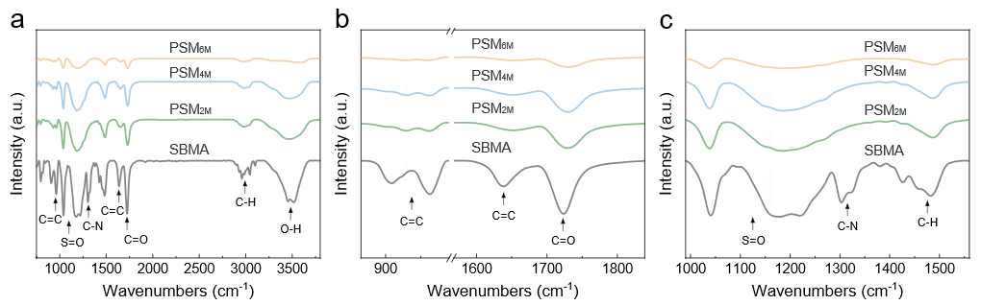
Supplementary Figure 1. FTIR spectra of SBMA monomer and dry gels with varying concentrations (PSM_{2M}, PSM_{4M}, PSM_{6M}). a. Full-range characteristic peak spectra from 750 to 3800 cm⁻¹. b. Characteristic absorption peaks corresponding to carbon-carbon double bonds within the wavelength range of 865-990 cm⁻¹ and 1570-1840 cm⁻¹. c. Characteristic peak spectra within the wavelength range of 990-1560 cm⁻¹.
In the FTIR spectra, the characteristic peaks corresponding to the C=C double bond at 908, 960, and 1638 cm⁻¹ decreased in intensity with increasing monomer concentration, and the shift of the C=O bond peak at 1723 cm⁻¹ to a higher wavenumber confirmed the occurrence of radical polymerization of SBMA. Meanwhile, the characteristic absorption peaks associated with S=O, C-N, and C-H bonds at 1040, 1147, 1302, and 1479 cm⁻¹ gradually diminished, indicating a progressive enhancement of the dipole effect with increasing monomer concentration.

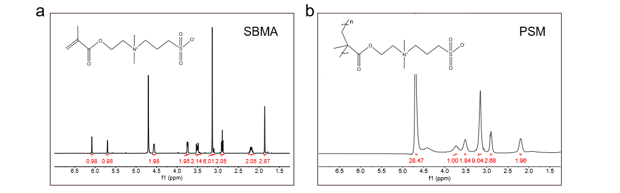
Supplementary Figure 2. Molecular structural formulas of SBMA monomer and polymerized PSM gel, as well as one-dimensional ¹H-NMR spectra of SBMA and PSM_{4M} gel diluents. a. SBMA monomer. b. PSM_{4M} hydrogel diluent (5mg/mL).
The disappearance of the characteristic peaks of the methacrylate group at 𝛿=6.10 and 5.72 ppm in the ¹H NMR spectrum proves that PSM is obtained through double bond polymerization.

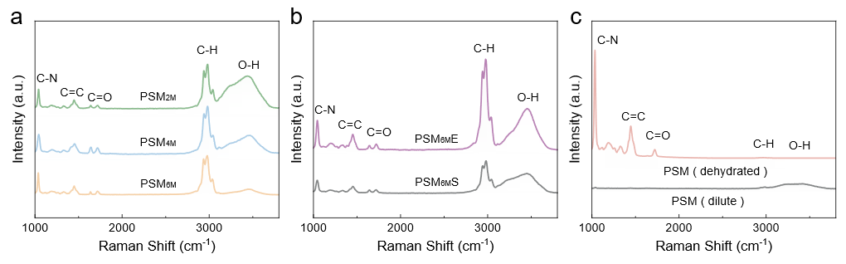
Supplementary Figure 3. Raman spectra of different hydrogels within the wavenumber range of 1000-3800 cm⁻¹. a. Hydrogels with varying monomer concentrations (PSM_{2M}, PSM_{4M}, PSM_{6M}). b. Hydrogel containing 5 M NaCl salt ions (PSM_{6M}E) and fully swollen PSM_{6M} hydrogel (PSM_{6M}S). c. Completely dehydrated gel (PSM-dehydrated) and gel solution diluted to a concentration of 5 mg/mL (PSM-dilute).
In the Raman spectra, as the PSM concentration increased (2M, 4M, 6M), the characteristic peaks of O-H bonds gradually diminished, indicating a reduction in water content and degree of hydration. When ions were introduced into the PSM_{6M} gel system or the gel was fully swollen, the O-H characteristic peak became more pronounced, which can be attributed to the disruption of electrostatic interactions and an increase in hydration degree. In the case of completely dehydrated gels, this characteristic peak was nearly absent. The diluted gel solution exhibited broad O-H stretching bands.

Supplementary Figure 4. SEM images of different freeze-dried gels. a. PSM_{2M}. b. PSM_{4M}. c. PSM_{6M}. d. PSM_{6M}S.
The micrometer-scale morphology of PSM was examined using scanning electron microscopy (SEM). PSM_{2M} displayed a porous three-dimensional structure with relatively large pore sizes (~20 μm). In contrast, PSM_{4M} exhibited a reduced degree of structural order and smaller pore sizes ranging from 2 to 10 μm. PSM_{6M} formed a dense, planar architecture. However, when fully swollen, PSM_{6M} developed a three-dimensional porous structure with pore sizes intermediate between those of PSM_{2M} and PSM_{4M}.

Supplementary Figure 5. Gel permeation chromatography (GPC) test curves of the diluted solutions (5mg/mL) of PSM_{2M} and PSM_{6M}.
The GPC analysis revealed that both PSM_{2M} and PSM_{6M} exhibited a weight-average molecular weight of approximately 120,000, with a polydispersity index of around 1.7, indicating that the molecular weights of the two samples were at a comparable level.

Supplementary Figure 6. Raman spectrum of PSM and integral intensity of the -OH peak.

Supplementary Figure 7. Normalized field correlation function g₁ (q, t) measured by dynamic light scattering. The line is the fitting curve fitted by two exponential decays and the points are the residuals between the fitting curve and the raw data. a. PSM_{2M}. b. PSM_{4M}. c. PSM_{6M}.
Dynamic light scattering can quantify the elasticity of the PSM. The electric field correlation function g₁ (q, t) is proportional to the correlation of the hydrogel’s strands displacement along the longitudinal. In general, there are several relaxation modes that can contribute to hydrogel dynamics, but we can only probe the slower modes with dynamic light scattering. The electric field correlation function g₁ (q, t) of the hydrogel matrix can be fitted by two exponential decays, the quality of the fitting can be seen from the fitting residuals.

Supplementary Figure 8. Corresponding relaxation rate distribution function obtained from CONTIN fit. a. PSM_{2M}. b. PSM_{4M}. c. PSM_{6M}.
The corresponding relaxation time distribution function f(t) can be obtained from CONTIN fitting method.

Supplementary Figure 9. q2 dependence of the relaxation rate Γ₁ (the first mode) and Γ₂ (the second mode) for the PSM. a. Γ₁ of PSM_{2M}. b. Γ₂ of PSM_{2M}. c. Γ₁ of PSM_{4M}. d. Γ₂ of PSM_{4M}. e. Γ₁ of PSM_{6M}. f. Γ₂ of PSM_{6M}.
There are two relaxation modes at each angle and is dominant and diffusive. If one relaxation mode is diffusive, the relaxation rate Γ at different scattering angles have the quadratic dependence on the scattering wavevector q, and from the slope of relaxation rate Γ/q², we can obtain the elastic diffusion coefficient of the hydrogels (D_{gel}). Besides, D_{gel} can also be interpreted as the cooperative diffusion coefficient related to the dynamic correlation length of concentration fluctuations of the hydrogel, analogous to that in the semidilute solutions. So D_{gel} can be converted to the dynamic correlation length ξ_{dynamic} by ξ_{dynamic}=k_{B}T/6πηD_{gel} (with k_{B}, T, and η are the Boltzmann constant, the absolute temperature, and the solvent viscosity, respectively).

Supplementary Figure 10. Creep test data of hydrogels with different concentrations.
The degree of elastic-plastic behaviour in the PSM gels can be quantified through rheological tests conducted in creep mode. Two stress regions were established, i.e., the pressure region (10 Pa - 900 s) and the recovery region (0 Pa - 900 s), to characterize the creep process of the gel. These designed regions encompass material states such as rapid elastic deformation, hysteretic elastic deformation, recoverable elastic deformation, and nonrecoverable plastic deformation. With increasing polymer concentration, the maximum strain in the pressure region significantly decreases, from 346% at c = 2M to 0.4% at c = 6M, indicating that the molecular chains at higher concentrations exhibit reduced mobility. The creep curve was further normalized. For the plastic gel (PSM_{2M}), the deformation rate in the pressure region is relatively slow, with most of the deformation being irrecoverable. The elastic ratio is only 6%, and 98% of the elasticity corresponds to stagnant elasticity, which depends on the high degree of freedom within the molecular chain network. For the elastic gel (PSM_{6M}), the proportion of rapid elastic deformation in the initial stage reaches 90%, approximately 58% of which represents ideal elasticity. Low stress levels are insufficient to disrupt the stable structure formed by high-concentration chain entanglements.

Supplementary Figure 11. Initial strain values and concentration-dependent curves of hydrogels with varying concentrations (2~7 M) under creep test conditions.

Supplementary Figure 12. Quantitative statistics of the elastic proportion of the hydrogels and concentration-related fitting.

Supplementary Figure 13. Ideal elastic ratio values and concentration-dependent fitting curves of hydrogels with varying concentrations (2~7 M) derived from creep test data.

Supplementary Figure 14. Stress relaxation test data of hydrogels with different concentrations.
To a certain extent, stress relaxation reflects the entanglement characteristics of molecular chains. Through rheological tests conducted under stress relaxation mode, we quantitatively assessed the relaxation behaviour of the polymer chains. Under the same strain (γ = 5%), the initial stress required by the elastic gel (PSM_{6M}) is significantly greater, approximately 290 Pa, whereas that of the plastic gel (PSM_{2M}) is only 1.9 Pa. The normalized relaxation curve reveals that the plastic gel (PSM_{2M}) exhibits rapid stress relaxation, with the stress decreasing to nearly zero within 300 s. Its relaxation interval is short, with half-relaxation time τ_{1/2} ≈ 22 s. In contrast, the elastic gel (PSM_{6M}) demonstrates a long relaxation interval, with τ_{1/2} ≈ 976 s, which is comparable to that of conventional hydrogels (e.g., chemically crosslinked polyacrylamide gels), indicating highly elastic characteristics. Under an external force, the elastic gel (PSM_{6M}) requires a longer time to achieve conformational transformations to adapt to the applied force, and this process is predominantly elastic deformation. Conversely, the plastic gel (PSM_{2M}) can more rapidly transition to another equilibrium state via plastic deformation and complete the relaxation process. Furthermore, when the degree of entanglement is sufficiently high, similar to a crosslinked network, the stress cannot be fully relaxed to zero. The Maxwell stress relaxation model was employed for fitting, and the relaxation times were statistically calculated on the basis of both experimental and theoretical data. The results indicate that the obtained model curve is highly consistent with the experimental curve and that the relaxation time is an exponential function (τ_{1/2} - c⁴) of the PSM polymer concentration. This result suggests that the model can be utilized to design and predict the deformation and stress distribution laws of PSM under external forces across a wide range of concentrations. Based on the above analysis, we have demonstrated that PSM hydrogels possess adjustable properties ranging from superplasticity to hyperelasticity.

Supplementary Figure 15. Initial stress values and concentration-dependent curves of hydrogels with varying concentrations (2~7 M) under stress relaxation test conditions.

Supplementary Figure 16. Quantitative statistics of the stress relaxation time of the hydrogels and concentration-related fitting.

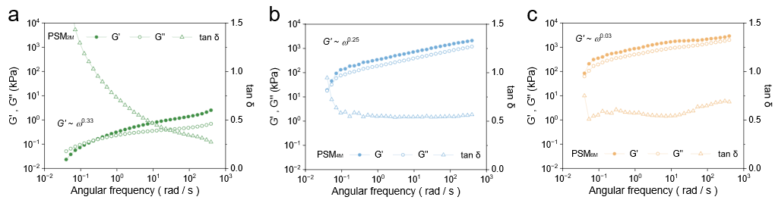
Supplementary Figure 17. Frequency scanning test curves of hydrogels with different concentrations a. PSM_{2M}. b. PSM_{4M}. c. PSM_{6M}.
For PSM physical gels, the dynamic rheological behavior of polymer chains can be described by the power-law relationship G’ ~ ω^{n}. On one hand, PSM6M exhibits a higher G’, indicating stronger elastic characteristics. On the other hand, fitting results reveal that PSM_{6M} has a lower power-law exponent (G’ ~ ω^{0.03}), whereas PSM_{2M} shows a significantly higher exponent (G’ ~ ω^{0.33}). Furthermore, PSM_{2M} displays a higher tanδ value, suggesting superior energy dissipation capacity and damping performance. These rheological data collectively reflect distinct gel behaviors: PSM_{2M} tends to undergo whole-chain relaxation at high frequencies, exhibiting soft and deformable liquid-like characteristics. In contrast, the polymer chains in PSM_{6M} are highly entangled, with slow diffusion dynamics that hinder relaxation, resulting in a rigid and elastic solid-like gel behavior.

Supplementary Figure 18. The changes of polymer content of PSM hydrogels with different concentrations during the swelling and deswelling processes.
In the initial state (preparation state), PSM_{2M} has a low polymer content (34%) and a high hydration degree, PSM_{4M} has a moderate polymer content (53%) and hydration degree, while PSM_{6M} has a high polymer content (63%) and a low hydration degree. In the fully swollen state, the polymer content in the hydrogel increases with the increase of concentration, but the difference is small, approximately 6% (between 2M and 6M).

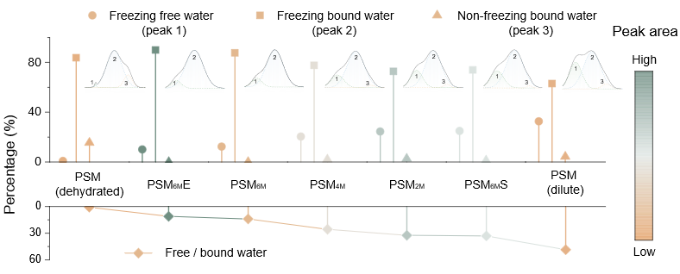
Supplementary Figure 19. Water binding states of various hydrogels, including free water (peak 1), frozen bound water (peak 2), and non-frozen bound water (peak 3), along with the ratio of free water to bound water.
For hydrogels with varying concentrations and post-treatment conditions, the extent and state of water binding within the polymer networks differ. Diluted gels exhibit the highest free-to-bound water ratio, whereas dehydrated gels show the lowest. When PSM_{6M} is fully swollen, the proportion of free water increases, indicating an enhanced hydration capacity. Conversely, upon ion introduction into PSM_{6M}, the free water content decreases, leading to a reduction in the degree of hydration.

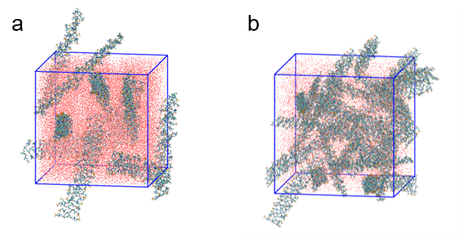
Supplementary Figure 20. Initial configuration of molecular chains in the molecular dynamics simulation system. a. PSM_{2M}. b. PSM_{6M}.
Specifically, we placed an appropriate number of polymer molecules and water molecules at a concentration of 2 M or 6 M within a simulation box measuring 10 × 10 × 10 nm³. This setup allowed us to minimize the system energy and achieve preliminary equilibrium. The polymer chains are represented by green stick models, water molecules are depicted as red spheres, and the blue cube illustrates the simulation box. All initial molecular chains were configured in a fully extended conformation, and the concentration of PSM_{6M} chains is three times higher than that of PSM_{2M}.

Supplementary Figure 21. Morphological transitions of polymer chain conformations with varying numbers (n) during MD simulations over time for PSM_{2M} and PSM_{6M}.
Overall, PSM_{2M} exhibits fewer molecular chain entanglements, whereas PSM_{6M} demonstrates a significantly higher degree of entanglement. During the simulation process, PSM_{2M} undergoes a greater extent of conformational transformation, indicating a higher degree of freedom. In contrast, PSM_{6M} displays relatively limited conformational changes and maintains a more stable structure.

Supplementary Figure 22. Data curves of the solvent accessible surface area (SASA) in MD simulations.
Supplementary Figure 23. Data curves of the mean square displacement (MSD) in MD simulations.

Supplementary Figure 24. Data curves of the root mean square deviation (RMSD) in MD simulations.

Supplementary Figure 25. Mean square radius of gyration (Rg) versus time plots from MD simulations.

Supplementary Figure 26. Final conformational structures of PSM_{2M} and PSM_{6M}.

Supplementary Figure 27. Radial distribution function (RDF) curves from MD simulations.

Supplementary Figure 28. Guinier theory fitting curves of PSM_{6M} hydrogels with different stretch. a. λ=0%. b. λ=500%. c. λ=0%.
Information extracted from the SAXS peaks was analysed using Guinier's theory. Within different q ranges, ln(I(q)) was plotted against q², allowing calculation of the mean square radius of gyration (Rg) of the molecular chains, which represents the average squared distance of chain segments from the centre of mass.

Supplementary Figure 29. Signal curves of PSM_{2M} and PSM_{6M} in low-field magnetic resonance testing. a. Relaxation signal. b. Attenuation signal.
The entanglement behavior of PSM was analyzed by using low-field nuclear magnetic resonance (LF-NMR). The fast decay component of the T₂ relaxation curve is attributed to restricted structures such as cross-links and entanglements, whereas the slower decay component corresponds to free polymer chains. As shown in Figure a, the reduced signal intensity (RS) within the T₂ range of 0.4 ms to 0.8 ms reflects the entanglement of hydrogen atoms with low mobility between adjacent chains. This RS intensity decreases significantly with decreasing monomer concentration. Furthermore, the proportion of the slow decay component in the PSM_{2M} is higher than that in PSM_{6M}. Comprehensive analysis indicates that the degree of molecular chain entanglement diminishes as the monomer concentration decreases.
Under the CPMG pulse sequence, the original T₂ decay curve was fitted using inverse Laplace transform (ILT) to obtain the T₂ distribution profile (Figure b). The T₂ distribution exhibits two distinct peaks: the shorter T₂ component is associated with entangled regions, while the longer T₂ component corresponds to free chain segments. The relaxation peaks observed between 0.1 and 30 ms are primarily attributed to hydrogen atoms in bound water and soft segments. When the monomer concentration increases from 6M to 2M, the relaxation time of this peak shows a slight shift toward longer values, indicating that PSM_{2M} exhibits a relatively lower degree of molecular chain entanglement in the fully swollen state.
The relaxation peaks in the range of 300 to 3000 ms correspond to hydrogen atoms in free water. Compared to PSM_{6M}, PSM_{2M} displays a more pronounced delay in relaxation time and an increased RS intensity, suggesting a greater presence of highly mobile water molecules. This phenomenon can be attributed to the reduced degree of molecular chain entanglement in PSM_{2M}.

Supplementary Figure 30. T₂ distribution curves and XLD 4 fitting curves of different hydrogels from low-field nuclear magnetic resonance tests.
The internal characteristic structures and corresponding proportions in PSM were quantitatively investigated. Drawing on traditional rubber elasticity theory, parameters such as the entanglement molecular weight and degree of entanglement were utilized to establish a direct connection between the structure and mechanical elastoplasticity. LF-NMR and rheological platform methods were employed to calculate the entanglement molecular weight (Me) and degree of entanglement (De) of the polymer. In the LF-NMR method, the T₂ distribution curve was fitted using the XLD 4 model, and the crosslinking density was obtained through built-in calculations and subsequently converted into the entanglement molecular weight (MeN). After calculation, the MeN values for PSM_{2M}, PSM_{4M}, and PSM_{6M} were determined to be 31743 g/mol, 12898 g/mol, and 4475 g/mol, respectively, with corresponding degrees of entanglement (DeN) of 3.8, 9.3, and 22.8, respectively. These data indicate that the degree of entanglement increases with increasing concentration. By fitting the experimental MeN values with concentration-dependent data, a correlation function was derived, enabling quantitative regulation of the degree of entanglement of the system through concentration control. Furthermore, the ion addition or swelling regulation mentioned in the previous section directly corresponds to a decrease in the degree of entanglement, reducing it from 22.8 (PSM_{6M}) to 11.3 (PSM_{6M}E) and 4.2 (PSM_{6M}S). Clearly, the reduction in the hydrophobic effect caused by swelling has a more significant impact on polymer entanglement.

Supplementary Figure 31. Concentration-dependent entanglement molecular weight (MeN) curves obtained by the nuclear magnetic resonance method and fitting results.

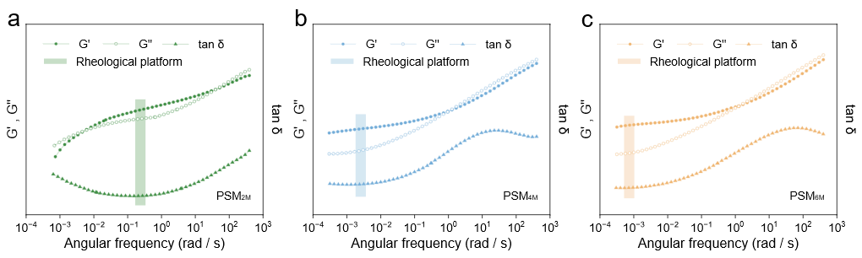
Supplementary Figure 32. Amplitude-frequency scanning curves of different hydrogels. a. PSM_{2M}. b. PSM_{4M}. c. PSM_{6M.}
The shear modulus (entangled platform modulus) was determined through amplitude-frequency scanning tests conducted across both the rubber and transition zones. Rheological data at very high and low frequencies were supplemented using the time-temperature superposition principle. Based on the criterion of minimizing the loss angle tangent (tanδ), the rubbery plateau regions of PSM are situated in the low-frequency domain and exhibit a dependence on polymer concentration. With increasing concentration, the frequency corresponding to the peak position of tanδ decreases, ranging from 0.2 rad/s for PSM_{2M} to 0.00075 rad/s for PSM_{6M}. This shift reflects the distinct relaxation behavior of polymer chains. The G’ value at the tanδ peak is defined as the plateau modulus of the gel, which arises from molecular entanglements. Consistent with previously established trends, as the polymer concentration increases, the degree of molecular chain entanglement increases, leading to a higher platform modulus and a shift of the viscoelastic transition to lower frequencies. This indicates that the characteristic full-chain relaxation time of the PSM is prolonged, reflecting an enhanced elastic behavior. Within the rubbery plateau region, the modulus of PSM remains independent of frequency, confirming its predominantly elastic response over this range. With increasing entanglement density and dipole interaction strength, the width of the rubbery plateau expands, signifying a greater contribution of elastic properties to the overall mechanical behavior of the material.

Supplementary Figure 33 Concentration-dependent entanglement molecular weight (MeR) curve obtained by the rheological method and fitting results.
The rheological method was employed to cross-validate the conclusions derived from LF-NMR. Frequency scanning tests were conducted on PSM. On the basis of the principle of minimizing the tangent of the loss angle (tanδ), the rubber plateau points of PSM were determined, and the entanglement molecular weight was calculated using the plateau modulus in conjunction with rubber elasticity theory. The results indicate that the entanglement molecular weights (MeR) of PSM_{2M}, PSM_{4M}, and PSM_{6M} are 59842 g/mol, 21456 g/mol, and 1463 g/mol, respectively, with corresponding entanglement degrees (DeR) of 2, 5.6, and 82, respectively. Similarly, fitting the experimental MeR yields the c ~ MeR correlation function.

Supplementary Figure 34. Comprehensive entanglement molecular weight (Me) curves and fitting results related to the concentration.
Importantly, due to the inherent differences between the two methods (molecular chain relaxation vs. gel viscoelasticity), discrepancies exist in the calculated results. The LF-NMR method is more suitable for plastic gels, whereas the rheological method is better suited for elastic gels. Since the PSM in this study has intermediate characteristics between plasticity and elasticity, a more practical quantitative evaluation of the entanglement data was achieved by combining the results obtained from both detection methods. Specifically, the modified Me was calculated as the product of MeN and the proportion of plasticity in the hydrogel plus the product of MeR and the proportion of elasticity in the hydrogel. Furthermore, through fitting, the model was simplified to the relevant function of c, enabling more objective prediction and regulation of the entanglement molecular weight of the system on the basis of the concentration. Combining this model with the elastoplastic data from the previous section, when the modified entanglement degree De (De=molecular weight/Me) of the system is 3.6, 6.6, and 69, the corresponding elastic degrees of PSM are 6.8%, 63.5%, and 89.6%, respectively. Through fitting, the correlation between the De and elastic degree of the gel was established (logarithmic correlation function), thereby quantifying the influence of the entanglement degree on the elastoplasticity of the gel.

Supplementary Figure 35. Relationship between the degree of entanglement (De) of the hydrogels and the elastic ratio (Er) and fitting results.

Supplementary Figure 36. Simulation diagrams of the hydrogels at different times in directional stretching MD simulations. a. PSM_{2M}. b. PSM_{6M.}
The tension-oriented MD simulation of PSM aligns with the microscopic tensile fracture behaviour of the gel. In the initial deformation region (< 20 ns), PSM_{2M} demonstrates pronounced molecular chain slip behaviour. Upon further stretching, the molecular chains exhibit enhanced slip, elongation, and alignment along the stretching direction, accompanied by a noticeable necking phenomenon. After surpassing the yield point, the material transitions into complete plastic deformation, with the stress gradually decreasing until fracture.
Unlike PSM_{2M}, PSM_{6M} demonstrates only chain stretching behaviour without chain slippage during the initial stage (< 20 ns). During continuous stretching (20 - 100 ns), the molecular chains subsequently undergo significant stretching and partial orientation, with the stress gradually increasing. When a certain degree of stretching is reached (~110 ns), internal defects emerge within the gel and progressively expand until fracture, exhibiting elastic deformation characteristics.

Supplementary Figure 37. Stress-time curves of PSM_{2M} and PSM_{6M} in tensile Oriented MD simulation
The stress curve trend derived from the tensile-oriented MD simulation is consistent with the actual experimental results. The linear elastic region of PSM_{2M} is relatively limited, leading to a more rapid onset of yielding followed by transition into plastic deformation. In contrast, PSM_{6M} exhibits a broader elastic range, higher tensile strength, and lacks distinct yield and plastic deformation stages.

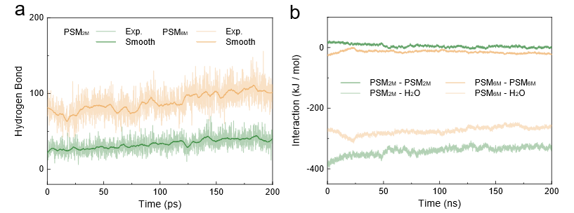
Supplementary Figure 38. Interaction force curves of PSM_{2M} and PSM_{6M} in the tensile-oriented MD simulation system. a. Hydrogen bonding interactions. b. Electrostatic interactions, including those between polymer chains and between polymer chains and water molecules.
The interaction forces within the system are quantitatively analyzed. Compared to PSM_{2M}, PSM_{6M} exhibits stronger inter-chain interactions (Figure a). In the PSM_{2M} system, the electrostatic interaction between polymer chains is negative, indicating the presence of electrostatic repulsion among the chains. In contrast, the corresponding interaction in the PSM_{6M} system is characterized by electrostatic attraction. Regarding the electrostatic interaction between polymer chains and water molecules, PSM_{2M} demonstrates a higher interaction strength, suggesting a greater degree of water binding.

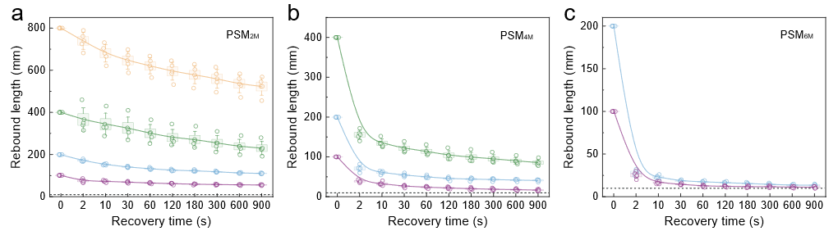
Supplementary Figure 39. Recovery length-time curves of hydrogel under different stretching lengths. a. PSM_{2M} (λ=1000%, 2000%, 4000%, 8000%). b. PSM_{4M} (λ=1000%, 2000%, 4000%). c. PSM_{6M} (λ=1000%, 2000%)
As the polymer chain concentration in the system increases, the degree of plasticity in PSM rises, leading to more pronounced plastic deformation during the stretching process. Consequently, the maximum stretching length increases, while the ratio of recoverable length after removal of the external force decreases. Furthermore, for the same gel material, an increase in stretch ratio also results in a lower recoverable length ratio.

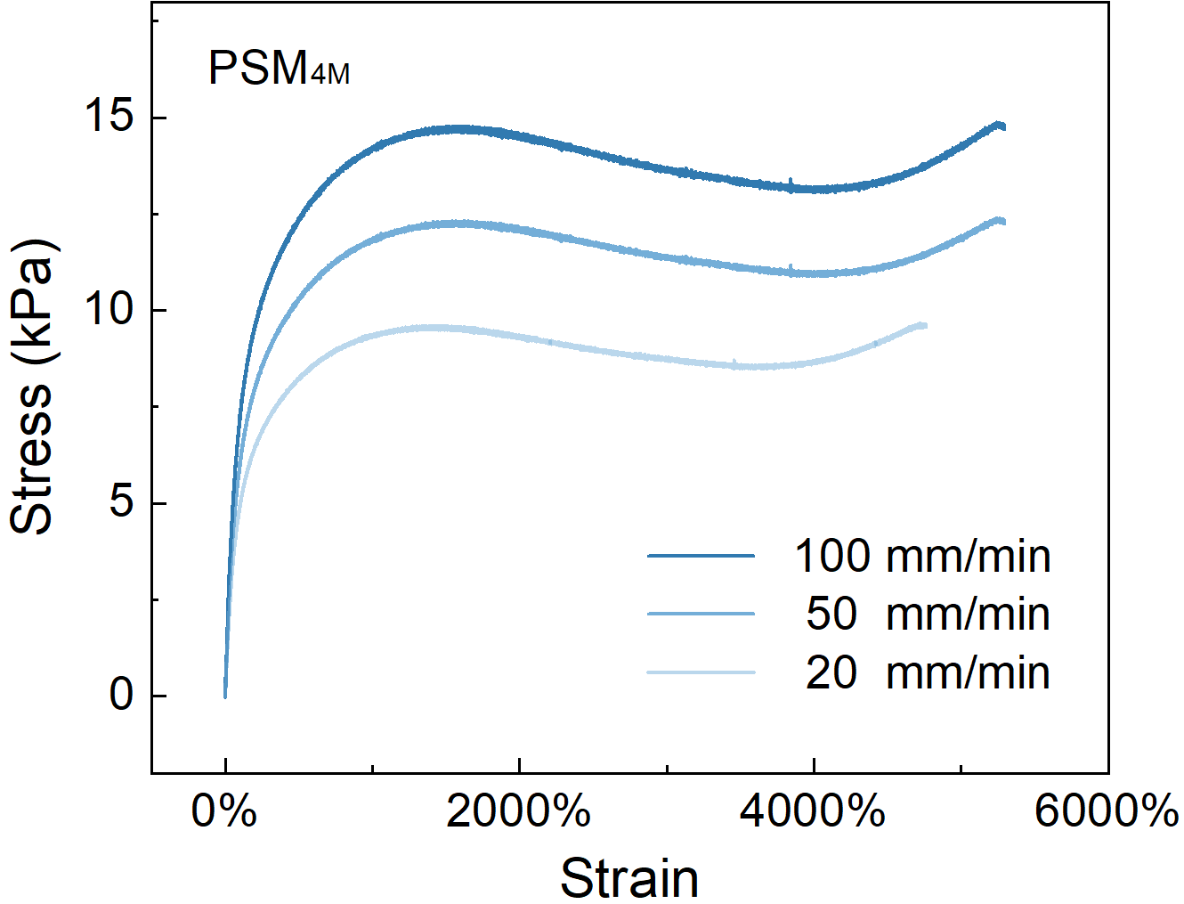
Supplementary Figure 40. Stress-strain curves of PSM_{4M} at different tensile rates (20, 50, 100 mm/min).
The strain rate sensitivity of PSM further demonstrates its elastoplastic behavior. In uniaxial tensile tests conducted at speeds of 20, 50, and 100 mm/min, PSM_{4M} exhibit greater sensitivity to the strain rate. Their stress-strain curves overlap only in the initial elastic deformation region, while the maximum tensile strength increases with the strain rate, and the yield point shifts toward higher strains. Conversely, PSM_{4M} possess shorter relaxation times, which lead to increased molecular chain slippage under lower tensile rates, thereby reducing the tensile strength.

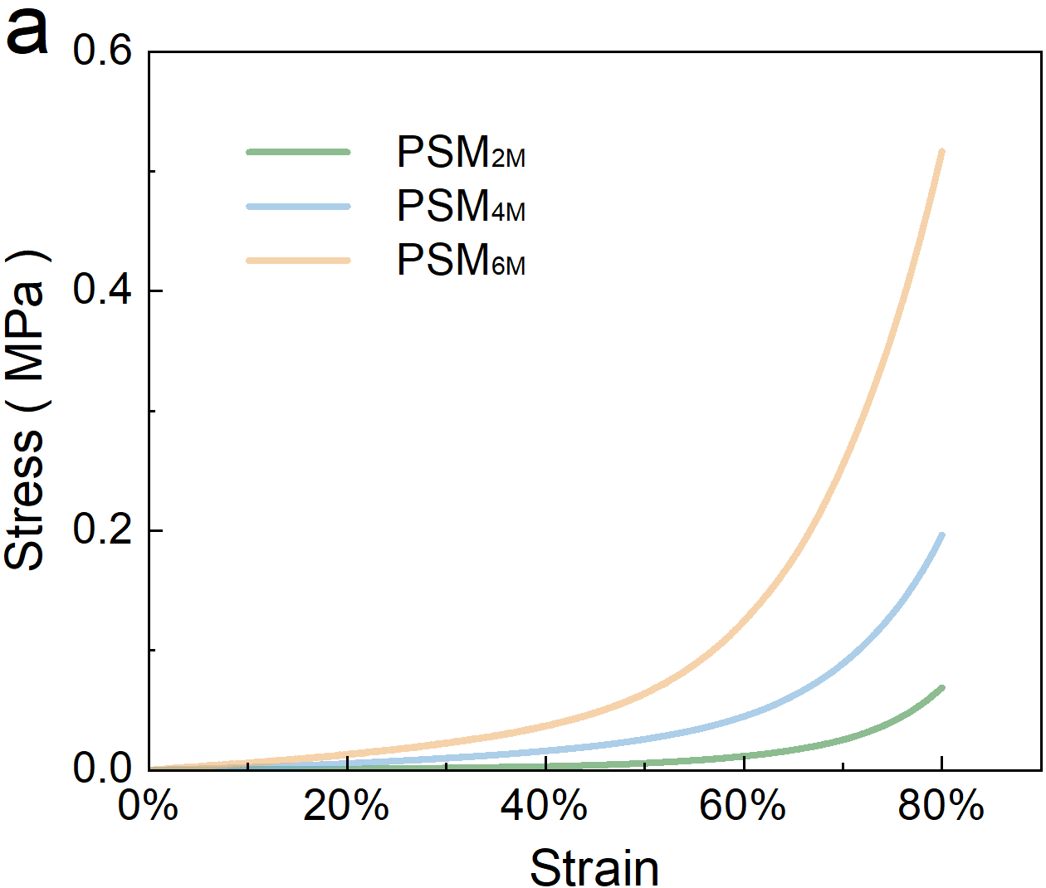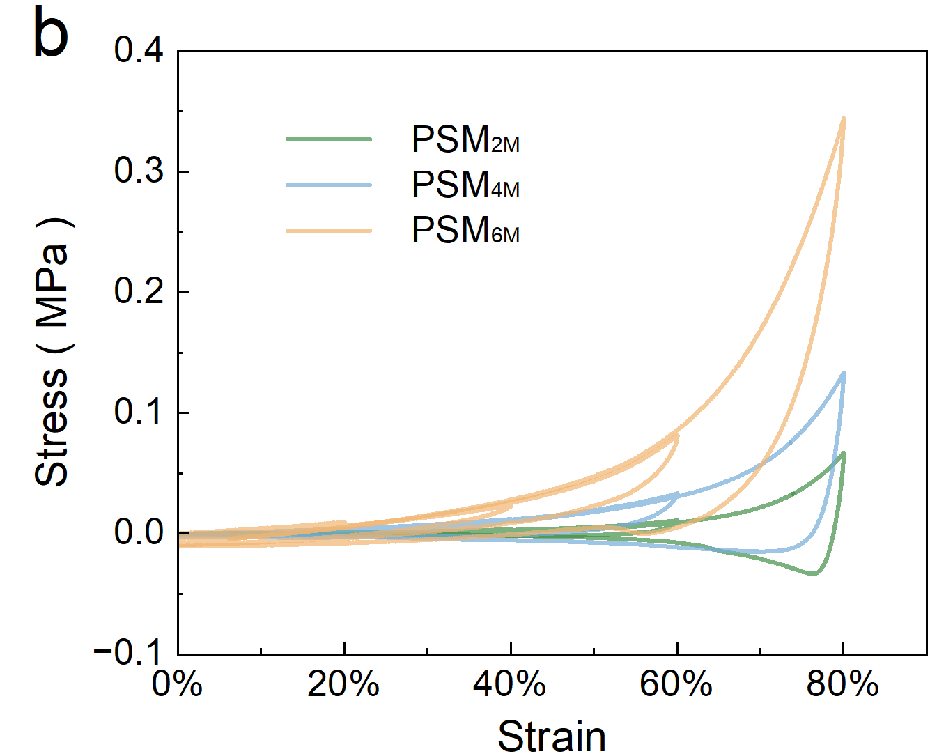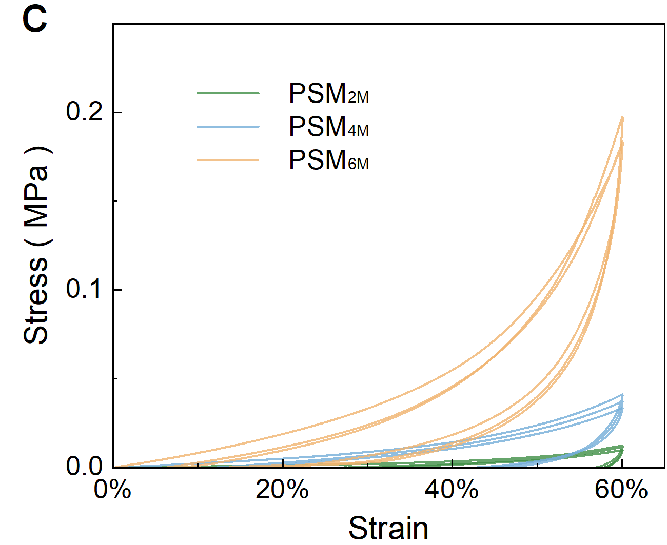
Supplementary Figure 41. Stress-strain curves in compression tests of hydrogels with different concentrations (PSM_{2M}, PSM_{4M}, PSM_{6M}). a. Uniaxial compression test (λ=80%). b. Incremental strain cyclic compression (λ=20%, 40%, 60%, 80%). c. Cyclic compression (λ=60%, cyclic n=3 times).
As the polymer concentration increases, the maximum compressive strength of PSM also increases, which can be attributed to the expansion of the entanglement region. In the cyclic loading tests, the stress of PSM_{2M} and PSM_{4M} gradually decreased with an increasing number of cycles, whereas the hysteresis loops of PSM_{6M} remained largely consistent across cycles. This difference was caused by variations in the extent of irreversible deformation exhibited by the different PSM samples.

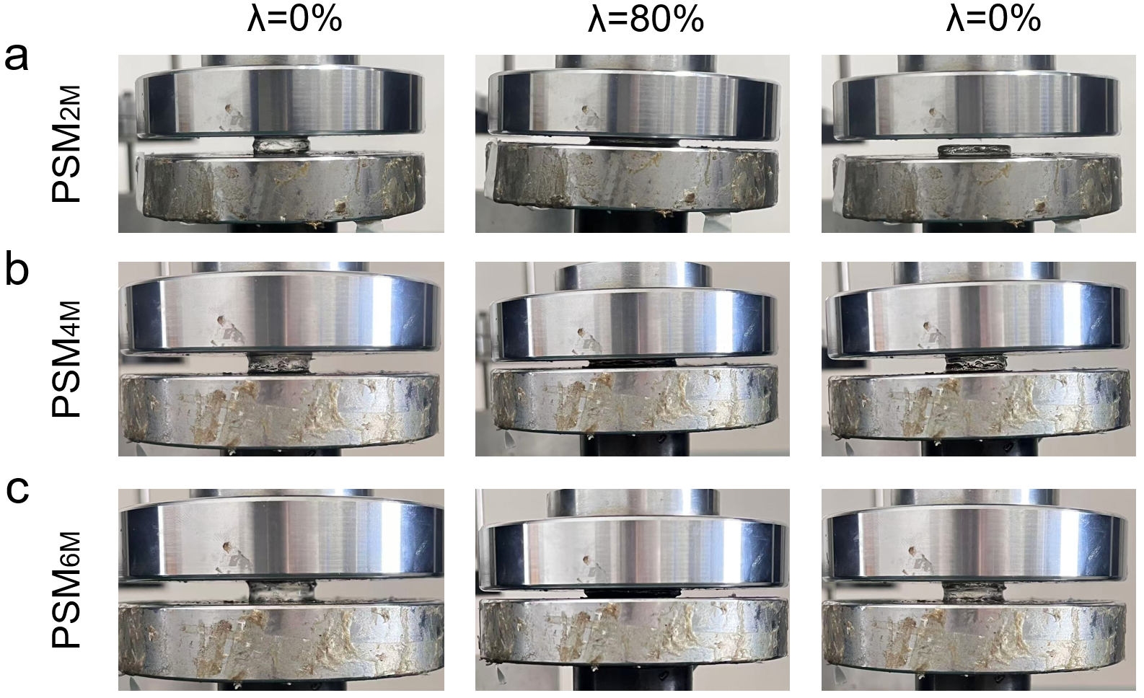
Supplementary Figure 42. Picture of the cyclic compression process of hydrogel (Initial-compression- recovery). a. PSM_{2M}. b. PSM_{4M}. c. PSM_{6M}.
Under single or cyclic compressive loading, PSM_{2M} becomes flattened and is unable to recover its original shape, with the majority of the deformation being irrecoverable. In contrast, PSM_{4M} exhibits reduced plasticity, where most of the deformation is recoverable. For the more ideal elastic gel, PSM_{6M}, the deformation can be completely restored due to its stable entangled network structure.

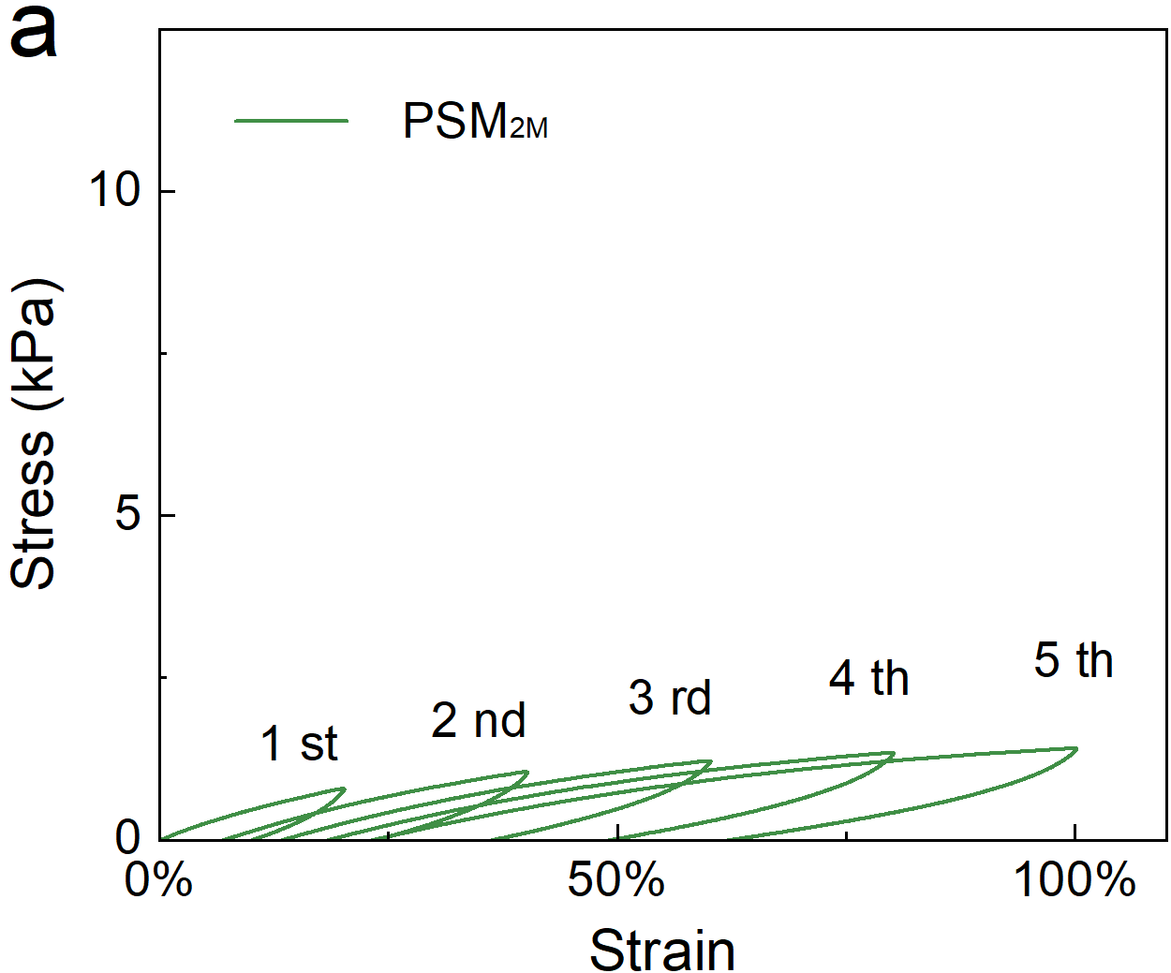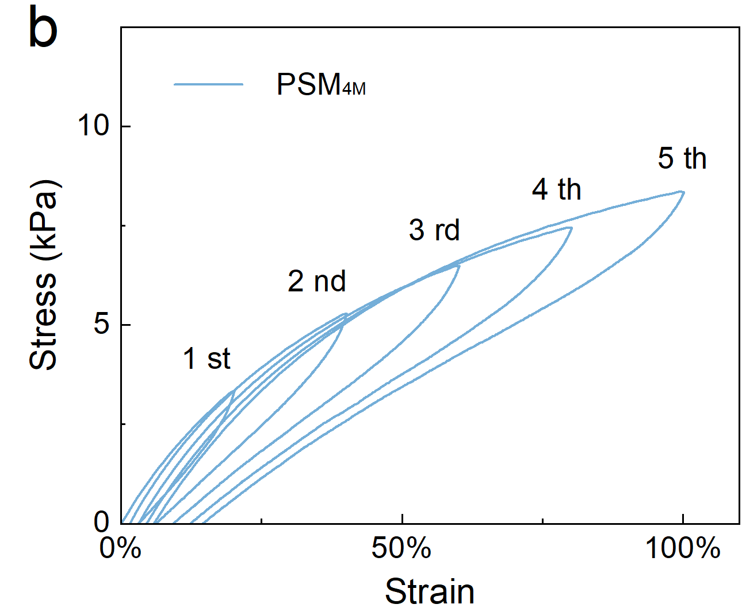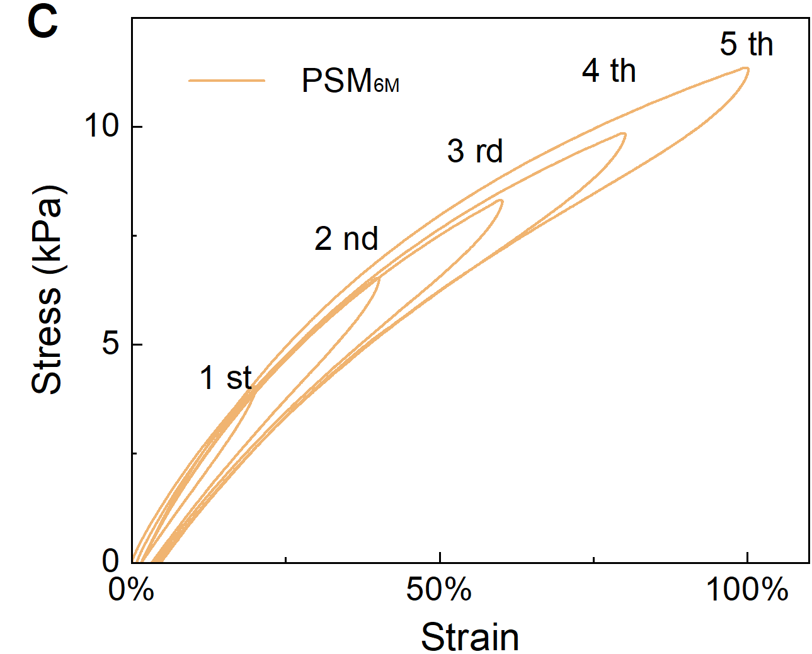
Supplementary Figure 43. Stress-strain curve of hydrogel in cyclic tensile test with increasing strain (λ=20%, 40%, 60%, 80%, 100%). a. PSM_{2M}. b. PSM_{4M}. c. PSM_{6M}.

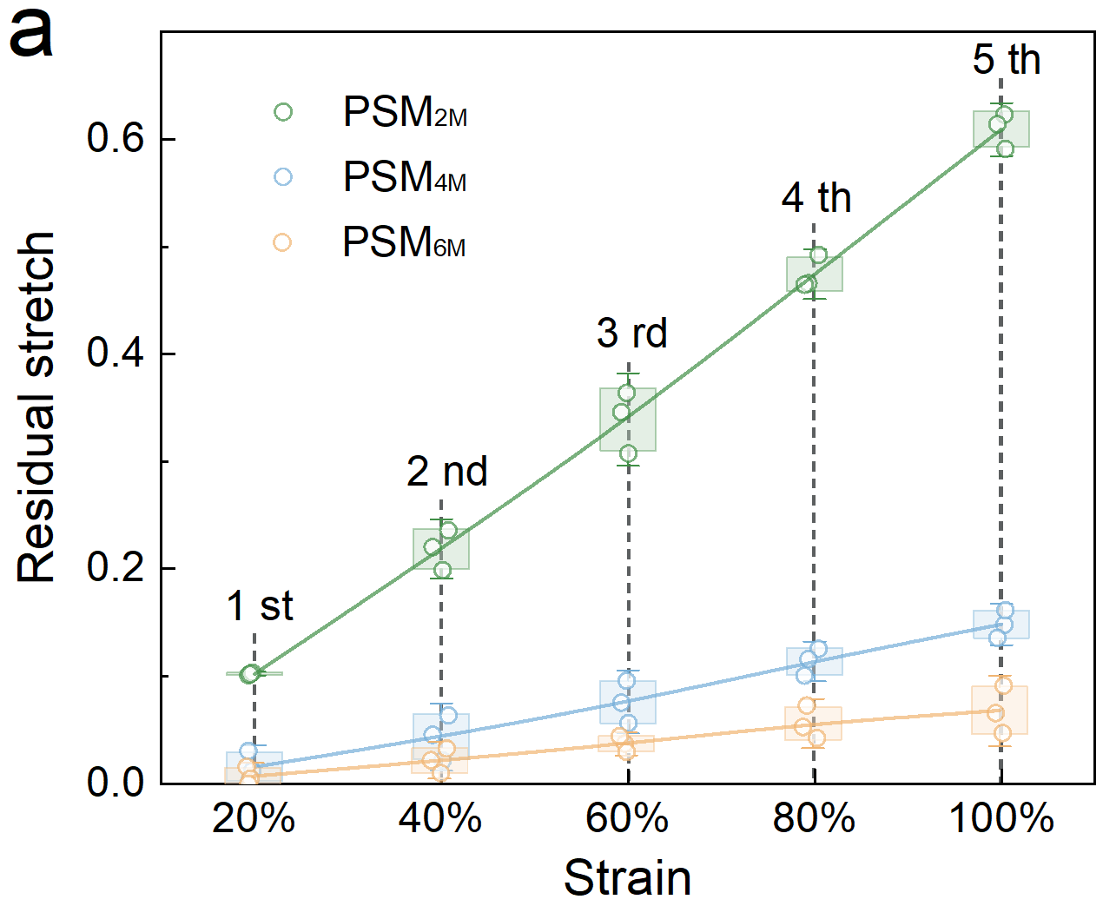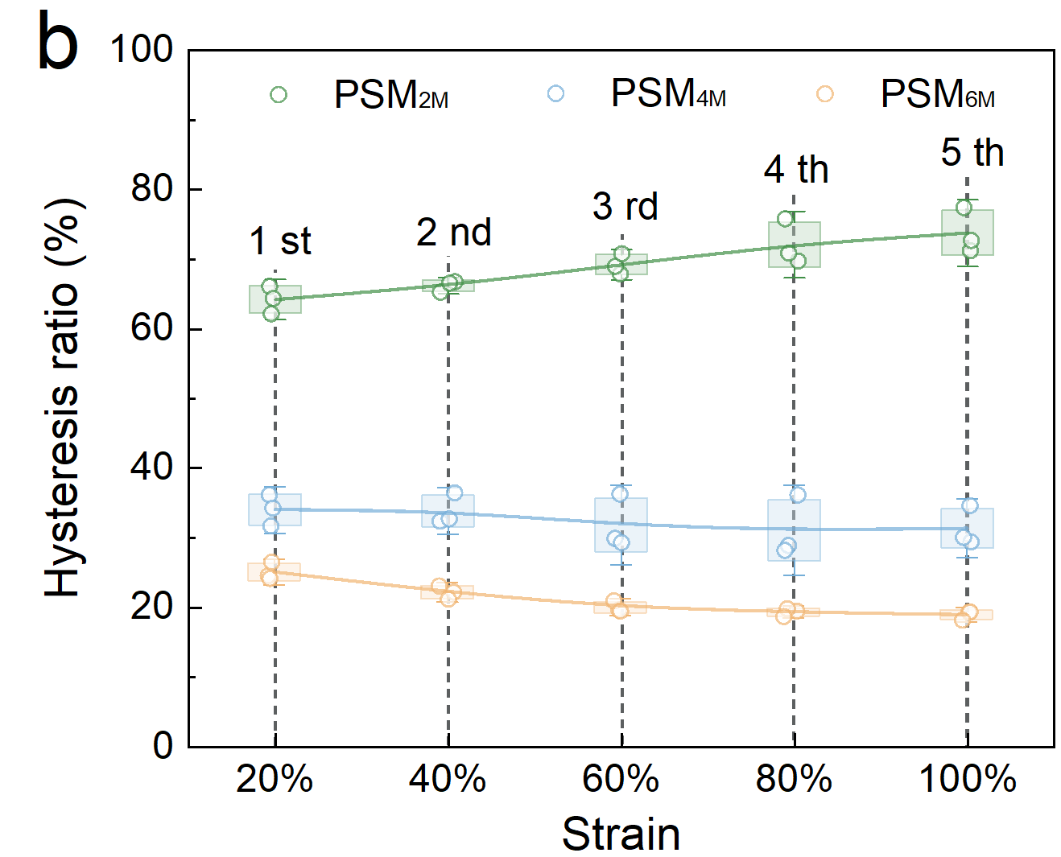
Supplementary Figure 44. Computational data of hydrogels with different polymer concentrations (PSM_{2M}, PSM_{4M}, PSM_{6M}) under cyclic tensile loading at increasing strain levels. a. Residual strain. b. Hysteresis ratio.
When subjected to incrementally increasing loads, the elastoplastic behavior of PSM becomes distinctly evident. The plastic gel PSM_{2M} exhibits a higher hysteresis ratio (64.4% to 72.7%), and its residual strain increases significantly with the number of loading cycles, ranging from 0.1 (first cycle, λ=20%) to 0.61 (fifth cycle, λ=100%). In contrast, the elastic gel (PSM_{6M}) demonstrates a lower hysteresis ratio (18%) and a much smaller residual strain, varying from 0.004 to 0.066 across the first to fifth loading cycles.

Supplementary Figure 45. SEM image of the PSM_{4M} after stretching (λ=1500%).
After stretching, all PSM samples exhibit varying degrees of molecular orientation. As described in the main text, along the stretching direction, the network structure of PSM_{4M} undergoes elongation and oriented deformation.

Supplementary Figure 46. Statistical data of the elastic modulus and concentration correlation and fitting curve.

Supplementary Figure 47. Statistical data of the toughness and concentration correlation and fitting curve.
On the basis of the aforementioned characteristics, we aimed to establish a direct correlation between the PSM concentration and mechanical properties to enable customization of its mechanical behaviour. The elastic modulus of PSM exponentially depends on the concentration (E ~ c^{7.4}) within the range of 2 M to 7 M (corresponding to 0.7 kPa–659 kPa at 25 °C). In contrast, its toughness within the same concentration range (17 kJ/m³–1221 kJ/m³) demonstrates a strong linear relationship with the concentration (Γ ~ c^{1.4}), allowing direct calculation of performance characteristics on the basis of the concentration. Furthermore, the mechanical property ranges of PSM encompass the performance ranges of most hydrogels and significantly surpass the performance of conventional hydrogels (modulus ~40 kPa, toughness ~100 kJ/m³) and entangled hydrogels (modulus ~180 kPa, toughness ~250 kJ/m³). Notably, across all the concentration ranges, PSM consistently exhibits excellent extensibility (λ ≥ 3000%), which adequately satisfies the application requirements of diverse scenarios.

Supplementary Figure 48. Shear toughness in shear tests.
When the polymer concentration was increased from 2M to 6M, the shear toughness increased from 8.1 to 765 kJ/m³, and the shear resistance was markedly enhanced.

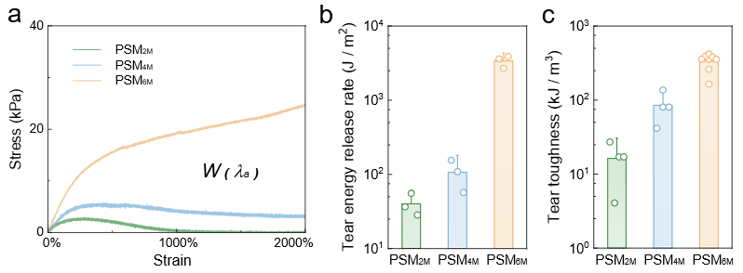
Supplementary Figure 49. Tear test data of hydrogels with different polymer concentrations (PSM_{2M}, PSM_{4M}, PSM_{6M}). a. Stress-strain curve. b. Crack release rate. c. Tear toughness.
As the polymer chain concentration increases, the tear strength of the hydrogel rises, with both the crack propagation resistance and tear toughness showing substantial improvements, thereby demonstrating excellent overall tear resistance.
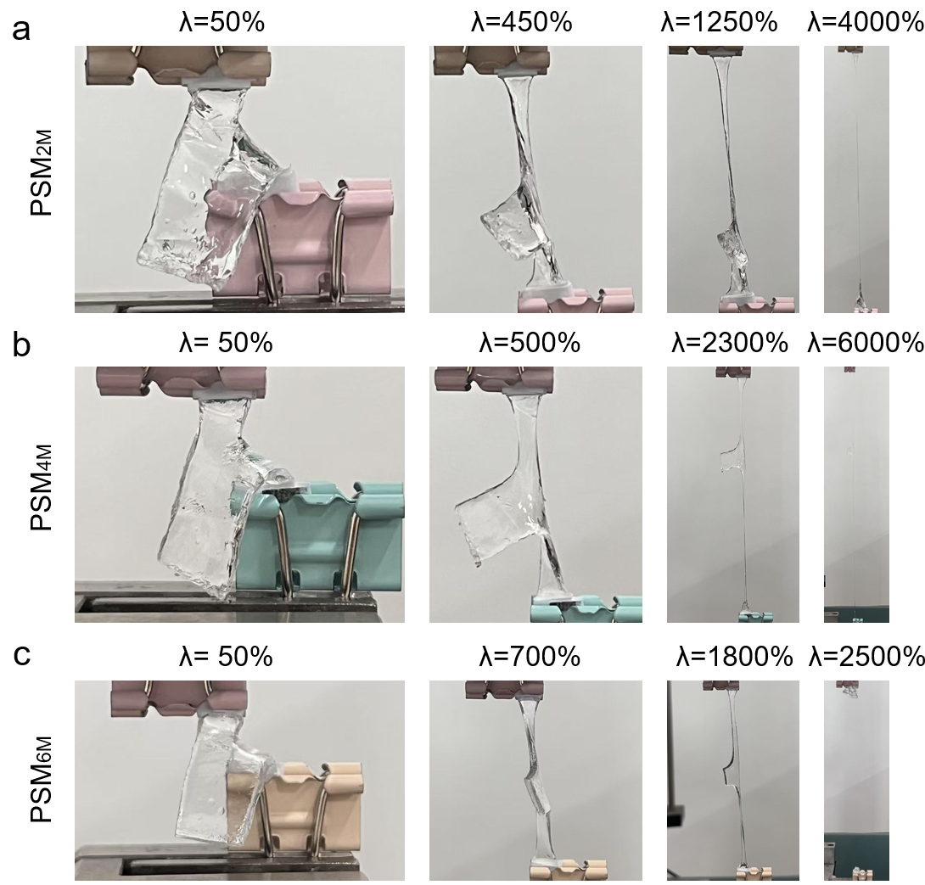
Supplementary Figure 50. Images of the tear test process. a. PSM_{2M}. b. PSM_{4M}. c. PSM_{6M}.
In the tear test, all PSM samples exhibited excellent tear resistance, as they could be stably stretched to over 20 times their original length. The initially introduced tears did not propagate but instead underwent both plastic and elastic deformation at the ends of the pant legs.

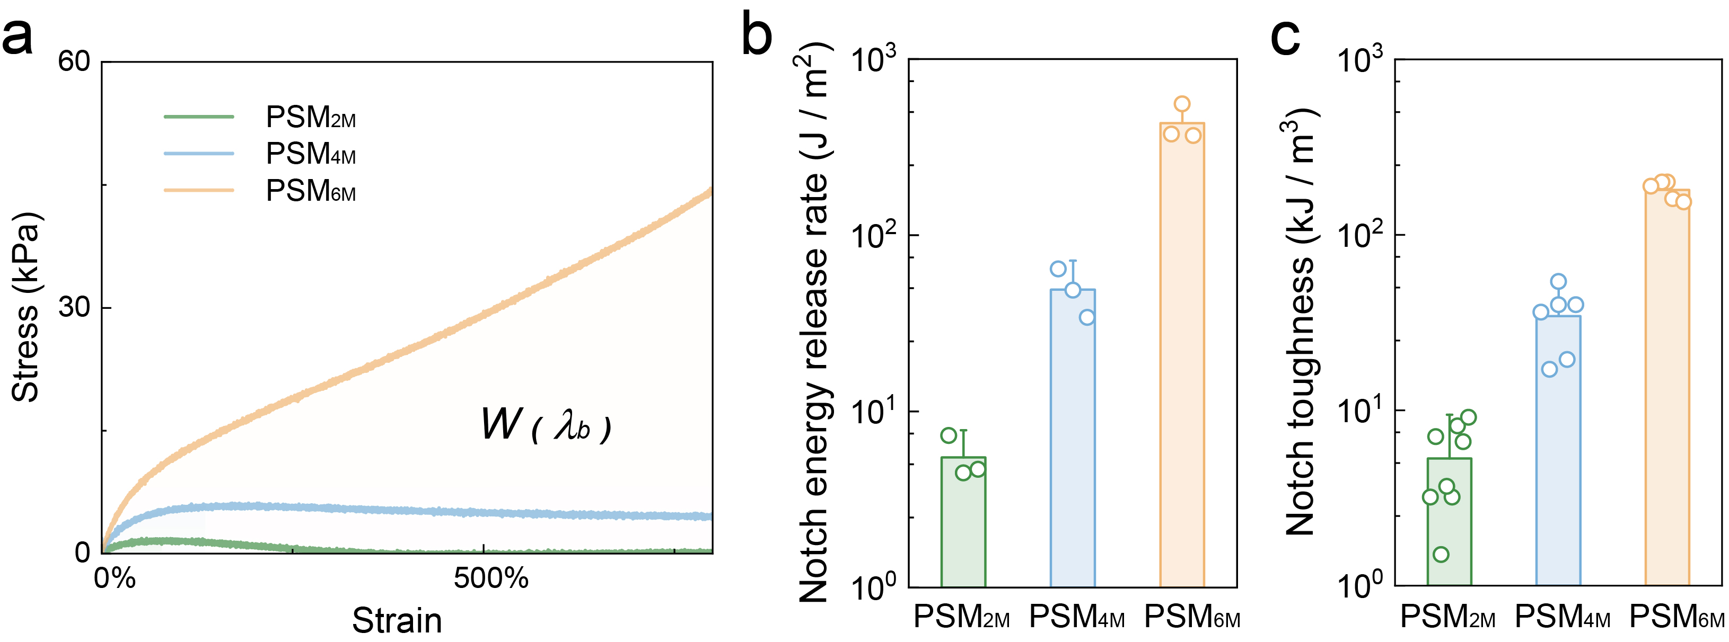
Supplementary Figure 51. Notch experimental test data of hydrogels with different concentrations (PSM_{2M}, PSM_{4M}, PSM_{6M}). a. Stress-strain curve. b. Crack propagation resistance. c. Notch toughness.
As the polymer chain concentration increases, the tensile strength of the hydrogel rises, with both the crack propagation resistance and notch toughness showing substantial improvements, thereby demonstrating excellent overall notch resistance.

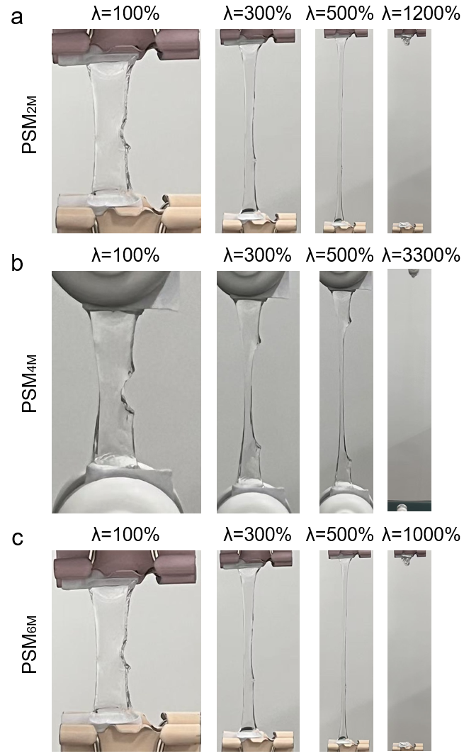
Supplementary Figure 52. Images of notched test process. a. PSM_{2M}. b. PSM_{4M}. c. PSM_{6M}.
In the notch test, all PSM samples exhibited passivation expansion and could be stably stretched up to 10 times their original length.

Supplementary Figure 53. Bright-field and DAPI/AO staining images during the co-culture of hydrogel and stem cells.
To evaluate its suitability, we cocultured PSM with human umbilical cord mesenchymal stem cells (UC-MSCs) and assessed key indicators such as cell survival, viability, and proliferation. Initially, two double-staining methods, DAPI/AO and AO/PI, were employed to evaluate the cell viability and survival during culture. Figure presents the DAPI/AO staining results after 24 hours of coculture. Blue represents nuclear staining by DAPI, while green indicates cell viability staining by AO. Compared with the blank control group, the PSM group presents a significantly greater number of cells and higher cell viability. Figure shows the AO/PI staining results after 24 hours of coculture. The green fluorescence and red fluorescence in the AO/PI images correspond to living and dead cells, respectively. The results reveal stronger green fluorescence signals from living cells in the PSM group, with virtually no red fluorescence indicating dead cells, thus confirming the excellent cytocompatibility of PSM.

Supplementary Figure 54. Bright-field and DAPI/EdU staining images during the co-culture of hydrogel and stem cells.
We further investigated the effect of PSM on cell proliferation using the DAPI/EdU staining method58. Proliferating cells were labelled with red EdU. PSM results in cell proliferation levels comparable to or greater than those in the blank control group, with PSM_{2M} exhibiting the most pronounced effect on proliferation.

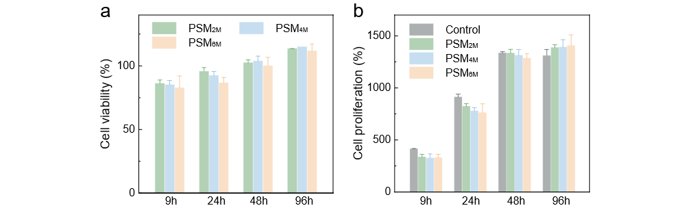
Supplementary Figure 55. Biocompatibility of PSM. a. Cell survival rates of different hydrogels. b. Cell proliferation rates of different hydrogels.
Cell survival and proliferation rates were quantitatively evaluated using the CCK-8 assay. The results indicate that after 24 hours of coculture, the survival rates of UC-MSCs cocultured with PSM_{2M}, PSM_{4M}, and PSM_{6M} are 96%, 92%, and 87%, respectively, demonstrating excellent cytocompatibility. Furthermore, after 48 hours of culture, the cell survival rates exceed 100%, indicating that PSM promotes cell proliferation. After 48 hours of culture, the proliferation rate in the gel group is comparable to that in the blank control group (~1300%). After 96 hours of culture, the proliferation rate in the gel group surpasses that in the blank control group, indicating significant promotion of stem cell proliferation. Collectively, these findings confirm that the PSM gel has excellent biocompatibility and cytocompatibility.

Supplementary Figure 56. Particle size distribution and particle concentration of exosomes.
PSM-Exo was utilized to load exosomes (Exos) derived from human UC-MSCs. The average diameter of the exosomes was approximately 120 nm. Additional characteristics, such as Western blot protein expression data, are provided in the supplementary materials. These data confirm the origin and characteristics of exosomes.
The nanoparticle tracking analysis (NTA) results revealed that the average diameter of exosomes was 120 nm, with a concentration of 1.2×10⁷ particles/ml.

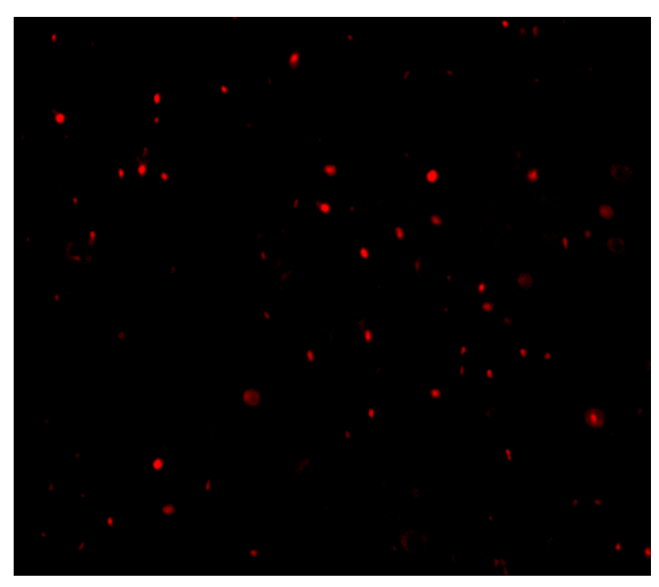
Supplementary Figure 57. PKH26 staining image of exosomes.
The exosomes were stained with PKH26 and observed under a fluorescence microscope. The results revealed that the exosomes exhibited a cup-shaped morphology with a uniform particle size distribution.

Supplementary Figure 58. WB analysis results of stem cells and exosomes derived from stem cells.
WB analysis demonstrated that exosomes derived from umbilical cord mesenchymal stem cells co-expressed CD63, CD81, and HSP70, which are well-established markers of exosomes.

Supplementary Figure 59. Exosome loading data of different hydrogels.
We evaluated the loading and sustained-release performance of the hydrogel for Exos using a BCA kit. Upon testing, PSM demonstrates an adjustable Exo loading capacity within the range of 0-10 mg/mL, satisfying the dosage requirements for local administration (approximately 0.1-1 mg/kg, as referenced). Figure shows the Exo loading curve of PSM (with a total loading of 125 μg). Notably, owing to the relatively low water content of PSM_{6M}, it can absorb a larger volume of exosome solution. This swelling process unties some of the entangled chains, enabling electrostatic adsorption of a greater number of exosomes. Consequently, PSM_{6M} achieves a higher loading capacity (103 μg, with an encapsulation efficiency of 83%) than PSM_{2M}, which exhibits a relatively low loading capacity, with a final loading of 97 μg (encapsulation efficiency of 78%). Compared with conventional gels, which typically exhibit a loading capacity of approximately 0.1-1.5 mg/mL and an encapsulation ratio of 50–70% (as referenced), PSM demonstrates superior performance.

Supplementary Figure 60. Exosome daily release rate of different hydrogels.
Reversible binding enables exosomes to exhibit excellent sustained-release properties. The in vitro release test of Exos loaded onto PSM demonstrates that the duration of Exo release increases amount lasted for up to 12 days, with uniform and continuous release (average daily release of approximately 6.4 μg, with a maximum difference between two consecutive days of less than 1.2 μg). This remarkable sustained-release capability provides significant therapeutic advantages over direct exosome administration and traditional organic gel encapsulation. In contrast, the polyacrylamide (PAAm)-Exo experimental group exhibits burst release, with approximately 85% released within 24 hours. Other types of gels also demonstrate relatively rapid release rates. For instance, the extracellular matrix hydrogel releases approximately 95% within 72 hours, and the dynamic Schiff base bound hydrogel releases approximately 86% within 5 days. The release cycle can be prolonged by constructing additional interactions with substances such as RGD peptides or dopamine, delaying release to 7-10 days. Moreover, we observe differences in the Exo release behaviour between plastic PSM and elastic PSM. Throughout the entire release cycle (12 days), PSM_{6M} exhibits a multistage release process. Initially, the release rate is relatively fast due to the release of exosomes located within the free chain domain. The release rate subsequently decreases, and the curve tends to flatten, as exosomes bound within the helical entangled domain are more difficult to release. Later, since the gel release environment is a PBS aqueous solution, swelling occurs during exosome release, disrupting some entangled regions and enabling secondary release of exosomes from these areas. In contrast, owing to the smaller entanglement regions in PSM_{2M} and its highly water-balanced free chain network, swelling has a minimal impact on the release rate, resulting in a more stable and continuous release profile.

Supplementary Figure 61. Flowchart of the diabetes wound treatment experiment.
We established a full-thickness skin defect wound model in diabetic mice and constructed a PSM-Exo group (using the PSM_{4M} formula with a modulus strength closer to that of skin) and a control group (commercial 3M wound dressings without exosome loading) for treatment. The specific method for model establishment is shown in Figure.

Supplementary Figure 62. Images of wound healing at different times.
The wound healing conditions at different treatment time points are presented in Figure. On days 3, 7, and 12, the percentages of residual wound areas in the control group are 64%, 40%, and 28%, respectively, indicating a relatively slow wound healing rate. In contrast, those in the PSM-Exo group are 60%, 23%, and 11%, respectively, with a significantly reduced residual wound area, indicating excellent therapeutic effects. These findings indicate that the released exosomes significantly promote repair of diabetic wounds.
Moreover, we compared the reparative effects of various types of exosome-loaded hydrogels on diabetic wounds to evaluate the influence of the gel properties. The ratios of residual wound areas at days 3, 7, and 12 were calculated. For the natural extracellular matrix hydrogel derived from porcine heart tissue (loaded with adipose-derived MSC exosomes), the ratios are 91%, 69%, and 25%, respectively. For the inflammatory environment-responsive chitosan hydrogel (loaded with M2 macrophage-derived exosomes), the ratios are 81%, 51%, and 21%, respectively. For the dynamic Schiff base hyaluronic acid hydrogel (loaded with UC-MSC-derived exosomes), the ratios are 75%, 40%, and 22%, respectively. These findings clearly indicate that PSM exhibits excellent loading and sustained release characteristics for Exos, which facilitate continuous regeneration and repair of refractory wounds. Moreover, its appropriate flexibility provides an optimal space and microenvironment for collagen deposition and angiogenesis at the wound site.

Supplementary Figure 63. Immunofluorescence staining images of the control and intervention groups showing CD31, α-SMA, Fibronectin 1, and Vimentin expression.
CD31, a well-established marker of endothelial cells, is utilized to assess the formation of new blood vessels through immunofluorescence staining. Immunofluorescence analysis confirmed the angiogenic potential of exosomes released by hydrogels. Compared with the control group, the PSM-Exo group exhibited an increased number of mature bloods ve22ssels, greater vessel size, and more pronounced tubular structures.

Supplementary References
1. Louf, J. F., Lu, N. B., O'Connell, M. G., Cho, H. J. & Datta, S. S. Under pressure: hydrogel swelling in a granular medium. Sci. Adv. 7, eabd2711 (2021).
2. Ma, X., Yue, Q., Fu, S., Liu, C. & Luan, J. Low-crosslinked hydrophilic decellularized adipose matrix hydrogels achieve efficient and functional xenotransplant fat regeneration by optimizing stem cell niche. Adv. Funct. Mater., 2504124 https://doi.org/10.1002/adfm.202504124 (2025).
3. Lu, J. et al. A 4arm-PEG macromolecule crosslinked chitosan hydrogels as antibacterial wound dressing. Carbohydr. Polym. 277, 118871 (2022).
4. Zhang, H. et al. Development of strong and tough silicone hydrogels enabled by polymerization-induced microphase separation and multiscaled electrostatic interactions and their application as water-shrinkable sleeves. Adv. Funct. Mater., e07061 https://doi.org/10.1002/adfm.202507061 (2025).
5. Xia, P. et al. A high-order double network hydrogel. Macromolecules 57, 11251–11265 (2024).
6. Wu, S. et al. Poly(vinyl alcohol) hydrogels with broad-range tunable mechanical properties via the hofmeister effect. Adv. Mater. 33, e2007829 (2021).
7. Zhao, Z. et al. Biphasic synergistic gel materials with switchable mechanics and self-healing capacity. Angew. Chem. Int. Ed. Engl. 56, 13464–13469 (2017).
8. Asadikorayem, M., Surman, F., Weber, P., Weber, D. & Zenobi-Wong, M. Zwitterionic granular hydrogel for cartilage tissue engineering. Adv. Healthc. Mater. 13, e2301831 (2024).
9. Asim, S. et al. Multi-functional gelatin-dithiolane hydrogels for tissue engineering. Adv. Funct. Mater. 35, 2407522 (2025).
10. Li, Z. et al. A tumor microenvironments-adapted polypeptide hydrogel/nanogel composite boosts antitumor molecularly targeted inhibition and immunoactivation. Adv. Mater. 34, e2200449 (2022).
11. Han, J. et al. Development of recombinant high-density lipoprotein platform with innate adipose tissue-targeting abilities for regional fat reduction. ACS Nano 18, 13635–13651 (2024).
12. Hang, J. T., Wang, H. & Xu, G. K. Scaling-law variance and invariance of cell plasticity. J. Mech. Phys. Solids 187, 105642 (2024).
13. Lei, L. et al. Dual-functional injectable hydrogel for osteoarthritis treatments. Adv. Healthc. Mater. 13, e2302551 (2024).
14. Qin, W. et al. Neurovascularization inhibiting dual responsive hydrogel for alleviating the progression of osteoarthritis. Nat. Commun. 16, 1390 (2025).
15. Nonoyama, T. et al. Instant thermal switching from soft hydrogel to rigid plastics inspired by thermophile proteins. Adv. Mater. 32, e1905878 (2020).
16. Li, L., Wu, B., Sun, S. & Wu, P. High-entropy thermal-stiffening hydrogels with fast switching dynamics. Natl. Sci. Rev. 12, nwaf072 (2025).
17. Yang, Y. et al. Ultra-durable cell-free bioactive hydrogel with fast shape memory and on-demand drug release for cartilage regeneration. Nat. Commun. 14, 7771 (2023).
18. Fu, L. et al. Cartilage-like protein hydrogels engineered via entanglement. Nature 618, 740–747 (2023).
19. Liu, Y., Gilchrist, A. E. & Heilshorn, S. C. Engineered protein hydrogels as biomimetic cellular scaffolds. Adv. Mater. 36, e2407794 (2024).
20. Xie, X. T. et al. Gene-engineered polypeptide hydrogels with on-demand oxygenation and ECM-cell interaction mimicry for diabetic wound healing. Biomaterials 316, 122984 (2025).
21. Chen, L. et al. A hyperelastic hydrogel with an ultralarge reversible biaxial strain. Science 383, 1455–1461 (2024).
22. Zhang, X., Wu, B., Sun, S. & Wu, P. Hybrid materials from ultrahigh-inorganic-content mineral plastic hydrogels: arbitrarily shapeable, strong, and tough. Adv. Funct. Mater. 30, 1910425 (2020).
23. Yuan, Z. et al. Methyl matters: molecular regulation of the soft-to-rigid transition of shape memory hydrogels for programmable deformation. Macromolecules 57, 7798–7807 (2024).
24. Liu, Y., Cui, H., Wang, X., Ouyang, G. & Guo, H. Hydrogels with reversible heat-trained toughness for convenient manufacture. Adv. Mater. Technol. 8, 2201346 (2023).
25. Liu, G. et al. 3D printing of hard/soft switchable hydrogels. Int. J. Extreme Manuf. 7, 045001 (2025).
26. Chen, F. et al. Phase-separation facilitated one-step fabrication of multiscale heterogeneous two-aqueous-phase gel. Nat. Commun. 14, 2793 (2023).
27. Zhang, G., Steck, J., Kim, J., Ahn, C. H. & Suo, Z. Hydrogels of arrested phase separation simultaneously achieve high strength and low hysteresis. Sci. Adv. 9, eadh7742 (2023).
28. Lu, J. et al. Construction and function of robust and moist bilayer chitosan-based hydrogel wound dressing. Mater. Des. 226, 111604 (2023).
29. Su, L. et al. Dilution-induced gel-sol-gel-sol transitions by competitive supramolecular pathways in water. Science 377, 213–218 (2022).
30. Wang, X. et al. A microgel-hydrogel hybrid for functional compensation and mechanical stability in 3D printed cell-dense vascularized liver tissue. Adv. Mater. 37, e2413940 (2025).
31. Chaudhuri, O. et al. Hydrogels with tunable stress relaxation regulate stem cell fate and activity. Nat. Mater. 15, 326–34 (2016).
32. Xu, R. et al. Enabling 3D printability and vascular morphogenesis with double network dynamic hydrogels. Mater. Today 84, 10–27 (2025).
33. Lei, Z., Wang, Q., Sun, S., Zhu, W. & Wu, P. A bioinspired mineral hydrogel as a self-healable, mechanically adaptable ionic skin for highly sensitive pressure sensing. Adv. Mater. 29, 1700321 (2017).
34. Yin, H., You, M., Shi, X., Yu, H. & Chen, Q. New insights into pure zwitterionic hydrogels with high strength and high toughness. Mater. Horiz. 11, 3946–3960 (2024).
35. Zhao, C. et al. Molecular co-assembled strategy tuning protein conformation for cartilage regeneration. Nat. Commun. 15, 1488 (2024).
36. Lian, W. Z. et al. Tough hydrogels with dynamic H-bonds: structural heterogeneities and mechanical performances. Macromolecules 54, 8996–9006 (2021).
37. Tian, Y. et al. Connective tissue inspired elastomer-based hydrogel for artificial skin via radiation-indued penetrating polymerization. Nat. Commun. 15, 636 (2024).
38. Jiang, H. et al. Mechanically robust, highly conductive, wide-voltage cellulose ionogels enabled by molecular network reconstruction. Adv. Funct. Mater., 2503512 https://doi.org/10.1002/adfm.202503512 (2025).
39. Li, X., Wu, B., Sun, S. & Wu, P. Making sticky-slippery switchable fluorogels through self-adaptive bicontinuous phase separation. Adv. Mater. 36, 2411273 (2024).
40. Li, W. et al. Symbolic regression accelerates the discovery of quantitative relationships in rubber material aging. J. Mater. Inform. 5, 29 (2025).
41. Huang, J. et al. Ultrahigh energy-dissipation elastomers by precisely tailoring the relaxation of confined polymer fluids. Nat. Commun. 12, 3610 (2021).
42. Soorani, M., Anjani, Q. K., Larrañeta, E., Donnelly, R. F. & Das, D. B. Modelling insertion behaviour of PVP (Polyvinylpyrrolidone) and PVA (Polyvinyl Alcohol) microneedles. Int. J. Pharm. 664, 124620 (2024).
43. Li, X. & Gong, J. P. Design principles for strong and tough hydrogels. Nat. Rev. Mater. 9, 380–398 (2024).
44. Fang, A. et al. Porous microneedle patch with sustained delivery of extracellular vesicles mitigates severe spinal cord injury. Nat. Commun. 14, 4011 (2023).
45. Yang, B. et al. Recapitulating hypoxic metabolism in cartilaginous organoids via adaptive cell-matrix interactions enhances histone lactylation and cartilage regeneration. Nat. Commun. 16, 2711 (2025).
46. Huan, Z. et al. Injectable self-healing hydrogels loaded with islet-integrated microfiber scaffolds for islet transplantation in diabetes mellitus. Sci. Bull. https://doi.org/10.1016/j.scib.2025.06.016 (2025).
47. Gupta, D., Zickler, A. M. & El Andaloussi, S. Dosing extracellular vesicles. Adv. Drug Deliv. Rev. 178, 113961 (2021).
48. Wang, J. et al. Exosome-hydrogel system in bone tissue engineering: a promising therapeutic strategy. Macromol. Biosci. 23, e2200496 (2023).
49. Fan, M. H. et al. Hydrogel-exosome system in tissue engineering: a promising therapeutic strategy. Bioact. Mater. 38, 1–30 (2024).
50. Pan, S. et al. Multifunctional injectable hydrogel microparticles loaded with miR-29a abundant BMSCs derived exosomes enhanced bone regeneration by regulating osteogenesis and angiogenesis. Small. 20, 2306721 (2024).
51. Huang, J., Rauscher, S., Nawrocki, G., Ran, T., & Mackerell, A. D. Charmm36m: an improved force field for folded and intrinsically disordered proteins. Biophys. J. 112, 175–176 (2017).
52. Humphrey, W., Dalke, A., & Schulten, K. Vmd: visual molecular dynamics. J. mol. graph. 14, 33–38 (1996).
53. Abraham, M. J. et. al. GROMACS: High performance molecular simulations through multi-level parallelism from laptops to supercomputers. SoftwareX. 1–2, 19–25 (2015).
54. Canongia Lopes, J.N., & Pádua, A.A.H. CL&P: A generic and systematic force field for ionic liquids modeling. Theor. Chem. Acc. 131, 1129 (2012).
55. Izadi S, & Onufriev A. V. Accuracy limit of rigid 3-point water models. J. Chem. Phys. 145, 074501 (2016).
56. Bussi, G., Donadio, D., & Parrinello, M. Canonical sampling through velocity rescaling. J. Chem. Phys. 1, 014101 (2007).
57. Berendsen, H. J. C. P., Postma, J. P. M. V., Gunsteren, W. F. V., Dinola, A. D., & Haak, J. R. Molecular-dynamics with coupling to an external bath. J Chem Phys. 81, 3684 (1984).
58. Darden, T., York, D., & Pedersen, L. Particle mesh Ewald: An Nlog(N) method for Ewald sums in large systems. J. Chem. Phys. 12, 10089–10092 (1993).
59. Chen, J. et al. Mesenchymal stem cell-derived exosomes protect beta cells against hypoxia-induced apoptosis via miR-21 by alleviating ER stress and inhibiting p38 MAPK phosphorylation. Stem Cell Res & Ther. 11, 97 (2020).

Supplementary Videos
1. The tensile properties (ultra-high strain stretching) of PSM with concentration regulation（6M → 2M）
2. The tensile properties (reversible stretching) of PSM with concentration regulation（6M → 2M → 6M）
3. Molecular dynamics simulation of directional stretching (PSM_{2M})
4. Molecular dynamics simulation of directional stretching (PSM_{6M})

