Table1 LC-MS/MS Identification of Prototype Blood Bioactive Components in Serum from GY2H-Treated Mice
Metabolite | m/z | Retention time | Fragmentation Score | Peak area | Category | Formula
(+)-Neo-olivil | 375.15 | 4.83 | 45.5 | 31927.29 | Others
1,7-Dihydroxy-3,5-dimethoxyxanthone | 287.06 | 4.76 | 37.7 | 98994.63 | Lipids | 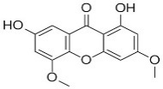
2-Linoleoyl Glycerol | 355.28 | 13.52 | 83.4 | 4973.15 | Flavonoids | 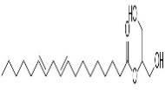
6-Hydroxykaempferol | 301.04 | 7.09 | 81.1 | 204500.47 | Terpenoids | 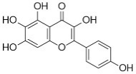
alpha-Boswellic acid | 455.35 | 14.82 | 35.7 | 43442.38 | Flavonoids | 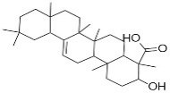
Apigenin | 251.03 | 9.07 | 74.8 | 32732.45 | Steroids and steroid derivatives | 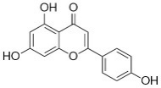
Beta-sitostenone | 413.38 | 14.19 | 61.6 | 47.49 | Flavonoids | 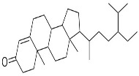
Calycosin-7-O-beta-D-glucoside | 447.13 | 4.21 | 98.6 | 1025926.04 | Phenolic acids and derivatives | 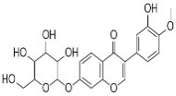
Diethyl Phthalate | 221.08 | 7.07 | 71.8 | 14846.90 | Flavonoids | 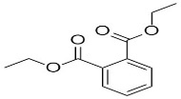
Diosmetin | 299.06 | 7.18 | 94.1 | 47621.57 | Flavonoids | 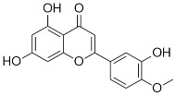
Fisetin | 287.0 | 7.10 | 95.7 | 197515.43 | Terpenoids | 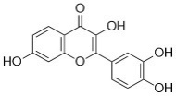
gamma-Calacorene | 201.16 | 13.58 | 88 | 4232.95 | Terpenoids | 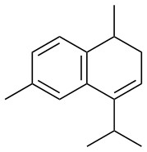
Gypsogenin | 471.35 | 11.86 | 82.10 | 8556.62 | Others | 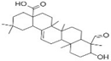
Mollugin | 283.10 | 9.72 | 45.50 | 6680.42 | - | 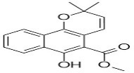
Negsehisandrin G | 485.25 | 13.74 | 74.70 | 1167101.08 | Flavonoids | 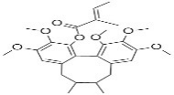
Nobiletin | 403.14 | 10.14 | 97.20 | 13249.38 | Terpenoids | 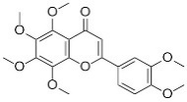
Oleanolic Acid | 455.35 | 15.40 | 87.70 | 26205.22 | Organic acids and derivatives | 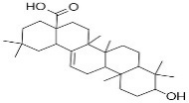
Oxalacetic acid | 131.00 | 0.99 | 86.40 | 6392.73 | Steroids and steroid derivatives | 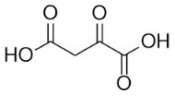
Progesterone | 315.23 | 10.28 | 76.70 | 9962.07 | Quinones | 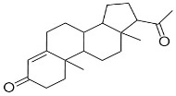
Purpurin | 315.05 | 4.74 | 54.00 | 2025.26 | Tannins | 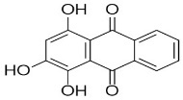
Schisandrin B | 401.20 | 13.69 | 88.70 | 7314167.94 | Flavonoids | 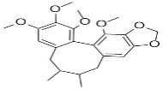
Scutellarein | 285.04 | 7.09 | 65.60 | 2581705.66 | Alkaloids and derivatives | 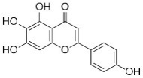
Yibeissine | 444.31 | 12.52 | 45.50 | 20286.45 | Others | 