Figure Captions
Fig. A1 Rarefaction curves of PA (orange), FL (blue), and total (red) assemblages of bacterioplankton in the Pacific Ocean.
Fig. A2 Relationships between the α-diversity (inverse Simpson index, 1/D) of PA and FL assemblages of bacterioplankton in the surface (0 m) water of the Pacific Ocean and environmental parameters selected by model selection (Table A3). The selected parameters were (a) log-transformed nitrate plus nitrite concentration and (b) log-transformed phosphate concentration for PA assemblages and (c) temperature, (d) salinity, (e) log-transformed nitrate plus nitrite concentration, and (f) log-transformed phosphate concentration for FL assemblages. The relationship between diversity and latitude is shown in Fig. 2.
Fig. A3 Comparison of the α-diversity (inverse Simpson index, 1/D) of PA (a) and FL (b) assemblages of bacterioplankton in 0 m, 100 m [PA (c) and FL (d)], 1000 m [PA (e) and FL (f)], and B-50 m [PA (g) and FL (h)] in the Northern and Southern hemispheres (<40°) and the equatorial region by boxplot (maximum and top quartile, median, bottom quartile, minimum). N, Northern Hemisphere; S, Southern Hemisphere; E, equatorial region.
Fig. A4 Relative abundance of bacterial taxa revealed by 16S rRNA gene amplicon sequencing of PA (a) and FL (b) assemblages of bacterioplankton in the surface (0–200 m) and PA (c) and FL (d) assemblages of bacterioplankton in the deep (250 m-B-50 m) of the Pacific Ocean.
Fig. A5 Distance-decay relationships of bacterioplankton community for PA (a, c, e, and g) and FL (b, d, f, and h) assemblages in the 0, 100, 1000, and B-50 m depths, respectively.
Fig. A6 Bar graphs of Spearman’s r-values obtained from partial Mantel tests. Round marks represent significant regression (P < 0.05). E, environmental component; S, spatial component; E|S, independent environmental component of the spatial component; S|E, independent spatial component of the environment component.
Fig. A7 Bar graphs of the contribution of environmental and spatial factors by VP for the variability of the bacterial community of PA and FL assemblages in the 0, 100, 1000, and B-50 m samples in the Pacific Ocean. Round marked samples were not shown due to minus contribution. E, environmental component; S, spatial component; E|S, environment independent of the spatial component; S|E, space independent of the environment component.

Fig. A1
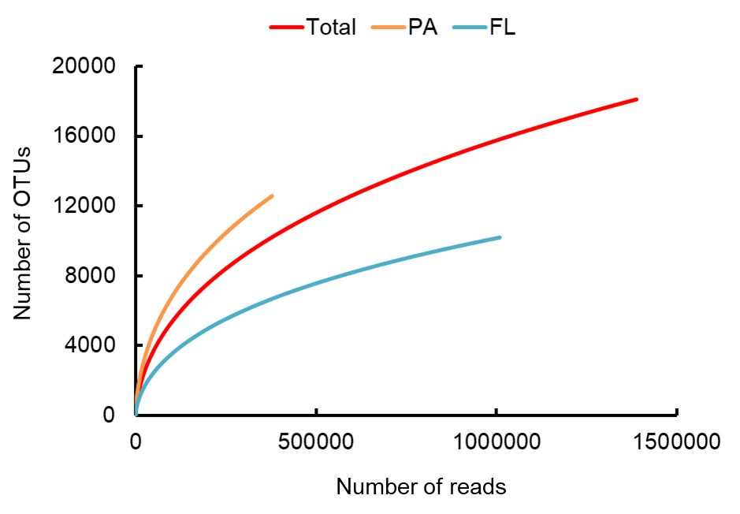

Fig. A2
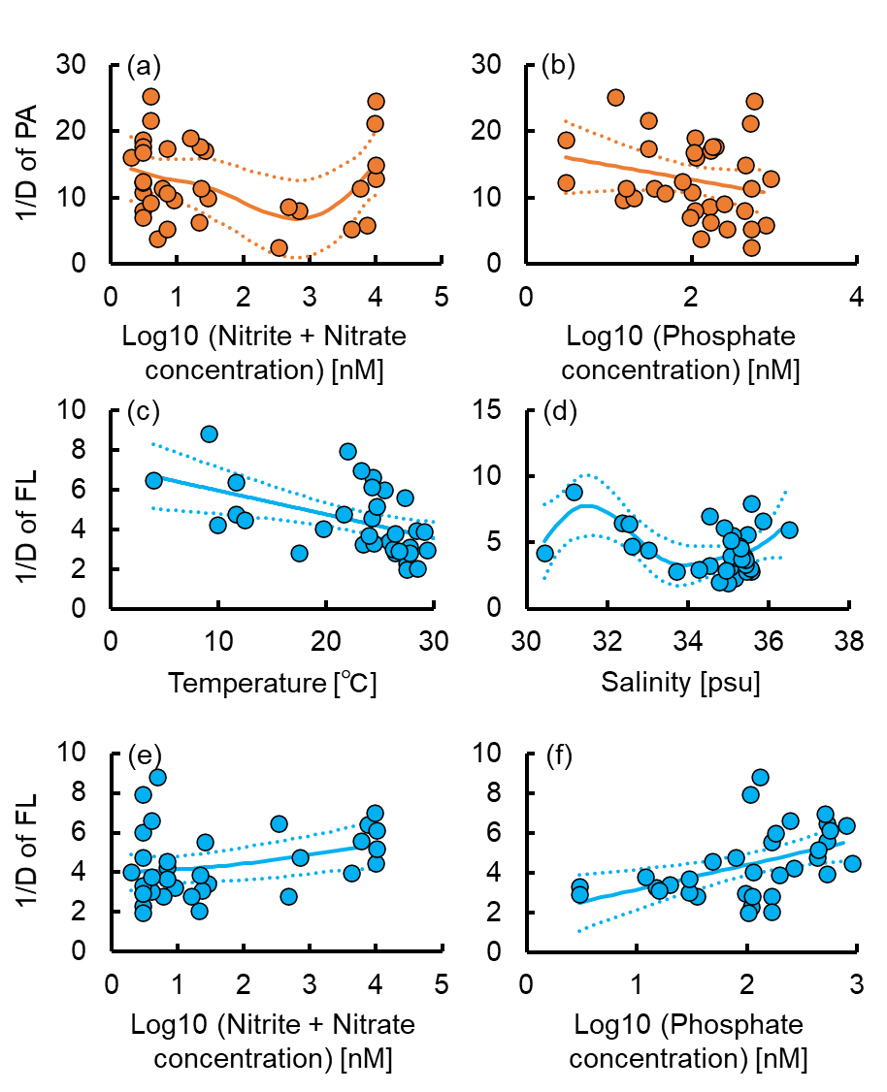

Fig. A3
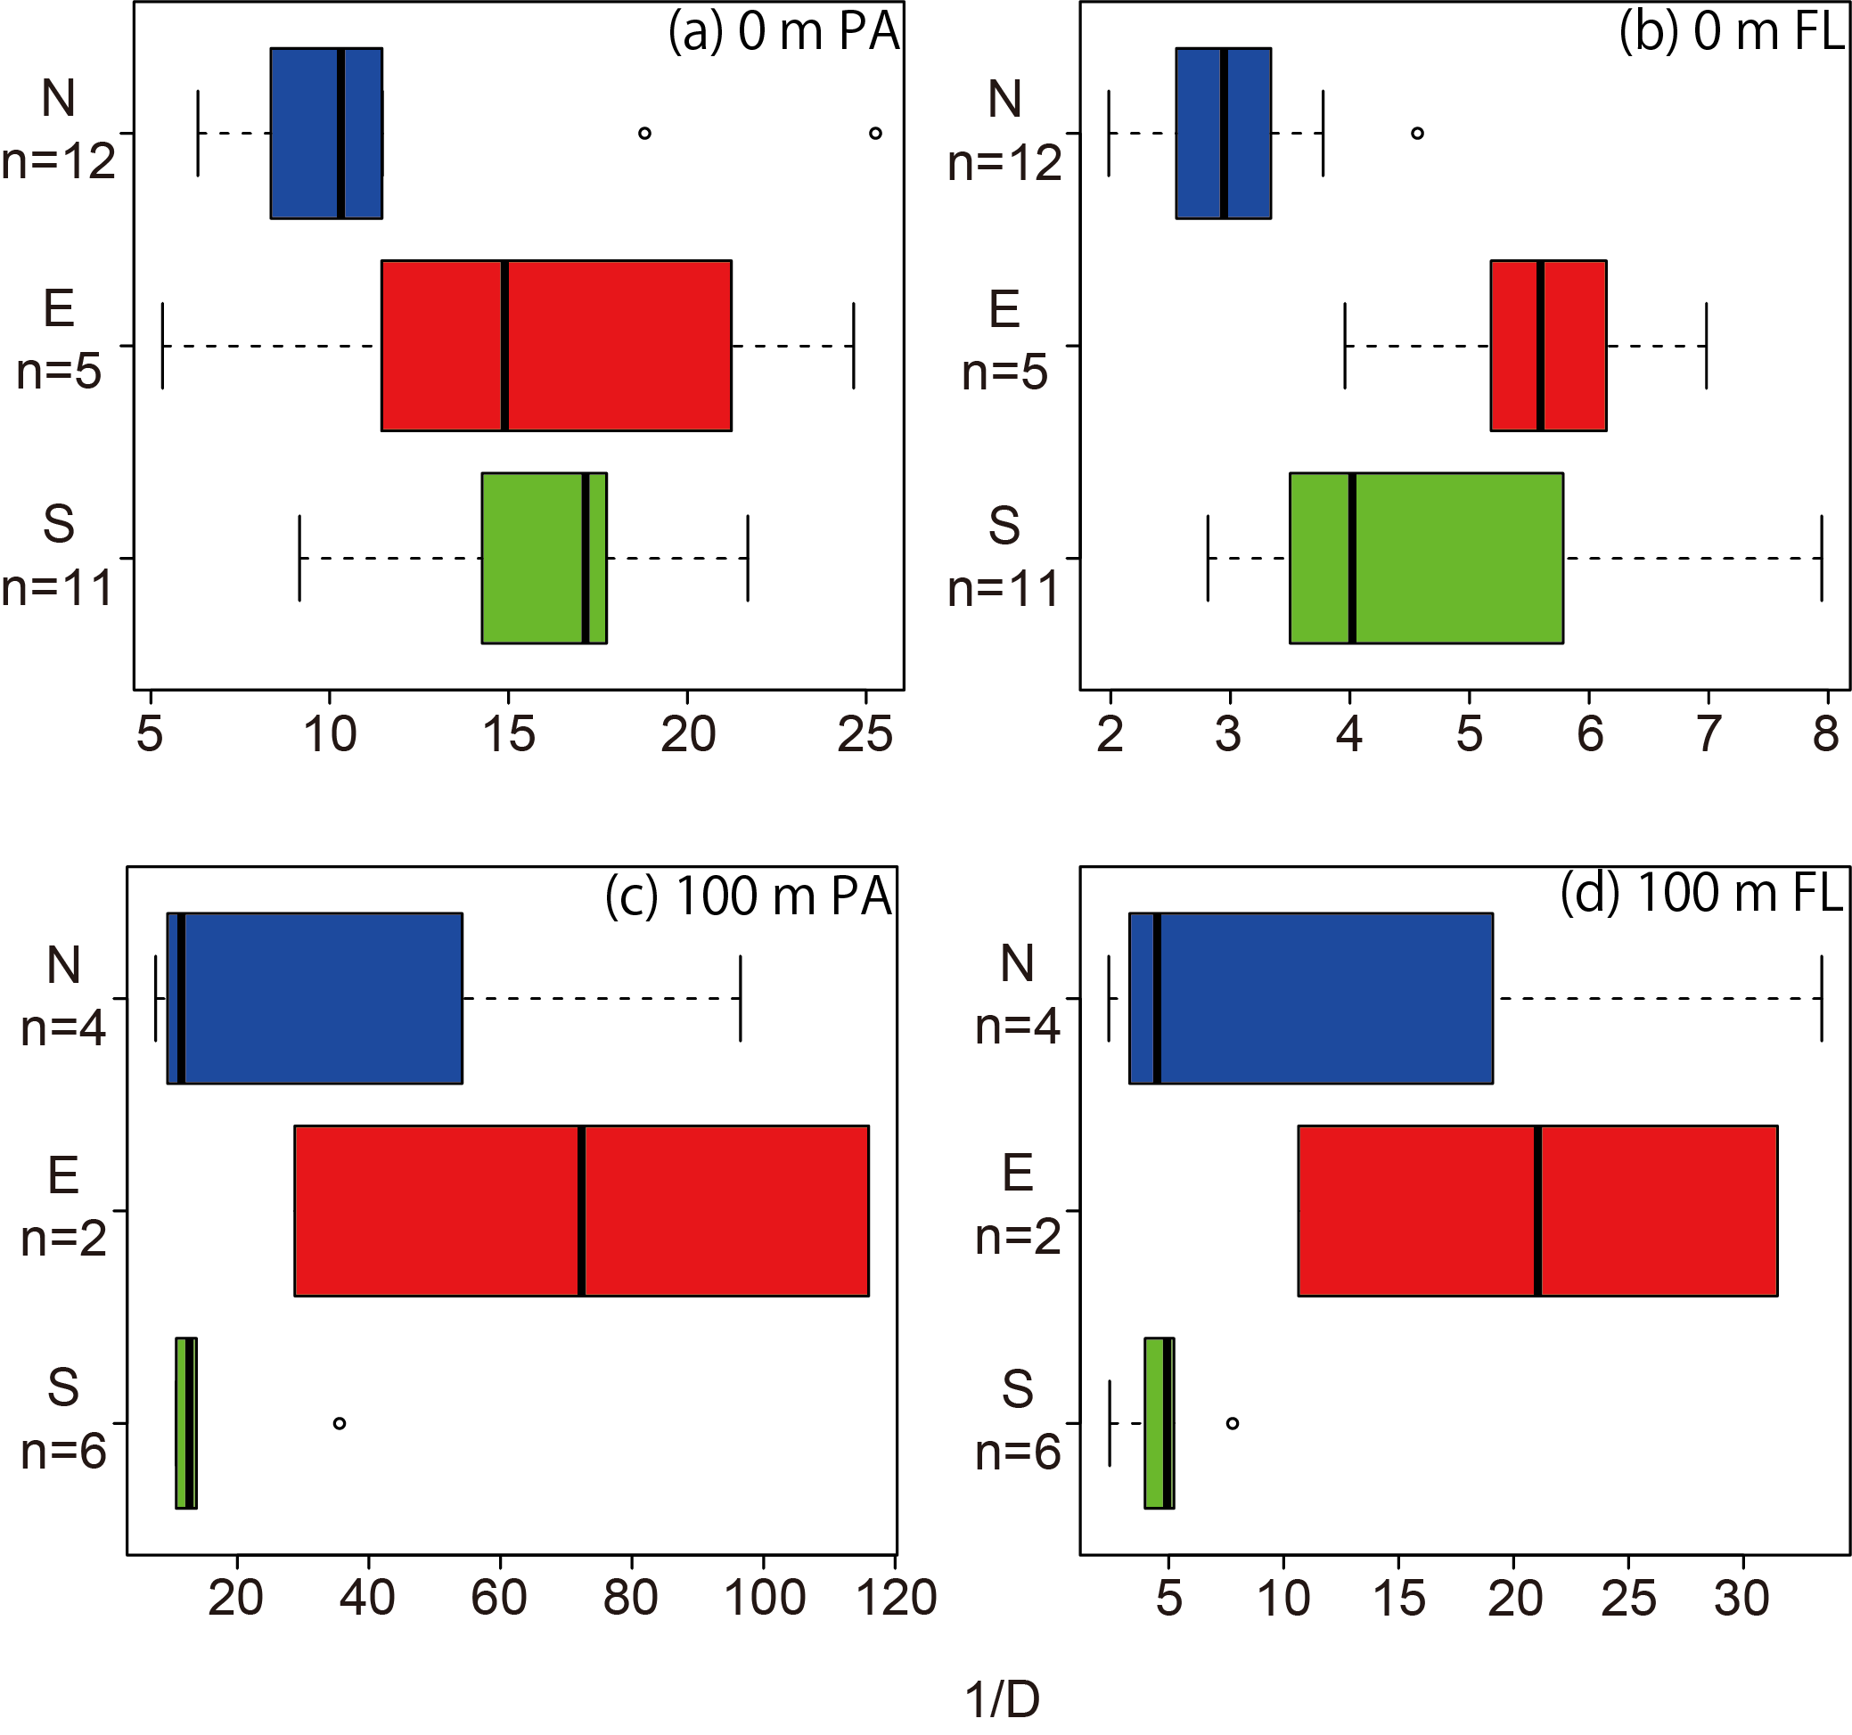

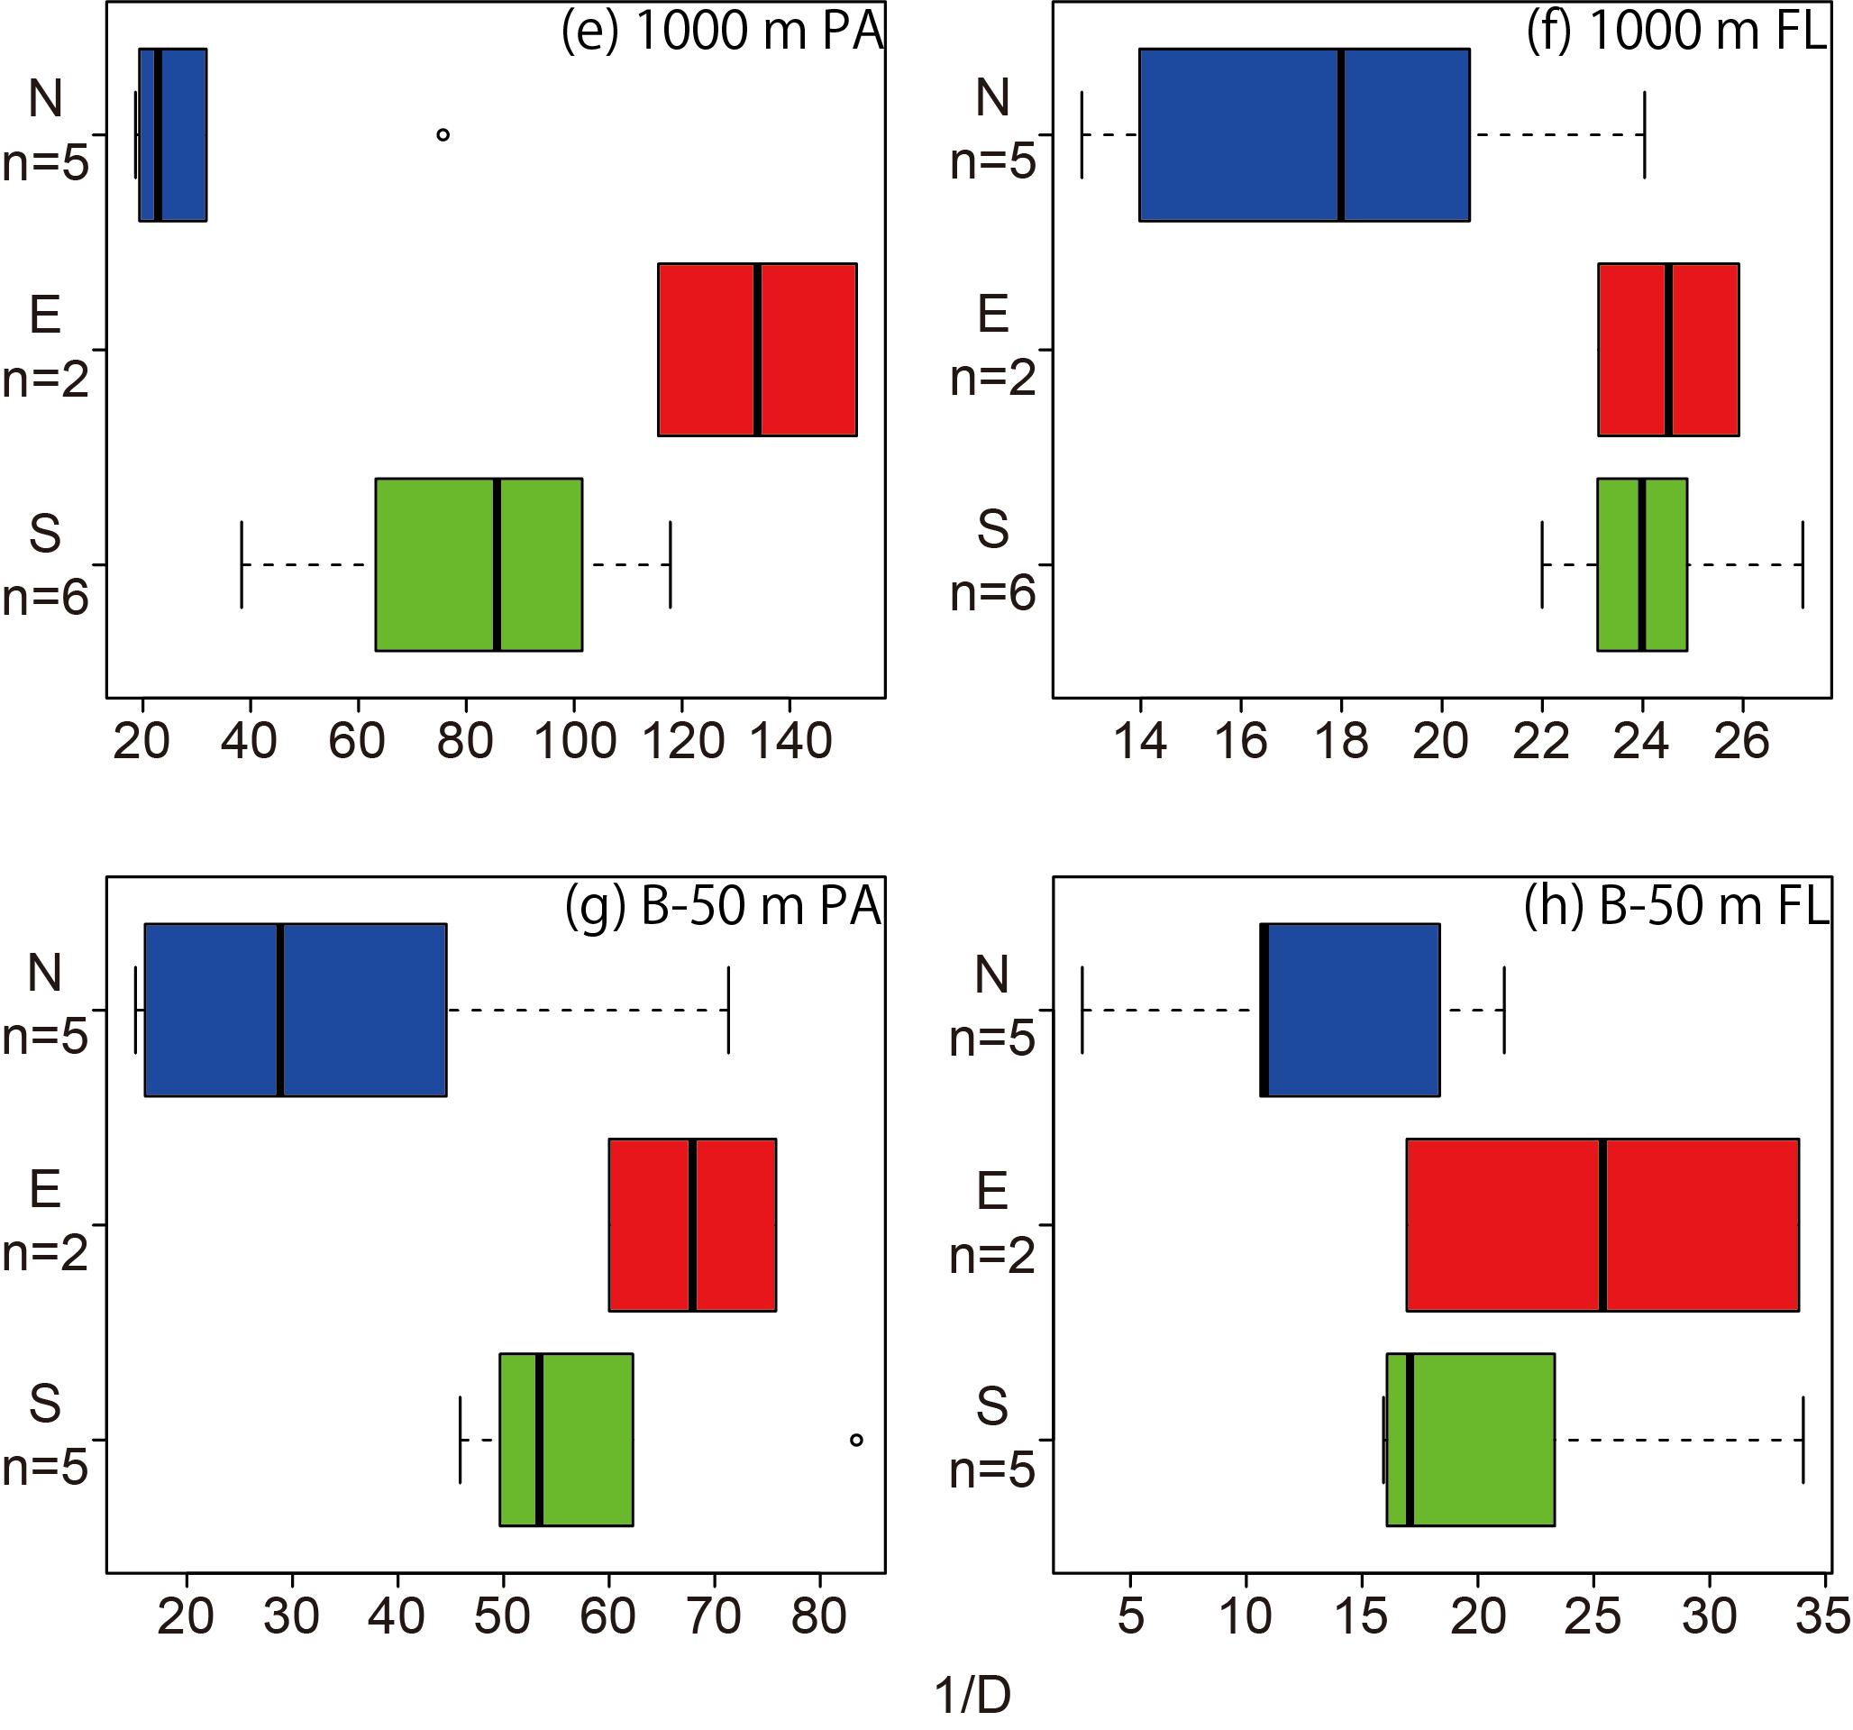

Fig. A4
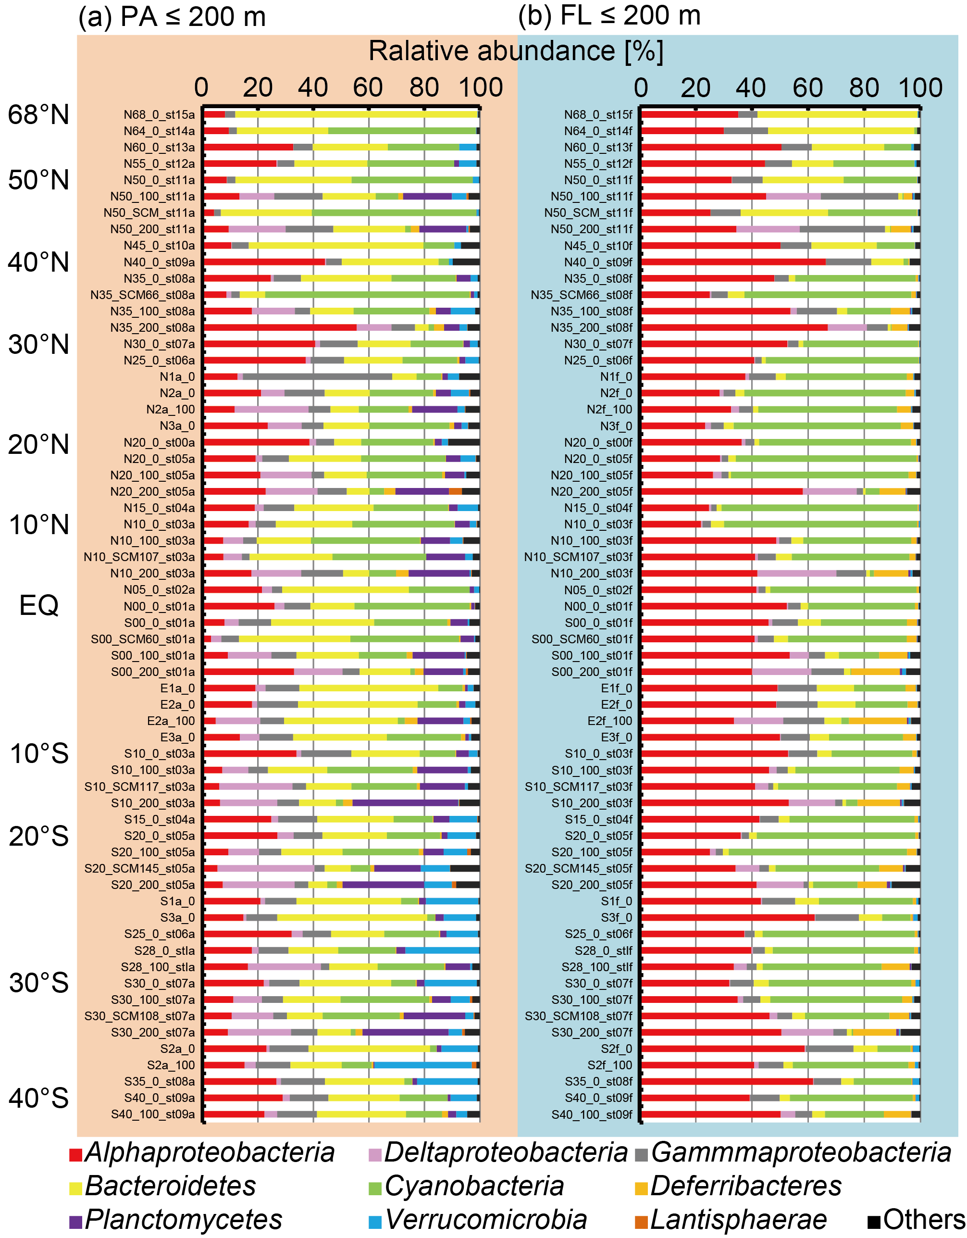

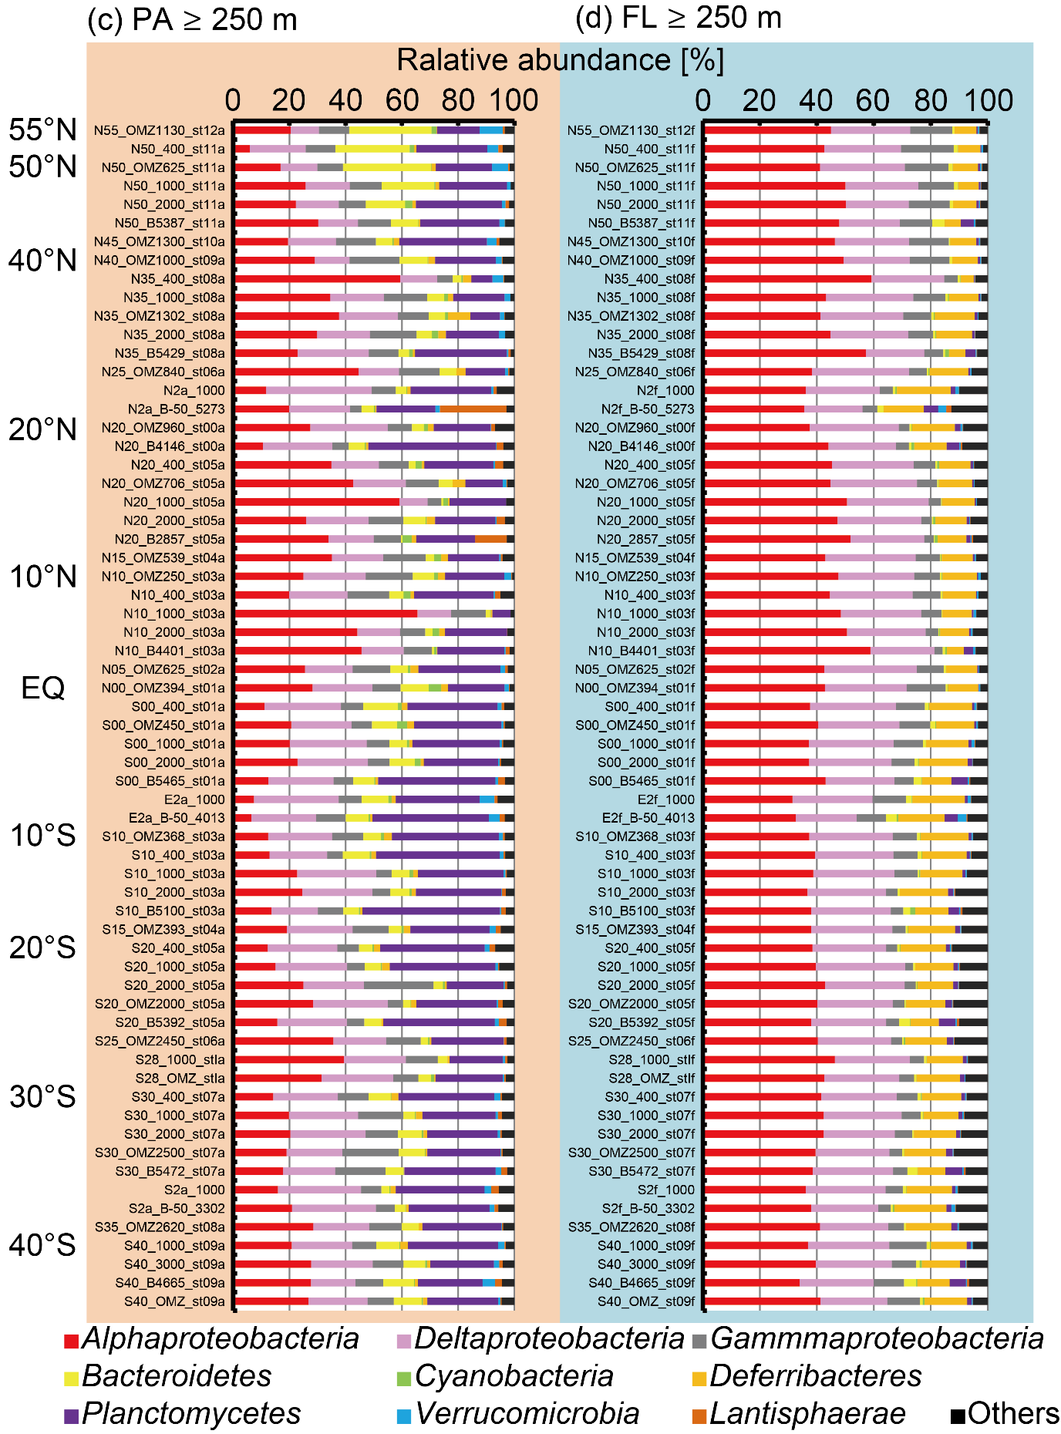

Fig. A5
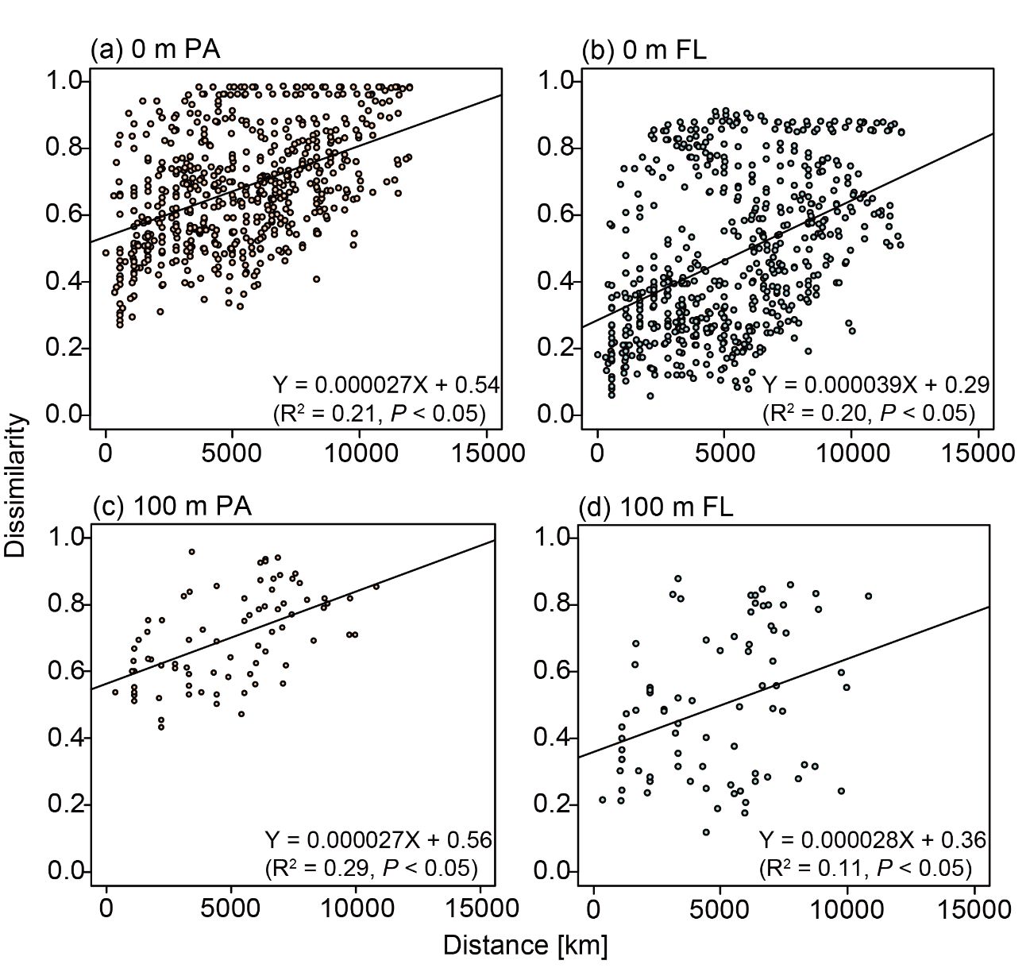
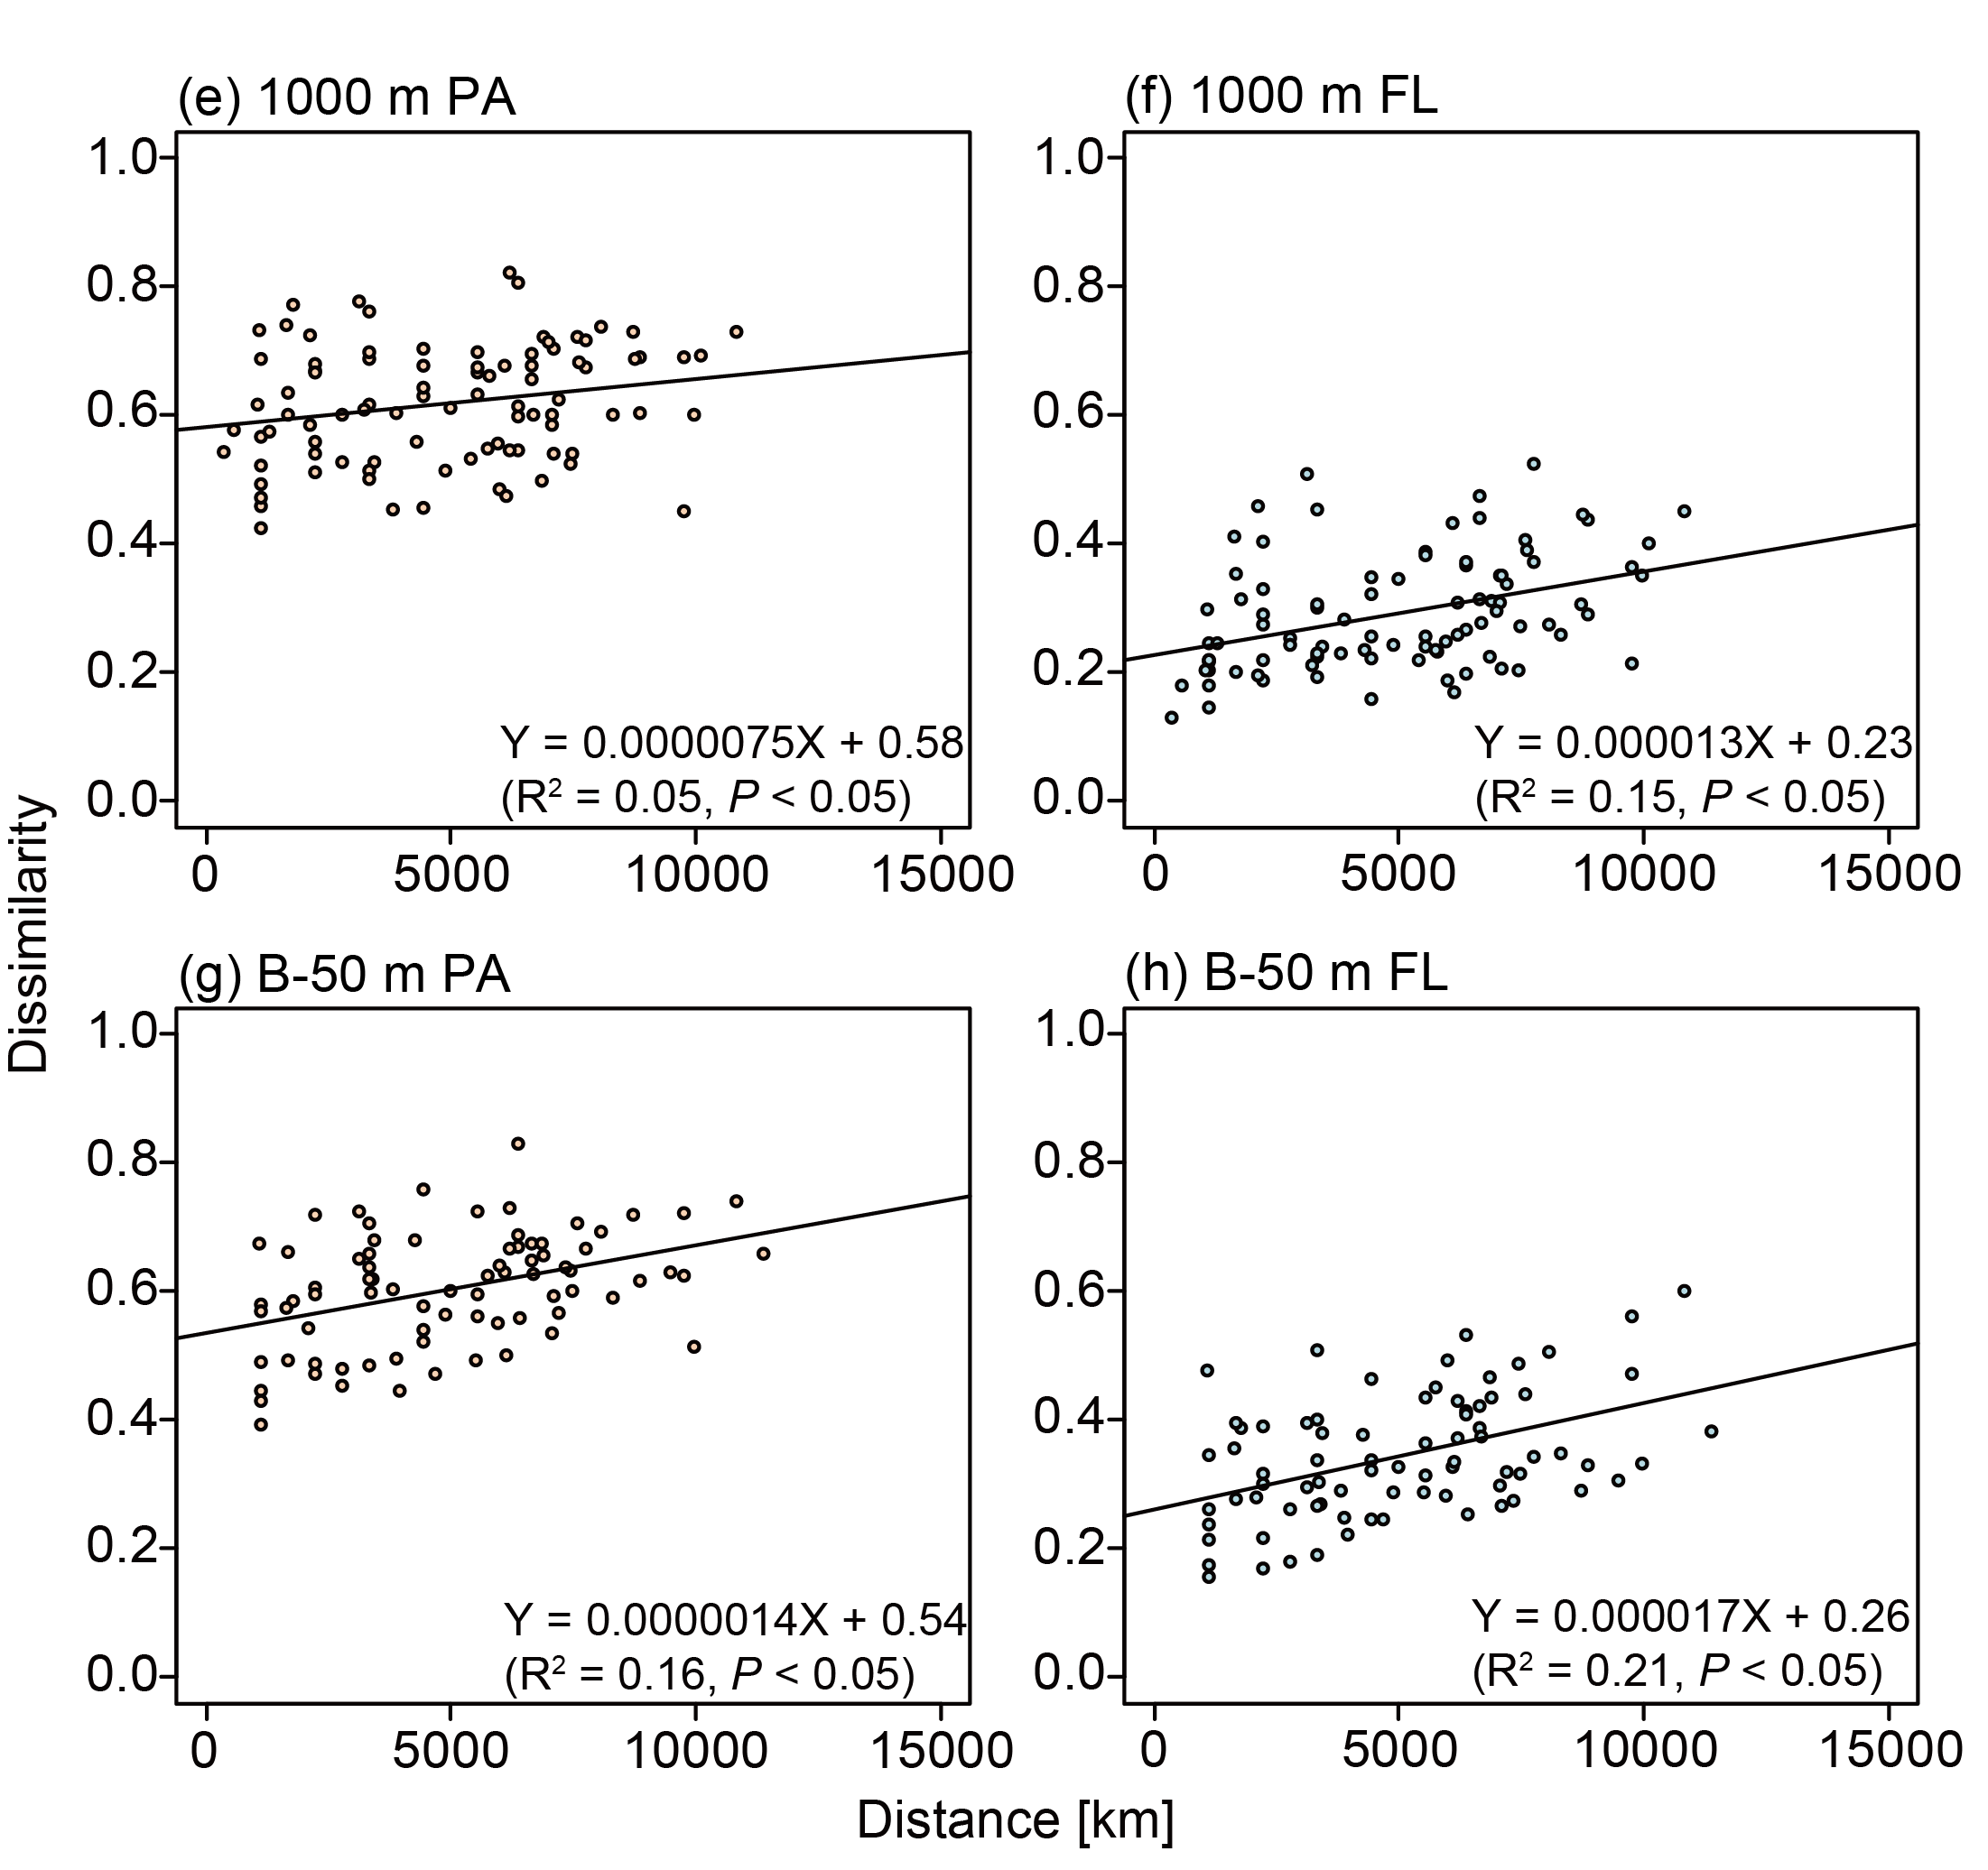

Fig. A6
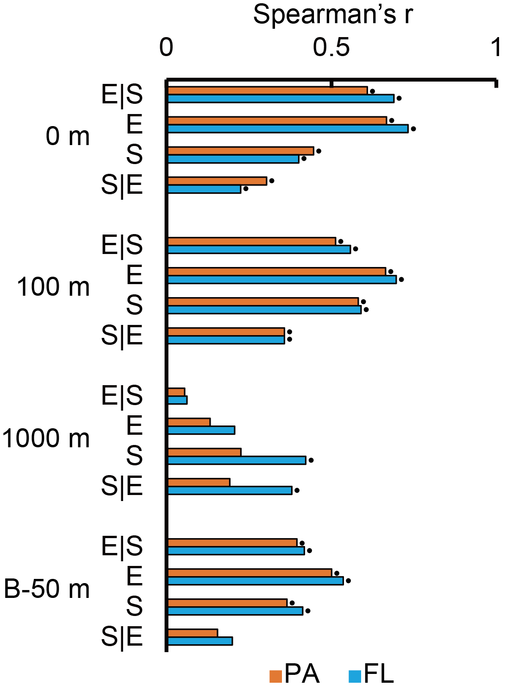

Fig. A7
