Figure S1. Correlations between each hemodynamic parameter and the CAVI score.
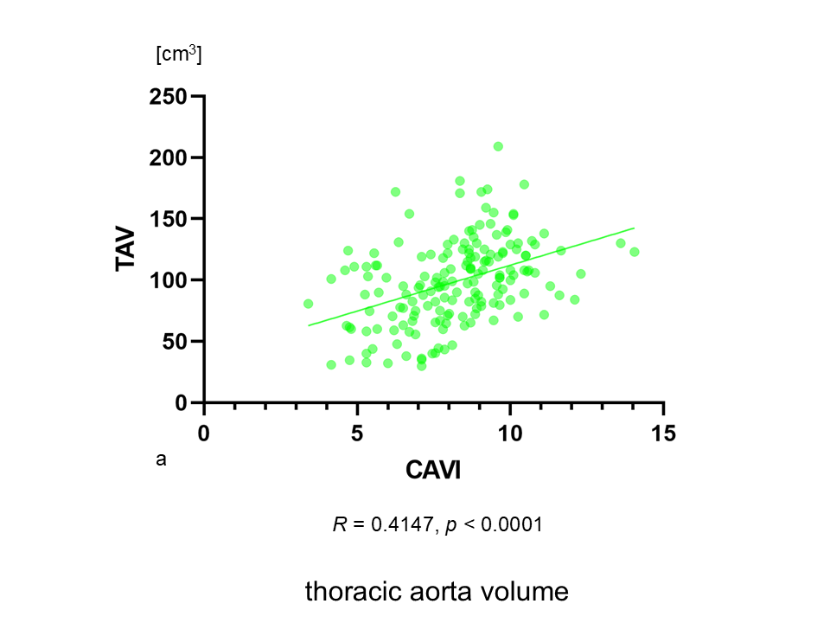
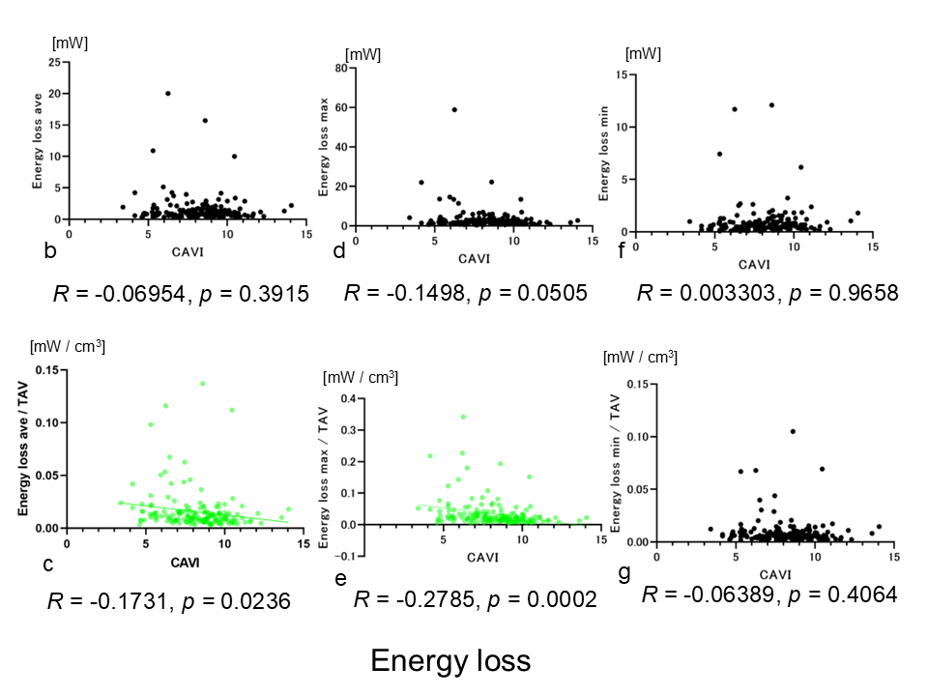
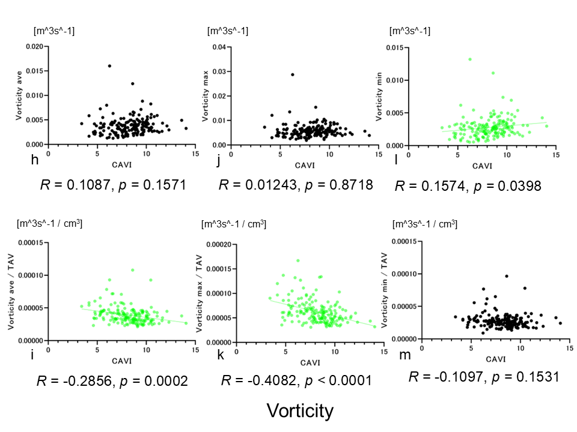
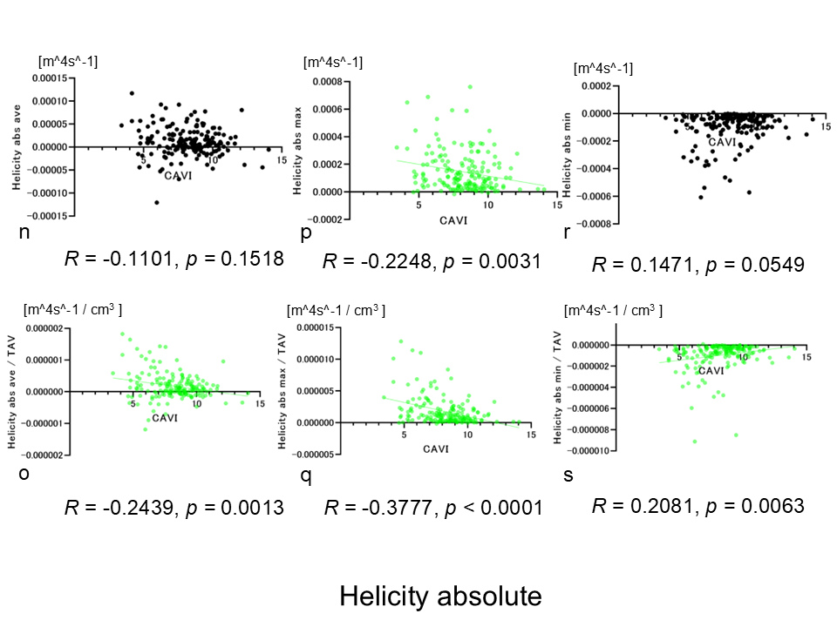
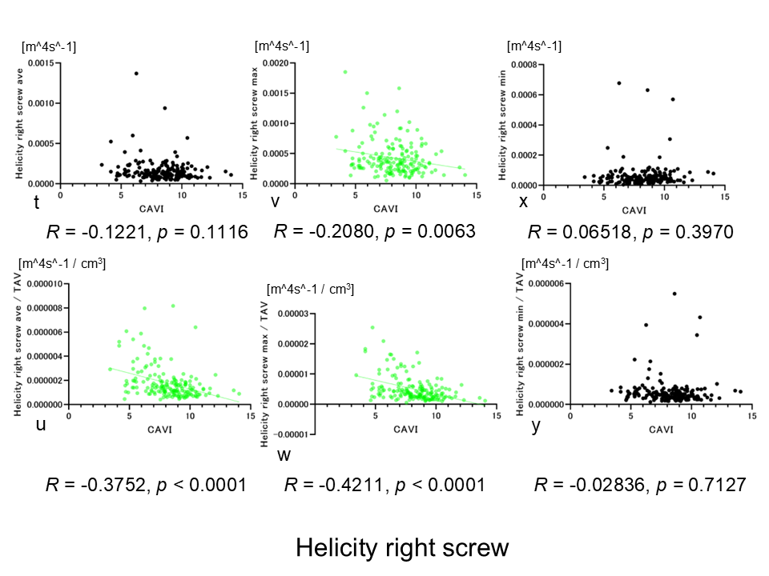
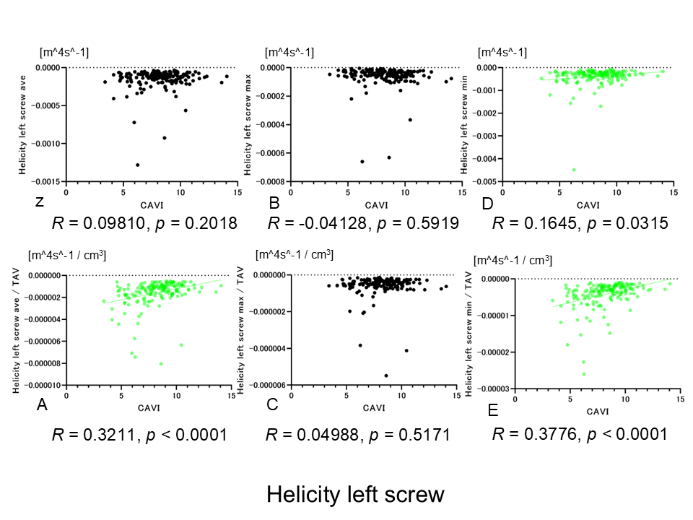

(a) TAV and CAVI score. (b) EL ave and CAVI score. (c) EL ave/TAV and CAVI score. (d) EL max and CAVI score. (e) EL max/TAV and CAVI score. (f) EL min and CAVI score. (g) EL min/TAV and CAVI score. (h) Vort ave and CAVI score. (i) Vort ave/TAV and CAVI score. (j) Vort max and CAVI score. (k) Vort max/TAV and CAVI score. (l) Vort min and CAVI score. (m) Vort min/TAV and CAVI score. (n) Hel abs ave and CAVI score. (o) Hel abs ave/TAV and CAVI score. (p) Hel abs max and CAVI score. (q) Hel abs max/TAV and CAVI score. (r) Hel abs min and CAVI score. (s) Hel abs min/TAV and CAVI score. (t) Hel right screw ave and CAVI score. (u) Hel right screw ave/TAV and CAVI score. (v) Hel right screw max and CAVI score. (w) Hel right screw max/TAV and CAVI score. (x) Hel right screw min and CAVI score. (y) Hel right screw min/TAV and CAVI score. (z) Hel left screw ave and CAVI score. (A) Hel left screw ave/TAV and CAVI score. (B) Hel left screw max and CAVI score. (C) Hel left screw max/TAV and CAVI score. (D) Hel left screw min and CAVI score. (E) Hel left screw min/TAV and CAVI score.

The four-dimensional hemodynamic parameters were significantly correlated with the CAVI score in the figures with green plots. By contrast, the four-dimensional flow parameters were not significantly correlated with the CAVI score in the figures with black plots.
Vort min, Hel abs min/TAV, Hel left screw ave/TAV, Hel left screw min, and Hel left screw min/TAV were weakly positively correlated with the CAVI score, while TAV was moderately positively correlated with the CAVI score.
EL ave/TAV, EL max/TAV, Vort ave/TAV, Hel abs ave/TAV, Hel abs max, Hel abs max/TAV, Hel right screw ave/TAV, and Hel right screw max were weakly negatively correlated with the CAVI score.
Vort max/TAV and Hel right screw max/TAV were moderately negatively correlated with the CAVI score.
EL ave, EL max, EL min, EL min/TAV, Vort ave, Vort max, Vort min/TAV, Hel abs ave, Hel abs min, Hel right screw ave, Hel right screw min, Hel right screw min/TAV, Hel left screw ave, Hel left screw max, and Hel left screw max/TAV were not significantly correlated with the CAVI score.
Abbreviations: CAVI, cardio-ankle vascular index; TAV, mean thoracic aorta volume; EL, energy loss; Vort, vorticity; Hel, helicity; ave, average; max, maximum; min, minimum; abs, absolute

