Topical instillation of cell-penetrating peptide-conjugated melphalan blocks metastases of retinoblastoma
Kuan Jiang^{1, 2}, Xingyan Fan¹, Yang Hu¹, Shengyu Yao¹, Yu Liu¹, Changyou Zhan^{2,} *, Weiyue Lu^{1, 3}, Gang Wei^{1, 3, 4,} *
¹Key Laboratory of Smart Drug Delivery, Ministry of Education & Department of Pharmaceutics, School of Pharmacy, Fudan University, Shanghai 201203, P.R. China
²Department of Pharmacology, School of Basic Medical Sciences & Center of Medical Research and Innovation, Shanghai Pudong Hospital & State Key Laboratory of Molecular Engineering of Polymers, Fudan University, Shanghai 200032, P.R. China
³The Institutes of Integrative Medicine of Fudan University, Shanghai 200040, P.R. China
⁴Shanghai Engineering Research Center of ImmunoTherapeutics, Shanghai 201203, P.R. China

Corresponding author:
Gang Wei, Ph.D. & Professor
Key Laboratory of Smart Drug Delivery, Ministry of Education & Department of Pharmaceutics, School of Pharmacy, Fudan University.
826 Zhangheng Road, Shanghai 201203, P.R. China
Tel: +86 21 51980091
Fax: +86 21 51980090
E-mail address: weigang@shmu.edu.cn

Changyou Zhan, Ph.D. & Professor
Department of Pharmacology, School of Basic Medical Sciences & Center of Medical Research and Innovation, Shanghai Pudong Hospital & State Key Laboratory of Molecular Engineering of Polymers, Fudan University.
130 Dongan Road, Shanghai 200032, P.R. China
Tel: +86 21 54237379
Fax: +86 21 54237379
E-mail address: cyzhan@fudan.edu.cn

Figure S1. Characterization of 89WP-Mel and Cy5-89WP. HPLC spectra of 89WP-Mel (A, 21.571 min) and Cy5-89WP (B, 19.875 min) at the wavelength of 214 nm. ESI-MS spectra of 89WP-Mel (C, 1332.8 [M+2H⁺]/2, 888.8 [M+3H⁺]/3, 666.8 [M+4H⁺]/4, 533.8 [M+5H⁺]/5) and Cy5-89WP (D, 1082.2 [M+3H⁺]/3, 811.4 [M+4H⁺]/4, 665.0 [M+5H⁺]/5).

Figure S2. Bioluminescence intensity of the intraocular tumor on Day 15 (D15) and Day 30 (D30) during the treatment. The retinoblastoma-bearing mice received treatments as following: normal saline (N.S.); melphalan (Mel), 3.0 mg/mL; 89WP-Mel, 3.0 mg/mL (melphalan); all the solutions were topically instilled (Topi.) into conjunctival sac of eye with a volume of 10 μL once daily. Intravitreal injection (IVT.) of 2 μL melphalan (0.5 mg/mL) on alternative weeks was used as the positive control.

Figure S3. Body weight variation of the intraocular tumor-bearing mice during the treatment. The retinoblastoma-bearing mice received treatments as in Fig. S2.

Figure S4. Immunohistochemical sections of the whole brains from intraocular tumor-bearing moribund mice. The letter “T” was the label of tumor regions. Scale bar, 1 mm.

Figure S5. Enlarged immunohistochemical sections of the brains from intraocular tumor-bearing moribund mice. The letter “T” was the label of tumor regions. The metastases grading was evaluated as following: positive (P), with obvious tumor regions; low positive (LP), without obvious tumor region but obvious brown dots (metastasizing intraocular tumor cells) distribution; negative (N), without brown dots distribution. Scale bar, 100 μm.

Figure S6. Quantitative cellular uptake of covalent conjugates of 89WP and small molecules. Flow cytometry analysis and the histogram plot of the mean fluorescence intensity in HCEC cells. The cells were treated with 3 μM conjugates at 37°C for 4 h. One-way ANOVA multiple comparisons corrected by Tukey's test was used to determine the statistical significance (n = 3).

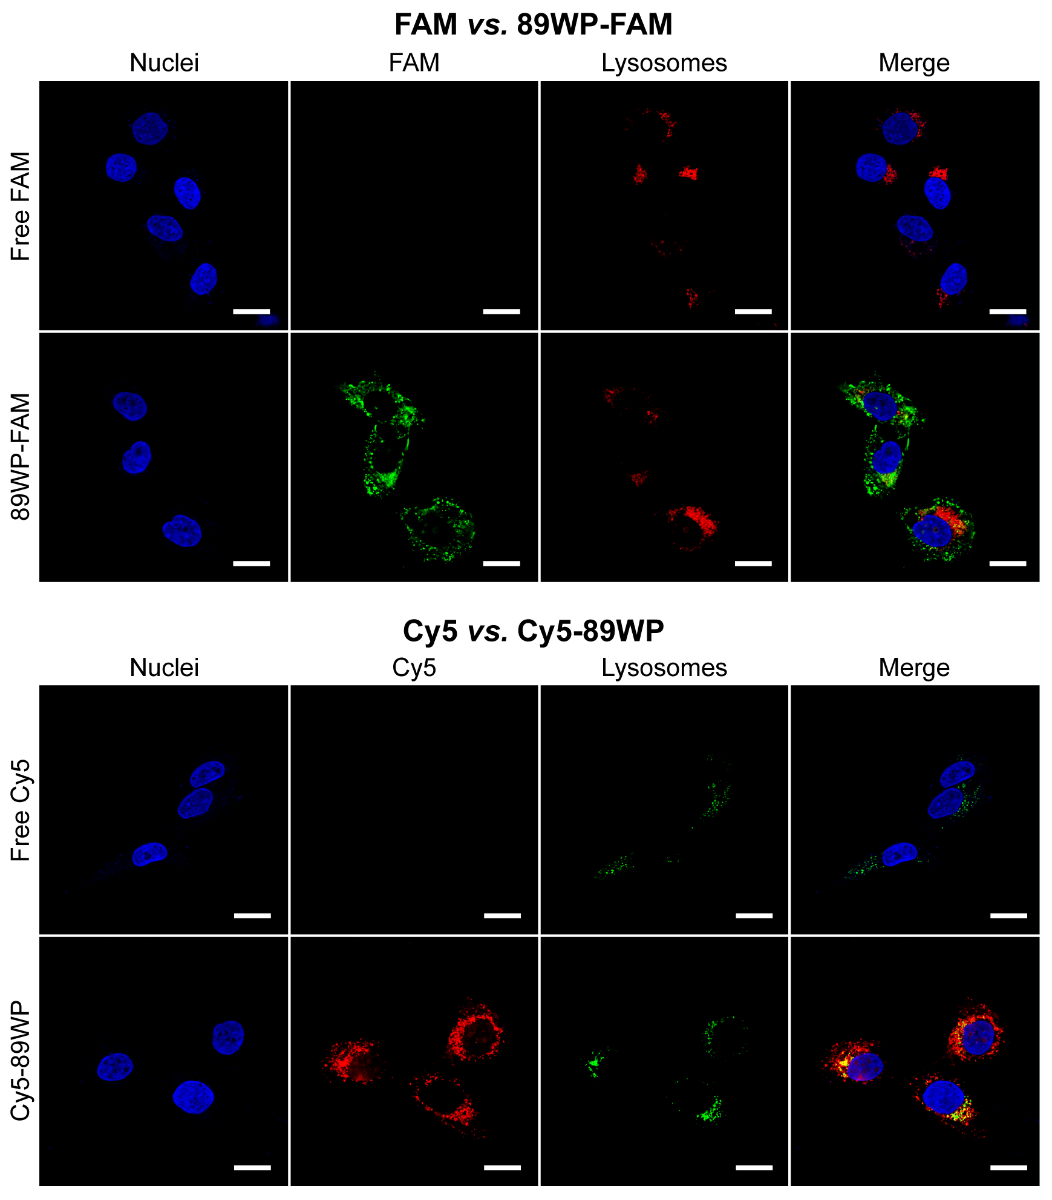
Figure S7. Intracellular distribution of 89WP-FAM and Cy5-89WP in HCEC cells. The cells were incubated with the dyes or their covalent conjugates with 89WP at a concentration of 3 μM for 4 h at 37°C. The nuclei were stained with DAPI (blue) while lysosomes were stained with LysoTracker Red DND-99 (The pseudo-color setup of lysosomes was red for 89WP-FAM while green for Cy5-89WP). Scale bar, 25 μm.

Figure S8. Intracellular distribution of 89WP-FAM and Cy5-89WP in ARPE-19 cells. The cells were incubated with the dyes or their covalent conjugates with 89WP at a concentration of 3 μM for 4 h at 37°C. The nuclei were stained with DAPI (blue) while lysosomes were stained with LysoTracker Red DND-99 (The pseudo-color setup of lysosomes was red for 89WP-FAM while green for Cy5-89WP). Scale bar, 25 μm.

Figure S9. Permeation behavior of 89WP-FAM across the ARPE-19 cell monolayer. A, D, Schematic of the in vitro ARPE-19 cell monolayer models. B, Fluorescence images of ARPE-19 cells oriented to donor side in the monolayer model. Scale bar, 200 μm. The nuclei were stained with DAPI (blue). C, ESI-MS spectrum of recovered sample (89WP-FAM) from basolateral side after dialysis. E, F, Flow cytometry analysis and the histogram plot of the mean fluorescence intensity of WERI-Rb-1 cells under the treated monolayer. The statistical significance was analyzed by two-tailed unpaired t-test (n = 3). The monolayer in both models was treated with solutions containing 3 μM FAM, 89WP/FAM or 89WP-FAM for 4 h at 37°C.

Figure S10. Permeation behaviors of Cy5-89WP across the ex vivo rabbit cornea and sclera. A, Merged images of DAPI-stained (blue) frozen sections of Cy5-89WP (red) treated cornea. Scale bar, 100 μm. B, (a), Merged images of DAPI-stained (blue) frozen sections of Cy5-89WP (red) treated sclera. The white arrows referred to the diffusion directions. Scale bar, 100 μm. (b), 2.5D images of Cy5-89WP distribution across the whole sclera. (c), Cy5 fluorescence intensity along the white arrows in B (a). The maximum value of intensity was 255. The distance was defined as percent of somewhere distance from the arrow origin (permeation depth) to the whole length of the white arrows (sclera thickness).

Figure S11. Time-dependent distribution of conjugates in DAPI-stained frozen sections of mice retina. Eyes were harvested at 0.5 h, 2 h, 4 h, 8 h, 12 h, 18 h and 24 h after the instillation. The retina was circled by the orange dash line. 89WP-FAM (A) or Cy5-89WP (B) was dissolved in 10 µL normal saline at a concentration of 30 μM and instilled into the conjunctiva sac of mice. Scale bar, 100 µm.

Figure S12. Inhibition effects of conjugates on cellular proliferation. Cell viabilities of HCEC, ARPE-19 and WERI-Rb-1 cells were determined by the MTT or CCK-8 assay (n = 4, mean ± SD). HCEC and ARPE-19 cells were incubated with the compounds at a series of concentrations for 4 h, followed by further cultivation in complete medium for 24 h before addition of MTT. WERI-Rb-1 cells were incubated with the compounds at a series of concentrations for 4 h, followed by incubation with CCK-8 reagent. Results were expressed as percent of the values obtained from untreated cells.

Figure S13. Hematoxylin-eosin staining sections of ex vivo treated rabbit cornea and retina. The tissues were treated with Cy5 or Cy5-89WP at a concentration of 5 μM for 4 h at 34 ± 0.5°C. Scale bar, 100 μm.

Figure S14. Hematoxylin-eosin staining sections of cornea from intraocular tumor bearing mice after the 1-month treatment. The mice received treatments as following: normal saline (N.S.); melphalan (Mel), 3.0 mg/mL; low or high-dose 89WP-Mel, 0.3 or 3.0 mg/mL (melphalan); all the solutions were topically instilled (Topi.) into conjunctival sac of eye with a volume of 10 μL once daily. Intravitreal injection (IVT.) of 2 μL melphalan (8.0 mg/mL) was used as control. Scale bar, 50 μm.

Figure S15. Hematoxylin-eosin staining sections of visceral organs from the mice subjected to treatment for one month. The mice were treated as in Fig. S14. Scale bar, 200 μm.

