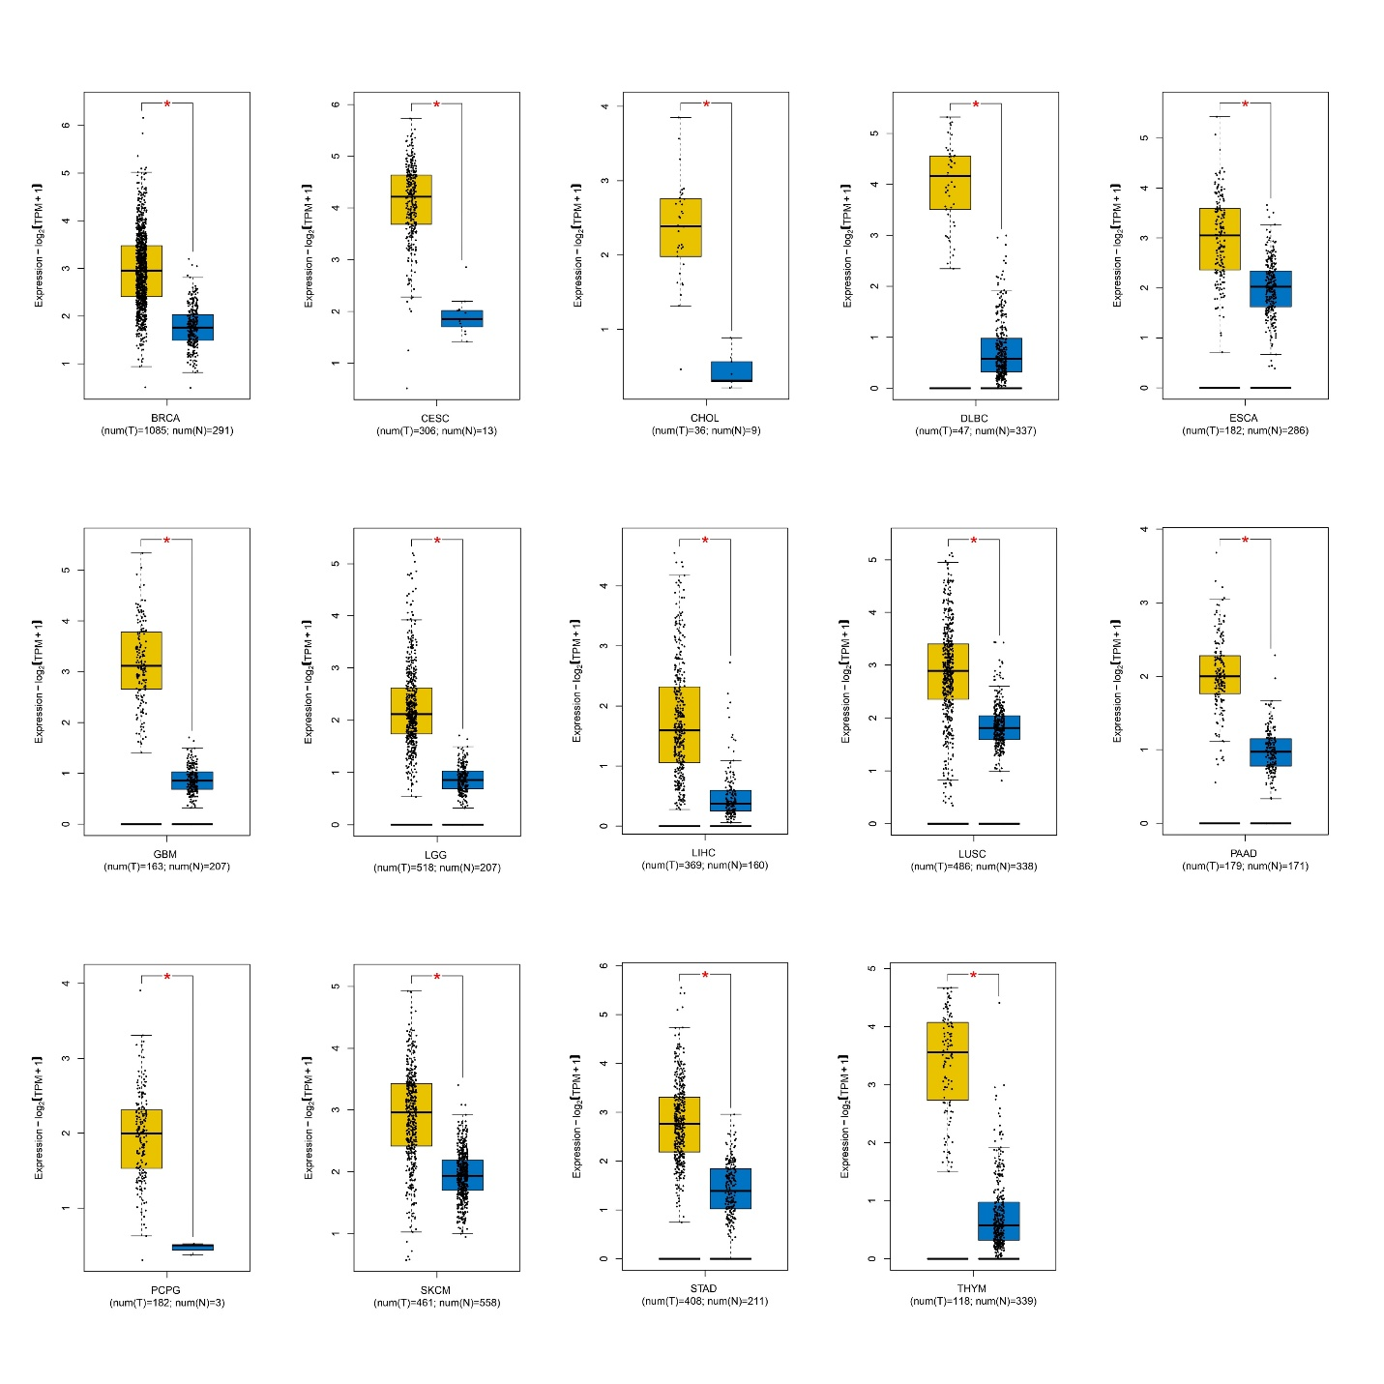
Fig. 1 Differential expression analysis by GEPIA2. The yellow box plots indicate tumors and blue boxes indicate correspondent normal tissues. There is significant higher expression of WDR76 in BRCA, CESC, CHOL, DLBC, ESCA, GBM, LGG, LIHC, LUSC, PAAD, PCPG, SKCM, STAD, and THYM.

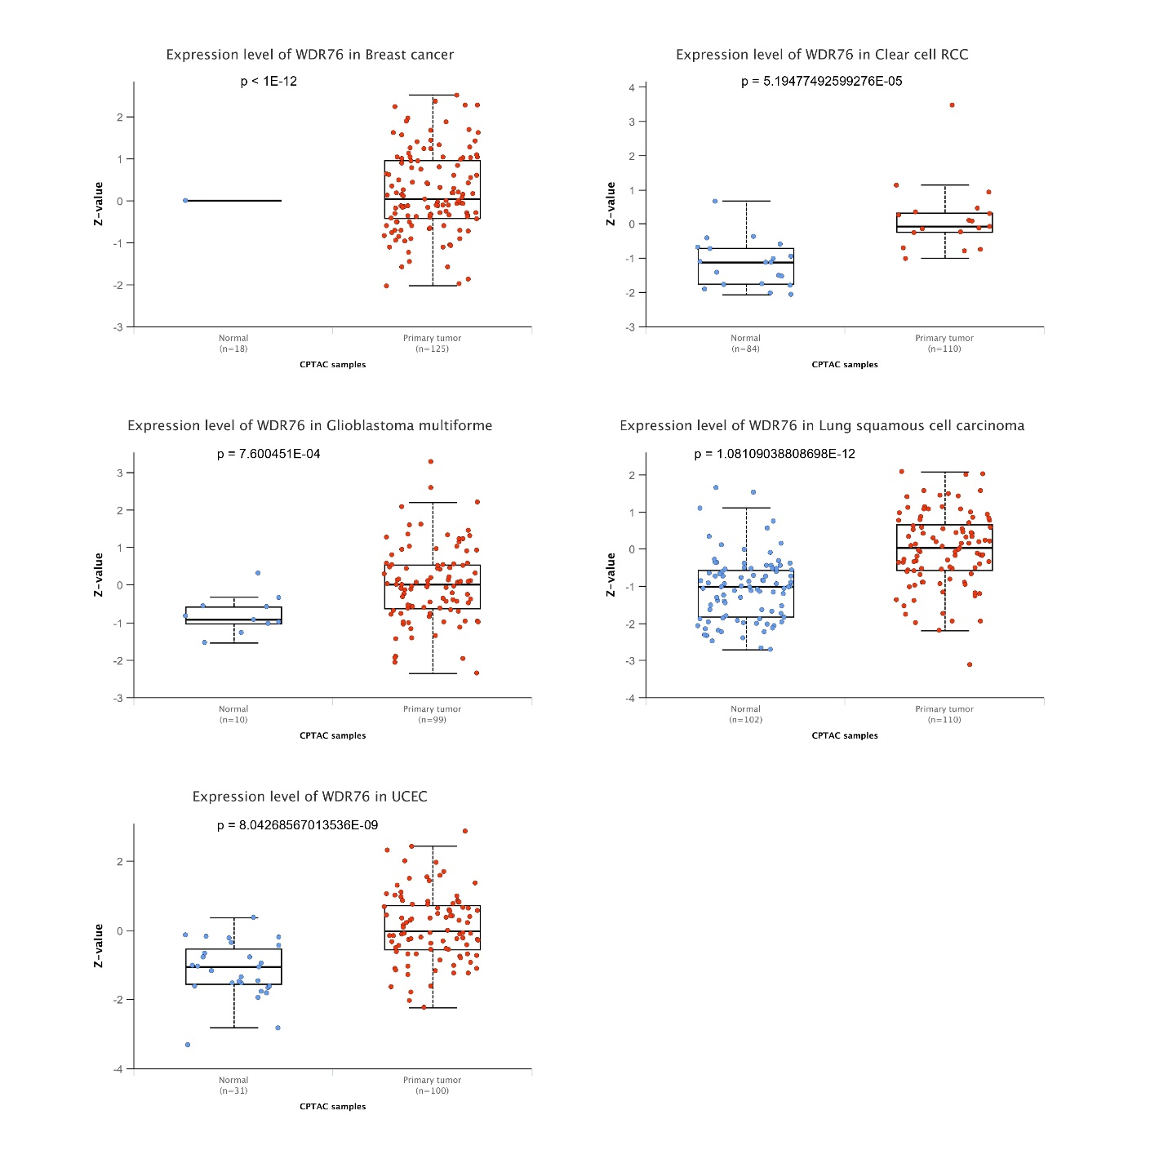
Fig. 2 Proteomic expression analysis of WDR76 in breast cancer, clear cell RCC, Glioblastoma multiforme, lung squamous cell Carcinoma, and uterine corpus endometrial Carcinoma (UCEC).

Table 1: The acronyms and full form of TCGA tumor types.
Acronym | Full form
ACC | Adrenocortical Carcinoma
BLCA | Bladder Urothelial Carcinoma
BRCA | Breast Invasive Carcinoma
CESC | Cervical Squamous Cell Carcinoma and Endocervical Adenocarcinoma
CHOL | Cholangiocarcinoma
COAD | Colon Adenocarcinoma
DLBC | Lymphoid Neoplasm Diffuse Large B-cell Lymphoma
ESCA | Esophageal Carcinoma
GBM | Glioblastoma Multiforme
HNSC | Head and Neck Squamous Cell Carcinoma
KICH | Kidney Chromophobe
KIRC | Kidney Renal Clear Cell Carcinoma
KIRP | Kidney Renal Papillary Cell Carcinoma
LAML | Acute Myeloid Leukemia
LGG | Brain Lower Grade Glioma
LIHC | Liver Hepatocellular Carcinoma
LUAD | Lung Adenocarcinoma
LUSC | Lung squamous cell Carcinoma
MESO | Mesothelioma
OV | Ovarian serous Cystadenocarcinoma
PAAD | Pancreatic Adenocarcinoma
PCPG | Pheochromocytoma and Paraganglioma
PRAD | Prostate Adenocarcinoma
READ | Rectum Adenocarcinoma
SARC | Sarcoma
SKCM | Skin Cutaneous Melanoma
STAD | Stomach Adenocarcinoma
TGCT | Testicular Germ Cell Tumors
THCA | Thyroid Carcinoma
THYM | Thymoma
UCS | Uterine Carcinosarcoma
UCEC | Uterine Corpus Endometrial Carcinoma
UCS | Uterine Carcinosarcoma
UVM | Uveal Melanoma

