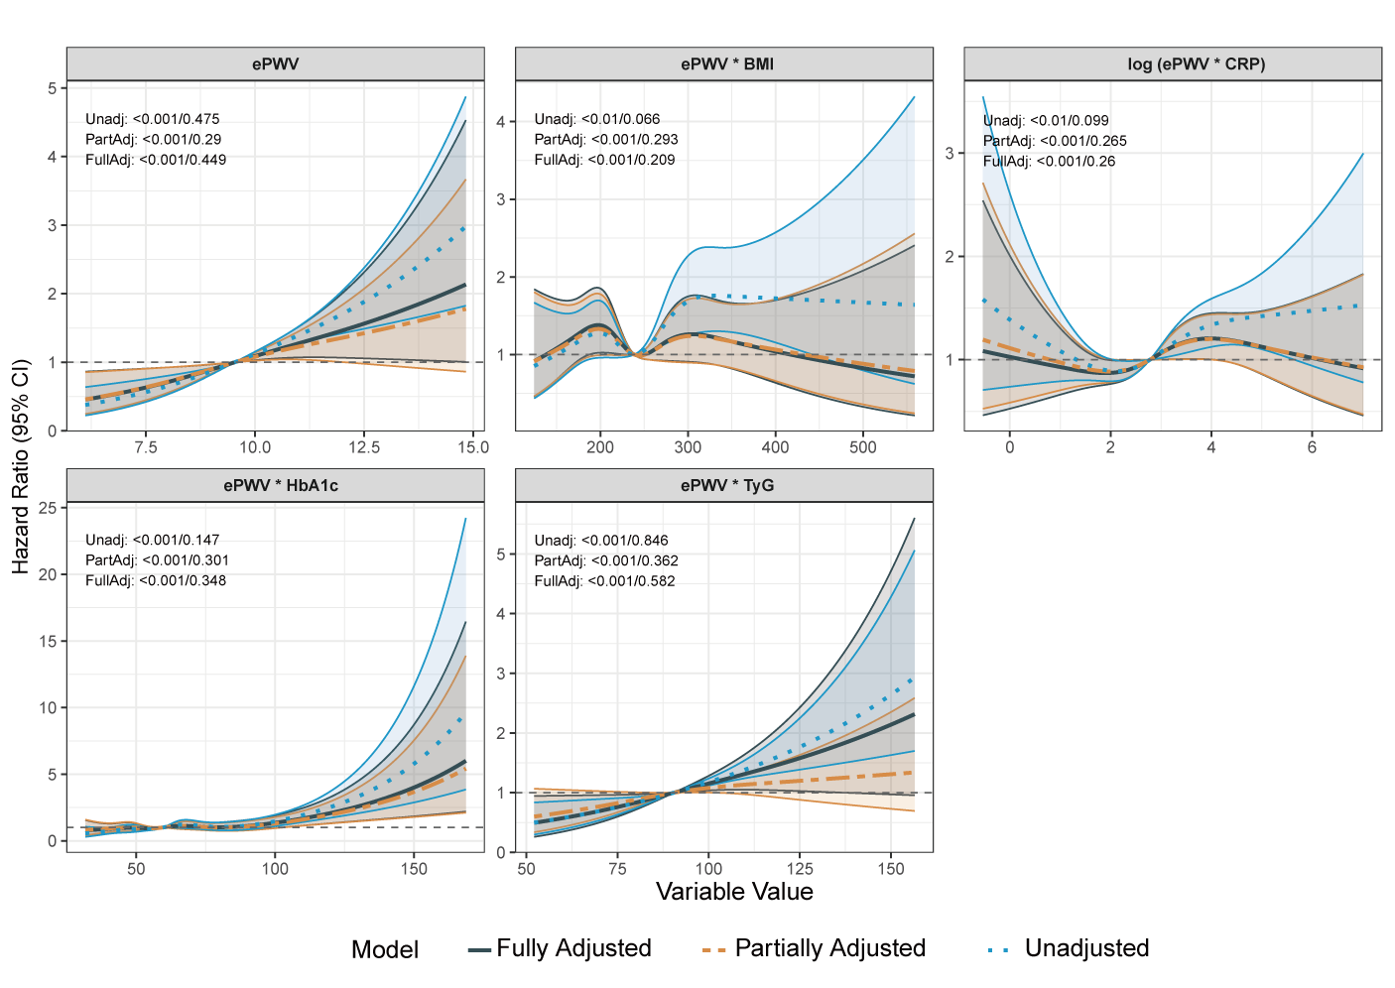
Figure S2. RCS-COX analysis. ePWV, estimated pulse wave velocity; BMI, Body mass index; CRP, C-reactive protein; TyG, Triglyceride-Glucose Index.

