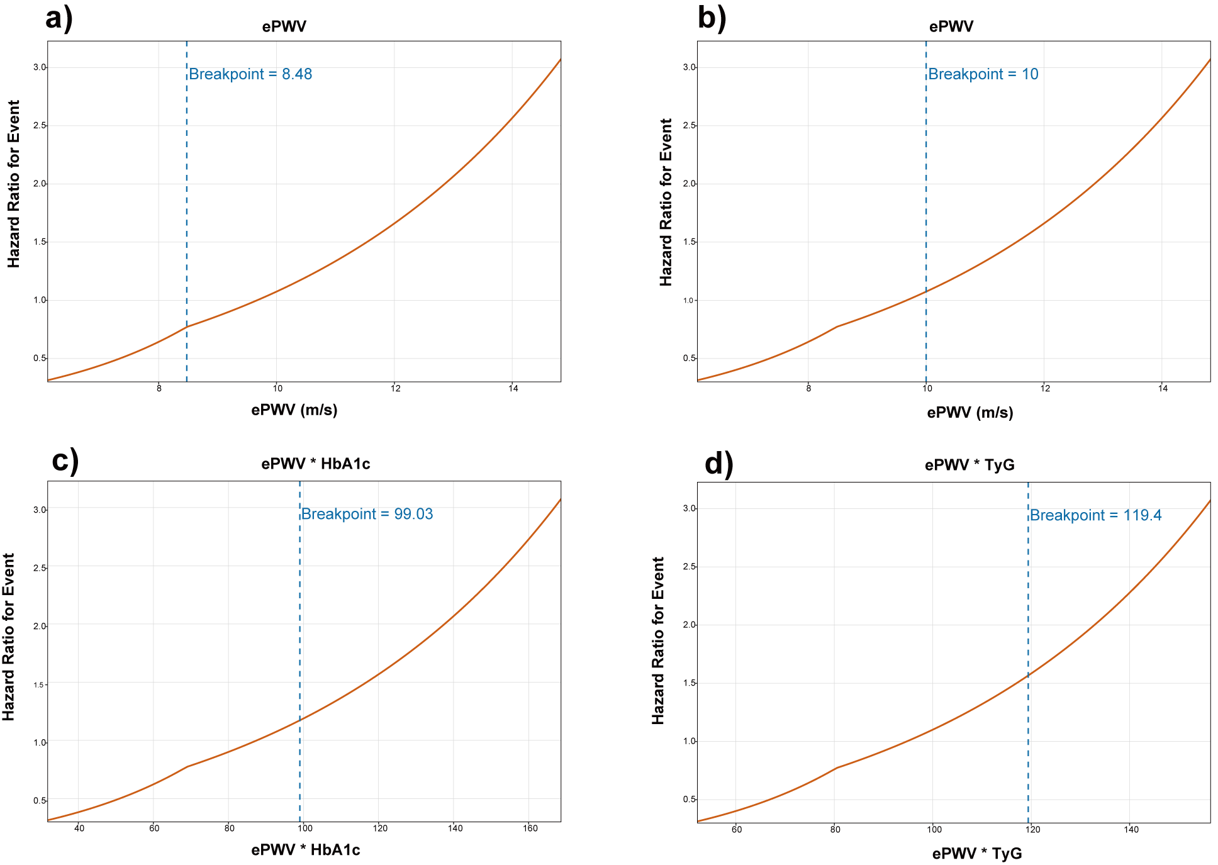
Figure S3. Cut-point identified in two-piece wise regression. ePWV, estimated pulse wave velocity; BMI, Body mass index; CRP, C-reactive protein; TyG, Triglyceride-Glucose Index.

