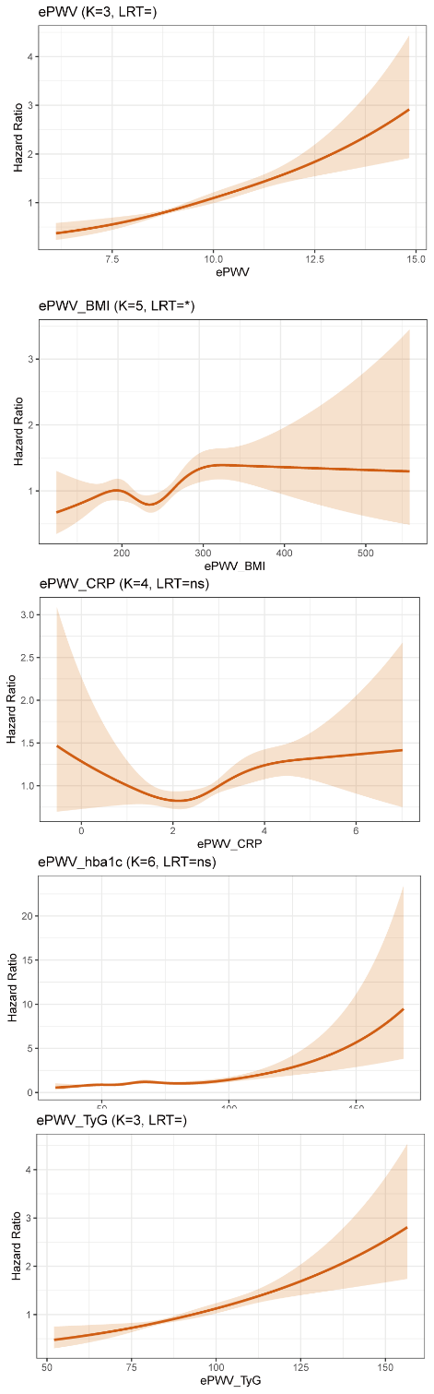
Figure S1. Optimal K-nodes number for different variables in RCS-COX analysis. . ePWV, estimated pulse wave velocity; BMI, Body mass index; CRP, C-reactive protein; TyG, Triglyceride-Glucose Index.

