Unlocking Soil Selenium: Indigenous Microorganisms Facilitate Speciation Shifts to Enhance Plant Bioavailability
Changmao Long · Yuexuan Wang · Zhen Li · Xianglei Cheng · Baojun Zhang
Appendix A. Supplementary Information
Table S1 Se content and corresponding enrichment coefficient in radish seedlings
 | Se content（mg kg⁻¹） | Enrichment coefficient
NS | 1.10±0.19a | 4.18±0.77a
NS4 | 1.58±0.17a | 3.73±0.39a
NS6 | 22.75±2.55b | 15.69±1.88b
DS | 1.04±0.12a | 4.54±0.63a
DS4 | 3.06±0.71a | 4.95±1.94a
DS6 | 23.36±0.60b | 16.71±0.65b
Different lowercase letters indicate statistically significant differences between treatments within the NS or DS groups (P < 0.05), and * indicate statistically significant differences between the sterilized and unsterilized groups (P < 0.05)

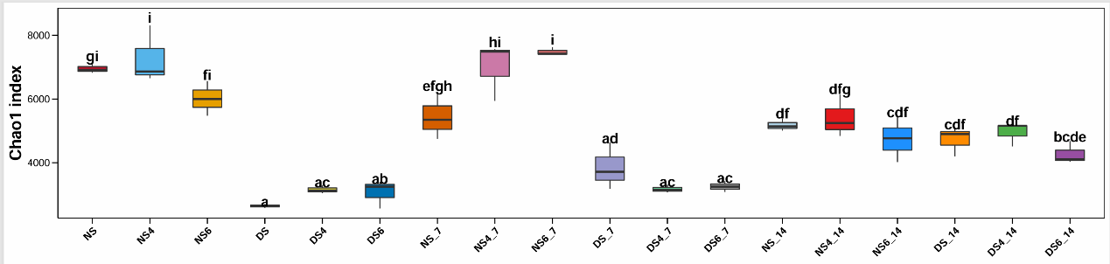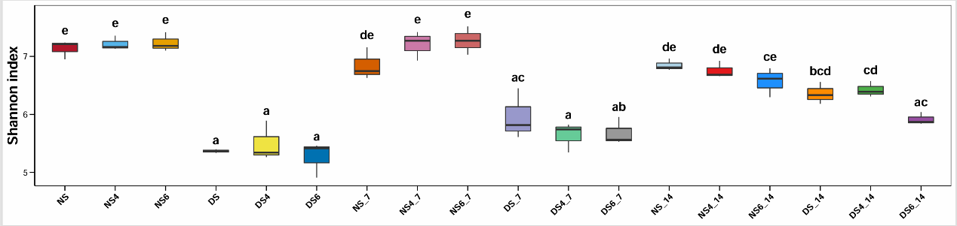
Fig. S1 Alpha diversity indices of bacterial communities in soil. Different letters denote statistically significant differences among treatment groups (P < 0.05)

Table S2 Alpha diversity indices of bacterial communities in soil
 | Chao1 | ACE | Shannon | Simpson | Pielou_J | PD_faith
NS | 6955.81±160.15 | 7656.22±181.68 | 7.13±0.16 | 0.99±0.002 | 0.82±0.01 | 154.28±8.51
NS4 | 7274.90±899.95 | 8039.53±1175.84 | 7.22±0.12 | 0.99±0.001 | 0.83±0.01 | 150.58±6.85
NS6 | 6013.26±543.77 | 6360.05±611.75 | 7.23±0.16 | 0.99±0.001 | 0.84±0.01 | 152.33±11.40
DS | 2642.09±57.28 | 2735.08±63.65 | 5.37±0.03 | 0.97±0.003 | 0.68±0.01 | 66.36±3.40
DS4 | 3157.20±120.76 | 3334.55±130.71 | 5.50±0.34 | 0.96±0.019 | 0.69±0.04 | 78.45±7.21
DS6 | 3069.15±443.35 | 3219.78±490.36 | 5.26±0.31 | 0.95±0.010 | 0.66±0.03 | 83.53±8.41
NS_7 | 5440.63±743.08 | 5797.95±829.47 | 6.85±0.28 | 0.99±0.006 | 0.80±0.02 | 151.09±18.02
NS4_7 | 6998.10±916.40 | 7548.21±1123.41 | 7.21±0.25 | 0.99±0.005 | 0.83±0.02 | 181.57±14.08
NS6_7 | 7481.05±131.09 | 8201.06±46.30 | 7.27±0.24 | 0.99±0.002 | 0.83±0.02 | 180.08±5.71
DS_7 | 3845.63±734.46 | 4178.92±778.78 | 5.96±0.44 | 0.98±0.004 | 0.73±0.04 | 94.70±15.29
DS4_7 | 3171.14±121.29 | 3340.84±158.59 | 5.64±0.25 | 0.97±0.013 | 0.70±0.03 | 89.88±3.78
DS6_7 | 3250.19±168.92 | 3418.12±180.67 | 5.68±0.24 | 0.97±0.004 | 0.71±0.02 | 85.46±6.15
NS_14 | 5178.34±190.35 | 5492.86±163.90 | 6.85±0.10 | 0.99±0.001 | 0.81±0.01 | 152.87±9.16
NS4_14 | 5407.63±664.11 | 5854.06±846.15 | 6.76±0.15 | 0.99±0.002 | 0.80±0.02 | 149.23±8.58
NS6_14 | 4737.46±701.59 | 5023.49±803.75 | 6.57±0.25 | 0.99±0.006 | 0.78±0.02 | 142.19±15.27
DS_14 | 4720.34±455.68 | 5112.18±588.19 | 6.36±0.19 | 0.99±0.006 | 0.76±0.02 | 123.92±3.76
DS4_14 | 4944.86±375.66 | 5405.21±403.43 | 6.43±0.14 | 0.99±0.001 | 0.76±0.01 | 126.42±13.55
DS6_14 | 4272.21±354.95 | 4719.75±413.08 | 5.92±0.11 | 0.98±0.007 | 0.72±0.02 | 108.23±6.26

Fig. S2 Relative abundance of the top 10 endophytic bacterial taxa in soil bacterial communities at the phylum level. Different letters denote statistically significant differences among treatment groups (P < 0.05)

Fig. S3 Relative abundance of the top 10 endophytic bacterial taxa in soil bacterial communities at the species level. Different letters denote statistically significant differences among treatment groups (P < 0.05)

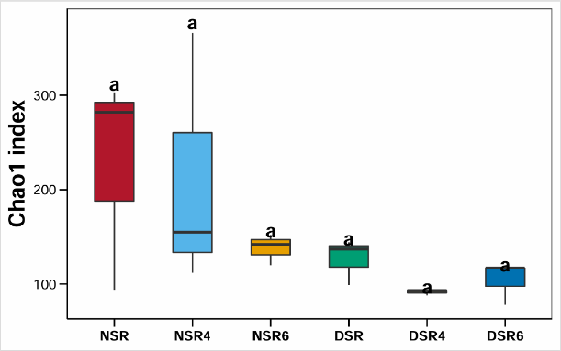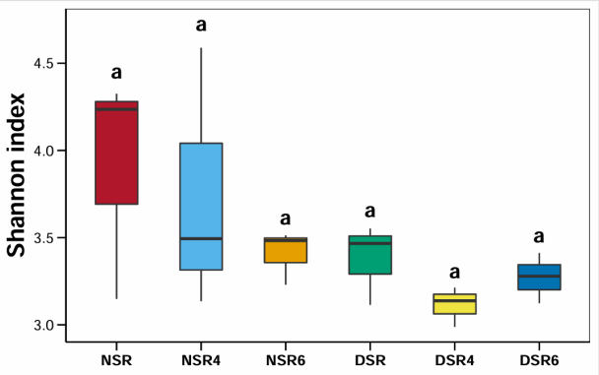
Fig. S4 Alpha diversity indices of bacterial communities in radish roots. Different letters denote statistically significant differences among treatment groups (P < 0.05)

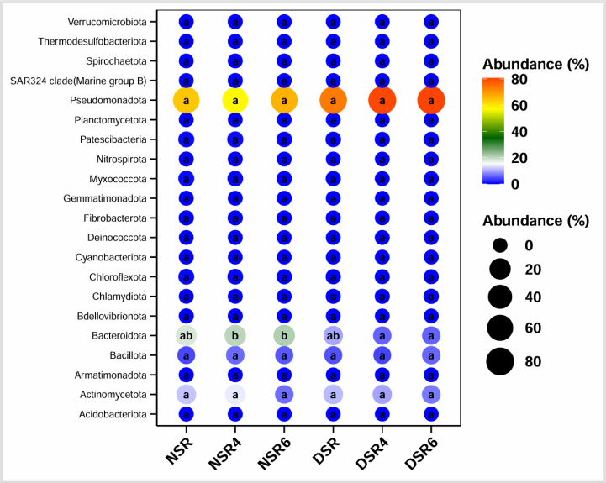
Fig. S5 Composition of endophytic bacterial communities in radish roots at the phylum level

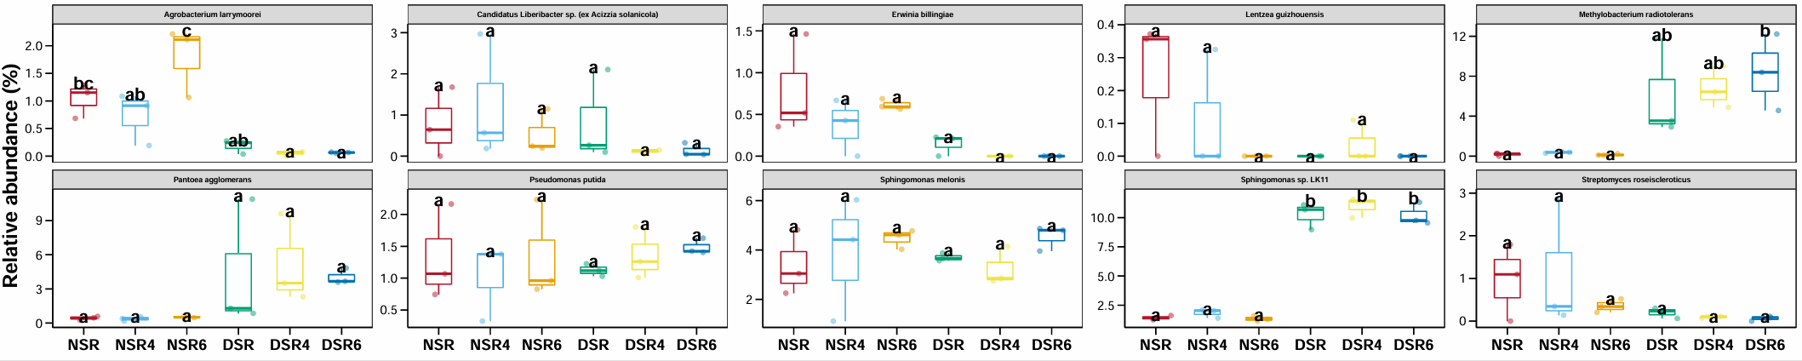
Fig. S6 Relative abundance of the top 10 endophytic bacterial taxa in radish roots at the phylum level. Different letters denote statistically significant differences between treatment groups (P < 0.05).

- Long · X. Cheng · B. Zhang () Jiangxi Provincial Key Laboratory of Disease Prevention and Public Health, No.1299, Xuefu Avenue, Nanchang 330031, Jiangxi, China School of Public Health, Nanchang University, No.1299, Xuefu Avenue, Nanchang 330031, Jiangxi, China e-mail: zhangbaojun@ncu.edu.cn Y. Wang · Z. Li School of Public Health, Nanchang University, No.1299, Xuefu Avenue, Nanchang 330031, Jiangxi, China

