Investigator/Lead Contact Name:
COIN or MIRECC (circle one)
Study/Project Name:
Please provide the following research materials for review at least 1 month prior to your scheduled meeting with the Board:
- Abstract in plain English or Objective of Project:

- Attach grant proposal and IRB protocol (if applicable) or other project documents
- Attach the 5-7 slide presentation (including relevant information about the health topic at hand and one slide with a simple, visual representation of your study design if relevant) that you will use to guide your verbal presentation to the Board.
- Where on the below Community Engagement Continuum would you like your interaction meeting interaction to be: 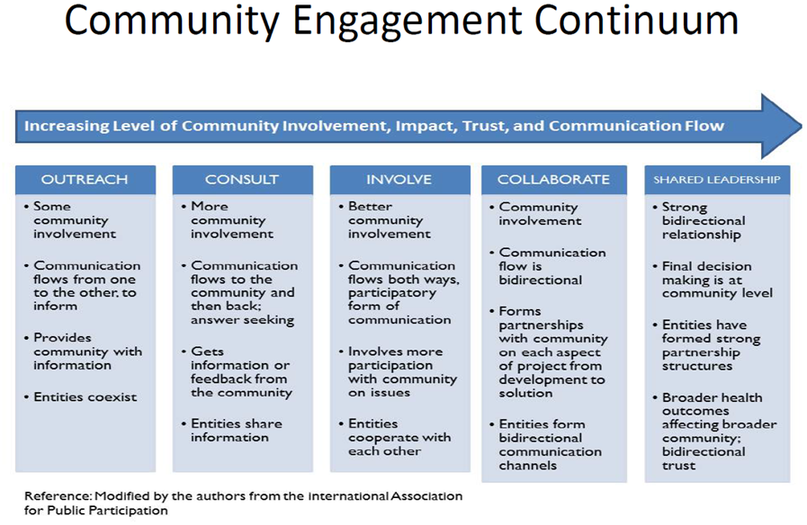*Examples can be provided by Leah or Kelty. Please contact if you would like more information on this question.
- What below areas of the project would you like to be informed or impacted by the board engagement? please circle all that apply:

- 2-3 specific questions for the board that you would like feedback/help on:

